Angular Howto (Angular course in Coursera)

Install Angular CLI

To install angular-cli globally, type the following at the prompt:
$ sudo npm install -g @angular/cli@6.2.1
or a more modern version
$ sudo npm install -g @angular/cli@9.0.0

This will make the command line tool for creating Angular applications. To learn more about the various commands that this CLI provides, type at the prompt:
$ ng help

Generating and Serving an Angular Project using Angular-CLI
At a convenient location on your computer, create a folder named <name of your app> and move into that folder.
Then type the following at the prompt to create a new Angular application named conFusion:

$ ng new conFusion –style=scss

francd @ debianito ~/git/angularCoursera (master)
└─ $ ng new conFusion --style=scss
? Would you like to add Angular routing? Yes
CREATE conFusion/README.md (1026 bytes)
CREATE conFusion/.editorconfig (246 bytes)
CREATE conFusion/.gitignore (631 bytes)
…
This should create a new folder named conFusion within your Angular folder and create the Angular application in that folder.

Move to the conFusion folder and type the following at the prompt:
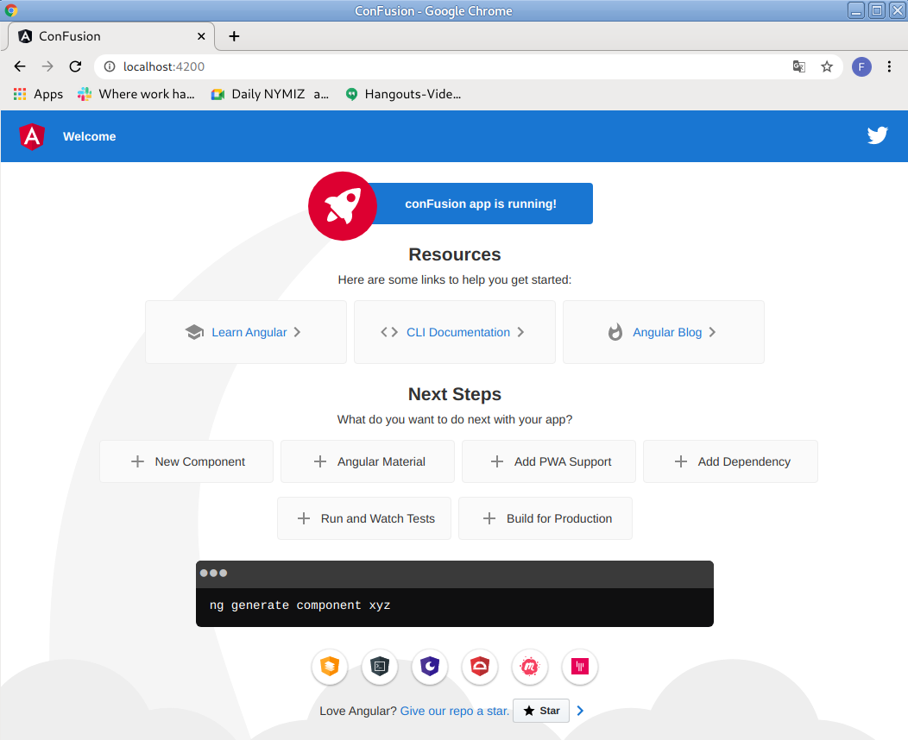
$ ng serve --open

This will compile the project and then open a tab in your default browser at the address http://localhost:4200.

Angular Application Architecture Overview

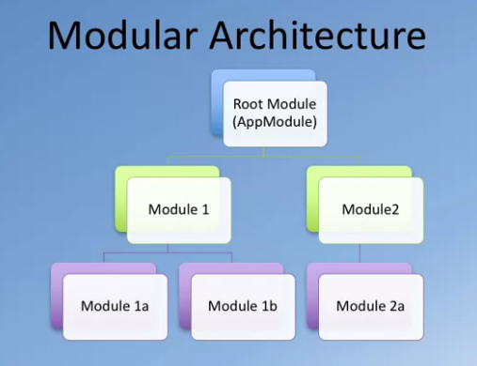

index.html: root page of the application
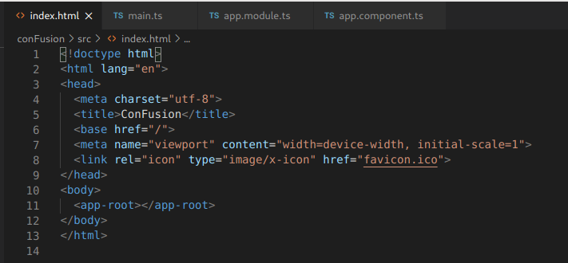

<app-root></app-root> → selector in app.component.ts specifies the main component of the application

main.ts: main class, it is a “companion“ to the index.html. It specifies which module is bootstrapped
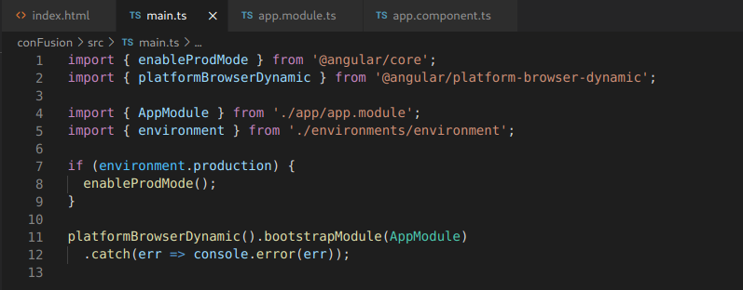

app.module.ts: it defines AppModule
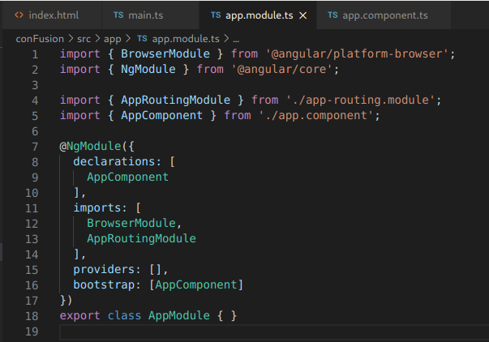

It defines which component is botstrapped (AppComponent in this case).
declarations: The set of components, directives, and pipes (declarables) that belong to this module.
imports: The set of NgModules whose exported declarables are available to templates in this module.
[
Example - The following example allows MainModule to use anything exported by CommonModule
*@NgModule*
({
imports: [CommonModule]
})
class MainModule {}
]
providers: The set of injectable objects that are available in the injector of this module.
[
Example - The following example defines a class that is injected in the HelloWorld NgModule:
class Greeter {
greet(name:string) {
return 'Hello ' + name + '!';
}
}

*@NgModule*
({
providers: [ Greeter ]
})
class HelloWorld {
greeter:Greeter;
constructor(greeter:Greeter) {
this.greeter = greeter;
}
}
]

bootstrap: The set of components that are bootstrapped when this module is bootstrapped. The components listed here are automatically added to entryComponents.

app.component.ts: it defines AppComponent
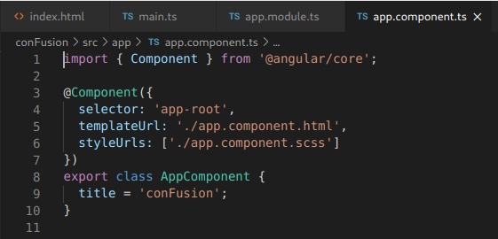

Configure Angular Application

We will set up our project to use Angular Material and Angular Flex Layout.

- Angular Material:
To configure your project to use Angular material, type the following at the prompt to install Angular Material, Angular Animations and HammerJS:
$ npm install @angular/material@6.4.7 --save
$ npm install @angular/cdk@6.4.7 --save
$ npm install --save @angular/animations@6.1.7
$ npm install --save hammerjs@2.0.8

Better this way:
https://medium.com/@reshailawan/how-to-install-angular-material-in-your-angular-project-edc26df22df

$ ng add @angular/material

This command will install Angular Material, the Component Dev Kit (CDK) and Angular Animations.
Then we install hammerjs:
$ npm install hammerjs – save

Next, include the following into the <head> of index.html to make use of Material Design icons:

<link href="https://fonts.googleapis.com/icon?family=Material+Icons" rel="stylesheet">

(It was already included by the installation process :)

-Flex layout:

$ npm install --save @angular/flex-layout@6.0.0-beta.18

If you don‘t indicate the version, the actual version is installed. Or the correct version for the Angular version, I hope:
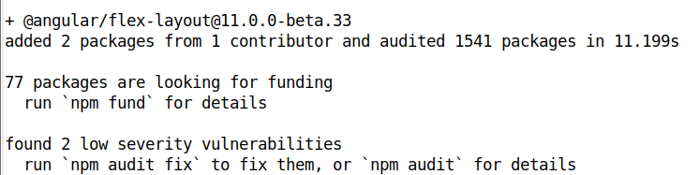

Now, import the Angular Animations Module, Angular Material Toolbar Module, Flex Layout Module and hammerjs into your root module (src/app/app.module.ts) as follows:

import { BrowserAnimationsModule } from '@angular/platform-browser/animations';
import { MatToolbarModule } from '@angular/material/toolbar';
import { FlexLayoutModule } from '@angular/flex-layout';
. . .
import 'hammerjs';

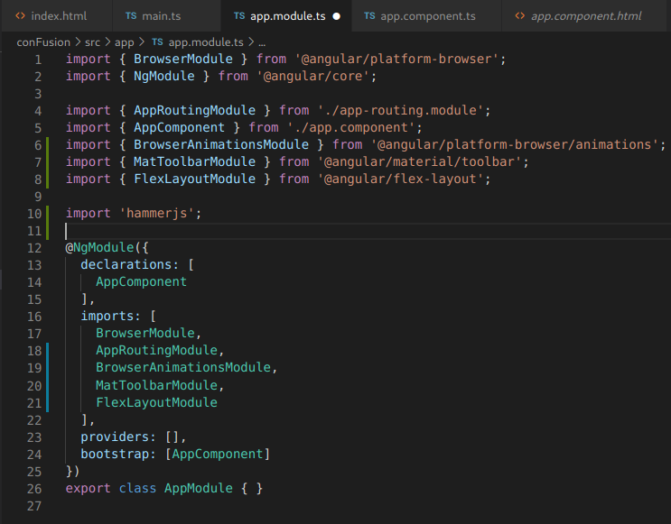
@NgModule({
. . .
imports: [
. . .,
BrowserAnimationsModule,
MatToolbarModule,
FlexLayoutModule
],

- Adding a Material Toolbar

Open app.component.html and replace its contents with the following code:

<mat-toolbar color="primary"> <span>Ristorante Con Fusion</span> </mat-toolbar>

- Adding Styles

Add the following styles to styles.scss file:

@import '~@angular/material/prebuilt-themes/deeppurple-amber.css';
// some basic resets
body {
padding: 0;
margin: 0;
font-family: Roboto, sans-serif;
}

This will add a built-in Material theme to our application.

