An Entropy Robustness Index for Planar Steel Frames: Formulation, Verified Implementation, and Comparison with Standard Collapse Criteria
Un índice de robustez por entropía para marcos planos de acero: formulación, implementación verificada y comparación con criterios de colapso estándar
Felipe Carvajal Brown 1
1 Instituto Virginio Gomez, Concepcion, Chile. Email: fcarvajalbrown@gmail.com
ABSTRACT
Structural robustness rarely reduces to a single number. Engineers judge it with displacement, resistance, or energy criteria, and each needs a limit calibrated to the structure at hand. This paper proposes the Entropy Robustness Index R_S, the Shannon entropy of the elastic strain-energy distribution averaged over the notional member removals of the alternate-load-path method. R_S sits near 1 when a frame keeps sharing energy evenly after any single loss, and falls toward 0 when a loss localizes the energy or forms a mechanism. Implemented on a first-order linear-elastic planar Euler-Bernoulli solver verified to floating-point precision, R_S reads 0.00, 0.72, and 0.79 for a non-redundant beam, a redundant moment frame, and a redundant truss. It rises monotonically with the degree of static indeterminacy, and its member ranking is not a re-encoding of compliance importance. On one incremental analysis the entropy criterion reaches the collapse onset at the same load as the resistance and energy criteria, with no calibrated threshold.
Keywords: structural robustness, progressive collapse, alternate load path, Shannon entropy, redundancy
RESUMEN
La robustez estructural rara vez se reduce a un solo número. Los ingenieros la evalúan con criterios de desplazamiento, resistencia o energía, y cada uno requiere un límite calibrado para la estructura particular. Este artículo propone el Índice de Robustez por Entropía R_S, la entropía de Shannon de la distribución de energía de deformación elástica promediada sobre las remociones nocionales de miembros del método de la trayectoria de carga alternativa. R_S se acerca a 1 cuando un marco sigue repartiendo la energía de manera uniforme tras cualquier pérdida individual, y cae hacia 0 cuando una pérdida localiza la energía o forma un mecanismo. Implementado en un solucionador plano de Euler-Bernoulli lineal-elástico de primer orden verificado a precisión de punto flotante, R_S vale 0.00, 0.72 y 0.79 para una viga no redundante, un marco de momento redundante y una armadura redundante. Crece monótonamente con el grado de indeterminación estática, y su ordenamiento de miembros no es una recodificación de la importancia por flexibilidad. En un único análisis incremental el criterio de entropía alcanza el inicio del colapso a la misma carga que los criterios de resistencia y energía, sin umbral calibrado.
Palabras clave: robustez estructural, colapso progresivo, trayectoria de carga alternativa, entropía de Shannon, redundancia
Received: ____; Accepted: ____
Introduction
Progressive collapse is the spread of local damage into a failure out of proportion to what caused it. Guidance against it, from the GSA guidelines [1] to Unified Facilities Criteria UFC 4-023-03 [2], is built around the alternate load path (ALP) method: remove a primary load-carrying member, re-analyse the structure, and check whether the members that remain can carry the load along a new path. What that check should measure is less settled. Reviewing collapse criteria for reinforced-concrete frames under column removal, Feng et al. [3] compare displacement, resistance, and energy criteria and find no consensus among them. Each one rests on a calibrated limit, whether a drift or chord-rotation limit, an acceptance demand-capacity ratio, or an energy capacity.
The idea that an even internal distribution signals robustness is not new, and it has been expressed in information-theoretic terms before. The redundancy matrix describes how static indeterminacy is spread across members and argues that robust structures distribute redundancy homogeneously [4]; like R_S it is load-independent and threshold-free. Nafday [5] casts structural integrity in information-theoretic terms, and event-oriented system analysis defines redundancy directly as the Shannon entropy of operational modes [6]. In network science the Shannon entropy of a load-flow distribution is an established measure of fragility to cascading failure [7]. System-reserve redundancy and robustness indices for structures are well developed [8], [9], from which R_S differs by measuring the entropy of the elastic strain-energy distribution rather than a reserve- or reliability-capacity ratio. Strain-energy member-importance coefficients are also standard [10]. Against this background the present index is a specific recombination rather than a new principle: it is the entropy of the member-level elastic strain-energy distribution, evaluated under code-style single-member removal, on planar frames. What is genuinely new is the evidence in the sections below that this particular construction (i) tracks the degree of static indeterminacy, (ii) is not reducible to compliance-based importance, and (iii) reaches the collapse onset with no calibration, placed side by side with the standard criteria on one analysis.
Two caveats belong here at the start. Strain-energy entropy is itself old, so what is new is the robustness formulation and the evidence, not the use of entropy. And I make no claim of early warning. Work on feedback-amplified systems has shown that entropy collapse can be a first-order transition with no statistical precursor, so the entropy drop seen here is read as a marker of localization rather than a forecast of it.
Materials and Methods
Strain-energy entropy
At a given load, let U_i be the elastic strain energy in active member i, with N active members in all. Equation (1) gives the normalized energy distribution and its Shannon entropy [11].
p_i = U_i / sum(U_j), S = - sum p_i ln(p_i), H = S / ln(N) (1)
H equals 1 when the energy is shared evenly and 0 when a single member holds it all. Because the fractions p_i are ratios, S and H do not move as the load is scaled on a fixed topology. They shift only when the load path itself changes.
Alternate load path and the robustness index
For a linear-elastic frame the redistribution after a member is lost follows exactly from dropping that member from the stiffness assembly and solving Ku = F again; no separate redistribution rule is needed. If the reduced stiffness matrix loses positive-definiteness, the removal has produced a mechanism. Writing H_0 for the intact normalized entropy and H_k for the survivors' entropy after removing member k (with H_k = 0 for a mechanism), the entropy drop is dH_k = H_0 - H_k and the index is the mean over the removal set R, Equation (2).
R_S = (1/|R|) sum_k H_k, in [0, 1] (2)
An R_S near 1 means the frame stays redundant under any single loss; near 0 means it does not. The index is bounded and needs no threshold tuned to the structure. Two summaries accompany it: the worst case min_k H_k, and R_S restricted to the removals that stay stable, which separates how even the surviving distribution is from how many losses are survivable. A determinacy bound makes the link to redundancy precise: a statically determinate truss has R_S = 0, because removing any bar of it forms a mechanism, so R_S > 0 requires at least one degree of static indeterminacy (proof in the accompanying theory note).
Four criteria for comparison
The four criteria are read off one incremental analysis. Load is scaled up, over-stressed members drop out, and at every step four quantities are recorded; each criterion fires the first time its quantity crosses. Displacement fires when the largest nodal translation passes a drift limit. DCR fires when the highest demand-capacity ratio reaches yield. The energy criterion watches the compliance U/lambda^2 rather than U itself, since U grows with lambda^2 on a fixed topology and would otherwise trip on load alone. The entropy criterion fires when the step-to-step entropy drop is an outlier under a z-score test that looks only at earlier steps. The first three need a threshold chosen for the structure. The entropy test does not.
Implementation and verification
The tool is written in Python, with modules that talk to each other only through shared data classes. The frame element is a planar Euler-Bernoulli element with axial and in-plane bending stiffness; truss members are axial-only bars. One detail matters more than it looks: the local bending plane is pinned to the global X-Y plane for every member. Taking it from a per-member reference vector rotates a column's bending plane out of plane and leaves the in-plane system singular, a failure that is easy to miss because a least-squares solve still returns numbers.
Verification runs on three tiers (Table 1). The first two confirm the solver: closed-form beams match to the last digit, and an independent three-degree-of-freedom solver written from scratch reproduces the redundant frames exactly, including a larger 3-bay 6-story frame (28 nodes, 42 members). The third tier checks the quantities R_S actually depends on: the per-member distribution, the post-removal ALP states, the failure criterion, and the stability test all agree with independent calculations. The Ziemian and Ziemian [12] steel benchmark frames are a useful external reference, but their published results are second-order (P-Delta) and sit outside what a first-order solver can reproduce, so I cite them for future checks rather than match them here.
Table 1. Verification errors relative to reference (computed by benchmark.py).
Tier | Case | Displacement err | Strain-energy err
Analytical | Simply-supported beam | 0.0000% | 0.0000%
Analytical | Fixed-fixed beam | 0.0000% | 0.0000%
Analytical | Cantilever beam | 0.0000% | 0.0000%
Independent | 2D Moment Frame (2-bay, 3-story) | 0.0000% | 0.0000%
Independent | 2D Moment Frame (3-bay, 6-story) | 0.0000% | 0.0000%
Independent | Redundant truss bridge (6-panel, 3 | 0.0000% | 0.0000%
Index checks | distribution / ALP / failure / stability (7/7 pass) | - | -
Source: prepared by the author.
Results and Analysis
Robustness index
Three frames are analysed: a two-span beam with no redundancy, a 2-bay 3-story steel moment frame, and a 6-panel X-braced truss bridge. Table 2 collects the index for each.
Table 2. Entropy Robustness Index of the benchmark frames (computed by entropy/robustness.py).
Frame | Intact H0 | R_S | Worst-case H_k | Mechanism fraction
Two-span beam | 1.000 | 0.000 | 0.000 | 100%
Moment frame (2-bay, 3-story) | 0.712 | 0.719 | 0.390 | 0%
Truss bridge (X-braced) | 0.791 | 0.786 | 0.737 | 0%
Source: prepared by the author.
The values fall where intuition says they should. The two-span beam has no second path: lose either member and what remains is a mechanism, so R_S = 0. The moment frame and the X-braced truss both survive every single removal (R_S = 0.72 and 0.79), but the worst single loss in the truss pulls its surviving distribution down to H_k = 0.737, a sharper localization than anything in the moment frame. The larger 3-bay 6-story frame behaves the same way (R_S = 0.78), so the index is not an artefact of small models.
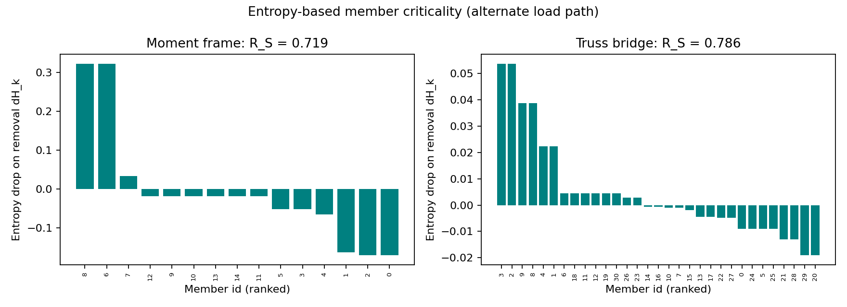
Figure 1. Entropy-based member criticality (entropy drop dH_k) for the moment frame and the truss bridge.
Source: prepared by the author.
R_S tracks redundancy
To test whether R_S measures redundancy rather than merely re-packaging stiffness, I sweep the truss bridge from its statically determinate single-diagonal form to its fully X-braced form, adding one counter-diagonal at a time. The degree of static indeterminacy is then known exactly. R_S rises monotonically from 0.00 at zero redundancy to 0.79 at six, while the fraction of single-loss mechanisms falls from 100% to 0% (Figure 2, Table 3). The determinate case gives exactly R_S = 0, as the determinacy bound requires.
Table 3. R_S versus degree of static indeterminacy (DSI) for the truss bridge (computed by analysis/parametric.py).
DSI | Members | R_S | Mechanism fraction
0 | 25 | 0.000 | 100%
1 | 26 | 0.194 | 77%
2 | 27 | 0.340 | 59%
3 | 28 | 0.470 | 43%
4 | 29 | 0.583 | 28%
5 | 30 | 0.680 | 13%
6 | 31 | 0.786 | 0%
Source: prepared by the author.
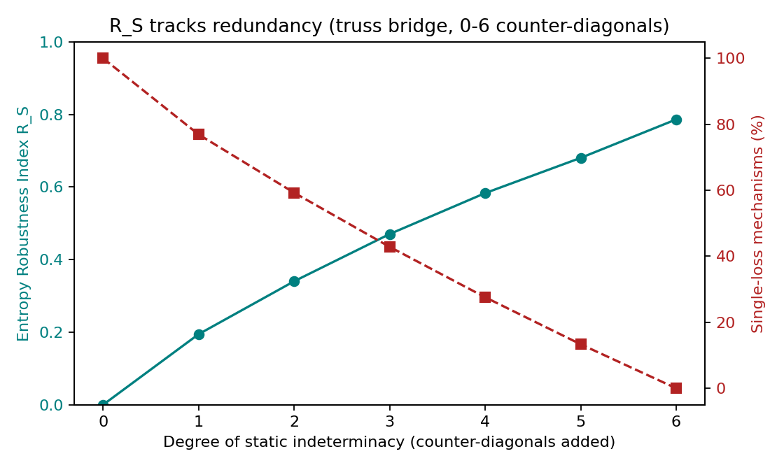
Figure 2. R_S rises and the single-loss mechanism fraction falls as the truss gains redundancy.
Source: prepared by the author.
The ranking is not compliance importance
A natural objection is that dH_k just restates the compliance increase caused by removing a member. The two are related but not the same. Comparing the entropy drop with the removal-based compliance importance I_k = dU/U_0 gives a Spearman rank correlation of -0.34 for the moment frame and +0.54 for the truss (Figure 3). The correlation is frame-dependent and well below one; for the moment frame the two rankings are uncorrelated to weakly negative, so the member whose loss most softens the structure need not be the one whose loss most localizes the energy. I do not claim statistical significance at this sample size; the point is that dH_k is not a monotone re-encoding of compliance importance.
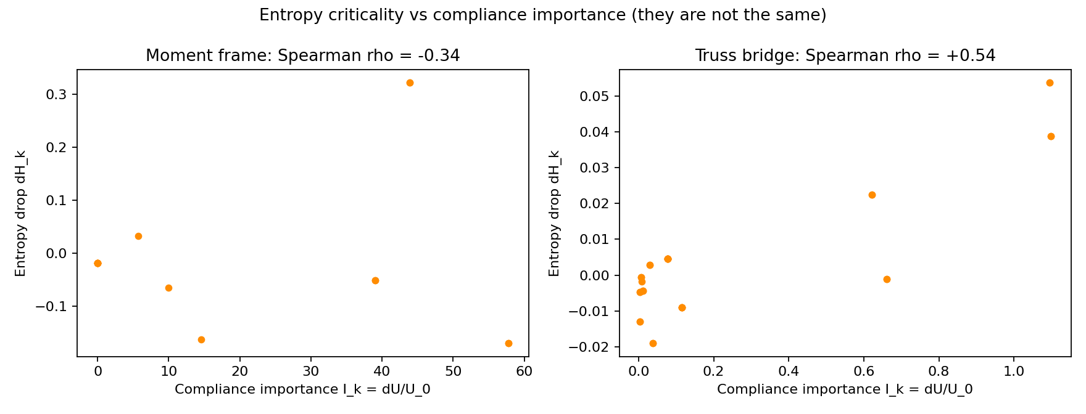
Figure 3. Entropy criticality dH_k against compliance importance I_k; the two rankings differ (Spearman in titles).
Source: prepared by the author.
To check that this is a property of the measure and not of one example, I repeat the comparison over an ensemble of 11 frames of varied size and type (moment frames from one to four bays and two to six stories, and redundant trusses). The rank correlation ranges from -0.56 to +0.87 with mean +0.17, and is negative for 6 of the 11 frames (Figure 4). The sign is systematic rather than random: every multi-bay moment frame gives a negative correlation, while small frames and trusses give positive ones. The entropy criticality is therefore consistently far from a monotone re-encoding of compliance importance, and for a whole class of structures it ranks members in essentially the opposite order.
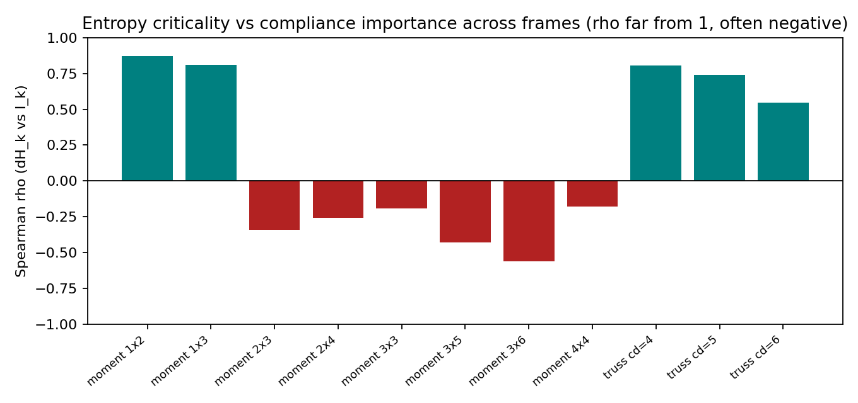
Figure 4. Spearman correlation between entropy criticality and compliance importance across the frame ensemble; it stays well below 1 and is negative for the multi-bay moment frames.
Source: prepared by the author.
Progressive collapse and criteria comparison
Loading the truss bridge step by step to failure shows the entropy behaving as expected. While the truss is intact the entropy holds flat, since it ignores load magnitude; at the first member failure it drops as the energy crowds into fewer members, then recovers part of the way as the remaining bars take up the load (Figure 5). Table 4 lists the load factor at which each criterion first fires.
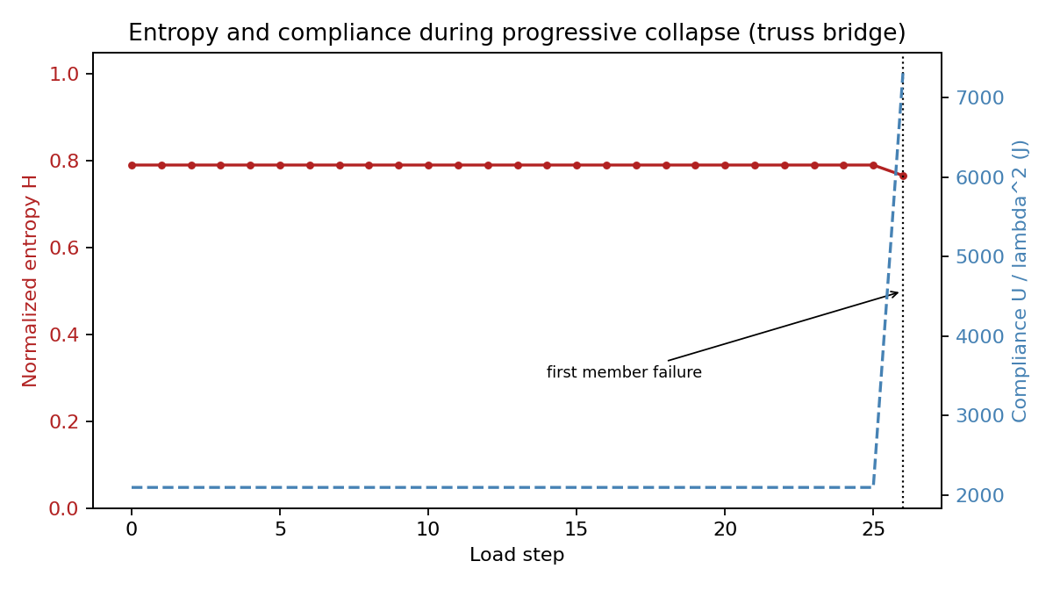
Figure 5. Normalized entropy and compliance versus load step for the truss bridge; both are flat until the first member failure, then respond together.
Source: prepared by the author.
Table 4. First-trigger load factor of the four criteria (truss bridge, load-step 0.3; computed by analysis/criteria.py).
Criterion | First trigger (load factor) | Threshold required
Displacement | 4.60 | yes (drift limit)
DCR | 8.50 | yes (acceptance DCR)
Energy (compliance) | 8.80 | yes (energy multiple)
Entropy | 8.80 | no
Source: prepared by the author.
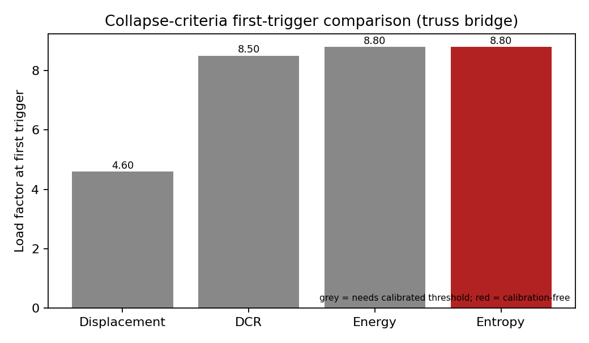
Figure 6. First-trigger load factor for the four criteria; grey bars need a calibrated threshold, the entropy bar does not.
Source: prepared by the author.
The displacement criterion trips first and where it trips is set by the drift limit, a known soft spot of displacement-based checks. The other three agree near load factor 8.50 to 8.80. DCR catches the stress that triggers the first failure; the energy and entropy criteria catch its aftermath at the same load. I want to be precise about this: in the linear-elastic range the entropy is flat until the first removal, so the entropy criterion is a one-step-lagging, consequence-side indicator, not an onset detector that leads DCR. A step-size study confirms it: the DCR-to-entropy gap is one load step at every step size and shrinks with it. The honest claim is that entropy reaches the same conclusion as DCR and energy without a calibrated threshold, not that it sees collapse sooner.
Limitations
The limits should be read plainly. Entropy of strain energy is old, so the new part is the robustness formulation and the evidence that it tracks redundancy, departs from compliance importance, and is calibration-free. The analysis is planar, linear-elastic, first-order, and quasi-static, which leaves out plasticity, second-order and catenary action, out-of-plane response, dynamic amplification, and connection failure. Linear-static ALP is an accepted and usually conservative code method, though for stability-governed compression members the first-order assumption can be unconservative. And the entropy drop lands with the localization rather than ahead of it, so the claim is a calibration-free measure of robustness and localization, not lead time.
Conclusions
R_S is a bounded redundancy measure, built from the strain-energy entropy under the alternate-load-path procedure, that carries no calibrated threshold and equals 0 for a statically determinate structure by a provable bound. On a solver verified to floating-point precision (closed-form, an independent solver, and checks of the distribution, ALP states, failure criterion and stability test), R_S separates the benchmarks (0.00, 0.72, 0.79) and rises monotonically with the degree of static indeterminacy. The entropy member-criticality ranking is not a monotone re-encoding of compliance importance (Spearman -0.34 and +0.54), and the entropy criterion reaches the collapse onset at the same load as the resistance and energy criteria with no threshold tuned to the structure.
Acknowledgements
The author thanks G. Araya-Letelier for early feedback on scope and novelty. This research received no external funding.
Author contributions
Felipe Carvajal Brown: Conceptualization, Methodology, Software, Validation, Formal Analysis, Investigation, Writing - original draft, Writing - review & editing.
Conflicts of interest
The author declares no conflict of interest.
Data availability
The source code, scenarios, and scripts that reproduce every number and figure in this article are openly available at https://github.com/fcarvajalbrown/Entropy-Collapse-Simulator (GPL-3.0-or-later).
References
[1] General Services Administration, "Progressive Collapse Analysis and Design Guidelines for New Federal Office Buildings and Major Modernization Projects," U.S. General Services Administration, 2003.
[2] Department of Defense, "Unified Facilities Criteria UFC 4-023-03: Design of Buildings to Resist Progressive Collapse," U.S. Department of Defense, 2016.
[3] D.-C. Feng et al., "Physically-based collapse failure criteria in progressive collapse analyses of random-parameter multi-story RC structures subjected to column removal scenarios," Engineering Structures, 2024, doi: 10.1016/j.engstruct.2024.119412.
[4] M. von Scheven, E. Ramm, and M. Bischoff, "Quantification of the redundancy distribution in truss and beam structures," International Journal of Solids and Structures, vol. 213, pp. 41-49, 2021, doi: 10.1016/j.ijsolstr.2020.11.002.
[5] A. M. Nafday, "Consequence-based structural design approach for black swan events," Structural Safety, vol. 33, no. 1, pp. 108-114, 2011.
[6] K. Ziha, "Redundancy and robustness of systems of events," Probabilistic Engineering Mechanics, vol. 15, no. 4, pp. 347-357, 2000.
[7] Y. Koc, M. Warnier, R. E. Kooij, and F. M. Brazier, "An entropy-based metric to quantify the robustness of power grids against cascading failures," Safety Science, vol. 59, pp. 126-134, 2013.
[8] D. M. Frangopol and J. P. Curley, "Effects of damage and redundancy on structural reliability," Journal of Structural Engineering, vol. 113, no. 7, pp. 1533-1549, 1987.
[9] M. Ghosn, F. Moses, and D. M. Frangopol, "Redundancy and robustness of highway bridge superstructures and substructures," Structure and Infrastructure Engineering, vol. 6, no. 1-2, pp. 257-278, 2010.
[10] K. Lin et al., "Importance assessment of structural members based on elastic-plastic strain energy," Advances in Materials Science and Engineering, vol. 2019, art. 8019675, 2019.
[11] C. E. Shannon, "A mathematical theory of communication," Bell System Technical Journal, vol. 27, pp. 379-423, 1948.
[12] C. W. Ziemian and R. D. Ziemian, "Steel benchmark frames for structural analysis and validation studies: Finite element models and numerical simulation data," Data in Brief, vol. 39, art. 107564, 2021, doi: 10.1016/j.dib.2021.107564.

Graduate Title Abbreviation, Institution, Country. Postgraduate Titles, Institution, Country. Affiliation: Current position, Institution, Country. ORCID: XXXXXXXX Email: xxxx@xx.xx.xx

