Research Article
A Calibration-Free Entropy Index for Screening Progressive-Collapse Vulnerability of Steel Building Frames: Column Triage Validated Against Alternate-Load-Path Analysis
Felipe Carvajal Brown 1, *
1 MSc in Numerical Simulations (Spain); fcarvajalbrown@gmail.com
* Correspondence: fcarvajalbrown@gmail.com
Received: ____; Accepted: ____; Published: ____
Citation: Carvajal Brown, F. (2026). A Calibration-Free Entropy Index for Screening Progressive-Collapse Vulnerability of Steel Building Frames. Revista de la Construccion. Journal of Construction.
Highlights:
- A calibration-free index R_S screens which steel-frame columns are critical, from a single linear analysis.
- It ranks columns like a code alternate-load-path (ALP) removal check, so it triages where costly nonlinear ALP is worth running.
- On the Vogel benchmark building the entropy ranking agrees with the ALP severity at Spearman rho = 0.91.
- R_S distinguishes design variants by redundancy and flags the columns whose loss the design cannot survive.
Abstract: Code guidance against progressive collapse (GSA, 2003; DoD, 2016) uses the alternate load path (ALP) method: notionally remove a primary column, re-analyse, and check that the remaining structure carries the load. Done faithfully this is a nonlinear analysis, and it must be repeated for every column the engineer chooses to remove, against acceptance limits calibrated to the structure. This paper proposes a cheap way to decide which columns deserve that effort. The Entropy Robustness Index R_S is the Shannon entropy of the elastic strain-energy distribution, averaged over single-member removals; its per-column entropy drop dH_k ranks columns by how much their loss localizes the load path. R_S needs no calibrated threshold and follows from one linear solve. We apply it to a published, recognisable steel building, the Vogel (1985) six-storey two-bay moment frame, and compare the entropy column ranking with a code-style ALP severity, the worst demand-capacity ratio (DCR) that appears after the column is removed. The two rankings agree strongly (Spearman rho = 0.91 over all 18 columns); the two columns whose loss most overstresses the frame are exactly the two the entropy ranking places first, so an engineer can reserve the nonlinear ALP runs for the columns R_S flags. Because the model is linear, this ranking is independent of the load level. We then show R_S supports a design decision: it ranks a fixed-base (moment) version of the building as more robust than a pinned-base variant (0.788 vs 0.702) and pinpoints the base columns whose loss the pinned design cannot survive. The scope is that of a screening tool: planar, first-order, linear-elastic and quasi-static, measuring load-path redundancy rather than strength, and marking localization as it happens rather than forecasting it.
Keywords: progressive collapse; steel frames; alternate load path; structural robustness; column removal; Shannon entropy; screening
Introduction
Progressive collapse is the spread of local damage into a failure out of proportion to its trigger. The design guidance written against it, from the General Services Administration guidelines (GSA, 2003) to Unified Facilities Criteria UFC 4-023-03 (DoD, 2016), is organised around the alternate load path (ALP) method: a primary load-carrying column is notionally removed, the structure is re-analysed, and the engineer checks whether the members that remain can carry the load along a new path. The method is powerful but expensive. A faithful ALP check is nonlinear, it is repeated once per removal scenario, and it is judged against acceptance limits (drift, chord rotation, an acceptance demand-capacity ratio) that must be chosen for the structure. On a real building with many columns, deciding which columns to remove, and how much analysis each deserves, is itself part of the engineering work.
This paper addresses that decision rather than replacing the ALP analysis. We ask whether a cheap, calibration-free index computed from a single linear analysis can tell the engineer which columns are critical, so that the costly nonlinear ALP effort is spent where it matters. The index we use is the Entropy Robustness Index R_S, the Shannon entropy of the elastic strain-energy distribution evaluated under single-member removal. The idea that an even internal distribution signals robustness is established: the redundancy matrix argues that robust structures distribute redundancy homogeneously (von Scheven et al., 2021); information-theoretic measures of structural integrity and of redundancy as the entropy of operational modes are older still (Nafday, 2011; Ziha, 2000); and the entropy of a load-flow distribution is a standard fragility measure for cascading failure in networks (Koc et al., 2013). System-reserve redundancy and robustness indices for structures are well developed (Frangopol and Curley, 1987; Ghosn et al., 2010), and strain-energy member-importance coefficients are standard (Lin, 2019). R_S differs from these by measuring the entropy of the member-level elastic strain-energy distribution under code-style single-member removal, and by being bounded in [0, 1] with no structure-specific threshold.
The contribution here is not the index itself, which prior work has set out, but its use as a construction-engineering screening tool and the evidence that it works as one. We evaluate R_S on a published, recognisable steel building rather than a toy frame, we show its per-column ranking agrees with a code-style ALP severity so that it can triage columns for nonlinear analysis, and we show it supports a real design decision. Two honesties frame the claim. First, R_S measures load-path redundancy, how evenly strain energy is shared and whether a single loss is survivable, not strength or stiffness; we make that boundary explicit and do not claim it substitutes for capacity checks. Second, the entropy drop marks localization as it occurs and is not an early-warning signal.
Materials and methods
The entropy robustness index
At a given load let U_i be the elastic strain energy in active member i, with N active members. The normalized energy distribution and its Shannon entropy are given by Equation (1).
$p_{i}\text{ = }\frac{U_{i}}{\sum_{j}{U_{j}}}\text{ , }S\text{ = -}\sum_{i}{p_{i}\text{ ln }p_{i}}\text{ , }H\text{ = }\frac{S}{\text{ln }N}$ (1)
H equals 1 when strain energy is shared evenly and 0 when a single member holds it all. Because the p_i are ratios, H does not change as the load is scaled on a fixed topology; it moves only when the load path changes. For a linear-elastic frame the redistribution after a column is lost follows exactly from dropping that member from the stiffness assembly and solving Ku = F again, which is the ALP redistribution with no separate rule. Writing H_0 for the intact normalized entropy and H_k for the survivors after removing member k (with H_k = 0 when the removal forms a mechanism), the per-member entropy drop is dH_k = H_0 - H_k and the index is the mean over the removal set R, Equation (2).
$R_{S}\text{ = }\frac{\text{1}}{\text{|R|}}\sum_{k}{H_{k}}\text{ , ∈ [0, 1]}$ (2)
R_S near 1 means the frame stays redundant under any single loss; near 0 means it does not. A determinacy bound ties this to redundancy: a statically determinate truss has R_S = 0, because removing any bar forms a mechanism, so R_S > 0 requires at least one degree of static indeterminacy. The per-column entropy drop dH_k is the screening output: columns with large dH_k are those whose loss most localizes the load path, and are the candidates for detailed analysis.
Code-style alternate-load-path severity
To test whether dH_k picks the columns an ALP analysis would flag, we compare it against a code-style severity for the same single-column removals. For each column we remove it, re-solve at the design load, and record the worst demand-capacity ratio (DCR, combined axial plus bending stress over yield) among the surviving members; a removal that forms a mechanism scores infinite severity. This is the quantity a linear-static ALP check inspects: whether the alternate path is within capacity or grossly overstressed. Unlike R_S it is threshold-based, which is the point of the comparison: a calibration-free index is judged against the threshold-based procedure it is meant to triage for. Because the model is linear, the post-removal DCR scales with the load factor, so the ranking of columns by severity is independent of the load level, as is dH_k; the agreement between them is therefore a structural property, not an artefact of the chosen load. We report their Spearman rank correlation and their top-k overlap.
Benchmark building
The study frame is the Vogel (1985) six-storey two-bay steel moment frame, a European calibration frame used to validate advanced steel-frame analyses and included in the Ziemian and Ziemian (2021) benchmark collection. It is 12 m wide (two 6 m bays) and 22.5 m tall (six 3.75 m storeys), with rigid beam-to-column connections, fixed bases, IPE floor beams and HEB columns in European S235 steel (E = 205 GPa). Beam sections range from IPE 400 at the lowest floor to IPE 240 at the roof; column sections from HEB 260/220 at the base to HEB 200/160 at the top. Gravity is the published distributed load (49.1 kN/m on floors, 31.7 kN/m on the roof), represented as work-equivalent joint loads, together with Vogel's notional horizontal loads. The model has 21 nodes and 30 members, of which 18 are columns. We stress that the analysis is first-order and linear-elastic: Vogel's own results are second-order and inelastic and are not reproduced here. The frame is used as a realistic, provenance-backed geometry on which to exercise the screening index, not as a second-order benchmark.
Implementation and verification
The analysis uses an in-house planar Euler-Bernoulli frame solver whose modules communicate only through shared data classes. The solver is verified to floating-point precision against three closed-form beam cases and against an independent three-degree-of-freedom solver written from scratch. On the Vogel building the independent solver reproduces the joint displacements and total strain energy of the production solver to within 0.0000% (that is, to floating-point precision), so the strain-energy distribution that R_S is built from is correct.
Results and discussion
Robustness of the benchmark building
The intact Vogel building has normalized entropy H_0 = 0.800 and Entropy Robustness Index R_S = 0.788. No single member loss forms a mechanism (mechanism fraction 0%), consistent with a redundant moment frame, and the worst single loss pulls the surviving distribution to H_k = 0.478. R_S is therefore in the range expected of a genuinely redundant building, well away from the determinate limit of 0.
R_S column triage agrees with the ALP check
The screening claim is that the entropy column ranking dH_k picks the same critical columns as the code-style ALP severity. Over all 18 columns the two rankings agree with a Spearman correlation of +0.91 (Figure 1). The agreement is strongest exactly where it matters for triage: the two columns whose loss produces the worst surviving overstress (post-removal DCR of 7.5 and 7.5, the top-storey exterior columns) are the same two columns the entropy ranking places first, and 4 of the five most severe columns by the ALP check are within the five most critical by dH_k. In practice this means an engineer can compute dH_k for all 18 columns from one linear solve and reserve the expensive nonlinear ALP analyses for the handful the index flags, rather than analysing every column or choosing removal scenarios by judgement alone. The ranking carries no calibrated threshold and, being scale-invariant, does not depend on the load level at which it is computed.
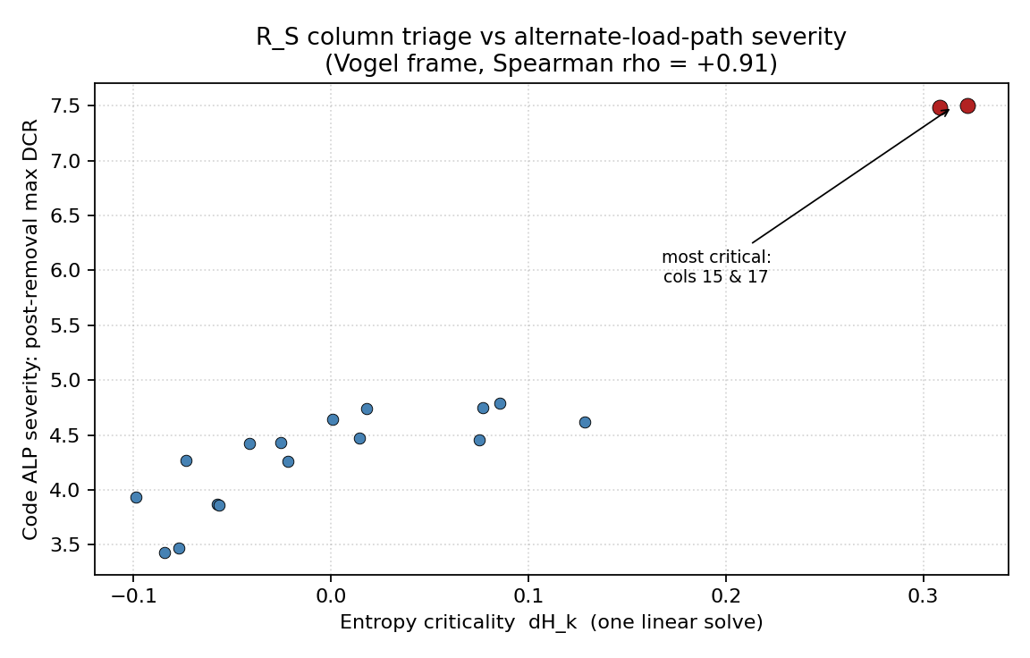
Figure 1. Entropy column criticality dH_k (one linear solve) against the code-style alternate-load-path severity (post-removal maximum DCR) for the Vogel building. The two most critical columns coincide and the overall Spearman correlation is +0.91.
The agreement is strong but not perfect, and this is expected. The two measures answer overlapping but different questions: dH_k measures how much a loss localizes the load path, while the ALP DCR measures how much it overstresses the survivors. They rank the most critical columns the same way, which is what a triage needs, while differing on the less critical columns where the decision matters least.
A design decision: base fixity
A screening index earns its place if it can tell two designs apart. We compare the Vogel building as built, with fixed (moment) column bases, against a variant with pinned bases, a genuine and cost-relevant steel-design choice. R_S ranks the fixed-base design as more robust (0.788) than the pinned-base design (0.702), a drop of 0.086 (Figure 2, Table 1). The reason is explicit in the index: with pinned bases the loss of a base column is no longer survivable, so 10% of single-column removals form a mechanism, and the worst-case surviving entropy falls to zero. Moreover the entropy criticality ranking of the pinned design places the three base columns [0, 1, 2] at the very top, so the index not only scores the weaker design lower but points at the exact members whose loss it cannot survive, i.e. where redundancy must be restored.
Table 1. Design-variant comparison for the Vogel building (computed by analysis/design_variants.py).
Design variant | R_S | Single-loss mechanisms | Mechanism-forming columns
Fixed (moment) bases, as built | 0.788 | 0% | none
Pinned bases | 0.702 | 10% | 0, 1, 2

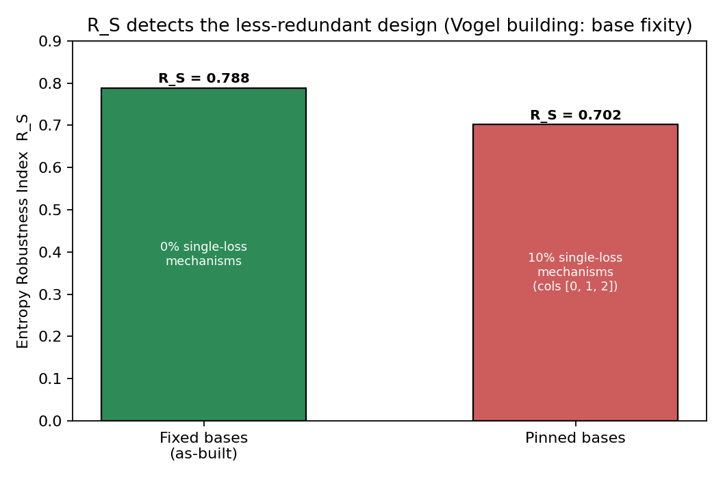
Figure 2. R_S distinguishes the two designs: the pinned-base variant is less redundant, admitting single-column-loss mechanisms at the base columns, and R_S scores it lower.
What R_S measures, and what it does not
It is important to state the boundary of the index, because it shapes how the screening should be used. R_S rewards distributed, redundant load paths and the survivability of single losses. It is not a strength or stiffness measure, and it does not reward member stiffening: increasing a member's section concentrates strain energy in it and can lower R_S, and adding a stiff brace to an already-redundant frame can do the same. R_S therefore screens for redundancy, the property the ALP method is concerned with, and it should be read alongside, not in place of, strength and serviceability checks. This division of labour is a feature for a triage tool: R_S answers 'which column losses does this structure struggle to survive', which is precisely the ALP question, and leaves 'is each member strong enough' to the capacity checks.
Limitations as the envelope of a screening tool
The limits define where the screening applies rather than apologise for it. The analysis is planar, first-order, linear-elastic and quasi-static, so it omits plasticity, second-order and catenary action, out-of-plane response, dynamic amplification, and connection failure. These are exactly the effects a detailed nonlinear ALP analysis is run to capture, which is why R_S is positioned as the cheap first pass that decides where to run it, not as a replacement. Linear-static ALP is itself an accepted, generally conservative code method, though for stability-governed compression members the first-order assumption can be unconservative, a further reason to reserve nonlinear analysis for the flagged columns. Finally, the entropy drop lands with the localization rather than ahead of it, so the index is a calibration-free measure of robustness and localization, not a predictive early warning.
Conclusions
The Entropy Robustness Index R_S provides a calibration-free screening of steel-frame columns for progressive-collapse vulnerability from a single linear analysis, ranking columns by the per-column entropy drop dH_k according to how much their loss localizes the load path. On the published Vogel (1985) benchmark building this ranking agrees with a code-style alternate-load-path severity at a Spearman correlation of 0.91, with the two most critical columns coinciding, so R_S can triage which columns deserve the expensive nonlinear ALP analysis. The index also supports design decisions: it ranks a fixed-base building as more robust than a pinned-base variant (0.788 against 0.702) and identifies the base columns whose loss the weaker design cannot survive.
R_S measures load-path redundancy rather than strength, so it belongs alongside the capacity checks and ahead of the nonlinear alternate-path analysis, within a planar, linear-elastic, quasi-static envelope and with no claim of early warning. Used this way it turns a single linear solve into a rational way to concentrate progressive-collapse assessment on the columns where it matters.
Author contributions: F.C.B. conceived the method, implemented the software, performed the analyses, and wrote the manuscript.
Funding: This research received no external funding.
Data availability: The software, benchmark frames and analysis scripts that reproduce every number and figure in this paper are openly available in the project repository.
Conflicts of interest: The author declares no conflict of interest.
References
Department of Defense. (2016). Unified Facilities Criteria UFC 4-023-03: Design of Buildings to Resist Progressive Collapse.
Feng, D.-C., et al. (2024). Physically-based collapse failure criteria in progressive collapse analyses of random-parameter multi-story RC structures subjected to column removal scenarios. Engineering Structures. https://doi.org/10.1016/j.engstruct.2024.119412
Frangopol, D. M., & Curley, J. P. (1987). Effects of damage and redundancy on structural reliability. Journal of Structural Engineering, 113(7), 1533-1549.
General Services Administration. (2003). Progressive Collapse Analysis and Design Guidelines for New Federal Office Buildings and Major Modernization Projects.
Ghosn, M., Moses, F., & Frangopol, D. M. (2010). Redundancy and robustness of highway bridge superstructures and substructures. Structure and Infrastructure Engineering, 6(1-2), 257-278.
Koc, Y., Warnier, M., Kooij, R. E., & Brazier, F. M. (2013). An entropy-based metric to quantify the robustness of power grids against cascading failures. Safety Science, 59, 126-134.
Lin, K., et al. (2019). Importance assessment of structural members based on elastic-plastic strain energy. Advances in Materials Science and Engineering, 2019, 8019675.
Nafday, A. M. (2011). Consequence-based structural design approach for black swan events. Structural Safety, 33(1), 108-114.
Shannon, C. E. (1948). A mathematical theory of communication. Bell System Technical Journal, 27, 379-423.
von Scheven, M., Ramm, E., & Bischoff, M. (2021). Quantification of the redundancy distribution in truss and beam structures. International Journal of Solids and Structures, 213, 41-49. https://doi.org/10.1016/j.ijsolstr.2020.11.002
Vogel, U. (1985). Calibrating frames. Stahlbau, 54, 293-301.
Ziemian, C. W., & Ziemian, R. D. (2021). Steel benchmark frames for structural analysis and validation studies: Finite element models and numerical simulation data. Data in Brief, 39, 107564. https://doi.org/10.1016/j.dib.2021.107564
Ziha, K. (2000). Redundancy and robustness of systems of events. Probabilistic Engineering Mechanics, 15(4), 347-357.

