Emergent and evolvable resource-trading mutualism in Symbio-Grid: an agent-based model of plant–fungi symbiosis under mutation and phosphorus stress
Felipe Carvajal Brown (Universidad Politécnica de Madrid, ORCID 0000-0002-8300-7587)
2026-07-07

Abstract
We present Symbio-Grid, a spatial agent-based model in which plant and fungi agents trade carbon and phosphorus under behavioral rules encoded in rule-tables that evolve by mutation and selection, and we study when a stable trading mutualism emerges versus collapses. Across ten seeds per condition we sweep the mutation rate, soil-phosphorus density, and phosphorus regeneration rate, measuring collapse frequency, final population, and the fraction of agents that choose to trade. Three results emerge. The mutualism is robust across mutation rates (0.0 to 0.5) and phosphorus densities (0.1 to 0.7), collapsing only when renewable phosphorus input approaches zero, a sharp resilience threshold near 0.005 units per tick. Cooperation is selected rather than assumed: from random rule-tables, expressed trading rises above the one-in-three chance level and, under scarcity, reaches nearly twice that level among survivors. Finally, this selection signal is visible only when trading is measured over the states agents actually visit, not by averaging over the whole rule-table, a caution for evolvable-strategy models. The model and all experiments are open source and reproducible.

1. Introduction
Mutualism, cooperation between species that exchange resources, is widespread in nature, yet how it arises and remains stable when either partner could instead defect is a long-standing question in ecology and complex-systems science. Mycorrhizal symbiosis, in which plants supply fungi with photosynthetic carbon in exchange for soil-derived phosphorus, is a canonical example and has been described as a biological market in which each partner trades the resource the other lacks [1]. A central puzzle is that cooperation is individually costly in the short term, so a purely self-interested agent might be expected to hoard rather than trade; explaining the persistence of trade therefore requires a mechanism, such as spatial structure, partner choice, or selection, that rewards cooperators.
Agent-based modeling (ABM) is well suited to studying such systems because macro-level order, here a self-sustaining trading economy, can be observed as an emergent product of many simple local interactions rather than being written into the model directly [2]. When the decision rules of the agents are themselves heritable and mutable, the model becomes evolutionary: the distribution of strategies in the population is shaped over generations by which strategies survive and reproduce. This lets one ask not only whether cooperation is stable, but whether it is actively selected for from an initially random population.
This paper introduces Symbio-Grid, a spatial ABM in which the trading behavior of each agent is not fixed but encoded in a rule-table that maps the agent’s local perception to an action, and which is inherited with mutation when the agent reproduces. Cooperation is thus never imposed; it must evolve. We use the model to ask three questions. First, how does the mutation rate affect whether a stable trading economy emerges or collapses, and does it change the level of cooperation that evolves? Second, how robust is the mutualism to phosphorus availability and, in particular, to the rate at which soil phosphorus is renewed? Third, is cooperation actually selected for, and if so, in which situations do the agents express it?
The contributions of this paper are: (i) an open-source, reproducible spatial ABM of evolvable plant–fungi resource trading, described using the ODD protocol; (ii) a systematic sweep study identifying a sharp resilience threshold in phosphorus renewal and a mutation load on population size; (iii) direct evidence that trading is selected for, most strongly under scarcity; and (iv) a methodological observation that this selection signal is visible only in expressed behavior, not in whole-genotype averages. The remainder of the paper reviews related work (Section 2), describes the model (Section 3) and the experimental setup (Section 4), reports results (Section 5), and discusses their interpretation and limitations (Sections 6 and 7).

2. Related work
Resource exchange in mycorrhizal symbiosis has been studied with both mathematical and individual-based models. Simard et al. review the mechanisms, ecology, and modeling of mycorrhizal networks and frame plant–fungal exchange in market terms [1]. Building on that framing, van ’t Padje et al. show, through experiment and modeling, that fungi adjust the “value” at which they trade phosphorus when resource availability undergoes abrupt crashes and booms, so the terms of trade respond to scarcity [3]. More recently, Grasso et al. present a plant–mycorrhizal resource-trade co-evolution model in which trading strategies co-evolve and which reproduces mutualism stability, extinction, and transitory parasitism through fitness feedback [4]. These models emphasize quantitative ecological realism, typically for a small number of interacting partners, and they establish that trade terms and stability depend on relative resource values and on selection.
A parallel literature in complex systems and artificial life studies the evolution of cooperation abstractly, often through spatial games in which strategies spread by imitation or reproduction and cooperation is sustained by spatial clustering of cooperators. Evolvable decision rules, encoded as lookup tables or bit-strings and modified by mutation and crossover, are a common device for letting behavior adapt without hand-coding it. Symbio-Grid sits between these traditions: it borrows the resource-trading, scarcity-sensitive economy of the mycorrhizal models and the evolvable-rule, spatially explicit apparatus of the artificial-life models.
On the software side, general ABM frameworks such as Mesa provide the scaffolding for building and analyzing such models and ship ecological and evolving-strategy examples [2, 5], and community standards such as the ODD protocol support their transparent description and replication [6]. What these frameworks do not provide is a specific, ready-to-study, fully reproducible model of evolvable trading mutualism with an interpretable strategy representation. Symbio-Grid contributes exactly that: a spatially explicit model in which the unit of evolution is a legible rule-table, released with both an interactive mode for exploration and a headless mode whose every result is reproducible from a fixed seed.

3. Model description
The model is implemented on the Mesa framework and described here following the ODD (Overview, Design concepts, Details) convention [6].

3.1 Purpose
To study when an evolvable, spatially explicit plant–fungi resource-trading mutualism reaches a stable equilibrium versus collapses, under varying mutation and resource stress.

3.2 Entities, state variables, and scales
Two agent types live on a toroidal MultiGrid of width W and height H. A plant is stationary and holds carbon and phosphorus (each a real number in [0, 20]). A fungus is mycelial and also holds carbon and phosphorus. The environment holds a soil-phosphorus field, one scalar per cell in [0, 10]. One time step is one generation.
Each agent owns a rule-table: a length-64 array over the three actions available to its species (a plant may TRADE, SPROUT, or IDLE; a fungus may TRADE, EXPAND, or IDLE). At each step the agent forms an integer index in the range 0–63 from a discretized perception of its local state and reads the corresponding action. The index packs three two-bit fields: the agent’s own carbon level, its own phosphorus level (each binned into four levels by dividing by five and capping at three), and the number of relevant neighbors (adjacent partners of the other species, capped at three). Writing these fields as $c$, $p$, and $n$, the index is $(c≪4)|(p≪2)|n$. Because the perception uses only these coarse features, the effective number of distinct states an agent actually encounters is small, a fact that matters for the analysis in Section 5.

3.3 Process overview and scheduling
Each step, all agents act in random order through a sense–deliberate–act loop: they perceive their neighborhood, index their rule-table to select an action, and execute it. Dead agents are then removed, soil phosphorus is replenished, and the generation counter advances. All randomness is drawn from a single seeded generator, making each run byte-identical under its seed.
As a concrete illustration, consider a plant holding carbon 11 and phosphorus 3 with two fungi in its Moore neighborhood. In the sense step it records its resources and its two partners; in the deliberate step it bins carbon to level 2, phosphorus to level 0, and partners to 2, forming the index $(2≪4)|(0≪2)|2=34$ and reads entry 34 of its rule-table, say TRADE. In the act step it first photosynthesizes and pays its phosphorus cost, then, because a partner is present and the action is TRADE, it gives carbon to one of the fungi and receives phosphorus in return. A sibling plant with the same rule-table but no fungal neighbor would read a different entry and, even if that entry were TRADE, could not act on it. Selection therefore operates only on the entries an agent’s circumstances actually cause it to read, which is the crux of the measurement issue discussed in Section 6.

3.4 Design concepts
Emergence: a persistent trading economy (or its collapse) is not coded but arises from local trades and selection. Adaptation: offspring inherit the parent rule-table with per-locus mutation. Objective: implicit survival, since agents that fail to secure their limiting resource die and leave no offspring. Sensing: an agent perceives its own carbon/phosphorus, neighboring agents, and (for fungi) soil phosphorus in its Moore neighborhood. Interaction: bilateral resource trade between adjacent plant and fungus. Stochasticity: placement, rule-table initialization/mutation, and choices among equals. Observation: per-tick populations and resources and end-state rule-tables are collected.

3.5 Initialization
N_p plants and N_f fungi are placed with fungi seated adjacent to plants so trade is possible from the start. Soil phosphorus is drawn as Uniform(0, 10) scaled by a density parameter. Plants start with carbon 5 and phosphorus 5; fungi with carbon 3 and phosphorus 5. All rule-tables are initialized uniformly at random.

3.6 Submodels
The submodels executed each step are as follows.
Metabolism. A plant photosynthesizes, gaining 1.0 carbon (capped at 20), and consumes $d_{p}$ phosphorus (parameter plant_p_decay). A fungus consumes $d_{c}$ carbon (parameter fungi_c_decay) and forages phosphorus: it draws up to $u$ units (parameter fungi_uptake) from the cells of its Moore neighborhood including its own, taking greedily from the richest cells first, which represents hyphae reaching into the surrounding soil. Carbon and phosphorus are capped at 20.
Trade. If a plant’s selected action is TRADE and at least one fungus is adjacent, it picks one and the pair swap equal amounts of the resource each lacks: the plant gives carbon and receives phosphorus, the fungus gives phosphorus and receives carbon. The traded amount is $min(0.25×\text{giver’s stock},2.0)$ and executes only if the receiver holds enough of the resource it must give in return, so a trade conserves total carbon and total phosphorus across the two agents. Fungi trade symmetrically when their action is TRADE.
Reproduction. A plant whose action is SPROUT, or a fungus whose action is EXPAND, reproduces if an empty neighboring cell exists and it holds sufficient resources (carbon above 12 and phosphorus above 6 for plants; phosphorus above 6 and carbon above 4 for fungi). The child is placed in the empty cell, inherits a copy of the parent’s rule-table with each entry independently re-randomized with probability equal to the mutation rate, and receives 40% of each of the parent’s resources, which the parent loses.
Mortality. An agent dies and is removed when its limiting resource (phosphorus for plants, carbon for fungi) reaches zero.
Environment. After all agents have acted and the dead have been removed, every soil cell regenerates phosphorus by $r$ (parameter phosphorus_regen), capped at 10.

3.7 Parameters
Table 1 lists the default parameters, which are held fixed except where a parameter is the subject of a sweep.
Parameter | Symbol | Default | Meaning
Grid width × height | W × H | 60 × 40 | toroidal grid size
Initial plants / fungi |  | 80 / 60 | starting populations
Rule-table size |  | 64 | perceptual states per agent
Mutation rate |  | 0.1 | per-entry re-randomization on reproduction
Phosphorus density |  | 0.5 | scales initial soil phosphorus
Phosphorus regeneration | r | 0.05 | soil phosphorus added per cell per step
Fungi uptake | u | 1.2 | max phosphorus a fungus forages per step
Plant phosphorus decay | d_p | 0.15 | phosphorus a plant consumes per step
Fungi carbon decay | d_c | 0.1 | carbon a fungus consumes per step

3.8 Implementation and reproducibility
The model is implemented in Python on the Mesa framework [2]. All stochasticity (initial placement, rule-table initialization, mutation, and the choice among tied options) is drawn from a single random generator seeded once per run, so a given seed and configuration reproduce a run exactly, down to byte-identical metric output. A run is driven either interactively, for observation, or headlessly through a batch runner that records per-tick population and resource series, a snapshot of every surviving agent’s rule-table, and a manifest capturing the configuration, seed, and code version. This determinism is what allows the same model to serve both exploration and controlled experimentation without the two diverging, and it makes every figure in this paper regenerable from the accompanying scripts.

4. Experimental setup
All experiments use the default grid and initial populations and are run for 300 generations with 10 random seeds each; a run is recorded as collapsed if either species goes extinct. For each run we record the collapse outcome and the final total population. To measure selection for cooperation we use an expressed metric: the fraction of living agents that actually choose the TRADE action in the situation they are in, recorded per tick. Because a randomly initialized rule-table selects any of the three actions with equal probability, a value above 1/3 indicates that selection has enriched trading behavior. (We deliberately avoid averaging TRADE over the whole 64-entry rule-table, because agents visit only a few states, so the unexpressed majority of entries drift neutrally and mask the signal; see the Discussion.)
- Experiment A (mutation rate): sweep the per-locus mutation rate over {0.0, 0.05, 0.1, 0.2, 0.35, 0.5}.
- Experiment B (phosphorus availability): sweep soil-phosphorus density over {0.1, 0.15, 0.2, 0.3, 0.5, 0.7}.
- Experiment C (phosphorus renewal): sweep the soil-phosphorus regeneration rate over {0.0, 0.0025, 0.005, 0.0075, 0.01, 0.02, 0.05} to locate the resilience boundary.
- Experiment D (mutation × renewal interaction): run the full factorial of mutation rate {0.0, 0.1, 0.35} and regeneration rate {0.0, 0.0025, 0.005, 0.0075, 0.01} to test whether mutation shifts the resilience threshold.
- Experiment E (grid-scale robustness): repeat the regeneration sweep {0.0, 0.005, 0.02, 0.05} at grid sizes 40 × 25, 60 × 40, and 80 × 50 (8 seeds, 200 generations) to check that the resilience threshold is not an artifact of a single scale.
- Experiment F (mechanism of selection): for ten runs at the default configuration, at generation 300 we recompute each surviving agent’s chosen action and split the population by whether a trade partner is currently adjacent, to test whether the selected behavior is conditional trading (trading when a partner is present).
Experiments A–C are reproducible via paper/study/run_study.py and D–F via paper/study/run_study_extended.py; parameter values, seeds, and generation counts are recorded there and in each run’s manifest.

5. Results
All values are means over 10 seeds per parameter point; “±” denotes one standard deviation of the final total population.

5.1 Mutation rate (Experiment A)
No run collapsed at any mutation rate from 0.0 to 0.5. The final population declined modestly and monotonically with mutation, from 713 ± 128 individuals at rate 0.0 to 592 ± 72 at rate 0.5, a mutation load that thins the population without destabilizing it. Expressed trading rose from about 0.25 early (generation 5) to 0.357–0.388 by generation 300, above the 1/3 random baseline at every mutation rate, indicating that selection enriches trading behavior even at rate 0.0 (selection acting on the standing variation in the initial random rule-tables). The late-generation trading fraction increased with mutation rate, peaking at 0.388 at rate 0.35, so higher mutation yielded slightly more expressed cooperation alongside fewer individuals (Figures 1–2).

5.2 Phosphorus availability (Experiment B)
No run collapsed across soil-phosphorus densities from 0.1 to 0.7. The final population scaled with resource availability, roughly linearly, from 464 ± 83 at density 0.1 to 748 ± 96 at density 0.7, so phosphorus supply sets the carrying capacity. Expressed trading remained modestly above baseline (about 0.34–0.38) with no strong dependence on density (Figure 4).

5.3 Resilience threshold (Experiment C)
The mutualism collapsed only when renewable phosphorus input was near zero: 50% of runs collapsed at regeneration rate 0.0 and 30% at 0.0025, but no run collapsed at 0.005 or above. That marks a sharp resilience threshold near 0.005 units per cell per tick. Final population rose steeply with renewal, from 8 ± 3 survivors at rate 0.0 to 657 ± 82 at rate 0.05. Notably, expressed trading was highest under scarcity: survivors at the survivable edge (rates 0.005–0.0075) traded at about 0.64, nearly double the baseline, declining toward 0.36 as phosphorus became abundant. Resource scarcity thus intensified selection for cooperation among the survivors (Figure 5).

5.4 Cooperation over time
For a representative run, the fraction of agents choosing to trade began below the random baseline and settled modestly above it within roughly fifty generations, then remained there (Figure 3).
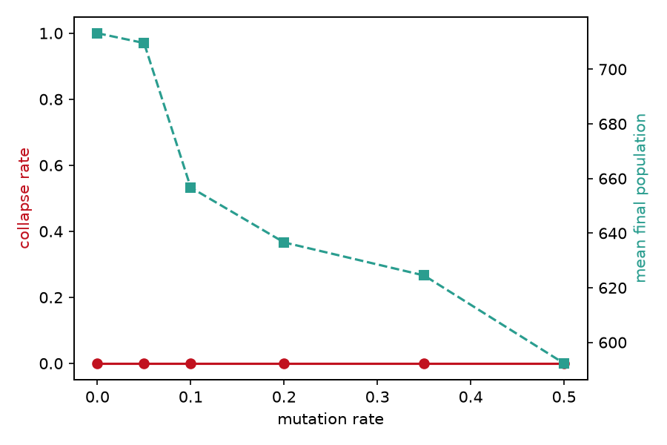
Ecosystem stability and final population versus mutation rate.
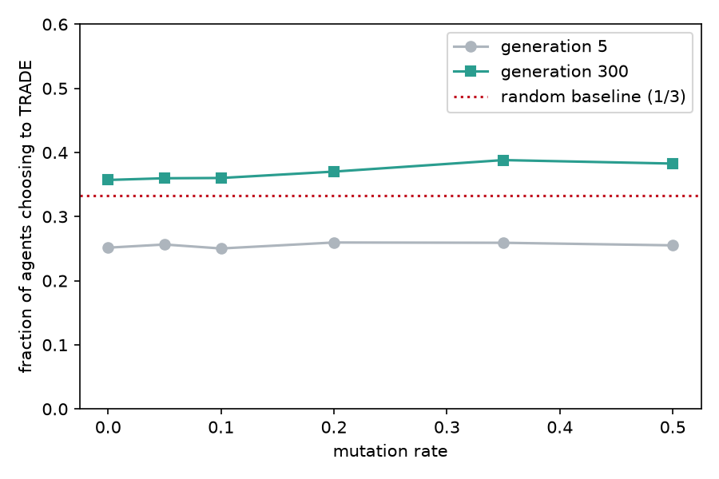
Selection for trading: the fraction of agents choosing to trade rises from early to late generations, above the random 1/3 baseline, across mutation rates.
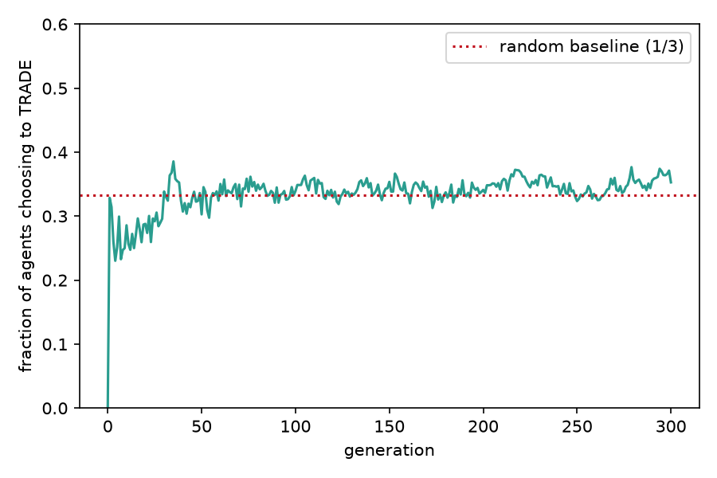
Realized trading behavior over generations for a representative run.
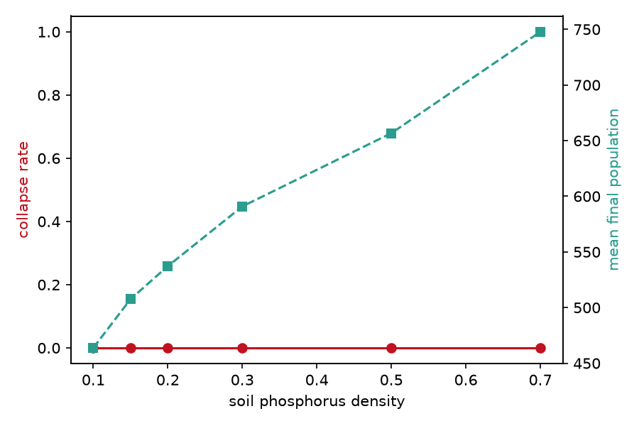
Final population versus soil-phosphorus density.
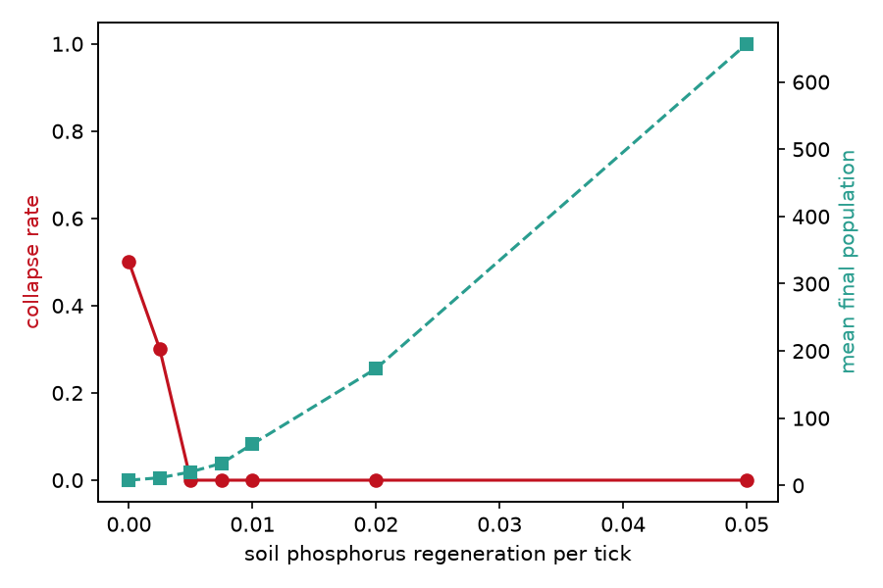
Resilience boundary: collapse rate versus soil-phosphorus regeneration rate.

5.5 Mutation × renewal interaction (Experiment D)
The resilience threshold is essentially independent of the mutation rate. Under zero renewal, roughly half to two-thirds of runs collapsed at every mutation rate (collapse rates 0.6, 0.5, and 0.7 at rates 0.0, 0.1, and 0.35), with no consistent ordering by mutation. At the knife-edge renewal rate 0.0025 the outcome was noisy and partial (0 to 0.3 collapse), and at renewal rates of 0.005 and above no run collapsed at any mutation rate. Mutation therefore does not move the collapse boundary, which is governed by phosphorus renewal rather than by the rate of behavioral variation (Figure 6).
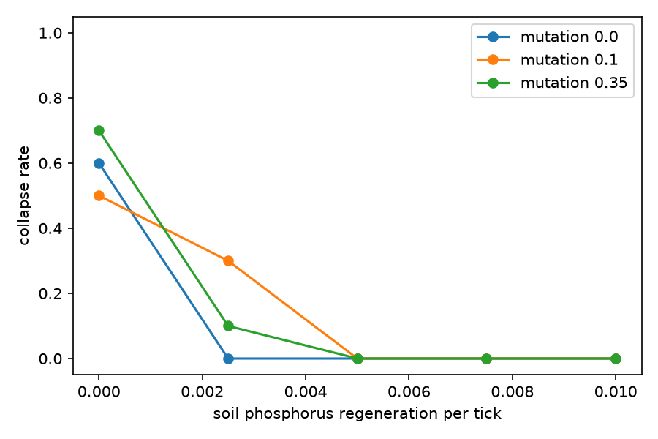
Collapse rate versus phosphorus regeneration at three mutation rates.

5.6 Grid-scale robustness (Experiment E)
Run to 400 generations, the resilience threshold appears at every grid scale. Under zero renewal essentially all runs collapsed (collapse rate 1.0 at 40 × 25 and 60 × 40, and 0.83 at 80 × 50); at the highest renewal (0.05) none collapsed at any scale. The transition lies in the 0.0025 to 0.005 range for all three grids, with larger grids somewhat more resilient near the boundary: at renewal 0.005 the collapse rate fell from 0.50 at 40 × 25 to 0.17 at 60 × 40 to 0.00 at 80 × 50. The threshold is therefore a robust feature across scales rather than an artifact of one grid size, though its exact position shifts slightly with area. Comparing with Experiment C, which used a 300-generation horizon, also shows that collapse under zero renewal is progressive: more runs have collapsed by generation 400 than by generation 300, because the finite soil stock drains gradually (Figure 7).
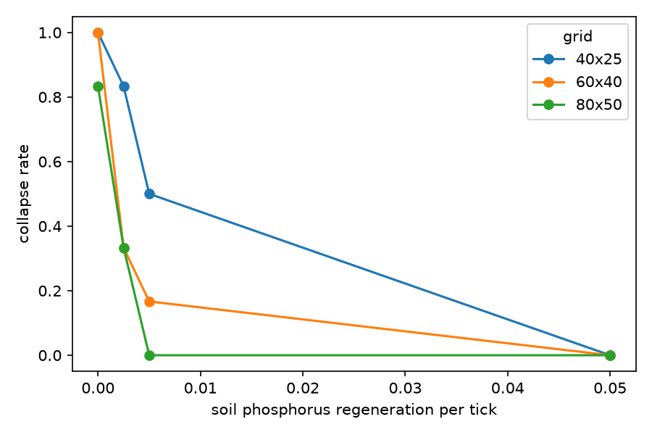
Collapse rate versus phosphorus regeneration at three grid sizes.

5.7 Mechanism of selected cooperation (Experiment F)
We asked whether the selected trading is conditional on a partner being present. Among surviving agents at generation 300, the fraction choosing to trade was 0.365 when a trade partner was adjacent (n = 6232) and 0.355 when none was adjacent (n = 335): both only slightly above the 1/3 chance level, and nearly equal. Contrary to our expectation, the selected increase in trading is therefore mild and largely unconditional under benign default conditions. Evolution nudges the population toward trading somewhat more than chance, but does not produce a sharply partner-conditional strategy here. Read together with the scarcity result of Experiment C, where expressed trading reached about 0.64, this suggests that a steeper, more strongly selected trading response emerges only when resources are tight (Figure 8).
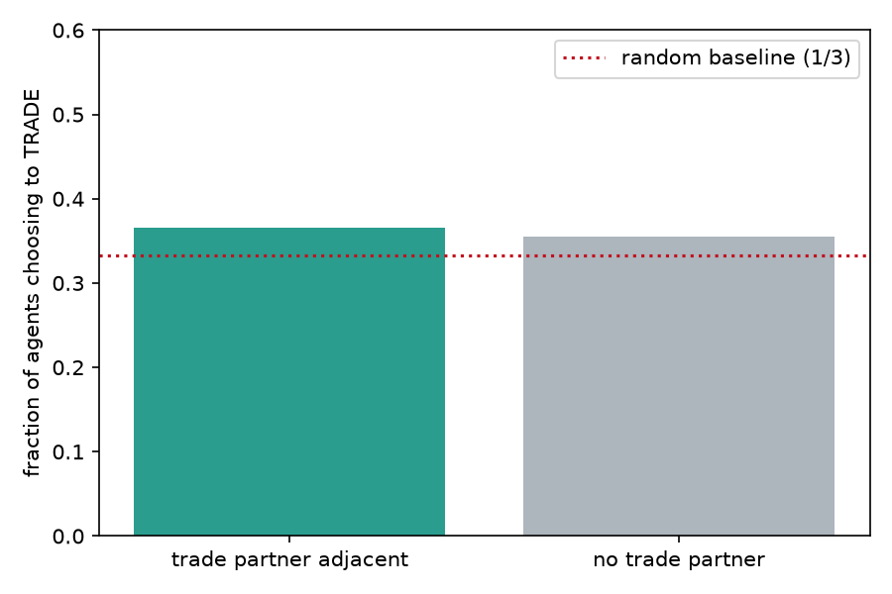
Fraction of agents choosing to trade, split by whether a trade partner is adjacent.

6. Discussion
Three observations stand out. First, the trading mutualism is robust: it persists across a wide range of mutation rates and phosphorus availabilities, and collapses only when renewable phosphorus input falls essentially to zero. This is intuitive in hindsight. Without renewal, the only phosphorus in the system is the finite initial soil stock, which the agents mine and consume until it is exhausted. Yet the transition is sharp, with even 0.005 units per tick sufficing to sustain the ecosystem indefinitely. The threshold is governed specifically by renewal: it does not move with the mutation rate (Experiment D), and it recurs at a similar location across the grid scales we tested (Experiment E), with larger grids only slightly more resilient near the boundary. In other words, whether the economy survives is set mainly by the environment’s capacity to replenish the limiting resource, not by how fast behavior varies or, to first order, by the size of the world.
Second, cooperation is selected for rather than assumed. Starting from random rule-tables, the fraction of agents that actually choose to trade rises above the level expected by chance and stays there. The effect is modest under benign conditions but pronounced under scarcity: at the edge of viability the survivors are strongly cooperative, trading at roughly twice the chance rate. The mechanism analysis (Experiment F) qualifies this picture: under benign default conditions the enrichment of trading is only slight and is not strongly conditional on a partner being present, so the population evolves a mild, largely unconditional propensity to trade rather than a finely tuned partner-contingent rule. The sharp, near-doubling response appears specifically under scarcity. This pattern is consistent with the biological-market view that a partner’s resource becomes more valuable as it becomes scarcer [3] and echoes, in a spatial evolutionary setting, the stability-through-fitness-feedback result of recent trade co-evolution models [4].
Third, there is a methodological caution. Averaging the TRADE action over the whole 64-entry rule-table gives a value indistinguishable from the 1/3 random baseline, which would wrongly suggest that no selection occurs. The signal appears only when trading is measured over the states agents actually visit, because the many never-expressed rule-table entries drift neutrally and dilute the average. Analysts of evolvable-strategy ABMs should measure expressed behavior, not genotype averages.
The sharp collapse at zero renewal is naturally read as a critical transition. The system has two qualitatively different long-run regimes, a populous self-sustaining trading economy and a drained, empty grid, and a narrow band of renewal rates separates them. The transition is also path-dependent and effectively irreversible within a run: once the finite soil stock is mined below the level the population needs, there is no trading strategy that can recover it, because the resource itself is gone rather than merely misallocated. This distinguishes the collapse from a behavioral failure; it is a resource-exhaustion tipping point. The progressive nature of the collapse under zero renewal, visible in the difference between the 300- and 400-generation horizons, is the slow approach to that tipping point as the stock runs down. Such threshold behavior, where a slowly changing environmental driver produces an abrupt regime shift, is a recurring theme in the study of resilience in ecological and other complex systems, and Symbio-Grid reproduces it from purely local rules.
The model’s intended use also shapes how these results are best read. Symbio-Grid is built to run both as an interactive visualization and as a headless, reproducible experiment engine, and the experiments reported here were designed to be repeatable by a student or reader in a single session. The three findings map onto three teachable ideas: emergence (a global trading economy arising without central control), evolution by natural selection (a heritable, mutable behavior enriched by differential survival), and critical transitions (a sharp, driver-controlled collapse). Because each result is reproducible from a fixed seed and every parameter is exposed, the same figures can be regenerated and the same questions re-posed with different parameters, which makes the model as useful as a hands-on teaching instrument as it is as a research testbed. We regard this dual character, rather than any single quantitative result, as the model’s main contribution.
These findings are exploratory, and several limitations should temper their interpretation. The model is not calibrated to or validated against empirical data, so the results are qualitative properties of the model rather than quantitative predictions about real mycorrhizal systems. Although we varied the grid scale, we held the initial population composition, the resource caps, and the trade and reproduction thresholds fixed, and each parameter point rests on a modest number of seeds (six to ten), so the noisy behavior at the collapse knife-edge is estimated only coarsely. Most importantly, the cooperation signal, while consistent and statistically visible, is small under benign conditions and becomes large only under scarcity; we would not want to overstate it. The perception available to each agent is deliberately coarse (three binned features), which both enables the interpretable rule-table and limits the strategies that can evolve.
Several extensions follow naturally. Calibrating the metabolic and trade parameters against measured carbon–phosphorus exchange would turn the qualitative threshold into a quantitative one. Giving agents richer perception or an explicit partner-choice mechanism would let more sophisticated, conditional strategies evolve and would test whether the weak partner-conditionality seen here is a limitation of the perception rather than of selection. A fuller sensitivity analysis over the remaining parameters, longer horizons, and a finer-grained analysis of exactly which perceptual states carry the selected behavior would each sharpen the picture. Finally, because the model runs both interactively and headlessly and is fully reproducible, it is well suited to classroom and outreach use, where the same experiments reported here can be reproduced and extended by students.

7. Conclusion
Symbio-Grid demonstrates that a stable resource-trading mutualism can emerge and be selected for from random strategies, and it quantifies how mutation, phosphorus availability, and phosphorus renewal shift the balance between a persistent economy and collapse. The clearest result is a sharp resilience threshold at near-zero phosphorus renewal that is set by the environment rather than by the population: it does not move with the mutation rate and recurs across grid scales. Cooperation is genuinely selected from random strategies, but the effect is mild and largely unconditional under benign conditions and becomes strong only under scarcity. Our mechanism analysis makes that pattern explicit, and it only appears when trading is measured in expressed behavior rather than in whole-genotype averages. Beyond the specific findings, the model is offered as an open, reproducible, and interactively explorable testbed for the emergence and evolution of cooperation, in which every result here can be regenerated from a fixed seed and extended. The software and all experiment scripts are openly available.

References
[1] S. W. Simard, K. J. Beiler, M. A. Bingham, J. R. Deslippe, L. J. Philip and F. P. Teste, Mycorrhizal networks: mechanisms, ecology and modelling, Fungal Biology Reviews, 26, 2012, 39-60.
[2] E. ter Hoeven, J. Kwakkel, V. Hess, T. Pike, B. Wang, rht and J. Kazil, Mesa 3: agent-based modeling with Python in 2025, Journal of Open Source Software, 10, 2025, 7668.
[3] A. van ‘t Padje, G. D. A. Werner and E. T. Kiers, Mycorrhizal fungi control phosphorus value in trade symbiosis with host roots when exposed to abrupt ’crashes’ and ‘booms’ of resource availability, New Phytologist, 229, 2021, 2933-2944.
[4] S. V. Grasso, M. H. Ryan, F. E. Albornoz and M. Renton, A simple plant-mycorrhizal fungal resource trade co-evolution model explains mutualism stability, extinction and transitory parasitism via fitness feedback, New Phytologist, 248, 2025, 1429-1441.
[5] D. Masad and J. Kazil, Mesa: an agent-based modeling framework, Proceedings of the 14th Python in Science Conference, 2015, 51-58.
[6] V. Grimm, S. F. Railsback, C. E. Vincenot, U. Berger, C. Gallagher, D. L. DeAngelis, B. Edmonds, J. Ge, J. Giske, J. Groeneveld, A. S. A. Johnston, A. Milles, J. Nabe-Nielsen, J. G. Polhill, V. Radchuk, M. Rohwader, R. A. Stillman, J. C. Thiele and D. Ayllon, The ODD protocol for describing agent-based and other simulation models: a second update to improve clarity, replication, and structural realism, Journal of Artificial Societies and Social Simulation, 23, 2020, 7.

