**Link**

[**http://h-deb.clg.qc.ca/Sujets/Divers--cdiese/async_await.html**](http://h-deb.clg.qc.ca/Sujets/Divers--cdiese/async_await.html)

[**https://zestedesavoir.com/tutoriels/884/lasynchrone-et-le-multithread-en-net/**](https://zestedesavoir.com/tutoriels/884/lasynchrone-et-le-multithread-en-net/)

[**https://zestedesavoir.com/tutoriels/884/lasynchrone-et-le-multithread-en-net/#fn-scheduler**](https://zestedesavoir.com/tutoriels/884/lasynchrone-et-le-multithread-en-net/#fn-scheduler)

[**https://blog.netapsys.fr/programmation-asynchrone-avec-progression-en-net/**](https://blog.netapsys.fr/programmation-asynchrone-avec-progression-en-net/)

[**https://cdiese.fr/utilisation-des-task-en-5-min/**](https://cdiese.fr/utilisation-des-task-en-5-min/)

[**https://blog.stephencleary.com/2012/02/async-and-await.html**](https://blog.stephencleary.com/2012/02/async-and-await.html)

**Tips**

*Equivalence synchrone / Asynchrone*

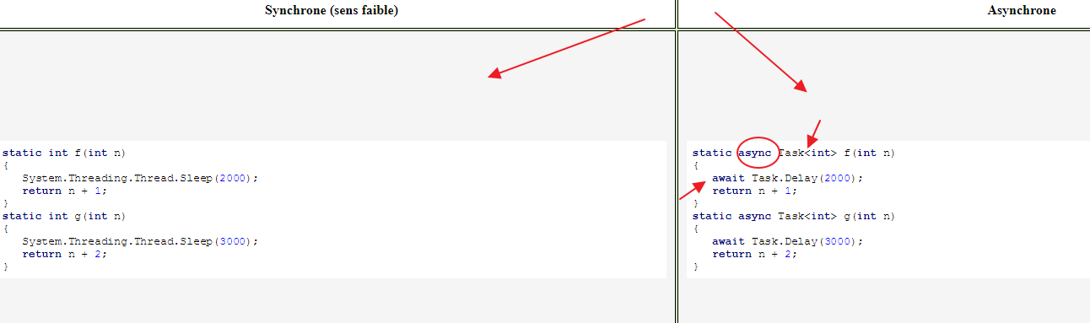

**Bug**

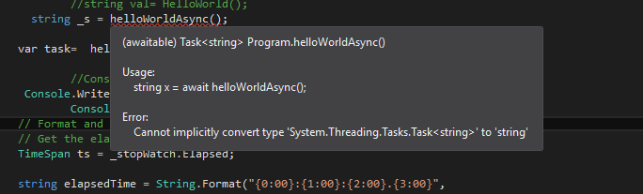

**Solution**

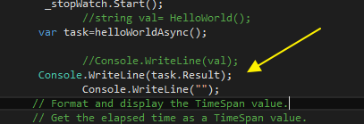

**TIPS :**

[**https://www.infoworld.com/article/3152735/application-development/my-two-cents-on-the-task-waitall-and-task-whenall-methods.html**](https://www.infoworld.com/article/3152735/application-development/my-two-cents-on-the-task-waitall-and-task-whenall-methods.html)

***WAitAll vs WhenALL !***

* ***Task.WaitAll : meme si une MAJ survient,fige l’IU principal jusqka la fin execution des toutes les taches***

*🡪blocks the current thread until all other tasks have completed execution.*

* ***Task.WhenAll :libere l’IU principal,et applique la MAJ sur le UI***

***🡪*** *The Task.WhenAll method is used to create a task that will complete if and only if all the other tasks are complete.*

***Il peut etre combine à « ContinueWith »***

**Bug**

Warning 1 Because this call is not awaited, execution of the current method continues before the call is completed. Consider applying the 'await' operator to the result of the call.

**Solution**

*Affecter la task à une variable var*



**Bug**

**Solution**

**Bug**

**Solution**