装箱清单报文结构定义

一、XML报文示例
<?xml version="1.0" encoding="UTF-8"?>
<Manifest xmlns="urn:Declaration:datamodel:standard:CN:[Name]:1" xmlns:xsi="http://www.w3.org/2001/XMLSchema-instance">
<Head>
<MessageID></MessageID>
<FunctionCode></FunctionCode>
<MessageType></MessageType>
<SenderID></SenderID>
<ReceiverID></ReceiverID>
<SendTime></SendTime>
<Version></Version>
</Head>
<Declaration>
<RepresentativePerson>
<Name></Name>
</RepresentativePerson>
<DeclarationOfficeID></DeclarationOfficeID>
<BorderTransportMeans>
<JourneyID></JourneyID>
<TypeCode></TypeCode>
<ID></ID>
<Name></Name>
</BorderTransportMeans>
<TransportEquipment>
<EquipmentIdentification>
<ID></ID>
<ReferenceID></ReferenceID>
</EquipmentIdentification>
<LoadingLocation>
<ID></ID>
<LoadingDate></LoadingDate>
</LoadingLocation>
<CharacteristicCode></CharacteristicCode>
<SupplierPartyTypeCode></SupplierPartyTypeCode>
<SealID AgencyCode=""/>
<Consignment>
<TransportContractDocument>
<ID></ID>
<Consolidator>
<ID></ID>
</Consolidator>
</TransportContractDocument>
<AssociatedTransportDocument>
<ID></ID>
</AssociatedTransportDocument>
……
</Declaration>
</Manifest>

二、报文结构
循环次数 节点名称
1 Manifest
1 |______ Head
1 | |______ MessageID
1 | |______ FunctionCode
1 | |______ MessageType
1 | |______ SenderID
1 | |______ ReceiverID
1 | |______ SendTime
1 | |______ Version
1 |______ Declaration
1 | |______ RepresentativePerson
1 | | |______ Name
1 | |______ DeclarationOfficeID
1 | |______ BorderTransportMeans
1 | | |______ JourneyID
1 | | |______ TypeCode
1 | | |______ ID
1 | | |______ Name
9999 | |______ TransportEquipment
1 | | |______ EquipmentIdentification
1 | | | |______ ID
1 | | | |______ ReferenceID
1 | | |______ LoadingLocation
1 | | | |______ ID
1 | | | |______ LoadingDate
1 | | |______ CharacteristicCode
1 | | |______ SupplierPartyTypeCode
9 | | |______ SealID
1 | | | |______ AgencyCode
9999 | | |______ Consignment
1 | | | |______ TransportContractDocument
1 | | | | |______ ID
1 | | | | |______ Consolidator
1 | | | | | |______ ID
1 | | | |______ AssociatedTransportDocument
1 | | | | |______ ID
1 | | | |______ CustomsStatusCode
1 | | | |______ Consignee
1 | | | | |______ ID
1 | | | | |______ Name
1 | | | | |______ Address
1 | | | | | |______ Line
1 | | | | | |______ CityName
1 | | | | | |______ CountrySubEntityID
1 | | | | | |______ CountrySubEntityName
1 | | | | | |______ PostcodeID
1 | | | | | |______ CountryCode
3 | | | | |______ Communication
1 | | | | | |______ ID
1 | | | | | |______ TypeID
1 | | | | |______ Contact
1 | | | | | |______ Name
3 | | | | | |______ Communication
1 | | | | | | |______ ID
1 | | | | | | |______ TypeID
1 | | | |______ NotifyParty
1 | | | | |______ ID
1 | | | | |______ Name
1 | | | | |______ Address
1 | | | | | |______ Line
1 | | | | | |______ CityName
1 | | | | | |______ CountrySubEntityID
1 | | | | | |______ CountrySubEntityName
1 | | | | | |______ PostcodeID
1 | | | | | |______ CountryCode
3 | | | | |______ Communication
1 | | | | | |______ ID
1 | | | | | |______ TypeID
1 | | | |______ UNDGContact
1 | | | | |______ Name
3 | | | | |______ Communication
1 | | | | | |______ ID
1 | | | | | |______ TypeID
9999 | | | |______ ConsignmentItem
1 | | | | |______ SequenceNumeric
1 | | | | |______ ConsignmentItemPackaging
1 | | | | | |______ QuantityQuantity
1 | | | | | |______ TypeCode
1 | | | | | |______ MarksNumbers
1 | | | | |______ Commodity
1 | | | | | |______ CargoDescription
1 | | | | | |______ UNDGCode
1 | | | | | |______ TariffClassificationCode
1 | | | | |______ AdditionalInformation
1 | | | | | |______ Content
1 | | | | |______ GoodsMeasure
1 | | | | | |______ GrossMassMeasure
1 | | | | |______ UCR
1 | | | | | |______ ID
1 | |______ AdditionalInformation
1 | | |______ Content

三、报文节点详细说明
element Manifest
diagram | 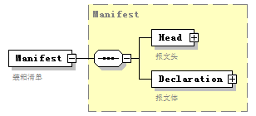
namespace | urn:Declaration:datamodel:standard:CN:[Name]:1
type | Manifest
properties
  content | complex
children | Head Declaration
annotation
  documentation
  装箱清单

complexType AdditionalInformation
diagram | 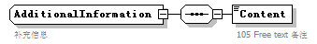
namespace | urn:Declaration:datamodel:standard:CN:[Name]:1
children | Content
used by
  elements | Declaration/AdditionalInformation ConsignmentItem/AdditionalInformation
annotation
  documentation
  补充信息

element AdditionalInformation/Content
diagram | 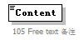
namespace | urn:Declaration:datamodel:standard:CN:[Name]:1
properties
  isRef | 0
annotation
  documentation
  105 Free text 备注

complexType AssociatedTransportDocument
diagram | 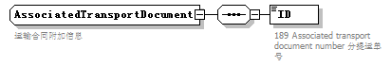
namespace | urn:Declaration:datamodel:standard:CN:[Name]:1
children | ID
used by
  element | Consignment/AssociatedTransportDocument
annotation
  documentation
  运输合同附加信息

element AssociatedTransportDocument/ID
diagram | 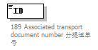
namespace | urn:Declaration:datamodel:standard:CN:[Name]:1
properties
  isRef | 0
annotation
  documentation
  189 Associated transport document number 分提运单号

complexType BorderTransportMeans
diagram | 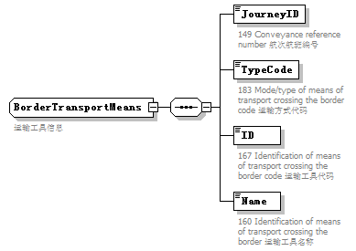
namespace | urn:Declaration:datamodel:standard:CN:[Name]:1
children | JourneyID TypeCode ID Name
used by
  element | Declaration/BorderTransportMeans
annotation
  documentation
  运输工具信息

element BorderTransportMeans/JourneyID
diagram | 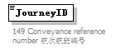
namespace | urn:Declaration:datamodel:standard:CN:[Name]:1
properties
  isRef | 0
annotation
  documentation
  149 Conveyance reference number 航次航班编号

element BorderTransportMeans/TypeCode
diagram | 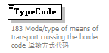
namespace | urn:Declaration:datamodel:standard:CN:[Name]:1
properties
  isRef | 0
annotation
  documentation
  183 Mode/type of means of transport crossing the border code 运输方式代码

element BorderTransportMeans/ID
diagram | 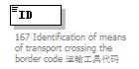
namespace | urn:Declaration:datamodel:standard:CN:[Name]:1
properties
  isRef | 0
annotation
  documentation
  167 Identification of means of transport crossing the border code 运输工具代码

element BorderTransportMeans/Name
diagram | 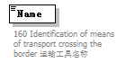
namespace | urn:Declaration:datamodel:standard:CN:[Name]:1
properties
  isRef | 0
annotation
  documentation
  160 Identification of means of transport crossing the border 运输工具名称

complexType Commodity
diagram | 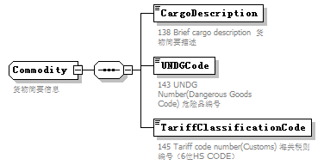
namespace | urn:Declaration:datamodel:standard:CN:[Name]:1
children | CargoDescription UNDGCode TariffClassificationCode
used by
  element | ConsignmentItem/Commodity
annotation
  documentation
  货物简要信息

element Commodity/CargoDescription
diagram | 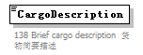
namespace | urn:Declaration:datamodel:standard:CN:[Name]:1
properties
  isRef | 0
annotation
  documentation
  138 Brief cargo description 货物简要描述

element Commodity/UNDGCode
diagram | 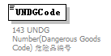
namespace | urn:Declaration:datamodel:standard:CN:[Name]:1
properties
  isRef | 0
annotation
  documentation
  143 UNDG Number(Dangerous Goods Code) 危险品编号

element Commodity/TariffClassificationCode
diagram | 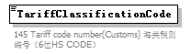
namespace | urn:Declaration:datamodel:standard:CN:[Name]:1
properties
  isRef | 0
annotation
  documentation
  145 Tariff code number(Customs) 海关税则编号（6位HS CODE）

complexType Communication
diagram | 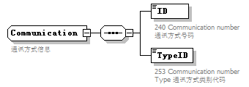
namespace | urn:Declaration:datamodel:standard:CN:[Name]:1
children | ID TypeID
used by
  elements | Consignee/Communication NotifyParty/Communication UNDGContact/Communication Contact/Communication
annotation
  documentation
  通讯方式信息

element Communication/ID
diagram | 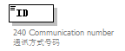
namespace | urn:Declaration:datamodel:standard:CN:[Name]:1
properties
  isRef | 0
annotation
  documentation
  240 Communication number 通讯方式号码

element Communication/TypeID
diagram | 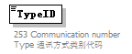
namespace | urn:Declaration:datamodel:standard:CN:[Name]:1
properties
  isRef | 0
annotation
  documentation
  253 Communication number Type 通讯方式类别代码

complexType Consignee
diagram | 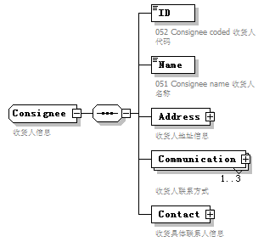
namespace | urn:Declaration:datamodel:standard:CN:[Name]:1
children | ID Name Address Communication Contact
used by
  element | Consignment/Consignee
annotation
  documentation
  收货人信息

element Consignee/ID
diagram | 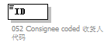
namespace | urn:Declaration:datamodel:standard:CN:[Name]:1
properties
  isRef | 0
annotation
  documentation
  052 Consignee coded 收货人代码

element Consignee/Name
diagram | 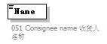
namespace | urn:Declaration:datamodel:standard:CN:[Name]:1
properties
  isRef | 0
annotation
  documentation
  051 Consignee name 收货人名称

element Consignee/Address
diagram | 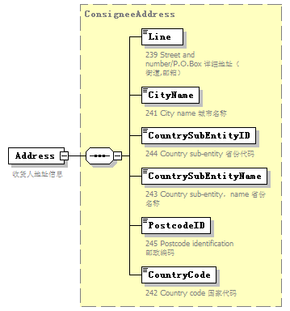
namespace | urn:Declaration:datamodel:standard:CN:[Name]:1
type | ConsigneeAddress
properties
  isRef | 0
  content | complex
children | Line CityName CountrySubEntityID CountrySubEntityName PostcodeID CountryCode
annotation
  documentation
  收货人地址信息

element Consignee/Communication
diagram | 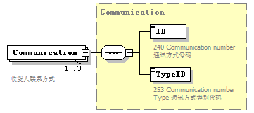
namespace | urn:Declaration:datamodel:standard:CN:[Name]:1
type | Communication
properties
  isRef | 0
  minOcc | 1
  maxOcc | 3
  content | complex
children | ID TypeID
annotation
  documentation
  收货人联系方式

element Consignee/Contact
diagram | 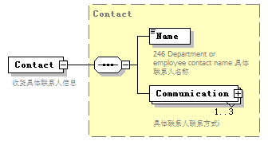
namespace | urn:Declaration:datamodel:standard:CN:[Name]:1
type | Contact
properties
  isRef | 0
  content | complex
children | Name Communication
annotation
  documentation
  收货具体联系人信息

complexType ConsigneeAddress
diagram | 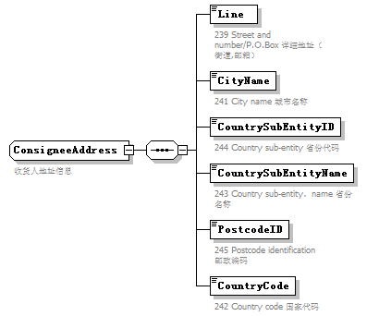
namespace | urn:Declaration:datamodel:standard:CN:[Name]:1
children | Line CityName CountrySubEntityID CountrySubEntityName PostcodeID CountryCode
used by
  element | Consignee/Address
annotation
  documentation
  收货人地址信息

element ConsigneeAddress/Line
diagram | 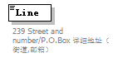
namespace | urn:Declaration:datamodel:standard:CN:[Name]:1
properties
  isRef | 0
annotation
  documentation
  239 Street and number/P.O.Box 详细地址（街道,邮箱）

element ConsigneeAddress/CityName
diagram | 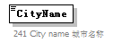
namespace | urn:Declaration:datamodel:standard:CN:[Name]:1
properties
  isRef | 0
annotation
  documentation
  241 City name 城市名称

element ConsigneeAddress/CountrySubEntityID
diagram | 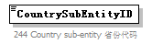
namespace | urn:Declaration:datamodel:standard:CN:[Name]:1
properties
  isRef | 0
annotation
  documentation
  244 Country sub-entity 省份代码

element ConsigneeAddress/CountrySubEntityName
diagram | 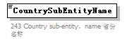
namespace | urn:Declaration:datamodel:standard:CN:[Name]:1
properties
  isRef | 0
annotation
  documentation
  243 Country sub-entity，name 省份名称

element ConsigneeAddress/PostcodeID
diagram | 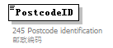
namespace | urn:Declaration:datamodel:standard:CN:[Name]:1
properties
  isRef | 0
annotation
  documentation
  245 Postcode identification 邮政编码

element ConsigneeAddress/CountryCode
diagram | 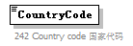
namespace | urn:Declaration:datamodel:standard:CN:[Name]:1
properties
  isRef | 0
annotation
  documentation
  242 Country code 国家代码

complexType Consignment
diagram | 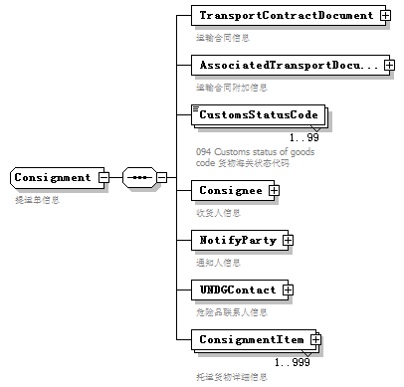
namespace | urn:Declaration:datamodel:standard:CN:[Name]:1
children | TransportContractDocument AssociatedTransportDocument CustomsStatusCode Consignee NotifyParty UNDGContact ConsignmentItem
used by
  element | TransportEquipment/Consignment
annotation
  documentation
  提运单信息

element Consignment/TransportContractDocument
diagram | 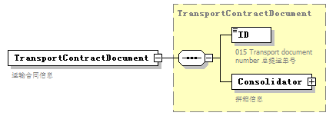
namespace | urn:Declaration:datamodel:standard:CN:[Name]:1
type | TransportContractDocument
properties
  isRef | 0
  content | complex
children | ID Consolidator
annotation
  documentation
  运输合同信息

element Consignment/AssociatedTransportDocument
diagram | 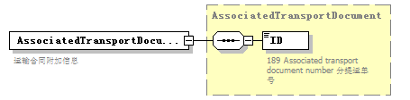
namespace | urn:Declaration:datamodel:standard:CN:[Name]:1
type | AssociatedTransportDocument
properties
  isRef | 0
  content | complex
children | ID
annotation
  documentation
  运输合同附加信息

element Consignment/CustomsStatusCode
diagram | 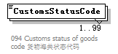
namespace | urn:Declaration:datamodel:standard:CN:[Name]:1
properties
  isRef | 0
  minOcc | 1
  maxOcc | 99
annotation
  documentation
  094 Customs status of goods code 货物海关状态代码

element Consignment/Consignee
diagram | 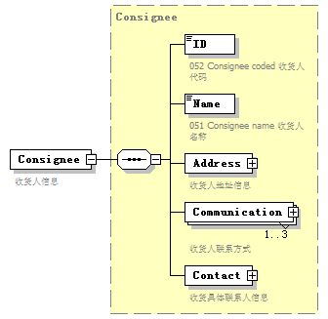
namespace | urn:Declaration:datamodel:standard:CN:[Name]:1
type | Consignee
properties
  isRef | 0
  content | complex
children | ID Name Address Communication Contact
annotation
  documentation
  收货人信息

element Consignment/NotifyParty
diagram | 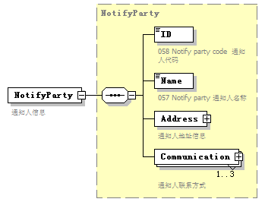
namespace | urn:Declaration:datamodel:standard:CN:[Name]:1
type | NotifyParty
properties
  isRef | 0
  content | complex
children | ID Name Address Communication
annotation
  documentation
  通知人信息

element Consignment/UNDGContact
diagram | 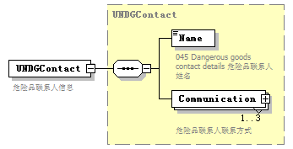
namespace | urn:Declaration:datamodel:standard:CN:[Name]:1
type | UNDGContact
properties
  isRef | 0
  content | complex
children | Name Communication
annotation
  documentation
  危险品联系人信息

element Consignment/ConsignmentItem
diagram | 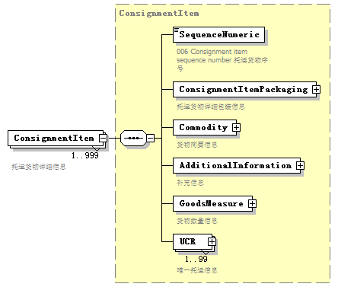
namespace | urn:Declaration:datamodel:standard:CN:[Name]:1
type | ConsignmentItem
properties
  isRef | 0
  minOcc | 1
  maxOcc | 999
  content | complex
children | SequenceNumeric ConsignmentItemPackaging Commodity AdditionalInformation GoodsMeasure UCR
annotation
  documentation
  托运货物详细信息

complexType ConsignmentItem
diagram | 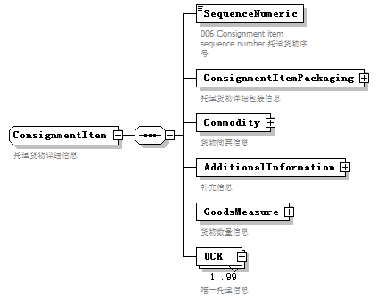
namespace | urn:Declaration:datamodel:standard:CN:[Name]:1
children | SequenceNumeric ConsignmentItemPackaging Commodity AdditionalInformation GoodsMeasure UCR
used by
  element | Consignment/ConsignmentItem
annotation
  documentation
  托运货物详细信息

element ConsignmentItem/SequenceNumeric
diagram | 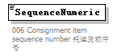
namespace | urn:Declaration:datamodel:standard:CN:[Name]:1
properties
  isRef | 0
annotation
  documentation
  006 Consignment item sequence number 托运货物序号

element ConsignmentItem/ConsignmentItemPackaging
diagram | 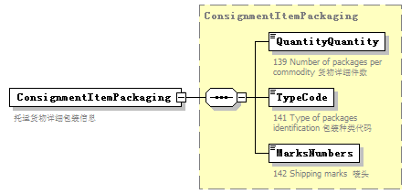
namespace | urn:Declaration:datamodel:standard:CN:[Name]:1
type | ConsignmentItemPackaging
properties
  isRef | 0
  content | complex
children | QuantityQuantity TypeCode MarksNumbers
annotation
  documentation
  托运货物详细包装信息

element ConsignmentItem/Commodity
diagram | 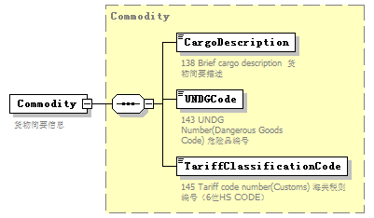
namespace | urn:Declaration:datamodel:standard:CN:[Name]:1
type | Commodity
properties
  isRef | 0
  content | complex
children | CargoDescription UNDGCode TariffClassificationCode
annotation
  documentation
  货物简要信息

element ConsignmentItem/AdditionalInformation
diagram | 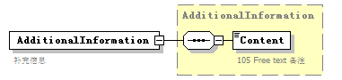
namespace | urn:Declaration:datamodel:standard:CN:[Name]:1
type | AdditionalInformation
properties
  isRef | 0
  content | complex
children | Content
annotation
  documentation
  补充信息

element ConsignmentItem/GoodsMeasure
diagram | 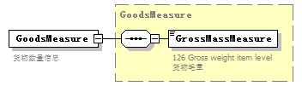
namespace | urn:Declaration:datamodel:standard:CN:[Name]:1
type | GoodsMeasure
properties
  isRef | 0
  content | complex
children | GrossMassMeasure
annotation
  documentation
  货物数量信息

element ConsignmentItem/UCR
diagram | 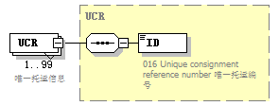
namespace | urn:Declaration:datamodel:standard:CN:[Name]:1
type | UCR
properties
  isRef | 0
  minOcc | 1
  maxOcc | 99
  content | complex
children | ID
annotation
  documentation
  唯一托运信息

complexType ConsignmentItemPackaging
diagram | 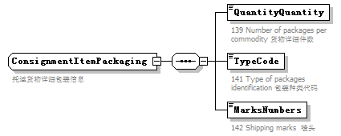
namespace | urn:Declaration:datamodel:standard:CN:[Name]:1
children | QuantityQuantity TypeCode MarksNumbers
used by
  element | ConsignmentItem/ConsignmentItemPackaging
annotation
  documentation
  托运货物详细包装信息

element ConsignmentItemPackaging/QuantityQuantity
diagram | 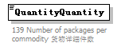
namespace | urn:Declaration:datamodel:standard:CN:[Name]:1
properties
  isRef | 0
annotation
  documentation
  139 Number of packages per commodity 货物详细件数

element ConsignmentItemPackaging/TypeCode
diagram | 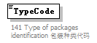
namespace | urn:Declaration:datamodel:standard:CN:[Name]:1
properties
  isRef | 0
annotation
  documentation
  141 Type of packages identification 包装种类代码

element ConsignmentItemPackaging/MarksNumbers
diagram | 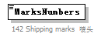
namespace | urn:Declaration:datamodel:standard:CN:[Name]:1
properties
  isRef | 0
annotation
  documentation
  142 Shipping marks 唛头

complexType Consolidator
diagram | 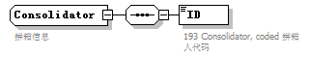
namespace | urn:Declaration:datamodel:standard:CN:[Name]:1
children | ID
used by
  element | TransportContractDocument/Consolidator
annotation
  documentation
  拼箱信息

element Consolidator/ID
diagram | 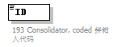
namespace | urn:Declaration:datamodel:standard:CN:[Name]:1
properties
  isRef | 0
annotation
  documentation
  193 Consolidator, coded 拼箱人代码

complexType Contact
diagram | 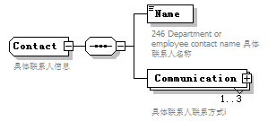
namespace | urn:Declaration:datamodel:standard:CN:[Name]:1
children | Name Communication
used by
  element | Consignee/Contact
annotation
  documentation
  具体联系人信息

element Contact/Name
diagram | 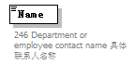
namespace | urn:Declaration:datamodel:standard:CN:[Name]:1
properties
  isRef | 0
annotation
  documentation
  246 Department or employee contact name 具体联系人名称

element Contact/Communication
diagram | 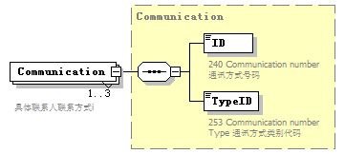
namespace | urn:Declaration:datamodel:standard:CN:[Name]:1
type | Communication
properties
  isRef | 0
  minOcc | 1
  maxOcc | 3
  content | complex
children | ID TypeID
annotation
  documentation
  具体联系人联系方式i

complexType Declaration
diagram | 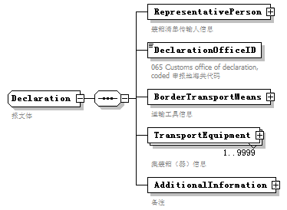
namespace | urn:Declaration:datamodel:standard:CN:[Name]:1
children | RepresentativePerson DeclarationOfficeID BorderTransportMeans TransportEquipment AdditionalInformation
used by
  element | Manifest/Declaration
annotation
  documentation
  报文体

element Declaration/RepresentativePerson
diagram | 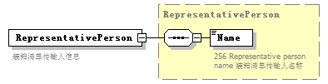
namespace | urn:Declaration:datamodel:standard:CN:[Name]:1
type | RepresentativePerson
properties
  isRef | 0
  content | complex
children | Name
annotation
  documentation
  装箱清单传输人信息

element Declaration/DeclarationOfficeID
diagram | 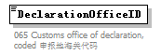
namespace | urn:Declaration:datamodel:standard:CN:[Name]:1
properties
  isRef | 0
annotation
  documentation
  065 Customs office of declaration, coded 申报地海关代码

element Declaration/BorderTransportMeans
diagram | 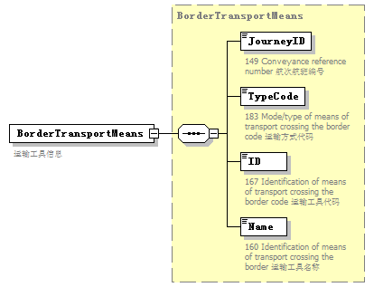
namespace | urn:Declaration:datamodel:standard:CN:[Name]:1
type | BorderTransportMeans
properties
  isRef | 0
  content | complex
children | JourneyID TypeCode ID Name
annotation
  documentation
  运输工具信息

element Declaration/TransportEquipment
diagram | 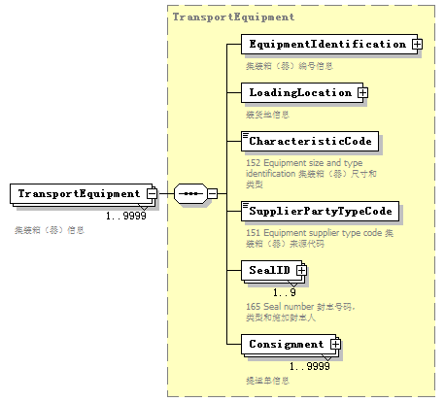
namespace | urn:Declaration:datamodel:standard:CN:[Name]:1
type | TransportEquipment
properties
  isRef | 0
  minOcc | 1
  maxOcc | 9999
  content | complex
children | EquipmentIdentification LoadingLocation CharacteristicCode SupplierPartyTypeCode SealID Consignment
annotation
  documentation
  集装箱（器）信息

element Declaration/AdditionalInformation
diagram | 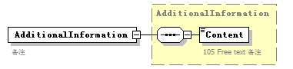
namespace | urn:Declaration:datamodel:standard:CN:[Name]:1
type | AdditionalInformation
properties
  isRef | 0
  content | complex
children | Content
annotation
  documentation
  备注

complexType EquipmentIdentification
diagram | 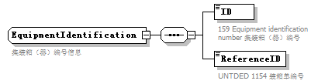
namespace | urn:Declaration:datamodel:standard:CN:[Name]:1
children | ID ReferenceID
used by
  element | TransportEquipment/EquipmentIdentification
annotation
  documentation
  集装箱（器）编号信息

element EquipmentIdentification/ID
diagram | 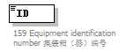
namespace | urn:Declaration:datamodel:standard:CN:[Name]:1
properties
  isRef | 0
annotation
  documentation
  159 Equipment identification number 集装箱（器）编号

element EquipmentIdentification/ReferenceID
diagram | 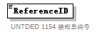
namespace | urn:Declaration:datamodel:standard:CN:[Name]:1
properties
  isRef | 0
annotation
  documentation
  UNTDED 1154 装箱单编号

complexType GoodsMeasure
diagram | 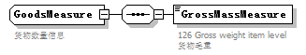
namespace | urn:Declaration:datamodel:standard:CN:[Name]:1
children | GrossMassMeasure
used by
  element | ConsignmentItem/GoodsMeasure
annotation
  documentation
  货物数量信息

element GoodsMeasure/GrossMassMeasure
diagram | 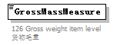
namespace | urn:Declaration:datamodel:standard:CN:[Name]:1
properties
  isRef | 0
annotation
  documentation
  126 Gross weight item level 货物毛重

complexType Head
diagram | 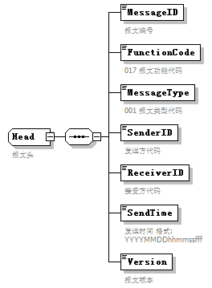
namespace | urn:Declaration:datamodel:standard:CN:[Name]:1
children | MessageID FunctionCode MessageType SenderID ReceiverID SendTime Version
used by
  element | Manifest/Head
annotation
  documentation
  报文头

element Head/MessageID
diagram | 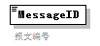
namespace | urn:Declaration:datamodel:standard:CN:[Name]:1
properties
  isRef | 0
annotation
  documentation
  报文编号

element Head/FunctionCode
diagram | 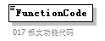
namespace | urn:Declaration:datamodel:standard:CN:[Name]:1
properties
  isRef | 0
annotation
  documentation
  017 报文功能代码

element Head/MessageType
diagram | 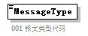
namespace | urn:Declaration:datamodel:standard:CN:[Name]:1
properties
  isRef | 0
annotation
  documentation
  001 报文类型代码

element Head/SenderID
diagram | 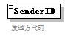
namespace | urn:Declaration:datamodel:standard:CN:[Name]:1
properties
  isRef | 0
annotation
  documentation
  发送方代码

element Head/ReceiverID
diagram | 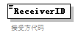
namespace | urn:Declaration:datamodel:standard:CN:[Name]:1
properties
  isRef | 0
annotation
  documentation
  接受方代码

element Head/SendTime
diagram | 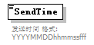
namespace | urn:Declaration:datamodel:standard:CN:[Name]:1
properties
  isRef | 0
annotation
  documentation
  发送时间 格式:YYYYMMDDhhmmssfff

element Head/Version
diagram | 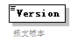
namespace | urn:Declaration:datamodel:standard:CN:[Name]:1
properties
  isRef | 0
annotation
  documentation
  报文版本

complexType LoadingLocation
diagram | 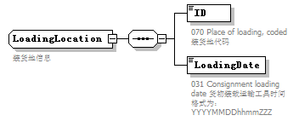
namespace | urn:Declaration:datamodel:standard:CN:[Name]:1
children | ID LoadingDate
used by
  element | TransportEquipment/LoadingLocation
annotation
  documentation
  装货地信息

element LoadingLocation/ID
diagram | 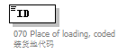
namespace | urn:Declaration:datamodel:standard:CN:[Name]:1
properties
  isRef | 0
annotation
  documentation
  070 Place of loading, coded 装货地代码

element LoadingLocation/LoadingDate
diagram | 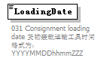
namespace | urn:Declaration:datamodel:standard:CN:[Name]:1
properties
  isRef | 0
annotation
  documentation
  031 Consignment loading date 货物装载运输工具时间 格式为：YYYYMMDDhhmmZZZ

complexType Manifest
diagram | 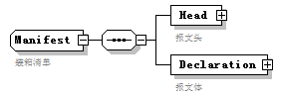
namespace | urn:Declaration:datamodel:standard:CN:[Name]:1
children | Head Declaration
used by
  element | Manifest
annotation
  documentation
  装箱清单

element Manifest/Head
diagram | 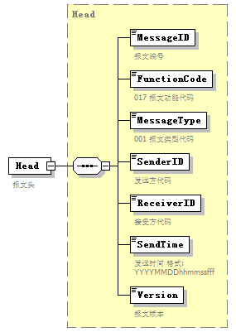
namespace | urn:Declaration:datamodel:standard:CN:[Name]:1
type | Head
properties
  isRef | 0
  content | complex
children | MessageID FunctionCode MessageType SenderID ReceiverID SendTime Version
annotation
  documentation
  报文头

element Manifest/Declaration
diagram | 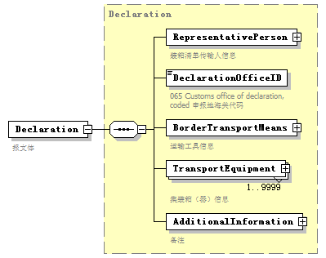
namespace | urn:Declaration:datamodel:standard:CN:[Name]:1
type | Declaration
properties
  isRef | 0
  content | complex
children | RepresentativePerson DeclarationOfficeID BorderTransportMeans TransportEquipment AdditionalInformation
annotation
  documentation
  报文体

complexType NotifyParty
diagram | 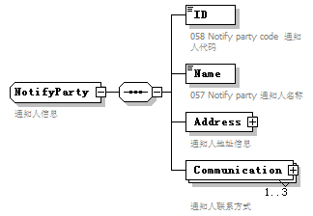
namespace | urn:Declaration:datamodel:standard:CN:[Name]:1
children | ID Name Address Communication
used by
  element | Consignment/NotifyParty
annotation
  documentation
  通知人信息

element NotifyParty/ID
diagram | 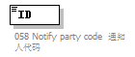
namespace | urn:Declaration:datamodel:standard:CN:[Name]:1
properties
  isRef | 0
annotation
  documentation
  058 Notify party code 通知人代码

element NotifyParty/Name
diagram | 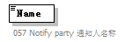
namespace | urn:Declaration:datamodel:standard:CN:[Name]:1
properties
  isRef | 0
annotation
  documentation
  057 Notify party 通知人名称

element NotifyParty/Address
diagram | 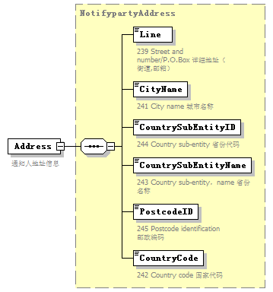
namespace | urn:Declaration:datamodel:standard:CN:[Name]:1
type | NotifypartyAddress
properties
  isRef | 0
  content | complex
children | Line CityName CountrySubEntityID CountrySubEntityName PostcodeID CountryCode
annotation
  documentation
  通知人地址信息

element NotifyParty/Communication
diagram | 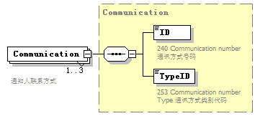
namespace | urn:Declaration:datamodel:standard:CN:[Name]:1
type | Communication
properties
  isRef | 0
  minOcc | 1
  maxOcc | 3
  content | complex
children | ID TypeID
annotation
  documentation
  通知人联系方式

complexType NotifypartyAddress
diagram | 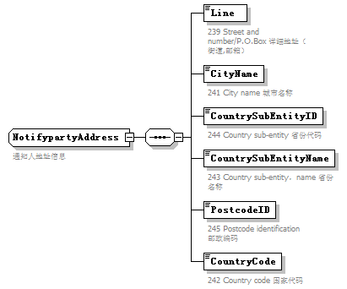
namespace | urn:Declaration:datamodel:standard:CN:[Name]:1
children | Line CityName CountrySubEntityID CountrySubEntityName PostcodeID CountryCode
used by
  element | NotifyParty/Address
annotation
  documentation
  通知人地址信息

element NotifypartyAddress/Line
diagram
namespace | urn:Declaration:datamodel:standard:CN:[Name]:1
properties
  isRef | 0
annotation
  documentation
  239 Street and number/P.O.Box 详细地址（街道,邮箱）

element NotifypartyAddress/CityName
diagram
namespace | urn:Declaration:datamodel:standard:CN:[Name]:1
properties
  isRef | 0
annotation
  documentation
  241 City name 城市名称

element NotifypartyAddress/CountrySubEntityID
diagram
namespace | urn:Declaration:datamodel:standard:CN:[Name]:1
properties
  isRef | 0
annotation
  documentation
  244 Country sub-entity 省份代码

element NotifypartyAddress/CountrySubEntityName
diagram
namespace | urn:Declaration:datamodel:standard:CN:[Name]:1
properties
  isRef | 0
annotation
  documentation
  243 Country sub-entity，name 省份名称

element NotifypartyAddress/PostcodeID
diagram
namespace | urn:Declaration:datamodel:standard:CN:[Name]:1
properties
  isRef | 0
annotation
  documentation
  245 Postcode identification 邮政编码

element NotifypartyAddress/CountryCode
diagram
namespace | urn:Declaration:datamodel:standard:CN:[Name]:1
properties
  isRef | 0
annotation
  documentation
  242 Country code 国家代码

complexType RepresentativePerson
diagram | 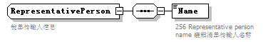
namespace | urn:Declaration:datamodel:standard:CN:[Name]:1
children | Name
used by
  element | Declaration/RepresentativePerson
annotation
  documentation
  舱单传输人信息

element RepresentativePerson/Name
diagram | 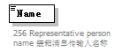
namespace | urn:Declaration:datamodel:standard:CN:[Name]:1
properties
  isRef | 0
annotation
  documentation
  256 Representative person name 装箱清单传输人名称

complexType TransportContractDocument
diagram | 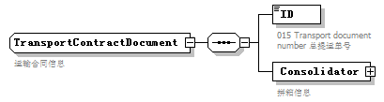
namespace | urn:Declaration:datamodel:standard:CN:[Name]:1
children | ID Consolidator
used by
  element | Consignment/TransportContractDocument
annotation
  documentation
  运输合同信息

element TransportContractDocument/ID
diagram | 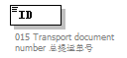
namespace | urn:Declaration:datamodel:standard:CN:[Name]:1
properties
  isRef | 0
annotation
  documentation
  015 Transport document number 总提运单号

element TransportContractDocument/Consolidator
diagram | 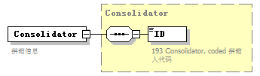
namespace | urn:Declaration:datamodel:standard:CN:[Name]:1
type | Consolidator
properties
  isRef | 0
  content | complex
children | ID
annotation
  documentation
  拼箱信息

complexType TransportEquipment
diagram | 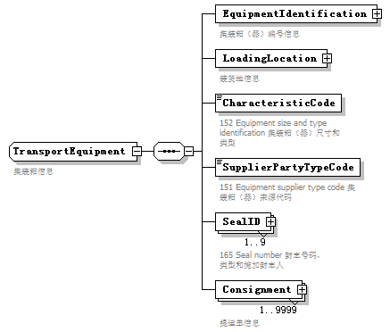
namespace | urn:Declaration:datamodel:standard:CN:[Name]:1
children | EquipmentIdentification LoadingLocation CharacteristicCode SupplierPartyTypeCode SealID Consignment
used by
  element | Declaration/TransportEquipment
annotation
  documentation
  集装箱信息

element TransportEquipment/EquipmentIdentification
diagram | 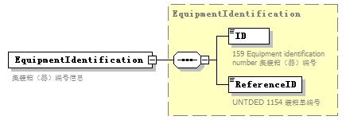
namespace | urn:Declaration:datamodel:standard:CN:[Name]:1
type | EquipmentIdentification
properties
  isRef | 0
  content | complex
children | ID ReferenceID
annotation
  documentation
  集装箱（器）编号信息

element TransportEquipment/LoadingLocation
diagram | 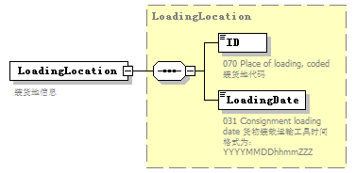
namespace | urn:Declaration:datamodel:standard:CN:[Name]:1
type | LoadingLocation
properties
  isRef | 0
  content | complex
children | ID LoadingDate
annotation
  documentation
  装货地信息

element TransportEquipment/CharacteristicCode
diagram | 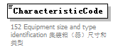
namespace | urn:Declaration:datamodel:standard:CN:[Name]:1
properties
  isRef | 0
annotation
  documentation
  152 Equipment size and type identification 集装箱（器）尺寸和类型

element TransportEquipment/SupplierPartyTypeCode
diagram | 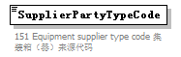
namespace | urn:Declaration:datamodel:standard:CN:[Name]:1
properties
  isRef | 0
annotation
  documentation
  151 Equipment supplier type code 集装箱（器）来源代码

element TransportEquipment/SealID
diagram | 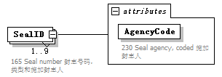
namespace | urn:Declaration:datamodel:standard:CN:[Name]:1
properties
  isRef | 0
  minOcc | 1
  maxOcc | 9
  content | complex
attributes
  Name | Type | Use | Default | Fixed | annotation
  AgencyCode |  | required
    documentation
    230 Seal agency, coded 施加封志人
annotation
  documentation
  165 Seal number 封志号码，类型和施加封志人

attribute TransportEquipment/SealID/@AgencyCode
properties
  isRef | 0
  use | required
annotation
  documentation
  230 Seal agency, coded 施加封志人

element TransportEquipment/Consignment
diagram | 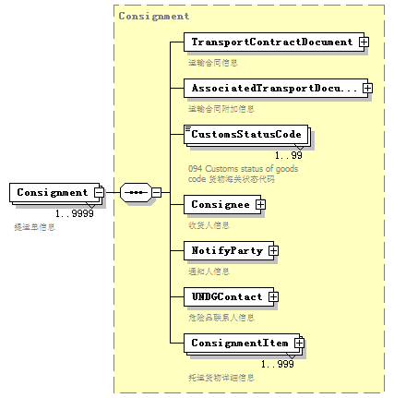
namespace | urn:Declaration:datamodel:standard:CN:[Name]:1
type | Consignment
properties
  isRef | 0
  minOcc | 1
  maxOcc | 9999
  content | complex
children | TransportContractDocument AssociatedTransportDocument CustomsStatusCode Consignee NotifyParty UNDGContact ConsignmentItem
annotation
  documentation
  提运单信息

complexType UCR
diagram | 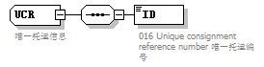
namespace | urn:Declaration:datamodel:standard:CN:[Name]:1
children | ID
used by
  element | ConsignmentItem/UCR
annotation
  documentation
  唯一托运信息

element UCR/ID
diagram | 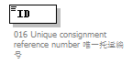
namespace | urn:Declaration:datamodel:standard:CN:[Name]:1
properties
  isRef | 0
annotation
  documentation
  016 Unique consignment reference number 唯一托运编号

complexType UNDGContact
diagram | 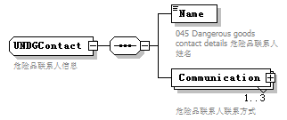
namespace | urn:Declaration:datamodel:standard:CN:[Name]:1
children | Name Communication
used by
  element | Consignment/UNDGContact
annotation
  documentation
  危险品联系人信息

element UNDGContact/Name
diagram | 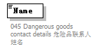
namespace | urn:Declaration:datamodel:standard:CN:[Name]:1
properties
  isRef | 0
annotation
  documentation
  045 Dangerous goods contact details 危险品联系人姓名

element UNDGContact/Communication
diagram | 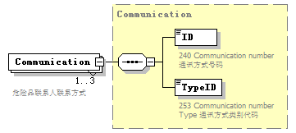
namespace | urn:Declaration:datamodel:standard:CN:[Name]:1
type | Communication
properties
  isRef | 0
  minOcc | 1
  maxOcc | 3
  content | complex
children | ID TypeID
annotation
  documentation
  危险品联系人联系方式

