进出境舱单回执报文结构定义

一、XML报文示例
<?xml version="1.0" encoding="UTF-8"?>
<Manifest xmlns:xsi="http://www.w3.org/2001/XMLSchema-instance">
<Head>
<MessageID></MessageID>
<FunctionCode></FunctionCode>
<MessageType></MessageType>
<SenderID></SenderID>
<ReceiverID></ReceiverID>
<SendTime></SendTime>
<Version></Version>
</Head>
<Response>
<BorderTransportMeans>
<JourneyID></JourneyID>
<ID></ID>
</BorderTransportMeans>
<Consignment>
<TransportContractDocument>
<ID></ID>
</TransportContractDocument>
<AssociatedTransportDocument>
<ID></ID>
</AssociatedTransportDocument>
<ResponseType>
<Code></Code>
<></>
</ResponseType>
</Consignment>
<TransportEquipment>
<EquipmentIdentification>
<ID></ID>
</EquipmentIdentification>
<ResponseType>
<Code></Code>
<></>
</ResponseType>
</TransportEquipment>
<ResponseType>
<Code></Code>
<></>
</ResponseType>
</Response>
</Manifest>

二、报文结构
循环次数 节点名称
1 Manifest
1 |______ Head
1 | |______ MessageID
1 | |______ FunctionCode
1 | |______ MessageType
1 | |______ SenderID
1 | |______ ReceiverID
1 | |______ SendTime
1 | |______ Version
1 |______ Response
1 | |______ BorderTransportMeans
1 | | |______ JourneyID
1 | | |______ ID
9999 | |______ Consignment
1 | | |______ TransportContractDocument
1 | | | |______ ID
1 | | |______ AssociatedTransportDocument
1 | | | |______ ID
1 | | |______ ResponseType
1 | | | |______ Code
1 | | | |______ Text
9999 | |______ TransportEquipment
1 | | |______ EquipmentIdentification
1 | | | |______ ID
1 | | |______ ResponseType
1 | | | |______ Code
1 | | | |______ Text
1 | |______ ResponseType
1 | | |______ Code
1 | | |______ Text

三、报文节点详细说明
element Manifest
diagram | 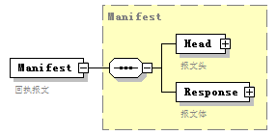
type | Manifest
properties
  content | complex
children | Head Response
annotation
  documentation
  回执报文

complexType AssociatedTransportDocument
diagram | 
children | ID
used by
  element | Consignment/AssociatedTransportDocument
annotation
  documentation
  运输合同附加信息

element AssociatedTransportDocument/ID
diagram | 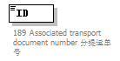
properties
  isRef | 0
annotation
  documentation
  189 Associated transport document number 分提运单号

complexType BorderTransportMeans
diagram | 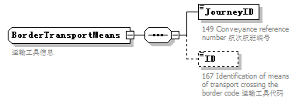
children | JourneyID ID
used by
  element | Response/BorderTransportMeans
annotation
  documentation
  运输工具信息

element BorderTransportMeans/JourneyID
diagram | 
properties
  isRef | 0
annotation
  documentation
  149 Conveyance reference number 航次航班编号

element BorderTransportMeans/ID
diagram | 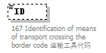
properties
  isRef | 0
  minOcc | 0
  maxOcc | 1
annotation
  documentation
  167 Identification of means of transport crossing the border code 运输工具代码

complexType Consignment
diagram | 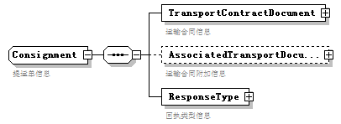
children | TransportContractDocument AssociatedTransportDocument ResponseType
used by
  element | Response/Consignment
annotation
  documentation
  提运单信息

element Consignment/TransportContractDocument
diagram | 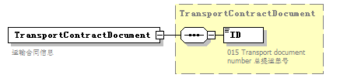
type | TransportContractDocument
properties
  isRef | 0
  content | complex
children | ID
annotation
  documentation
  运输合同信息

element Consignment/AssociatedTransportDocument
diagram | 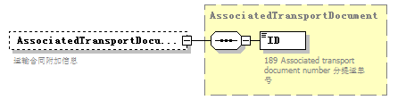
type | AssociatedTransportDocument
properties
  isRef | 0
  minOcc | 0
  maxOcc | 1
  content | complex
children | ID
annotation
  documentation
  运输合同附加信息

element Consignment/ResponseType
diagram | 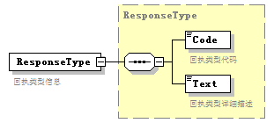
type | ResponseType
properties
  isRef | 0
  content | complex
children | Code Text
annotation
  documentation
  回执类型信息

complexType EquipmentIdentification
diagram | 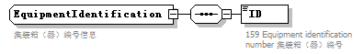
children | ID
used by
  element | TransportEquipment/EquipmentIdentification
annotation
  documentation
  集装箱（器）编号信息

element EquipmentIdentification/ID
diagram | 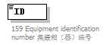
properties
  isRef | 0
annotation
  documentation
  159 Equipment identification number 集装箱（器）编号

complexType Head
diagram | 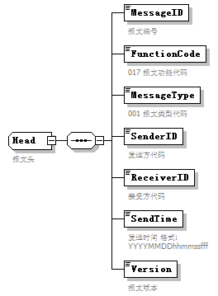
children | MessageID FunctionCode MessageType SenderID ReceiverID SendTime Version
used by
  element | Manifest/Head
annotation
  documentation
  报文头

element Head/MessageID
diagram | 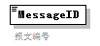
properties
  isRef | 0
annotation
  documentation
  报文编号

element Head/FunctionCode
diagram | 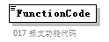
properties
  isRef | 0
annotation
  documentation
  017 报文功能代码

element Head/MessageType
diagram | 
properties
  isRef | 0
annotation
  documentation
  001 报文类型代码

element Head/SenderID
diagram | 
properties
  isRef | 0
annotation
  documentation
  发送方代码

element Head/ReceiverID
diagram | 
properties
  isRef | 0
annotation
  documentation
  接受方代码

element Head/SendTime
diagram | 
properties
  isRef | 0
annotation
  documentation
  发送时间 格式:YYYYMMDDhhmmssfff

element Head/Version
diagram | 
properties
  isRef | 0
annotation
  documentation
  报文版本

complexType Manifest
diagram | 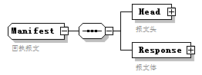
children | Head Response
used by
  element | Manifest
annotation
  documentation
  回执报文

element Manifest/Head
diagram | 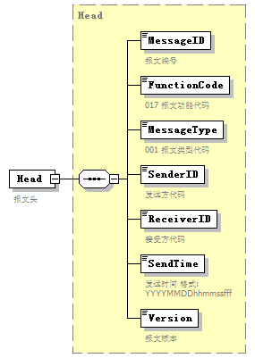
type | Head
properties
  isRef | 0
  content | complex
children | MessageID FunctionCode MessageType SenderID ReceiverID SendTime Version
annotation
  documentation
  报文头

element Manifest/Response
diagram | 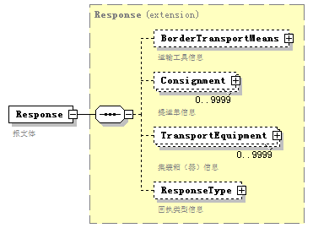
type | extension of Response
properties
  isRef | 0
  content | complex
children | BorderTransportMeans Consignment TransportEquipment ResponseType
annotation
  documentation
  报文体

complexType Response
diagram | 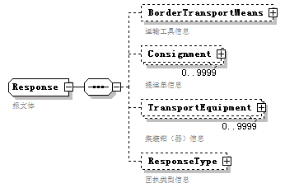
children | BorderTransportMeans Consignment TransportEquipment ResponseType
used by
  element | Manifest/Response
annotation
  documentation
  报文体

element Response/BorderTransportMeans
diagram | 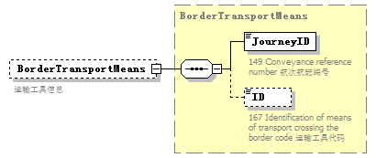
type | BorderTransportMeans
properties
  isRef | 0
  minOcc | 0
  maxOcc | 1
  content | complex
children | JourneyID ID
annotation
  documentation
  运输工具信息

element Response/Consignment
diagram | 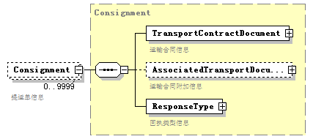
type | Consignment
properties
  isRef | 0
  minOcc | 0
  maxOcc | 9999
  content | complex
children | TransportContractDocument AssociatedTransportDocument ResponseType
annotation
  documentation
  提运单信息

element Response/TransportEquipment
diagram | 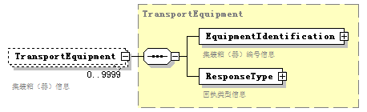
type | TransportEquipment
properties
  isRef | 0
  minOcc | 0
  maxOcc | 9999
  content | complex
children | EquipmentIdentification ResponseType
annotation
  documentation
  集装箱（器）信息

element Response/ResponseType
diagram | 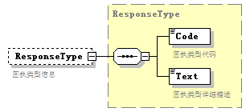
type | ResponseType
properties
  isRef | 0
  minOcc | 0
  maxOcc | 1
  content | complex
children | Code Text
annotation
  documentation
  回执类型信息

complexType ResponseType
diagram | 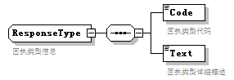
children | Code Text
used by
  elements | Response/ResponseType Consignment/ResponseType TransportEquipment/ResponseType
annotation
  documentation
  回执类型信息

element ResponseType/Code
diagram | 
properties
  isRef | 0
annotation
  documentation
  回执类型代码

element ResponseType/Text
diagram | 
properties
  isRef | 0
annotation
  documentation
  回执类型详细描述

complexType TransportContractDocument
diagram | 
children | ID
used by
  element | Consignment/TransportContractDocument
annotation
  documentation
  运输合同信息

element TransportContractDocument/ID
diagram | 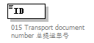
properties
  isRef | 0
annotation
  documentation
  015 Transport document number 总提运单号

complexType TransportEquipment
diagram | 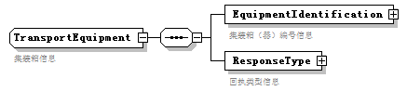
children | EquipmentIdentification ResponseType
used by
  element | Response/TransportEquipment
annotation
  documentation
  集装箱信息

element TransportEquipment/EquipmentIdentification
diagram | 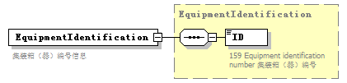
type | EquipmentIdentification
properties
  isRef | 0
  content | complex
children | ID
annotation
  documentation
  集装箱（器）编号信息

element TransportEquipment/ResponseType
diagram
type | ResponseType
properties
  isRef | 0
  content | complex
children | Code Text
annotation
  documentation
  回执类型信息

