预配舱单报文结构定义

一、XML报文示例
<?xml version="1.0" encoding="UTF-8"?>
<Manifest xmlns="urn:Declaration:datamodel:standard:CN:[Name]:1" xmlns:xsi="http://www.w3.org/2001/XMLSchema-instance">
<Head>
<MessageID></MessageID>
<FunctionCode></FunctionCode>
<MessageType></MessageType>
<SenderID></SenderID>
<ReceiverID></ReceiverID>
<SendTime></SendTime>
<Version></Version>
</Head>
<Declaration>
<RepresentativePerson>
<Name></Name>
</RepresentativePerson>
<ExitCustomsOffice>
<ID></ID>
</ExitCustomsOffice>
<Agent>
<ID></ID>
</Agent>
<Carrier>
<ID></ID>
</Carrier>
<BorderTransportMeans>
<JourneyID></JourneyID>
<TypeCode></TypeCode>
<ID></ID>
<Name></Name>
<FirstArrivalLocationID></FirstArrivalLocationID>
<ArrivalDateTime></ArrivalDateTime>
<DepartureDateTime></DepartureDateTime>
</BorderTransportMeans>
<Consignment>
<TransportContractDocument>
<ID></ID>
<ChangeReasonCode></ChangeReasonCode>
<ConditionCode></ConditionCode>
<Consolidator>
<ID></ID>
</Consolidator>
</TransportContractDocument>
<AssociatedTransportDocument>
<ID></ID>
</AssociatedTransportDocument>
……
</Declaration>
</Manifest>

二、报文结构
循环次数 节点名称
1 Manifest
1 |______ Head
1 | |______ MessageID
1 | |______ FunctionCode
1 | |______ MessageType
1 | |______ SenderID
1 | |______ ReceiverID
1 | |______ SendTime
1 | |______ Version
1 |______ Declaration
1 | |______ RepresentativePerson
1 | | |______ Name
1 | |______ ExitCustomsOffice
1 | | |______ ID
1 | |______ Agent
1 | | |______ ID
1 | |______ Carrier
1 | | |______ ID
1 | |______ BorderTransportMeans
1 | | |______ JourneyID
1 | | |______ TypeCode
1 | | |______ ID
1 | | |______ Name
1 | | |______ FirstArrivalLocationID
1 | | |______ ArrivalDateTime
1 | | |______ DepartureDateTime
9999 | |______ Consignment
1 | | |______ TransportContractDocument
1 | | | |______ ID
3 | | | |______ ChangeReasonCode
1 | | | |______ ConditionCode
1 | | | |______ Consolidator
1 | | | | |______ ID
1 | | |______ AssociatedTransportDocument
1 | | | |______ ID
1 | | |______ GrossVolumeMeasure
1 | | |______ ValueAmount
1 | | | |______ CurrencyTypeCode
1 | | |______ LoadingLocation
1 | | | |______ ID
1 | | | |______ LoadingDate
1 | | |______ UnloadingLocation
1 | | | |______ ID
1 | | | |______ ArrivalDate
1 | | |______ GoodsReceiptPlace
1 | | | |______ ID
1 | | | |______ Name
1 | | |______ TranshipmentLocation
1 | | | |______ ID
1 | | |______ TransitDestination
1 | | | |______ ID
1 | | |______ RoutingCountryCode
1 | | |______ GoodsConsignedPlace
1 | | | |______ ID
1 | | |______ CustomsStatusCode
1 | | |______ TransportSplitIndicator
1 | | |______ FreightPayment
1 | | | |______ MethodCode
1 | | |______ ConsignmentPackaging
1 | | | |______ QuantityQuantity
1 | | | |______ TypeCode
1 | | |______ TotalGrossMassMeasure
1 | | |______ PreviousCustomsDocument
1 | | | |______ ID
1 | | | |______ TypeCode
1 | | |______ DeliveryDestination
1 | | | |______ Line
1 | | | |______ CityName
1 | | | |______ CountrySubEntityID
1 | | | |______ CountrySubEntityName
1 | | | |______ PostcodeID
1 | | | |______ CountryCode
1 | | |______ Handling
1 | | | |______ InstructionsCodeCode
1 | | |______ IntermediateCarrier
1 | | | |______ ID
3 | | | |______ Communication
1 | | | | |______ ID
1 | | | | |______ TypeID
1 | | |______ Consignee
1 | | | |______ ID
1 | | | |______ Name
1 | | | |______ Address
1 | | | | |______ Line
1 | | | | |______ CityName
1 | | | | |______ CountrySubEntityID
1 | | | | |______ CountrySubEntityName
1 | | | | |______ PostcodeID
1 | | | | |______ CountryCode
3 | | | |______ Communication
1 | | | | |______ ID
1 | | | | |______ TypeID
1 | | | |______ Contact
1 | | | | |______ Name
3 | | | | |______ Communication
1 | | | | | |______ ID
1 | | | | | |______ TypeID
1 | | |______ Consignor
1 | | | |______ ID
1 | | | |______ Name
1 | | | |______ Address
1 | | | | |______ Line
1 | | | | |______ CityName
1 | | | | |______ CountrySubEntityID
1 | | | | |______ CountrySubEntityName
1 | | | | |______ PostcodeID
1 | | | | |______ CountryCode
3 | | | |______ Communication
1 | | | | |______ ID
1 | | | | |______ TypeID
1 | | |______ NotifyParty
1 | | | |______ ID
1 | | | |______ Name
1 | | | |______ Address
1 | | | | |______ Line
1 | | | | |______ CityName
1 | | | | |______ CountrySubEntityID
1 | | | | |______ CountrySubEntityName
1 | | | | |______ PostcodeID
1 | | | | |______ CountryCode
3 | | | |______ Communication
1 | | | | |______ ID
1 | | | | |______ TypeID
1 | | |______ UNDGContact
1 | | | |______ Name
3 | | | |______ Communication
1 | | | | |______ ID
1 | | | | |______ TypeID
9999 | | |______ TransportEquipment
1 | | | |______ EquipmentIdentification
1 | | | | |______ ID
1 | | | |______ CharacteristicCode
1 | | | |______ SupplierPartyTypeCode
1 | | | |______ FullnessCode
9 | | | |______ SealID
1 | | | | |______ AgencyCode
9999 | | |______ ConsignmentItem
1 | | | |______ SequenceNumeric
1 | | | |______ ConsignmentItemPackaging
1 | | | | |______ QuantityQuantity
1 | | | | |______ TypeCode
1 | | | | |______ MarksNumbers
1 | | | |______ Commodity
1 | | | | |______ CargoDescription
1 | | | | |______ UNDGCode
1 | | | | |______ TariffClassificationCode
1 | | | |______ AdditionalInformation
1 | | | | |______ Content
1 | | | |______ GoodsMeasure
1 | | | | |______ GrossMassMeasure
9999 | | | |______ EquipmentIdentification
1 | | | | |______ ID
1 | | | |______ CustomsProcedure
1 | | | | |______ CurrentCode
99 | | | |______ UCR
1 | | | | |______ ID
1 | | | |______ Origin
1 | | | | |______ OriginCountryCode
1 | |______ AdditionalInformation
1 | | |______ Content

三、报文节点详细说明
element Manifest
diagram | 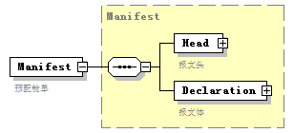
namespace | urn:Declaration:datamodel:standard:CN:[Name]:1
type | Manifest
properties
  content | complex
children | Head Declaration
annotation
  documentation
  预配舱单

complexType AdditionalInformation
diagram | 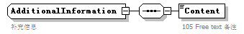
namespace | urn:Declaration:datamodel:standard:CN:[Name]:1
children | Content
used by
  elements | Declaration/AdditionalInformation ConsignmentItem/AdditionalInformation
annotation
  documentation
  补充信息

element AdditionalInformation/Content
diagram | 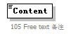
namespace | urn:Declaration:datamodel:standard:CN:[Name]:1
properties
  isRef | 0
annotation
  documentation
  105 Free text 备注

complexType Agent
diagram | 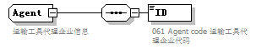
namespace | urn:Declaration:datamodel:standard:CN:[Name]:1
children | ID
used by
  element | Declaration/Agent
annotation
  documentation
  运输工具代理企业信息

element Agent/ID
diagram | 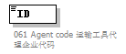
namespace | urn:Declaration:datamodel:standard:CN:[Name]:1
properties
  isRef | 0
annotation
  documentation
  061 Agent code 运输工具代理企业代码

complexType AssociatedTransportDocument
diagram | 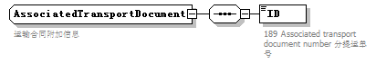
namespace | urn:Declaration:datamodel:standard:CN:[Name]:1
children | ID
used by
  element | Consignment/AssociatedTransportDocument
annotation
  documentation
  运输合同附加信息

element AssociatedTransportDocument/ID
diagram | 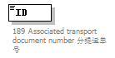
namespace | urn:Declaration:datamodel:standard:CN:[Name]:1
properties
  isRef | 0
annotation
  documentation
  189 Associated transport document number 分提运单号

complexType BorderTransportMeans
diagram | 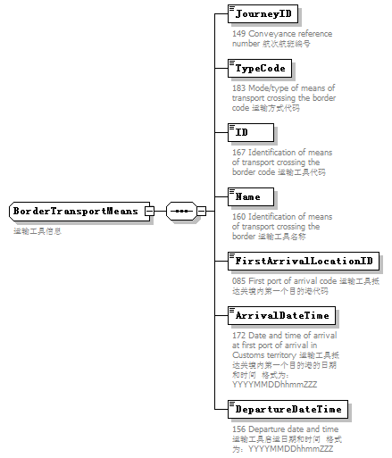
namespace | urn:Declaration:datamodel:standard:CN:[Name]:1
children | JourneyID TypeCode ID Name FirstArrivalLocationID ArrivalDateTime DepartureDateTime
used by
  element | Declaration/BorderTransportMeans
annotation
  documentation
  运输工具信息

element BorderTransportMeans/JourneyID
diagram | 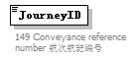
namespace | urn:Declaration:datamodel:standard:CN:[Name]:1
properties
  isRef | 0
annotation
  documentation
  149 Conveyance reference number 航次航班编号

element BorderTransportMeans/TypeCode
diagram | 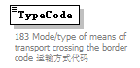
namespace | urn:Declaration:datamodel:standard:CN:[Name]:1
properties
  isRef | 0
annotation
  documentation
  183 Mode/type of means of transport crossing the border code 运输方式代码

element BorderTransportMeans/ID
diagram | 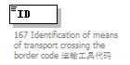
namespace | urn:Declaration:datamodel:standard:CN:[Name]:1
properties
  isRef | 0
annotation
  documentation
  167 Identification of means of transport crossing the border code 运输工具代码

element BorderTransportMeans/Name
diagram | 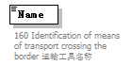
namespace | urn:Declaration:datamodel:standard:CN:[Name]:1
properties
  isRef | 0
annotation
  documentation
  160 Identification of means of transport crossing the border 运输工具名称

element BorderTransportMeans/FirstArrivalLocationID
diagram | 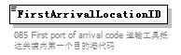
namespace | urn:Declaration:datamodel:standard:CN:[Name]:1
properties
  isRef | 0
annotation
  documentation
  085 First port of arrival code 运输工具抵达关境内第一个目的港代码

element BorderTransportMeans/ArrivalDateTime
diagram | 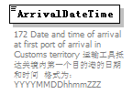
namespace | urn:Declaration:datamodel:standard:CN:[Name]:1
properties
  isRef | 0
annotation
  documentation
  172 Date and time of arrival at first port of arrival in Customs territory 运输工具抵达关境内第一个目的港的日期和时间 格式为：YYYYMMDDhhmmZZZ

element BorderTransportMeans/DepartureDateTime
diagram | 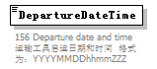
namespace | urn:Declaration:datamodel:standard:CN:[Name]:1
properties
  isRef | 0
annotation
  documentation
  156 Departure date and time 运输工具启运日期和时间 格式为：YYYYMMDDhhmmZZZ

complexType Carrier
diagram | 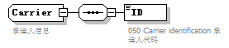
namespace | urn:Declaration:datamodel:standard:CN:[Name]:1
children | ID
used by
  element | Declaration/Carrier
annotation
  documentation
  承运人信息

element Carrier/ID
diagram | 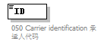
namespace | urn:Declaration:datamodel:standard:CN:[Name]:1
properties
  isRef | 0
annotation
  documentation
  050 Carrier identification 承运人代码

complexType Commodity
diagram | 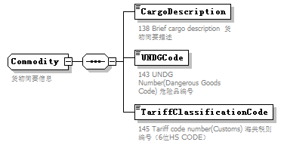
namespace | urn:Declaration:datamodel:standard:CN:[Name]:1
children | CargoDescription UNDGCode TariffClassificationCode
used by
  element | ConsignmentItem/Commodity
annotation
  documentation
  货物简要信息

element Commodity/CargoDescription
diagram | 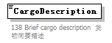
namespace | urn:Declaration:datamodel:standard:CN:[Name]:1
properties
  isRef | 0
annotation
  documentation
  138 Brief cargo description 货物简要描述

element Commodity/UNDGCode
diagram | 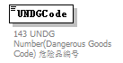
namespace | urn:Declaration:datamodel:standard:CN:[Name]:1
properties
  isRef | 0
annotation
  documentation
  143 UNDG Number(Dangerous Goods Code) 危险品编号

element Commodity/TariffClassificationCode
diagram | 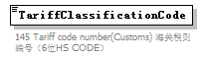
namespace | urn:Declaration:datamodel:standard:CN:[Name]:1
properties
  isRef | 0
annotation
  documentation
  145 Tariff code number(Customs) 海关税则编号（6位HS CODE）

complexType Communication
diagram | 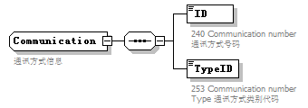
namespace | urn:Declaration:datamodel:standard:CN:[Name]:1
children | ID TypeID
used by
  elements | IntermediateCarrier/Communication Consignee/Communication Consignor/Communication NotifyParty/Communication UNDGContact/Communication Contact/Communication
annotation
  documentation
  通讯方式信息

element Communication/ID
diagram | 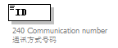
namespace | urn:Declaration:datamodel:standard:CN:[Name]:1
properties
  isRef | 0
annotation
  documentation
  240 Communication number 通讯方式号码

element Communication/TypeID
diagram | 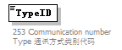
namespace | urn:Declaration:datamodel:standard:CN:[Name]:1
properties
  isRef | 0
annotation
  documentation
  253 Communication number Type 通讯方式类别代码

complexType Consignee
diagram | 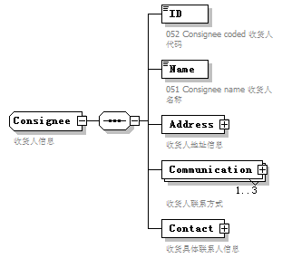
namespace | urn:Declaration:datamodel:standard:CN:[Name]:1
children | ID Name Address Communication Contact
used by
  element | Consignment/Consignee
annotation
  documentation
  收货人信息

element Consignee/ID
diagram | 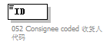
namespace | urn:Declaration:datamodel:standard:CN:[Name]:1
properties
  isRef | 0
annotation
  documentation
  052 Consignee coded 收货人代码

element Consignee/Name
diagram | 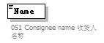
namespace | urn:Declaration:datamodel:standard:CN:[Name]:1
properties
  isRef | 0
annotation
  documentation
  051 Consignee name 收货人名称

element Consignee/Address
diagram | 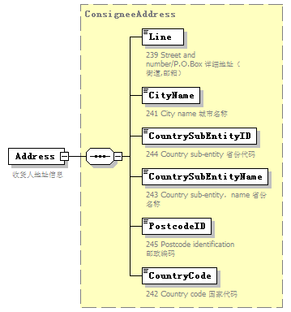
namespace | urn:Declaration:datamodel:standard:CN:[Name]:1
type | ConsigneeAddress
properties
  isRef | 0
  content | complex
children | Line CityName CountrySubEntityID CountrySubEntityName PostcodeID CountryCode
annotation
  documentation
  收货人地址信息

element Consignee/Communication
diagram | 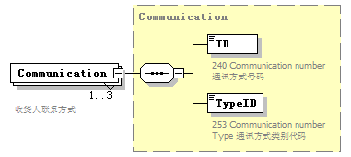
namespace | urn:Declaration:datamodel:standard:CN:[Name]:1
type | Communication
properties
  isRef | 0
  minOcc | 1
  maxOcc | 3
  content | complex
children | ID TypeID
annotation
  documentation
  收货人联系方式

element Consignee/Contact
diagram | 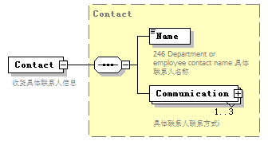
namespace | urn:Declaration:datamodel:standard:CN:[Name]:1
type | Contact
properties
  isRef | 0
  content | complex
children | Name Communication
annotation
  documentation
  收货具体联系人信息

complexType ConsigneeAddress
diagram | 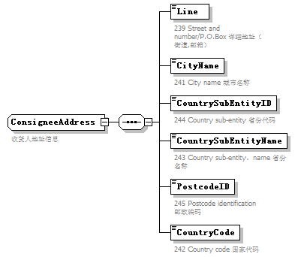
namespace | urn:Declaration:datamodel:standard:CN:[Name]:1
children | Line CityName CountrySubEntityID CountrySubEntityName PostcodeID CountryCode
used by
  element | Consignee/Address
annotation
  documentation
  收货人地址信息

element ConsigneeAddress/Line
diagram | 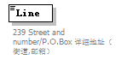
namespace | urn:Declaration:datamodel:standard:CN:[Name]:1
properties
  isRef | 0
annotation
  documentation
  239 Street and number/P.O.Box 详细地址（街道,邮箱）

element ConsigneeAddress/CityName
diagram | 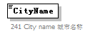
namespace | urn:Declaration:datamodel:standard:CN:[Name]:1
properties
  isRef | 0
annotation
  documentation
  241 City name 城市名称

element ConsigneeAddress/CountrySubEntityID
diagram | 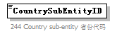
namespace | urn:Declaration:datamodel:standard:CN:[Name]:1
properties
  isRef | 0
annotation
  documentation
  244 Country sub-entity 省份代码

element ConsigneeAddress/CountrySubEntityName
diagram | 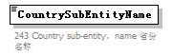
namespace | urn:Declaration:datamodel:standard:CN:[Name]:1
properties
  isRef | 0
annotation
  documentation
  243 Country sub-entity，name 省份名称

element ConsigneeAddress/PostcodeID
diagram | 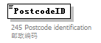
namespace | urn:Declaration:datamodel:standard:CN:[Name]:1
properties
  isRef | 0
annotation
  documentation
  245 Postcode identification 邮政编码

element ConsigneeAddress/CountryCode
diagram | 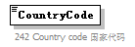
namespace | urn:Declaration:datamodel:standard:CN:[Name]:1
properties
  isRef | 0
annotation
  documentation
  242 Country code 国家代码

complexType Consignment
diagram | 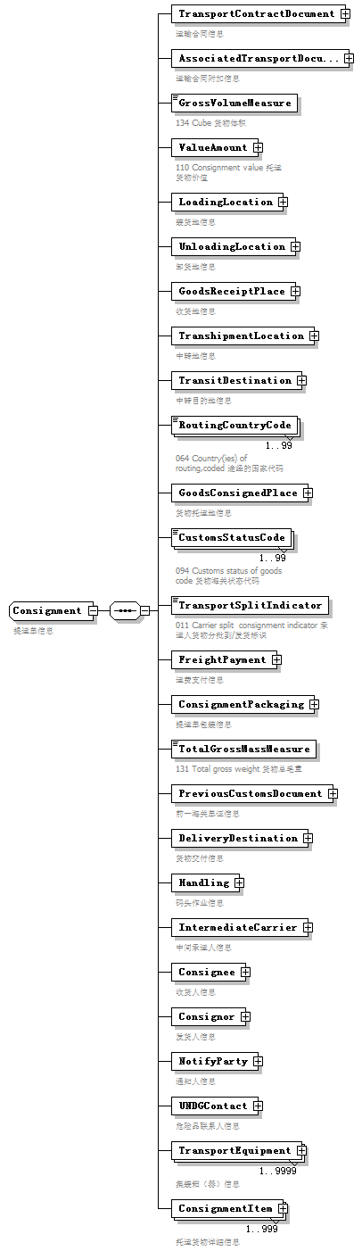
namespace | urn:Declaration:datamodel:standard:CN:[Name]:1
children | TransportContractDocument AssociatedTransportDocument GrossVolumeMeasure ValueAmount LoadingLocation UnloadingLocation GoodsReceiptPlace TranshipmentLocation TransitDestination RoutingCountryCode GoodsConsignedPlace CustomsStatusCode TransportSplitIndicator FreightPayment ConsignmentPackaging TotalGrossMassMeasure PreviousCustomsDocument DeliveryDestination Handling IntermediateCarrier Consignee Consignor NotifyParty UNDGContact TransportEquipment ConsignmentItem
used by
  element | Declaration/Consignment
annotation
  documentation
  提运单信息

element Consignment/TransportContractDocument
diagram | 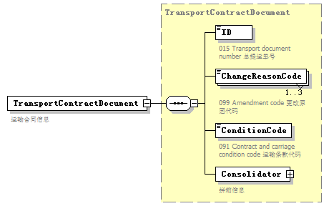
namespace | urn:Declaration:datamodel:standard:CN:[Name]:1
type | TransportContractDocument
properties
  isRef | 0
  content | complex
children | ID ChangeReasonCode ConditionCode Consolidator
annotation
  documentation
  运输合同信息

element Consignment/AssociatedTransportDocument
diagram | 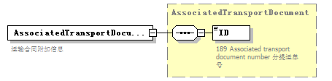
namespace | urn:Declaration:datamodel:standard:CN:[Name]:1
type | AssociatedTransportDocument
properties
  isRef | 0
  content | complex
children | ID
annotation
  documentation
  运输合同附加信息

element Consignment/GrossVolumeMeasure
diagram | 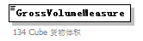
namespace | urn:Declaration:datamodel:standard:CN:[Name]:1
properties
  isRef | 0
annotation
  documentation
  134 Cube 货物体积

element Consignment/ValueAmount
diagram | 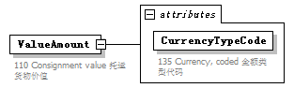
namespace | urn:Declaration:datamodel:standard:CN:[Name]:1
properties
  isRef | 0
  content | complex
attributes
  Name | Type | Use | Default | Fixed | annotation
  CurrencyTypeCode |  | required
    documentation
    135 Currency, coded 金额类型代码
annotation
  documentation
  110 Consignment value 托运货物价值

attribute Consignment/ValueAmount/@CurrencyTypeCode
properties
  isRef | 0
  use | required
annotation
  documentation
  135 Currency, coded 金额类型代码

element Consignment/LoadingLocation
diagram | 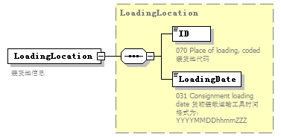
namespace | urn:Declaration:datamodel:standard:CN:[Name]:1
type | LoadingLocation
properties
  isRef | 0
  content | complex
children | ID LoadingDate
annotation
  documentation
  装货地信息

element Consignment/UnloadingLocation
diagram | 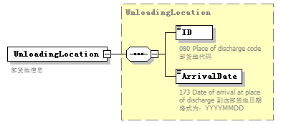
namespace | urn:Declaration:datamodel:standard:CN:[Name]:1
type | UnloadingLocation
properties
  isRef | 0
  content | complex
children | ID ArrivalDate
annotation
  documentation
  卸货地信息

element Consignment/GoodsReceiptPlace
diagram | 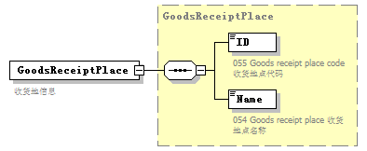
namespace | urn:Declaration:datamodel:standard:CN:[Name]:1
type | GoodsReceiptPlace
properties
  isRef | 0
  content | complex
children | ID Name
annotation
  documentation
  收货地信息

element Consignment/TranshipmentLocation
diagram | 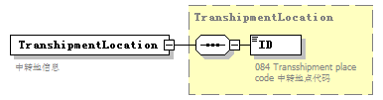
namespace | urn:Declaration:datamodel:standard:CN:[Name]:1
type | TranshipmentLocation
properties
  isRef | 0
  content | complex
children | ID
annotation
  documentation
  中转地信息

element Consignment/TransitDestination
diagram | 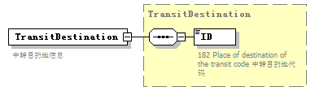
namespace | urn:Declaration:datamodel:standard:CN:[Name]:1
type | TransitDestination
properties
  isRef | 0
  content | complex
children | ID
annotation
  documentation
  中转目的地信息

element Consignment/RoutingCountryCode
diagram | 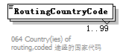
namespace | urn:Declaration:datamodel:standard:CN:[Name]:1
properties
  isRef | 0
  minOcc | 1
  maxOcc | 99
annotation
  documentation
  064 Country(ies) of routing,coded 途经的国家代码

element Consignment/GoodsConsignedPlace
diagram | 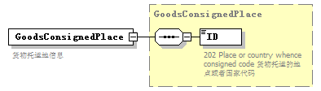
namespace | urn:Declaration:datamodel:standard:CN:[Name]:1
type | GoodsConsignedPlace
properties
  isRef | 0
  content | complex
children | ID
annotation
  documentation
  货物托运地信息

element Consignment/CustomsStatusCode
diagram | 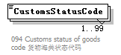
namespace | urn:Declaration:datamodel:standard:CN:[Name]:1
properties
  isRef | 0
  minOcc | 1
  maxOcc | 99
annotation
  documentation
  094 Customs status of goods code 货物海关状态代码

element Consignment/TransportSplitIndicator
diagram | 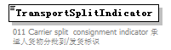
namespace | urn:Declaration:datamodel:standard:CN:[Name]:1
properties
  isRef | 0
annotation
  documentation
  011 Carrier split consignment indicator 承运人货物分批到/发货标识

element Consignment/FreightPayment
diagram | 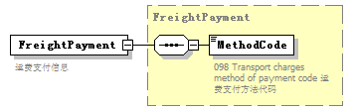
namespace | urn:Declaration:datamodel:standard:CN:[Name]:1
type | FreightPayment
properties
  isRef | 0
  content | complex
children | MethodCode
annotation
  documentation
  运费支付信息

element Consignment/ConsignmentPackaging
diagram | 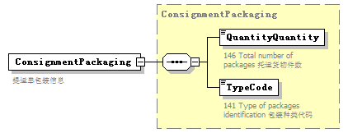
namespace | urn:Declaration:datamodel:standard:CN:[Name]:1
type | ConsignmentPackaging
properties
  isRef | 0
  content | complex
children | QuantityQuantity TypeCode
annotation
  documentation
  提运单包装信息

element Consignment/TotalGrossMassMeasure
diagram | 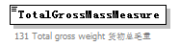
namespace | urn:Declaration:datamodel:standard:CN:[Name]:1
properties
  isRef | 0
annotation
  documentation
  131 Total gross weight 货物总毛重

element Consignment/PreviousCustomsDocument
diagram | 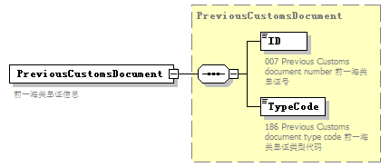
namespace | urn:Declaration:datamodel:standard:CN:[Name]:1
type | PreviousCustomsDocument
properties
  isRef | 0
  content | complex
children | ID TypeCode
annotation
  documentation
  前一海关单证信息

element Consignment/DeliveryDestination
diagram | 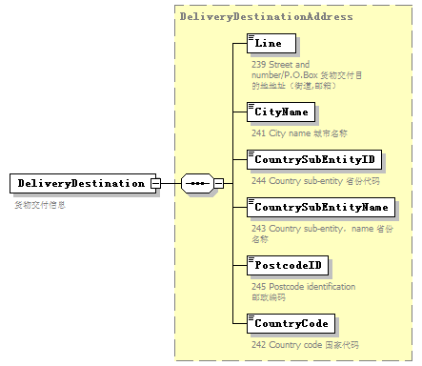
namespace | urn:Declaration:datamodel:standard:CN:[Name]:1
type | DeliveryDestinationAddress
properties
  isRef | 0
  content | complex
children | Line CityName CountrySubEntityID CountrySubEntityName PostcodeID CountryCode
annotation
  documentation
  货物交付信息

element Consignment/Handling
diagram | 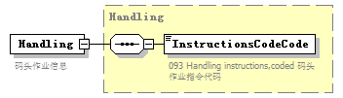
namespace | urn:Declaration:datamodel:standard:CN:[Name]:1
type | Handling
properties
  isRef | 0
  content | complex
children | InstructionsCodeCode
annotation
  documentation
  码头作业信息

element Consignment/IntermediateCarrier
diagram | 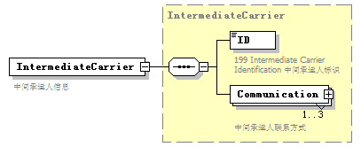
namespace | urn:Declaration:datamodel:standard:CN:[Name]:1
type | IntermediateCarrier
properties
  isRef | 0
  content | complex
children | ID Communication
annotation
  documentation
  中间承运人信息

element Consignment/Consignee
diagram | 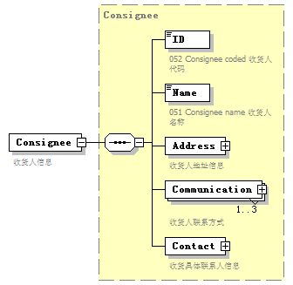
namespace | urn:Declaration:datamodel:standard:CN:[Name]:1
type | Consignee
properties
  isRef | 0
  content | complex
children | ID Name Address Communication Contact
annotation
  documentation
  收货人信息

element Consignment/Consignor
diagram | 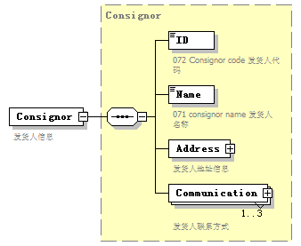
namespace | urn:Declaration:datamodel:standard:CN:[Name]:1
type | Consignor
properties
  isRef | 0
  content | complex
children | ID Name Address Communication
annotation
  documentation
  发货人信息

element Consignment/NotifyParty
diagram | 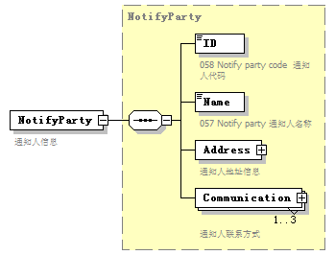
namespace | urn:Declaration:datamodel:standard:CN:[Name]:1
type | NotifyParty
properties
  isRef | 0
  content | complex
children | ID Name Address Communication
annotation
  documentation
  通知人信息

element Consignment/UNDGContact
diagram | 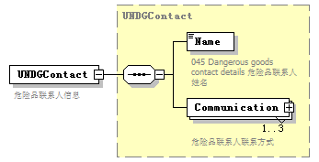
namespace | urn:Declaration:datamodel:standard:CN:[Name]:1
type | UNDGContact
properties
  isRef | 0
  content | complex
children | Name Communication
annotation
  documentation
  危险品联系人信息

element Consignment/TransportEquipment
diagram | 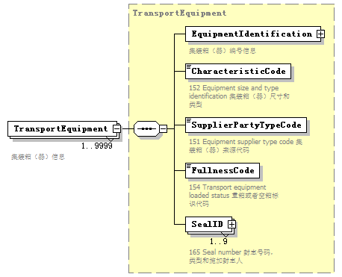
namespace | urn:Declaration:datamodel:standard:CN:[Name]:1
type | TransportEquipment
properties
  isRef | 0
  minOcc | 1
  maxOcc | 9999
  content | complex
children | EquipmentIdentification CharacteristicCode SupplierPartyTypeCode FullnessCode SealID
annotation
  documentation
  集装箱（器）信息

element Consignment/ConsignmentItem
diagram | 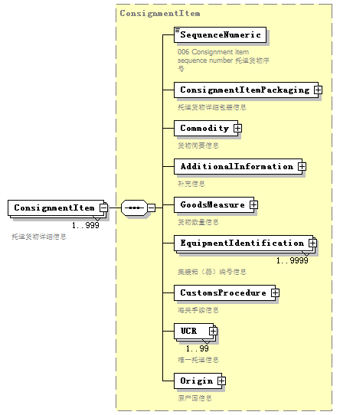
namespace | urn:Declaration:datamodel:standard:CN:[Name]:1
type | ConsignmentItem
properties
  isRef | 0
  minOcc | 1
  maxOcc | 999
  content | complex
children | SequenceNumeric ConsignmentItemPackaging Commodity AdditionalInformation GoodsMeasure EquipmentIdentification CustomsProcedure UCR Origin
annotation
  documentation
  托运货物详细信息

complexType ConsignmentItem
diagram | 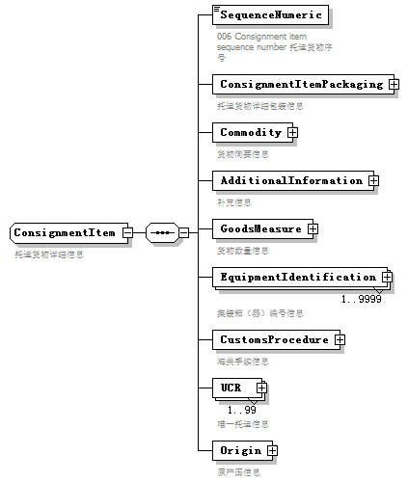
namespace | urn:Declaration:datamodel:standard:CN:[Name]:1
children | SequenceNumeric ConsignmentItemPackaging Commodity AdditionalInformation GoodsMeasure EquipmentIdentification CustomsProcedure UCR Origin
used by
  element | Consignment/ConsignmentItem
annotation
  documentation
  托运货物详细信息

element ConsignmentItem/SequenceNumeric
diagram | 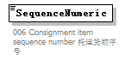
namespace | urn:Declaration:datamodel:standard:CN:[Name]:1
properties
  isRef | 0
annotation
  documentation
  006 Consignment item sequence number 托运货物序号

element ConsignmentItem/ConsignmentItemPackaging
diagram | 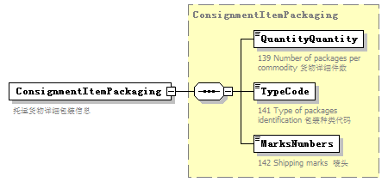
namespace | urn:Declaration:datamodel:standard:CN:[Name]:1
type | ConsignmentItemPackaging
properties
  isRef | 0
  content | complex
children | QuantityQuantity TypeCode MarksNumbers
annotation
  documentation
  托运货物详细包装信息

element ConsignmentItem/Commodity
diagram | 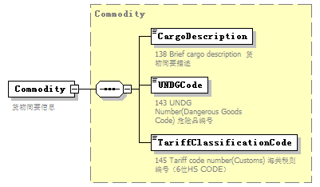
namespace | urn:Declaration:datamodel:standard:CN:[Name]:1
type | Commodity
properties
  isRef | 0
  content | complex
children | CargoDescription UNDGCode TariffClassificationCode
annotation
  documentation
  货物简要信息

element ConsignmentItem/AdditionalInformation
diagram | 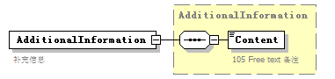
namespace | urn:Declaration:datamodel:standard:CN:[Name]:1
type | AdditionalInformation
properties
  isRef | 0
  content | complex
children | Content
annotation
  documentation
  补充信息

element ConsignmentItem/GoodsMeasure
diagram | 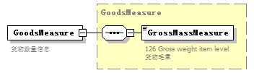
namespace | urn:Declaration:datamodel:standard:CN:[Name]:1
type | GoodsMeasure
properties
  isRef | 0
  content | complex
children | GrossMassMeasure
annotation
  documentation
  货物数量信息

element ConsignmentItem/EquipmentIdentification
diagram | 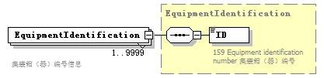
namespace | urn:Declaration:datamodel:standard:CN:[Name]:1
type | EquipmentIdentification
properties
  isRef | 0
  minOcc | 1
  maxOcc | 9999
  content | complex
children | ID
annotation
  documentation
  集装箱（器）编号信息

element ConsignmentItem/CustomsProcedure
diagram | 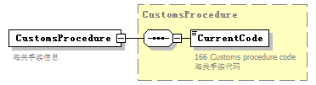
namespace | urn:Declaration:datamodel:standard:CN:[Name]:1
type | CustomsProcedure
properties
  isRef | 0
  content | complex
children | CurrentCode
annotation
  documentation
  海关手续信息

element ConsignmentItem/UCR
diagram | 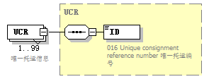
namespace | urn:Declaration:datamodel:standard:CN:[Name]:1
type | UCR
properties
  isRef | 0
  minOcc | 1
  maxOcc | 99
  content | complex
children | ID
annotation
  documentation
  唯一托运信息

element ConsignmentItem/Origin
diagram | 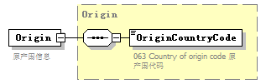
namespace | urn:Declaration:datamodel:standard:CN:[Name]:1
type | Origin
properties
  isRef | 0
  content | complex
children | OriginCountryCode
annotation
  documentation
  原产国信息

complexType ConsignmentItemPackaging
diagram | 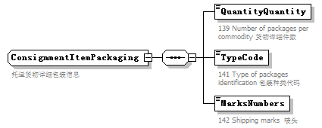
namespace | urn:Declaration:datamodel:standard:CN:[Name]:1
children | QuantityQuantity TypeCode MarksNumbers
used by
  element | ConsignmentItem/ConsignmentItemPackaging
annotation
  documentation
  托运货物详细包装信息

element ConsignmentItemPackaging/QuantityQuantity
diagram | 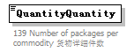
namespace | urn:Declaration:datamodel:standard:CN:[Name]:1
properties
  isRef | 0
annotation
  documentation
  139 Number of packages per commodity 货物详细件数

element ConsignmentItemPackaging/TypeCode
diagram | 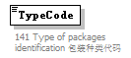
namespace | urn:Declaration:datamodel:standard:CN:[Name]:1
properties
  isRef | 0
annotation
  documentation
  141 Type of packages identification 包装种类代码

element ConsignmentItemPackaging/MarksNumbers
diagram | 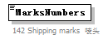
namespace | urn:Declaration:datamodel:standard:CN:[Name]:1
properties
  isRef | 0
annotation
  documentation
  142 Shipping marks 唛头

complexType ConsignmentPackaging
diagram | 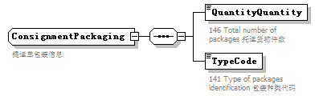
namespace | urn:Declaration:datamodel:standard:CN:[Name]:1
children | QuantityQuantity TypeCode
used by
  element | Consignment/ConsignmentPackaging
annotation
  documentation
  提运单包装信息

element ConsignmentPackaging/QuantityQuantity
diagram | 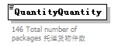
namespace | urn:Declaration:datamodel:standard:CN:[Name]:1
properties
  isRef | 0
annotation
  documentation
  146 Total number of packages 托运货物件数

element ConsignmentPackaging/TypeCode
diagram
namespace | urn:Declaration:datamodel:standard:CN:[Name]:1
properties
  isRef | 0
annotation
  documentation
  141 Type of packages identification 包装种类代码

complexType Consignor
diagram | 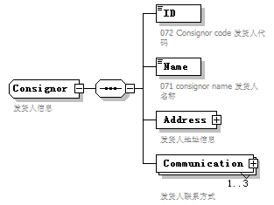
namespace | urn:Declaration:datamodel:standard:CN:[Name]:1
children | ID Name Address Communication
used by
  element | Consignment/Consignor
annotation
  documentation
  发货人信息

element Consignor/ID
diagram | 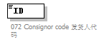
namespace | urn:Declaration:datamodel:standard:CN:[Name]:1
properties
  isRef | 0
annotation
  documentation
  072 Consignor code 发货人代码

element Consignor/Name
diagram | 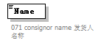
namespace | urn:Declaration:datamodel:standard:CN:[Name]:1
properties
  isRef | 0
annotation
  documentation
  071 consignor name 发货人名称

element Consignor/Address
diagram | 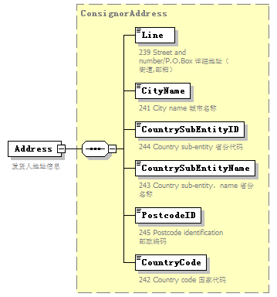
namespace | urn:Declaration:datamodel:standard:CN:[Name]:1
type | ConsignorAddress
properties
  isRef | 0
  content | complex
children | Line CityName CountrySubEntityID CountrySubEntityName PostcodeID CountryCode
annotation
  documentation
  发货人地址信息

element Consignor/Communication
diagram | 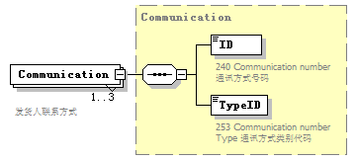
namespace | urn:Declaration:datamodel:standard:CN:[Name]:1
type | Communication
properties
  isRef | 0
  minOcc | 1
  maxOcc | 3
  content | complex
children | ID TypeID
annotation
  documentation
  发货人联系方式

complexType ConsignorAddress
diagram | 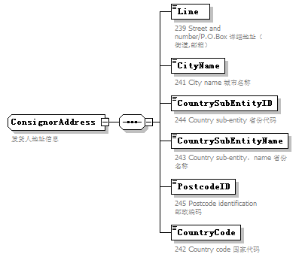
namespace | urn:Declaration:datamodel:standard:CN:[Name]:1
children | Line CityName CountrySubEntityID CountrySubEntityName PostcodeID CountryCode
used by
  element | Consignor/Address
annotation
  documentation
  发货人地址信息

element ConsignorAddress/Line
diagram
namespace | urn:Declaration:datamodel:standard:CN:[Name]:1
properties
  isRef | 0
annotation
  documentation
  239 Street and number/P.O.Box 详细地址（街道,邮箱）

element ConsignorAddress/CityName
diagram
namespace | urn:Declaration:datamodel:standard:CN:[Name]:1
properties
  isRef | 0
annotation
  documentation
  241 City name 城市名称

element ConsignorAddress/CountrySubEntityID
diagram
namespace | urn:Declaration:datamodel:standard:CN:[Name]:1
properties
  isRef | 0
annotation
  documentation
  244 Country sub-entity 省份代码

element ConsignorAddress/CountrySubEntityName
diagram
namespace | urn:Declaration:datamodel:standard:CN:[Name]:1
properties
  isRef | 0
annotation
  documentation
  243 Country sub-entity，name 省份名称

element ConsignorAddress/PostcodeID
diagram
namespace | urn:Declaration:datamodel:standard:CN:[Name]:1
properties
  isRef | 0
annotation
  documentation
  245 Postcode identification 邮政编码

element ConsignorAddress/CountryCode
diagram
namespace | urn:Declaration:datamodel:standard:CN:[Name]:1
properties
  isRef | 0
annotation
  documentation
  242 Country code 国家代码

complexType Consolidator
diagram | 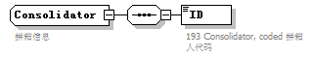
namespace | urn:Declaration:datamodel:standard:CN:[Name]:1
children | ID
used by
  element | TransportContractDocument/Consolidator
annotation
  documentation
  拼箱信息

element Consolidator/ID
diagram | 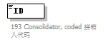
namespace | urn:Declaration:datamodel:standard:CN:[Name]:1
properties
  isRef | 0
annotation
  documentation
  193 Consolidator, coded 拼箱人代码

complexType Contact
diagram | 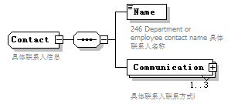
namespace | urn:Declaration:datamodel:standard:CN:[Name]:1
children | Name Communication
used by
  element | Consignee/Contact
annotation
  documentation
  具体联系人信息

element Contact/Name
diagram | 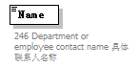
namespace | urn:Declaration:datamodel:standard:CN:[Name]:1
properties
  isRef | 0
annotation
  documentation
  246 Department or employee contact name 具体联系人名称

element Contact/Communication
diagram | 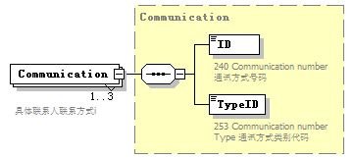
namespace | urn:Declaration:datamodel:standard:CN:[Name]:1
type | Communication
properties
  isRef | 0
  minOcc | 1
  maxOcc | 3
  content | complex
children | ID TypeID
annotation
  documentation
  具体联系人联系方式i

complexType CustomsProcedure
diagram | 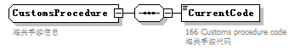
namespace | urn:Declaration:datamodel:standard:CN:[Name]:1
children | CurrentCode
used by
  element | ConsignmentItem/CustomsProcedure
annotation
  documentation
  海关手续信息

element CustomsProcedure/CurrentCode
diagram | 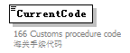
namespace | urn:Declaration:datamodel:standard:CN:[Name]:1
properties
  isRef | 0
annotation
  documentation
  166 Customs procedure code 海关手续代码

complexType Declaration
diagram | 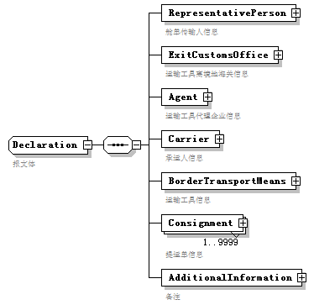
namespace | urn:Declaration:datamodel:standard:CN:[Name]:1
children | RepresentativePerson ExitCustomsOffice Agent Carrier BorderTransportMeans Consignment AdditionalInformation
used by
  element | Manifest/Declaration
annotation
  documentation
  报文体

element Declaration/RepresentativePerson
diagram | 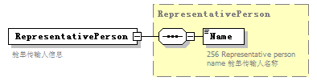
namespace | urn:Declaration:datamodel:standard:CN:[Name]:1
type | RepresentativePerson
properties
  isRef | 0
  content | complex
children | Name
annotation
  documentation
  舱单传输人信息

element Declaration/ExitCustomsOffice
diagram | 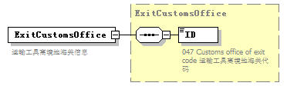
namespace | urn:Declaration:datamodel:standard:CN:[Name]:1
type | ExitCustomsOffice
properties
  isRef | 0
  content | complex
children | ID
annotation
  documentation
  运输工具离境地海关信息

element Declaration/Agent
diagram | 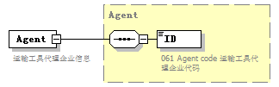
namespace | urn:Declaration:datamodel:standard:CN:[Name]:1
type | Agent
properties
  isRef | 0
  content | complex
children | ID
annotation
  documentation
  运输工具代理企业信息

element Declaration/Carrier
diagram | 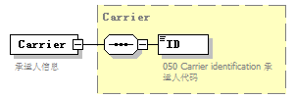
namespace | urn:Declaration:datamodel:standard:CN:[Name]:1
type | Carrier
properties
  isRef | 0
  content | complex
children | ID
annotation
  documentation
  承运人信息

element Declaration/BorderTransportMeans
diagram | 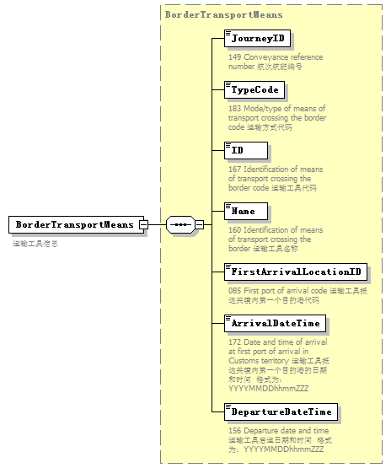
namespace | urn:Declaration:datamodel:standard:CN:[Name]:1
type | BorderTransportMeans
properties
  isRef | 0
  content | complex
children | JourneyID TypeCode ID Name FirstArrivalLocationID ArrivalDateTime DepartureDateTime
annotation
  documentation
  运输工具信息

element Declaration/Consignment
diagram | 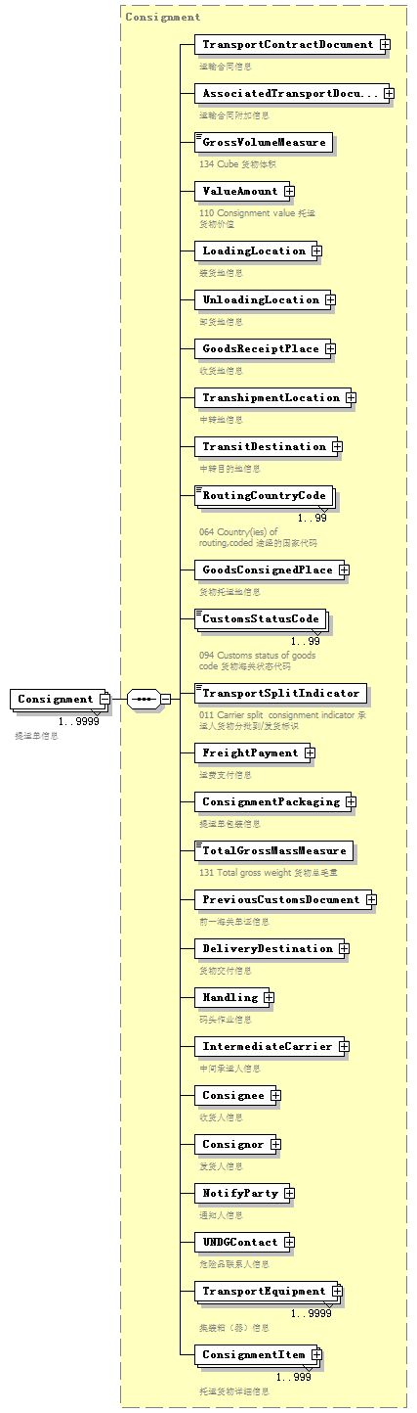
namespace | urn:Declaration:datamodel:standard:CN:[Name]:1
type | Consignment
properties
  isRef | 0
  minOcc | 1
  maxOcc | 9999
  content | complex
children | TransportContractDocument AssociatedTransportDocument GrossVolumeMeasure ValueAmount LoadingLocation UnloadingLocation GoodsReceiptPlace TranshipmentLocation TransitDestination RoutingCountryCode GoodsConsignedPlace CustomsStatusCode TransportSplitIndicator FreightPayment ConsignmentPackaging TotalGrossMassMeasure PreviousCustomsDocument DeliveryDestination Handling IntermediateCarrier Consignee Consignor NotifyParty UNDGContact TransportEquipment ConsignmentItem
annotation
  documentation
  提运单信息

element Declaration/AdditionalInformation
diagram | 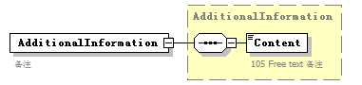
namespace | urn:Declaration:datamodel:standard:CN:[Name]:1
type | AdditionalInformation
properties
  isRef | 0
  content | complex
children | Content
annotation
  documentation
  备注

complexType DeliveryDestinationAddress
diagram | 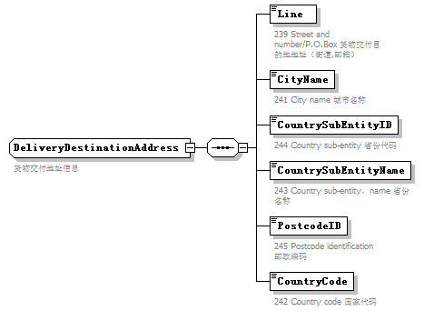
namespace | urn:Declaration:datamodel:standard:CN:[Name]:1
children | Line CityName CountrySubEntityID CountrySubEntityName PostcodeID CountryCode
used by
  element | Consignment/DeliveryDestination
annotation
  documentation
  货物交付地址信息

element DeliveryDestinationAddress/Line
diagram | 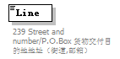
namespace | urn:Declaration:datamodel:standard:CN:[Name]:1
properties
  isRef | 0
annotation
  documentation
  239 Street and number/P.O.Box 货物交付目的地地址（街道,邮箱）

element DeliveryDestinationAddress/CityName
diagram
namespace | urn:Declaration:datamodel:standard:CN:[Name]:1
properties
  isRef | 0
annotation
  documentation
  241 City name 城市名称

element DeliveryDestinationAddress/CountrySubEntityID
diagram
namespace | urn:Declaration:datamodel:standard:CN:[Name]:1
properties
  isRef | 0
annotation
  documentation
  244 Country sub-entity 省份代码

element DeliveryDestinationAddress/CountrySubEntityName
diagram
namespace | urn:Declaration:datamodel:standard:CN:[Name]:1
properties
  isRef | 0
annotation
  documentation
  243 Country sub-entity，name 省份名称

element DeliveryDestinationAddress/PostcodeID
diagram
namespace | urn:Declaration:datamodel:standard:CN:[Name]:1
properties
  isRef | 0
annotation
  documentation
  245 Postcode identification 邮政编码

element DeliveryDestinationAddress/CountryCode
diagram
namespace | urn:Declaration:datamodel:standard:CN:[Name]:1
properties
  isRef | 0
annotation
  documentation
  242 Country code 国家代码

complexType EquipmentIdentification
diagram | 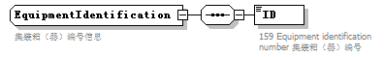
namespace | urn:Declaration:datamodel:standard:CN:[Name]:1
children | ID
used by
  elements | TransportEquipment/EquipmentIdentification ConsignmentItem/EquipmentIdentification
annotation
  documentation
  集装箱（器）编号信息

element EquipmentIdentification/ID
diagram | 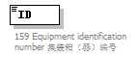
namespace | urn:Declaration:datamodel:standard:CN:[Name]:1
properties
  isRef | 0
annotation
  documentation
  159 Equipment identification number 集装箱（器）编号

complexType ExitCustomsOffice
diagram | 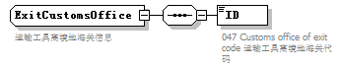
namespace | urn:Declaration:datamodel:standard:CN:[Name]:1
children | ID
used by
  element | Declaration/ExitCustomsOffice
annotation
  documentation
  运输工具离境地海关信息

element ExitCustomsOffice/ID
diagram | 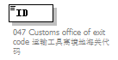
namespace | urn:Declaration:datamodel:standard:CN:[Name]:1
properties
  isRef | 0
annotation
  documentation
  047 Customs office of exit code 运输工具离境地海关代码

complexType FreightPayment
diagram | 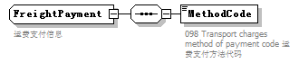
namespace | urn:Declaration:datamodel:standard:CN:[Name]:1
children | MethodCode
used by
  element | Consignment/FreightPayment
annotation
  documentation
  运费支付信息

element FreightPayment/MethodCode
diagram | 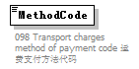
namespace | urn:Declaration:datamodel:standard:CN:[Name]:1
properties
  isRef | 0
annotation
  documentation
  098 Transport charges method of payment code 运费支付方法代码

complexType GoodsConsignedPlace
diagram | 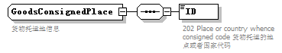
namespace | urn:Declaration:datamodel:standard:CN:[Name]:1
children | ID
used by
  element | Consignment/GoodsConsignedPlace
annotation
  documentation
  货物托运地信息

element GoodsConsignedPlace/ID
diagram | 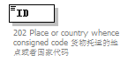
namespace | urn:Declaration:datamodel:standard:CN:[Name]:1
properties
  isRef | 0
annotation
  documentation
  202 Place or country whence consigned code 货物托运的地点或者国家代码

complexType GoodsMeasure
diagram | 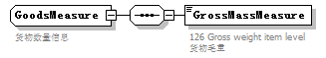
namespace | urn:Declaration:datamodel:standard:CN:[Name]:1
children | GrossMassMeasure
used by
  element | ConsignmentItem/GoodsMeasure
annotation
  documentation
  货物数量信息

element GoodsMeasure/GrossMassMeasure
diagram | 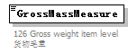
namespace | urn:Declaration:datamodel:standard:CN:[Name]:1
properties
  isRef | 0
annotation
  documentation
  126 Gross weight item level 货物毛重

complexType GoodsReceiptPlace
diagram | 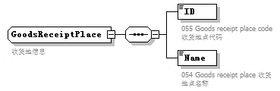
namespace | urn:Declaration:datamodel:standard:CN:[Name]:1
children | ID Name
used by
  element | Consignment/GoodsReceiptPlace
annotation
  documentation
  收货地信息

element GoodsReceiptPlace/ID
diagram | 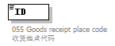
namespace | urn:Declaration:datamodel:standard:CN:[Name]:1
properties
  isRef | 0
annotation
  documentation
  055 Goods receipt place code 收货地点代码

element GoodsReceiptPlace/Name
diagram | 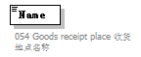
namespace | urn:Declaration:datamodel:standard:CN:[Name]:1
properties
  isRef | 0
annotation
  documentation
  054 Goods receipt place 收货地点名称

complexType Handling
diagram | 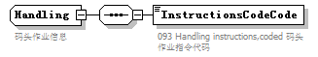
namespace | urn:Declaration:datamodel:standard:CN:[Name]:1
children | InstructionsCodeCode
used by
  element | Consignment/Handling
annotation
  documentation
  码头作业信息

element Handling/InstructionsCodeCode
diagram | 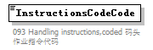
namespace | urn:Declaration:datamodel:standard:CN:[Name]:1
properties
  isRef | 0
annotation
  documentation
  093 Handling instructions,coded 码头作业指令代码

complexType Head
diagram | 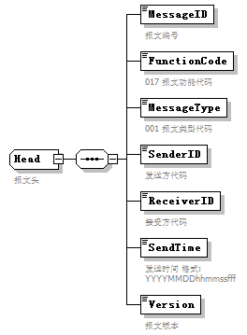
namespace | urn:Declaration:datamodel:standard:CN:[Name]:1
children | MessageID FunctionCode MessageType SenderID ReceiverID SendTime Version
used by
  element | Manifest/Head
annotation
  documentation
  报文头

element Head/MessageID
diagram | 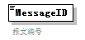
namespace | urn:Declaration:datamodel:standard:CN:[Name]:1
properties
  isRef | 0
annotation
  documentation
  报文编号

element Head/FunctionCode
diagram | 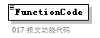
namespace | urn:Declaration:datamodel:standard:CN:[Name]:1
properties
  isRef | 0
annotation
  documentation
  017 报文功能代码

element Head/MessageType
diagram | 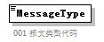
namespace | urn:Declaration:datamodel:standard:CN:[Name]:1
properties
  isRef | 0
annotation
  documentation
  001 报文类型代码

element Head/SenderID
diagram | 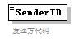
namespace | urn:Declaration:datamodel:standard:CN:[Name]:1
properties
  isRef | 0
annotation
  documentation
  发送方代码

element Head/ReceiverID
diagram | 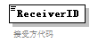
namespace | urn:Declaration:datamodel:standard:CN:[Name]:1
properties
  isRef | 0
annotation
  documentation
  接受方代码

element Head/SendTime
diagram | 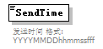
namespace | urn:Declaration:datamodel:standard:CN:[Name]:1
properties
  isRef | 0
annotation
  documentation
  发送时间 格式:YYYYMMDDhhmmssfff

element Head/Version
diagram | 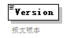
namespace | urn:Declaration:datamodel:standard:CN:[Name]:1
properties
  isRef | 0
annotation
  documentation
  报文版本

complexType IntermediateCarrier
diagram | 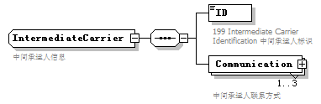
namespace | urn:Declaration:datamodel:standard:CN:[Name]:1
children | ID Communication
used by
  element | Consignment/IntermediateCarrier
annotation
  documentation
  中间承运人信息

element IntermediateCarrier/ID
diagram | 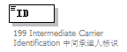
namespace | urn:Declaration:datamodel:standard:CN:[Name]:1
properties
  isRef | 0
annotation
  documentation
  199 Intermediate Carrier Identification 中间承运人标识

element IntermediateCarrier/Communication
diagram | 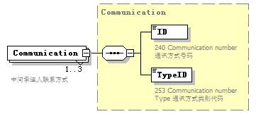
namespace | urn:Declaration:datamodel:standard:CN:[Name]:1
type | Communication
properties
  isRef | 0
  minOcc | 1
  maxOcc | 3
  content | complex
children | ID TypeID
annotation
  documentation
  中间承运人联系方式

complexType LoadingLocation
diagram | 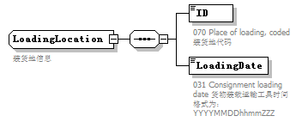
namespace | urn:Declaration:datamodel:standard:CN:[Name]:1
children | ID LoadingDate
used by
  element | Consignment/LoadingLocation
annotation
  documentation
  装货地信息

element LoadingLocation/ID
diagram | 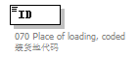
namespace | urn:Declaration:datamodel:standard:CN:[Name]:1
properties
  isRef | 0
annotation
  documentation
  070 Place of loading, coded 装货地代码

element LoadingLocation/LoadingDate
diagram | 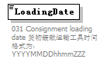
namespace | urn:Declaration:datamodel:standard:CN:[Name]:1
properties
  isRef | 0
annotation
  documentation
  031 Consignment loading date 货物装载运输工具时间 格式为：YYYYMMDDhhmmZZZ

complexType Manifest
diagram | 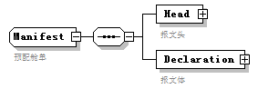
namespace | urn:Declaration:datamodel:standard:CN:[Name]:1
children | Head Declaration
used by
  element | Manifest
annotation
  documentation
  预配舱单

element Manifest/Head
diagram | 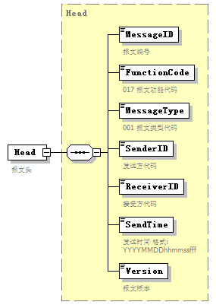
namespace | urn:Declaration:datamodel:standard:CN:[Name]:1
type | Head
properties
  isRef | 0
  content | complex
children | MessageID FunctionCode MessageType SenderID ReceiverID SendTime Version
annotation
  documentation
  报文头

element Manifest/Declaration
diagram | 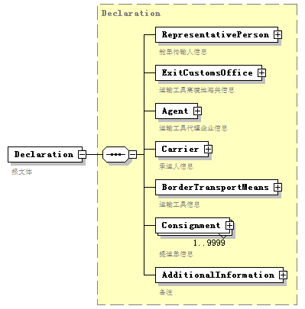
namespace | urn:Declaration:datamodel:standard:CN:[Name]:1
type | Declaration
properties
  isRef | 0
  content | complex
children | RepresentativePerson ExitCustomsOffice Agent Carrier BorderTransportMeans Consignment AdditionalInformation
annotation
  documentation
  报文体

complexType NotifyParty
diagram | 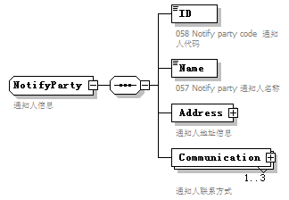
namespace | urn:Declaration:datamodel:standard:CN:[Name]:1
children | ID Name Address Communication
used by
  element | Consignment/NotifyParty
annotation
  documentation
  通知人信息

element NotifyParty/ID
diagram | 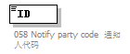
namespace | urn:Declaration:datamodel:standard:CN:[Name]:1
properties
  isRef | 0
annotation
  documentation
  058 Notify party code 通知人代码

element NotifyParty/Name
diagram | 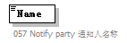
namespace | urn:Declaration:datamodel:standard:CN:[Name]:1
properties
  isRef | 0
annotation
  documentation
  057 Notify party 通知人名称

element NotifyParty/Address
diagram | 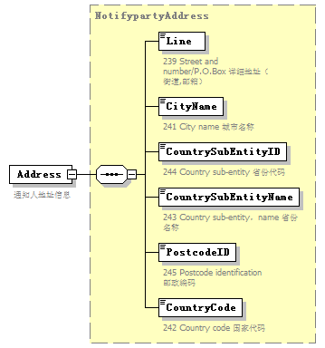
namespace | urn:Declaration:datamodel:standard:CN:[Name]:1
type | NotifypartyAddress
properties
  isRef | 0
  content | complex
children | Line CityName CountrySubEntityID CountrySubEntityName PostcodeID CountryCode
annotation
  documentation
  通知人地址信息

element NotifyParty/Communication
diagram | 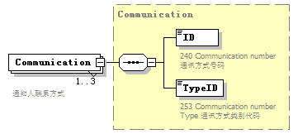
namespace | urn:Declaration:datamodel:standard:CN:[Name]:1
type | Communication
properties
  isRef | 0
  minOcc | 1
  maxOcc | 3
  content | complex
children | ID TypeID
annotation
  documentation
  通知人联系方式

complexType NotifypartyAddress
diagram | 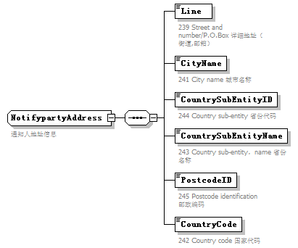
namespace | urn:Declaration:datamodel:standard:CN:[Name]:1
children | Line CityName CountrySubEntityID CountrySubEntityName PostcodeID CountryCode
used by
  element | NotifyParty/Address
annotation
  documentation
  通知人地址信息

element NotifypartyAddress/Line
diagram
namespace | urn:Declaration:datamodel:standard:CN:[Name]:1
properties
  isRef | 0
annotation
  documentation
  239 Street and number/P.O.Box 详细地址（街道,邮箱）

element NotifypartyAddress/CityName
diagram
namespace | urn:Declaration:datamodel:standard:CN:[Name]:1
properties
  isRef | 0
annotation
  documentation
  241 City name 城市名称

element NotifypartyAddress/CountrySubEntityID
diagram
namespace | urn:Declaration:datamodel:standard:CN:[Name]:1
properties
  isRef | 0
annotation
  documentation
  244 Country sub-entity 省份代码

element NotifypartyAddress/CountrySubEntityName
diagram
namespace | urn:Declaration:datamodel:standard:CN:[Name]:1
properties
  isRef | 0
annotation
  documentation
  243 Country sub-entity，name 省份名称

element NotifypartyAddress/PostcodeID
diagram
namespace | urn:Declaration:datamodel:standard:CN:[Name]:1
properties
  isRef | 0
annotation
  documentation
  245 Postcode identification 邮政编码

element NotifypartyAddress/CountryCode
diagram
namespace | urn:Declaration:datamodel:standard:CN:[Name]:1
properties
  isRef | 0
annotation
  documentation
  242 Country code 国家代码

complexType Origin
diagram | 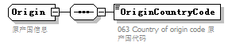
namespace | urn:Declaration:datamodel:standard:CN:[Name]:1
children | OriginCountryCode
used by
  element | ConsignmentItem/Origin
annotation
  documentation
  原产国信息

element Origin/OriginCountryCode
diagram | 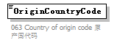
namespace | urn:Declaration:datamodel:standard:CN:[Name]:1
properties
  isRef | 0
annotation
  documentation
  063 Country of origin code 原产国代码

complexType PreviousCustomsDocument
diagram | 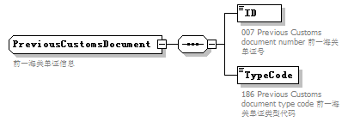
namespace | urn:Declaration:datamodel:standard:CN:[Name]:1
children | ID TypeCode
used by
  element | Consignment/PreviousCustomsDocument
annotation
  documentation
  前一海关单证信息

element PreviousCustomsDocument/ID
diagram | 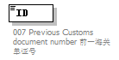
namespace | urn:Declaration:datamodel:standard:CN:[Name]:1
properties
  isRef | 0
annotation
  documentation
  007 Previous Customs document number 前一海关单证号

element PreviousCustomsDocument/TypeCode
diagram | 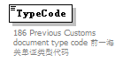
namespace | urn:Declaration:datamodel:standard:CN:[Name]:1
properties
  isRef | 0
annotation
  documentation
  186 Previous Customs document type code 前一海关单证类型代码

complexType RepresentativePerson
diagram | 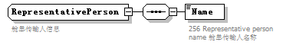
namespace | urn:Declaration:datamodel:standard:CN:[Name]:1
children | Name
used by
  element | Declaration/RepresentativePerson
annotation
  documentation
  舱单传输人信息

element RepresentativePerson/Name
diagram | 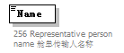
namespace | urn:Declaration:datamodel:standard:CN:[Name]:1
properties
  isRef | 0
annotation
  documentation
  256 Representative person name 舱单传输人名称

complexType TranshipmentLocation
diagram | 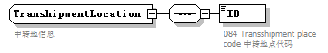
namespace | urn:Declaration:datamodel:standard:CN:[Name]:1
children | ID
used by
  element | Consignment/TranshipmentLocation
annotation
  documentation
  中转地信息

element TranshipmentLocation/ID
diagram | 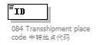
namespace | urn:Declaration:datamodel:standard:CN:[Name]:1
properties
  isRef | 0
annotation
  documentation
  084 Transshipment place code 中转地点代码

complexType TransitDestination
diagram | 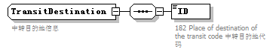
namespace | urn:Declaration:datamodel:standard:CN:[Name]:1
children | ID
used by
  element | Consignment/TransitDestination
annotation
  documentation
  中转目的地信息

element TransitDestination/ID
diagram | 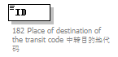
namespace | urn:Declaration:datamodel:standard:CN:[Name]:1
properties
  isRef | 0
annotation
  documentation
  182 Place of destination of the transit code 中转目的地代码

complexType TransportContractDocument
diagram | 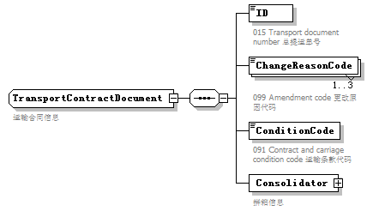
namespace | urn:Declaration:datamodel:standard:CN:[Name]:1
children | ID ChangeReasonCode ConditionCode Consolidator
used by
  element | Consignment/TransportContractDocument
annotation
  documentation
  运输合同信息

element TransportContractDocument/ID
diagram | 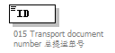
namespace | urn:Declaration:datamodel:standard:CN:[Name]:1
properties
  isRef | 0
annotation
  documentation
  015 Transport document number 总提运单号

element TransportContractDocument/ChangeReasonCode
diagram | 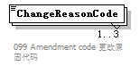
namespace | urn:Declaration:datamodel:standard:CN:[Name]:1
properties
  isRef | 0
  minOcc | 1
  maxOcc | 3
annotation
  documentation
  099 Amendment code 更改原因代码

element TransportContractDocument/ConditionCode
diagram | 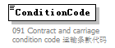
namespace | urn:Declaration:datamodel:standard:CN:[Name]:1
properties
  isRef | 0
annotation
  documentation
  091 Contract and carriage condition code 运输条款代码

element TransportContractDocument/Consolidator
diagram | 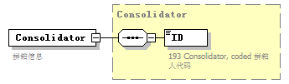
namespace | urn:Declaration:datamodel:standard:CN:[Name]:1
type | Consolidator
properties
  isRef | 0
  content | complex
children | ID
annotation
  documentation
  拼箱信息

complexType TransportEquipment
diagram | 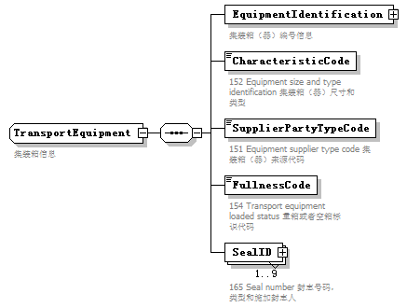
namespace | urn:Declaration:datamodel:standard:CN:[Name]:1
children | EquipmentIdentification CharacteristicCode SupplierPartyTypeCode FullnessCode SealID
used by
  element | Consignment/TransportEquipment
annotation
  documentation
  集装箱信息

element TransportEquipment/EquipmentIdentification
diagram | 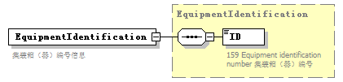
namespace | urn:Declaration:datamodel:standard:CN:[Name]:1
type | EquipmentIdentification
properties
  isRef | 0
  content | complex
children | ID
annotation
  documentation
  集装箱（器）编号信息

element TransportEquipment/CharacteristicCode
diagram | 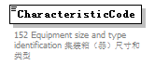
namespace | urn:Declaration:datamodel:standard:CN:[Name]:1
properties
  isRef | 0
annotation
  documentation
  152 Equipment size and type identification 集装箱（器）尺寸和类型

element TransportEquipment/SupplierPartyTypeCode
diagram | 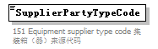
namespace | urn:Declaration:datamodel:standard:CN:[Name]:1
properties
  isRef | 0
annotation
  documentation
  151 Equipment supplier type code 集装箱（器）来源代码

element TransportEquipment/FullnessCode
diagram | 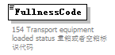
namespace | urn:Declaration:datamodel:standard:CN:[Name]:1
properties
  isRef | 0
annotation
  documentation
  154 Transport equipment loaded status 重箱或者空箱标识代码

element TransportEquipment/SealID
diagram | 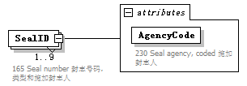
namespace | urn:Declaration:datamodel:standard:CN:[Name]:1
properties
  isRef | 0
  minOcc | 1
  maxOcc | 9
  content | complex
attributes
  Name | Type | Use | Default | Fixed | annotation
  AgencyCode |  | required
    documentation
    230 Seal agency, coded 施加封志人
annotation
  documentation
  165 Seal number 封志号码，类型和施加封志人

attribute TransportEquipment/SealID/@AgencyCode
properties
  isRef | 0
  use | required
annotation
  documentation
  230 Seal agency, coded 施加封志人

complexType UCR
diagram | 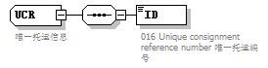
namespace | urn:Declaration:datamodel:standard:CN:[Name]:1
children | ID
used by
  element | ConsignmentItem/UCR
annotation
  documentation
  唯一托运信息

element UCR/ID
diagram | 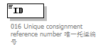
namespace | urn:Declaration:datamodel:standard:CN:[Name]:1
properties
  isRef | 0
annotation
  documentation
  016 Unique consignment reference number 唯一托运编号

complexType UNDGContact
diagram | 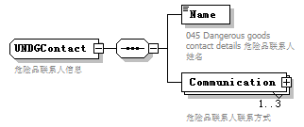
namespace | urn:Declaration:datamodel:standard:CN:[Name]:1
children | Name Communication
used by
  element | Consignment/UNDGContact
annotation
  documentation
  危险品联系人信息

element UNDGContact/Name
diagram | 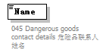
namespace | urn:Declaration:datamodel:standard:CN:[Name]:1
properties
  isRef | 0
annotation
  documentation
  045 Dangerous goods contact details 危险品联系人姓名

element UNDGContact/Communication
diagram | 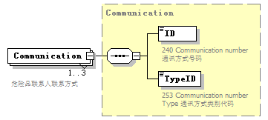
namespace | urn:Declaration:datamodel:standard:CN:[Name]:1
type | Communication
properties
  isRef | 0
  minOcc | 1
  maxOcc | 3
  content | complex
children | ID TypeID
annotation
  documentation
  危险品联系人联系方式

complexType UnloadingLocation
diagram | 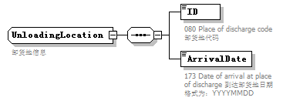
namespace | urn:Declaration:datamodel:standard:CN:[Name]:1
children | ID ArrivalDate
used by
  element | Consignment/UnloadingLocation
annotation
  documentation
  卸货地信息

element UnloadingLocation/ID
diagram | 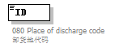
namespace | urn:Declaration:datamodel:standard:CN:[Name]:1
properties
  isRef | 0
annotation
  documentation
  080 Place of discharge code 卸货地代码

element UnloadingLocation/ArrivalDate
diagram | 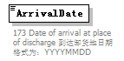
namespace | urn:Declaration:datamodel:standard:CN:[Name]:1
properties
  isRef | 0
annotation
  documentation
  173 Date of arrival at place of discharge 到达卸货地日期 格式为：YYYYMMDD

