理货报告报文结构定义

一、XML报文示例
<?xml version="1.0" encoding="UTF-8"?>
<Manifest xmlns="urn:Declaration:datamodel:standard:CN:[Name]:1" xmlns:xsi="http://www.w3.org/2001/XMLSchema-instance">
<Head>
<MessageID></MessageID>
<FunctionCode></FunctionCode>
<MessageType></MessageType>
<SenderID></SenderID>
<ReceiverID></ReceiverID>
<SendTime></SendTime>
<Version></Version>
</Head>
<Declaration>
<DeclarationOfficeID></DeclarationOfficeID>
<BorderTransportMeans>
<JourneyID></JourneyID>
<TypeCode></TypeCode>
<ID></ID>
<Name></Name>
<ActualDateTime></ActualDateTime>
<CompletedDateTime></CompletedDateTime>
<LoadingLocation>
<ID></ID>
</LoadingLocation>
<UnloadingLocation>
<ID></ID>
</UnloadingLocation>
<Master>
<Name></Name>
<Communication>
<ID></ID>
<TypeID></TypeID>
</Communication>
</Master>
</BorderTransportMeans>
<TallyParty>
<ID></ID>
<Contact>
<Name></Name>
<Communication>
<ID></ID>
<TypeID></TypeID>
</Communication>
</Contact>
</TallyParty>
<Consignment>
<TransportContractDocument>
<ID></ID>
</TransportContractDocument>
<AssociatedTransportDocument>
<ID></ID>
</AssociatedTransportDocument>
<ConsignmentPackaging>
<QuantityQuantity></QuantityQuantity>
<TypeCode></TypeCode>
</ConsignmentPackaging>
<TotalGrossMassMeasure></TotalGrossMassMeasure>
<GrossVolumeMeasure></GrossVolumeMeasure>
</Consignment>
<TransportEquipment>
<EquipmentIdentification>
<ID></ID>
</EquipmentIdentification>
<CharacteristicCode></CharacteristicCode>
<FullnessCode></FullnessCode>
<SealID AgencyCode=""/>
<Damage>
<DamageType>
<Code></Code>
<></>
</DamageType>
<DamageArea>
<Code></Code>
<></>
</DamageArea>
<Severity></Severity>
</Damage>
<TransportMeans>
<StowageLocationID></StowageLocationID>
</TransportMeans>
</TransportEquipment>
<AdditionalInformation>
<Content></Content>
</AdditionalInformation>
</Declaration>
</Manifest>

二、报文结构
循环次数 节点名称
1 Manifest
1 |______ Head
1 | |______ MessageID
1 | |______ FunctionCode
1 | |______ MessageType
1 | |______ SenderID
1 | |______ ReceiverID
1 | |______ SendTime
1 | |______ Version
1 |______ Declaration
1 | |______ DeclarationOfficeID
1 | |______ BorderTransportMeans
1 | | |______ JourneyID
1 | | |______ TypeCode
1 | | |______ ID
1 | | |______ Name
1 | | |______ ActualDateTime
1 | | |______ CompletedDateTime
1 | | |______ LoadingLocation
1 | | | |______ ID
1 | | |______ UnloadingLocation
1 | | | |______ ID
1 | | |______ Master
1 | | | |______ Name
3 | | | |______ Communication
1 | | | | |______ ID
1 | | | | |______ TypeID
1 | |______ TallyParty
1 | | |______ ID
1 | | |______ Contact
1 | | | |______ Name
3 | | | |______ Communication
1 | | | | |______ ID
1 | | | | |______ TypeID
9999 | |______ Consignment
1 | | |______ TransportContractDocument
1 | | | |______ ID
1 | | |______ AssociatedTransportDocument
1 | | | |______ ID
1 | | |______ ConsignmentPackaging
1 | | | |______ QuantityQuantity
1 | | | |______ TypeCode
1 | | |______ TotalGrossMassMeasure
1 | | |______ GrossVolumeMeasure
9999 | |______ TransportEquipment
1 | | |______ EquipmentIdentification
1 | | | |______ ID
1 | | |______ CharacteristicCode
1 | | |______ FullnessCode
9 | | |______ SealID
1 | | | |______ AgencyCode
1 | | |______ Damage
1 | | | |______ DamageType
1 | | | | |______ Code
1 | | | | |______ Text
1 | | |______
1 | | | |______ DamageArea
1 | | | | |______ Code
1 | | | | |______ Text
1 | | |______
1 | | | |______ Severity
1 | | |______ TransportMeans
1 | | | |______ StowageLocationID
1 | |______ AdditionalInformation
1 | | |______ Content

三、报文节点详细说明
element Manifest
diagram | 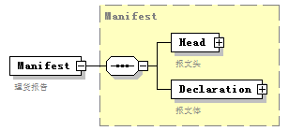
namespace | urn:Declaration:datamodel:standard:CN:[Name]:1
type | Manifest
properties
  content | complex
children | Head Declaration
annotation
  documentation
  理货报告

complexType AdditionalInformation
diagram | 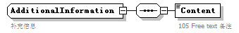
namespace | urn:Declaration:datamodel:standard:CN:[Name]:1
children | Content
used by
  element | Declaration/AdditionalInformation
annotation
  documentation
  补充信息

element AdditionalInformation/Content
diagram | 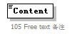
namespace | urn:Declaration:datamodel:standard:CN:[Name]:1
properties
  isRef | 0
annotation
  documentation
  105 Free text 备注

complexType AssociatedTransportDocument
diagram | 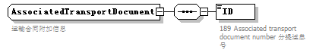
namespace | urn:Declaration:datamodel:standard:CN:[Name]:1
children | ID
used by
  element | Consignment/AssociatedTransportDocument
annotation
  documentation
  运输合同附加信息

element AssociatedTransportDocument/ID
diagram | 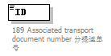
namespace | urn:Declaration:datamodel:standard:CN:[Name]:1
properties
  isRef | 0
annotation
  documentation
  189 Associated transport document number 分提运单号

complexType BorderTransportMeans
diagram | 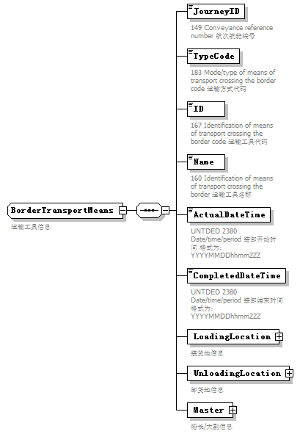
namespace | urn:Declaration:datamodel:standard:CN:[Name]:1
children | JourneyID TypeCode ID Name ActualDateTime CompletedDateTime LoadingLocation UnloadingLocation Master
used by
  element | Declaration/BorderTransportMeans
annotation
  documentation
  运输工具信息

element BorderTransportMeans/JourneyID
diagram | 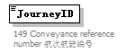
namespace | urn:Declaration:datamodel:standard:CN:[Name]:1
properties
  isRef | 0
annotation
  documentation
  149 Conveyance reference number 航次航班编号

element BorderTransportMeans/TypeCode
diagram | 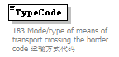
namespace | urn:Declaration:datamodel:standard:CN:[Name]:1
properties
  isRef | 0
annotation
  documentation
  183 Mode/type of means of transport crossing the border code 运输方式代码

element BorderTransportMeans/ID
diagram | 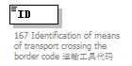
namespace | urn:Declaration:datamodel:standard:CN:[Name]:1
properties
  isRef | 0
annotation
  documentation
  167 Identification of means of transport crossing the border code 运输工具代码

element BorderTransportMeans/Name
diagram | 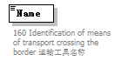
namespace | urn:Declaration:datamodel:standard:CN:[Name]:1
properties
  isRef | 0
annotation
  documentation
  160 Identification of means of transport crossing the border 运输工具名称

element BorderTransportMeans/ActualDateTime
diagram | 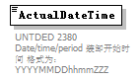
namespace | urn:Declaration:datamodel:standard:CN:[Name]:1
properties
  isRef | 0
annotation
  documentation
  UNTDED 2380 Date/time/period 装卸开始时间 格式为：YYYYMMDDhhmmZZZ

element BorderTransportMeans/CompletedDateTime
diagram | 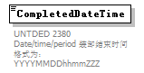
namespace | urn:Declaration:datamodel:standard:CN:[Name]:1
properties
  isRef | 0
annotation
  documentation
  UNTDED 2380 Date/time/period 装卸结束时间 格式为：YYYYMMDDhhmmZZZ

element BorderTransportMeans/LoadingLocation
diagram | 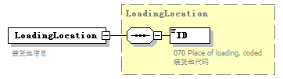
namespace | urn:Declaration:datamodel:standard:CN:[Name]:1
type | LoadingLocation
properties
  isRef | 0
  content | complex
children | ID
annotation
  documentation
  装货地信息

element BorderTransportMeans/UnloadingLocation
diagram | 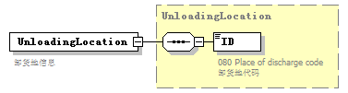
namespace | urn:Declaration:datamodel:standard:CN:[Name]:1
type | UnloadingLocation
properties
  isRef | 0
  content | complex
children | ID
annotation
  documentation
  卸货地信息

element BorderTransportMeans/Master
diagram | 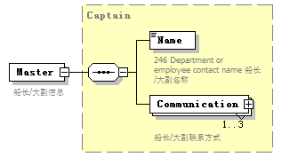
namespace | urn:Declaration:datamodel:standard:CN:[Name]:1
type | Captain
properties
  isRef | 0
  content | complex
children | Name Communication
annotation
  documentation
  船长/大副信息

complexType Captain
diagram | 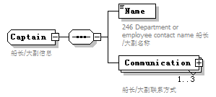
namespace | urn:Declaration:datamodel:standard:CN:[Name]:1
children | Name Communication
used by
  element | BorderTransportMeans/Master
annotation
  documentation
  船长/大副信息

element Captain/Name
diagram | 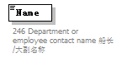
namespace | urn:Declaration:datamodel:standard:CN:[Name]:1
properties
  isRef | 0
annotation
  documentation
  246 Department or employee contact name 船长/大副名称

element Captain/Communication
diagram | 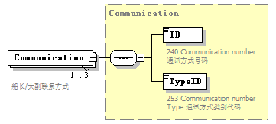
namespace | urn:Declaration:datamodel:standard:CN:[Name]:1
type | Communication
properties
  isRef | 0
  minOcc | 1
  maxOcc | 3
  content | complex
children | ID TypeID
annotation
  documentation
  船长/大副联系方式

complexType Communication
diagram | 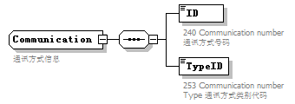
namespace | urn:Declaration:datamodel:standard:CN:[Name]:1
children | ID TypeID
used by
  elements | Contact/Communication Captain/Communication
annotation
  documentation
  通讯方式信息

element Communication/ID
diagram | 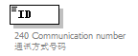
namespace | urn:Declaration:datamodel:standard:CN:[Name]:1
properties
  isRef | 0
annotation
  documentation
  240 Communication number 通讯方式号码

element Communication/TypeID
diagram | 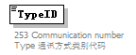
namespace | urn:Declaration:datamodel:standard:CN:[Name]:1
properties
  isRef | 0
annotation
  documentation
  253 Communication number Type 通讯方式类别代码

complexType Consignment
diagram | 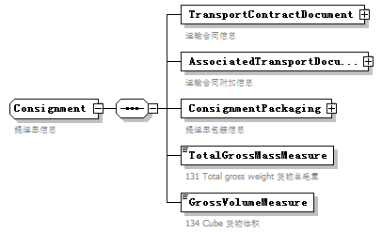
namespace | urn:Declaration:datamodel:standard:CN:[Name]:1
children | TransportContractDocument AssociatedTransportDocument ConsignmentPackaging TotalGrossMassMeasure GrossVolumeMeasure
used by
  element | Declaration/Consignment
annotation
  documentation
  提运单信息

element Consignment/TransportContractDocument
diagram | 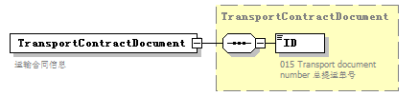
namespace | urn:Declaration:datamodel:standard:CN:[Name]:1
type | TransportContractDocument
properties
  isRef | 0
  content | complex
children | ID
annotation
  documentation
  运输合同信息

element Consignment/AssociatedTransportDocument
diagram | 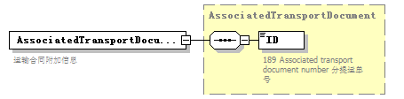
namespace | urn:Declaration:datamodel:standard:CN:[Name]:1
type | AssociatedTransportDocument
properties
  isRef | 0
  content | complex
children | ID
annotation
  documentation
  运输合同附加信息

element Consignment/ConsignmentPackaging
diagram | 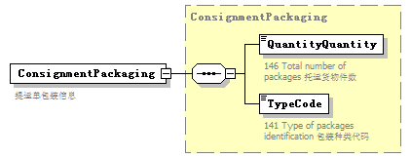
namespace | urn:Declaration:datamodel:standard:CN:[Name]:1
type | ConsignmentPackaging
properties
  isRef | 0
  content | complex
children | QuantityQuantity TypeCode
annotation
  documentation
  提运单包装信息

element Consignment/TotalGrossMassMeasure
diagram | 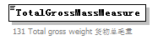
namespace | urn:Declaration:datamodel:standard:CN:[Name]:1
properties
  isRef | 0
annotation
  documentation
  131 Total gross weight 货物总毛重

element Consignment/GrossVolumeMeasure
diagram | 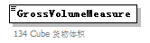
namespace | urn:Declaration:datamodel:standard:CN:[Name]:1
properties
  isRef | 0
annotation
  documentation
  134 Cube 货物体积

complexType ConsignmentPackaging
diagram | 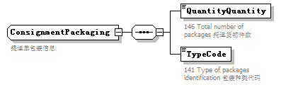
namespace | urn:Declaration:datamodel:standard:CN:[Name]:1
children | QuantityQuantity TypeCode
used by
  element | Consignment/ConsignmentPackaging
annotation
  documentation
  提运单包装信息

element ConsignmentPackaging/QuantityQuantity
diagram | 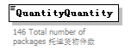
namespace | urn:Declaration:datamodel:standard:CN:[Name]:1
properties
  isRef | 0
annotation
  documentation
  146 Total number of packages 托运货物件数

element ConsignmentPackaging/TypeCode
diagram | 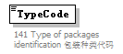
namespace | urn:Declaration:datamodel:standard:CN:[Name]:1
properties
  isRef | 0
annotation
  documentation
  141 Type of packages identification 包装种类代码

complexType Contact
diagram | 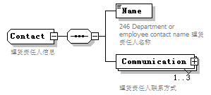
namespace | urn:Declaration:datamodel:standard:CN:[Name]:1
children | Name Communication
used by
  element | Party/Contact
annotation
  documentation
  理货责任人信息

element Contact/Name
diagram | 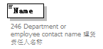
namespace | urn:Declaration:datamodel:standard:CN:[Name]:1
properties
  isRef | 0
annotation
  documentation
  246 Department or employee contact name 理货责任人名称

element Contact/Communication
diagram | 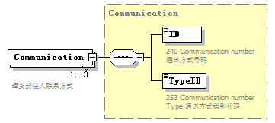
namespace | urn:Declaration:datamodel:standard:CN:[Name]:1
type | Communication
properties
  isRef | 0
  minOcc | 1
  maxOcc | 3
  content | complex
children | ID TypeID
annotation
  documentation
  理货责任人联系方式

complexType Damage
diagram | 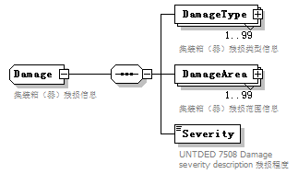
namespace | urn:Declaration:datamodel:standard:CN:[Name]:1
children | DamageType DamageArea Severity
used by
  element | TransportEquipment/Damage
annotation
  documentation
  集装箱（器）残损信息

element Damage/DamageType
diagram | 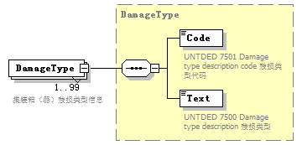
namespace | urn:Declaration:datamodel:standard:CN:[Name]:1
type | DamageType
properties
  isRef | 0
  minOcc | 1
  maxOcc | 99
  content | complex
children | Code Text
annotation
  documentation
  集装箱（器）残损类型信息

element Damage/DamageArea
diagram | 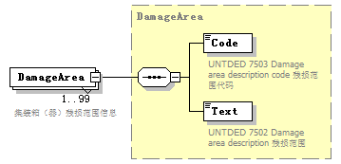
namespace | urn:Declaration:datamodel:standard:CN:[Name]:1
type | DamageArea
properties
  isRef | 0
  minOcc | 1
  maxOcc | 99
  content | complex
children | Code Text
annotation
  documentation
  集装箱（器）残损范围信息

element Damage/Severity
diagram | 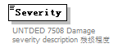
namespace | urn:Declaration:datamodel:standard:CN:[Name]:1
properties
  isRef | 0
annotation
  documentation
  UNTDED 7508 Damage severity description 残损程度

complexType DamageArea
diagram | 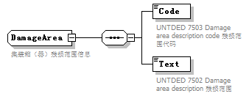
namespace | urn:Declaration:datamodel:standard:CN:[Name]:1
children | Code Text
used by
  element | Damage/DamageArea
annotation
  documentation
  集装箱（器）残损范围信息

element DamageArea/Code
diagram | 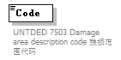
namespace | urn:Declaration:datamodel:standard:CN:[Name]:1
properties
  isRef | 0
annotation
  documentation
  UNTDED 7503 Damage area description code 残损范围代码

element DamageArea/Text
diagram | 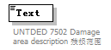
namespace | urn:Declaration:datamodel:standard:CN:[Name]:1
properties
  isRef | 0
annotation
  documentation
  UNTDED 7502 Damage area description 残损范围

complexType DamageType
diagram | 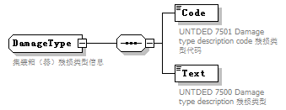
namespace | urn:Declaration:datamodel:standard:CN:[Name]:1
children | Code Text
used by
  element | Damage/DamageType
annotation
  documentation
  集装箱（器）残损类型信息

element DamageType/Code
diagram | 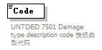
namespace | urn:Declaration:datamodel:standard:CN:[Name]:1
properties
  isRef | 0
annotation
  documentation
  UNTDED 7501 Damage type description code 残损类型代码

element DamageType/Text
diagram | 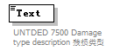
namespace | urn:Declaration:datamodel:standard:CN:[Name]:1
properties
  isRef | 0
annotation
  documentation
  UNTDED 7500 Damage type description 残损类型

complexType Declaration
diagram | 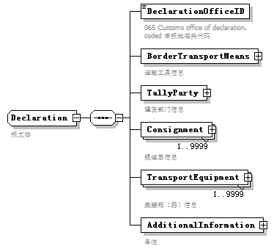
namespace | urn:Declaration:datamodel:standard:CN:[Name]:1
children | DeclarationOfficeID BorderTransportMeans TallyParty Consignment TransportEquipment AdditionalInformation
used by
  element | Manifest/Declaration
annotation
  documentation
  报文体

element Declaration/DeclarationOfficeID
diagram | 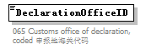
namespace | urn:Declaration:datamodel:standard:CN:[Name]:1
properties
  isRef | 0
annotation
  documentation
  065 Customs office of declaration, coded 申报地海关代码

element Declaration/BorderTransportMeans
diagram | 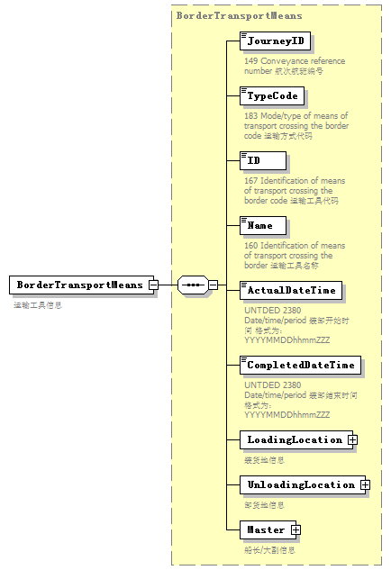
namespace | urn:Declaration:datamodel:standard:CN:[Name]:1
type | BorderTransportMeans
properties
  isRef | 0
  content | complex
children | JourneyID TypeCode ID Name ActualDateTime CompletedDateTime LoadingLocation UnloadingLocation Master
annotation
  documentation
  运输工具信息

element Declaration/TallyParty
diagram | 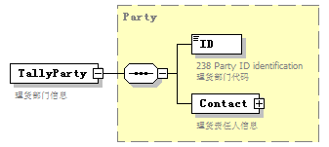
namespace | urn:Declaration:datamodel:standard:CN:[Name]:1
type | Party
properties
  isRef | 0
  content | complex
children | ID Contact
annotation
  documentation
  理货部门信息

element Declaration/Consignment
diagram | 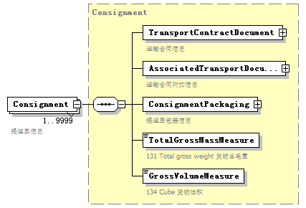
namespace | urn:Declaration:datamodel:standard:CN:[Name]:1
type | Consignment
properties
  isRef | 0
  minOcc | 1
  maxOcc | 9999
  content | complex
children | TransportContractDocument AssociatedTransportDocument ConsignmentPackaging TotalGrossMassMeasure GrossVolumeMeasure
annotation
  documentation
  提运单信息

element Declaration/TransportEquipment
diagram | 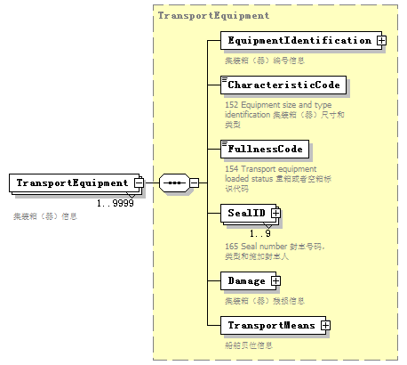
namespace | urn:Declaration:datamodel:standard:CN:[Name]:1
type | TransportEquipment
properties
  isRef | 0
  minOcc | 1
  maxOcc | 9999
  content | complex
children | EquipmentIdentification CharacteristicCode FullnessCode SealID Damage TransportMeans
annotation
  documentation
  集装箱（器）信息

element Declaration/AdditionalInformation
diagram | 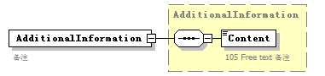
namespace | urn:Declaration:datamodel:standard:CN:[Name]:1
type | AdditionalInformation
properties
  isRef | 0
  content | complex
children | Content
annotation
  documentation
  备注

complexType EquipmentIdentification
diagram | 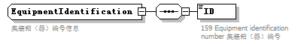
namespace | urn:Declaration:datamodel:standard:CN:[Name]:1
children | ID
used by
  element | TransportEquipment/EquipmentIdentification
annotation
  documentation
  集装箱（器）编号信息

element EquipmentIdentification/ID
diagram | 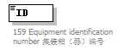
namespace | urn:Declaration:datamodel:standard:CN:[Name]:1
properties
  isRef | 0
annotation
  documentation
  159 Equipment identification number 集装箱（器）编号

complexType Head
diagram | 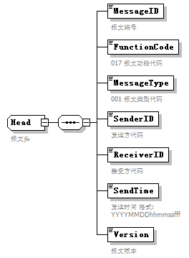
namespace | urn:Declaration:datamodel:standard:CN:[Name]:1
children | MessageID FunctionCode MessageType SenderID ReceiverID SendTime Version
used by
  element | Manifest/Head
annotation
  documentation
  报文头

element Head/MessageID
diagram | 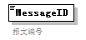
namespace | urn:Declaration:datamodel:standard:CN:[Name]:1
properties
  isRef | 0
annotation
  documentation
  报文编号

element Head/FunctionCode
diagram | 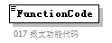
namespace | urn:Declaration:datamodel:standard:CN:[Name]:1
properties
  isRef | 0
annotation
  documentation
  017 报文功能代码

element Head/MessageType
diagram | 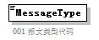
namespace | urn:Declaration:datamodel:standard:CN:[Name]:1
properties
  isRef | 0
annotation
  documentation
  001 报文类型代码

element Head/SenderID
diagram | 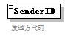
namespace | urn:Declaration:datamodel:standard:CN:[Name]:1
properties
  isRef | 0
annotation
  documentation
  发送方代码

element Head/ReceiverID
diagram | 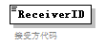
namespace | urn:Declaration:datamodel:standard:CN:[Name]:1
properties
  isRef | 0
annotation
  documentation
  接受方代码

element Head/SendTime
diagram | 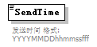
namespace | urn:Declaration:datamodel:standard:CN:[Name]:1
properties
  isRef | 0
annotation
  documentation
  发送时间 格式:YYYYMMDDhhmmssfff

element Head/Version
diagram | 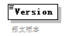
namespace | urn:Declaration:datamodel:standard:CN:[Name]:1
properties
  isRef | 0
annotation
  documentation
  报文版本

complexType LoadingLocation
diagram | 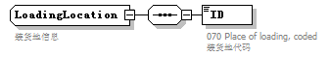
namespace | urn:Declaration:datamodel:standard:CN:[Name]:1
children | ID
used by
  element | BorderTransportMeans/LoadingLocation
annotation
  documentation
  装货地信息

element LoadingLocation/ID
diagram | 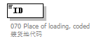
namespace | urn:Declaration:datamodel:standard:CN:[Name]:1
properties
  isRef | 0
annotation
  documentation
  070 Place of loading, coded 装货地代码

complexType Manifest
diagram | 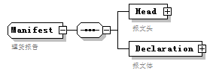
namespace | urn:Declaration:datamodel:standard:CN:[Name]:1
children | Head Declaration
used by
  element | Manifest
annotation
  documentation
  理货报告

element Manifest/Head
diagram | 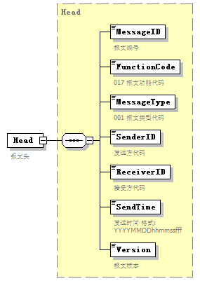
namespace | urn:Declaration:datamodel:standard:CN:[Name]:1
type | Head
properties
  isRef | 0
  content | complex
children | MessageID FunctionCode MessageType SenderID ReceiverID SendTime Version
annotation
  documentation
  报文头

element Manifest/Declaration
diagram | 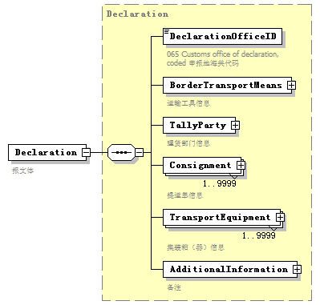
namespace | urn:Declaration:datamodel:standard:CN:[Name]:1
type | Declaration
properties
  isRef | 0
  content | complex
children | DeclarationOfficeID BorderTransportMeans TallyParty Consignment TransportEquipment AdditionalInformation
annotation
  documentation
  报文体

complexType Party
diagram | 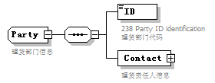
namespace | urn:Declaration:datamodel:standard:CN:[Name]:1
children | ID Contact
used by
  element | Declaration/TallyParty
annotation
  documentation
  理货部门信息

element Party/ID
diagram | 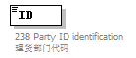
namespace | urn:Declaration:datamodel:standard:CN:[Name]:1
properties
  isRef | 0
annotation
  documentation
  238 Party ID identification 理货部门代码

element Party/Contact
diagram | 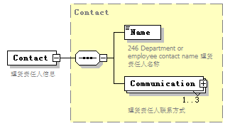
namespace | urn:Declaration:datamodel:standard:CN:[Name]:1
type | Contact
properties
  isRef | 0
  content | complex
children | Name Communication
annotation
  documentation
  理货责任人信息

complexType TransportContractDocument
diagram | 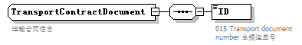
namespace | urn:Declaration:datamodel:standard:CN:[Name]:1
children | ID
used by
  element | Consignment/TransportContractDocument
annotation
  documentation
  运输合同信息

element TransportContractDocument/ID
diagram | 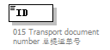
namespace | urn:Declaration:datamodel:standard:CN:[Name]:1
properties
  isRef | 0
annotation
  documentation
  015 Transport document number 总提运单号

complexType TransportEquipment
diagram | 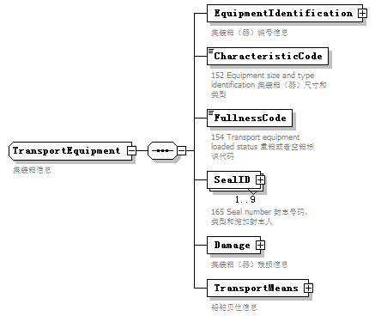
namespace | urn:Declaration:datamodel:standard:CN:[Name]:1
children | EquipmentIdentification CharacteristicCode FullnessCode SealID Damage TransportMeans
used by
  element | Declaration/TransportEquipment
annotation
  documentation
  集装箱信息

element TransportEquipment/EquipmentIdentification
diagram | 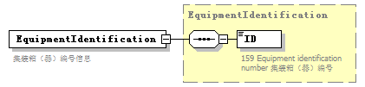
namespace | urn:Declaration:datamodel:standard:CN:[Name]:1
type | EquipmentIdentification
properties
  isRef | 0
  content | complex
children | ID
annotation
  documentation
  集装箱（器）编号信息

element TransportEquipment/CharacteristicCode
diagram | 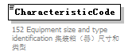
namespace | urn:Declaration:datamodel:standard:CN:[Name]:1
properties
  isRef | 0
annotation
  documentation
  152 Equipment size and type identification 集装箱（器）尺寸和类型

element TransportEquipment/FullnessCode
diagram | 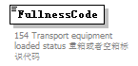
namespace | urn:Declaration:datamodel:standard:CN:[Name]:1
properties
  isRef | 0
annotation
  documentation
  154 Transport equipment loaded status 重箱或者空箱标识代码

element TransportEquipment/SealID
diagram | 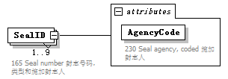
namespace | urn:Declaration:datamodel:standard:CN:[Name]:1
properties
  isRef | 0
  minOcc | 1
  maxOcc | 9
  content | complex
attributes
  Name | Type | Use | Default | Fixed | annotation
  AgencyCode |  | required
    documentation
    230 Seal agency, coded 施加封志人
annotation
  documentation
  165 Seal number 封志号码，类型和施加封志人

attribute TransportEquipment/SealID/@AgencyCode
properties
  isRef | 0
  use | required
annotation
  documentation
  230 Seal agency, coded 施加封志人

element TransportEquipment/Damage
diagram | 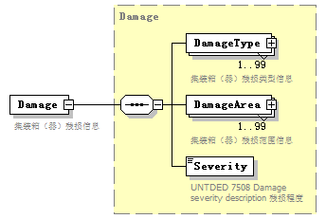
namespace | urn:Declaration:datamodel:standard:CN:[Name]:1
type | Damage
properties
  isRef | 0
  content | complex
children | DamageType DamageArea Severity
annotation
  documentation
  集装箱（器）残损信息

element TransportEquipment/TransportMeans
diagram | 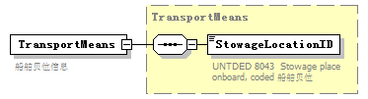
namespace | urn:Declaration:datamodel:standard:CN:[Name]:1
type | TransportMeans
properties
  isRef | 0
  content | complex
children | StowageLocationID
annotation
  documentation
  船舶贝位信息

complexType TransportMeans
diagram | 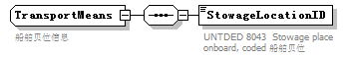
namespace | urn:Declaration:datamodel:standard:CN:[Name]:1
children | StowageLocationID
used by
  element | TransportEquipment/TransportMeans
annotation
  documentation
  船舶贝位信息

element TransportMeans/StowageLocationID
diagram | 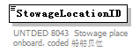
namespace | urn:Declaration:datamodel:standard:CN:[Name]:1
properties
  isRef | 0
annotation
  documentation
  UNTDED 8043 Stowage place onboard, coded 船舶贝位

complexType UnloadingLocation
diagram | 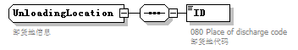
namespace | urn:Declaration:datamodel:standard:CN:[Name]:1
children | ID
used by
  element | BorderTransportMeans/UnloadingLocation
annotation
  documentation
  卸货地信息

element UnloadingLocation/ID
diagram | 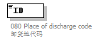
namespace | urn:Declaration:datamodel:standard:CN:[Name]:1
properties
  isRef | 0
annotation
  documentation
  080 Place of discharge code 卸货地代码

