装载舱单报文结构定义

一、XML报文示例
<?xml version="1.0" encoding="UTF-8"?>
<Manifest xmlns="urn:Declaration:datamodel:standard:CN:[Name]:1" xmlns:xsi="http://www.w3.org/2001/XMLSchema-instance">
<Head>
<MessageID></MessageID>
<FunctionCode></FunctionCode>
<MessageType></MessageType>
<SenderID></SenderID>
<ReceiverID></ReceiverID>
<SendTime></SendTime>
<Version></Version>
</Head>
<Declaration>
<Carrier>
<ID></ID>
</Carrier>
<BorderTransportMeans>
<JourneyID></JourneyID>
<TypeCode></TypeCode>
<ID></ID>
<Name></Name>
</BorderTransportMeans>
<Consignment>
<TransportContractDocument>
<ID></ID>
</TransportContractDocument>
<LoadingLocation>
<ID></ID>
<LoadingDate></LoadingDate>
</LoadingLocation>
<ConsignmentPackaging>
<QuantityQuantity></QuantityQuantity>
<TypeCode></TypeCode>
</ConsignmentPackaging>
<TotalGrossMassMeasure></TotalGrossMassMeasure>
<TransportSplitIndicator></TransportSplitIndicator>
<TransportEquipment>
<EquipmentIdentification>
<ID></ID>
</EquipmentIdentification>
<CharacteristicCode></CharacteristicCode>
<FullnessCode></FullnessCode>
<SealID AgencyCode=""/>
</TransportEquipment>
<ConsignmentItem>
<Commodity>
<CargoDescription></CargoDescription>
</Commodity>
</ConsignmentItem>
</Consignment>
<AdditionalInformation>
<Content></Content>
</AdditionalInformation>
</Declaration>
</Manifest>

二、报文结构
循环次数 节点名称
1 Manifest
1 |______ Head
1 | |______ MessageID
1 | |______ FunctionCode
1 | |______ MessageType
1 | |______ SenderID
1 | |______ ReceiverID
1 | |______ SendTime
1 | |______ Version
1 |______ Declaration
1 | |______ Carrier
1 | | |______ ID
1 | |______ BorderTransportMeans
1 | | |______ JourneyID
1 | | |______ TypeCode
1 | | |______ ID
1 | | |______ Name
9999 | |______ Consignment
1 | | |______ TransportContractDocument
1 | | | |______ ID
1 | | |______ LoadingLocation
1 | | | |______ ID
1 | | | |______ LoadingDate
1 | | |______ ConsignmentPackaging
1 | | | |______ QuantityQuantity
1 | | | |______ TypeCode
1 | | |______ TotalGrossMassMeasure
1 | | |______ TransportSplitIndicator
9999 | | |______ TransportEquipment
1 | | | |______ EquipmentIdentification
1 | | | | |______ ID
1 | | | |______ CharacteristicCode
1 | | | |______ FullnessCode
9 | | | |______ SealID
1 | | | | |______ AgencyCode
9999 | | |______ ConsignmentItem
1 | | | |______ Commodity
1 | | | | |______ CargoDescription
1 | |______ AdditionalInformation
1 | | |______ Content

三、报文节点详细说明
element Manifest
diagram | 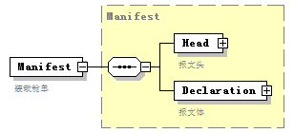
namespace | urn:Declaration:datamodel:standard:CN:[Name]:1
type | Manifest
properties
  content | complex
children | Head Declaration
annotation
  documentation
  装载舱单

complexType AdditionalInformation
diagram | 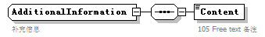
namespace | urn:Declaration:datamodel:standard:CN:[Name]:1
children | Content
used by
  element | Declaration/AdditionalInformation
annotation
  documentation
  补充信息

element AdditionalInformation/Content
diagram | 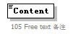
namespace | urn:Declaration:datamodel:standard:CN:[Name]:1
properties
  isRef | 0
annotation
  documentation
  105 Free text 备注

complexType BorderTransportMeans
diagram | 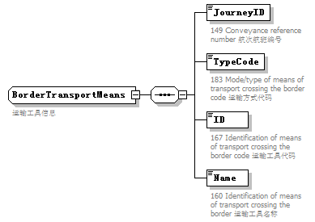
namespace | urn:Declaration:datamodel:standard:CN:[Name]:1
children | JourneyID TypeCode ID Name
used by
  element | Declaration/BorderTransportMeans
annotation
  documentation
  运输工具信息

element BorderTransportMeans/JourneyID
diagram | 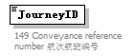
namespace | urn:Declaration:datamodel:standard:CN:[Name]:1
properties
  isRef | 0
annotation
  documentation
  149 Conveyance reference number 航次航班编号

element BorderTransportMeans/TypeCode
diagram | 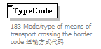
namespace | urn:Declaration:datamodel:standard:CN:[Name]:1
properties
  isRef | 0
annotation
  documentation
  183 Mode/type of means of transport crossing the border code 运输方式代码

element BorderTransportMeans/ID
diagram | 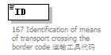
namespace | urn:Declaration:datamodel:standard:CN:[Name]:1
properties
  isRef | 0
annotation
  documentation
  167 Identification of means of transport crossing the border code 运输工具代码

element BorderTransportMeans/Name
diagram | 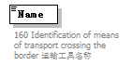
namespace | urn:Declaration:datamodel:standard:CN:[Name]:1
properties
  isRef | 0
annotation
  documentation
  160 Identification of means of transport crossing the border 运输工具名称

complexType Carrier
diagram | 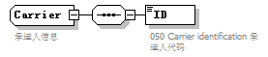
namespace | urn:Declaration:datamodel:standard:CN:[Name]:1
children | ID
used by
  element | Declaration/Carrier
annotation
  documentation
  承运人信息

element Carrier/ID
diagram | 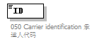
namespace | urn:Declaration:datamodel:standard:CN:[Name]:1
properties
  isRef | 0
annotation
  documentation
  050 Carrier identification 承运人代码

complexType Commodity
diagram | 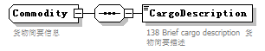
namespace | urn:Declaration:datamodel:standard:CN:[Name]:1
children | CargoDescription
used by
  element | ConsignmentItem/Commodity
annotation
  documentation
  货物简要信息

element Commodity/CargoDescription
diagram | 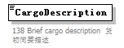
namespace | urn:Declaration:datamodel:standard:CN:[Name]:1
properties
  isRef | 0
annotation
  documentation
  138 Brief cargo description 货物简要描述

complexType Consignment
diagram | 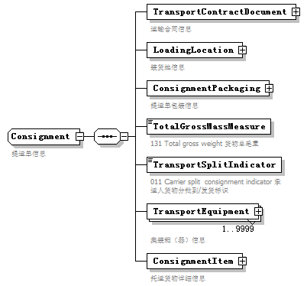
namespace | urn:Declaration:datamodel:standard:CN:[Name]:1
children | TransportContractDocument LoadingLocation ConsignmentPackaging TotalGrossMassMeasure TransportSplitIndicator TransportEquipment ConsignmentItem
used by
  element | Declaration/Consignment
annotation
  documentation
  提运单信息

element Consignment/TransportContractDocument
diagram | 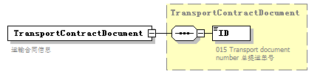
namespace | urn:Declaration:datamodel:standard:CN:[Name]:1
type | TransportContractDocument
properties
  isRef | 0
  content | complex
children | ID
annotation
  documentation
  运输合同信息

element Consignment/LoadingLocation
diagram | 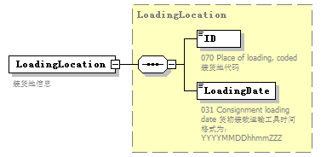
namespace | urn:Declaration:datamodel:standard:CN:[Name]:1
type | LoadingLocation
properties
  isRef | 0
  content | complex
children | ID LoadingDate
annotation
  documentation
  装货地信息

element Consignment/ConsignmentPackaging
diagram | 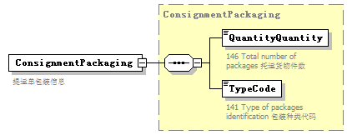
namespace | urn:Declaration:datamodel:standard:CN:[Name]:1
type | ConsignmentPackaging
properties
  isRef | 0
  content | complex
children | QuantityQuantity TypeCode
annotation
  documentation
  提运单包装信息

element Consignment/TotalGrossMassMeasure
diagram | 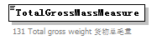
namespace | urn:Declaration:datamodel:standard:CN:[Name]:1
properties
  isRef | 0
annotation
  documentation
  131 Total gross weight 货物总毛重

element Consignment/TransportSplitIndicator
diagram | 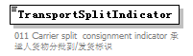
namespace | urn:Declaration:datamodel:standard:CN:[Name]:1
properties
  isRef | 0
annotation
  documentation
  011 Carrier split consignment indicator 承运人货物分批到/发货标识

element Consignment/TransportEquipment
diagram | 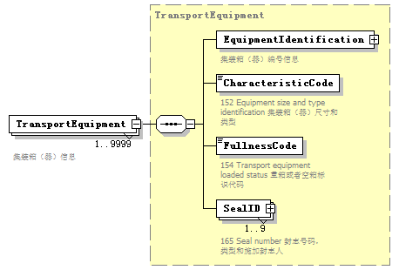
namespace | urn:Declaration:datamodel:standard:CN:[Name]:1
type | TransportEquipment
properties
  isRef | 0
  minOcc | 1
  maxOcc | 9999
  content | complex
children | EquipmentIdentification CharacteristicCode FullnessCode SealID
annotation
  documentation
  集装箱（器）信息

element Consignment/ConsignmentItem
diagram | 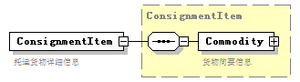
namespace | urn:Declaration:datamodel:standard:CN:[Name]:1
type | ConsignmentItem
properties
  isRef | 0
  content | complex
children | Commodity
annotation
  documentation
  托运货物详细信息

complexType ConsignmentItem
diagram | 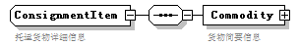
namespace | urn:Declaration:datamodel:standard:CN:[Name]:1
children | Commodity
used by
  element | Consignment/ConsignmentItem
annotation
  documentation
  托运货物详细信息

element ConsignmentItem/Commodity
diagram | 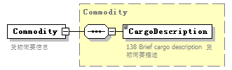
namespace | urn:Declaration:datamodel:standard:CN:[Name]:1
type | Commodity
properties
  isRef | 0
  content | complex
children | CargoDescription
annotation
  documentation
  货物简要信息

complexType ConsignmentPackaging
diagram | 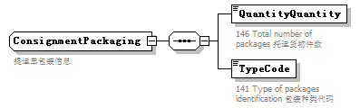
namespace | urn:Declaration:datamodel:standard:CN:[Name]:1
children | QuantityQuantity TypeCode
used by
  element | Consignment/ConsignmentPackaging
annotation
  documentation
  提运单包装信息

element ConsignmentPackaging/QuantityQuantity
diagram | 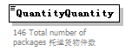
namespace | urn:Declaration:datamodel:standard:CN:[Name]:1
properties
  isRef | 0
annotation
  documentation
  146 Total number of packages 托运货物件数

element ConsignmentPackaging/TypeCode
diagram | 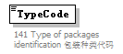
namespace | urn:Declaration:datamodel:standard:CN:[Name]:1
properties
  isRef | 0
annotation
  documentation
  141 Type of packages identification 包装种类代码

complexType Declaration
diagram | 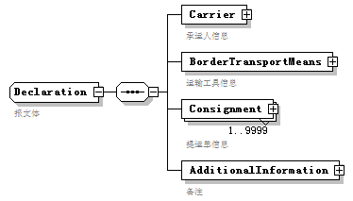
namespace | urn:Declaration:datamodel:standard:CN:[Name]:1
children | Carrier BorderTransportMeans Consignment AdditionalInformation
used by
  element | Manifest/Declaration
annotation
  documentation
  报文体

element Declaration/Carrier
diagram | 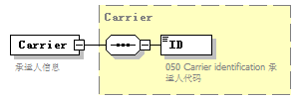
namespace | urn:Declaration:datamodel:standard:CN:[Name]:1
type | Carrier
properties
  isRef | 0
  content | complex
children | ID
annotation
  documentation
  承运人信息

element Declaration/BorderTransportMeans
diagram | 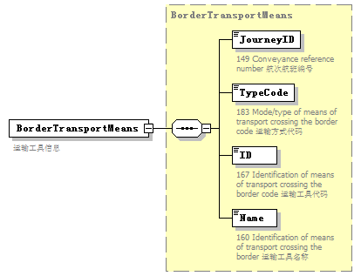
namespace | urn:Declaration:datamodel:standard:CN:[Name]:1
type | BorderTransportMeans
properties
  isRef | 0
  content | complex
children | JourneyID TypeCode ID Name
annotation
  documentation
  运输工具信息

element Declaration/Consignment
diagram | 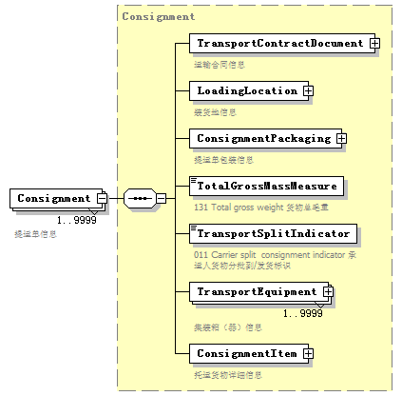
namespace | urn:Declaration:datamodel:standard:CN:[Name]:1
type | Consignment
properties
  isRef | 0
  minOcc | 1
  maxOcc | 9999
  content | complex
children | TransportContractDocument LoadingLocation ConsignmentPackaging TotalGrossMassMeasure TransportSplitIndicator TransportEquipment ConsignmentItem
annotation
  documentation
  提运单信息

element Declaration/AdditionalInformation
diagram | 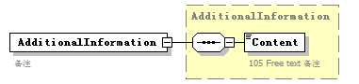
namespace | urn:Declaration:datamodel:standard:CN:[Name]:1
type | AdditionalInformation
properties
  isRef | 0
  content | complex
children | Content
annotation
  documentation
  备注

complexType EquipmentIdentification
diagram | 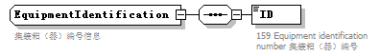
namespace | urn:Declaration:datamodel:standard:CN:[Name]:1
children | ID
used by
  element | TransportEquipment/EquipmentIdentification
annotation
  documentation
  集装箱（器）编号信息

element EquipmentIdentification/ID
diagram | 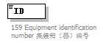
namespace | urn:Declaration:datamodel:standard:CN:[Name]:1
properties
  isRef | 0
annotation
  documentation
  159 Equipment identification number 集装箱（器）编号

complexType Head
diagram | 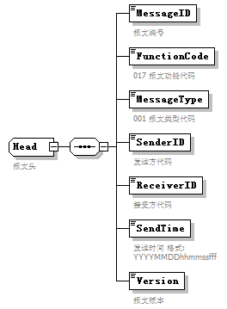
namespace | urn:Declaration:datamodel:standard:CN:[Name]:1
children | MessageID FunctionCode MessageType SenderID ReceiverID SendTime Version
used by
  element | Manifest/Head
annotation
  documentation
  报文头

element Head/MessageID
diagram | 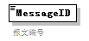
namespace | urn:Declaration:datamodel:standard:CN:[Name]:1
properties
  isRef | 0
annotation
  documentation
  报文编号

element Head/FunctionCode
diagram | 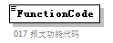
namespace | urn:Declaration:datamodel:standard:CN:[Name]:1
properties
  isRef | 0
annotation
  documentation
  017 报文功能代码

element Head/MessageType
diagram | 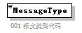
namespace | urn:Declaration:datamodel:standard:CN:[Name]:1
properties
  isRef | 0
annotation
  documentation
  001 报文类型代码

element Head/SenderID
diagram | 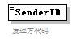
namespace | urn:Declaration:datamodel:standard:CN:[Name]:1
properties
  isRef | 0
annotation
  documentation
  发送方代码

element Head/ReceiverID
diagram | 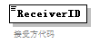
namespace | urn:Declaration:datamodel:standard:CN:[Name]:1
properties
  isRef | 0
annotation
  documentation
  接受方代码

element Head/SendTime
diagram | 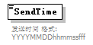
namespace | urn:Declaration:datamodel:standard:CN:[Name]:1
properties
  isRef | 0
annotation
  documentation
  发送时间 格式:YYYYMMDDhhmmssfff

element Head/Version
diagram | 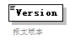
namespace | urn:Declaration:datamodel:standard:CN:[Name]:1
properties
  isRef | 0
annotation
  documentation
  报文版本

complexType LoadingLocation
diagram | 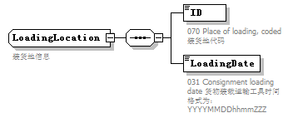
namespace | urn:Declaration:datamodel:standard:CN:[Name]:1
children | ID LoadingDate
used by
  element | Consignment/LoadingLocation
annotation
  documentation
  装货地信息

element LoadingLocation/ID
diagram | 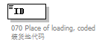
namespace | urn:Declaration:datamodel:standard:CN:[Name]:1
properties
  isRef | 0
annotation
  documentation
  070 Place of loading, coded 装货地代码

element LoadingLocation/LoadingDate
diagram | 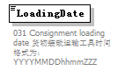
namespace | urn:Declaration:datamodel:standard:CN:[Name]:1
properties
  isRef | 0
annotation
  documentation
  031 Consignment loading date 货物装载运输工具时间 格式为：YYYYMMDDhhmmZZZ

complexType Manifest
diagram | 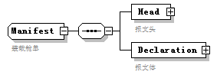
namespace | urn:Declaration:datamodel:standard:CN:[Name]:1
children | Head Declaration
used by
  element | Manifest
annotation
  documentation
  装载舱单

element Manifest/Head
diagram | 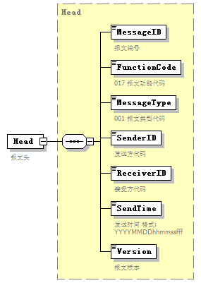
namespace | urn:Declaration:datamodel:standard:CN:[Name]:1
type | Head
properties
  isRef | 0
  content | complex
children | MessageID FunctionCode MessageType SenderID ReceiverID SendTime Version
annotation
  documentation
  报文头

element Manifest/Declaration
diagram | 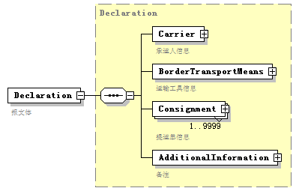
namespace | urn:Declaration:datamodel:standard:CN:[Name]:1
type | Declaration
properties
  isRef | 0
  content | complex
children | Carrier BorderTransportMeans Consignment AdditionalInformation
annotation
  documentation
  报文体

complexType TransportContractDocument
diagram | 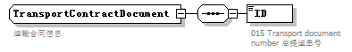
namespace | urn:Declaration:datamodel:standard:CN:[Name]:1
children | ID
used by
  element | Consignment/TransportContractDocument
annotation
  documentation
  运输合同信息

element TransportContractDocument/ID
diagram | 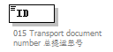
namespace | urn:Declaration:datamodel:standard:CN:[Name]:1
properties
  isRef | 0
annotation
  documentation
  015 Transport document number 总提运单号

complexType TransportEquipment
diagram | 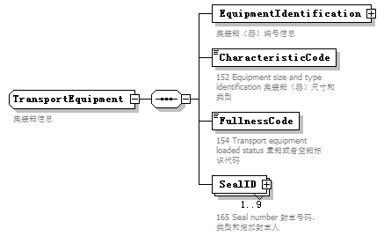
namespace | urn:Declaration:datamodel:standard:CN:[Name]:1
children | EquipmentIdentification CharacteristicCode FullnessCode SealID
used by
  element | Consignment/TransportEquipment
annotation
  documentation
  集装箱信息

element TransportEquipment/EquipmentIdentification
diagram | 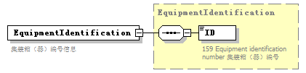
namespace | urn:Declaration:datamodel:standard:CN:[Name]:1
type | EquipmentIdentification
properties
  isRef | 0
  content | complex
children | ID
annotation
  documentation
  集装箱（器）编号信息

element TransportEquipment/CharacteristicCode
diagram | 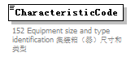
namespace | urn:Declaration:datamodel:standard:CN:[Name]:1
properties
  isRef | 0
annotation
  documentation
  152 Equipment size and type identification 集装箱（器）尺寸和类型

element TransportEquipment/FullnessCode
diagram | 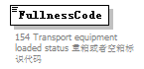
namespace | urn:Declaration:datamodel:standard:CN:[Name]:1
properties
  isRef | 0
annotation
  documentation
  154 Transport equipment loaded status 重箱或者空箱标识代码

element TransportEquipment/SealID
diagram | 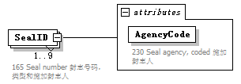
namespace | urn:Declaration:datamodel:standard:CN:[Name]:1
properties
  isRef | 0
  minOcc | 1
  maxOcc | 9
  content | complex
attributes
  Name | Type | Use | Default | Fixed | annotation
  AgencyCode |  | required
    documentation
    230 Seal agency, coded 施加封志人
annotation
  documentation
  165 Seal number 封志号码，类型和施加封志人

attribute TransportEquipment/SealID/@AgencyCode
properties
  isRef | 0
  use | required
annotation
  documentation
  230 Seal agency, coded 施加封志人

