### **Auto-Enrollment.**

**1]** Run **gpmc.msc** from a domain controller then Right click on root domain then click on **Create a GPO**.

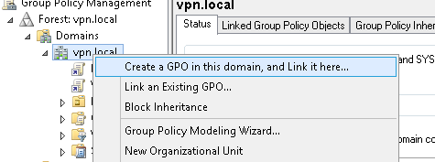

***2]*** *Enter name same as certificate template we created before* ***“VpnUsers”.***

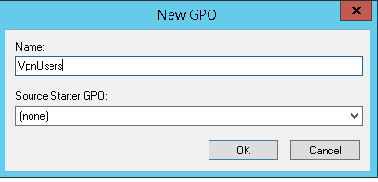

**3]** Edit the GPO and navigate to **User Configuration > Policies > Windows Settings > Public Key Services**. Edit **Certificate Services Client - Auto-Enrollment policy**. Set settings as below then click **OK**.

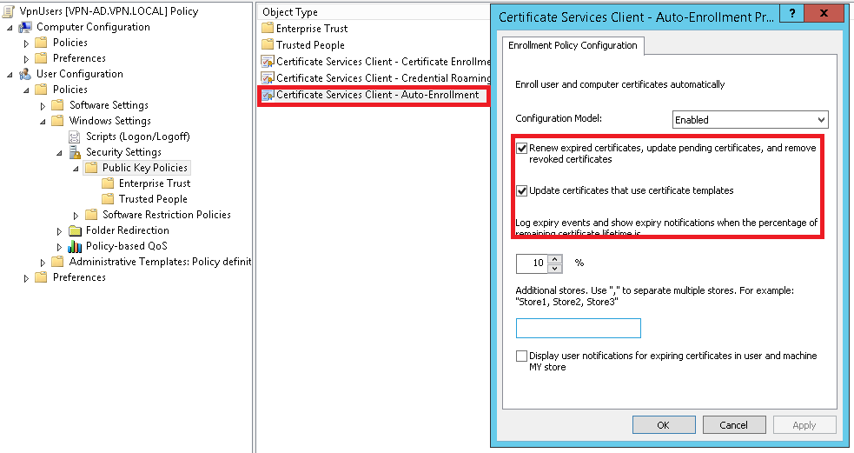

**4]** After this when user will get login on domain controller his/her AD certificate will get created automatically.

Note: run **gpupdate /force** from admin cmd to apply changed policies.