Practical 2A – Git Commands

- Create a project directory and change to that directory:
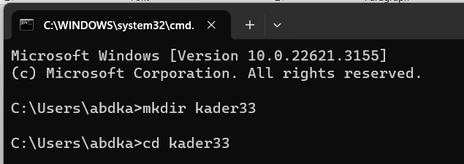

- Initialize the directory – git init

- git config
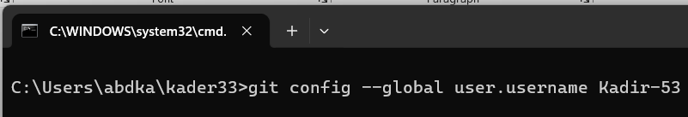

- git clone
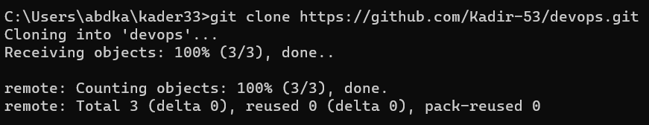

- git add
Created a txt file in that directory named test.txt and then type git add text.txt on the prompt
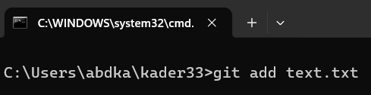
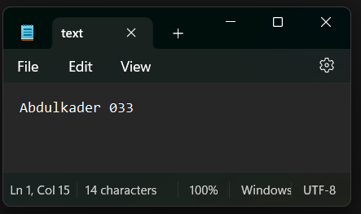

- git commit
After adding the file, we commit.
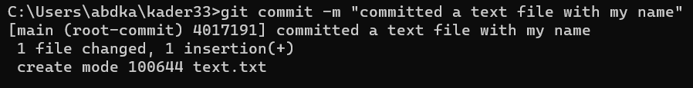

- git status
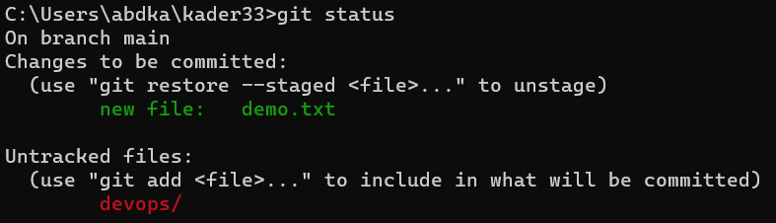

- git log
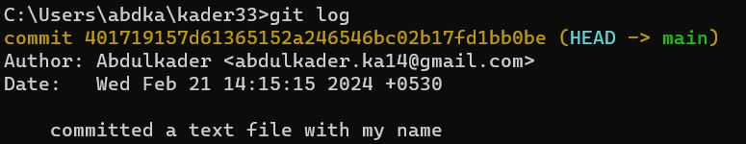

- git remote

Practical 2B – Perform Version Control System in Github.

- Change into the directory of the cloned repository.

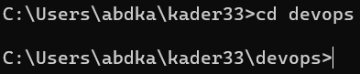

- To create a new branch to work on, we use the git branch command.

- Move to the newly created branch using the git checkout command.

- Make changes to files or add files in the local repository.

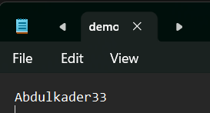

- Add your changes to the staging area.

- Commit your changes to the local repository with a commit message.

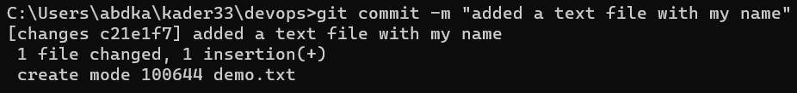

- Push your changes to the remote repository on GitHub using the git push command.

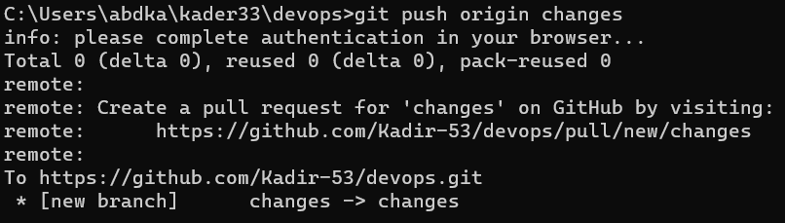

- If there are changes made to the remote repository by others, you can pull those changes to your local repository. We use the git pull command to pull the changes.

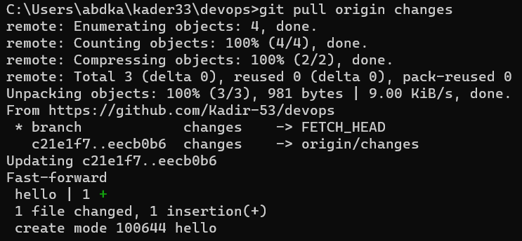

- Fetch updates from the remote repository without merging them into your local branches. We use the git fetch command for this.

- To merge branches, we use the git merge command. This command incorporates changes from the specified branch (changes) into your current branch.

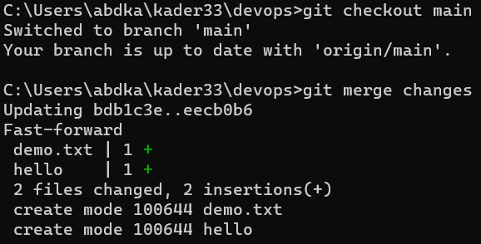

Practical 4 – Docker Commands.

- Docker images

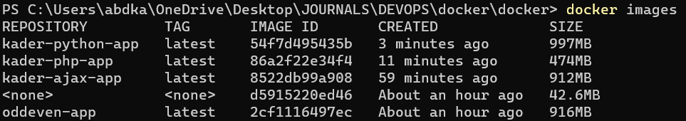

- docker search mysql

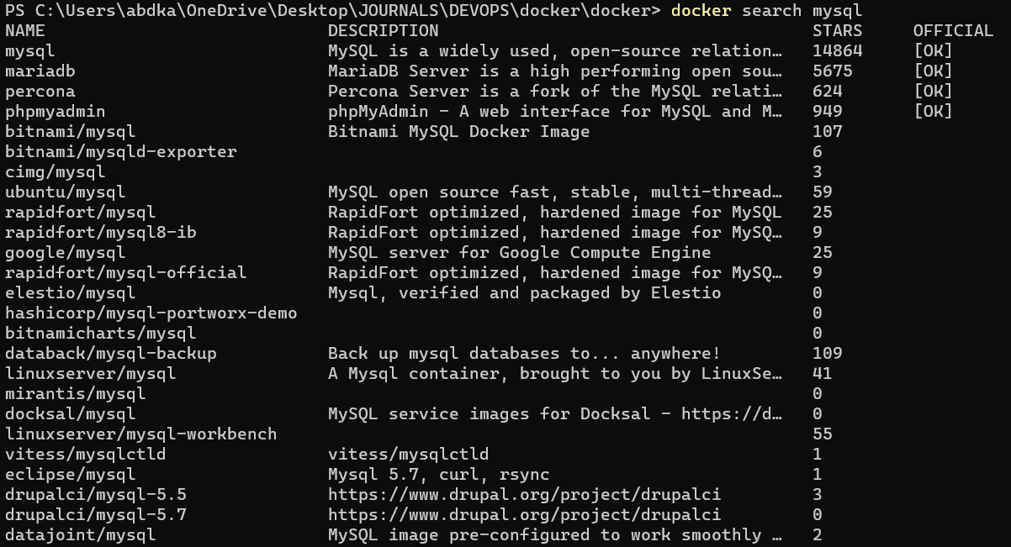

- docker pull arm64v8/alpine

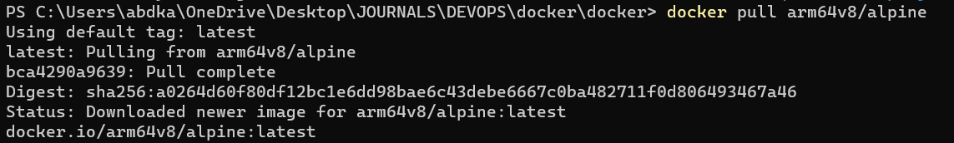

- docker ps

- docker stop <container id>

- docker restart <container name or id>

- docker run

- docker rm <container name or id>

- docker logs <container name or id>

Practical 9 – Kubernets Commands

- Start Minikube
Syntax: minikube start
Explanation: This command starts a local Kubernetes cluster using Minikube. Minikube is a tool that makes it easy to run Kubernetes clusters locally for development and testing purposes.

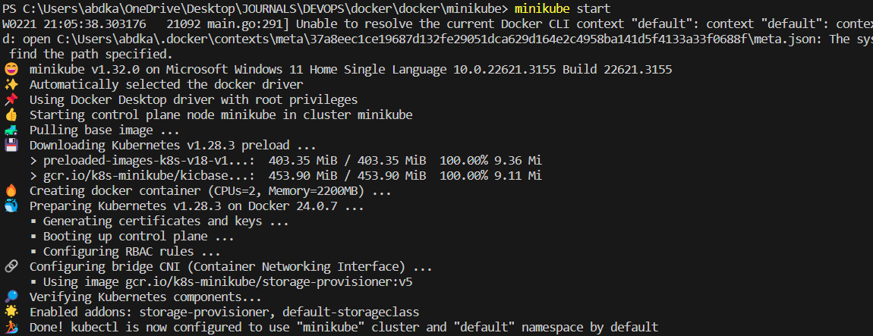

- Get Minikube Status
Syntax: minikube status
Explanation: Displays the current status of the Minikube cluster, including whether it is running.

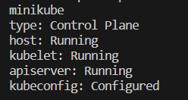

- kubectl get service
Syntax: kubectl get service [NAME] [-n NAMESPACE] [-o wide]
Example: kubectl get service my-service -n my-namespace
This command would retrieve information about the service named "my-service" in the namespace "my-namespace."

- Describe pods:
Syntax: kubectl describe pod
Explanation : Provides detailed information about a specific pod, including its containers, volumes, and events.

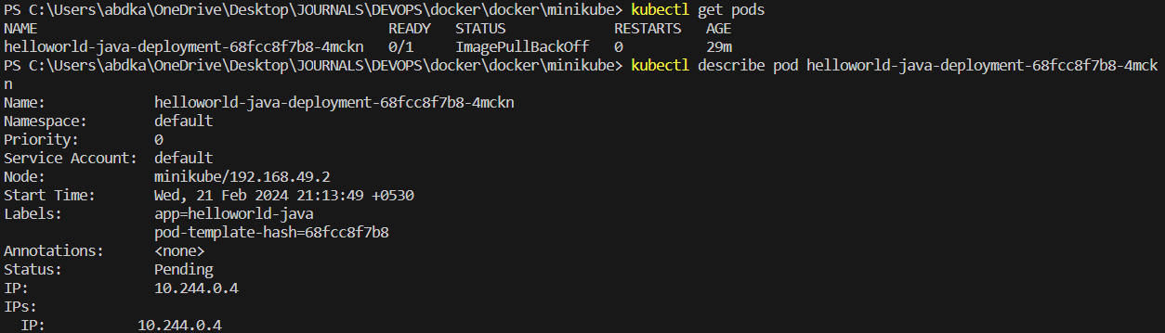

- Kubectl cluster info
Syntax: kubectl cluster info
Explanation: Provides detailed information cluster.

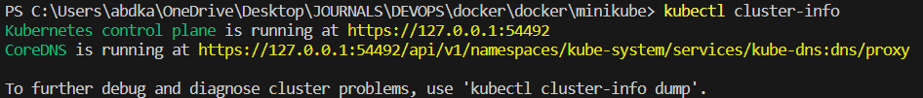

- Kubectl get all
Syntax: kubectl get all
Explanation: It will display all the pods which is currently running.

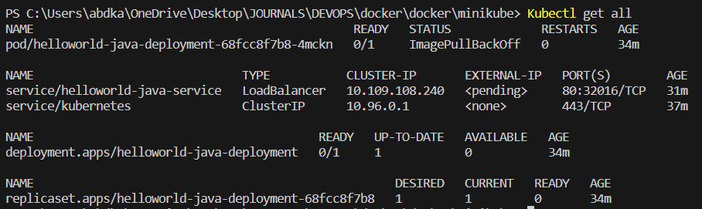

- Get Nodes:
Syntax: kubectl get nodes
Explanation: Lists the nodes in the Kubernetes cluster, along with their status.

- Stop Minikube
Syntax: minikube stop
Explanation: This command stops the running Minikube cluster.

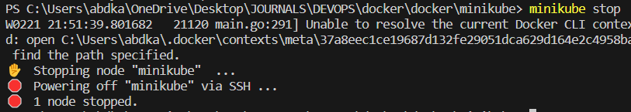

- Delete Minikube
Syntax: minikube delete
Explanation: This command deletes the Minikube cluster, removing all associated resources.
