Configure OSPF MD5 authentication and support SSH connections

2. Configure Router

Router 1
Router>en
Router#conf t
Router(config)#host r1
r1(config)#int g0/1
r1(config-if)# ip address 192.168.1.1 255.255.255.0
r1(config-if)#no shut
r1(config-if)#int s0/0/0
r1(config-if)#ip address 10.1.1.1 255.255.255.252
r1(config-if)#no shut

Router 2
Router>en
Router#conf t
Router(config)#host r2
r2(config)#int s0/0/0
r2(config-if)#ip address 10.1.1.2 255.255.255.252
r2(config-if)#no shut
r2(config-if)#int s0/0/1
r2(config-if)#ip address 10.2.2.2 255.255.255.252
r2(config-if)#no shut

Router 3
Router>en
Router#conf t
Router(config)#host r3
r3(config)#int g0/1
r3(config-if)#ip address 192.168.3.1 255.255.255.0
r3(config-if)#no shut
r3(config-if)#int s0/0/1
r3(config-if)#ip address 10.2.2.1 255.255.255.252
r3(config-if)#no shut

3. Configure OSPF

Router 1
r1(config)#router ospf 1
r1(config-router)#network 192.168.1.0 0.0.0.255 area 0
r1(config-router)#network 10.1.1.0 0.0.0.3 area 0
r1(config-router)#exit
r1(config)#exit
r1#sh ip route

Router 2
r2(config)#router ospf 1
r2(config-router)#network 10.1.1.0 0.0.0.3 area 0
r2(config-router)#network 10.2.2.0 0.0.0.3 area 0
r2(config-router)#exit
r2(config)#exit
r2#sh ip route

Router 3
r3(config)#router ospf 1
r3(config-router)#network 192.168.3.0 0.0.0.255 area 0
r3(config-router)#network 10.2.2.0 0.0.0.3 area 0
r3(config-router)#exit
r3(config)#exit
r3#sh ip route

4. Configure MD5 Authentication
Router 1
r1(config)#router ospf 1
r1(config-router)#int s0/0/0
r1(config-router)#ip ospf message-digest-key 1 md5 ty33
r1(config-router)#exit
r1(config)#do sh ip ospf int

Router 2
r2(config)#router ospf 1
r2(config-router)#int s0/0/0
r2(config-router)#ip ospf message-digest-key 1 md5 ty33
r2(config-router)#int s0/0/1
r2(config-router)#ip ospf message-digest-key 1 md5 ty33
r2(config-router)#exit
r2(config)#do sh ip ospf int

r3(config)#router ospf 1
r3(config-router)#int s0/0/1
r3(config-router)#ip ospf message-digest-key 1 md5 ty33
r3(config-router)#exit
r3(config)#do sh ip ospf int

5. Configure Router 3 to support SSH connections

Router 3
r3(config)#ip domain-name tyitsecurity.com
r3(config)#enable secret ty33

Exit the connections and enable the router again. It will ask for password, enter ty33, it will not be visible but the system will accept it. Once you press enter, it will take you to config mode of the router.

r3(config)#username admin123 privilege 15 secret ty33
r3(config)#line vty 0 4
r3(config-line)#login local
r3(config-line)#transport input ssh
r3(config-line)#exit
r3(config)#crypto key generate rsa
How many bits in the modulus? 1024
r3(config)#do sh ip ssh

Check results
Open Command Prompt of PC – C.
Enter telnet 192.168.3.1, the connection will open. Enter ssh -l admin123 192.168.3.1
Password will be asked type ty23 which will not be visible but will be accepted by the system. Router 3 configuration is now accessible from PC – C

Configure AAA authentication on routers.

2. Configure Router

Router 1
Router>en
Router#conf t
Router(config)#host r1
r1(config)#int g0/1
r1(config-if)# ip address 192.168.1.1 255.255.255.0
r1(config-if)#no shut
r1(config-if)#int s0/0/0
r1(config-if)#ip address 10.1.1.2 255.255.255.252
r1(config-if)#no shut

Router 2
Router>en
Router#conf t
Router(config)#host r2
r2(config)#int g0/0
r2(config-if)#ip address 192.168.2.1 255.255.255.0
r2(config-if)#no shut
r2(config-if)#int s0/0/0
r2(config-if)#ip address 10.1.1.1 255.255.255.252
r2(config-if)#no shut
r2(config-if)#int s0/0/1
r2(config-if)#ip address 10.2.2.1 255.255.255.252
r2(config-if)#no shut

Router 3
Router>en
Router#conf t
Router(config)#host r3
r3(config)#int g0/1
r3(config-if)#ip address 192.168.3.1 255.255.255.0
r3(config-if)#no shut
r3(config-if)#int s0/0/1
r3(config-if)#ip address 10.2.2.2 255.255.255.252
r3(config-if)#no shut

3. Configure RIP on routers

Router 1
r1(config)#router rip
r1(config-router)#network 192.168.1.0
r1(config-router)#network 10.1.1.0
r1(config-router)#exit
r1>sh ip route
Router 2
r2(config)#router rip
r2(config-router)#network 10.1.1.0
r2(config-router)#network 192.168.2.0
r2(config-router)#network 10.2.2.0
r2(config-router)#exit
r2>sh ip route

Router 3
r3(config)#router rip
r3(config-router)#network 192.168.3.0
r3(config-router)#network 10.2.2.0
r3(config-router)#exit
r3>sh ip route

4. Configure local AAA authentication on Router 1

Router 1
r1>en
r1#conf t
r1(config)#username admin123 secret ty33
r1(config)#aaa new-model
r1(config)#aaa authentication login default local
r1(config)#line console 0
r1(config-line)#login authentication default
Username is admin123 and password is ty33.

5. Configure local AAA authentication for vty lines on Router 1
From security.com it is

Router 1
r1>en
r1#conf t
r1(config)#ip domain-name security.com
r1(config)#crypto key generate rsa
How many bits in the modulus will be asked, enter 1024.
r1(config)#aaa authentication login SSH-LOGIN local
r1(config)#line vty 0 4
r1(config-line)#login authentication SSH-LOGIN
r1(config-line)#transport input ssh
r1(config-line)#exit

Go to PC – A Command Prompt and enter ssh -l admin123 192.168.1.1. It will ask for password, enter ty33.

6. Configure service-based AAA authentication using TACACS+ on Router 2
Go to services of TACACS+ Server and then select AAA. Switch on the service and enter the client IP and password. Setup username and password as well.
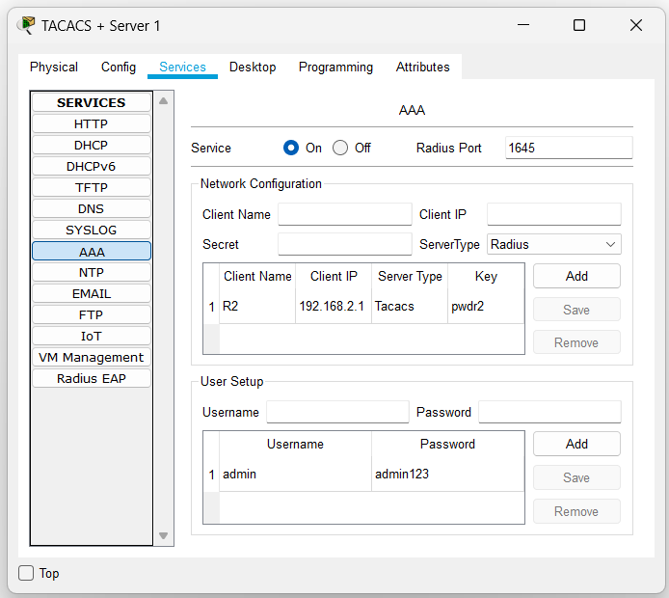
Router 2
r2>en
r2#conf t
r2(config)#username admin secret admin123
r2(config)#tacacs-server host 192.168.2.2
r2(config)#tacacs-server key pwdr2
r2(config)#aaa new-model
r2(config)#aaa authentication login default group tacacs+ local
r2(config)#line console 0
r2(config-line)#login authentication default
User Access Verification is asked enter the credentials of the TACACS+ Server.
Username is admin and password is admin123 which is also the username and password set for TACACS Server.

7. Configure server-based AAA authentication using RADIUS on Router 3
Go to services of RADIUS Server and then select AAA. Switch on the service and enter the client IP and
password. Setup username and password as well.

Router 3
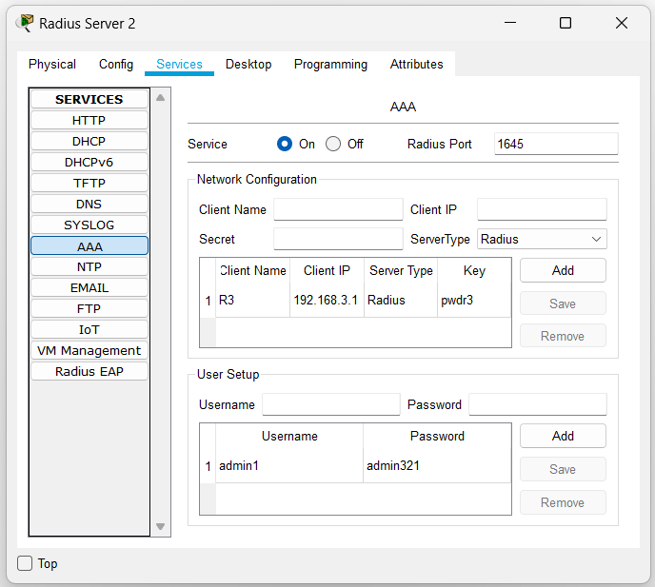
r3>en
r3#conf t
r3(config)#username admin1 secret admin321
r3(config)#radius-server host 192.168.3.2
r3(config)#radius-server key pwdr3
r3(config)#aaa new-model
r3(config)#aaa authentication login default group radius local
r3(config)#line console 0
r3(config-line)#login authentication default
User Access Verification is asked enter the credentials of the RADIUS Server.
Username is admin1 and password is admin321 which is also set in radius server.

Configure a Zone-Based Policy Firewall (ZPF)

B) Configure Router
Router 1
Router>en
Router#conf t
Router(config)#host r1
r1(config)#int g0/1
r1(config-if)# ip address 192.168.1.1 255.255.255.0
r1(config-if)#no shut
r1(config-if)#int s0/0/0
r1(config-if)#ip address 10.1.1.1 255.255.255.252
r1(config-if)#no shut

Router 2
Router>en
Router#conf t
Router(config)#host r2
r2(config)#int s0/0/0
r2(config-if)#ip address 10.1.1.2 255.255.255.252
r2(config-if)#no shut
r2(config-if)#int s0/0/1
r2(config-if)#ip address 10.2.2.2 255.255.255.252
r2(config-if)#no shut

Router 3
Router>en
Router#conf t
Router(config)#host r3
r3(config)#int g0/1
r3(config-if)#ip address 192.168.3.1 255.255.255.0
r3(config-if)#no shut
r3(config-if)#int s0/0/1
r3(config-if)#ip address 10.2.2.1 255.255.255.252
r3(config-if)#no shut

C) Configure Static Routing
Go to Config of Router 1 → Static under Routing and add
the details that are
Network: 0.0.0.0
Mask: 0.0.0.0
Next Hop: 10.1.1.2
r1#show ip route

Router 2
Network: 192.168. 1.0
Mask: 255.255.255.0
Next Hop: 10.1.1.1
Network: 192.168.3.0
Mask: 255.255.255.0
Next Hop: 10.2.2.1
r2#show ip route

Router 3
Network: 0.0.0.0
Mask: 0.0.0.0
Next Hop: 10.2.2.2
r3#show ip route

D) Password Authentication of Router
Router 1
r1(config)#enable secret ty23
r1(config)#line console 0
r1(config-line)#password ty23
r1(config-line)#login
r1(config-line)#exit

Exit from the connection. Under User Access Verification password is asked, enter ty23, it will not be seen but the system will accept it. Connection to the router will open again.

Router 1
r1#conf t
r1(config)#username admin1 secret admin123
r1(config)#aaa new-model
r1(config)#aaa authentication login default local
r1(config)#line console 0
r1(config-line)#login authentication default
r1(config-line)#end

End the connection completely. Again, User Access Verification will come, enter Username as admin1and Password as admin123. After enabling the router if again a password is asked enter ty23.

Router 1
r1(config)#ip domain-name security.com
r1(config)#crypto key generate rsa
How many bits in the modulus will be asked, enter
1024.
r1(config)#aaa authentication login sshlogin local
r1(config)#line vty 0 4
r1(config-line)#login authentication sshlogin
r1(config-line)#transport input ssh
r1(config-line)#end

E) Enable security technology package on Router3
Router 3
r3(config)#license boot module c1900 technology-package securityk9
Accept the agreement by typing yes.
r3#reload
Confirm the reload.
r3#show version

F) Create firewall zone on Router3
r3(config)#zone security IN-ZONE
r3(config-sec-zone)#exit
r3(config)#zone security OUT-ZONE
r3(config-sec-zone)#exit

G) Identify traffic using a class-map
r3(config)# access-list 101 permit ip
192.168.3.0 0.0.0.255 any
r3(config)# class-map type inspect match-all IN-NET-CLASS-MAP
r3(config-cmap)# match access-group 101
r3(config-cmap)# exit

H) Firewall policies
r3(config)# policy-map type inspect IN-2-OUT-PMAP
r3(config-pmap)# class type inspect IN-NET-CLASS-MAP
r3(config-pmap-c)# inspect
r3(config-pmap-c)# exit
r3(config-pmap)# exit
r3(config)# zone-pair security IN-2-OUT-ZPAIR source IN-ZONE destination OUTZONE
r3(config-sec-zone-pair)# service-policy type inspect IN-2-OUT-PMAP
r3(config-sec-zone-pair)# exit
r3(config)# interface g0/1
r3(config-if)# zone-member security IN-ZONE
r3(config-if)# exit
r3(config)# interface s0/0/1
r3(config-if)# zone-member security OUT-ZONE
r3(config-if)# exit

I) Test firewall functionality from IN-ZONE to OUT- ZONE
Open Command Prompt of PC – C and ping 192.168.1.3 that is PC – A (Server). It should be successful.

In CLI mode of Router 3 type,
r3#show policy-map type inspect zone-pair sessions The details regarding the policy should be displayed.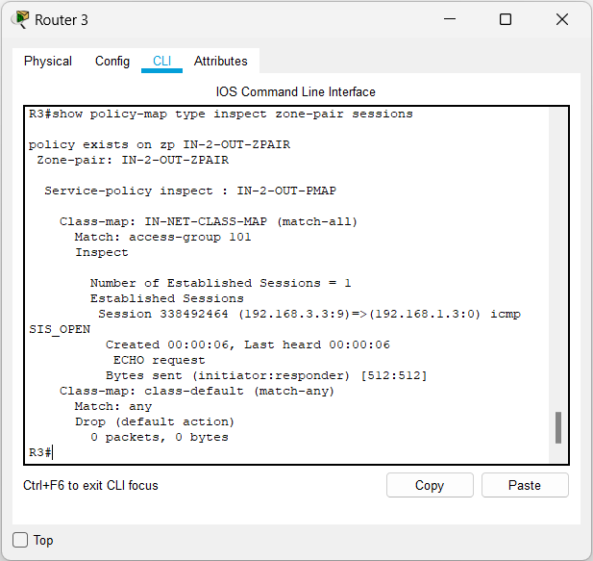

Go to Web Browser of PC - C enter
http://192.168.1.3 and click on Go, Cisco Packet Tracer page will be displayed.
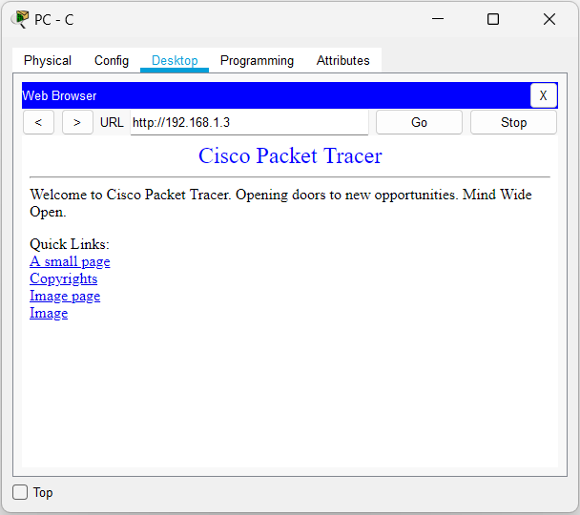
- Test firewall functionality from OUT-ZONE to IN-ZONE

Open Command Prompt of PC – A and ping 192.168.3.3 that is PC – C. It should fail.

