1. Login to MySQL Administrator as the user steve/st3v3 or root

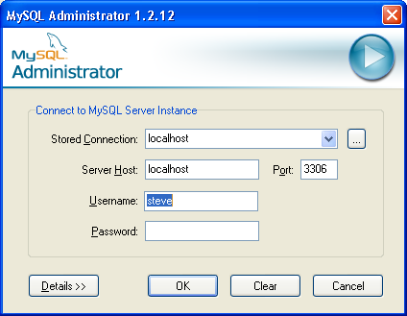

2. Create the catalog “jade” with MySQL Administrator.

Select the “Catalogs” icon → Right mouse click on the lower left panel → Select “Create New Schema”

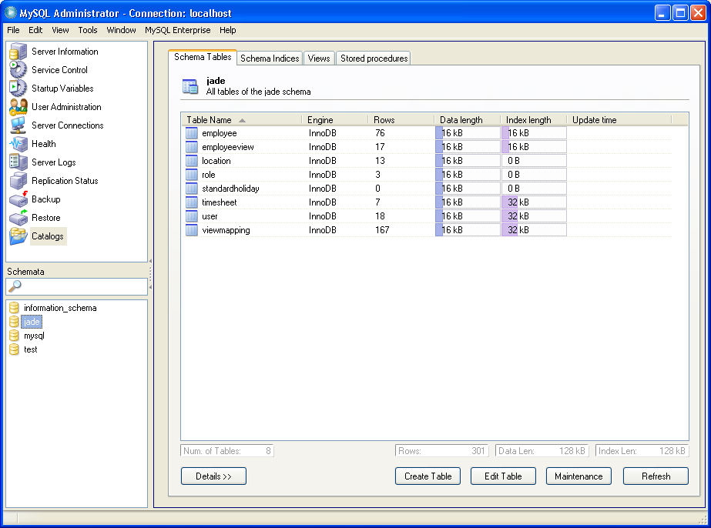

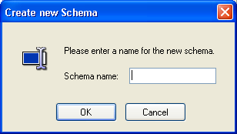

Enter the name “jade” and click the OK button

3. logon to MySQL Query Browser

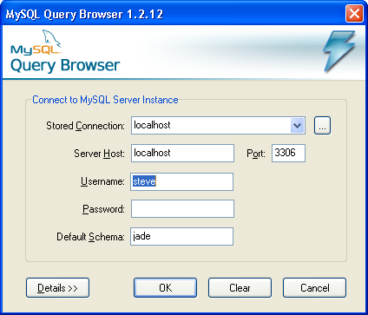

4. (Optional) Drop existing tables, only do this if the tables is already exist
Select File→ Open script … → Select the file “dropTimesheetSchema.sql”
Once the file is opened, click on the “Execute” button on the top right corner to execute the sql script:

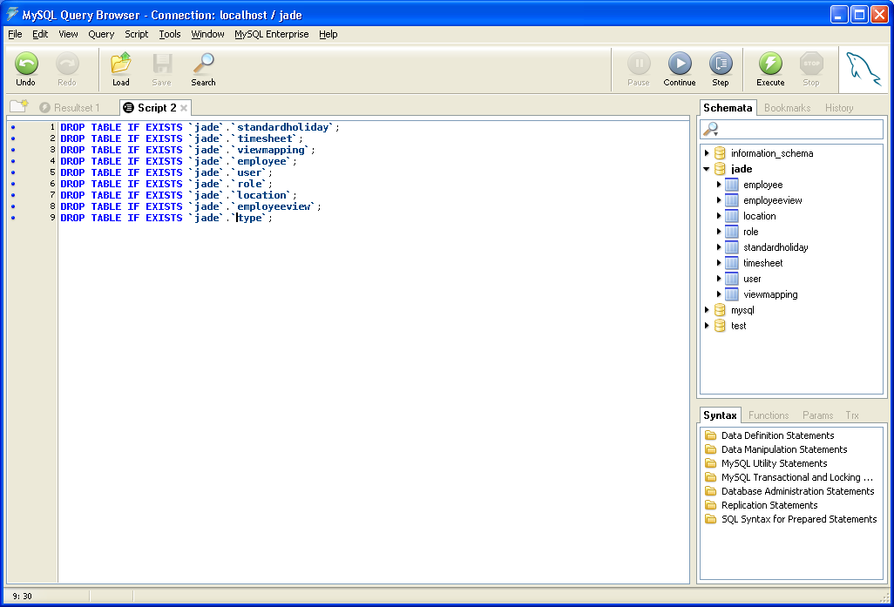

5. Create the schema (tables) for the Timesheet Application
Select File→ Open script … → Select the file “createTimesheetSchema.sql”

Once the file is opened, click on the “Execute” button on the top right corner

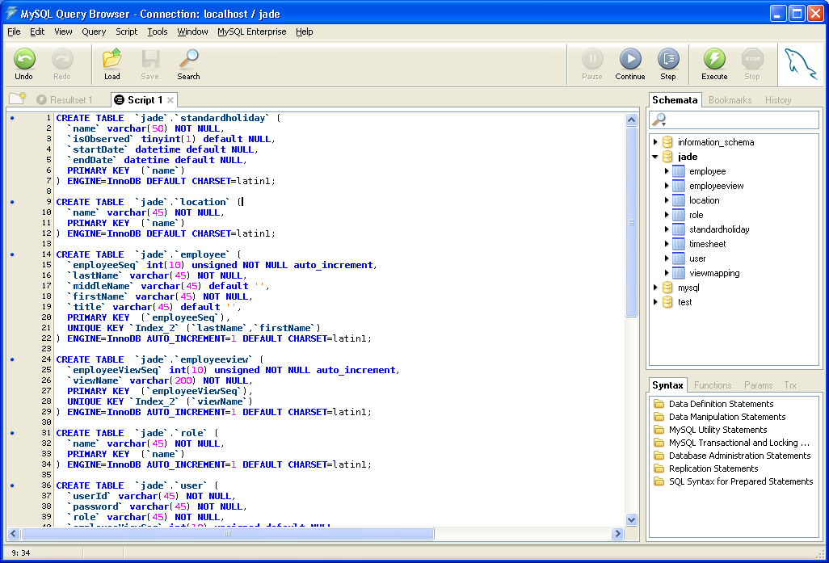

Once the schema is created, you will see it on the right panel

6. Loading employee data
Select File→ Open script … → Select the file “bhrData.sql”

Once the file is opened, click on the “Execute” button on the top right corner

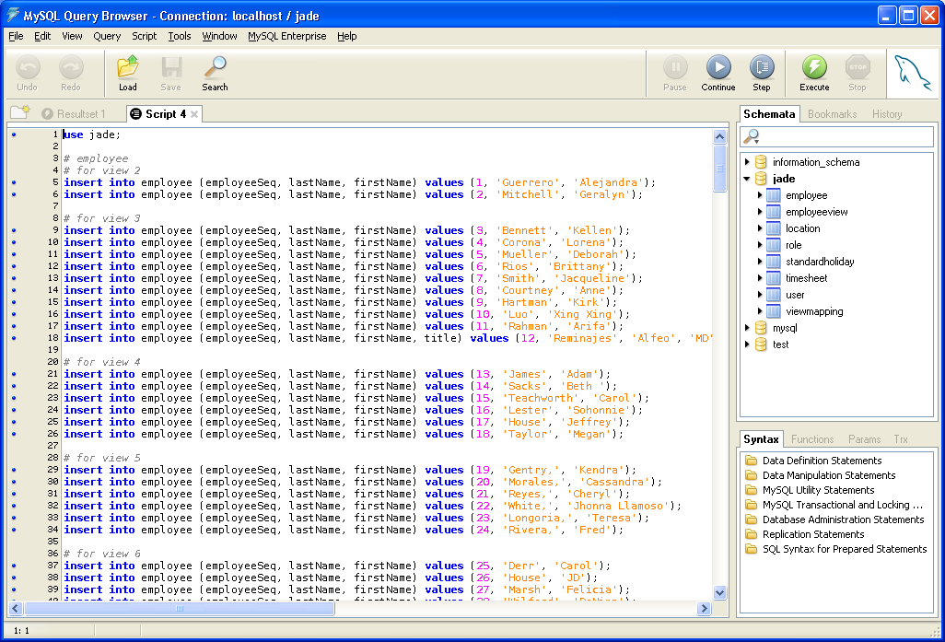

7. Check the data
You can execute the following query to check if the data is there:
SELECT * FROM employee

