ISE 311 Engineering Economic Analysis HW-2

1. For Gee-Whiz Devices, calculate the following:

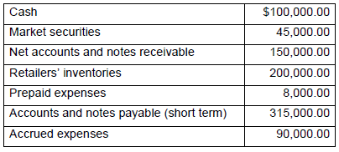

1. Working capital

* Current assets = cash + market securities + receivables + inventories

= 100000 + 45000+ 150000 + 200000

= 495000

Current liabilities = expenses + notes + payable accounts

= 8000 + 315000 + 90000

= 413000

Working Capital = Current assets – Current liabilities

= 495000 – 413000

= 82000

1. Current ratio

* current ratio = current assets / current liabilities

= 495000 / 413000

= 1.199

1. Acid-test ratio

* Acid-test ratio = quick assets / current liabilities

= (current assets – inventories) / current liabilities

= 295000 / 413000

= .714

1. Explain the accounting function within a firm. What does this function do, and why is it important?

The primary purpose of accounting function within a firm is to record analyze and report business transaction. Accounting function also finds, synthesizes, summarizes, and analyzes data. Most accounting is done in nominal or stable dollars. Accounting function provides data for general accounting and cost accounting. Accounting function is important because it help track financial information for business functions.

1. The general ledger of the Fly-Buy-Nite (FBN) Engineering Company contained the following account balances. Construct an income statement.

d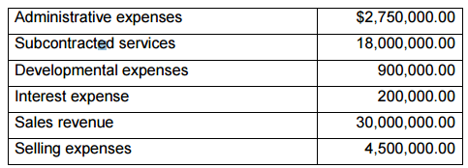

* 1. What is the net income before taxes?

Net income = total revenues - total expenses

= 30000000 – ( 18000000 + 2750000 + 900000 + 200000 + 4500000 )

= 30000000 – 26350000

= 3650000

* 1. What is the net profit after taxes when FBN has a 27% tax rate.

Net profit = 3650000 - (3650000 \* .27) = 2664500

1. RLW-II Enterprises estimated that indirect manufacturing costs for the year would be $60 million and that 12,000 machine hours would be used.
   1. Compute the predetermined indirect cost application rate using machine hours as the burden vehicle.

predetermined indirect cost application rate = indirect manufacturing costs / machine hours = 60000000 / 12000 = $5000 per direct machine hour

* 1. Determine the total cost of production for a product with direct material costs of $1 million, direct labor cost for $600,000 and 200 machine hours (remember to use the calculations from above).

Total cost of production = material cost + labor cost + machine hours cost

= 1000000 + 600000 + 200 \* 5000

= $ 2600000