**NUI Galway**

**Programming and Tools for AI (CT5132/CT5148)**

|  |  |
| --- | --- |
| **Student Name** | **Student ID** |
| Preeti Jagdish Sajjan | 19232625 |
| Sampritha Hassan Manjunath | 19232922 |
| Swati. | 19233301 |

**List of tasks:**

1. 25d8a9c8.json
2. 2dee498d.json
3. d631b094.json
4. 8be77c9e.json
5. 3ac3eb23.json
6. d10ecb37.json

**GitHub Link:** [**https://github.com/samprithahm/ARC.git**](https://github.com/samprithahm/ARC.git)

|  |
| --- |
| **Task Description:** |

**Task 1:** **25d8a9c8.json**

<img> Input output

The task takes the input of 3*3 grid with random colors filling in. The output of this task is a 3*3 grid with gray and black colors where a row is colored gray only if all the three consecutive boxes in a row of input grid are of same color else will be colored black.

The solve method carries out the bellow steps:

* Check if all the boxes in a row have same color.
* If true then fill the row with gray color in output grid else color it black.
* Iterate the above logic over the rows

A statement:

if(solution == train_output):

print("Training Data Verified!!!")

if(solution == test_output):

print("Testing Data Verified!!!")

**Task 2:** **2dee498d.json**

<img> Input output

The task takes the input of m*n grid. The output of this task is a grid of (m*(n/3)) which is (1/3)rd of the input.

The solve method carries out the bellow steps:

* Divide the input grip by 3
* Assign the first (1/3)rd. division to output grid

A statement:

if(solution == train_output):

print("Training Data Verified!!!")

if(solution == test_output):

print("Testing Data Verified!!!")

**Task 3:** **d631b094.json**

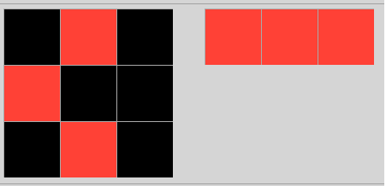

The task takes the input of m*n grid. The output of this task is a grid of m

The solve method carries out the bellow steps:

* The input grid is parsed through for non-zero numbers.
* Each non-zero element in the list is added to the output
* The output contains all the non-zero elements in the input

A statement:

* From Training set, tested with 00d62c1b.json, 0d3d703e.json and 1e0a9b12.json and verified successfully
* From Evaluation set, tested with 0a2355a6.json, 0b17323b.json and 0bb8deee.json and verified successfully.

**Task 4:** **8be77c9e.json**

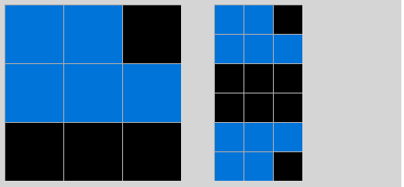

The task takes the input of m*n grid. The output of this task is a grid of ((2*m) *n)

The solve method carries out the bellow steps:

* Input matrix is reversed and stored in separate list
* The original Input and the reversed input are appended together to get the output

A statement:

* From Training set, tested with 1b2d62fb.json, 3aa6fb7a.json and 3bd67248.json and verified successfully
* From Evaluation set, tested with 0f63c0b9.json, 1c0d0a4b.json and 2a5f8217.json and verified successfully.

**Task 5:** **3ac3eb23.json**

<img> Input output

(Verbal Description)

(Method Description)

(A Statement)

**Task 6:** **d10ecb37.json**

<img> Input output

(Verbal Description)

(Method Description)

(A Statement)

**Summary:**

**<Yet to Write>**

**Contributions:**

|  |  |  |
| --- | --- | --- |
| Sl. No | Name | Contribution |
| 1 | **Preeti Jagadish Sajjan** | 1. Tasks:   25d8a9c8.json  2dee498d.json   1. Report Template creation 2. Writing summary of each of above-mentioned task |
| 2 | **Sampritha Hassan Manjunath** | 1. Tasks:   d631b094.json  8be77c9e.json   1. GitHub and common utilities creation 2. Writing summary of each of above-mentioned task |
| 3 | **Swati** | 1. Tasks:   d631b094.json  8be77c9e.json   1. Readme.md 2. Writing summary of each of above-mentioned task |