8일차 실습 과제

조민주

2020 5 22

library( dplyr )

##   
## Attaching package: 'dplyr'

## The following objects are masked from 'package:stats':  
##   
## filter, lag

## The following objects are masked from 'package:base':  
##   
## intersect, setdiff, setequal, union

library( ggplot2 )

# 문제 1

ggplot( data = mtcars, aes( x = gear ) ) +  
 geom_bar() +  
 labs( x = "기어의 수", y = "빈도수" )

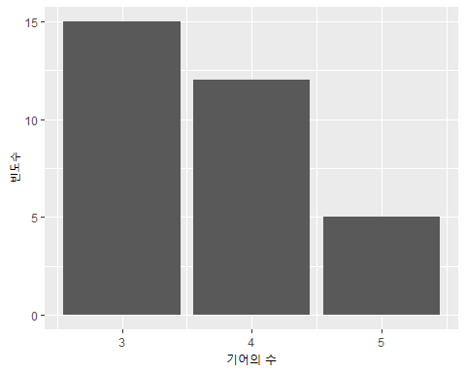

# 문제 2

ggplot( data = mtcars, aes( x = cyl ) ) +  
 geom_bar( fill = "green" )

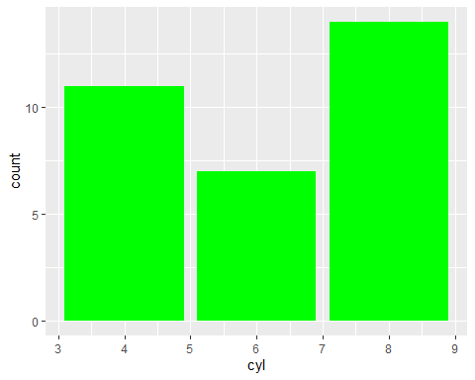

# 문제 3

ggplot( mtcars, aes( mpg ) ) +  
 geom_histogram( binwidth = 5.0 )

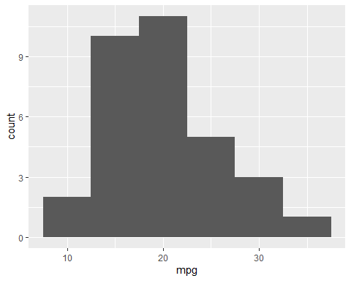

# 문제 4

ggplot( trees, aes( x = Girth ) ) +  
 geom_histogram( binwidth = 3.0, fill = "steelblue" ) +  
 ggtitle( "나무 둘레" ) +  
 labs( x = "나무 둘레")

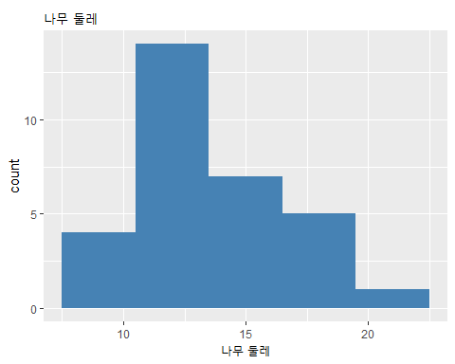

# 문제 5

ggplot( data = mtcars, aes( x = mpg,  
 y = wt,  
 color = gear ) ) +  
 geom_point()

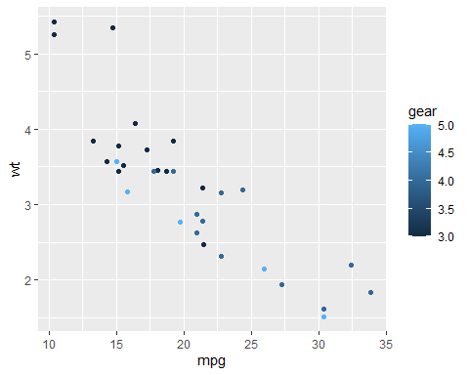

# 문제 6

ggplot( mtcars, aes( y = mpg, fill = cyl ) ) +  
 geom_boxplot()

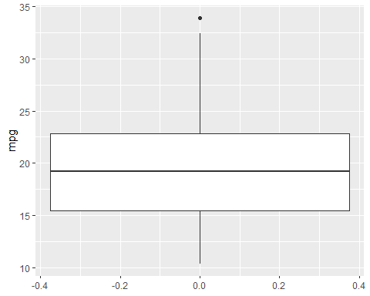

# 문제 7

year <- 2015:2026  
pop <- c( 51014, 51245, 51446, 51635, 51811, 51973,   
 52123, 52261, 52388, 52504, 52609, 52704 )  
df <- data.frame( year, pop )  
  
ggplot( df, aes( x = year, y = pop ) ) +  
 geom_line()

