COMP6039 Design Exercise
Table of Contents
1. Introduction 3
2. Limitations & Assumptions 3
2.1. Limitations: 3
2.2 Assumptions 3
3. Network Topology & Design 4
3.1. Topology: 4
4. IP Addressing & VLAN Configuration 5
4.1. VLAN Assignment: 5
4.2. Segmentation Justification: 5
4.3. Inter-VLAN routing: 5
5. Wireless LAN & BYOD Configuration 6
5.1. Wireless Architecture 6
5.2. BYOD & Guest VLAN 6
5.3. Security & Coverage: 6
6. Layer 2 Security 7
6.1. Port Security: 7
5.2. Spanning Tree Configuration: 7
6.3. PortFast & BPDU Guard: 7
6.4. Port States: 7
6.5. Native VLAN: 7
7. Routing & Internet Access 8
7.1. Internal Routing: 8
7.2. External Routing, OSPF & NAT : 8
7.3. Redundancy 8
8. Design Justifications 9
8.1. Device Choices: 9
8.2. Protocol Choices: 9
9. Future Scalability: 10
9.1. Performance Considerations: 10
9.2. Cost Considerations: 10
10. Packet Tracer Implementation 11
10.1. Commands Used: 11
11. Test Screenshots: 12
11.1. Ping Tests: 12
11.2. Device Configurations 13
12. Conclusion 14
References 15
Appendix 16
Appendix A – GitHub Repo: 16
Appendix B – Wireless Configuration: 16

1. Introduction
This report details the design and implementation of a medium-sized manufacturer with 200 staff members distributed across six departments, on a single site. The network has been designed to facilitate wireless connectivity with BYOD (Bring-Your-Own-Devices), ensure Layer 2 security, provide external internet access, enable inter-VLAN (Virtual LAN) routing and maintain overall network integrity.
The design adopts a three-layer hierarchical architecture following Cisco practices, with an implementation inside of Packet Tracer (See Appendix A). The design supports current operations, with capacity for future expansion via VLSM (Variable Length Subnet Masking) to optimise space utilisation across department VLANs.

2. Limitations & Assumptions

2.1. Limitations:
- Packet Tracer did not fully support WLC (Wireless LAN Controller) for BYOD connectivity, wireless access points (APs) are simulated with provided configurations (See Appendix B).
- WAN optimisation past OSPF and NAT are not implemented due to single-site operation.
- Advanced security features (IDS/IPS) are conceptualised but not implemented.
- OSPF is simplified to area 0 without advanced features.
- End devices simulated with 1-2 per department, one WLC and AP for demonstration.
2.2 Assumptions:
- Each department operates in one building with one switch.
- Wired connection for all users, wireless supplements rather than replaces.
- Expansion limited to 1000-1200 staff, justifying VLSM allocation.
- BYOD devices trusted after authentication; advanced endpoint management is not implemented.
- Management VLAN segregates sensitive data traffic; Native VLAN is used for untagged 801.2Q traffic.

3. Network Topology & Design

3.1. Topology:
The topology follows a hierarchical three-layer architecture composed of specific distinct layers:
- Core Layer:
  - Two multilayer switches (CSW-1 & CSW-2) for the redundant core., interconnected via EtherChannel Port-Channel 1 using LACP for external vendor support, providing fault tolerance.
  - Deployed HSRP, a Cisco Proprietary protocol for first-hop IP redundancy (Cisco, 2022). CSW-1 is the active gateway with priority 110, and CSW-2 is on standby with priority 100.
  - Both host SVIs for the eight departmental VLANS to enable inter-VLAN routing. Active router IP used as the default gateway.
- Distribution Layer:
  - Six distribution switches (DSW-1 to DSW-6), one per department, aggregating Layer 2 traffic. Each switch connects to both core multilayer switches using trunk links, providing redundancy.
  - All switches are configured with RSTP (Rapid Spanning Tree Protocol) to eliminate Layer 2 loops.
  - Distribution switches have management VLANs (10.0.99.11 – 10.0.99.16) to carry sensitive traffic (SSH, Telnet etc.), and a common default gateway for the current active virtual router (10.0.99.254).
- Access Layer:
  - Six departmental access switches per building, they connect end devices to the network.
  - Access ports use BPDU (Bridge-Protocol-Data-Unit) Guard and PortFast to disable STP reconvergence by skipping to the forward state (Tamang, 2023) and immediately forward traffic.
- External Connectivity:
  - Two WAN routers (R1-WAN & R2-WAN) provide redundant internet connectivity, OSPF for better load balancing, and NAT (Network-Address-Translation) to mask the private network from public. These are connected to the core.
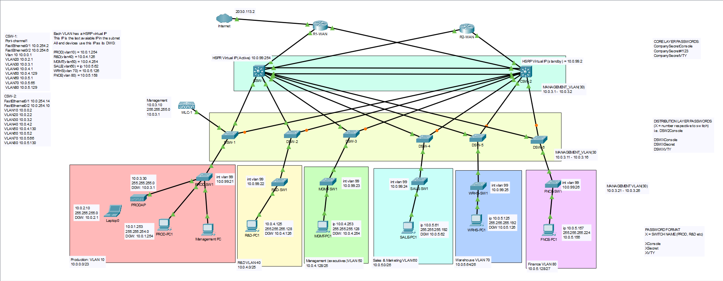
Figure 1: Topology

4. IP Addressing & VLAN Configuration

4.1. VLAN Assignment:
The table corresponds to the VLAN configuration (produced via VLSM) for each department, utilising a 10.0.0.0/16 private network:
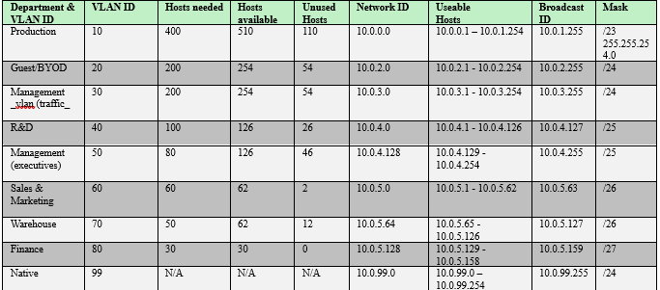
Figure 2: VLAN Assignment

4.2. Segmentation Justification:
The subnets were assigned with the current staff and future expansions in mind.:
- Production supports /23 hosts (400) to support 100 hosts and BYOD growth.
- R&D supports /25 hosts (100) as research grows exponentially with new projects.
- Management (executives) get /25 hosts (80), it’s a stable department.
- Sales & Marketing, and Warehouse support /26 hosts (60).
- Finance receives /27 hosts (30), reflecting its small, stable nature.
- Management VLAN (30) receives /24 hosts (200) to carry secure SSH/Telnet traffic.
- Native VLAN (99) handles untagged 801.2Q frames.
Core switches use .1 - .2 addresses, distribution uses .11/ - 16 and access switches use .21 - .26.
Lastly, a voice VLAN is not configured in this network, however if required, a small VLSM recalculation from 10.0.5.159/27 is needed and implemented on switches.

4.3. Inter-VLAN routing:
Inter-VLAN is performed via the two core multilayer switches, with allocated host SVIs for all VLANs. The HSRP configuration ensures all traffic is directed through CSW-1 by default, due to its HSRP priority; with automatic failover via CSW-2. All distribution layer switches utilise 10.0.99.254 as the virtual default gateway, whereas access layer switches use their directly connected distribution switch (i.e. PROD-SW1: 10.0.99.1) as their default gateway. This ensures a deterministic forwarding path while providing redundancy at the default gateway.

5. Wireless LAN & BYOD Configuration
5.1. Wireless Architecture:
A main WLC is deployed on the distribution layer to manage enterprise network AP connectivity. Various APs are deployed within departments to provide wireless access in each building; the department production demonstrates this approach. However, with scalability, multiple inter-connected WLCs should be deployed for better management.
5.2. BYOD & Guest VLAN:
Guests and BYOD devices are segmented to VLAN 20, ensuring security policies and traffic isolation from common attacks. Within production, this VLAN operates behind a closed wireless SSID with WPA2-Personal authentication using local authentication credentials. Furthermore, NAC (Network Access Control) policies may be implemented upon expansion to guarantee non-compliant devices before granting authorization.
Lastly, the VLAN 20 accommodates additional 254 useable addresses, excluding the BYOD address space allocated within each individual departmental VLAN.

5.3. Security & Coverage:
Wireless SSIDs should segmented per department and must be managed via various WLCs for security and bandwidth management. Guest networks are further isolated with internet-only access to prevent access to sensitive data in departments. APs are configured with strong AES-256 encryption with MAC filtering.

6. Layer 2 Security

6.1. Port Security:
Each access port is limited to a maximum of two MAC addresses using the sticky learn method. If a port violates this policy, it enters restrict mode, dropping any incoming frames and generating auditing logs without disabling the port. This permits administrators to monitor potentially malicious traffic without affecting network operations.
Sticky-learn learns to record MAC addresses into a switches running-configuration, providing persistence if it fails allowing immediate recovery with no data loss.

5.2. Spanning Tree Configuration:
RSTP is enabled on all switches globally to eliminate Layer 2 loops. CSW-1 is configured as the root bridge for all VLANs, providing priority 0. This design choice simplifies network traffic and provides optimal paths, where if CSW-1 fails, CSW-2 successfully takes over as the root bridge and automatically recalculates STP in the network.

6.3. PortFast & BPDU Guard:
All access switch end-ports have configured PortFast, enabling traffic to immediately pass without forcing a 30-50 second delay, eliminating RSTP convergence. Furthermore, BPDU Guard blocks end-users from receiving BPDUs, eliminating the possibility of connecting rogue switches and APs.

6.4. Port States:
All unused ports were administratively disabled to prevent unauthorized device connectivity. Port security violations on unused ports would automatically be error disabled regardless.

6.5. Native VLAN:
Untagged 801.2Q data automatically passes through VLAN 99, ensuring untagged frames are handled accordingly, eliminating threats like VLAN double-tagging.

7. Routing & Internet Access

7.1. Internal Routing:
CSW-1 handles inter-VLAN routing, performing both dynamic switching and routing via associated SVIs. Traffic between departments follow the most direct path to the core layer, with failover to CSW-2 performing the same operations if the primary multilayer switch encounters an error.

7.2. External Routing, OSPF & NAT :
Both WAN (Wide-Area-Network) routers (R1-WAN & R2-WAN) provide redundant internet-connectivity via connections to an ISP. The routers advertise the internal network range (10.0.254.0/22, summarising all departmental subnets) via OSPF to ensure returned traffic is distributed across both routers.
OSPF Area 0 is used as the backbone of the network, with router ID’s set to 1.1.1.1 and 2.2.2.2 respectively. Both routers use NAT on external-facing interfaces to resolve private 10.0.x.x/16 IP addresses to public ones, ensuring security via a boundary between routers and the internet.

7.3. Redundancy
Should either WAN router fail, OSPF reconverges traffic automatically and re-routes through the alternating path. This eliminates points of failure at the most critical area in the network.

8. Design Justifications

8.1. Device Choices:
- Multilayer switches (Core): These combine Layer 2 and Layer 3 operations into a singular device. Overall, they provide increased performance, allow ACLs (Access-Control-Lists) to be configured to further enforce stronger authorization; and provide easy scalability without having to purchase additional devices. The only drawback is this implementation is costly.
- Distribution Switches: Layer 2 switches aggregate internal traffic and maintain VLAN connectivity across different buildings. These switches have IP routing disabled, simplifying configuration and reducing additional costs. Their primary function is to provide redundant uplinks to core switches.
- Access Switches: These purely maintain simplicity and cost-effectiveness at the ‘edge’. With their configurations, they are intended to minimise common Layer 2 attack exposure to the network.
- Dedicated WAN Routers: These provide clear Layer 2 and Layer 3 segmentation. Their dual connection to core switches ensures no single points of failure would isolate external network access.

8.2. Protocol Choices:
- VLAN-Trunking Protocol (VTP): While not explicitly configured, VTP in server mode could be deployed on the core switches to automatically propagate VLAN configuration.
- Spanning Tree Protocol (RSTP): This non-proprietary protocol was chosen over legacy STP configurations purely for performance’s sake, and to allow non-vendor devices to converge successfully.
- HSRP: In hindsight, a non-proprietary protocol like GLBP should have been configured for different vendor support, however its functionality provides adequate default gateway failover.
- OSPF (Open-Shortest-Path-First): Chosen for its dynamic WAN routing as it is scalable, not vendor locked, and supports ECMP (Equal Cost Multipath) load balancing. For this network, simple routing would have been sufficient, however it takes expansion into account.

9. Future Scalability:
The current design tackles most scalability concerns:
- Address Space: VLSM ensures no VLAN is over-allocated, and the 10.0.0.0/16 network provides 65536 overall addresses. If department growth exceeds initial assumptions, new subnets may easily be created from 10.0.6.0/16 onwards.
- Additional Switches: New distribution and access switches can easily be inter-connected to the network via already configured trunk links. For building switches, they purely must be connected to a designed distribution switch, unaffecting the core and external-routing layer.
- Wireless Expansion: APs should be implemented within specific buildings and registering them with potentially new WLCs with appropriate SSID and VLAN configuration; eliminating switch reconfigurations.
- WAN Capacity: Should bandwidth bottleneck, additional WAN routers may be connected to the multilayer switches, only requiring basic configuration.

9.1. Performance Considerations:
The network was designed with intent to separate switching and routing completely, avoiding bottlenecks during peak performance. Core switches only handle Layer 3 routing and provide greater bandwidth via its EtherChannel configuration.

9.2. Cost Considerations:
This design balances cost, performance and redundancy uniformly. Using different devices for different functions ensures proper practices are followed, warranting unnecessary costs are not present. Multilayer switches provide sufficient performance and hardware availability, rendering additional purchases unnecessary.

10. Packet Tracer Implementation

10.1. Commands Used:
The network was designed in Packet Tracer. Some of the key commands include:
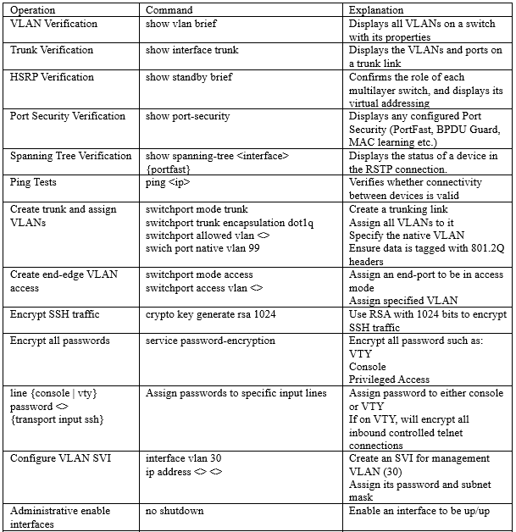
Figure 3: Commands

11. Test Screenshots:

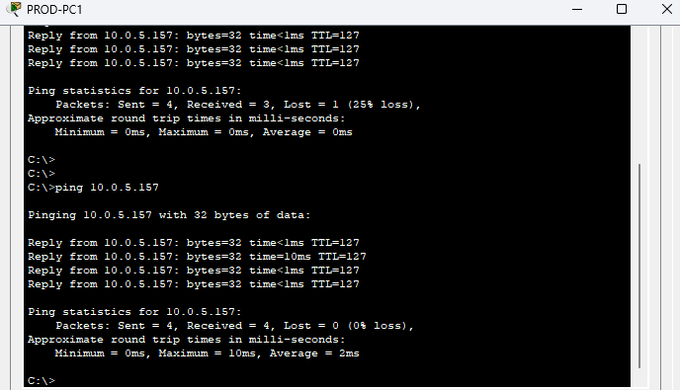
11.1. Ping Tests:

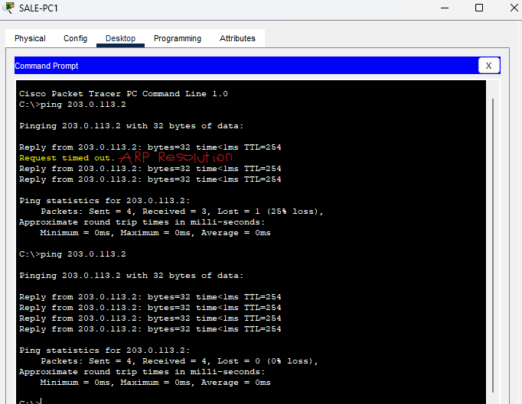
Figure 4: PROD-PC1 ping FNCE-PC1

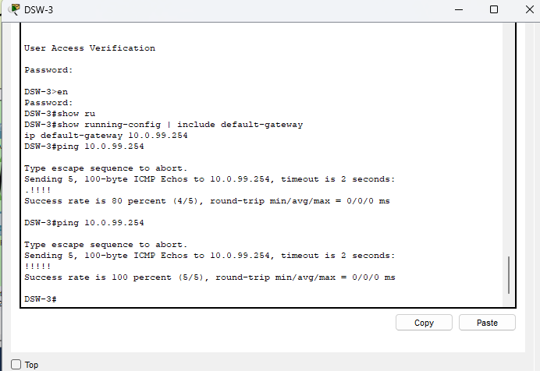
Figure 5: SALE-PC1 to Internet

Figure 6: DSW-3 to DGW
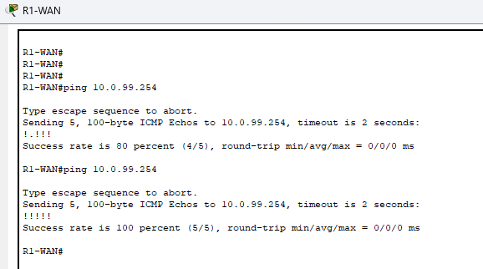

Figure 7: R1-WAN to CSW-1

11.2. Device Configurations:
Certain commands used to verify general statuses of interfaces, routing and switching operations.
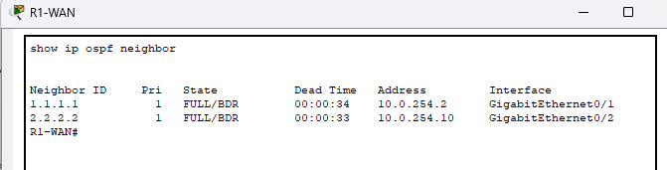
Figure 8: R1-WAN OSPF
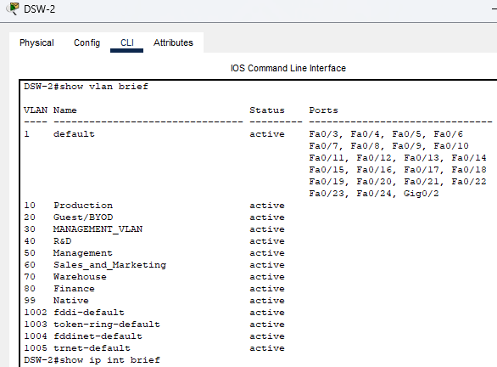
Figure 9: DSW-2 VLANS & Trunking
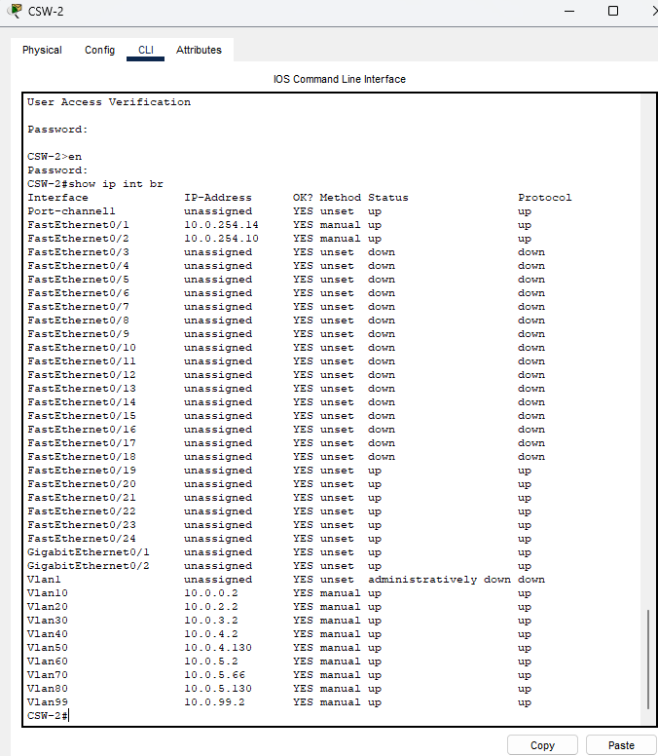
Figure 10: CSW-2 SVIs

12. Conclusion
This network design provides a robust, scalable and secure architecture for a 200 staff-sized operation across six departments. The three-tier hierarchical topology separates Layer 2 and Layer 3 operations via Core, Distribution and Access layers, providing easy troubleshooting and configuration needs.
VLSM-based IP subnetting enables efficient traffic flow, segregation between departments and space utilisation accommodating potential growth. Redundancy is provided via HSRP, dual WAN connectivity and EtherChannel. Furthermore, the various Layer 2 security features (BPDU Guard, RSTP etc.) mitigate the whole network from common attacks.
Whilst centralised DHCP, RADIUS, AAA services are not implemented, the design facilitates straightforward future addition of these services into an organisation-sized network.

References
Understand the hot standby router protocol features and functionality (2022) Understand the Hot Standby Router Protocol Features and Functionality. Available at: https://www.cisco.com/c/en/us/support/docs/ip/hot-standby-router-protocol-hsrp/9234-hsrpguidetoc.html.
Tamang, P.L. (2023) Securing Networks: Understanding and Implementing PortFast and BPDU Guard. Available at: https://medium.com/@pasanglamatamang/securing-networks-understanding-and-implementing-portfast-and-bpdu-guard-3ac3f18f58d5.

Appendix

Appendix A – GitHub Repo:
The public repository for this assignment, containing the source program .pkt: https://github.com/fchrzedu/-CCNA-COMP6039-Design-Exercise

Appendix B – Wireless Configuration:
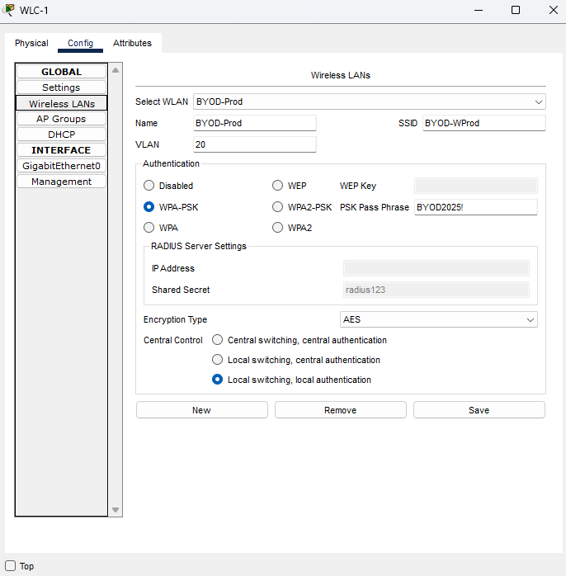
The correct wireless configuration for simulated WLC and AP:
