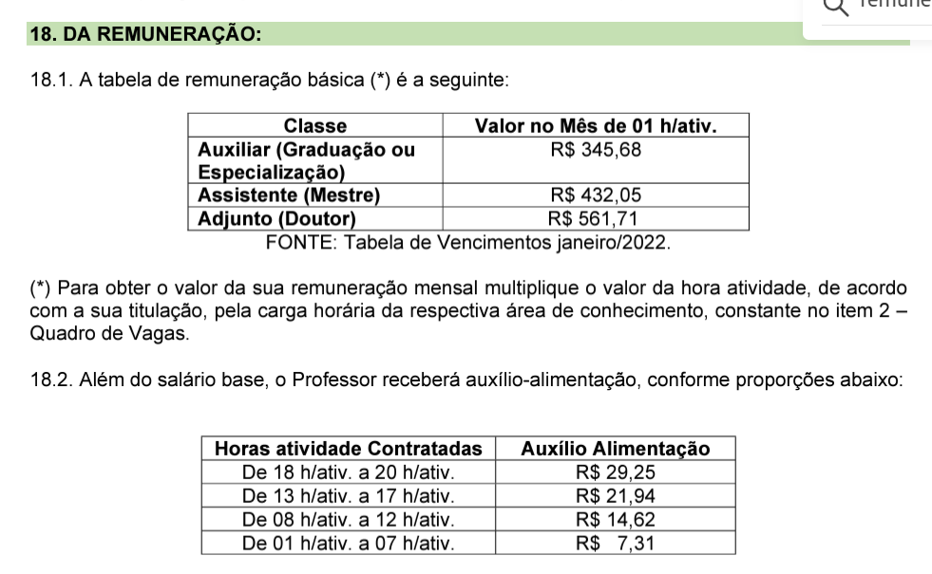

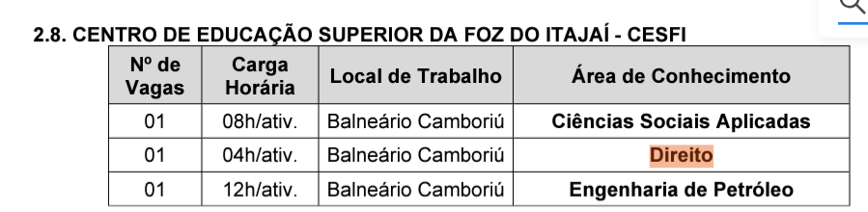

28/02 – 912,51

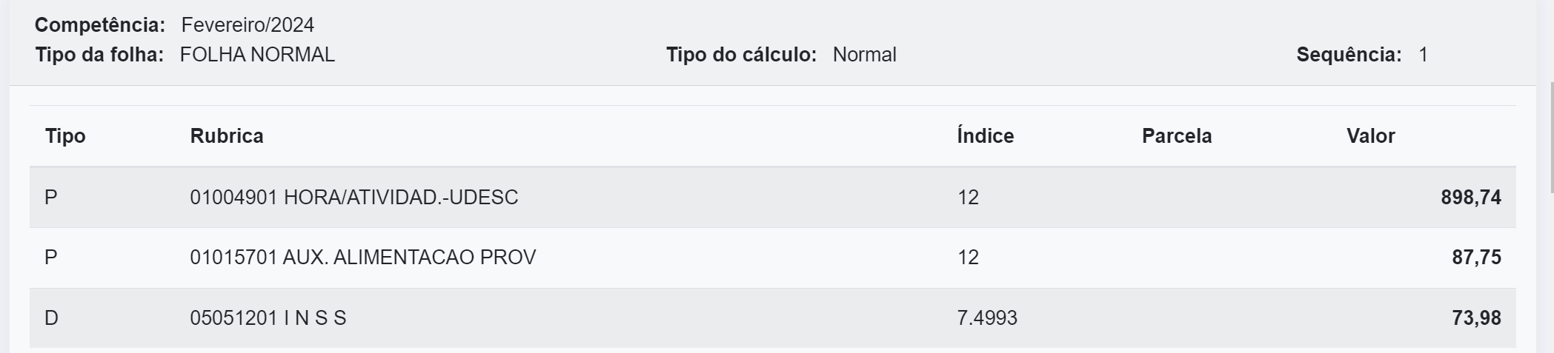

28/03 – 2.212,22 –

