# Esquema ligações

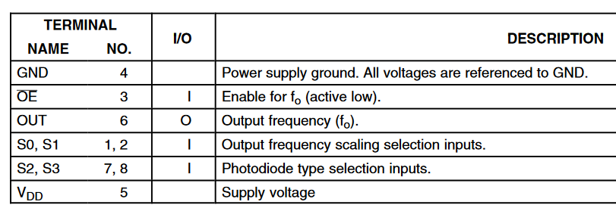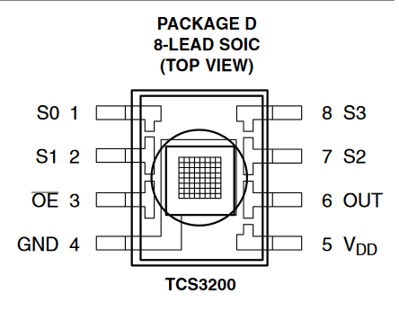

# Diagrama de funcionamento

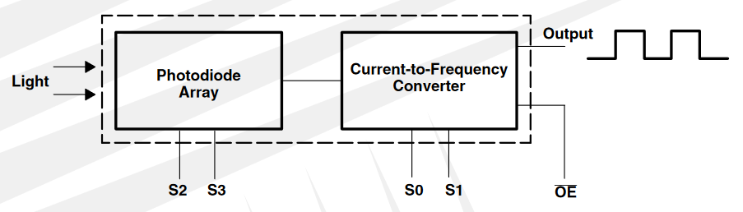

Output – duty cycle:50%

# Operating range:

Power supply lines must be decoupled: [0.01,0.1]F capacitor (short leads) close to the device

low-impedance electrical connection between the device OE pin and the device GND pin is required – noise immunity

all pins must be connected (logic signal/VDD/Ground)

If lines greater than 12 inches are used on the output, a buffer or line driver is recommended

See output frequency scaling

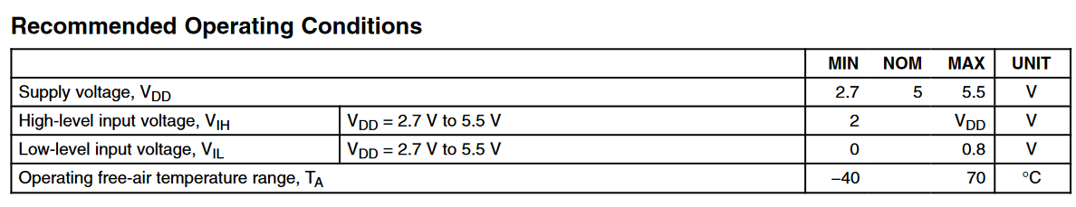

MÁXIMO VDD : 6V

Input voltage range : [-0.3,VDD+0.3]V

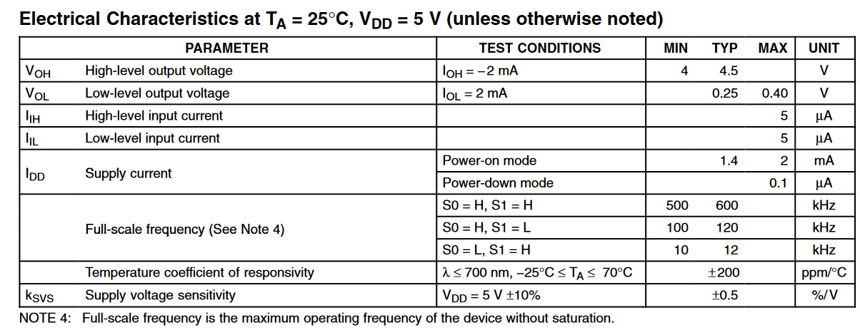

# Selectable options

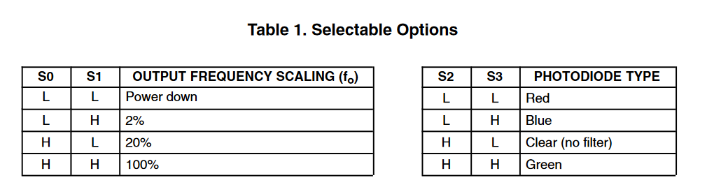

S0-1

S1-1

S2-1

S3-0

# Output

