ASTE404 Mini Project – Rocket Relations EP

PROJECT GOALS:
Primary goal is to find the optimal design for an EP thruster under fixed mission requirements.
- Mission Requirements:
  - Reasonable $ΔV=9500\frac{m}{s}$
  - Burn time $T_{b}=200$ days
- Maximize the payload fraction ((M_L/M_0)).
- Consider multiple configurations and test their stability:
  - Thruster configurations vary by $α$ specific mass of the power plant) and $η$ (efficiency)

Report Outline:
1. Project overview: What you built, why it matters, what question you’re answering
- Built an interactive electric propulsion optimization tool for spacecraft mission design
- Answers: "What thruster configuration (structural mass ratio α, efficiency η, specific impulse Isp) maximizes payload delivery for a given mission?"
- Matters because optimal thruster selection directly impacts mission feasibility and payload capacity
- Enables comparison of multiple thruster configurations and identifies globally optimal parameters
2. Numerical method(s): Equations, discretization/algorithm (pseudocode is fine), stability/accuracy/considerations/limitations
- Rocket equation: M_L/M_0 = 1 - (1-η)·α·Δv·tb·g/Isp - exp(Δv/(Isp·g))
- Optimization algorithm: L-BFGS-B (Limited-memory Broyden-Fletcher-Goldfarb-Shanno with Bounds) – finding minimum value
- Global optimization: Searches parameter space (α: 0.002-0.03 kg/W, η: 0.4-0.9, Isp: 100-9000s)
- Stability: Bounded optimization prevents non-physical results; gradient-based so requires smooth objective function
- Accuracy: Convergence tolerance set to ensure numerical precision in optimal values
- Limitations:
  - Can find local optima (not guaranteed global)
  - Assumes constant thrust, neglects gravity losses
  - Single-stage vehicle assumption

3. Implementation notes: Key design choices, file/directory layout, how to run (similar to README)
4. Progress log: Dated entries or milestones (what you tried, what broke, what you changed, what you
learned)
5. Verification/validation evidence: Even just partial is okay here. Show what you checked, what you
were thinking about, and what remains
6. Results: Plots/tables/screenshots—interpret what’s shown (and feel free to ask me for help if necessary)
7. Reflection/next steps: What would you do if you had more time? What did you learn?
8. LLM transcripts: Include it all at the end, each individual conversation sorted by date. Feel free toreference this in the progress log or elsewhere
------------- PROGRESS LOG -------------------
Preliminary
- Main goal – find optimal ISP for EP thruster,
- Numerical method? Starting simple first just
  - Goal: is to find optimal ISP – when graph slope = 0
  - Either Newton-Raphson method or Secant
- LLM suggestions Notes :
- Golden-Section Search Method
  - This isn't technically a root-finding method but is incredibly useful if the function is unimodal (single peak/valley). It narrows the search space iteratively.
  - Suitable for simple optimization problems without needing derivatives.
- Might use Golden Section Search

Equations:
 | $$\frac{M_{L}}{M_{0}}{=e}^{-\frac{ΔV}{v_{e }}}\left(1+\frac{αv_{e}^{2}}{2ηt_{b}}\right)-\frac{α}{η}\frac{v_{e}^{2}}{2t_{b}}$$ | Equation 1
- Equation 1 from Hill& Peterson Page 492
- Using this as main equation: $\frac{M_{L}}{M_{0}}{=e}^{-\frac{ΔV}{v_{e }}}\left(1+\frac{αv_{e}^{2}}{2ηt_{b}}\right)-\frac{α}{η}\frac{v_{e}^{2}}{2t_{b}}$
  - plot vs isp to find optimal point
  - Where $v_{e}=isp*g$
- Using scipy minimize scalar function – and finding “minimum value” of (-)ML/M0 to get maximum ratio value
- Alternative (not using but considered it): $\frac{M_{b}}{M_{0}}=e^{-ΔV/v_{e}}$
- Leftoff – found two equation s (put them here mb or the ML one long) and decided which one to use, for now using simple (even tho it says Mb) Page 492
Troubleshooting + Notes:
- Plots weren’t behaving right (giving negative values of ML/M0) (went through each value in equation 1, found that $α$ needs to be smaller than ~0.277
- TLDR: Hill & Peterson has a table of $α$ values in Kg/KW, which produced errors in graph (negative ML/Mo values due to too high correction factor) but switching this to units of Kg/W fixed it
- Notes: H&P really only have graph up to Payload ratio of 0.8, try to keep within bounds
GITHUB Notes:
- Note: For Github, made separate branch called master (the one for HW5 was main)
- Updates are in the following file: (typo for hw4- I had meant hw5 but just keep it as h4repo) 
Runs: File: electric_propulsion.py
- 1st run using equation 1 and units of $α$ [Kg/W]
- 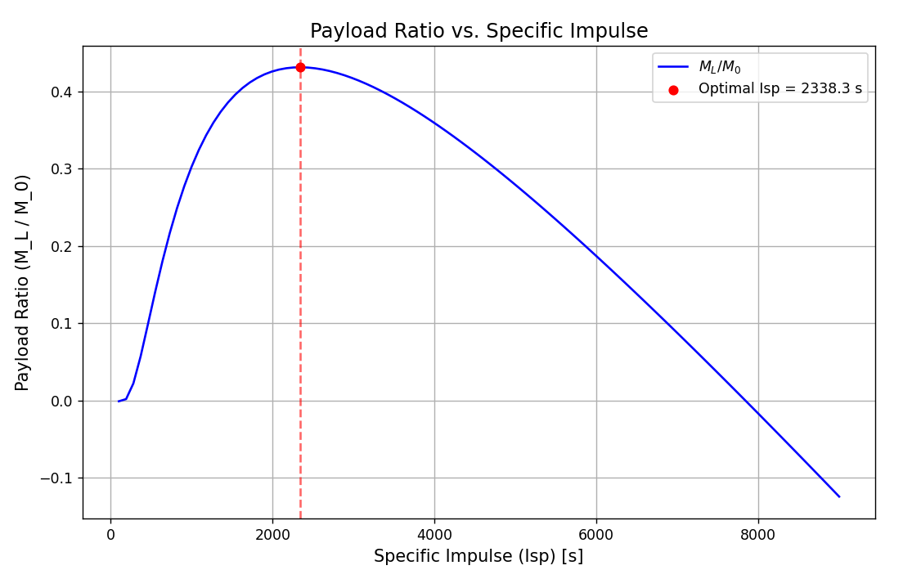
- 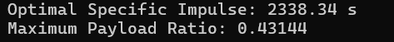
- Now, testing to break code
  - Notes: limits very low alpha (.0014 (mPP+ms/P) requires super high isp, means PP and structure mass are too low
- 2nd run:
- 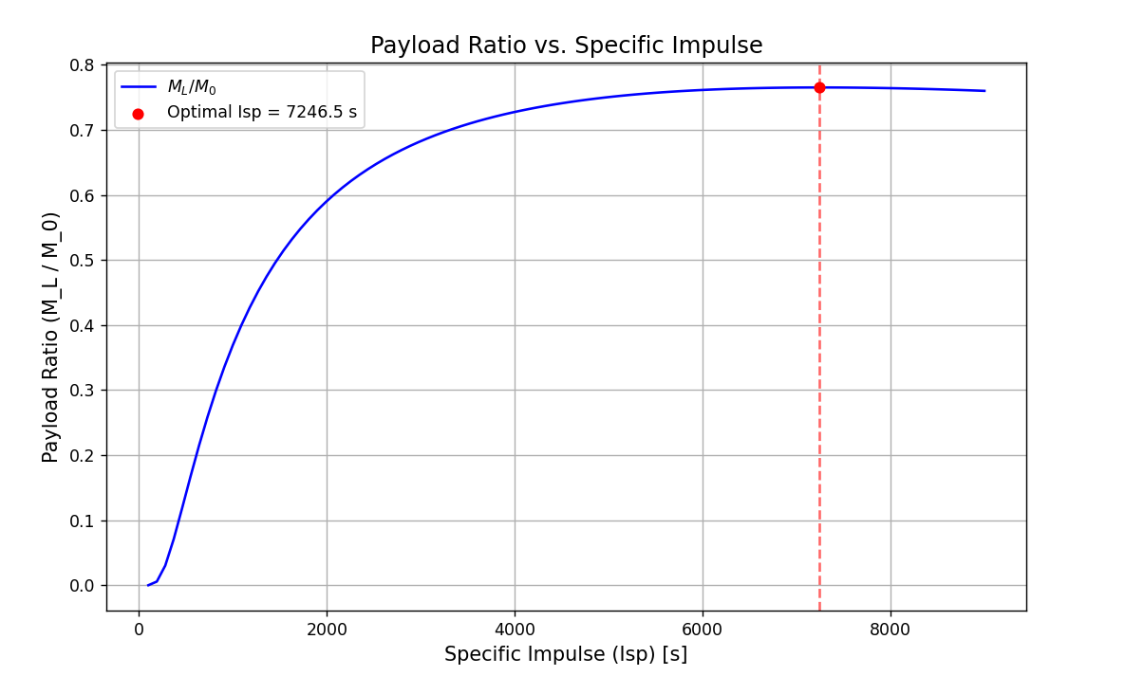
- 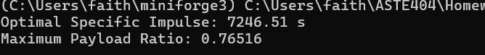
- Future iterations of this code should involve
- testing bounds so it doesn’t break, or setting a limit somehow
- including more than just one “thruster configuration” (values of alpha and eta) and plotting them all
- iterating over tables of alpha and eta values?? seeing where it breaks
- thinking about overall purpose of this code is to find the optimal design for an EP thruster, must have given parameters (make that be the mission requirements, aka reasonable value of Delta V – 9500 m/s and burn time Tb – 200 days)

Note 12/14
- 
- ^ between these two commits: In all honesty I forgot to start with the first interactive tool iteration – MANY iterations to the tool were implemented, with most troubleshooting happening with the version of this code that ONLY had two methods: Method A and B. - See LLM log

LLM Co-pilot questions:
- The line if __name__ == "__main__": means only execute when the script is run directly (as opposed to being imported as a module in another script
- Notes on: L-BFGS-B algorithm:
  - Limited-memory Broyden–Fletcher–Goldfarb–Shanno with Box constraints.
  - A gradient-based quasi-newton method (meaning instead of calculating full 2nd derivative matrix, it uses gradients from previous steps)
  - B- using simple “boxed” constraints
  - Limited memory – not very memory intensive, runs faster/efficient

