Fedora Developers Document:
The Validation Framework
Last Modified: July 09, 2008

This document provides an introduction to the ObjectValidator framework.

Overview:
The ObjectValidator is a tool that inspects the qualities of a digital object in the repository and checks to see whether they satisfy the requirements of the object's stated content model(s). It also check the content models themselves to insure that they are self-consistent.

The intent is for the ObjectValidator to be useful in a variety of contexts. The initial implementation is as a client-based utility which runs against the remote repository and produces a report. In the future, other uses might include embedding the ObjectValidator in the server and using it as part of the ingest method, to insure correctness of ingested objects. Additional uses can be envisioned.

In accordance with this multi-use model, an object is not declared to be valid or invalid. Rather, the result of the validation is a collection of “notations” which then may be interpreted as appropriate to the context.

Principal class structure:
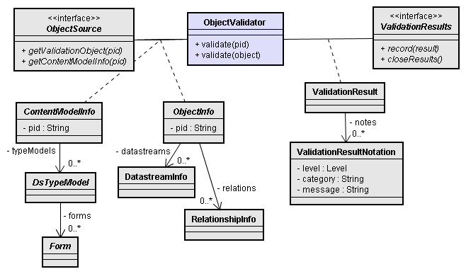

The ObjectInfo is a representation of the digital object to be validated. It contains representations of the relationships and datastream definitions for the object.

When the ObjectValidator is asked to validate such an object, it has an ObjectSource available, from which it can obtain a representation of any content model as ContentModelInfo objects, and any other objects that may be needed for the validation.

During this process, the ObjectValidator creates a ValidationResult, which holds a reference to the original object as well as zero or more ValidationResultNotation objects. These "notations" indicate facts that were determined about the object during the validation process.

In addition to a user-readable message text, each notation is assigned a severity level of INFO, WARN, or ERROR, as a guide to the importance of the notation. The notation also has a category string to identify the nature of the notation.

Using these, a user or application may tailor their actions based on their own needs. For example, an application may choose to disregard any notation that is not an ERROR level, or may decide to act on any notation with the category "NoContentModel".

Validation checks:
If an object does not have an content model, or if the content model URI does not resolve to an object PID, validation stops with just a notation.

If the content model is found, however, it is checked for validity. It must have a DS-COMPOSITE-MODEL datastream with the correct format-URI. The datastream contents are parsed as XML and an internal representation of the model is then checked against the original object being validated. The object must have a datastream for each type- model in the content model, and the datastream must conform to any restrictions on its type-model.

Package organization:
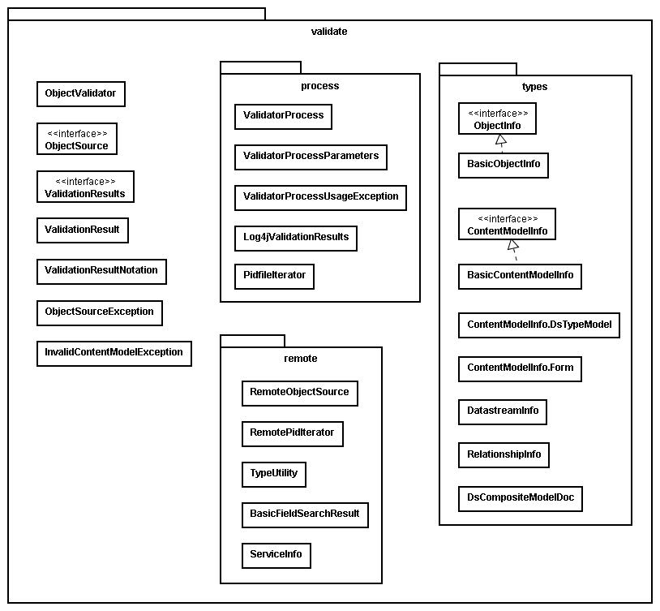

The principal classes described above are all included either fedora.client.utility.validate or fedora.client.utility.validate.types

Classes for the client-side ValidatorProcess are stored in fedora.client.utility.validate.process, with the exception of the classes that implement the ObjectSource interface. These are stored in fedora.client.utility.validate.remote, with the idea that they might be useful in other Validator implementations.

