|  |
| --- |
| Anang Fachreza |
| 2018150001 |
| Teknik Informatika/Semester 3 |
| Basis data kelas 1 |
| Kode soal A |

1. 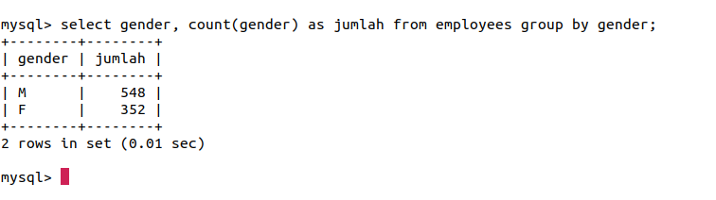select gender, count(gender) as jumlah from employees group by gender;
2. select employees.first_name, employees.last_name, sum(salaries.salary) as totalSalary

from employees left join salaries on employees.emp_no=salaries.emp_no

group by employes.emp_no;

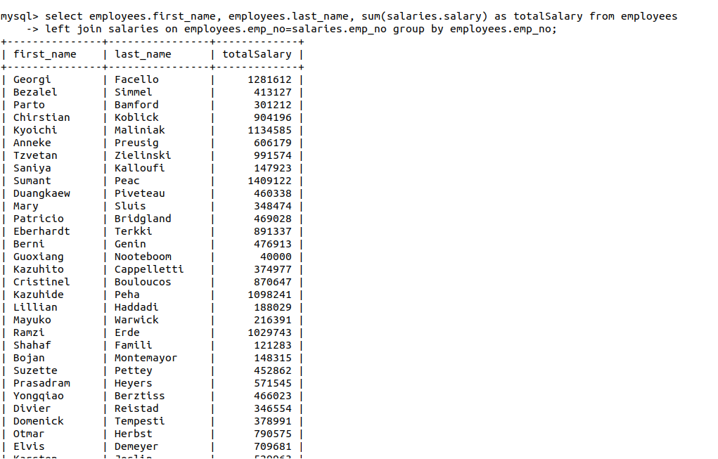

1. select employees.*, dept_emp.dept_no, departments.dept_name from employees

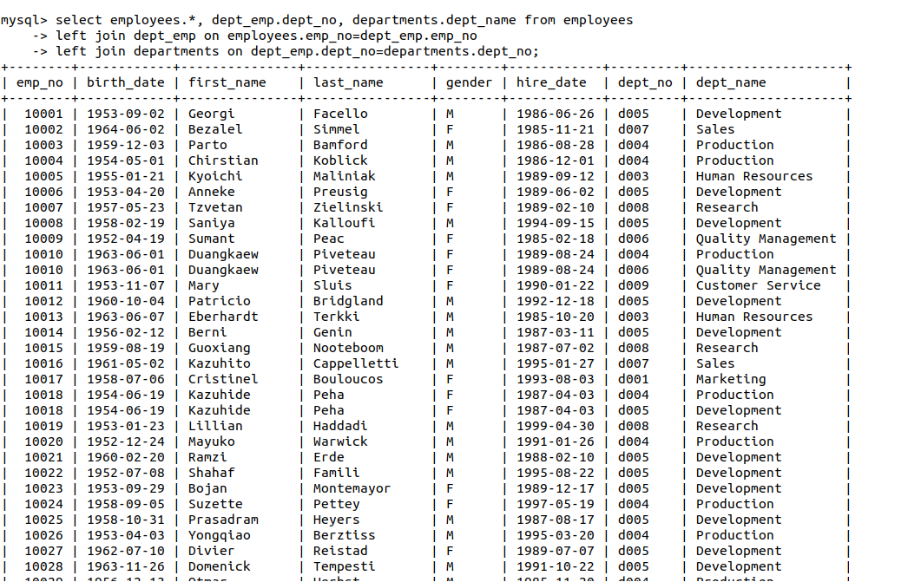left join dept_emp on employees.emp_no=dept_emp.emp_no

left join departments on dept_emp.dept_no=departments.dept_no;

1. select concat(employees.first_name, ' ', employees.last_name) as fullName, dept_manager.from_date, dept_manager.to_date from employees

left join dept_manager on employees.emp_no=dept_manager.emp_no

where dept_manager.from_date < '1995-01-01' and dept_manager.to_date > '1995-01-01';

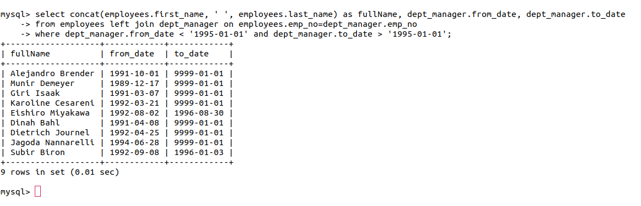

1. select employees.first_name, titles.title, (year(titles.to_date)-year(titles.from_date))

as jumlah from employees left join titles on employees.emp_no=titles.emp_no

where titles.title='Engineer' order by (year(titles.to_date)-year(titles.from_date))

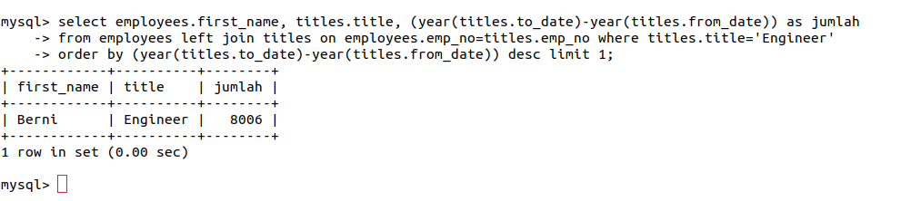desc limit 1;