Project Proposal
Fred Criscuolo
EN605_441 Summer, 2011
fcriscu1@jhu.edu

Project Name: Genomic Structural Variations In Human Cancers (GSVIHC) database

Database Description
A relational database cataloging sets of genomic structural variations observed from the analysis of human cancer tissue samples. Only structural variations determined to be somatic mutations will be considered. The data describing genomic aberrations will be supplemented by data describing and or referencing normal genomic structure and function. The intent of this later content is to suggest which biochemical pathways have been affected by the disease.

Introduction
Cancer is a genomic disease characterized by a wide range of structural variations in the genetic and epigenetic compliment of the diseased cell. These variations are classified as somatic in that they were not derived from the inherited germline genetic material and that they are not characteristic of the genetic material within the organism’s normal cells. The variations include DNA base substitutions, small insertions and deletions (indels), copy number variations, and severe chromosomal rearrangements. As noted, these variations extend beyond changes to the linear DNA sequences to encompass variations in the packaging of the DNA molecules (i.e. epigenetic) such as changes in DNA methylation patterns.

The dramatic decrease in the cost of genomic sequencing realized through the use of Next Generation Sequencing technology (NGS) has made it cost effective to sequence the genome of a patient’s cancer cells in order to determine the best treatment protocol. Many costly chemotherapy regimens are only efficacious against particular sets of cancer mutations. Cancer is not a static disease and the pattern of somatic mutations changes as the disease progresses. In practice, the reappearance of some mutations is often the first diagnostic indicator that a cancer thought to be in remission, is in fact, reemerging. In such cases, aggressive treatment at this stage can prove especially beneficial.

The use of NGS technologies to characterize the genomes of cancer cells has resulted in a number of public and restricted access databases to manage these data. Two primary examples are the Catalog Of Somatic Mutations In Cancer (COSMIC) (http://www.sanger.ac.uk/genetics/CGP/cosmic/) and The Cancer Genome Atlas (http://cancergenome.nih.gov/).

Project Database Details
The primary design objective of the project database will be to support the model of cancer as a dynamic and evolving pathology. Analysis of tumor cells from cancer patients afflicted with the same type of cancer (solid tumor and hematologic) and from the same tissue type will demonstrate a different set of structural variations. As noted, the set of structural variations within the same patient will change as the disease goes into remission or progresses. The structural variations seen in metastasized cells will be different than those seen in the tissue of origin although there is usually sufficient commonality to determine the origin. To support this objective, the central entity within the database will represent a sample of cancer cells taken from a particular tissue type from a particular patient at a noted point in time. Instances of this entity will relate to each other, but will model different time points and in the case of metastasis, different tissue types as well. Each of these cell entities will relate to another entity representing the collection of structural variations seen in the genome of that cell. Depending upon the frequency of cellular analysis relative to disease progression, two or more cell samples may relate to the same collection of observed structural variations.

In turn, entries within these collections will relate to entities that provide data about each observed structural variation. The attributes for this entity will specify the type of structural variation, the actual variation from the reference genome, its normal genetic map location, its aberrant location in the case of translocations, and a description of its possible impact on normal cell function. The entity will also contain flags indicating whether the variation is indicative of a loss of tumor suppression or an activator of oncogenic activity. The specification of the structural variation will be expressed using the nomenclature for genetic variants published by the Human Genome Variation Society (http://www.hgvs.org/). For example, a duplication of a thymidine base at position 451 within a genomic reference sequence is represented as g.451_452insT. Although the project database will include disruptions to alternative splicing patterns, practical scope limitations will preclude characterizing changes to actual coding sequences. That is, the specific sequence effect that a structural variation has on a transcribed sequence will not be maintained. The database will, of course, note whether a sequence variation results in a nonsense or missense mutation.

Wherever possible, attribute values will be persisted as terms or references to terms from major domain ontologies. In addition to the noted HGVS standard, the project database will utilize published nomenclature from National Cancer Institute Thesaurus (http://ncit.nci.nih.gov/ncitbrowser/) .

A common feature of many genetic-related databases is to provide support for data annotations.
In the GenBank sequence databases maintained by the National Center for Biotechnology Information (NCBI) the volume of annotation content far exceeds the volume of sequence data. The project database will provide for annotations on central entities.

The project database will also extend its own limited data collection by supporting references to major Web-based data repositories. Genetic locations will be consistent with UCSC Genome Browser (http://genome.ucsc.edu/) coordinates. Reference sequence data will be obtained for the Genome Reference Consortium (http://www.ncbi.nlm.nih.gov/projects/genome/assembly/grc/) data repositories. Where possible, the impact of a cancer on a particular biochemical pathway will be supported by a reference to the KEGG Pathway Database (http://www.genome.jp/kegg/pathway.html). The project database will support an entity containing the base URLs for referenced sites. The assumption is that a supporting application will be able to couple the base URL and the particular remote entry id to access the remote data. The incorporation of federated resources reduces the size and complexity of the project database and provides access to well-maintained supplemental data.

Planned Database Implementation
The intended platform for the project database is a Microsoft SQL Azure instance. SQL Azure is the approximate equivalent of Microsoft SQL Server minus some advance functionality that would not be utilized in the project. The benefit to using a cloud-based deployment is that, with the proper credentials, it can be accessed from location using the SQL Server Management Studio. If use of SQL Azure proves impractical, the database will be deployed on a traditional SQL Server instance.

Supporting Material
The figure below is a Circos diagram of the somatic mutations seen in a particular type of cancer. Each concentric ring represents a particular type of mutation. The inner arcs represent major chromosomal rearrangements. This type of diagram is very effective in conveying the havoc that cancer causes within the human genome. The human genome has often been represented as analogous to a complex computer program. One can image the level of devastation that would occur if a critical real-time system, say an air traffic control system, was disrupted to a similar degree.
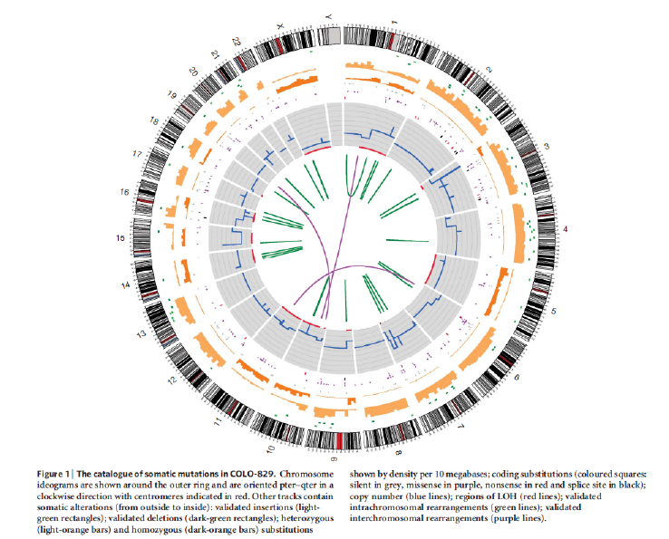

Chin et al, Making sense of cancer genomic data, Genes & Development (2011) 25:534-555
Metzker M., Sequencing technologies – the next generation, Nature Reviews Genetics (2010) 11:31-46
McDermott et al, Genomics and the Continuum of Cancer Care, NEJM (2011) 364: 340-350
? Pleasance et al, A comprehensive catalogue of somatic mutations from the human cancer genome, Nature (2010) 463:191-197

