National Cancer Institute Data Curator
Frederick Criscuolo
fcriscu1@jhu.edu
EN605 Course Project
The Johns Hopkins University

The National Cancer Institute Data Curator (NCIDC) is an application suite and database designed to assist scientists involved in cancer research. Specifically, it allows a scientist to examine an extensive range of Web-based data related to genes which have been identified by the National Cancer Institute (NCI) as being associated with cancer, and from that collection, to persist highly specialized data about selected genes of interest into a local database. The NCIDC provides an application programming interface (API) that allows locally developed applications to access these data. A GUI allows scientists to supplement mined data with personal annotations. The application's codebase is written in Java while data are exchanged and persisted using XML. The application utilizes an instance of Oracle's Berkeley DB XML for its database. The technological goal of this project was to demonstrate that available XML-based technologies can support an integration database that is more readily extended and customized than a design based on relational database technology.

Introduction

The National Cancer Institute (NCI) maintains the Cancer Gene Index [CABIG], a collection of human genes identified from literature reviews as having an association with cancer. The criterion for a gene's inclusion in this index is that the gene or the gene's product co-occurs in a Medline sentence with a cancer disease term from the NCI Thesaurus. The current disease index includes 6955 human genes. All index entries are structured around the gene name defined by the HUGO Gene Nomenclature Committee. The Hugo Gene symbol assigned to a gene is unique and thus represents the database equivalent of a primary key within the disease index. Each gene entry contains the identifiers of analogous entries in related sequence databases such as UniProt, and LocusLink (i.e. NCBI Gene). It also includes a sequence of annotations referred to as Sentences that provide evidence, including PubMed identifiers, justifying the gene's inclusion in the index. These Sentences incorporate Evidence Codes and Role Codes from NCI's ontology. As stated in the Cancer Index Overview,

The goal of the Cancer Gene Index is to further translational cancer research by providing a high quality data resource consisting of genes that have been experimentally associated with human cancer diseases and/or pharmacological compounds, the evidence of these associations, and relevant annotations on the data.

The completion of the Cancer Gene Index took over 6 years and required the scanning of 92 million sentences in approximately 20 million abstracts. As such, it embodies a valuable data resource for cancer research. The data are available for download in two large XML files; the Cancer Gene Index Gene-Disease file and the Cancer Gene Index Gene-Compound file. Both XML files are validated by accompanying Document Type Definition (DTD) files. This proof-of-concept project is limited a subset of genes included in the gene-disease file.

The data provided by the Cancer Disease Index is, in turn, supplemented by the vast cancer data resources maintained by NCI and made accessible through their cancer Bioinformatics Infrastructure Objects (caBIO) framework. caBIO provides a Web server and programmatic access to data from an extensive list of genomic and clinical information sources. In addition to Web-based query services, programmatic access is supported via a Java API, SOAP-based Web services, and REST-based interfaces. Perl, Python, and .NET APIs are under development and there is also an iPhone app to access caBIO data. As seen in the following example from the caBIO Technical Guide [CABIOTG], the Java API utilizes a query by example methodology to retrieve additional data about a specified gene. Using a series of queries, an application can complete an extensive biological object graph for a gene. Since the starting point for these queries is usually the same gene symbol that is the primary key for the disease index data, an index user can readily use caBIO resources to acquire more information about a gene. In reviewing the Java example it is worth noting that the client application makes a connection to the caBIO server at NCI. An API user does not have to install any server-side components, although such components are available for downloading.

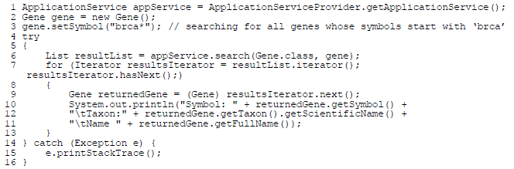
Figure 1 Sample QBE Java code from CaBio Tech Ref [CABIOTG]
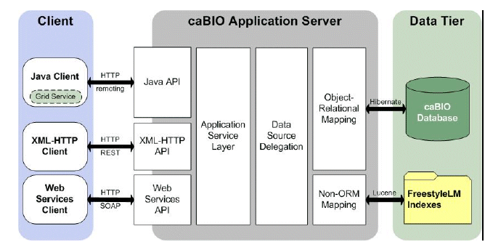
Figure 2 caBio Architecture from caBio Tech Ref [CABIOTG]

While caBIO provides Web-based query access to its data resources, the paths through these data, and what data are displayed, is constrained by the decisions of the Web site designers. . The real value of the resource is better realized through one of its programmatic interfaces. For example, the CaBIO server utilizes the object-relational mapping tool Hibernate for its data access layer. The caBIO Java API exposes methods that support direct read-only access to database using the Hibernate Query Language (HQL). This level of customized access to data is not supported via Web server access. Thus, there is a need for an application that can provide a customized portal to the data and services provided by NCI as well as the data and services provided by related bioinformatics resources.

The National Cancer Institute Data Curator (NCIDC) is a proof-of-concept application suite and database designed to serve as such a portal. Its primary user group is intended to be scientists and clinicians who need to access oncology data organized from a genomic perspective. Its secondary user group is software developers who will use the application's own API to provide customized access to it data resources. The anticipated mode of operation is that the primary users will use the application's GUI tool to identify genes of interest from the NCI Cancer Gene Index. The GUI allows the user to bring up a number of Web pages displaying information about a selected gene. Having selected a gene of interest, the user can request that the application mine data related to that gene from a number of Web-based resources including NCI. This mined information is then available via the NCIDC API to support specialized applications written by software developers. The application's GUI provides a mechanism for primary users to enter their own annotations regarding a selected gene.

The primary design objective for the NCIDC was easy extensibility. Functioning as a data and service mediator, it was imperative that new sources of data and services be incorporated in a timely manner and without affecting existing clients. This design objective was achieved by utilizing XML-based technologies for data transport, object design, and data persistence.

Project Objectives

The NCIDC proof of concept is intended to address two (2) development issues highlighted by Lacroix and Critchlow[Lacroix]:

- The relational data model is not a good technology choice to model complex graphs of biological objects.
- The length development time and comparatively rigid structure of a relational database exceeds the frequency of requirement changes due to the availability of new biological data

The relational model relies on tuples of data (i.e. rows) maintained in table entities. Every row in a table must have one or more attributes (i.e. columns) whose collective values are unique within that table. This uniqueness identifies these column/columns as a primary key. Ideally every attribute (i.e. column) within a row is directly dependent upon the primary key’s value. Rows from one table can be associated with rows from other tables by maintaining copies of their primary keys as columns within the referencing table. Thus a typical Employee table might have an Employee ID in a column as a primary key, some data attributes about the employee in dedicated columns, and a copy of the Department table’s primary key value for the employee’s department. By joining these associated tables through this replicated key value, a database query can return information about a specific employee and information about the department he/she is assigned to. Using this capability, complex data models can be created.

The basic principles of relational database technology were established long before object oriented programming (OOP) became a prominent model for software development. The limited, and essentially non-extendable, set of data types supported by the SQL92 standard do not match the unlimited number of types available to a developer using OOP or XSchema. While relational technology can generate complex data models, it cannot match the sophisticated object graphs of OOP.

Columns within a table are assumed to be related, but when these data are mapped to objects within an application, their relationship must be inferred, For example the location of a well on a multi-well plate is usually persisted as two independent data values representing the X and Y coordinates. It is up to the application to maintain the combined meaning of these two pieces of data. The OOP paradigm allows for the definition of a hypothetical WellPosition type, composed of an X and a Y coordinate. Here, the semantics of the data are defined not implied.

Moving from the simplicity of a two-dimensional coordinate system to the growing complexity of biological information definitely stretches the limits of relational model. It places the burden of decomposing a complex object graph that attempts to model biological phenomenon to a limited relational model on the application programmer. It also invites semantic ambiguity if another application incorrectly interprets the intent of the data model to populate a different object graph.

The relational data model introduced by Codd [Codd], defined the principles for the most successful formal database technology in use today. Codd also introduced the concept of normalization, in particular the database design goal of minimizing redundancy to obtain third normal form (3NF). Achieving 3NF in a complex database requires a great deal of design effort and review. This implies a lengthy development period and a resulting design that is often difficult to modify. Applications intended to work with the new database are built with the assumption of a relatively stable data model. The result is an application and database environment that is relatively inflexible. Database model modifications need to support one client application’s changed requirements must be coordinated with updates to all other client applications. If is often the case, that needed database modifications are significantly delayed because one or more project teams do not have sufficient resources to update their applications.

Long development cycles and a rigid design model may not be significant impediments to supporting static and long-lived business process, but they are to supporting research in fast moving scientific disciples, especially data intense fields such as bioinformatics. For example two areas of molecular biology that have gained considerable attention in a very short time are non-coding RNAs, particularly microRNA, and alternative transcript splicing. Both subjects have been associated with a growing range of pathologies and represent new classes of potential drug targets. Researchers who need to incorporate data from new related bioinformatics resources such as EMBL’s Alternative Splicing Database (ASD) or the miRBase resource will face considerable delays as existing relational models and client applications are updated to reflect new entities and relationships.

Large relational databases platforms, especially those offered by the leading vendors, represent complex environments that require highly trained personnel to implement and maintain. Their skill set is distinct from application developers thus adding another layer between a researcher’s bioinformatics requirements and their final implementation. Faced with these challenges and delays, many researchers turn to less robust forms of data persistence such as spreadsheets and CSV files.

Tuples of data encoded in the Extensible Markup Language (XML) are generally easy to process within computer application because, if designed properly, the data are self-describing. That is the data values are embedded within their own data dictionary. The hierarchical structure of the collection, commonly referred to as a document, supports multiple levels of data encapsulation. So for example, a sequence of characters isn't just a string but is the value of a Name element, and that Name element belongs to a particular Person element. Documenting the allowable structure of a type of XML document in either a Document Type Definition (DTD) or an XSchema xsd file facilitates the use of conforming documents for data transport and persistence. The consuming application can readily map the encoded data into application entities (e.g. objects). The defined document structure also allows technologies such as XQuery to retrieve specific sub-components from a document.

XML is the data encoding used to support SOAP-based Web services; both for describing published service operations in WSDL files and for the SOAP messages transmitted between client and server. XSchema represents the cornerstone in this form of distributed computing since it allows both parties to share XML vocabularies. By stating within an XML document, that the document conforms to one or more XSchema definitions, the consumer of the document has a clear understanding of the document's content and structure. XML binding technologies such as the Java Architecture for XML Binding (JAXB) can utilize a schema file to generate a graph of Java classes that mirrors the data structure described within the schema. It also provides the capability of an instance of an XML document based on that schema to a collection of Java objects and vice versa. Since the schema design is used to establish the design of both the XML document and the Java classes, the transition from document to object is more direct than the transition from relational data to java object.

A secondary design objective was that the initial implementation NCIDC and any future extension, not require the significant resources associated with a traditional relational database product such as Oracle or MS SQL Server. The goal here was that the database be owned by the application and not require development skills that exceed those needed for the application's codebase. This encapsulation principle is not to be equated with data "hiding". Access to the persisted data will be provided via the NCIDC's API and GUI client as well as DB XML’s command shell. Should the need arise, it will also be possible to expose the applications' data access layer and allow users to submit XQuery requests directly.

Project Technology Selections

TreeMap Visualization

The primary panel of the Swing GUI is a treemap visualization of the GeneEntry documents currently persisted in the DB XML database. Treemap visualization was invented by Ben Shnieiderman [Bederson] at the University of Maryland's Human Computer Interaction Laboratory (HCIL). Treemaps graphically represent tree-structured data as a collection of nested rectangles. Generally leaf-level rectangles are sized and colored relative to specified data criteria. The leaf-level nodes are encapsulated into tree structured groupings. Used effectively treemaps can provide a highly efficient mechanism for visualizing large quantities of related data. Perhaps the best-known implementation of treemap technology is the Wall Street Journal's Smart Money Map of the Market Web site. An important feature of the WSJ treemap is an option list that appears when a user clicks on a particular stock. The options allow the user to request more data about a particular aspect of the selected company's financial state. This design model was utilized in the NCIDC GUI. The user can click on a gene and will see a list of options providing more information about that gene. For example, selecting the NCI Gene option will open the user's Web Browser at the NCI Gene Web page for that gene. The NCI Gene identifier is provided by a cross reference in the NCI disease index file.

Ketan Barbaria [Barbaria] at HCIL used treemap technology to visualize data from the Gene Ontology (GO) database. This treemap visualization starts at the top level of the GO term hierarchy (e.g. cellular component) and braches down using nested squares down to leaf-level nodes (e.g. plasma membrane). The HCIL treemap software displays an adjoining text table with attributes for the selected treemap node (e.g. GO number) as well as GUI controls which allow the user to adjust the treemap presentation. The GO treemap is not accessible via a Web site, but it is included in the HCIL Treemap Project download. The software available from HCIL does not publish an API and as a result is not amenable to programmatic extension. A few software vendors have licensed treemap technology from the HCIL and some of their product offerings do have an API.

The NCIDC incorporates a trial license of Macrofocus's TreeMap product which does support a Java API. Documentation and Java examples are rather sparse for this product and it required decompiling the binary jar files and reviewing the generated source code to understand how to customize the treemap control. Essentially the user needs to replace the treemap's controller and action classes. Email correspondence with Macrofocus support staff indicated that a revised API will be available soon. Nonetheless, the Macrofocus API allows the NCIDC treemap to provide some of the features found in the WSJ treemap. Adding new selections to the options menu in NCIDC is relatively straight forward.

Currently the NCIDC sizes and groups genes by the same simple criterion: the number of Sentences in the NCI GeneEntry for a gene. In a production environment, it is assumed that more meaningful criteria will be utilized. For example, the size of a gene's display may be dictated by its overall expression level in a particular study and its color may reflect the change in its expression relative to a comparative study or reference point. Given that the NCI Cancer Gene Index contains almost 7000 genes, visualizations will need to be limited by one or more user specified filters. Using the expression study example, genes with expression levels below a specified level and whose expression level didn't vary significantly from the comparison study may be excluded from the treemap display.

In the NCIDC Swing GUI, the treemap visualization is the primary panel in a multi-panel display. When a gene is selected in the treemap, the other panels are automatically updated to display more information about the selected gene. For example, the Gene Alias panel displays all the gene aliases for the selected gene provided in the disease index entry.

One of the selections within the options menu is Create Annotation. Selecting this entry brings up a Swing data entry form which allows a user to enter a personal annotation about the selected gene. The generated object is called an ApplicationAnnotation to distinguish it from other annotation types and was designed by an Xschema file, ApplicationAnnotation.xsd. The object design includes support for the user to enter supporting evidence for his/her annotation, but the current proof of concept implementation does not utilize this capability. A requirement for a production implementation would be to relate an annotation to one or more ontology terms. A user may create an unlimited number of annotations for the same gene. When a gene is annotated for the first time, additional data for that gene are mined from registered sources and persisted into the local database. This mining is executed on separate threads and does not impact the responsiveness of the GUI. Subsequent annotations for a gene do not invoke data mining unless the currently persisted data have exceeded their expiration date.

Oracle Berkeley DB XML

The database used to support NCIDC is an instance of Oracle Berkeley DB XML. (DBXML). DBXML is a specialized variant of Berkeley DB, an embedded database that uses key/value pairs to persist data as byte arrays(7). There is also a Java database variant called Berkeley DB Java Edition. Originally developed at the University of California, Berkeley and distributed as a component in BSD UNIX, the products are now available under a dual license model. They can be obtained as open-source products under the terms of a Sleepycat Public License. If a user wishes to avoid the redistribution terms of this license, they can purchase a proprietary copy from the Oracle Corporation. The distribution used in NCIDC is from Oracle and was downloaded under the terms of their Developer License.

DB XML is an embedded XML database whose functional components are referenced as external libraries; there isn't the equivalent of a database server common to most relational systems. DB XML supports XQuery 1.0, XPath 2.0, XSD namespaces, and schema validation. All data are stored as XML documents within files called containers. Queries against these documents are performed using the XQuery language and queries can be performed against a collection of documents within a container or against a specified document. Within a container, individual documents may be stored as individual nodes for improved query performance or as intact documents for improved loading performance. Documents within a container are not required to have the same structure, but their structure should be similar enough to support queries across all the documents within a container. NCIDC takes advantage of this feature to persist similar documents from different sources in the same container. DB XML also provides an interactive command shell. This feature proved useful in debugging queries. The application used the DB XML Java API to support programmatic access to the database. DB XML supports both transaction processing and data replication; these features were not utilized in the initial version of the NCIDC.

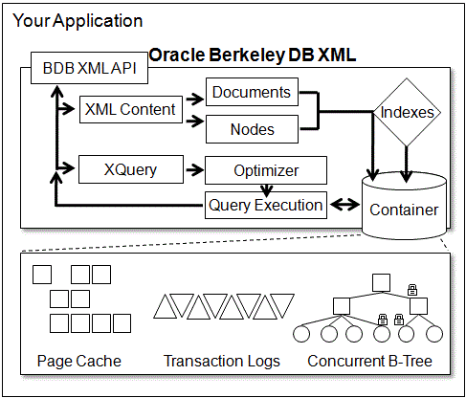
Figure 3 Berkeley DB XML Architecture

NCIDC Design and Implementation
As noted the NCIDC consists of three (3) major components:
- A Berkeley DB XML database. Each major type of data (e.g. sequence, reference, and gene) resides in a dedicated container. With the exception of the disease index data, all individual entities are persisted as distinct XML documents. Node-based decomposition is used throughout the database. All database entities are validated by XML schemas, either defined by the application or supplied by the data source. All objects have Java Binding (JAXB) classes defined for them. All mined entities include provenance data.
- A Java Swing GUI (NcidcClientApp) provides a mechanism for a researcher to browse entries within the NCI Cancer Gene Index, select individual genes, use options to obtain additional information from external Web servers, and to enter annotations about a gene. As noted, the creation of the first annotation for a gene invokes background data mining from registered data sources. The application is designed to facilitate adding or changing information options.
- A collection of Java classes responsible for data mining, database operations, event handling and message handling
Data of the same type mined from different sources and having distinct structures are stored in the same database container using the same XML Schema file for validation. For example, all mined sequence data are persisted as individual SequenceReference XML documents in the same sequence container. An examination of the design file for this schema, SequenceReference.xsd, will show that the document has two sections. The first consists of data elements common to all sequence entities (i.e. source, type, identifier, and sequence). The second is the original XML data mined from the source including its own schema reference(s). This second XML document is contained within an xs:anyType element. This allows different documents mapped to the same schema and managed by the database as identical entities to have such disparate content. The intent is that the common section will be used to support general queries. Once a SequenceReference has been selected, its unique content can be extracted and used to instantiate the appropriate set of JAXB classes. The sequence data is replicated in the common section as a processing convenience. Currently, the proof of concept application mines complete UniProt entries and mines RefSeq entries as simple FASTA entries.
Adding a new source of data is relatively straight forward. The developer uses a schema file provided by the source to generate a graph of JAXB classes. This provides programmatic access to the mined XML data. The developer then maps the appropriate data from the mined XML into the common section of the SequenceReference. This includes completion of the SequenceProvenanceChain which provides details on how the data were obtained. The original mined XML data is then mapped to the RetrievedSequenceEntry element. Since all these data are now encapsulated into a SequenceReference entity, no new database operations are needed. Any defined queries against SequenceReference objects will also work against the new data. Upon retrieval from the database, the generated JAXB classes will provide full programmatic access to the specialized data. Since the mined data is retained in its original structure, customized XQuery operations can be performed against the original content.
It is important to note that persisting mined XML data in this fashion is very different than persisting the same data as a CLOB in a relational table. CLOBs do not maintain an inherent structure and are usually processed as a stream of bytes. It is not possible to complete a query within a CLOB, nor is it possible to retrieve portions of a CLOB based on query parameters. All these operations are possible with the NCIDC design assuming that the structure of the retrieved XML is known. There is also no concept of data validity associated with a CLOB. Retrieved XML that references either a DTD or schema file can be validated against standards defined in those files.
As an XML database, the NCIDC database does not have the equivalent of a relational data model. Documents persisted in each of the reference containers are expected to conform to a particular XSD file (e.g. SequenceReference.xsd for documents in the sequence_container). This is implemented in order to support queries across all persisted documents. But as noted, these restrictions only apply to the common header section. The main body of documents containing retrieved data maintains the structure and content of the retrieved data. Thus the bulk of these documents will differ based on their original source structure. Adding a new data type (e.g. pathways) would involve defining a new container, designing a new XML schema, generating a set of Java Binding class using the new schema definition, and writing the Java code to mine pathway data sources for pathway data. Ideally the mined data should be in XML format that includes a reference to a DTD or xsd file. The availability of either of these design files facilitates generating Java classes that can map the retrieved data. The design of the new schema should follow the design practice of an header section attributes common to all pathway data as well as provenance data, followed by the xs:anyType element which will contain the retrieved data.
As noted in Lacroix and Critchlow [Lacroix], data provenance is a major design consideration in any database, but especially in one that integrates data from many federated repositories. The growing availability of Web services that allow applications to mine data programmatically increases the priority of this issue. Since some Web service interfaces are easier to use than others, data may be preferentially mined from a secondary resource rather than its primary location. For example, in NCIDC, PubMed data is mined from EMBL, a secondary source, rather than its primary source NCBI, even though these data are available from NCBI using their Entrez Programming Utilities. The selection of EMBL was made based on the fact that the XML returned from EMBL referenced a schema while the XML returned from NCBI did not. The ability to access a source's schema ensured that that generated binding classes would be accurate.
All retrieved data in the NCIDC database includes a ProvenenceChain element; ReferenceProvenanceChain for reference data. This element is recursive supporting a chain of sources back to the original source. In the case of PubMed data, the provenance chain starts with the entry's location at EMBL, and then includes another embedded ReferenceProvenenceChain element defining the data's location at NCBI. If this design pattern is upheld by developers extending NCIDC, a database user will always be able to trace data extracted from NCIDC back to its original source. The design schemas for retrieved data persisted into the database require at least one ProvenceChain element be defined. Since adding a new XML document to a database container includes validation, an attempt to add a document without some provenance data will fail.
As noted, NCIDC provides a Java Swing user interface based on treemap technology. An obvious future extension to the application would be to allow individual users to control the treemap visualization by specifying grouping, size, and color parameters. A review of well designed treemap implementations demonstrates how effective this technology can be. An additional personalized extension would be to allow users to specify which options appear in the option drop down list. The most import UI extension would be to provide users with an easy to use filter mechanism. The NCI Cancer Gene Index includes almost 700 genes; too many to display on typical screens. Users will need controls to filter the displayed population to those genes that meet their specified criteria. What may be worth exploring is a developing a hierarchy of treemap displays. Displaying an initial treemap of genes groups and allowing a user to drill down into a group by generating treemaps at a more detailed level. If restricted to a reasonable number of levels, this design is feasible using Swing and treemap components.

In the proof of concept implementation, the Swing class NcidcClientApp, serves as the application's starting point. The Java classes used to support other functions are initiated by the Swing app. These classes are organized into Java packages to facilitate application extension. For example, the individual data miner classes are placed into packages representing the database containers they support. They also extend an abstract class in that container that is responsible for setting up the database connection to that container. This design ensures that all data miners of a particular type use the correct database container for persistence. There is nothing within the DB XML API to prevent a document being stored in the wrong container. In effect , this document would be overlooked by all but the most basic of queries against that container and could cause some queries to fail.
The application also implements a MessageBus class that allows event producing classes to post event messages and other classes to register as listeners to one or more events. This design supports a broad class to class communication system without the necessity of direct class coupling. Currently when a user elects to save a personal annotation, the component that persist that annotation publishes that event to the MessageBus which in turn notifies classes that have register as listeners to that event type. In this case DataMiningService class will check if the annotation refers to a gene whose data has already been mined and has not yet reached their expiration date. If these conditions are not met, the DataMiningService invokes each registered data mining class to retrieve data for the selected gene. Each data miner is invoke on its own thread to avoid impacting the user interface. This same event model is used to update the background panels in the UI. When a new a new gene is selected within the treemap, their content is automatically refreshed. As recommended by the TogoWS design [Katayama], data retrieval operations utilize REST Web services.

Future Extensions
The most important extension for NCIDC would be to decouple the data mining and data access classes from the user interface. This would be accomplished by supporting these classes within a J2EE application server that supports Web services. A combination of Apache Tomcat and Apache Axis would represent a good platform. The existing treemap user would communicate with the relocated server components using a new REST API for data retrieval and a SOAP-based API for service requests. The existing packaging of all components within a single Java application was chosen to facilitate distribution of the proof of concept to remote locations for evaluation.
The project should also be extended to include more data sources, Many of the Sentences with a disease index entry include OMIM identifiers and there are several Web services that provide OMIM data. This would be an ideal data retrieval and UI display extension.
The project should also support more extensive data mining of the NCI data resources via its caBIO API. The Gene object returned by the NCI caBIO service in the simple Java example (Figure 1) represents the starting point of an extensive and complex object graph of genomic information. The NCIDC could mine this information and provide customized representations of these data. In a recent paper, Ruano et al [Ruanao] proposed that, "genetic variation that influences complex traits accumulates at foci on convergence that act across different pathways." Their paper suggested a horizontal grouping of genes based on cellular function that act across multiple pathways. This concept is illustrated in the following diagram from the cited article.
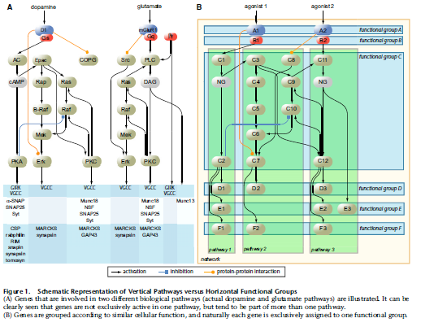
Figure 4 Diagram from Ruano AJHG paper
While the Ruano paper concentrated on genes involved in synaptic networks, a similar study could help identify cancer related genes that serve as critical foci in multiple pathways. The caBIO APiI provides operations that list the pathways that an individual gene is a part of and operations that list all the genes with a specific pathway. Thus horizontal and vertical groupings as shown in Figure 8 can be established for those genes listed in the disease index.

The registration and invocation of data miners should be improved. The miners should implement a common interface and the DataMiningService should utilize Java Reflection capabilities to detect and invoke concrete implementations of this interface.
Moving the application from a proof of concept to production-level quality would require that many of its aspects be made more robust. For example, access to a traditional relational database would be useful to keep track of users and their preferences as well as provide a means of moving application values from a shared interface to app value tables. A production-level logging mechanism should be incorporated. As the quantity of persisted data increase, query performance can be maintained by introducing map-reduce techniques. A single container could be split into multiple containers on different drives and a query could be concurrently executed on different CPU cores against the container collection. The results could then be pooled as the individual queries are completed.

Conclusion
The primary object of the NCIDC proof of concept was to demonstrate that the incorporation of XML-based technologies could support a more flexible data integration platform than a platform based on traditional relational database design. The proof of concept succeeded in this effort. A new data source whose data is described by a DTD or schema file can be fully integrated into the NCIDC in a matter of a few hours. The automatic generation of Java Binding classes makes the new data accessible to application components. The use of an XML schema and JAXB completely eliminates the need for developing complex object-relational mapping classes. The retention of the retrieved data in its original structure along with its schema file ensures that the semantic meaning of the original data is not lost during the integration process. The use of XSchema's unlimited type definition generates data models that represent a more natural fit to the domain being model than is possible with a relational data model. XSchema distributed via a public URI reference allows anyone on the Web to share a schema design model and facilitates the transport of data. Given that the current application design can quickly integrate and utilize data dorm disparate bioinformatics services, this objective has been achieved.
The second objective was to establish a persistence layer that did not require the specialized skills of a database administrator. The project’s Berkeley DB XML database includes a Windows installer and basic instructions for defining document containing. It provides a well-documented Java API for programmatic access and a command shell. Queries are expressed in XQuery rather than SQL. Overall the XML related skills needed to continue NCIDC development do not significantly exceed those needed to work with the XML responses provided by Web services operations. A database specialist is not required in this environment.
In addition to meeting its stated objectives the project use of the NCI Cancer Gene Index as a prototype data source, demonstrated how valuable this resource is. By mining specific data via the caBIO interface the NCIDC can simplify the implementation of highly specialized bioinformatics studies.

Appendix A: NCIDC GUI Screenshots

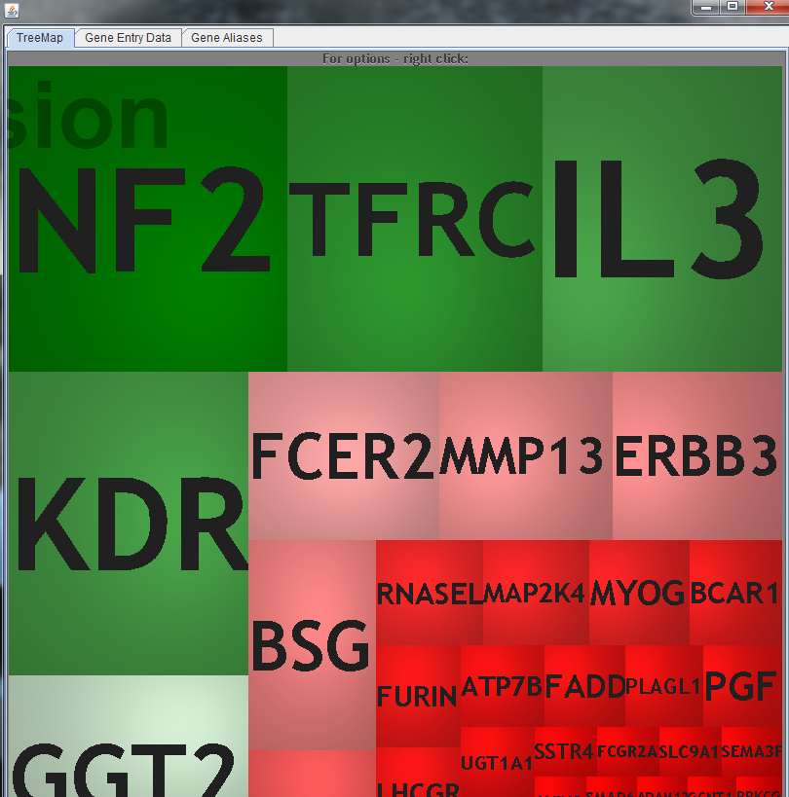
Figure 5 GUI Treemap
This is the initial screen presented to the user when the GUI application starts up. Each square represents a gene in the NCI Cancer Disease Index. The size of the square is proportional to the number of NCI Sentences (i.e. annotations) belonging to that gene. The Treemap API allows more meaningful criteria to be used to determine gene groupings, size, and background color. The intent is to use these visual clues to help a user quickly identify gene of interest. The contents of the other tabbed panels are determined by which gene is selected. At startup, the selected gene defaults to the one in the upper left hand corner. In this example that would be NF2.
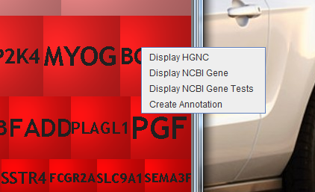
Figure 6 Treemap Options Menu
When a user right-clicks on a gene selection, a list of options for additional data or functions appears. The display options will open up a Web page in the user's Web browser that will display data associated with the current gene from that Web service. Functional options are intended to invoke application functions and may display another Swing component.

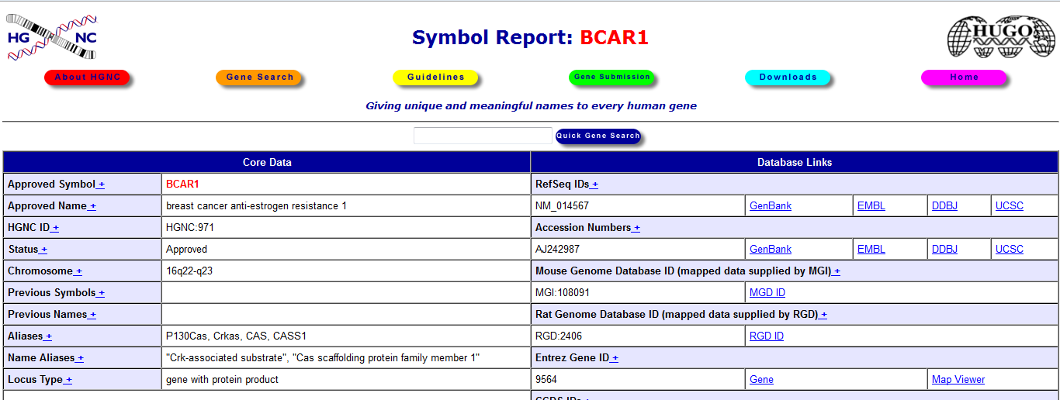
Figure 7 HGNC Option for BCAR1
If the user selects the "Display HGNC" option, the HGNC page for the selected gene will open up in a Web browser. The HGNC identifier is included in the NCI Cancer Disease Index entry for that gene. Since this Web page is displayed within a browser, as opposed to a Swing HTML display window, all links within that page to other resources are fully functional.
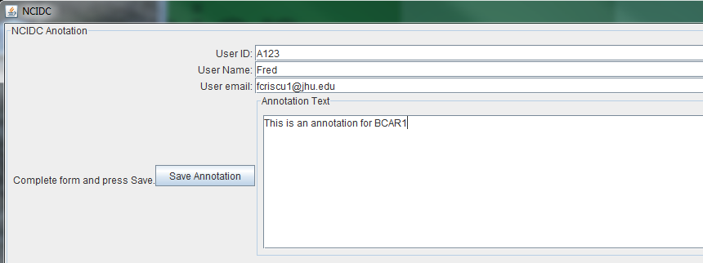
Figure 8 Annotation Form Component
When the user selects the "Create Annotation" option, a Swing data entry form will be displayed. The user can then complete the fields as shown. In a production version it is anticipated that the user's credentials will auto-filled by the application. The "Save Annotation" button is not enabled until the user enters text in the text area. A user may create multiple annotations for the same gene. The entered data is used to create an ApplicationAnnotation XML document with is persisted in the database's annotation container. The schema document that validates the ApplicationAnnotation includes optional elements that support a reference for the annotation. These XML elements are not supported in the proof of concept implementation. Saving an ApplicationAnnotation also invokes populating the database with data from cross-reference entries in other bioinformatics resources. For example all the unique PubMed entries listed in the Disease Index for a gene are mined. Because data mining operations can be time consuming, each type of data miner is invoked on its own thread. This avoids disrupting use of the GUI tool.

Bibliography

Babaria | Babaria, K.,(2001) Using Treemaps to Visualize Gene Ontologies, Human Computer Interaction Lab and Institute for Systems Research, University of Maryland, College Park, MD (http://www.cs.umd.edu/hcil/treemap/GeneOntologyTreemap.pdf)
Baehrecke | Baehrecke,E, Dang, N., Babaria, K, Shneiderman, B, Visualization and analysis of microarray and gene ontology data with treemaps, BMC Bioinformatics 2004, 5: 84-93
Bederson | Bederson,B. , Shneiderman,B, Wattenberg,W., (2001) Ordered and Quantum Treemaps: Making Effective Use of 2D Space to Display Hierarchies, Human Computer Interaction Lab and Institute for Systems Research, University of Maryland, College Park, MD  (ftp://ftp.cs.umd.edu/pub/hcil/Reports-Abstracts-Bibliography/2001-18html/2001-18.pdf)
CABIG | The caBig Cancer Gene Index  (https://cabig.nci.nih.gov/inventory/data-resources/cancer-gene-index)
CABIOTG | caBIO 4.3.1 Technical Guide (2009). Available via: https://wiki.nci.nih.gov/display/caBIO/caBIO+Data+Sources
CABIOAPI | caBIO Java API, http://ncicb.nci.nih.gov/core/caBIO/API/
Codd | Codd, E., A Relational Model of Data for Large Shared Data Banks, Communications of the ACM, 1970,13:6 377-387  (http://www.seas.upenn.edu/~zives/03f/cis550/codd.pdf)
Daum | Daum, B., Modeling Business Objects With XML Schema, San Francisco, Elsevier Science, 2003
Katayama | Katayama, T, Nakao,M, Takagi, T, TogoWS: integrated SOAP and REST APIs for interoperable bioinformatics Web services, Nucleic Acids Research, 2010, 38, No. suppl_2 W706-W711 (Web Server Issue 2010)
Lacroix | Lacroix, Z, Critchlow, T, Bioinformatics Managing Scientific Data, San Francisco Elsevier Science, 2004
Olson | Olson, M., Bostic, K., Seltzer,M.(1999) Proceedings of the FREENIX Track: 1999 USENIX Annual Technical Conference (http://www.usenix.org/events/usenix99/full_papers/olson/olson.pdf)
Ruano | Ruano, D., et al, Functional Gene Group Analysis Reveals a Role of Synaptic Heterotrimeric G Proteins in Cognitive Ability, American Journal of Human Genetics, 2010, 86:2 112-125

Bruford, et al,, The HGNC Database in 2008: a resource for the human genome, Nucleic Acids Res. 2008 Database Issue 36:D445-448
UniProt: http://www.uniprot.org/
NCBI Gene: http://www.ncbi.nlm.nih.gov/gene
PubMed : http://www.ncbi.nlm.nih.gov/pubmed
Overview of the Cancer Gene Index: https://wiki.nci.nih.gov/display/ICR/Cancer+Gene+Index+End+User+Documentation
caBIO : https://cabig.nci.nih.gov/tools/cabio/
CaBIO Data Sources: https://wiki.nci.nih.gov/display/caBIO/caBIO+Data+Sources
caBio Web Server: http://cabioapi.nci.nih.gov/cabio43/Home.action
Hibernate http://www.hibernate.og
SQL92 Standard: http://www.contrib.andrew.cmu.edu/~shadow/sql/sql1992.txt
All columns in a table depend directly on the primary key.
Stamm S, Riethoven J-JM, Le Texier V, Gopalakrishnan C, Kumanduri V, Tang Y, Barbosa-Morais NL, Thanaraj TA. ASD: a bioinformatics resource on alternative splicing.. Nucleic Acids Res 2006 34: D46-D55.
Griffiths-Jones, S. et al, miRBase: tools for microRNA genomics Nucleic Acids Research, 2008 36: D154-158
XML http://www.w3.org/XML
JAXB: http://www.oracle.com/technetwork/articles/javase/index-140168.html
Map of the Market: (http://www.smartmoney.com/map-of-the-market/ ). Some features on this site are closed to non-subscribers, but enough are accessible to demonstrate the power of treemap visualization.
Gene Ontology Treemap: http://www.cs.umd.edu/hcil/bioinfovis/treemap.shtml
Macrofocus: http://www.macrofocus.com/public/
Oracle Berkeley DB XML: http://www.oracle.com/technetwork/database/berkeleydb/overview/index-083851.html
Oracle Technology Network Developer License Terms: http://www.oracle.com/technetwork/testcontent/standard-license-088383.html
Berkeley DB XML Java API: http://download.oracle.com/docs/cd/E17276_01/html/java/index.html
An available DTD file can be converted to a XSD file. If necessary sample XML can be used to generate an XSD file but that can be problematic if the chosen XML is not fully representative.
Entrez Programming Utilities: http://eutils.ncbi.nlm.nih.gov/
Representational State Transfer (a.k.a. RESTful)
Online Mendelian Inheritance In Man: http://www.ncbi.nlm.nih.gov/omim

