AgriConnect
System Architecture and UML Design Suite
Offline-first, satellite-integrated farm management for smallholder farms in Botswana
Botswana School of Business and Science
October 2026

Contents | Description
Sections 1 to 3 | Overview, team role allocation, and the technology stack
Sections 4 to 7 | Ten UML diagrams with explanations: use case, class, component, deployment, two sequence, two activity, and two state machine diagrams
Section 8 | Architectural traceability matrix
Section 9 | Resolution of the open requirements using the diagrams
Sections 10 and 11 | Design review notes and recommended next steps
Appendix A | PlantUML source for every diagram

1. Overview
AgriConnect is an offline-first farm management ecosystem built for smallholder agricultural environments in Botswana, where mobile internet is unreliable. Farmers record harvests, livestock, sales and expenses on an Android device that works fully offline. The data is queued locally and synchronized automatically when a connection returns. The platform also maps farm plots, retrieves satellite crop-health information (NDVI), and lets farmers publish produce to a marketplace where buyers can browse and order.
This document brings together the complete UML suite produced by the team: ten diagrams that describe the system's scope, data model, software architecture, physical deployment, behavior, business logic and state lifecycles.

1.1 Design principles
- Offline first. The local Room database is the single source of truth on the device. Every write succeeds locally and is synchronized later.
- Decoupled sync. A background WorkManager service owns queueing, connectivity detection and retries, so the user interface never waits on the network.
- Role-based access. Three roles (Farmer, Farm Employee, Buyer) are enforced by the backend. There is no facial recognition or biometric feature.
- Cached intelligence. Satellite alerts are computed in the cloud, compressed, and cached on the device so farmers can view them offline.

2. Team Role Allocation
Team member | Assigned focus and role | Deliverables
Phemelo Nyambiwa | Structural domain and interaction models (UML Specialist 1) | 1. Use case diagram; 2. Class diagram
Thabiso Elias Keitiile | System architecture and physical infrastructure (UML Specialist 2) | 3. Component diagram; 4. Deployment diagram
Donovan Ntsima | Behavioral interactions and sequences (UML Specialist 3) | 5. Sequence diagram 1 (sync engine); 6. Sequence diagram 2 (NDVI)
Tsholofelo Butana | Business logic and state lifecycles (UML Specialist 4) | 7. Activity diagrams (x2); 8. State machine diagrams (x2)
Karabo Moshashane | Documentation and technical integration | Master LaTeX report and Overleaf project
Thato Letsididi | Technical data collection co-lead | Network benchmarking and latency logs
Kutlo Kebaabetswe | Domain data collection co-lead | Farmer TAM survey data (N = 30 to 50)

3. Architecture at a Glance
The system has three tiers: an Android client, a Node.js cloud backend, and Google Earth Engine for satellite processing. The table lists the technology chosen for each layer, as shown across the component, deployment and sequence diagrams.
Layer | Technology | Role
Mobile user interface | Kotlin presentation layer (Android) | Screens, forms, client-side validation, and sync status badges
Local storage | Room over SQLite | Single source of truth on the device; works offline
Background sync | WorkManager with ConnectivityMonitor | Queue scheduling, connectivity detection, and exponential-backoff retries
API client | REST API client | JSON serialization, JWT token authentication, and HTTPS requests
Cloud backend | Node.js REST API (Express) | Endpoint security, payload validation, role-based access control, and conflict resolution
Central database | PostgreSQL | Synchronized records and global marketplace data
Satellite processing | Google Earth Engine, Sentinel-2 | NDVI = (NIR - RED) / (NIR + RED) from Band 8 and Band 4

4. Structural Domain Models

4.1 Use Case Diagram
Owner: Phemelo Nyambiwa. The diagram defines the system scope and shows how each actor interacts with the system in online and offline states.
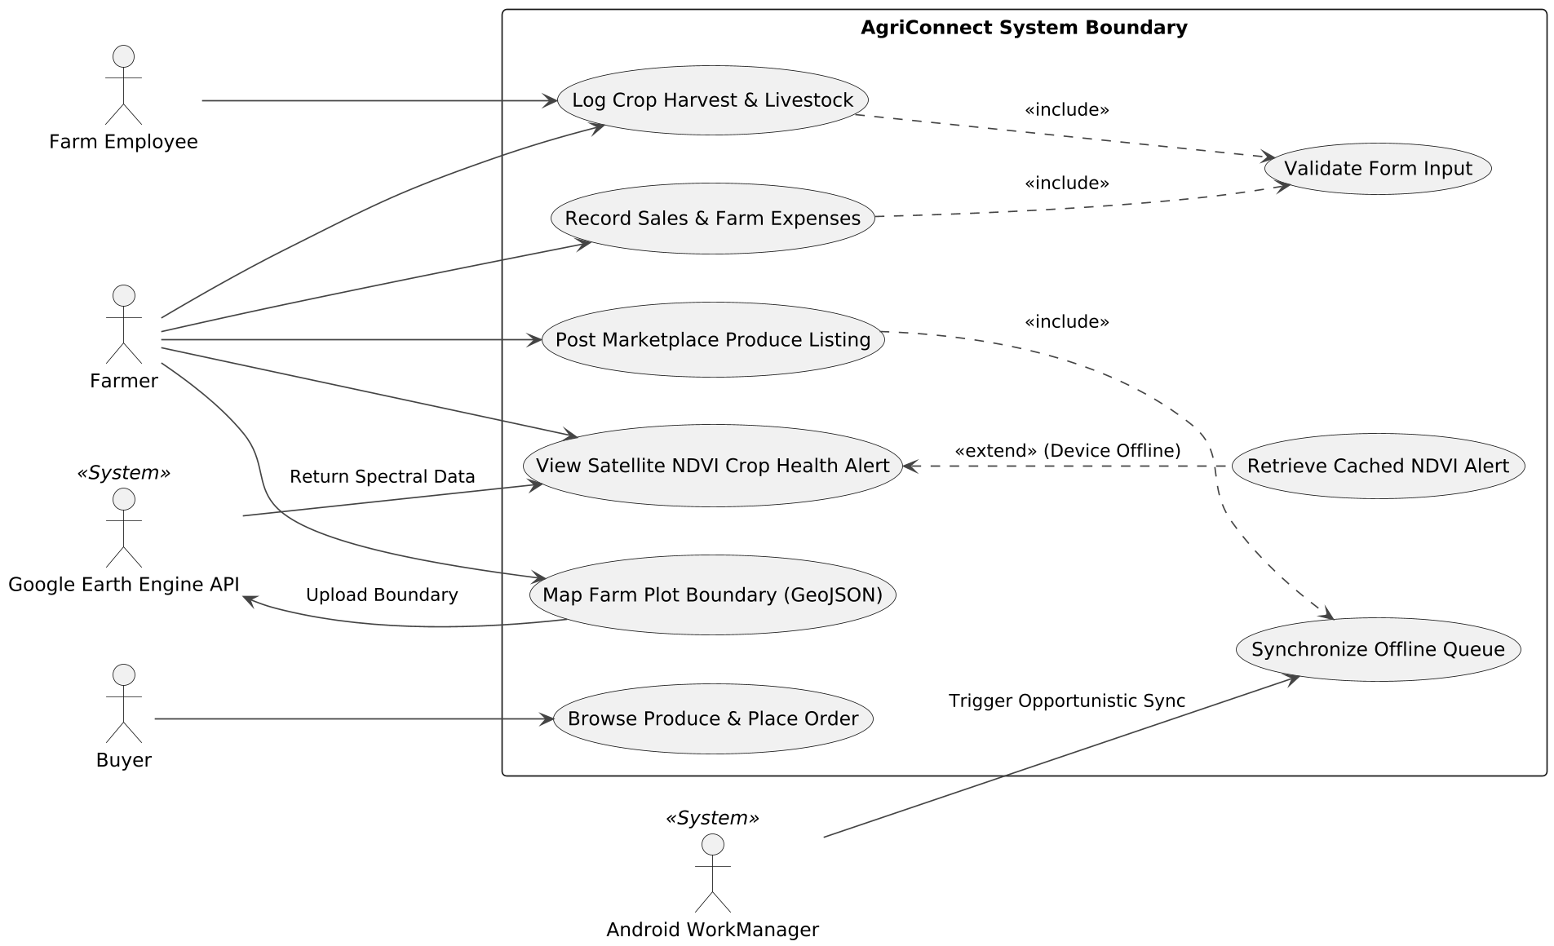
Figure 1. Use case diagram: AgriConnect system boundary
- Farmer: the main user. Logs harvests and livestock, records sales and expenses, maps plot boundaries, views satellite crop-health alerts, and posts marketplace listings.
- Farm Employee: limited to field data collection (Log Crop Harvest & Livestock).
- Buyer: browses published produce and places orders.
- System actors: Google Earth Engine API returns spectral data; Android WorkManager triggers opportunistic synchronization.
- Validate Form Input is included by the harvest, livestock, sales and expense use cases, so required fields and non-negative values are checked before anything is saved locally.
- Post Marketplace Produce Listing includes Synchronize Offline Queue, because a listing must reach the cloud to be visible.
- Retrieve Cached NDVI Alert extends View Satellite NDVI Crop Health Alert when the device is offline.

4.2 Class Diagram
Owner: Phemelo Nyambiwa. The diagram maps the domain model across the Room database on the device and the PostgreSQL database in the cloud.
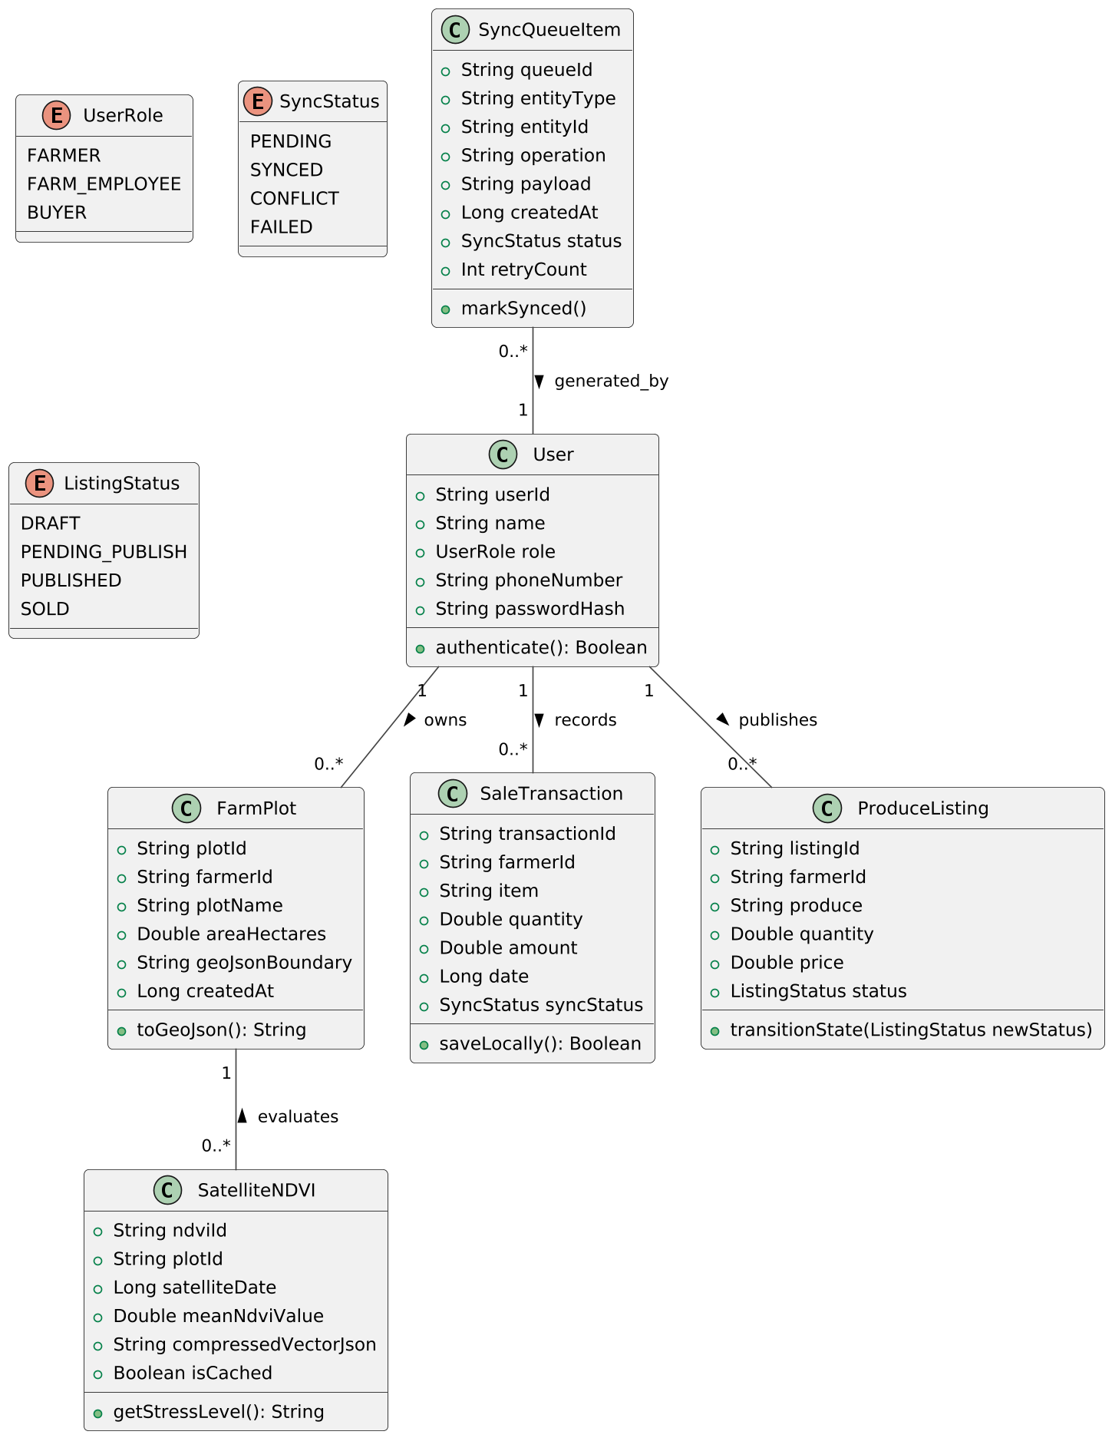
Figure 2. Class diagram: Room and domain model
- User holds identity and authorization data. Its UserRole (FARMER, FARM_EMPLOYEE, BUYER) decides what the user may do, and authenticate() checks the password hash.
- FarmPlot and SatelliteNDVI store plot boundaries as GeoJSON and the calculated vegetation index. SatelliteNDVI has an isCached flag and getStressLevel().
- SaleTransaction and ProduceListing carry the ledger and marketplace data. Each tracks its own state (SyncStatus or ListingStatus).
- SyncQueueItem is the heart of the offline engine. It records the entity type, operation, JSON payload, status and retry count for each pending change.

5. System Architecture and Physical Infrastructure

5.1 Component Diagram
Owner: Thabiso Elias Keitiile. The diagram shows the software packages and the dependencies between them.
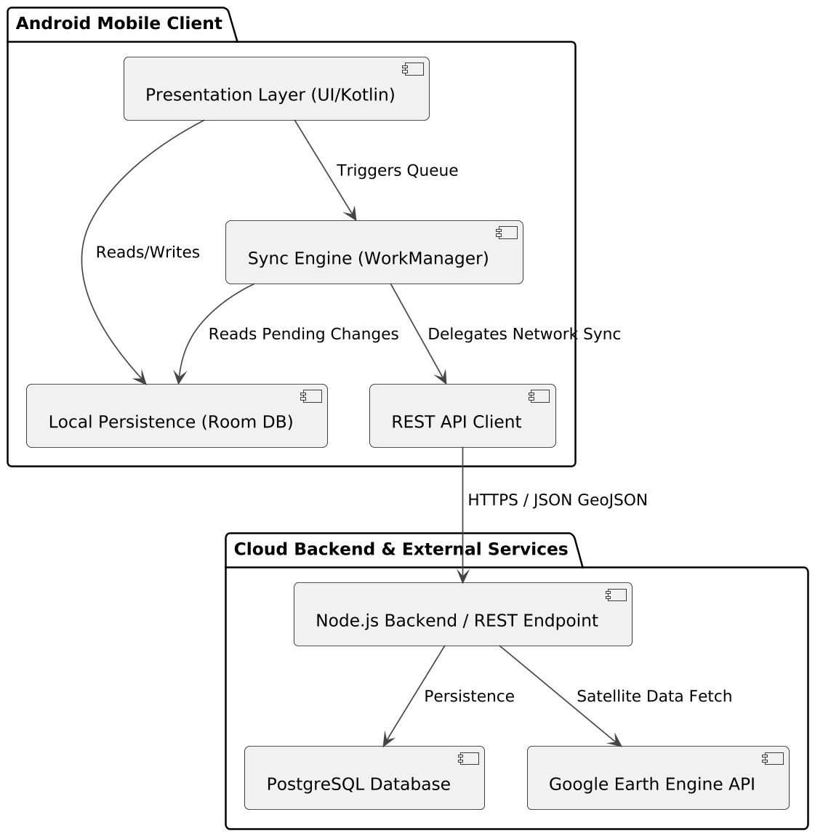
Figure 3. Component diagram: software architecture
- Presentation layer: renders views, handles forms, and reads and writes the local database. It triggers the sync queue but never calls the network directly.
- Room database: the embedded SQLite engine that acts as the device's single source of truth.
- Sync engine (WorkManager): a decoupled background service that reads pending changes, monitors connectivity, and retries with backoff.
- REST API client: serializes JSON and GeoJSON, attaches the token, and sends HTTPS requests to the backend.
- Cloud side: the Node.js backend validates payloads, enforces roles and resolves conflicts, persisting to PostgreSQL and fetching satellite data from Google Earth Engine.

5.2 Deployment Diagram
Owner: Thabiso Elias Keitiile. The diagram models the physical nodes, deployed artifacts and communication protocols.
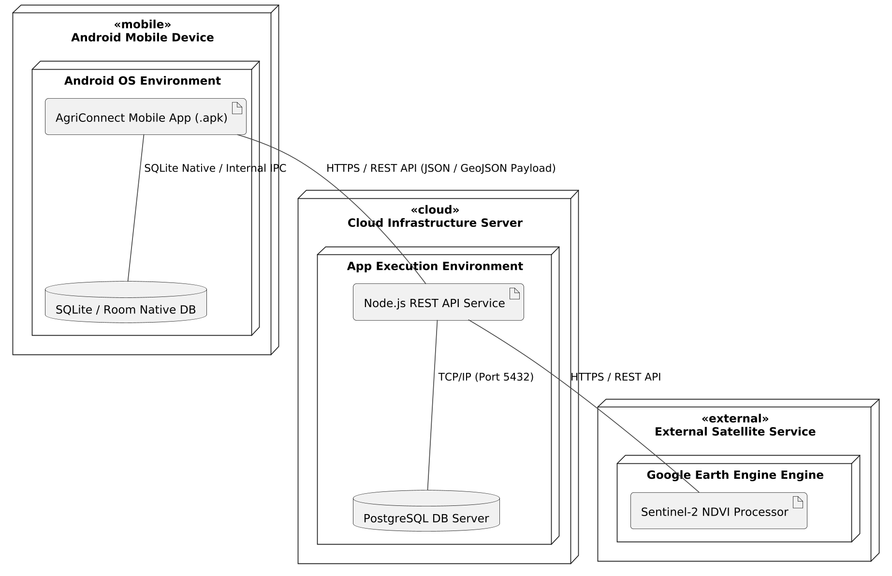
Figure 4. Deployment diagram: nodes, artifacts and protocols
- Android device: runs the AgriConnect .apk and the local SQLite/Room database.
- Cloud server: hosts the Node.js REST service and the PostgreSQL server, connected over TCP/IP on port 5432.
- External satellite service: Google Earth Engine runs the Sentinel-2 NDVI processing.
- Protocols: REST over HTTPS carrying JSON for ledger items and GeoJSON for field plots.

6. Behavioral Interactions
The two sequence diagrams are on the landscape pages that follow (Figures 5 and 6). Their explanations are given here.

6.1 Sequence Diagram 1: Offline Synchronization Workflow (Figure 5)
Owner: Donovan Ntsima. The diagram follows a transaction that is logged offline, queued, and synchronized when the network returns.
- Local commit. The farmer enters a sale or expense. The UI writes it straight to Room, so there is no waiting on the network.
- Queueing. A SyncQueueItem (operation CREATE, status PENDING) is stored, and the farmer sees "Saved Locally (Pending Sync)".
- Detection. ConnectivityMonitor detects that the network is back and signals the SyncQueueWorker.
- Batch push. For each pending item the worker sends a POST to /api/v1/sync/push with a JWT. The backend writes to PostgreSQL and resolves conflicts.
- Acknowledgment. On HTTP 200 the local item becomes SYNCED and the UI badge changes to "Synced".

6.2 Sequence Diagram 2: Satellite NDVI Push Pipeline (Figure 6)
Owner: Donovan Ntsima. The diagram covers plot mapping, the Google Earth Engine request, and alert caching.
- Spatial capture. GPS points are converted by GeoJsonMapper into a GeoJSON polygon and saved locally.
- Cloud processing (online). The Node.js server sends the polygon to Google Earth Engine, which reads Sentinel-2 Near-Infrared (Band 8) and Red (Band 4) imagery.
- Spectral calculation. Earth Engine computes NDVI = (NIR - RED) / (NIR + RED) and returns a compressed vector alert.
- Caching. The alert is shown on the map and cached in Room.
- Offline branch. The latest cached alert is displayed with a "CACHED" badge.

6.1 Sequence Diagram 1: Offline Synchronization
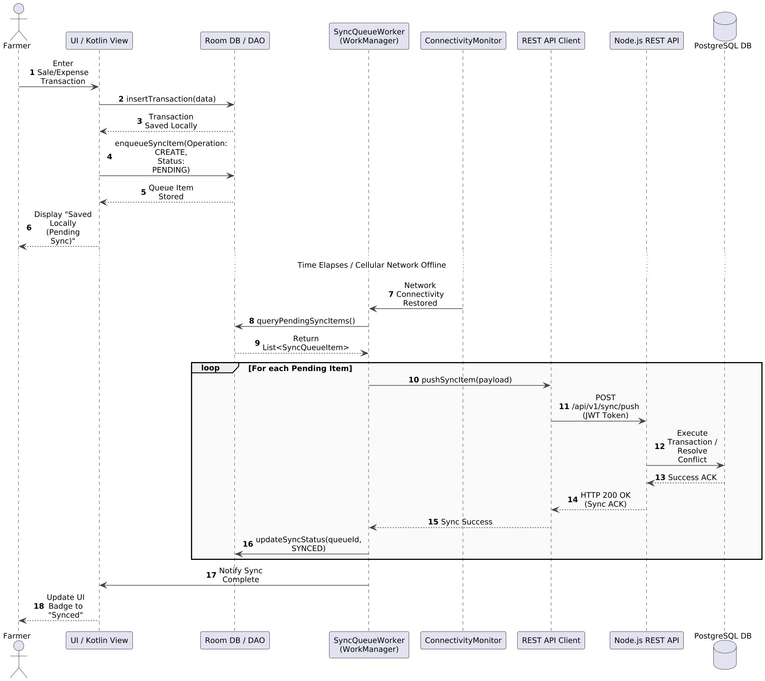
Figure 5. Sequence diagram: offline synchronization workflow

6.2 Sequence Diagram 2: Satellite NDVI Push Pipeline
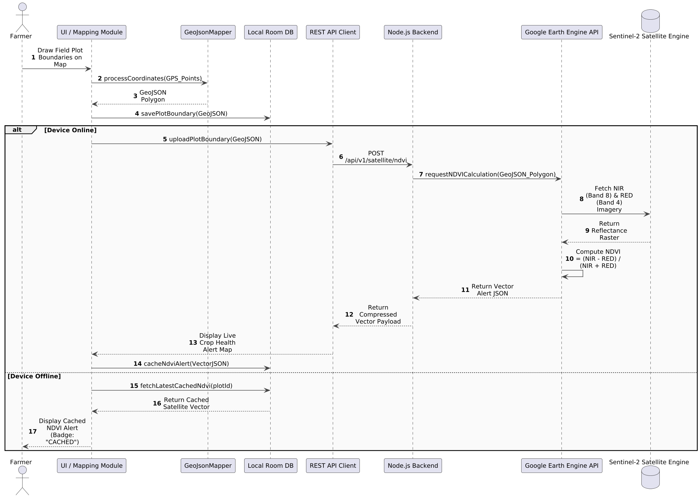
Figure 6. Sequence diagram: satellite NDVI push pipeline

7. Business Logic and State Lifecycles

7.1 Activity Diagram 1: Farm Boundary Mapping and Health Inspection
Owner: Tsholofelo Butana. The diagram shows the connectivity branch after a farmer maps a plot.
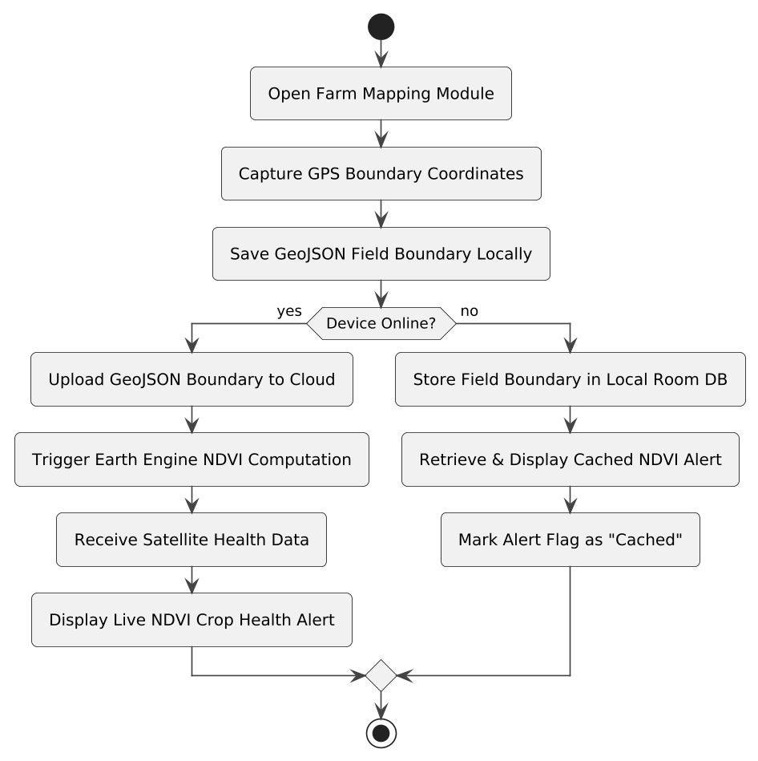
Figure 7. Activity diagram: boundary mapping and health inspection
- Online: the GeoJSON boundary is uploaded, Earth Engine computes NDVI, and the live crop-health alert is displayed.
- Offline: the boundary stays in Room, and the last cached NDVI alert is shown and flagged as cached.

7.2 Activity Diagram 2: Offline Inventory and Expense Ledger Entry
Owner: Tsholofelo Butana. The diagram covers data entry, validation, queueing and sync retry logic.
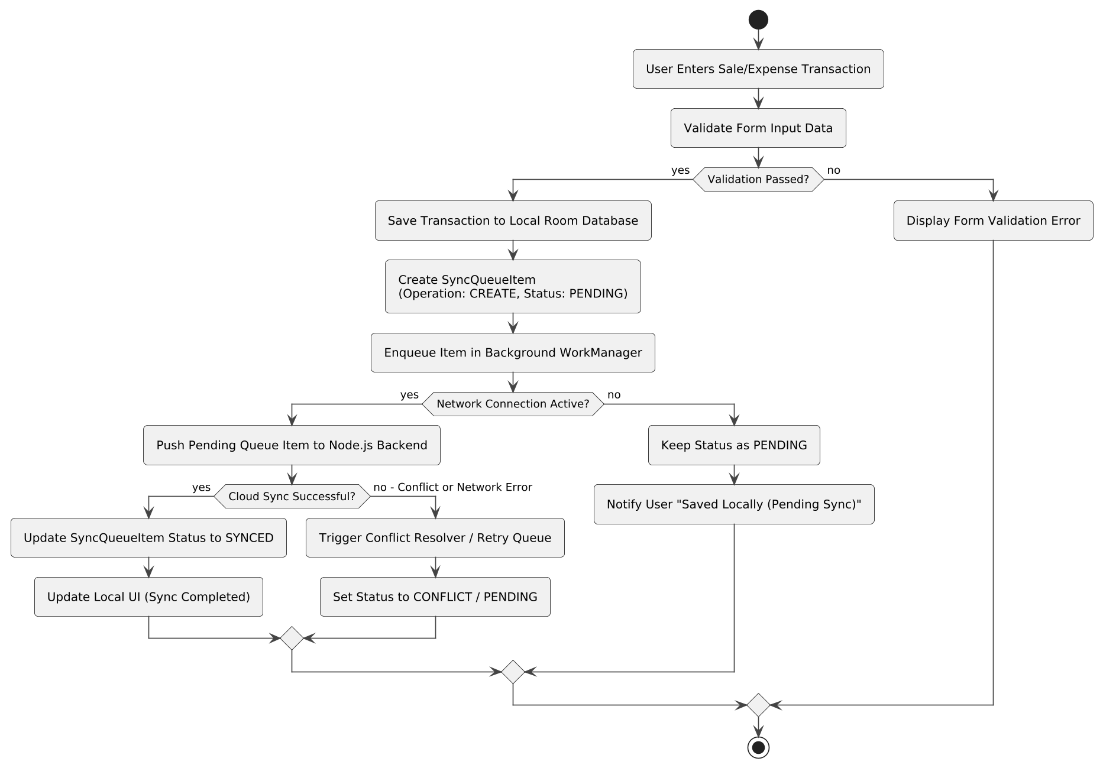
Figure 8. Activity diagram: offline ledger entry and sync decisions
- The form is validated first. Invalid input shows an error and nothing is saved.
- A valid record is saved to Room, a PENDING SyncQueueItem is created, and the item is queued in WorkManager.
- With no connection the status stays PENDING and the user is told the record is saved locally. With a connection the item is pushed, and success sets SYNCED.
- A conflict or network error goes to the conflict resolver and retry queue, with status CONFLICT or PENDING.

7.3 State Machine Diagram 1: Produce Listing Sync Lifecycle
Owner: Tsholofelo Butana. The diagram tracks a listing from local draft to sold.
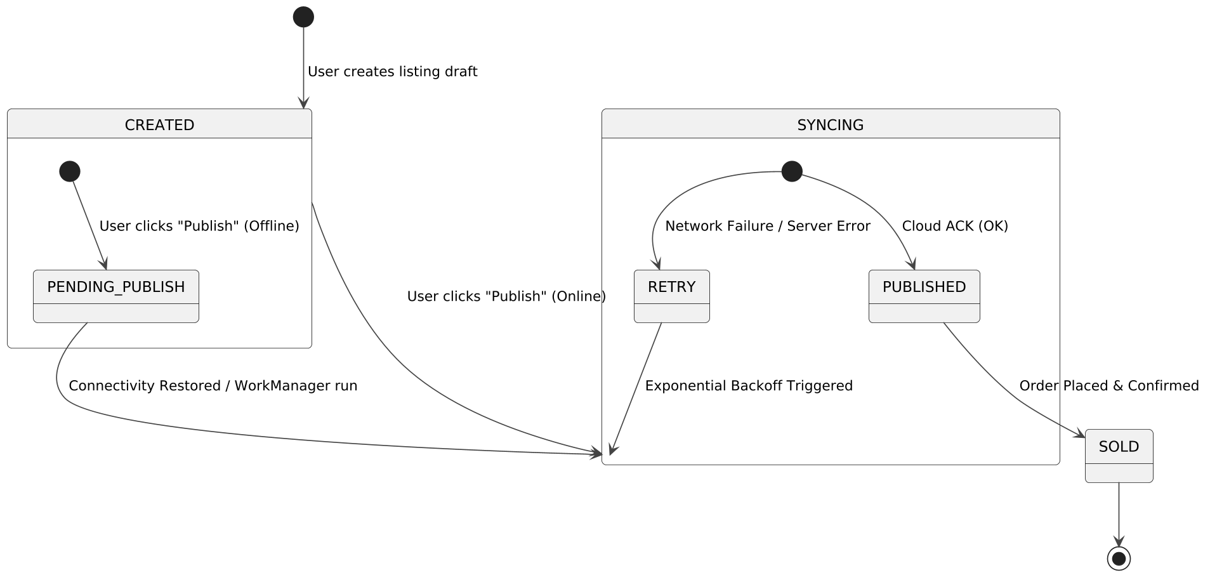
Figure 9. State machine: produce marketplace listing lifecycle
- CREATED: a draft stored locally in Room.
- PENDING_PUBLISH: the farmer pressed Publish while offline; the listing waits for connectivity.
- SYNCING and RETRY: WorkManager is uploading the listing. A network or server failure moves it to RETRY, which re-enters SYNCING after exponential backoff.
- PUBLISHED and SOLD: the cloud acknowledged the listing and buyers can see it. It becomes SOLD when an order is placed and confirmed.

7.4 State Machine Diagram 2: Satellite Imagery and NDVI Lifecycle
Owner: Tsholofelo Butana. The diagram models processing from boundary submission to caching on the phone.
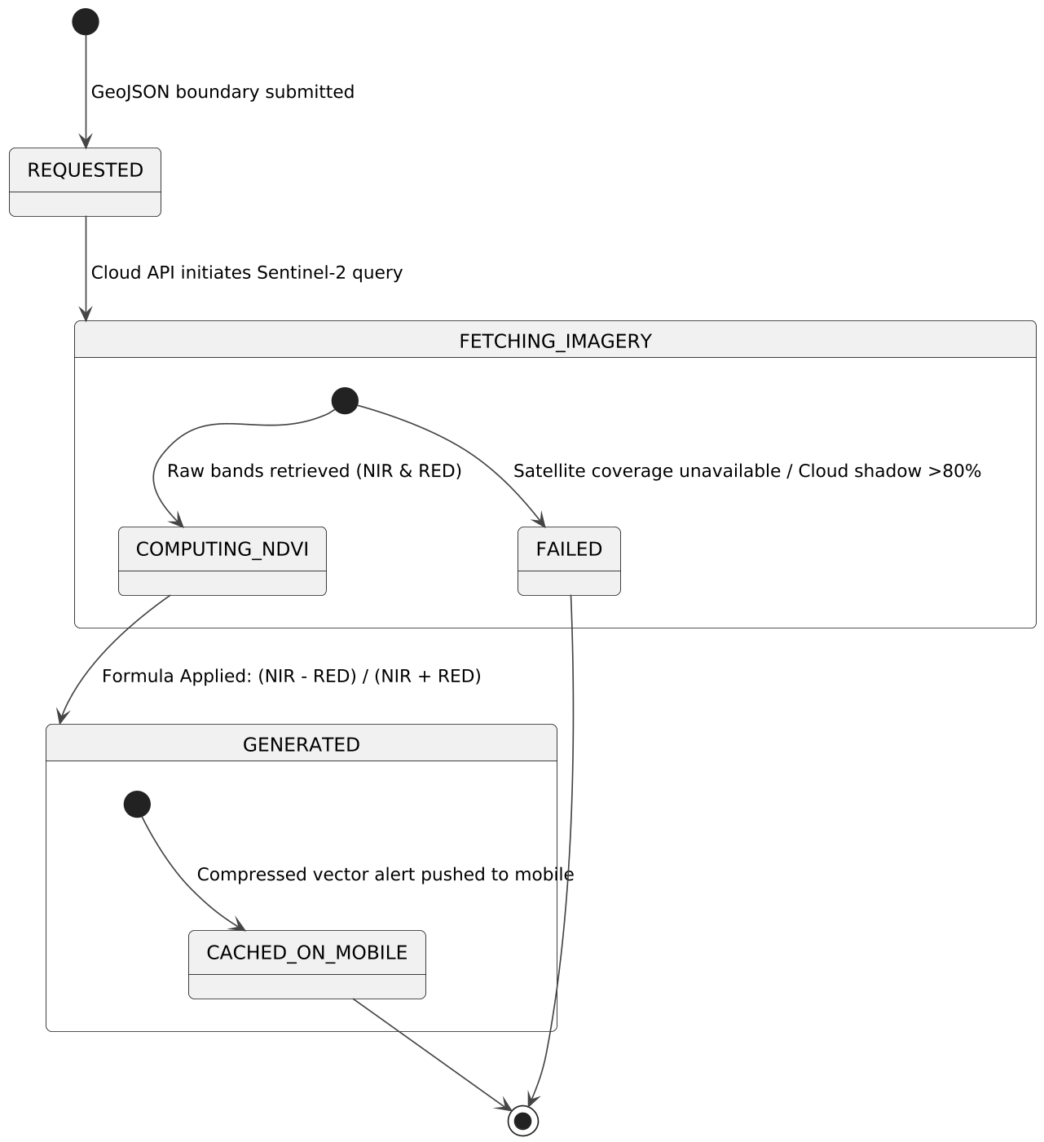
Figure 10. State machine: satellite imagery and NDVI computation lifecycle
- REQUESTED: the client submitted a GeoJSON boundary.
- FETCHING_IMAGERY: the cloud queries Sentinel-2. It moves to FAILED if coverage is unavailable or cloud cover is above 80%.
- COMPUTING_NDVI and GENERATED: the NIR and RED bands are combined with the NDVI formula, and the raster is converted to a compressed vector alert.
- CACHED_ON_MOBILE: the alert is pushed to the device and stored locally.

8. Architectural Traceability Matrix
Each diagram is mapped to the requirements it supports and the main failure it guards against. The FR and NFR identifiers below should be checked against the numbering in the final SRS before release.
Diagram | Member | Core focus | Requirements | Failure guard
Use case | Phemelo Nyambiwa | Actor interfaces and scope | FR-01, FR-02, FR-03 | Role guarding
Class | Phemelo Nyambiwa | Room and server entities | FR-04, FR-05, NFR-01 | Database validation
Component | Thabiso Keitiile | Software modules | NFR-02, NFR-03 | Decoupled modules
Deployment | Thabiso Keitiile | Hardware and network nodes | NFR-04, NFR-05 | Encrypted transport
Sequence 1 | Donovan Ntsima | Sync engine workflow | FR-10, FR-11 | Backoff retries
Sequence 2 | Donovan Ntsima | NDVI satellite pipeline | FR-20, FR-21 | Local caching
Activity (x2) | Tsholofelo Butana | Process and decision logic | FR-30, FR-31 | Form validation
State machine (x2) | Tsholofelo Butana | Entity state transitions | FR-40, FR-41 | Conflict resolver

9. Resolution of the Open Requirements
The SRS lists open requirements that needed confirmation. The table answers each one from the diagrams above. Status shows whether the diagrams settle the question fully, partly, or not at all. One decision is already fixed: the system has no facial recognition feature.
# | Open question | Answer from the diagrams | Status
1 | Access-control approach (facial recognition or motion capture) | Facial recognition is not part of the system. Access is by user account: authenticate() checks a password hash, each user has a UserRole, and the Node.js backend enforces role-based access with a JWT on API calls. No camera or motion-sensor component appears in any diagram. | Resolved: remove the biometric access-control requirements from the SRS
2 | Exact user roles and permissions | Three roles: FARMER, FARM_EMPLOYEE, BUYER. The permission matrix below is taken from the use case diagram. | Resolved
3 | Database fields and validation rules | Fields are defined in the class diagram for User, FarmPlot, SatelliteNDVI, SaleTransaction, ProduceListing and SyncQueueItem. Validation: required fields and non-negative values are checked before saving locally. No entities exist yet for harvest, livestock, expenses or orders. | Partly resolved: add the missing entities
4 | Marketplace workflow after buyer interest | Listings move CREATED, then PENDING_PUBLISH or SYNCING, then PUBLISHED, then SOLD when an order is placed and confirmed. Buyers browse and place orders. Not yet defined: who confirms an order, how the farmer and buyer are notified, and how payment and delivery are handled. | Partly resolved
5 | Numerical performance thresholds | The only numeric rule in the diagrams is that imagery fails when cloud cover is above 80%. Sync latency, sync success rate, retry intervals and NDVI accuracy have no values yet. | Decision needed: set them from the benchmarking data
6 | Satellite retrieval schedule and alert thresholds | Retrieval is on demand. It starts when the farmer submits a plot boundary while online. Earth Engine computes NDVI from Sentinel-2 Band 8 and Band 4, and the result is cached on the device. Offline users see the cached alert with a CACHED badge. There is no background schedule, and the stress levels returned by getStressLevel() have no defined NDVI ranges. | Partly resolved: define NDVI stress ranges
7 | Final backend and mobile technology | Kotlin Android app with Room (SQLite) and WorkManager; REST over HTTPS with JWT; Node.js REST backend; PostgreSQL; Google Earth Engine with Sentinel-2 imagery. | Resolved
8 | Security and retention policy for biometric images | No longer applies, because no biometric images are captured. The personal data that remains is names, phone numbers, password hashes and plot locations. Replace this item with a short data-protection statement: hashed passwords, TLS in transit, role-limited access, and a retention rule for plot data. | Closed: replace with a data-protection note

9.1 Role permission matrix
Capability (use case) | Farmer | Farm Employee | Buyer
Log crop harvest and livestock | Yes | Yes | No
Record sales and farm expenses | Yes | No | No
Map farm plot boundary | Yes | No | No
View satellite NDVI crop health alert | Yes | No | No
Post marketplace produce listing | Yes | No | No
Browse produce and place order | No | No | Yes
Synchronize offline queue | Automatic (WorkManager) | Automatic (WorkManager) | Not applicable

10. Design Review Notes
These gaps were found while comparing the diagrams with each other and with the open requirements. None blocks development, but each should be fixed before the design is frozen.
- Missing entities. The use cases include harvest, livestock and expense logging, and buyers placing orders, but the class diagram has no HarvestRecord, LivestockCount, Expense, Order or Notification classes. SaleTransaction is the only ledger entity.
- Sync status coverage. Only SaleTransaction carries a syncStatus. Every synchronized entity needs one, or must be tracked through SyncQueueItem.
- Failure path in Sequence 1. The sequence shows only the success case. Add an alternative for conflict and network failure showing retryCount and backoff, matching Activity Diagram 2 and State Machine 1.
- Listing state naming. ListingStatus lists DRAFT, PENDING_PUBLISH, PUBLISHED and SOLD, but the state machine uses CREATED, SYNCING and RETRY. In the state machine, PUBLISHED is drawn inside SYNCING, although it is a stable state. Align the names and move PUBLISHED outside SYNCING.
- Conflicts versus retries. Activity Diagram 2 sends both conflicts and network errors to one step. A network error should retry with backoff; a data conflict should go to the conflict resolver (for example LastWriteWinsResolver).
- Use case notation. UML associations have no direction, so the labeled arrows between the plot-mapping use case and Google Earth Engine are better shown as plain lines, with the data flow left to the sequence diagram. Consider whether Android WorkManager is an external actor or part of the system.
- Traceability IDs. Confirm that FR-01 to FR-41 and NFR-01 to NFR-05 match the numbering in the SRS.

11. Recommended Next Steps
- Release SRS v1.0. Apply Section 9: remove the facial recognition and biometric requirements, the matching evaluation measures and the image-retention item, and describe role-based login instead. Correct the school name to "Botswana School of Business and Science", fix the duplicated section numbers, and fill in the version.
- Close the design gaps. Work through Section 10: the class diagram owner adds the missing entities and an order lifecycle; the sequence owner adds the failure path; the state machine owner aligns the listing states.
- Collect the data that sets the numbers. Use the network benchmarking and latency logs to set sync latency and retry values, the farmer survey to confirm the marketplace workflow, and an agronomy source to set NDVI stress ranges.
- Freeze architecture v1 and set up the project. Create the Android project (Kotlin, Room, WorkManager), the Node.js and PostgreSQL backend skeleton, and the Google Earth Engine access.
- Build the first vertical slice. Record a sale offline, queue it, sync it, and confirm it in PostgreSQL. This proves the riskiest part of the design first. Then add the NDVI pipeline and the marketplace.
- Write test cases from the requirements. Map each test to an FR or NFR identifier so the traceability matrix drives testing.

Appendix A: PlantUML Source
The diagrams in this document were rendered from the following PlantUML source. Paste any block into a PlantUML renderer to edit and regenerate it.

A.1 Use case diagram
@startuml
left to right direction
skinparam packageStyle rectangle

actor "Farmer" as farmer
actor "Farm Employee" as employee
actor "Buyer" as buyer
actor "Google Earth Engine API" as GEE << System >>
actor "Android WorkManager" as worker << System >>

rectangle "AgriConnect System Boundary" {
usecase "Log Crop Harvest & Livestock" as UC_LogField
usecase "Record Sales & Farm Expenses" as UC_RecordFinance
usecase "Map Farm Plot Boundary (GeoJSON)" as UC_MapPlot
usecase "View Satellite NDVI Crop Health Alert" as UC_ViewNDVI
usecase "Post Marketplace Produce Listing" as UC_PostListing
usecase "Browse Produce & Place Order" as UC_BrowseOrder
usecase "Synchronize Offline Queue" as UC_SyncQueue
usecase "Validate Form Input" as UC_Validate
usecase "Retrieve Cached NDVI Alert" as UC_CacheNDVI
}

farmer --> UC_LogField
farmer --> UC_RecordFinance
farmer --> UC_MapPlot
farmer --> UC_ViewNDVI
farmer --> UC_PostListing

employee --> UC_LogField

buyer --> UC_BrowseOrder

UC_RecordFinance ..> UC_Validate : <<include>>
UC_LogField ..> UC_Validate : <<include>>
UC_PostListing ..> UC_SyncQueue : <<include>>

UC_ViewNDVI <.. UC_CacheNDVI : <<extend>> (Device Offline)

UC_MapPlot --> GEE : Upload Boundary
GEE --> UC_ViewNDVI : Return Spectral Data
worker --> UC_SyncQueue : Trigger Opportunistic Sync
@enduml

A.2 Class diagram
@startuml
enum UserRole {
FARMER
FARM_EMPLOYEE
BUYER
}

enum SyncStatus {
PENDING
SYNCED
CONFLICT
FAILED
}

enum ListingStatus {
DRAFT
PENDING_PUBLISH
PUBLISHED
SOLD
}

class User {
+ String userId
+ String name
+ UserRole role
+ String phoneNumber
+ String passwordHash
+ authenticate(): Boolean
}

class FarmPlot {
+ String plotId
+ String farmerId
+ String plotName
+ Double areaHectares
+ String geoJsonBoundary
+ Long createdAt
+ toGeoJson(): String
}

class SatelliteNDVI {
+ String ndviId
+ String plotId
+ Long satelliteDate
+ Double meanNdviValue
+ String compressedVectorJson
+ Boolean isCached
+ getStressLevel(): String
}

class SaleTransaction {
+ String transactionId
+ String farmerId
+ String item
+ Double quantity
+ Double amount
+ Long date
+ SyncStatus syncStatus
+ saveLocally(): Boolean
}

class ProduceListing {
+ String listingId
+ String farmerId
+ String produce
+ Double quantity
+ Double price
+ ListingStatus status
+ transitionState(ListingStatus newStatus)
}

class SyncQueueItem {
+ String queueId
+ String entityType
+ String entityId
+ String operation
+ String payload
+ Long createdAt
+ SyncStatus status
+ Int retryCount
+ markSynced()
}

User "1" -- "0..*" FarmPlot : owns >
FarmPlot "1" -- "0..*" SatelliteNDVI : evaluates <
User "1" -- "0..*" SaleTransaction : records >
User "1" -- "0..*" ProduceListing : publishes >
SyncQueueItem "0..*" -- "1" User : generated_by >
@enduml

A.3 Component diagram
@startuml
package "Android Mobile Client" {
[Presentation Layer (UI/Kotlin)] as UI
[Local Persistence (Room DB)] as DB
[Sync Engine (WorkManager)] as Sync
[REST API Client] as APIClient

UI --> DB : Reads/Writes
UI --> Sync : Triggers Queue
Sync --> DB : Reads Pending Changes
Sync --> APIClient : Delegates Network Sync
}

package "Cloud Backend & External Services" {
[Node.js Backend / REST Endpoint] as Node
[PostgreSQL Database] as Postgres
[Google Earth Engine API] as GEE

Node --> Postgres : Persistence
Node --> GEE : Satellite Data Fetch
}

APIClient --> Node : HTTPS / JSON GeoJSON
@enduml

A.4 Deployment diagram
@startuml
node "<<mobile>>\nAndroid Mobile Device" as mobileNode {
node "Android OS Environment" {
artifact "AgriConnect Mobile App (.apk)" as appArtifact
database "SQLite / Room Native DB" as localDbArtifact
}
}

node "<<cloud>>\nCloud Infrastructure Server" as cloudNode {
node "App Execution Environment" {
artifact "Node.js REST API Service" as nodeArtifact
database "PostgreSQL DB Server" as postgresArtifact
}
}

node "<<external>>\nExternal Satellite Service" as satelliteNode {
node "Google Earth Engine Engine" {
artifact "Sentinel-2 NDVI Processor" as geeArtifact
}
}

appArtifact -- localDbArtifact : SQLite Native / Internal IPC
appArtifact -- nodeArtifact : HTTPS / REST API (JSON / GeoJSON Payload)
nodeArtifact -- postgresArtifact : TCP/IP (Port 5432)
nodeArtifact -- geeArtifact : HTTPS / REST API
@enduml

A.5 Sequence diagram 1: offline sync
@startuml
autonumber
actor Farmer
participant "UI / Kotlin View" as UI
participant "Room DB / DAO" as DB
participant "SyncQueueWorker\n(WorkManager)" as Worker
participant "ConnectivityMonitor" as Monitor
participant "REST API Client" as API
participant "Node.js REST API" as Server
database "PostgreSQL DB" as CloudDB

Farmer -> UI : Enter Sale/Expense Transaction
UI -> DB : insertTransaction(data)
DB --> UI : Transaction Saved Locally
UI -> DB : enqueueSyncItem(Operation: CREATE, Status: PENDING)
DB --> UI : Queue Item Stored
UI --> Farmer : Display "Saved Locally (Pending Sync)"

... Time Elapses / Cellular Network Offline ...

Monitor -> Worker : Network Connectivity Restored
Worker -> DB : queryPendingSyncItems()
DB --> Worker : Return List<SyncQueueItem>

loop For each Pending Item
Worker -> API : pushSyncItem(payload)
API -> Server : POST /api/v1/sync/push (JWT Token)
Server -> CloudDB : Execute Transaction / Resolve Conflict
CloudDB --> Server : Success ACK
Server --> API : HTTP 200 OK (Sync ACK)
API --> Worker : Sync Success
Worker -> DB : updateSyncStatus(queueId, SYNCED)
end

Worker -> UI : Notify Sync Complete
UI --> Farmer : Update UI Badge to "Synced"
@enduml

A.6 Sequence diagram 2: NDVI pipeline
@startuml
autonumber
actor Farmer
participant "UI / Mapping Module" as UI
participant "GeoJsonMapper" as Mapper
participant "Local Room DB" as DB
participant "REST API Client" as API
participant "Node.js Backend" as Server
participant "Google Earth Engine API" as GEE
database "Sentinel-2 Satellite Engine" as SatEngine

Farmer -> UI : Draw Field Plot Boundaries on Map
UI -> Mapper : processCoordinates(GPS_Points)
Mapper --> UI : GeoJSON Polygon
UI -> DB : savePlotBoundary(GeoJSON)

alt Device Online
UI -> API : uploadPlotBoundary(GeoJSON)
API -> Server : POST /api/v1/satellite/ndvi
Server -> GEE : requestNDVICalculation(GeoJSON_Polygon)
GEE -> SatEngine : Fetch NIR (Band 8) & RED (Band 4) Imagery
SatEngine --> GEE : Return Reflectance Raster
GEE -> GEE : Compute NDVI = (NIR - RED) / (NIR + RED)
GEE --> Server : Return Vector Alert JSON
Server --> API : Return Compressed Vector Payload
API --> UI : Display Live Crop Health Alert Map
UI -> DB : cacheNdviAlert(VectorJSON)
else Device Offline
UI -> DB : fetchLatestCachedNdvi(plotId)
DB --> UI : Return Cached Satellite Vector
UI --> Farmer : Display Cached NDVI Alert (Badge: "CACHED")
end
@enduml

A.7 Activity diagram 1: boundary mapping
@startuml
start
:Open Farm Mapping Module;
:Capture GPS Boundary Coordinates;
:Save GeoJSON Field Boundary Locally;

if (Device Online?) then (yes)
:Upload GeoJSON Boundary to Cloud;
:Trigger Earth Engine NDVI Computation;
:Receive Satellite Health Data;
:Display Live NDVI Crop Health Alert;
else (no)
:Store Field Boundary in Local Room DB;
:Retrieve & Display Cached NDVI Alert;
:Mark Alert Flag as "Cached";
endif

stop
@enduml

A.8 Activity diagram 2: ledger entry
@startuml
start
:User Enters Sale/Expense Transaction;
:Validate Form Input Data;

if (Validation Passed?) then (yes)
:Save Transaction to Local Room Database;
:Create SyncQueueItem\n(Operation: CREATE, Status: PENDING);
:Enqueue Item in Background WorkManager;

if (Network Connection Active?) then (yes)
:Push Pending Queue Item to Node.js Backend;
if (Cloud Sync Successful?) then (yes)
:Update SyncQueueItem Status to SYNCED;
:Update Local UI (Sync Completed);
else (no - Conflict or Network Error)
:Trigger Conflict Resolver / Retry Queue;
:Set Status to CONFLICT / PENDING;
endif
else (no)
:Keep Status as PENDING;
:Notify User "Saved Locally (Pending Sync)";
endif
else (no)
:Display Form Validation Error;
endif

stop
@enduml

A.9 State machine 1: listing lifecycle
@startuml
[*] --> CREATED : User creates listing draft

state CREATED {
[*] --> PENDING_PUBLISH : User clicks "Publish" (Offline)
}

CREATED --> SYNCING : User clicks "Publish" (Online)
PENDING_PUBLISH --> SYNCING : Connectivity Restored / WorkManager run

state SYNCING {
state PUBLISHED
state RETRY

[*] --> PUBLISHED : Cloud ACK (OK)
[*] --> RETRY : Network Failure / Server Error
RETRY --> SYNCING : Exponential Backoff Triggered
}

PUBLISHED --> SOLD : Order Placed & Confirmed
SOLD --> [*]
@enduml

A.10 State machine 2: NDVI lifecycle
@startuml
[*] --> REQUESTED : GeoJSON boundary submitted

REQUESTED --> FETCHING_IMAGERY : Cloud API initiates Sentinel-2 query

state FETCHING_IMAGERY {
[*] --> FAILED : Satellite coverage unavailable / Cloud shadow >80%
[*] --> COMPUTING_NDVI : Raw bands retrieved (NIR & RED)
}

COMPUTING_NDVI --> GENERATED : Formula Applied: (NIR - RED) / (NIR + RED)

state GENERATED {
[*] --> CACHED_ON_MOBILE : Compressed vector alert pushed to mobile
}

FAILED --> [*]
CACHED_ON_MOBILE --> [*]
@enduml

