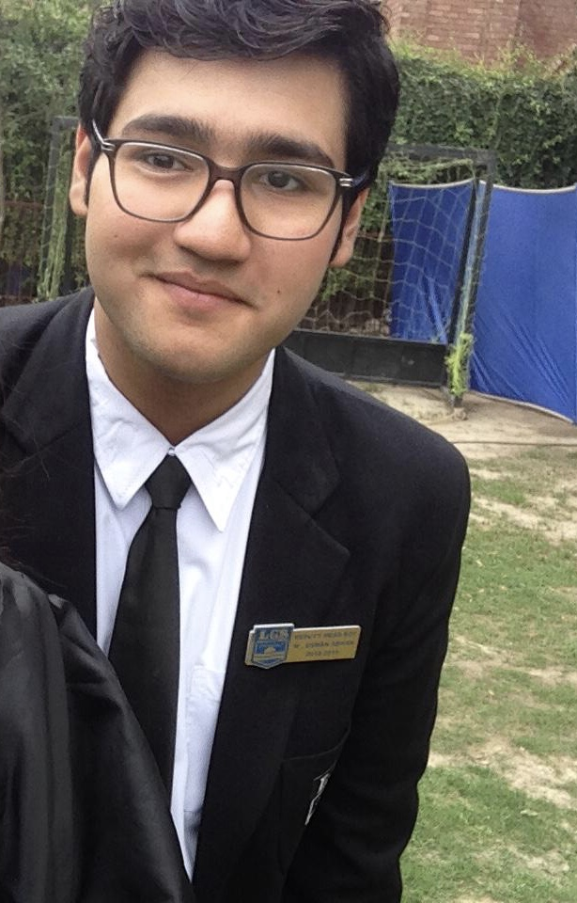

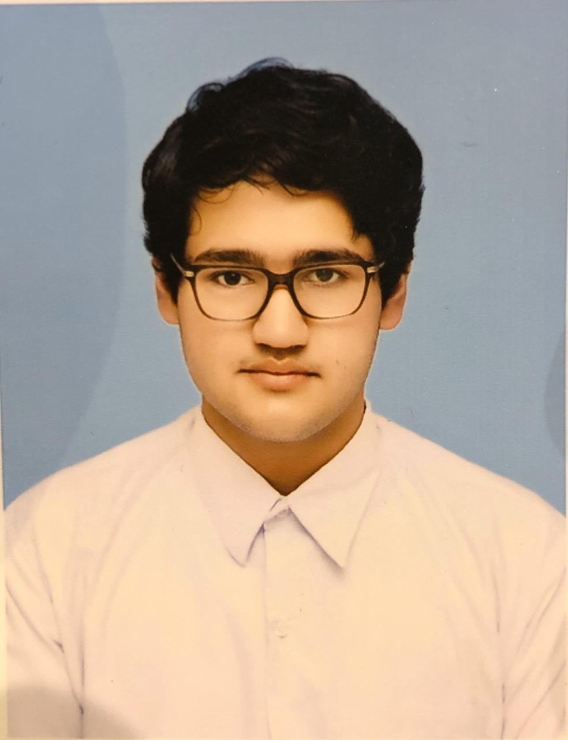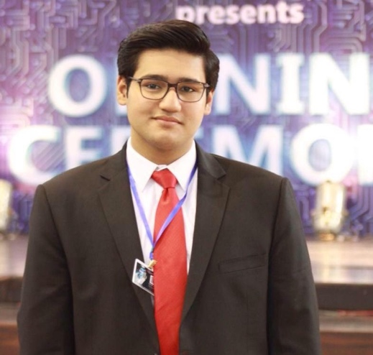

**-Email:** [u.amz@live.com](mailto:u.amz@live.com)

**-Phone:** 0334-4254111

**-Area:** Saddar, Karachi

**-**Cooking

**-**Writing

**-**Videography & Video Editing

**-Internship:** Community Service at WWF Pakistan (2018)

**-Summer-school:** Juvenile cooking course at SCAFA (2016)

**-Student Council Position:** Deputy Head Boy at LGS Paragon(2018-19)

**-A-Level Subjects:** Maths, Physics, Chemistry & Biology

**-O-Level Subjects:** Science Group & Food And Nutrition

**-Domicile Province:** Punjab

**-Domicile City:** Lahore

**-Schooling:** LGS Paragon

**-Currently:** Majoring in Computer Science at IBA Karachi (Freshman)

**HOBBIES**

**EDUCATION**

**PROFILE**

**EXPERIENCE**

**CONTACT**

*CURRICULUM VITAE*

*CURRICULUM VITAE*

**MUHAMMAD USMAN ADNAN**