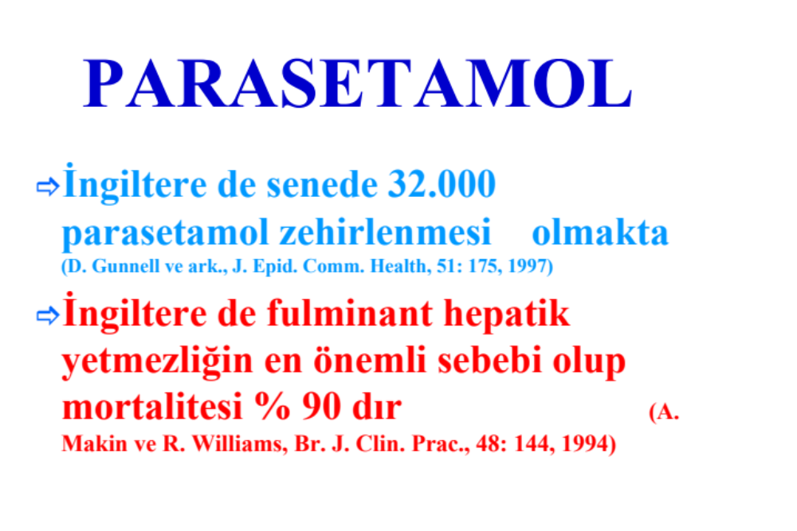

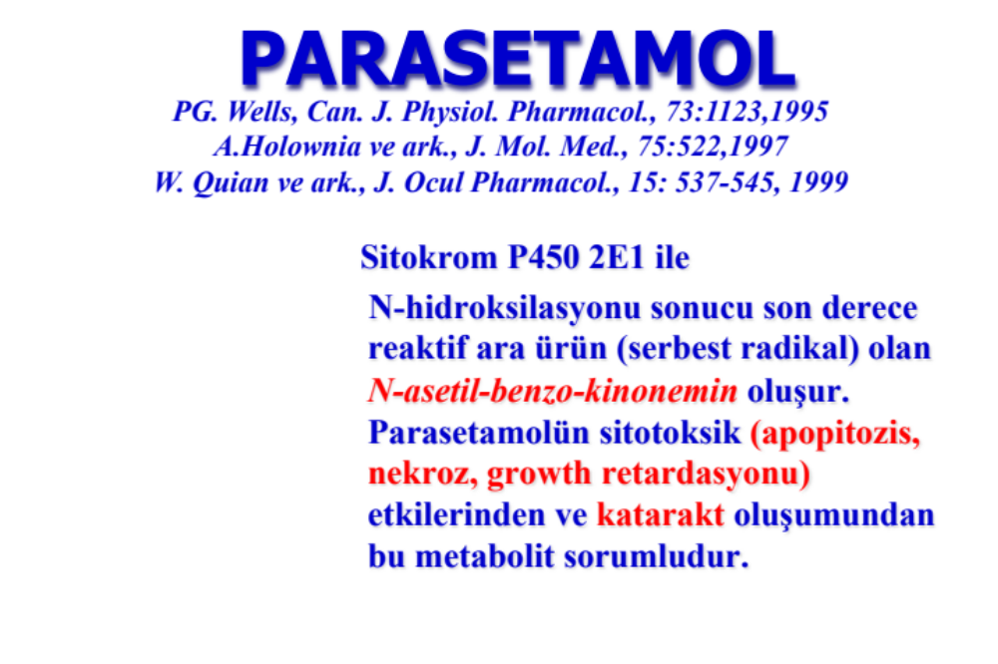

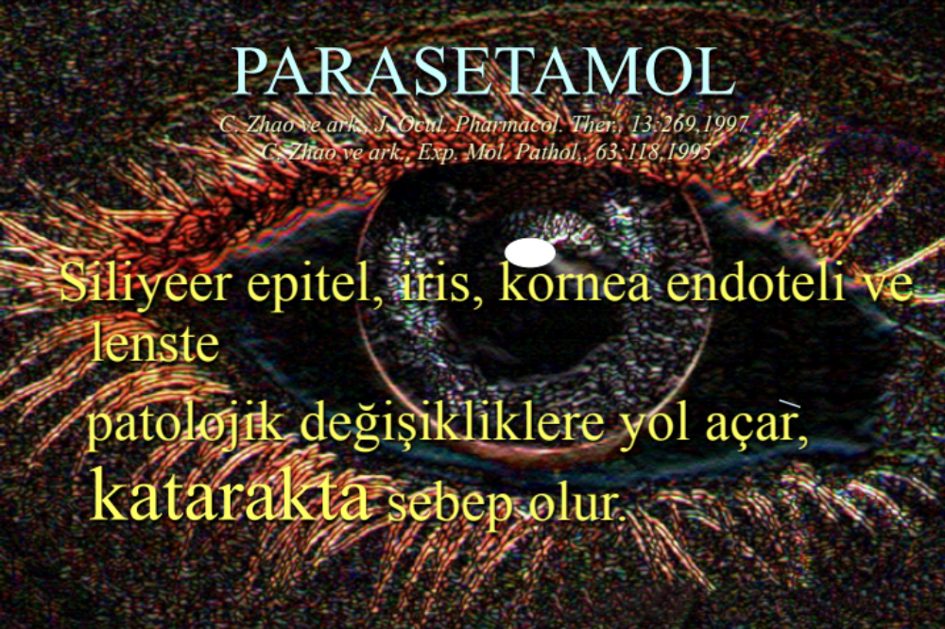

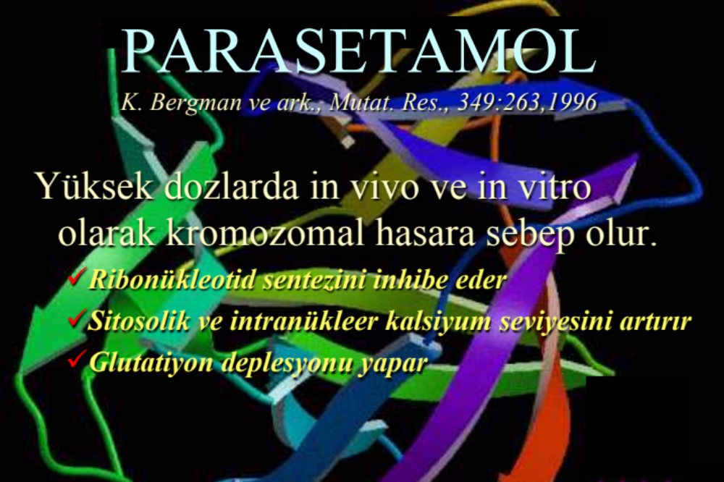

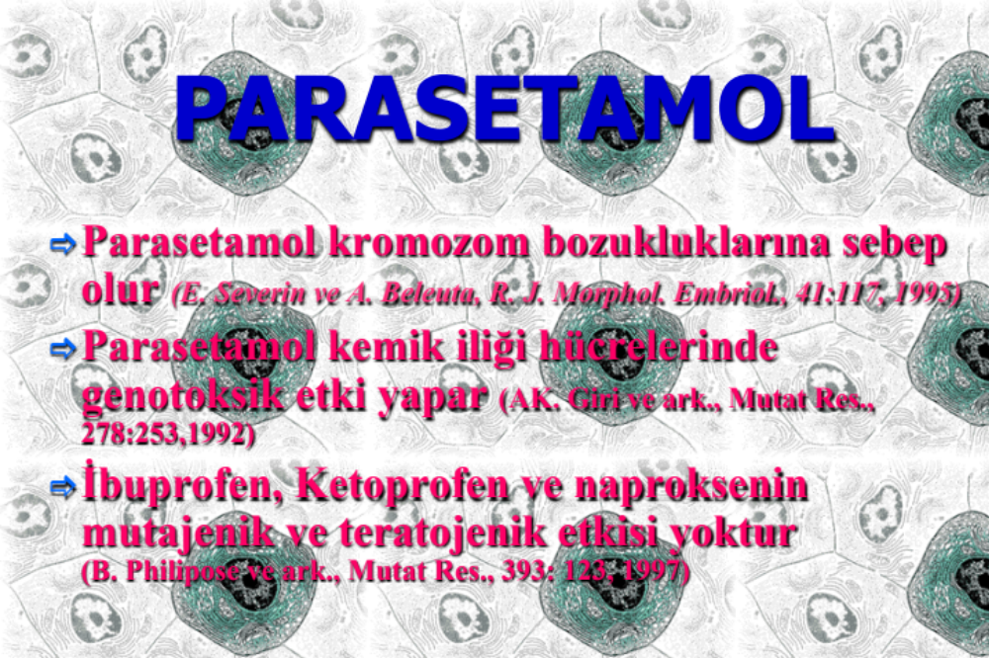

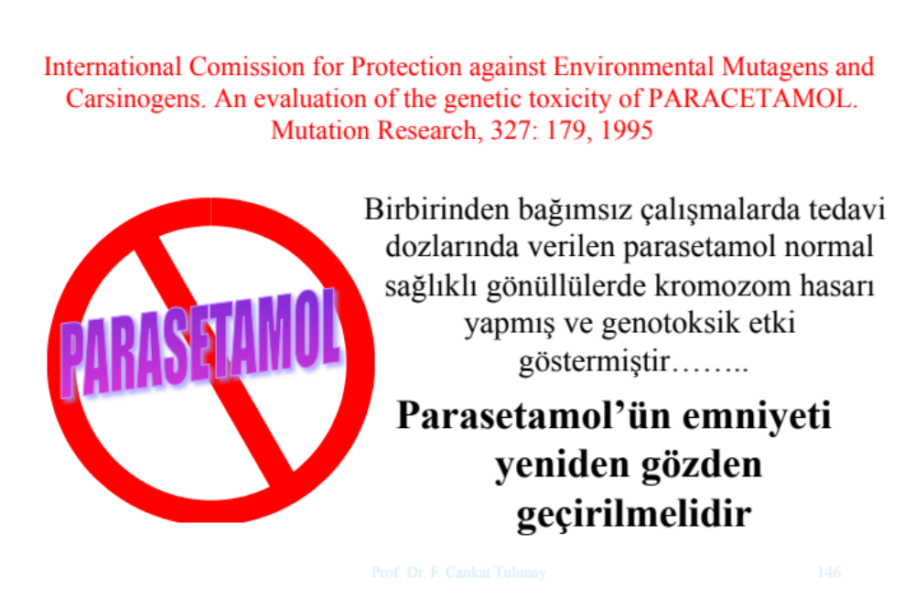

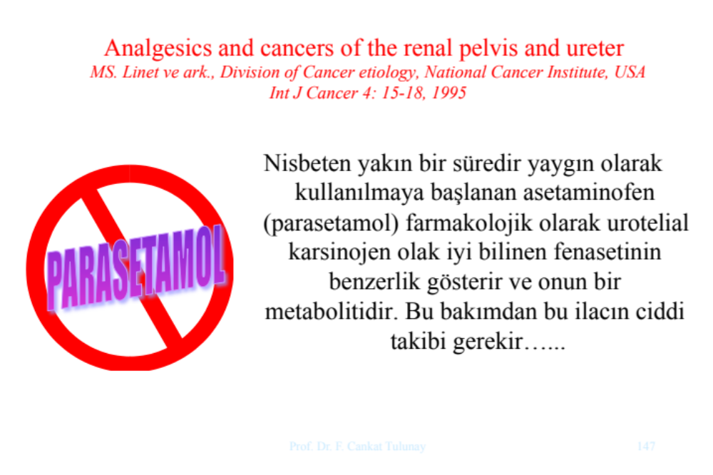

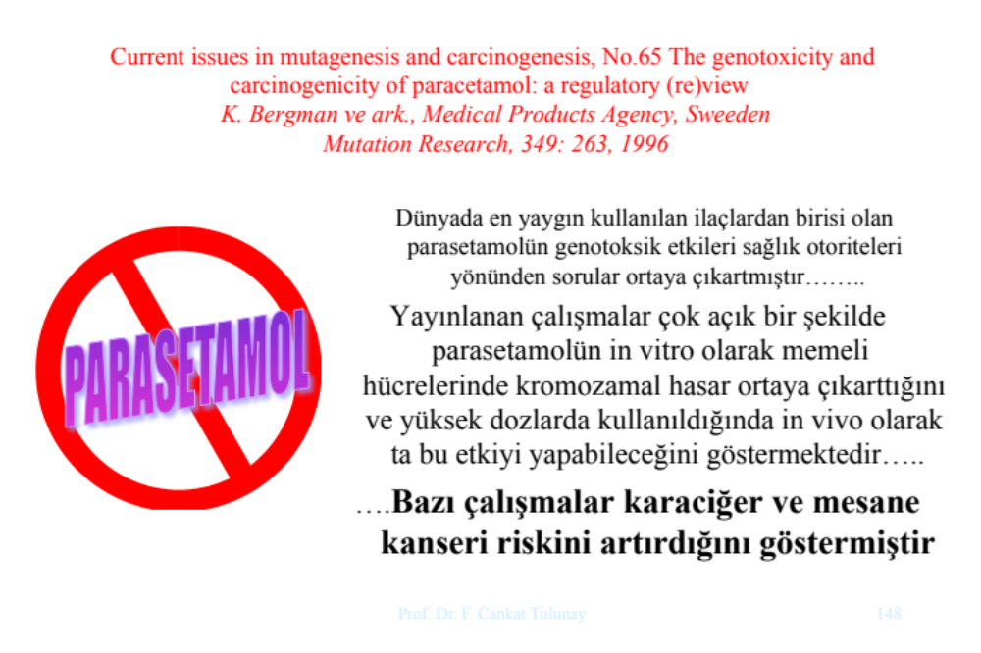

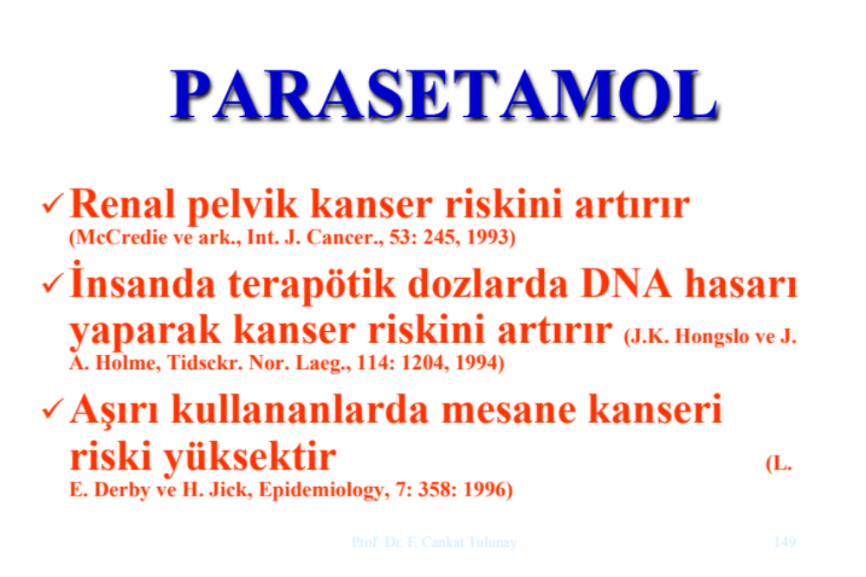

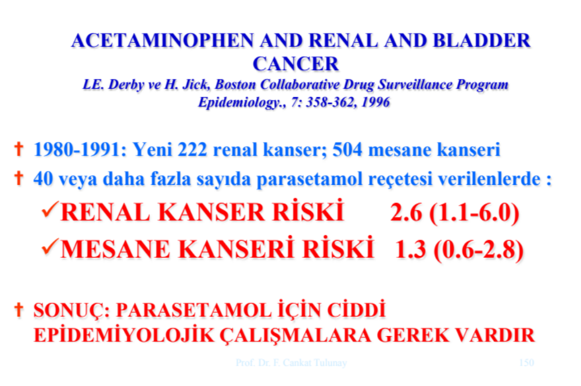

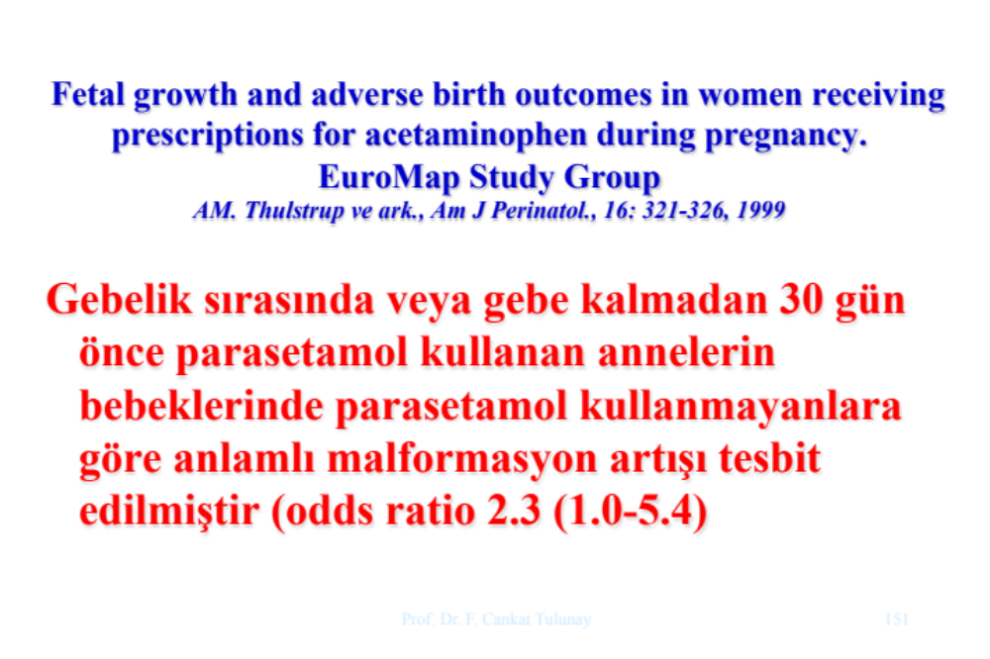

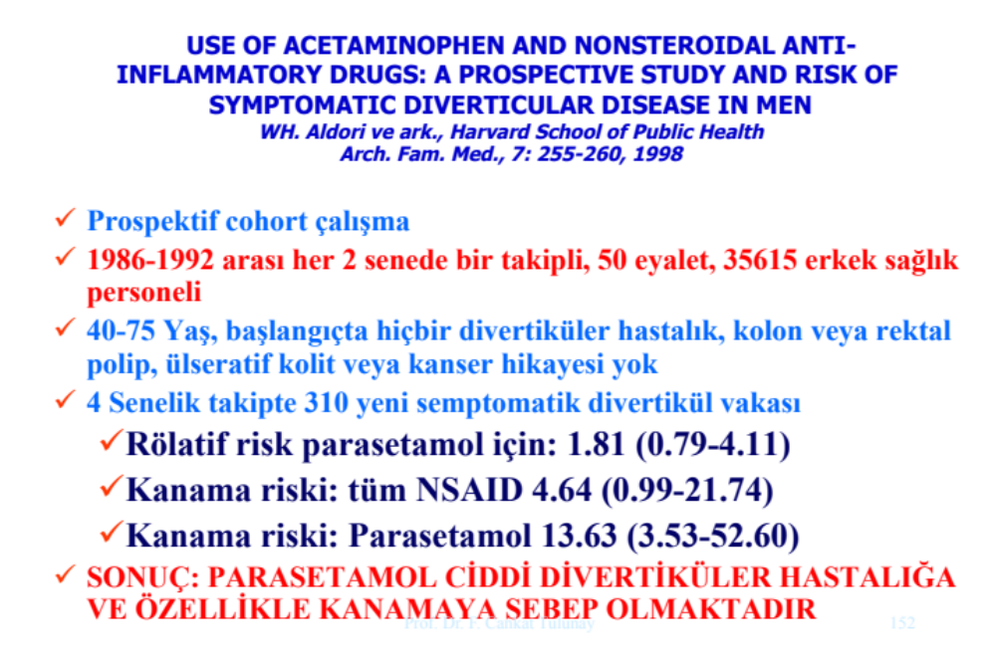

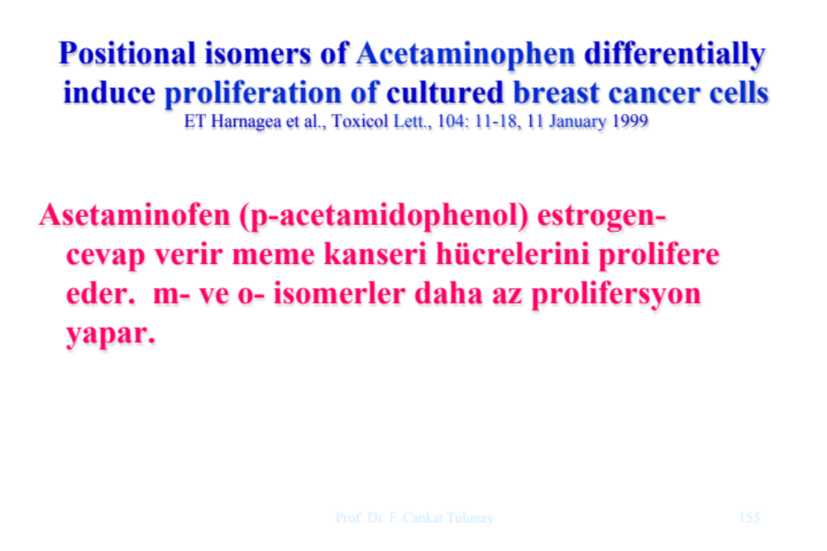
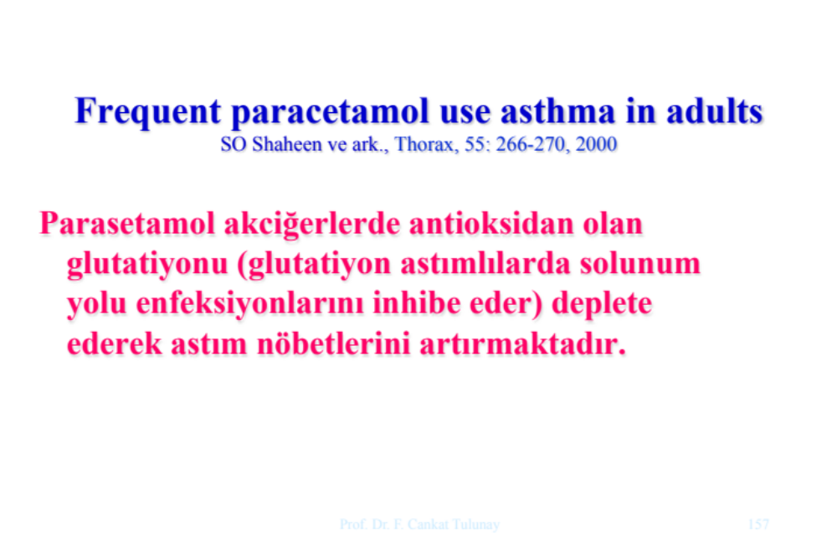

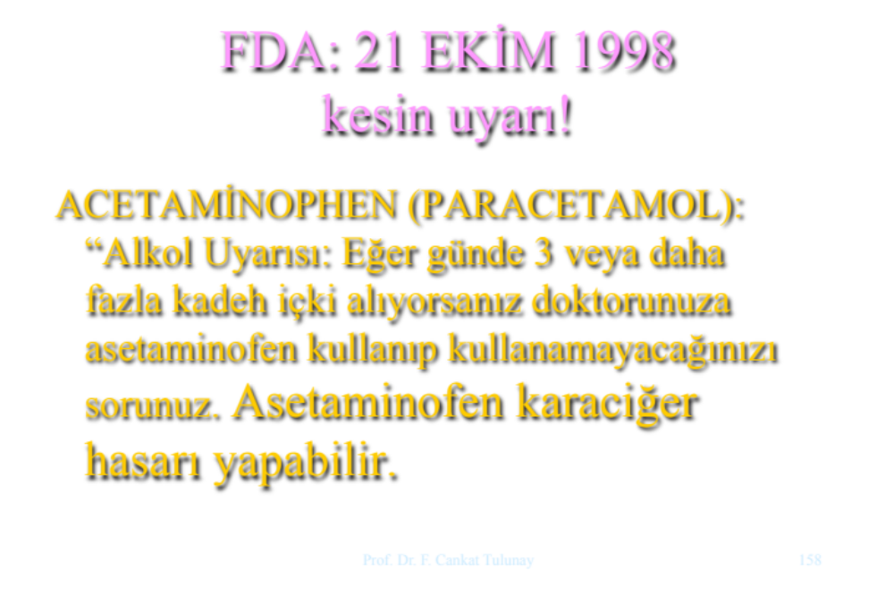

Mutat Res. 1995 Mar;327(1-2):179-200.
International Commission for Protection against Environmental Mutagens and Carcinogens. An evaluation of the genetic toxicity of paracetamol.
Rannug U, Holme JA, Hongslo JK, Srám R.
Source
Department of Genetic and Cellular Toxicology, Stockholm University, Sweden.
Abstract
During the last years, several reports have indicated genotoxic effects of paracetamol, a widely used non-prescription analgesic and antipyretic drug. Thus, a careful evaluation of a possible genotoxic effect related to paracetamol use is warranted. Studies in vitro and in vivo indicate that the reactive metabolite of paracetamol can bind irreversibly to DNA and cause DNA strand breaks. Paracetamol inhibits both replicative DNA synthesis and DNA repair synthesis in vitro and in experimental animals. Paracetamol does not cause gene mutations, either in bacteria or in mammalian cells. On the other hand, a co-mutagenic effect of paracetamol has been reported. Furthermore, paracetamol increases the frequency of chromosomal damage in mammalian cell lines, isolated human lymphocytes and experimental animals. Two independent studies have shown an increase in chromosomal damage in lymphocytes of human volunteers after intake of therapeutic doses of paracetamol, whereas a third study was negative. Paracetamol-induced chromosomal damage appears to be caused by an inhibition of ribonucleotide reductase. This indicates that a threshold level for the paracetamol-induced chromosomal damage may exist. Genotoxic effects of paracetamol have, however, been demonstrated both in vitro and in vivo at or near therapeutic concentrations. The data indicate that the use of paracetamol may contribute to an increase in the total burden of genotoxic damage in man. Thus, there may be a need to evaluate the therapeutic benefit of paracetamol, taking into consideration not only its potential to induce acute and chronic organ damage, but also genotoxic effects.

Arch Intern Med. 2011 Sep 12;171(16):1487-93. doi:
10.1001/archinternmed.2011.356.
Prospective evaluation of analgesic use and risk of renal cell cancer.
Cho E, Curhan G, Hankinson SE, Kantoff P, Atkins MB, Stampfer M, Choueiri TK.
Source
Channing Laboratory, Department of Medicine, Brigham and Women's Hospital and Harvard Medical School, Boston, MA 02115, USA. eunyoung.cho@channing.harvard.edu
Abstract
BACKGROUND:
Epidemiologic data suggest that analgesic use increases the risk of renal cell cancer (RCC), but few prospective studies have been published. We investigated the association between analgesic use and RCC in 2 large prospective studies.
METHODS:
We examined the relationship between analgesic use and RCC risk in the Nurses' Health Study and the Health Professionals Follow-up Study. Use of aspirin, other nonsteroidal anti-inflammatory drugs (NSAIDs), and acetaminophen was ascertained in 1990 in the Nurses' Health Study and in 1986 in the Health Professionals Follow-up Study, and every 2 years thereafter. We evaluated baseline and duration of use of analgesics.
RESULTS:
During follow-up of 16 years among 77,525 women and 20 years among 49,403 men, we documented 333 RCC cases. Aspirin and acetaminophen use were not associated with RCC risk. However, regular use of nonaspirin NSAIDs was associated with an increased RCC risk; the pooled multivariate relative risk was 1.51 (95% confidence interval, 1.12-2.04) at baseline. The absolute risk differences for users vs nonusers of nonaspirin NSAIDs were 9.15 per 100 000 person-years in women and 10.92 per 100,000 person-years in men. There was a dose-response relationship between duration of nonaspirin NSAID use and RCC risk; compared with nonregular use, the pooled multivariate relative risks were 0.81 (95% confidence interval, 0.59-1.11) for use less than 4 years, 1.36 (0.98-1.89) for 4 to less than 10 years, and 2.92 (1.71-5.01) for use for 10 or more years (P < .001 for trend).
CONCLUSION:
Our prospective data suggest that longer duration of use of nonaspirin NSAIDs may increase the risk of RCC

J Clin Oncol. 2011 Jun 10;29(17):2424-31. doi: 10.1200/JCO.2011.34.6346. Epub 2011 May 9.
Long-term use of acetaminophen, aspirin, and other nonsteroidal anti-inflammatory drugs and risk of hematologic malignancies: results from the prospective Vitamins and Lifestyle (VITAL) study.
Walter RB, Milano F, Brasky TM, White E.
Source
Clinical Research Division, Fred Hutchinson Cancer Research Center, 1100 Fairview Ave N., Seattle, WA 98109-1024, USA. rwalter@fhcrc.org
Abstract
PURPOSE:
Among previous studies examining the associations of over-the-counter analgesics or nonsteroidal anti-inflammatory drugs (NSAIDs) and incident hematologic malignancies, results were inconsistent for NSAIDs but suggested an increased risk with acetaminophen (paracetamol). Herein, we used a large prospective cohort study to examine these associations.
PATIENTS AND METHODS:
In total, 64,839 men and women age 50 to 76 years were recruited from 2000 to 2002 to the Vitamins and Lifestyle (VITAL) study. Incident hematologic malignancies (n = 577) were identified through December 2008 by linkage to the Surveillance, Epidemiology and End Results cancer registry. Hazard ratios (HRs) associated with use of analgesics for total incident hematologic malignancies and cancer subcategories were estimated by Cox proportional hazards models. Models were adjusted for age, sex, race/ethnicity, education, smoking, self-rated health, arthritis, chronic musculoskeletal pain, migraines, headaches, fatigue, and family history of leukemia/lymphoma.
RESULTS:
After adjustment, there was an increased risk of incident hematologic malignancies associated with high use (≥ 4 days/week for ≥ 4 years) of acetaminophen (HR, 1.84; 95% CI, 1.35 to 2.50 for high use; P trend = .004). This association was seen for myeloid neoplasms (HR, 2.26; 95% CI, 1.24 to 4.12), non-Hodgkin's lymphomas (HR, 1.81; 95% CI, 1.12 to 2.93), and plasma cell disorders (HR, 2.42; 95% CI, 1.08 to 5.41), but not chronic lymphocytic leukemia/small lymphocytic lymphoma (CLL/SLL; HR, 0.84; 95% CI, 0.31 to 2.28). By comparison, there was no association with risk of incident hematologic malignancies for increasing use of aspirin, nonaspirin NSAIDs, or ibuprofen.
CONCLUSION:
High use of acetaminophen was associated with an almost two-fold increased risk of incident hematologic malignancies other than CLL/SLL. Neither aspirin nor nonaspirin NSAIDs are likely useful for prevention of hematologic malignancies.

Natl Cancer Inst Monogr. 1985 Dec;69:217-22.
Relation of analgesic use to renal cancer: population-based findings.
McLaughlin JK, Blot WJ, Mehl ES, Fraumeni JF Jr.
Abstract
A population-based case-control study of renal cancer (495 cases of renal cell cancer, 74 cases of renal pelvis cancer, and 697 controls) was conducted in the Minneapolis-St. Paul 7-county metropolitan area. Information was obtained on a large number of variables, including the use of analgesic drugs. Long-term use (greater than 36 mo) of phenacetin-containing products was associated in both sexes with a twofold increased risk for renal cell cancer. Long-term use of phenacetin- and acetaminophen-containing products was associated with elevated risks of nearly threefold to eightfold for cancer of the renal pelvis. The separate effects of these analgesics could not be adequately assessed because most long-term users took both products.

Int J Cancer. 1993 Jan 21;53(2):245-9.
Different roles for phenacetin and paracetamol in cancer of the kidney and renal pelvis.
McCredie M, Stewart JH, Day NE.
Source
Cancer Epidemiology Research Unit, NSW Cancer Council, Sydney, Australia.
Abstract
A population-based case-control study of kidney cancer was carried out in New South Wales using data from structured interviews with 489 cases of renal-cell cancer and 147 cases of renal pelvic cancer diagnosed in 1989 and 1990, together with 523 controls from the electoral rolls. This study showed that the risk of renal pelvic cancer was increased by phenacetin/aspirin compound analgesics (RR = 12.2; 95% CI 6.8-22.2) to a far greater extent than by paracetamol (RR = 1.3; 95% CI 0.7-2.4; not significant). There was a doubling of risk (RR = 2.0; 95% CI 0.9-4.4) in the highest tertile of paracetamol taken in any form compared with values for non-users of any type of analgesic. By contrast, the risk of renal-cell cancer appeared to be increased to a similar degree by phenacetin/aspirin compound analgesics (RR = 1.4; 95% CI 0.9-2.3) and paracetamol taken in any form (RR = 1.5; 95% CI 1.0-2.3). When both drugs were treated as alternative forms of the same risk factor, the risk was increased by 1.7 (95% CI 1.2-2.4). On this evidence, we postulate that phenacetin/aspirin compounds are weakly carcinogenic in the renal parenchyma through the metabolic conversion of phenacetin to paracetamol, and potently carcinogenic in the renal pelvis by different or additional pathways involving renal papillary necrosis. In addition, there is an indication of a weak link between paracetamol and renal pelvic cancer.

