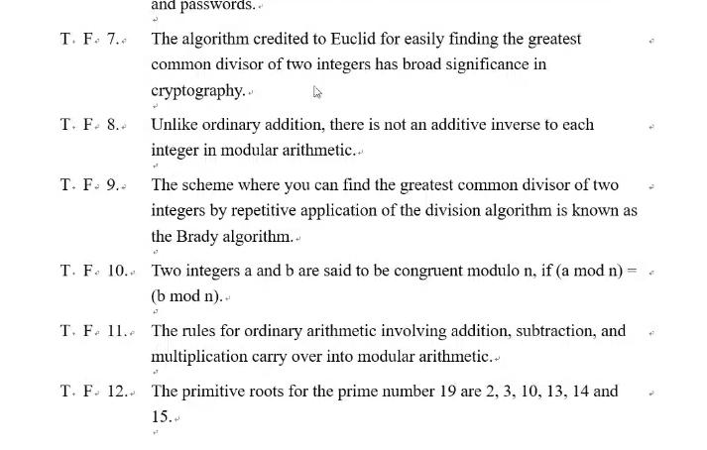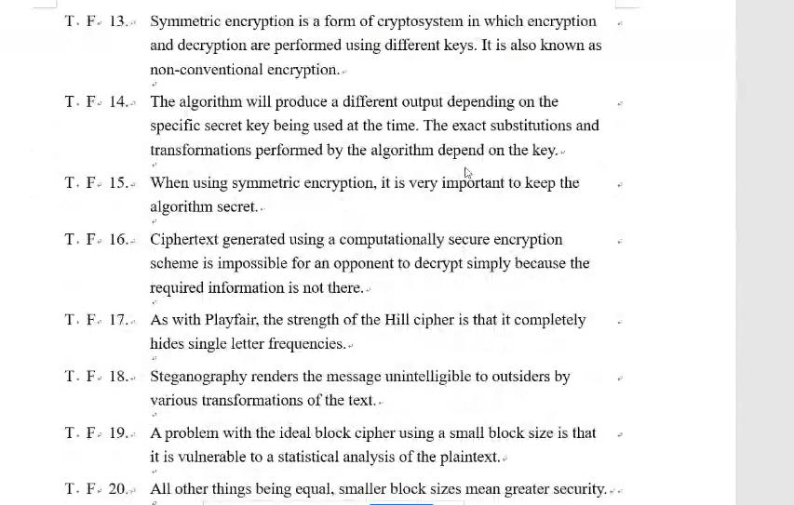

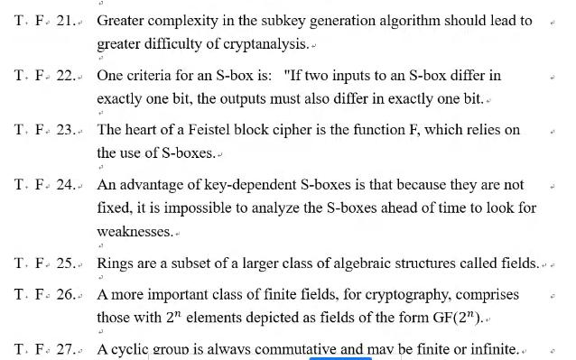

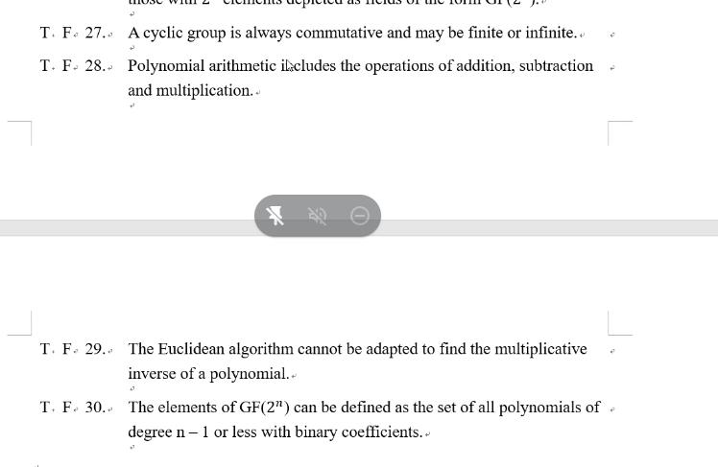

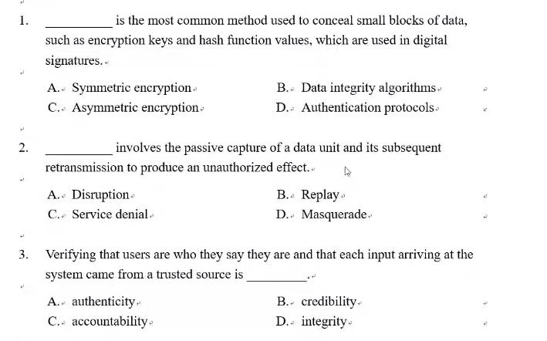

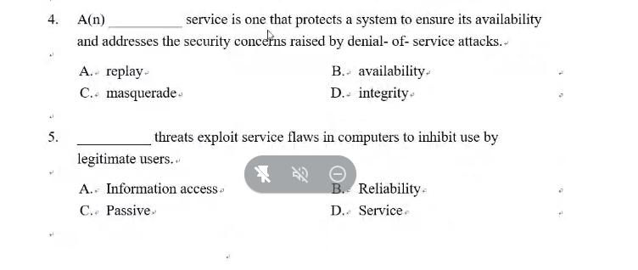

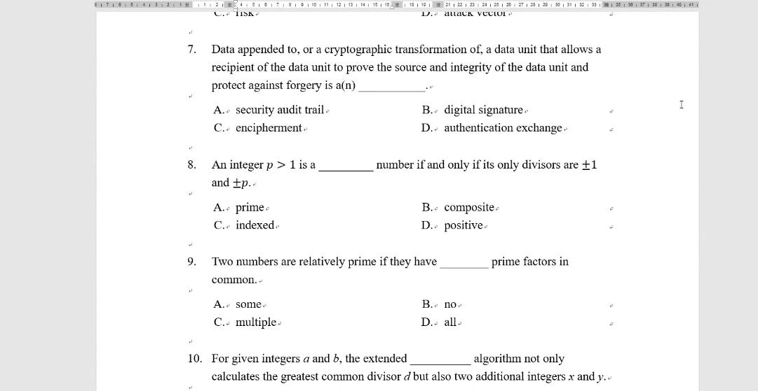

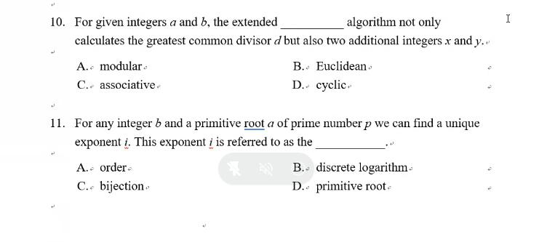

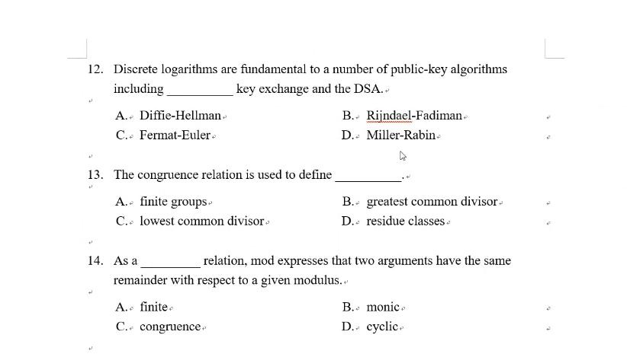

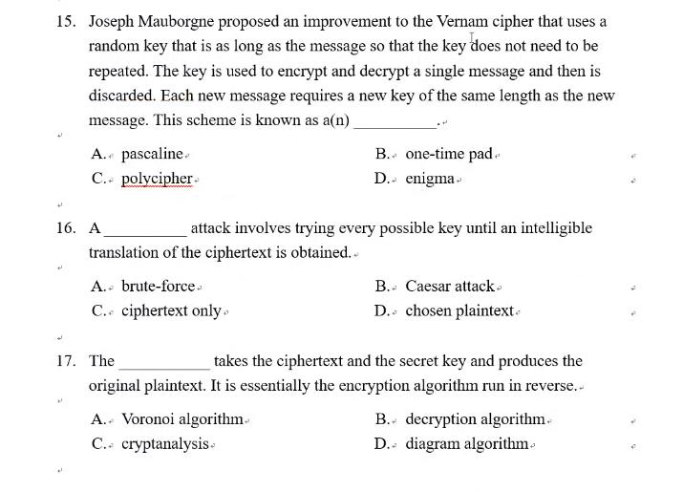

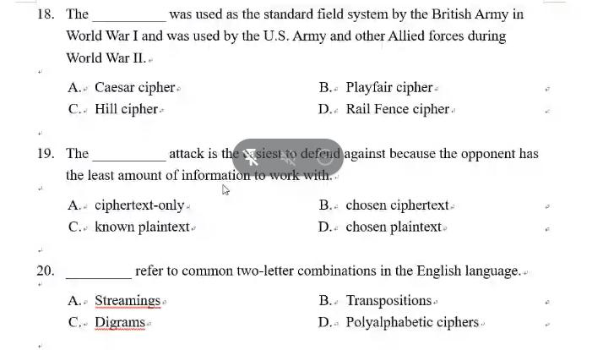

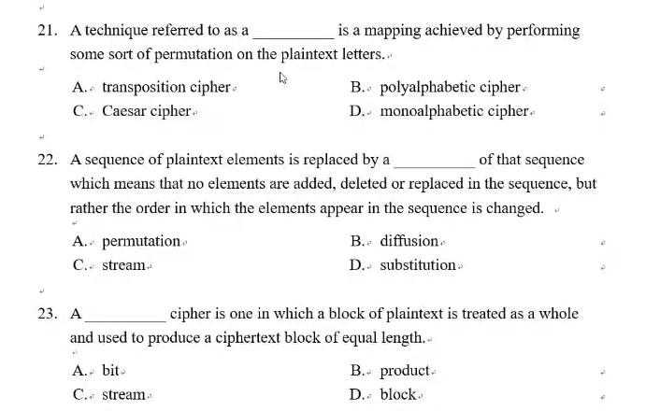

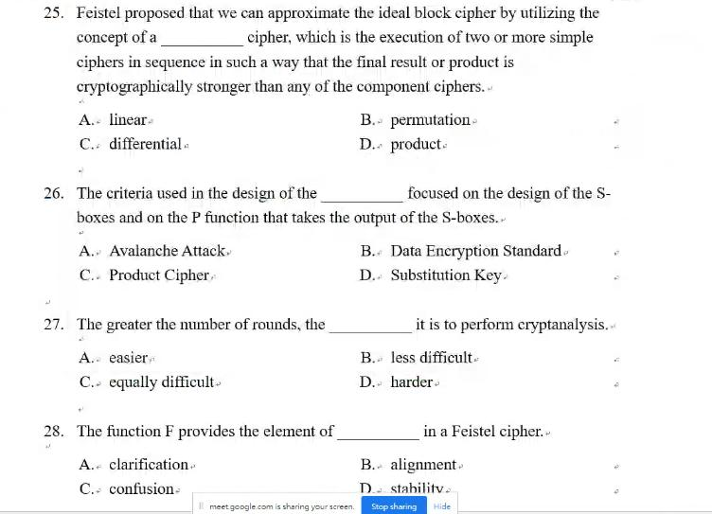

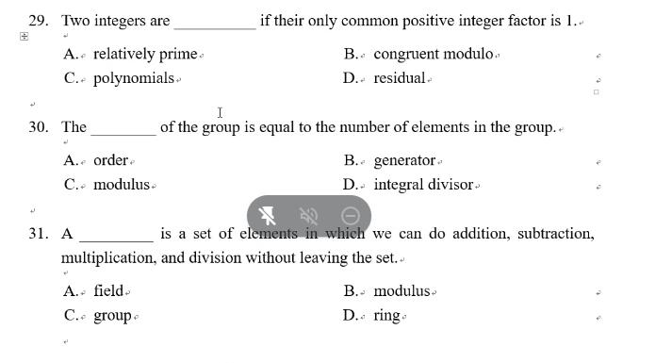

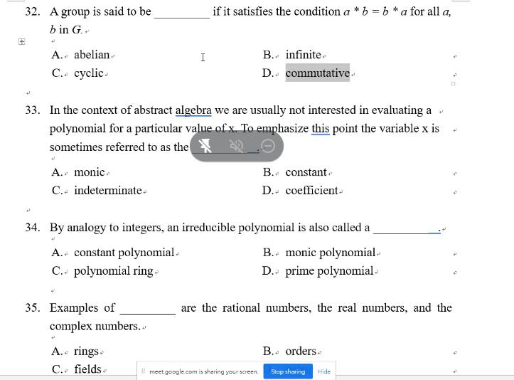

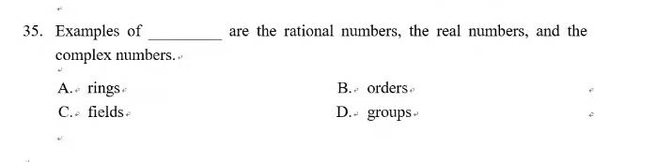

1. F ,2. T,3. F,4. F,5. T,6. T,7. T,8. F,9. F,10.T,11.T,12.T,13.F,14.T,15.F,16.F

17.T,18.F,19.T,20.F,21.T,22.F,23.T,24.T,25.F,26.T,27.F,28.T,29.F,30.T

1.C,2.B,3.A,4.B,5.D,6.A (threat),7.B,8.A,9.B,10.B,11.B,12.A,13.D,14.C,15.B

16.A,17.B,18.B,19.A,20.C,21.A,22.A,23.D,24.A (substitution),25.D,26.B,27.D

28.C,29.A,30.A,31.A,32.A,D,33.C,34.D,35.C