1. Story / Narrative
- Premise:
A cynical, truth-driven private detective is forced to compete in Master of Mundane Mysteries, a flashy reality game show that dramatizes trivial disputes into absurd “cases.” While contestants chase fame and spectacle, the protagonist wrestles with their disdain for the show and the need to either play along or expose the truth.
- Tone:
Parody comedy-drama with exaggerated theatrics, blending Ace Attorney satire, Danganronpa absurdity, and WWE-style spectacle.
- Conflict:
The protagonist must solve ridiculous cases, win over eccentric judges, and balance integrity with pandering to the audience—all while uncovering signs of corruption behind the game show.

2. Goals / Objectives
- Short-Term (per episode):
  - Win “Detective-Off” rounds by outperforming rivals.
  - Collect clues, improvise deductions, and impress judges.
  - Earn audience approval and style points.
- Long-Term (season):
  - Win the grand prize and the gaudy Master of Mundane Mysteries trophy.
  - Uncover and expose the game show’s staged corruption.
  - Balance integrity vs spectacle to shape the ending: Sell Out, Expose Truth, or Fail.

3. Mechanics
- Core Gameplay:
  - Rebuttals – player challenges contradictions in statements by presenting evidence or choosing probing dialogue options. Implemented through the dialogue system with branching choices and meter adjustments.
  - Investigations – navigate a scene and gather evidence (still placeholder, not fully implemented yet). Current progress uses dialogue events + planned integration with interactable objects.
  - Stand Improv – dialogue choices combined with timed inputs (QTE-like) to boost audience reaction. System is partly prototyped with meter influence from choices; QTE mechanic pending.

- Secondary Systems:
  - Reputation Meter – split between Truth (integrity) and Spectacle (audience pandering). Implemented as a MeterController that updates values based on player dialogue choices.
  - Judge Nitpicks – random modifiers that change dialogue style (e.g., rhyme, disguise, noir slang). Not yet implemented, but placeholders exist in the dialogue/event system to allow conditional modifiers later.
  - Dialogue Logging – tracks all previous statements for debugging and narrative recall (added system for scrolling text history).

4. Progression
- Structure:
Each case = 1 episode → Case Intro → Investigations → Spotlight → Judging → Results.
- Escalation:
  - Early Episodes: Silly disputes (stolen lunch, unpaid loans).
  - Mid Episodes: Larger theatrics (pet framed as thief, neighborhood feuds).
  - Late Episodes: Meta cases revealing the show is staged.

5. Character Design
- Protagonist:
  - Cynical, weary detective. Customizable flair (costumes, hats, accessories, catchphrases).
  - Morality arc: play straight or lean into showbiz.
- Rivals:
  - Trickster Detective – uses magic tricks.
  - Grandma Gumshoe – sweet but ruthless.
- Judges (Tribunal):
  - Fashion Fiend – obsessed with wardrobe.
  - Film Noir Nut – loves detective slang.
  - Chef Forensics – evidence must be plated like food.

6. Technology: Unity
- Why Unity:
  - Strong support for narrative-driven games with integrated mini-games.
  - 2.5D stylized visuals mixing noir parody with flashy game-show staging.
  - Flexible UI system for scoreboards, meters, and tribunal judging panels.
- Implementation Approach:
  - Visual Novel Framework for dialogue, branching choices.
  - Self-contained Unity scenes for mini-games (obstacle course, clue board, rebuttal duels).
  - Style: toon-shaded 2D characters with somewhat exaggerated poses.
  - Platforms: PC + Mobile.

7. Control Scheme (with diagrams if necessary)
- Main Input Controls - Handles mouse/touch input, crosshair movement, and object interaction
- Background Control - Manages scene transitions and door interactions
- Dialogue Controls - Handles all conversation systems with typewriter effects and choices
- Cross-Examination Controls - Manages courtroom trial sequences with evidence presentation
- File Collection Controls - Evidence collection and management system Profile Collection Controls - Character interaction and profile management
- UI Controls - Interface panel management and state control Spotlight Control - Logic meter system with visual feedback
- Sequence Control - Game flow and phase progression management
- Settings Controls - Configuration and preferences management
Key Features Documented: Input Methods: Mouse, touch, keyboard controls Object Interaction: Items, doors, characters with different behaviors UI State Management: Panel toggles and crosshair visibility Game Phases: Investigation, dialogue, trial sequences Accessibility: Visual feedback, audio integration, customization options

8. Team Progress & Contribution Report
- Francis Neil Cuadra (Technical Lead):
Planned the Unity framework structure, outlined how modular mini-games will integrate with the visual novel system, and ensured technical feasibility of core mechanics.
- John Lloyd Monterola (Gameplay Designer / Level Designer / Tester):
Designed the main gameplay systems (Investigation, Cross-Examination, Reputation Meter), created the first-level flow, and performed initial playtesting to refine mechanics.
- Daniell Marie Castada (Documentation / Tester / UI Design):
Developed the first-level mockup, organized clue placement for gameplay clarity, contributed to drafting project documentation, and currently assisted in testing UI layouts for player interaction.
- Mika Ysabelle Regalado (Artist / Designer / Writer):
Produced character design concepts for the protagonist, rivals, and judges, created currently creating sprites for the rest of the cast, and to writing dialogue and narrative flavor elements.

9. Unity Game Development Challenges & Solutions
Dialogue System & Choice Handling
Challenge:
- Creating a branching dialogue system where player choices affect flow.
- Needed to support text, jump indexes, and optional meter changes.
Solution:
- Built a DialogManager with DialogueChoice and DialogueEvent classes.
- Used jumpIndex for branching logic.
- Added meterAdjustment field so choices could directly affect stats (reputation, trust, etc.).
Dialogue Logging & UI
Challenge:
- Needed to track past dialogues for debugging or review.
- UI text wrapping and overflow issues in TMP.
Solution:
- Implemented a dialogue logger system that appends lines to a scrollable panel.
- Used TextMeshProUGUI with auto-sizing + layout groups for clean display.
Character Activity & Disabling
Challenge:
- Multiple characters speaking at once caused overlap or wrong ones being “active.”
- Wanted a way to disable inactive characters while keeping UI consistent.
Solution:
- Added toggles in DialogManager to enable/disable speaker portraits & audio sources.
- Used CanvasGroups and alpha control to fade inactive characters instead of destroying them.
Meter Integration
Challenge:
- Needed player choices to influence game stats (e.g., trust, suspicion, morale).
- Difficulty connecting choice data to meter UI.
Solution:
- Created a MeterController interface so DialogManager could call adjustments.
- Choices carry a float meterAdjustment value that updates meters automatically.
Audio / Voice Line Sync
Challenge:
- Wanted dialogue to optionally play character voice lines.
- Needed fallback to text-only if no audio provided.
Solution:
- DialogueEvent holds optional AudioSource.
- DialogManager checks if audio clip exists, then plays it alongside text.
Data Organization & Scaling
Challenge:
- Dialogue events getting too large & messy to manage manually.
- Risk of spaghetti code as branching grows.
Solution (in progress):
- Discussed moving dialogue into ScriptableObjects or external JSON.
- Keeps Unity inspector cleaner and allows future editing tools.
Unfinished / Placeholder Art
Challenge:
- Missing final art assets (character portraits, backgrounds, UI elements).
- Needed stand-ins to test systems without blocking progress.
Solution:
- Used colored placeholders and text labels in UI.
- Temporary sprites & free Unity Asset Store art as stand-ins.
- Kept all art references modular so final assets can be swapped without rewriting code.

10. First Level Design Mockup

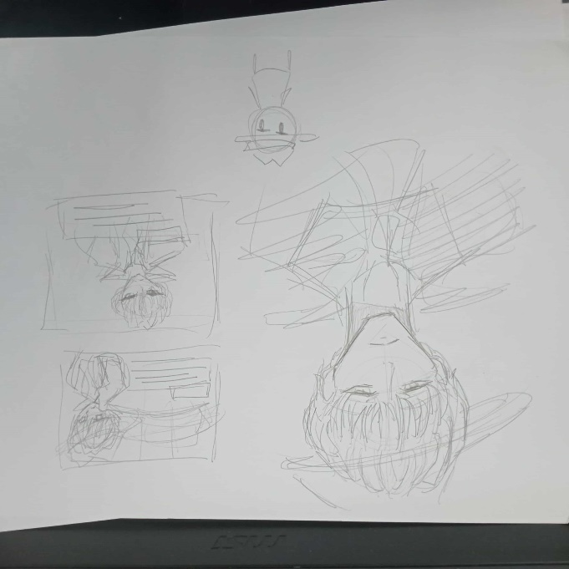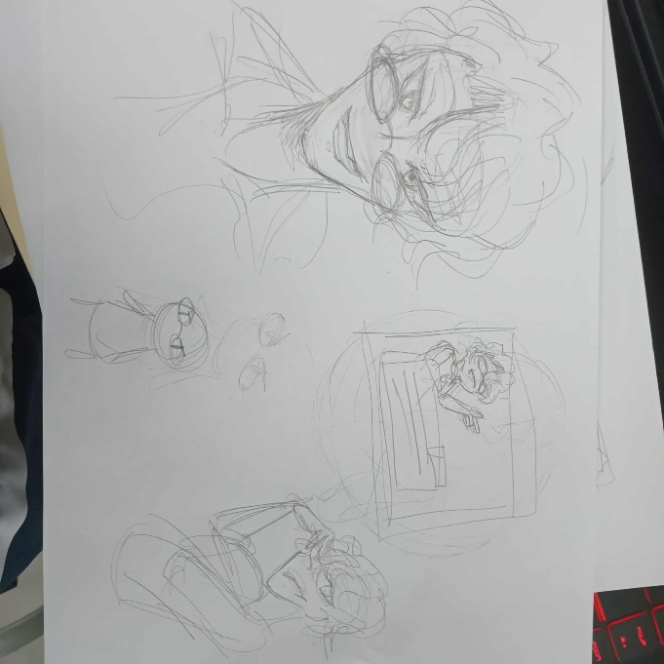
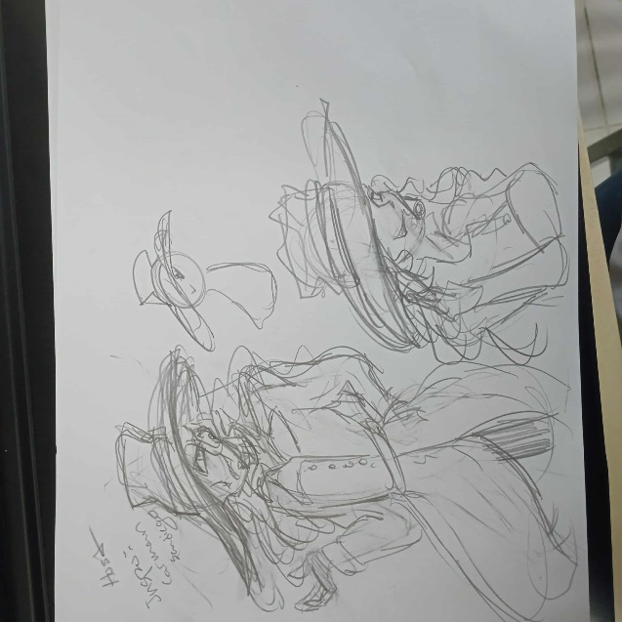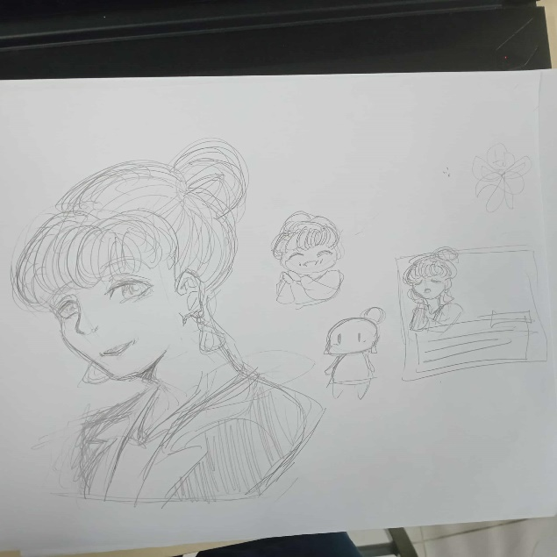

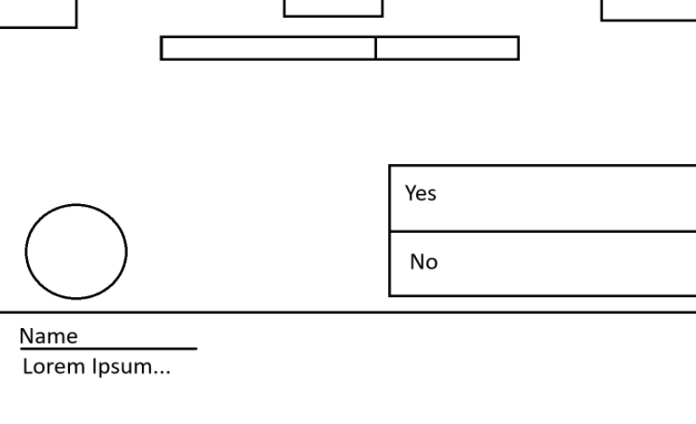

11. Prototype Video
https://youtu.be/BW3wtXst_po

