

Heat transfer model for linear concentrating solar energy technologies receivers

Authored by:
Felipe Cuevas
Annie Hofer
Anna Heimsath
Joris Nettelstroth

Revised by:
Peter Nitz

Address
Fraunhofer-Institut
für Solare Energiesysteme ISE
Department Solar Thermal and Optics
Heidenhofstrasse 2
79110 FREIBURG
Deutschland
Index

1 Introduction 3
1.1 Scope and contents 3
2 Receiver configurations 4
2.1 Definition of heat loss 4
2.2 Single tube 4
2.3 Tube with glass envelope 7
2.4 Tube with glass envelope and secondary concentrator 12
2.5 Tube with secondary concentrator and glass plate 18
3 References 22

Introduction

Scope and contents

Thermal Resistance Model (TRM):
A Thermal Resistance Model (TRM) has been implemented to perform fast thermal loss calculations for different types of CSP receiver geometries, in particular for receiver geometries of Linear Fresnel Collectors (LFC).
As LFC Receiver geometry is complex, no detailed and validated heat transfer equations are available from literature. Therefore, several (partly severe) simplifications and assumptions have been made in the implementation of the model, in order to provide a fast and simple tool for heat loss calculations.
Due to these simplifications and assumptions, and the uncertainties and errors introduced by them, the TRM shall not be considered as a model or tool to calculate the absolute heat loss of CSP receivers quantitatively and in detail. Instead, it is meant to assess
* impact of certain (free) model parameters, e.g. tube diameters, by comparing the heat loss of different scenarios (care should be taken when assessing ‘general’ model parameters: users shall reflect critically whether such an assessment is probing the detail of implementation in the model instead of the impact of the parameter)
* impact of changes and variants in general, e.g. different material options, geometry options, coating options, temperature levels, …. (again: check the details of implementation and make sure the impact of the parameter is calculated and not the detail of implementation).
In such assessments, the implications of all simplifications will have the same (or at least similar) impact on all variants which are calculated applying this same TRM model. Therefore, in a first order approximation, trends when comparing different variants should be reproduced correctly, even though the absolute values may be off significantly, or connected with very large (? – mostly unknown ! and therefore potentially very large) uncertainties.
This fact should be seriously considered whenever applying the TRM. Any use of the TRM should be reflected with respect to this documentation and whether the TRM is suited at all to answer a given question. This applies even more to any quantitative use of model results.
This documentation:
Aim of this documentation is to
* Provide documentation on the implementation of the TRM, which assumptions have been made, which simplified heat transfer equations have been implemented;
* document information on the impact of the assumptions and simplifications, where available,
* document lack/absence of information where no information is available.

Receiver configurations

The scope of this report is to present thermal models for linear solar concentrating technologies receivers. The scope of the thermal model is to characterize the heat loss from the receiver to the surroundings.In solar thermal, the heat loss of a receiver is defined as the reduction of useful heat. For all cases described in this report, this heat loss can be described as the heat released from the outer absorber surface, which means there will not be an analysis of the heat transfer from the absorber to the heat transfer fluid. For every configuration there will be a brief explanation of its components and how the heat loss is calculated. In the report, four configurations are analyzed. In references [3] and [4], there is a detailed explanation of a model for receivers used in parabolic trough collectors. The receivers for parabolic trough collectors are the first two configurations analyzed here. Although they are well explained in the references mentioned above, they will be explained again here to take them as a basis for more complex receiver geometries. At the end of every configuration, there will be a discussion about the assumptions, the accuracy of the model and how it could be improved if it is needed.

Definition of heat loss

Here in the case of solar collectors which transfer solar energy to useful thermal energy, the term ‘heat loss’ shall be defined as the reduction of useful heat which can be taken by a heat transfer fluid:
heat loss := reduction of useful heat
In practical terms and within the framework of the models presented here, this reduction is equivalent to the heat loss of the outer absorber tube surface to its surroundings – all energy that is transferred to the surroundings of the tube cannot be transferred to the heat transfer fluid.
It should be noted that in this definition, the heat loss may become negative in the special case where energy is transferred from the surroundings TO the absorber tube surface. This may be the case e.g. in situations where the surroundings have higher temperatures than the absorber surface.

Single tube

The simplest receiver for a linear concentrating system is a tube. In this case the absorber surface is in direct contact with the environment, which makes it rather unlikely for high temperatures applications, as the heat loss increases significantly with temperature.
For a tube, the heat loss is given by the radiation and convection losses leaving the surface of the absorber tube.
As a simplification, the temperature of the absorber tube is assumed to be constant in tangential direction across the entire absorber surface.
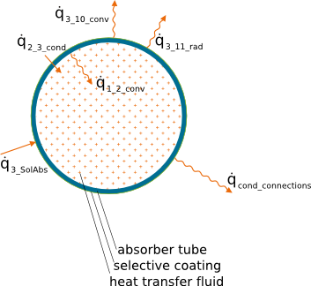
Fig. 1 Sketch of tube and the corresponding heat transport contributions (modes)

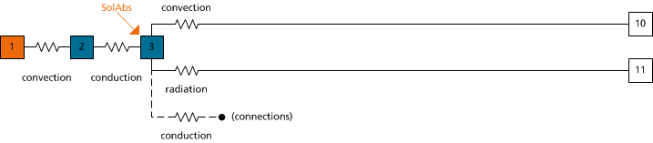
Fig. 2 Analog thermal resistance configuration

Convection from tube to the surroundings$({\dot{q}}_{3_10_conv}$)

For the calculation of the heat transfer coefficient, there are 2 possible conditions, namely wind and no wind, which corresponds to forced or natural convection respectively. In every case, there are correlations available in literature for the Nusselt number, from which the convective heat transfer coefficient is calculated.
- No wind case

$${Nu}_{D3}= {\left(0.60+\frac{0.387* {({Ra}_{3 }){ }}^{1/6}}{{(1+{{(0.559}/{{Pr}_{f})}}^{9/{16}})}^{8/{27}}}\right)}^{2}$$

where,
- ${Pr}_{f}$, Prandtl number for air at $T_{f}$
- ${Ra}_{3 }$, Rayleigh number for air based on the outer diameter, $D_{3}$
- ${Nu}_{D3}$, Nusselt number based on the outer diameter, $D_{3}$

- Wind case

There are 2 cases, depending on the wind velocity. The cases are laminar or turbulent flow.

2.1) Laminar flow (Re < 2300)

$${Nu}_{lam}=0.644 {Re}_{l}^{1/2} {Pr}_{l}^{1/3}$$

2.2) Turbulent flow (Re > 2300)

$${Nu}_{turb}=\frac{0.037 {Re}_{l}^{8/{10}} {Pr}_{l}}{1+2.443 ×{Re}_{l}^{-0.1}({Pr}_{l}^{2/3}-1)}$$

The calculation of forced convection outside tubes generally requires the same Nusselt-equations as flow over a flat plate. The difference is the use of the 'streamed length $l_{c}$ ' which is used in $Re = v_wind*l_{c}/υ_{f}$ and$h = Nu*k/l_{c}$. While for a plate it is simply its length (in direction of wind flow), for a tube in cross-flow it is $π×r$. This way the forced convection for cross-flow can be calculated. In practical terms, this means that the calculation of forced convection for different geometries requires the determination of the characteristic length exposed to the flow.
The same principles apply to the longitudinal flow over a cylinder: it is basically treated as a flat plate as well. The difference "is due to the curvature of the cylinder wall. This influence depends upon the ratio of boundary layer thickness and radius of the cylinder. If it is small enough the influence of curvature may be neglected, and the heat transfer coefficients can be calculated for a flat plate." [2]
The implementation of the wind flow direction is implemented through correction factors with respect to normal wind direction. Table 1 shows the factors used for different angles [ 5].
Table 1, Corrections factors used to consider wind direction
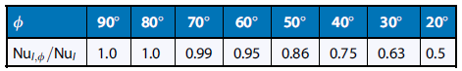

Radiation from tube to the surroundings$({\dot{q}}_{3_11_rad}$)

The surroundings of a single tube for a concentrating collector is the sky and the primary field. The approximation of a tube exchanging heat by radiation with the sky and the primary field has been analyzed by Forristal [3]. The analysis considers 4 different configurations, taking into account the primary field and its temperature. The results of the analysis show that by assuming the primary field has no effect and that the tube temperature is uniform around the circumference, there is an error in over predicting radiation heat transfer of 5% to 10%.

In this case is assumed that the whole tube exchange heat by radiation with the sky. Given this, the view factor between the tube and the sky is 1.

$${\dot{q}}_{3_11_rad}= σ × ε_{3}×A_{tube} ×(T_{3}^{4}- T_{11}^{4})$$
where,
- $ε_{3}$, emissivity of tube's outer surface
- $T_{3}$, outer surface temperature (K)
- $T_{11}$, effective sky temperature (K)
- $A_{tube}$, area of absorber tube (m)
- $σ$, Stefan-Boltzmann constant, $5.67 × {10}^{-8} W/{{(m}^{2}K^{4}})$

Discussion

As it is explained in the beginning, one main assumption in this case is considering the temperature of the absorber tube as constant. Given the non-uniform distribution of the concentrated radiation in the surface of the absorber, there could be a non-uniform temperature distribution along it, but this distribution will depend strongly on the irradiance onto the tube and on the fluid dynamics of the heat transfer fluid inside the tube as well. As the analysis will not consider the behavior of the heat transfer fluid, the assumption of constant temperature allows analyzing in a general way the heat loss from the tube. The analysis mentioned above has been done for an evacuated absorber tube with glass envelope, therefore the temperature of the glass envelope is the range of 50 – 150 °C. For a single tube the temperature range may be higher, therefore a similar analysis is recommended to check the validity of this assumption.

Tube with glass envelope

For protecting the tube from the environment and to reduce heat losses, a glass envelope can be installed around the receiver. This configuration has the advantage that the space between the tube and the glass envelope can be evacuated, decreasing significantly the heat loss by convection. Anyway, not all the configurations are necessarily evacuated.

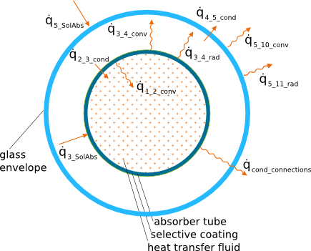
Fig. 3 Sketch of a tube with glass envelope and the corresponding heat transport modes
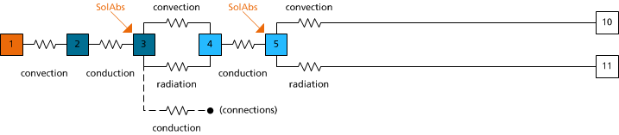
Fig. 4 Analog thermal resistance configuration

Convection between absorber tube and glass envelope (${\dot{q}}_{3_4_conv}$)

For concentric tubes aligned horizontally, closed formula are available. Three correlations for natural convection between concentric tubes have been implemented.

- From VDI Atlas [5], chapter F3, the following correlation is proposed

$$Nu=0.20{\left(Ra\right)}^{0.25}{\left(\frac{r_{4}}{r_{3}}\right)}^{0.5}$$
Validity: Applies for $Ra>7.1 ×{10}^{3}$, and ${r_{4}}/{r_{3 } }≤8$. In the range from ${r_{4}}/{r_{3 } }=6$ to ${r_{4}}/{r_{3 } }=8$, the relationship tends toward that for a horizontal single-tube.

- Forristal [3] has implemented the following correlation

$$q_{3_4_conv}= \frac{2.425 k \left(T_{3}- T_{4}\right)* {({Pr}_{34}{ {{Ra}_{3}}/{(0.861+{Pr}_{34})) } }}^{0.25}}{{(1+{{{(D}_{3}}/{D_{4})}}^{3/5})}^{5/4}}$$

where

- $k$, thermal conductance of air at $T_{f}$, $(W/{m °C)}$
- $T_{3}$, temperature of the outer side of the absorber tube, (°C)
- $T_{4}$, temperature of the inner side of the glass envelope, (°C)
- $D_{3}$, diameter of the outer side of the tube, (m)
- $D_{4}$, diameter of the inner side of the glass envelope, (m)
- ${Pr}_{34}$, Prandtl number of the air inside the annulus
- ${Ra}_{3}$, Rayleigh number evaluated at $D_{3}$
- $T_{34}$ is the average temperature ($T_{3}+ T_{4}$)/2, (°C)

Validity: ${Ra}_{out}>{({D_{4}}/{(D_{4}- D_{3})) }}^{4}$. All physical properties are evaluated at the average temperature $({T_{3}- T_{4})}/2$.

- Cengel [1] proposes the following correlation, which has the same form as an equation for conduction between concentric tubes, but defining an effective thermal conductivity.

$$k_{eff}=k Nu$$

In case Nu=1, the effective thermal conductivity of the enclosure becomes equal to the conductivity of the fluid.
In case of concentric cylinders, the characteristic length is defined as $L_{c}=$ $({D_{4}- D_{3})}/2$. The rate of heat transfer through the annular space between the tubes by natural convection is given by
$$q_{3_4_conv}= \frac{2π k_{eff} }{{ln⁡(D_{4}}/{D_{3})}} (T_{3}- T_{4})$$
where $k_{eff}$is defined as
$$\frac{k_{eff} }{k}=0.386 {\left(\frac{{Pr}_{34}}{0.861+{Pr}_{34}}\right)}^{0.25}{(F_{cyl}{Ra}_{L})}^{0.25}$$

and $F_{cyl}$ is a geometric factor for concentric cylinders defined as

$$F_{cyl}= \frac{{({ln⁡(D_{4}}/{D_{3})}}^{4}}{L_{c}^{3} {(D_{3}^{{-3}/5}+ D_{4}^{{-3}/5})}^{5}}$$

Validity: The $k_{eff}$relation is valid for $0.70 ≤ Pr ≤6000$and${10}^{2} ≤ F_{cyl}{Ra}_{L} ≤ {10}^{7}$. For$F_{cyl}{Ra}_{L} <100$, natural convection currents are negligible and $k_{eff}=k$. $k_{eff}$ cannot be less that $k$, therefore in case ${k_{eff}}/k <1$, $k_{eff}$ is set to $k$. This implementation accounts immediately for the conduction between the tubes, when no convection currents are present

Discussion: Correlations analyzed above are based on empirical analysis. The analysis done by different researchers for generating the correlations is based on the whole behavior between the tubes, taking an average value of the Nusselt number. Given the geometry and the fact that natural convection is mainly driven by buoyancy forces, it is expected that the behavior is not uniform along the sections of the tubes. The non-uniform behavior is reflected in larger heat transfer rate from the inner tube to the top section of the outer tube.

Radiation between absorber tube and glass envelope (${\dot{q}}_{3_11_rad}$)

Radiation transport between concentric tubes is a well-known geometry (for tubes of infinite length) and there are relations to calculate it from literature, [1] and [3]. The following relation is used

$${\dot{q}}_{3_11_rad}= \frac{σ × ε_{3}×A_{3 }×(T_{3}^{4}- T_{4}^{4})}{\frac{1}{ε_{3}}+ \frac{1- ε_{4}}{ε_{4}} \left(\frac{r_{3 }}{r_{4 }}\right)}$$
where
- $ε_{3}$, emissivity of absorber tube's outer surface
- $ε_{4}$, emissivity of glass envelope inner surface
- $T_{3}$, outer absorber surface temperature (K)
- $T_{4}$, temperature of inner glass envelope surface (K)
- $A_{3}$, Area of of absorber tube (m)
- $r_{4}$, inner radius of glass envelope (m)
- $σ$, Stefan-Boltzmann constant, $5.67 × {10}^{-8} W/{{(m}^{2}K^{4}})$

what would be the view factor for a 4m PTR70 absorber to see the bellows/interconnections between absorber and envelope ? (would be very small, i.e. the assiumption/simplification of tubes of infinite length should be a very good assumption here …
Discussion: The assumption of infinite length tubes takes into account the relation between characteristic lengths in longitudinal and transversal direction. For the specific case of the absorber tube from Schott PTR70, the longitudinal characteristic length is 4 (m) and the transversal characteristic length (gap between tubes) is 0.022 (m). As the longitudinal characteristic length is about 180 times higher, it is considered a good approximation.

Conduction through glass envelope

Conduction through the walls of a hollow cylinder is calculated using the following relation
$${\dot{q}}_{4_5_cond}= \frac{2π k}{{ln⁡(r_{5}}/{r_{4})}} (T_{5}- T_{4})$$
where
- $k$, thermal conductivity, $(W/{m °C)}$
- $T_{4}$, temperature of inner glass envelope surface (°C)
- $T_{5}$, temperature of outer glass envelope surface (°C)
- $r_{4}$, inner radius of glass envelope (m)
- $r_{5}$, outer radius of glass envelope (m)
In this relation is assumed that the surface temperatures are constant across the entire circumference of the tube surfaces. In consequence, heat is conducted only in the radial direction and not in the longitudinal or tangential direction.
Discussion: Whereas the temperature of the surfaces are constant, the relation is accurate. If there are non-uniformities of the surface temperatures, heat is going to be conducted from zones with high temperature to zones with low temperatures.
Discussion ? is this a good approximation ? any experimental data / evidence ?

Heat generation in glass envelope

to be completed …

Convection between glass envelope and surroundings

Refer to section 2.2.1, with properly defined index considering sketch shown in Fig. 3 and Fig. 4

Radiation between glass envelope and surroundings

Refer to section 2.2.2, with properly defined index considering sketch shown in Fig. 3 and Fig. 4

Tube with glass envelope and secondary concentrator

Explanation…

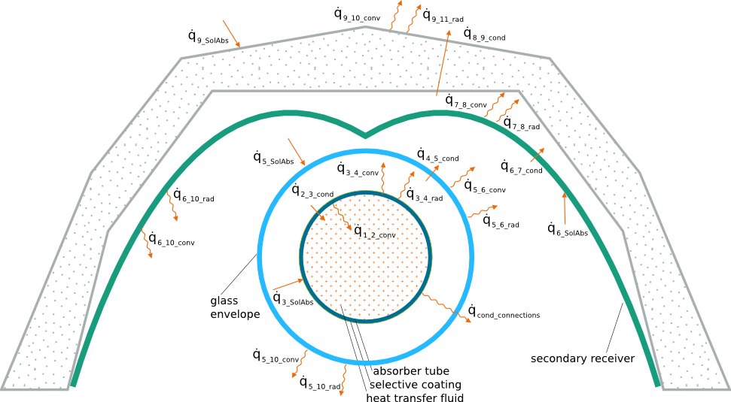
Fig. 5 Sketch of a tube with glass envelope and a secondary concentrator and the corresponding heat transport modes
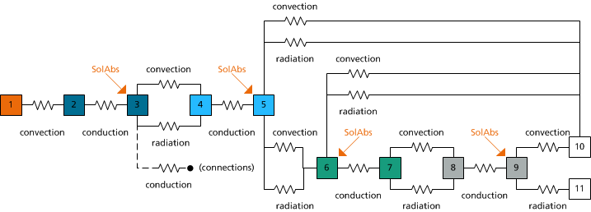
Fig. 6 Analog thermal resistance configuration

Convection between absorber tube and glass envelope

Refer to section 2.3.1, with properly defined index considering sketch shown in Fig. 5 and Fig. 6

Radiation between absorber tube and glass envelope

Refer to section 2.3.2, with properly defined index considering sketch shown in Fig. 5 and Fig. 6

Conduction through glass envelope

Refer to section 2.3.3, with properly defined index considering sketch shown in Fig. 5 and Fig. 6

Heat generation in glass envelope

Refer to section 2.3.3 , with properly defined index considering sketch shown in Fig. 5 and Fig. 6

Heat generation in secondary concentrator

The primary mirror field reflects the direct normal radiation into the cavity and due to astigmatism and optical inaccuracies only part of the reflected radiation is hitting the absorber directly. A fraction of the radiation interacts with the secondary reflector and is redirected onto the absorber. Since reflection by the secondary is not loss-less, a component of the short wavelength radiation is absorbed by the secondary reflector, increasing its temperature
The heat flux distribution is obtained through ray tracing simulations. Together with the optical efficiency of a Fresnel collector, it is possible to obtain a spatial distribution of the heat flux absorbed by the secondary mirror. However in the thermal resistance model the secondary mirror is treated and implemented as one surface, therefore the spatial distribution is integrated to obtain a single value of the absorbed heat.
The following figure shows the results from a ray tracing simulation of absorbed heat flux. It should be noted that both the absorbed flux and its spatial distribution will vary with the position of the sun, i.e. with the incidence angles of direct radiation onto the collector.
In the TRM as currently implemented, the absorbed heat flux is given as an input parameter.
The example shown has been calculated by raytracing for normal incidence of direct radiation onto the collector. Other incidence angles have not been investigated, i.e. it is not clear whether the normal case is a conservative estimation or not.
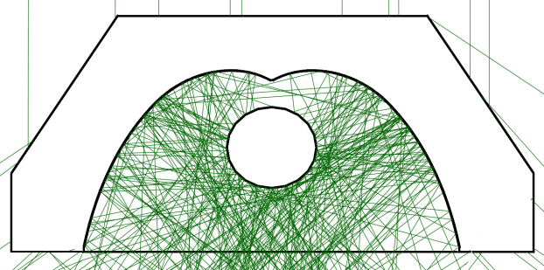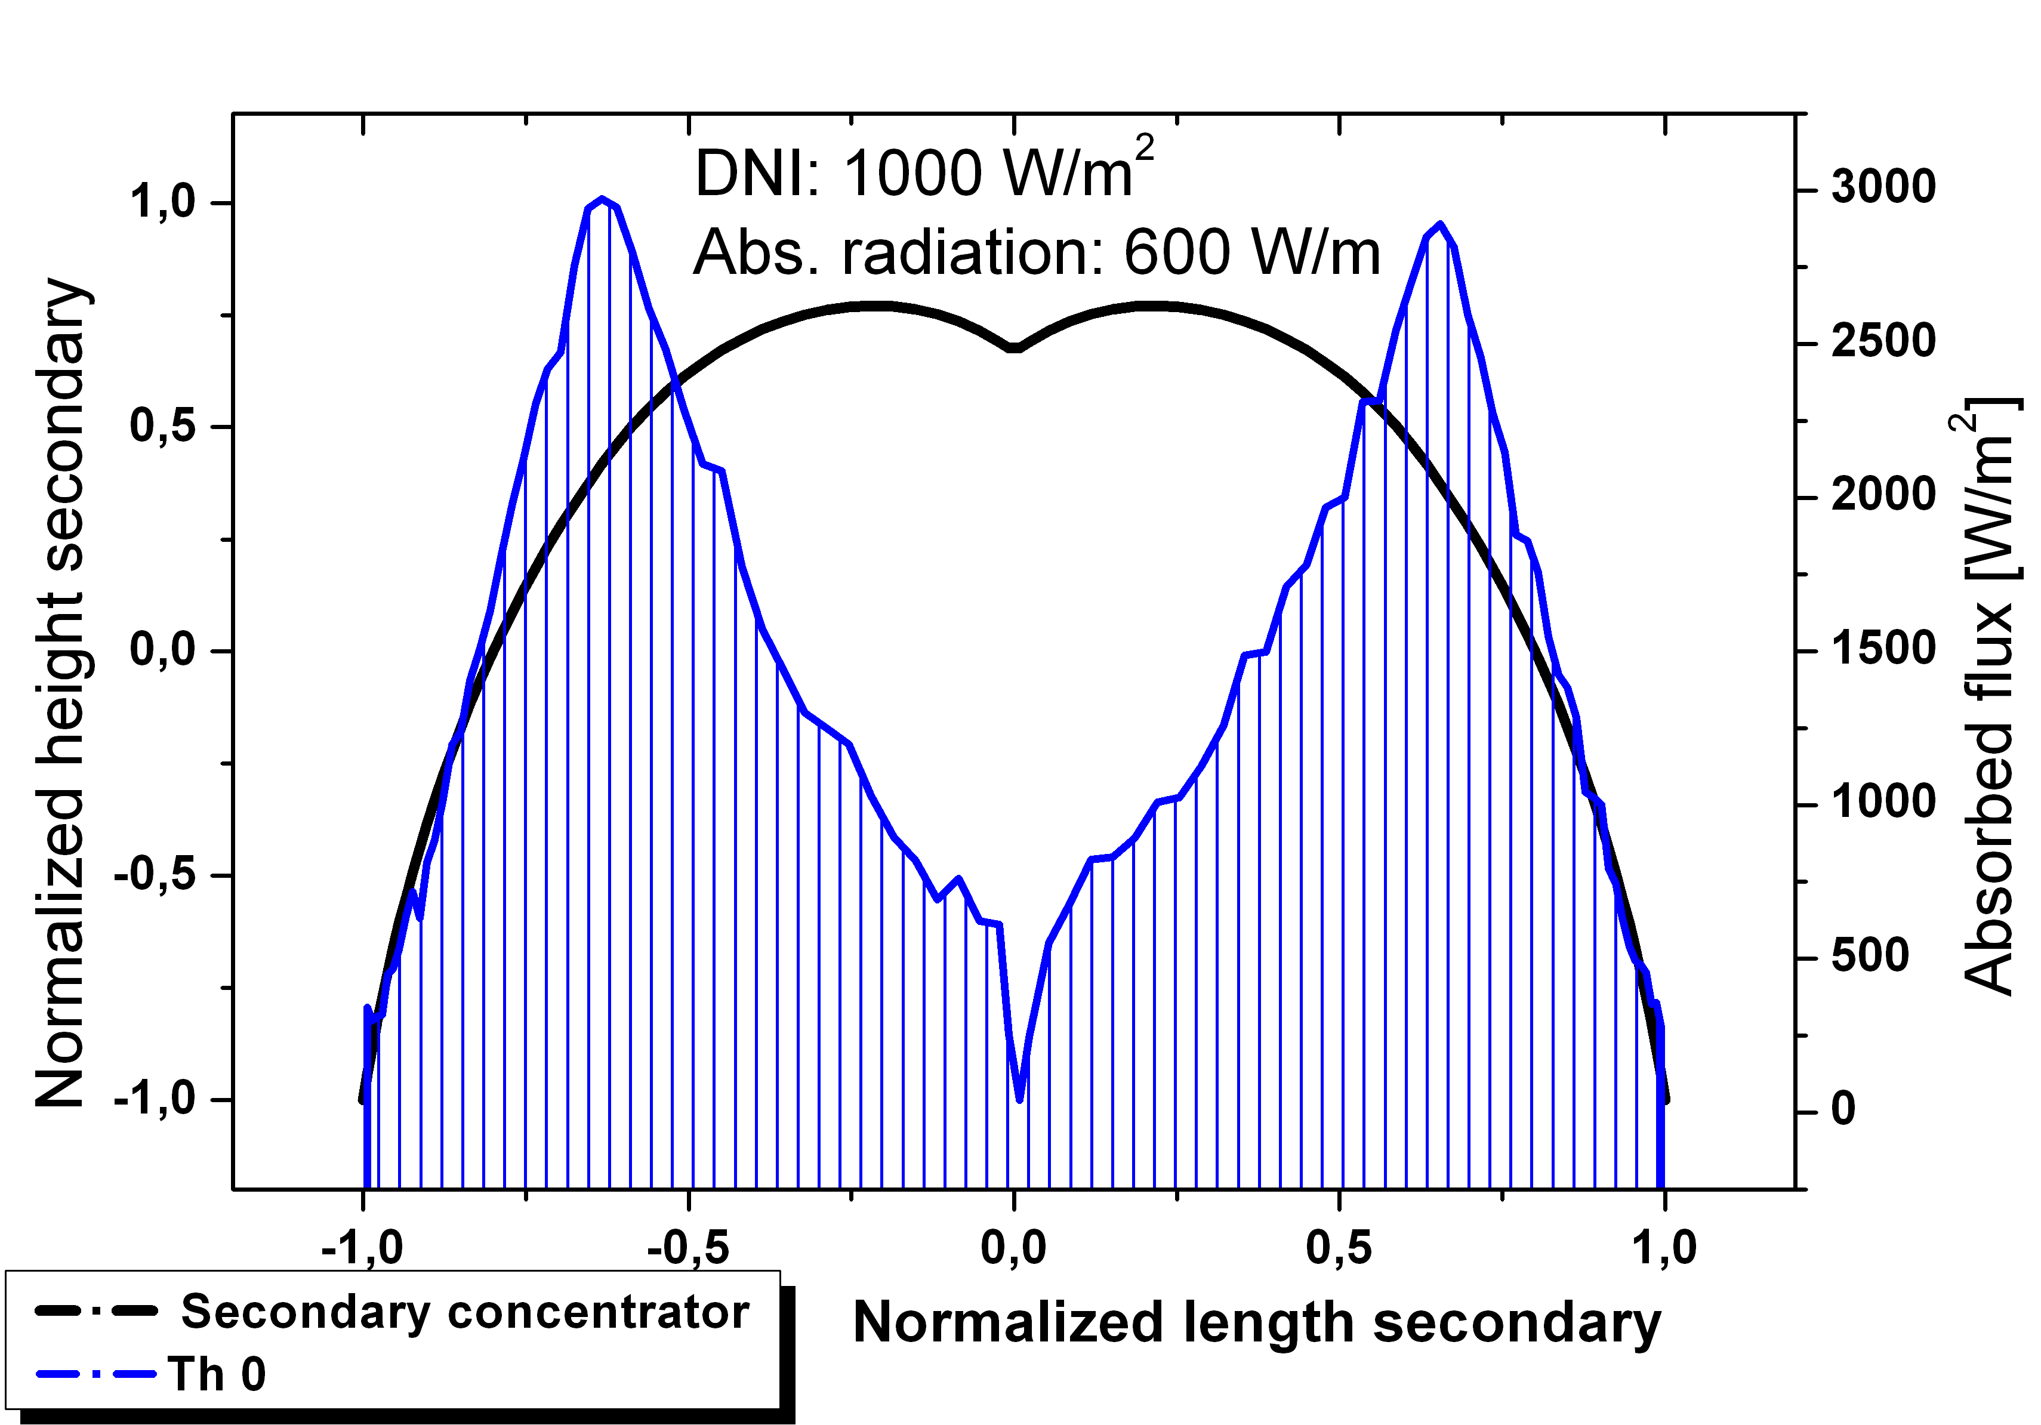
Fig. 7 (Left) ray tracing on a Fresnel receiver. (Rigth) Spatial distribution of the heat flux absorbed by the secondary

Convection between glass envelope and secondary concentrator

As the space between the glass envelope and the secondary concentrator is not an enclosure, it is possible to have both, natural and/or forced convection. At the same time, the geometry of glass envelope and secondary mirror is so complex that no closed solution to describe the heat transfer is available (e.g. from literature). Therefore, some simplifying approximations and assumptions have to be applied when implementing the TRM.
- Natural convection

When there is no wind, it is assumed all the heat by convection is transported from the glass envelope to the secondary concentrator In this case we consider the heat transport between concentric tubes, as it is explained in section 2.3.1

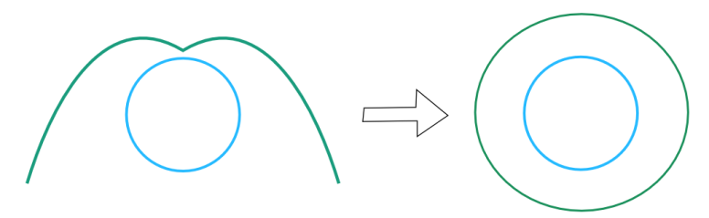
Fig. 8 Geometrical simplification of the secondary mirror and absorber tube for the case of natural convection (no wind)

- Forced convection

In case there is wind, there is forced convection over the surface of the secondary and the surface of the glass envelope. A simplification is applied in this case is to consider the space between the glass envelope and the secondary as parallel plates. Wind direction has not been implemented for this geometry. The geometrical simplification is represented in Fig. 9

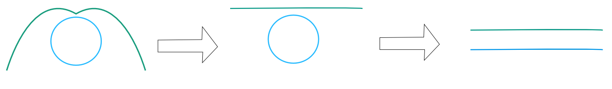
Fig. 9 Geometrical simplification of the secondary mirror and absorber tube for the case of forced convection

The correlations for the calculation of the heat transfer coefficient for each surface are detailed in [ 5]

In this case we have two coefficients, one for the glass envelope and one for the secondary concentrator. The assumption in this case is to consider all the heat is transported from the surfaces to the air, meaning there is no heat transport between the surfaces. For short and wide channels the assumption is realistic. As the channel becomes narrower and larger, the temperature of the air begins to increase and this assumption should be reconsidered.

Discussion: As we have seen in section Fehler! Verweisquelle konnte nicht gefunden werden., there is a non-uniform energy flux over the secondary surface, which produces a non-uniform temperature distribution on it. The main simplifying assumption in this part is considering the surface of the secondary concentrator as isothermal. Forced convection has been considered through a simplified geometry. From a fluid dynamic point of view, the simplification represents the general behavior of the fluid, but experimental data is needed to check if the assumption is within an acceptable range. Besides the geometrical simplification it has to be considered as well the simplification of isothermal surfaces. Given these aspects, it is recommended to treat the results with care and take them as reference and not as absolute true values.

Radiation losses of glass envelope, between glass envelope and secondary concentrator

Heat transport by radiation can be calculated using the view factor method. The view factor matrix is calculated considering three surfaces that form an enclosure. The surfaces are the secondary, the tube and an artificial plate on the bottom of the secondary.. The artificial bottom surface acts as a blackbody at ambient temperature, and is equivalent to the receiver open to ambient (no physical cover plate). It absorbs all incident radiation and emits radiation in all directions. For calculating the view factor matrix we use the code View3D [7].
Discussion: In the view factor method it is assumed that all surfaces are isothermal, opaque and gray. As we have seen in section 0, there is a non-uniform energy flux over the secondary surface, which produces a non-uniform temperature distribution on it. The main simplifying assumption in this part is considering the surface of the secondary concentrator as isothermal. The assumption of an opaque surface is not critical as in this part we analyze the long wavelength radiation transport. In the case of short wavelength radiation transport, the surface is specular.
Improvements: The assumption of forming an enclosure with an artificial surface on the bottom of the secondary can be modified and expanded if it is needed. In that case the enclosure can be formed with the primary field and/or the ground.

Conduction through (across) secondary concentrator

The secondary mirror is approximated to a circumference of radii equals to half the aperture of the secondary. As the effective area exchanging heat is larger in the circumference compare to the secondary mirror, the results are corrected by a correction factor. The approximation is represented in Fig. 10

$$C_{f}=\frac{A_{sec}}{A_{cicumference}}$$

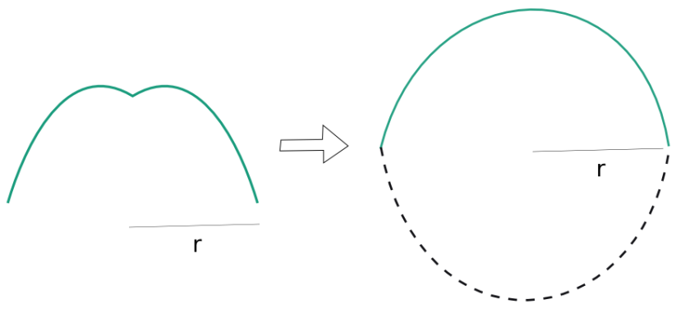
Fig. 10 Schematical representation of the approximated geometries

Considering this approximation, conduction is calculated in the same way as in section 2.3.3, with corresponding index according Fig. 5 and Fig. 6
Discussion: Whereas the temperature of the surfaces are constant, the relation for heat transport by conduction across the secondary mirror is accurate. However, we know that in reality we have non-uniform temperatures on the secondary mirror, which would imply conduction along the secondary mirror as well. Since in the TRM we assume constant temperatures, any conduction along the mirror is ignored / neglected.

Convection between secondary concentrator and housing

The housing material is implemented as solid material, the secondary mirror as metal sheet. For both surfaces, constant temperatures (one T node only) apply. Secondary mirror and housing are not in direct contact, but there is an interspacing.
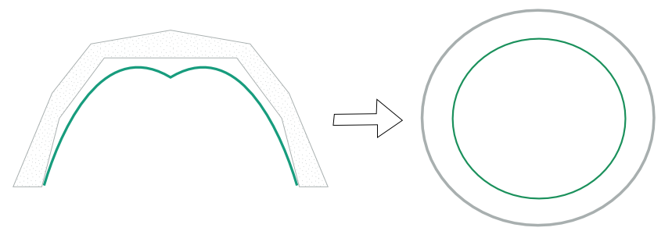
Fig. 11 Schematical representation of the approximated geometries
The correlations used are the same as the ones explained in section 2.3.2, considering corresponding indexes according Fig. 5 and Fig. 6.

to be completed …

Radiation between secondary concentrator and housing

Same approximation as in section 2.4.9. To solve the radiation balance, same equations as in section 2.3.2 are used, considering corresponding indexes according Fig. 5 and Fig. 6

Conduction through insulation

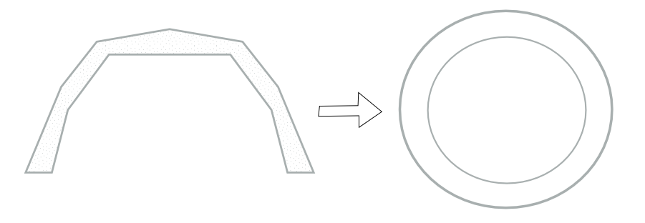
Fig. 12 Schematical representation of the approximated geometries
Refer to section 2.4.8 with properly defined index considering sketch shown in Fig. 5 and Fig. 6

Convection between housing and surroundings

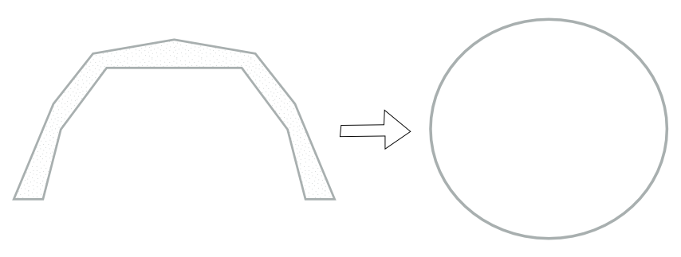
Fig. 13 Schematical representation of the approximated geometries
The approximation is shown in Fig. 13. The correlations used for this geometry are the same as in section 2.2.1, using corresponding index according Fig. 5 and Fig. 6

Radiation between housing and surroundings

Refer to section 2.2.2 with properly defined index considering sketch shown in Fig. 5 and Fig. 6. For counting the different areas, the same correction factor explained in section 2.4.12 is applied.
ambient / albedo/ground primary mirror array sky ?

Tube with secondary concentrator and glass plate

Explanation…

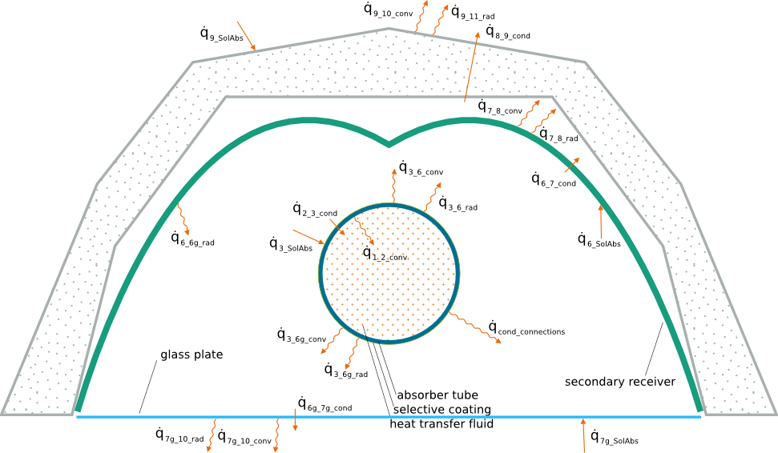
Fig. 14 Sketch of a tube and a secondary concentrator with a glass plate on the bottom and the corresponding heat transport modes

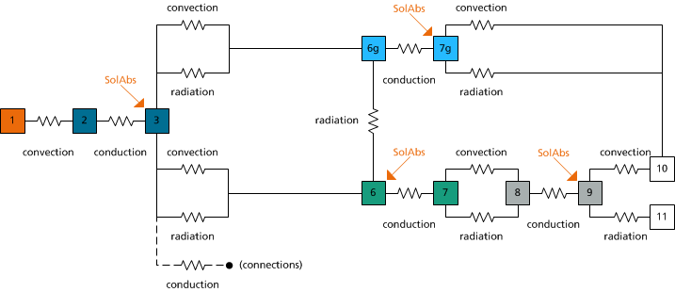
Fig. 15 Analog thermal resistance configuration

Convection between absorber tube and secondary concentrator (included glass plate)

The geometry of the secondary mirror and glass plate has been simplified considering two concentric tubes. The approximation is represented in Fig. 13
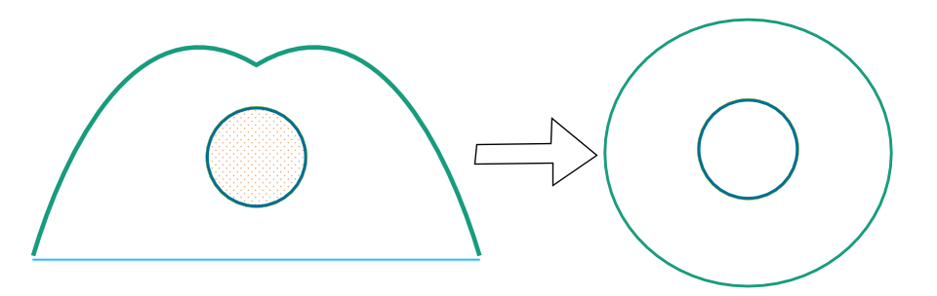
Fig. 16 Schematical representation of the approximated geometries

Radiation losses of absorber tube (to secondary concentrator and glass cover plate)

Heat transport by radiation can be calculated using the view factor method. The view factor matrix is calculated considering three surfaces that form an enclosure. The surfaces are the secondary, the tube and the plate on the bottom of the secondary. For calculating the view factor matrix we use the code View3D [7].
Emittances, …. ?

Conduction through secondary concentrator

Refer to section 2.4.8 with properly defined index considering sketch shown in Fig. 11 and Fig. 12

Heat generation in secondary concentrator

Refer to section 2.4.5 with properly defined index considering sketch shown in Fig. 11 and Fig. 12
to be completed …

Convection between secondary concentrator and housing

Refer to section 2.4.9 with properly defined index considering sketch shown in Fig. 11 and Fig. 12

Radiation between secondary concentrator and housing

Refer to section 2.4.10 with properly defined index considering sketch shown in Fig. 11 and Fig. 12

Conduction through insulation

Refer to section 2.4.8 with properly defined index considering sketch shown in Fig. 11 and Fig. 12

Convection between housing and surroundings

Refer to section 2.4.12 with properly defined index considering sketch shown in Fig. 11 and Fig. 12

Radiation between housing and surroundings

Refer to section 2.4.13 with properly defined index considering sketch shown in Fig. 11 and Fig. 12

Conduction through glass plate

Conduction through a plate is a well-known geometry. The equation used to calculate the heat transport is the following
$${\dot{q}}_{6g_7g_cond}= -kA \frac{(T_{7}-T_{6})}{L}$$
where
- $k$, thermal conductivity, $(W/{m °C)}$
- $T_{6}$, temperature of inner glass plate surface (°C)
- $T_{7}$, temperature of outer glass plate surface (°C)
- $A$, area containing the normal to the glass plate, ($m^{2}$)
- $L$, thickness of the glass plate, (m)

Again, the main simplification results from the assumption of a constant temperature across the entire surfaces of the glass cover plate.

Heat generation in glass plate

to be completed …

Convection between glass plate and surroundings

There can be two cases depending on the wind velocity
- Natural convection

In this case the correlation needed for the Nusselt number is for a plate with hot side facing down. From [1] the following correlation is implemented
$$Nu=0.27× {Ra}_{L}^{0.25}$$

- Forced convection
A correlation for a plate applies in this case, which has been described in section 2.2.1, where it is defined for a tube but the same correlations applied for a plate, with appropriate definition of the “streamed length$l_{c}$”. Wind direction has not been considered.

Radiation between glass plate and surroundings

The following equation is implemented
$${\dot{q}}_{7g_10_rad}= σ × ε_{7}×l_{7 }(T_{7}^{4}- T_{10}^{4})$$
where,
- $ε_{7}$, emissivity of glass plate
- $T_{7}$, outer surface temperature of glass plate (K)
- $T_{10}$, ambient temperature (K)
- $7$, length of glass plate (m)
- $σ$, Stefan-Boltzmann constant, $5.67 × {10}^{-8} W/{{(m}^{2}K^{4}})$

References

[ 1 ] Cengel Y, Heat Transfer, A Practical Approach, Second Edition.
[ 2 ] Modest M, Radiative Heat Transfer, 2002, Second Edition, Academic Press.
[ 3 ] Forristall R, Heat Transfer Analysis and Modeling of a Parabolic Trough Solar Receiver Implemented in Engineering Equation Solver, Technical Report, National Renewable Energy Laboratory NREL.
[ 4 ] Burkholder F, Kutscher C, Heat Loss Testing of Schott’s 2008 PTR70 Parabolic Trough Receiver, Technical Report, National Renewable Energy Laboratory NREL.
[ 5 ] VDI Heat Atlas. 2002, Second Edition, Springer, Berlin Heidelberg
[ 6 ] Bass M, Handbook of Optics, Second Edition, Vol. 3
[ 7 ] View3D, http://view3d.sourceforge.net
[ 8 ]http://www.thermalradiation.net/indexCat.html
[ 9 ] Gnu scientific library, http://www.gnu.org/software/gsl/

