Thesis

Contents

List of Figures 4
List of Tables 5
List of Abbreviations 6
1 Introduction 7
1.1 Motivation 7
1.2 Aim of the work 7
1.3 Methodology 7
2 Chilean situation 9
2.1 Primary energy supply 9
2.1.1 Thermal energy demand 9
2.1.2 Electrical energy demand 10
2.2 Mining sector 11
2.3 Expected situation by 2025 12
2.4 Solar energy resource 13
2.4.1 Data available 13
2.5 Particular issues in the Chilean context 13
3 Principles of solar energy and concentrating collectors 14
3.1 Nature of solar energy 14
3.2 Concentrating solar energy technologies 17
3.3 Linear Fresnel collector 19
3.3.1 Main components 19
3.4 Collector characterization 22
3.4.1 Optical analysis 22
3.4.1.1 Optical efficiency 23
3.4.1.2 Source of optical losses 24
3.4.2 Thermal analysis 25
4 Manufacture of components and Chilean local industry 26
4.1 Mirrors 26
4.1.1 Primary field 26
4.1.1.1 Silvered glass 27
4.1.1.2 Aluminum 34
4.1.1.3 Local industry 39
4.2 Receiver 41
4.2.1 Absorber tube 41
4.2.2 Secondary concentrator 42
4.3 Structure 49
4.3.1 Structure 49
4.4 Auxiliary equipment 53
4.4.1 Auxiliary equipment 54
4.5 Cost model of collector 54
5 System performance evaluation and integration 55
5.1 Optical characterization 55
5.1.1.1 Primary field 55
5.1.1.2 Secondary mirror 56
5.1.1.3 Glass cover 56
5.1.1.4 Absorber 57
5.1.2 Exemplary calculations 57
5.1.2.1 Optical efficiency and Incidence Angle Modifier (IAM) 57
5.1.2.2 Energy gained by the secondary mirror 57
5.1.2.3 Energy gain by glass plate 58
5.1.2.4 Annual optical yield 59
5.2 Thermal characterization 59
5.2.1 Thermal balance 59
5.2.2 Computer Fluid Dynamics (CFD) model 60
5.2.2.1 Problem description and implementation 61
5.2.2.2 Domain 62
5.2.2.3 Boundary conditions 62
5.2.2.4 Exemplary results 62
5.2.3 Thermal Resistance Model (TRM) 63
5.2.3.1 Exemplary results 64
5.3 Electro-winning copper recuperation process 65
5.3.1 Plant layout and energy demand 66
5.3.2 Solar energy integration 68
5.3.3 Scenarios definition 68
6 Analysis and optimization 69
6.1 Optical yield 69
7 Summary and Outlook 70
Bibliography 71

List of Figures

List of Tables

List of Abbreviations

Introduction

Increase of energy demand in the world. Chile is in the same situation
Need of supply energy demand with new sources
Characteristics of Chile in terms of population distribution and energy demand.
Energy demand in Northern Chile driven mainly by demand of an industrial sector
Opportunity of implement new solutions
Interest of knowing if Chile can be part of supply chain for concentrating solar energy technologies

Motivation

Need of implement new sources of energy in the northern part of Chile to supply both heat and electricity
Concentrating solar energy technologies have a great potential.
Linear Fresnel Collector is more simple than parabolic trough
- Lower resistance to wind loads
- Receiver fixed above the primary field
- Primary field made of flat or slightly curved mirrors
- Integration of secondary concentrator to increase optical efficiency
Simplicity of its components has to compensate lower optical efficiency compare to PTC
Linear Fresnel Collector for heat process as a first step to adapt technology
Potential of local manufacture components to promove R&D and local industry development

Aim of the work

Design and characterize a Linear Fresnel Collector considering conditions in Chile.
- Ambient conditions: DNI
- Energy demand: temperature range
- Location: North of Chile, close to copper mines
- Local industry: capabilities of manufacturing LFC components

Develop a methodology that can be used in case of implementing a LFC (or other concentrating solar energy technology) for other application

Methodology

ToDo
- flow diagram of the methodology
- find synonims for “characterize”

- Characterize copper mining sector to determine potential of integrating LFC and options to integrate LFC in heat processes applications
- Characterize main components of LFC, materials needed and manufacturing processes to identify synergies with local industry
- Conceptual design of geometries, based on possibilities of manufacturing components in Chile
- Develop models to characterize thermal behavior of LFC receivers
- Use ray tracing tools to calculate optical performance
- Calculate annual yield of LFC and LCE (Levelized Cost of Energy)
- Optimize concept
- Identify Strenghts, Weakness, Opportunities and Threats (SWOT analysis) of building Linear Fresnel Collectors in Chile.

Chilean situation

This chapter describes the context that places Chile as a suitable potential market for solar energy technologies

Primary energy supply

Primary energy is the one that must be processed before made use of it. Main sources of primary energy are “…TBF…”. Chile has a considerable amount of hydro resources. In particular, the southern part of the country is vast with rivers, which flow from the Anden mountains up to the Pacific ocean. The hydro resource is being used by means of hydro power plants to convert the potential energy of the water in electrical energy. The installed capacity of hydro power plants represents about 42% of the total installed capacity of the country. However, electrical yield from hydro power plants is not constant in a yearly scale, as severe droughts have affected the country in the last years.

Fossil fuels cover a significant part of the contribution to the land,
Table 2.1
Resource | Yield | Yield
Diesel | XX
Natural gas | XX
Coal | XX
Hydro power | XX
Wind | XX
Biomass | XX
Solar | XX
Biogas | XX

Thermal energy demand

Figure 2.1

Figure 2.2

Electrical energy demand

Figure 2.3

ToDo
- Graph. Location of electricity systems, installed capacity and table with sources of energy
In Chile, the classification of the electricity systems is done according the size. Major systems are those with an installed capacity greater or equal to 200 MW, medium-sized systems are those with an installed capacity greater than 1.5 MW and lower than 200 MW, and small-sized systems have an installed capacity equal or less than 1.5 MW. Electricity in Chile is supplied by four electrical systems. In FIG BBB are shown all of them, mentioning the installed capacity

GRAPH SIC-SING
Figure 2.4

Central Interconnected System (SIC): Electrical system that supplies the central part of Chile. It covers a distance of about 2100 kms and represents 70% of Chile’s total installed capacity.

Nothern Interconected System (SING): Electrical system that supplies the northern zone of Chile. It represents about 28% of Chile’s total installed capacity. Its generation is primarily based on fossil fuels and the energy is mainly consumed by the mining sector.
The extreme southern part is supplied by two medium size electrical systems, representing about 1% of Chile’s total installed capacity.

Table 2.2

In Table 2.2 is shown the installed capacity by generation technology for each major system

Mining sector

The copper mining industry has been the main driving force of the Chilean economic development over the past years. According to the United States Geological Survey (USGS), in 2010 Chile was the main copper producer in the world, with a mine production about 5.419.000 metric tons, followed by China (1.160.000 metric tons) and Peru (1.094.000 metric tons).

In Chile the copper mining sector is primarily located in the Atacama Desert, which is surrounded by the Pacific Ocean on the west side and the Andes Mountains on the east side. Most of the mines are located inland, whereas the population is mainly settled on the coast. Copper extraction and production is a high energy demand industry. The different stages of the processing requires both electrical and thermal energy, the plants operate in a 24/7 basis, so the infrastructure needed has to be robust and reliable. As stated by the Chilean National Energy Commission (CNE), 70% of the electrical energy generated in the Northern zone has been supplied to the mining sector.

Copper is present in the earth’s crust as sulfides or oxides. To obtain pure copper cathodes, different processes are needed according to the nature of the ore. Chile is the main world copper producer from oxides, where hydrometallurgy methods are used. The final stage to produce copper cathodes with less than 20 parts per million (ppm) impurities is electro-winning. To reach the desired level of metal purity, the process is closely monitored and controlled. Electro-winning involves an aqueous solution called electrolyte, which contains copper, sulfuric acid and water, and is permanently flowing between anodes and cathodes. An electrical potential is applied between anodes and cathodes, resulting in a plating of pure metallic copper from the electrolyte onto the cathodes. The process takes place for about one week. To maximize copper purity, the electrolyte is heated up to temperatures between 45 and 60°C. Water heaters are integrated into the system to keep the electrolyte warm. Depending on the specific design of the electro-winning plant, the water heaters operate between 60° and 90°C.

BIOLEACHING

NON METALLIC INDUSTRY

Given the conditions in the Atacama Desert, namely high solar energy resource, land availability and energy demand from the mining sector, there is a potential to integrate solar systems to supply both thermal and electrical energy. Nowadays, two mines in Chile have integrated a solar system to heat the electrolyte. In 2010 Minera El Tesoro implemented a parabolic trough collector system with an aperture area of 16.700 m², in order to produce 7.0 MWth. In 2013 Minera Gaby implemented a flat plate collector system with an aperture area of 39.000 m² to produce 32 MWth.

ToDo
- Picture of mines location and electrical grid
Figure 2.5

Describe location and development
Significance for Chile and numbers positioning Chile as main copper producer in the world
Copper extraction process, briefly describing energy and water demand by process

Expected situation by 2025

Based on reports from Chilean governanmental organizations, define the mid-term situation in Chile. Topics to consider: Copper production, nature of the ores, consecuences on energy and water demand

Solar energy resource

Description of solar energy resource in Chile, based on public information
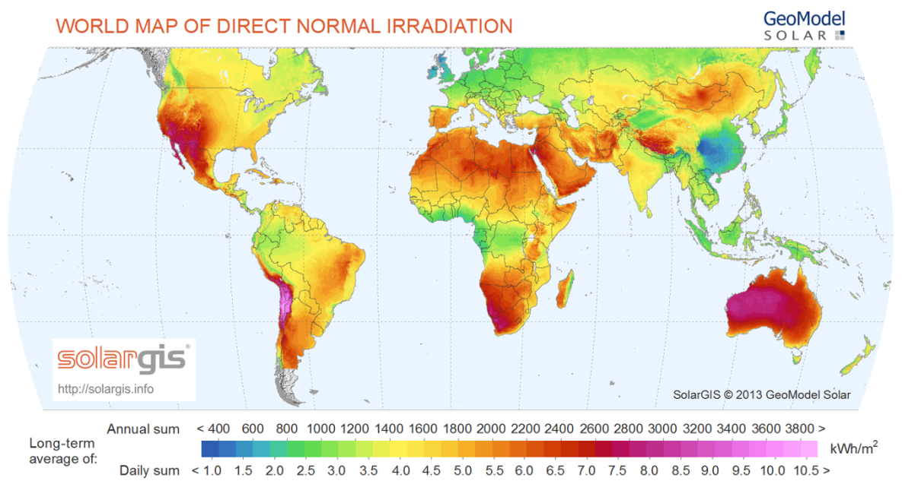
Figure 2.6

Data available

Measurements of solar energy (DNI, GHI, DHI). Station: Crucero II, data available from 08.2012 up to 01.2014. Instrumentation installed by CSP Service
Table with main indicators. Acumulated annual DNI, monthly average, hours of sun, sun position…

Table 2.3

Particular issues in the Chilean context

- Earthquakes
- Environmemt nearby copper mines
- Technology development
  - Technology push
  - Market pull

Principles of solar energy and concentrating collectors

In this chapter, the basic principles describing the nature of solar radiation and how concentrating collectors can make use of it are explained. First, details about the relation between the sun and the earth are given. This defines the radiation available outside the earth’s atmosphere. Then, it is explained the interaction between the solar radiation and the earth’s atmosphere, which defines the amount of energy at the level of the ground. Together with the energy quantity, the angles that defines the sun position are defined. Finally, there is an explanation about concentrating solar energy technologies, with special emphasis on the Linear Fresnel collector, which is the main technology studied in this work. In this part, the components of the collector and its performance indicators are described.

Nature of solar energy

The sun is a sphere of hot gaseous matter with a diameter of 1.39 x ${10}^{9}$ m and is located at an average distance from earth of 1.49 x ${10}^{11}$ m. It has an effective blackbody temperature of 5777 K and radiates continuously the earth’s surface with radiation in a wavelength between 0.25 and 3.0 $μm$.

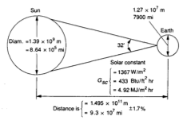(EDIT PICTURE)
Figure 3.1

Figure 3.1 shows a scheme of the geometry relationships between the sun and the earth. The distance between the sun and the earth varies by 1.7% along the year. At the mean earth-sun distance, the sun subtends an angle of 32’. The radiation emmited by the sun and the spatial relationship to the earth result in an almost constant radiation flux outside the atmosphere. The solar constant $G_{sc}$ is the energy from the sun per unit time received on a unit area of surface perpendicular to the direction of propagation of the radiation. The solar constant is defined at the mean earth-sun distance outside the atmosphere.

The solar constant is an indicator of the total energy outside the earth’s atmosphere. Together with the total energy, it is useful to know the spectral distribution of the extraterrestrial radiation. Figure 3.2 shows the WRC standard.

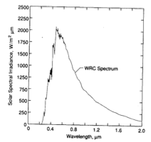(EDIT PICTURE)
Figure 3.2

The spectral radiation is divided in three regions:
Ultraviolet range, which spans a range of 100 to 400 nm. The term ultraviolet refers to the fact that the radiation is at higher frequency than violet light, therefore invisible to the human eye.
Visible range or light spans 380 to 780 nm. As the name suggests, it is this range that is visible to the naked eye. It is also the strongest output range of the sun's total irradiance spectrum.
Infrared range that spans 700 nm to 1,000,000 nm (1 mm). It is responsible for an important part of the electromagnetic radiation that reaches the Earth.
Once the solar radiation enters the atmosphere, it is not travelling through vacuum anymore and interacts with particles in the atmosphere. The effects of the interaction is absorption and scattering. Absorption decreases the amount of energy. Scattering changes the rays’s direction. The interaction of light with particles is schematically shown in Figure 3.3

(EDIT PICTURE)
Figure 3.3

The length of the path that radiation travels in the atmosphere varies according the sun position and location in earth. The air mass is defined as the ratio of the mass atmosphere through which beam radiation passes to the mass it would pass if the sun where at the zenith. At sea level, when the sun is at the zenith, the air mass has a value of 1.

(EDIT PICTURE)
Figure 3.4

Radiation reaching the level of the ground has two components. Direct radiation (sometimes called beam radiation) is the radiation received from the sun that has not suffered scattering by the atmosphere. Diffuse radiation (sometimes called sky radiation) is the radiation received from the sun after its direction has been changed by scattering in the atmosphere. The sum of the direct and diffuse components defines the total solar radiation.

The apparent movement of the sun due to earth rotation and translation is described by two angles.

- Zenith angle ($θ_{z}$) is the angle between the vertical and the line to the sun, or in other words, the zenith angle is the angle of incidence of beam radiation on a horizontal surface.
- Solar azimuth angle ($γ_{s}$) is the angular displacement from south of the projection of beam radiation on the horizontal plane. Displacements east of south are negative and west of south are positive.

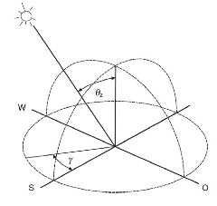(EDIT PICTURE)
Figure 3.5

In this part it has been described the solar radiation reaching the earth’s surface, which is the solar resorce available to be used. Depending on the type of technology, solar energy is transformed into heat or electricity. The present work deals with concentrating solar thermal technologies, therefore, the direct component of th solar energy is used to transform solar radiation into heat.

Concentrating solar energy technologies

Light concentration can be achieved through lens or mirrors. This work is based on the light reflection principle, so all technologies using lens are discarded. In this part is briefly explained the different technologies that concentrates solar radiation by means of mirrors, making a distinction between line-focusing and point focusing collectors. Besides, the reasons for concentrating energy are described.

The need of concentrating solar radiation lies in the temperature limits that a surface can reach under certain conditions. The temperature of a surface depends on the net balance between energy gain and energy loss. As an example, Figure 3.6 shows the energy balance of a surface (from now, called absorber) exposed to ambient conditions. Table 3.1 shows the parameter needed for the exemplary calculation

Table 3.1 Properties of absorber surface and ambient conditions used in exemplary calculations
Property
Area (m²) | XX
Absorptance (%) | XX
Emittance (%) | XX
Ambient temperature | XX
Wind velocity | XX

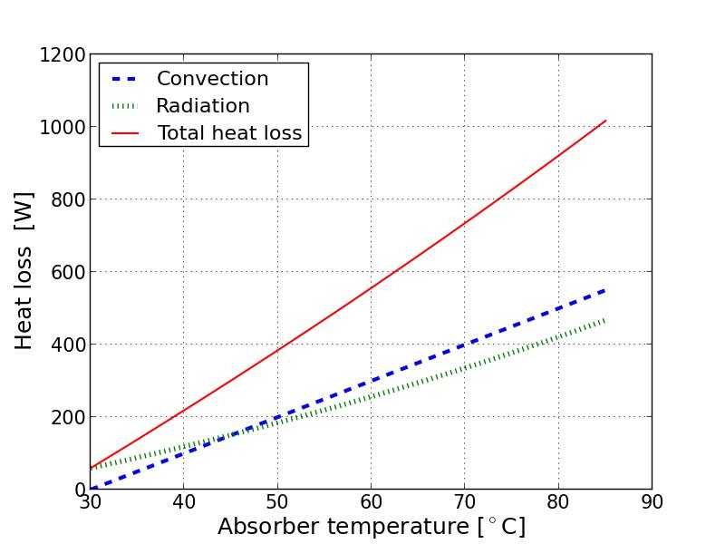(ADD SKETCH THERMAL BALANCE)

Figure 3.6

Under conditions described above, the absorber reaches a maximum temperature of 85 °C. To increase its maximum temperature, one can either decrease the heat loss or increase the energy gain. To decrease the heat loss, the absorber can be protected so convection is decreased. Besides, it can be coated with low emittance surfaces, so radiation is decreased as well. This is the working principle of e.g. flat plate collectors. Considering these improvements, an absorber can reach temperatures above 200 °C, as is shown in Figure 3.7.

Table 3.2 Properties of absorber surface and glass plate used in exemplary calculations
Property | Solkote
Area (m²) | XX
Absorptance (%) | XX
Emittance (%) | XX
Ambient temperature | XX
Wind velocity | XX

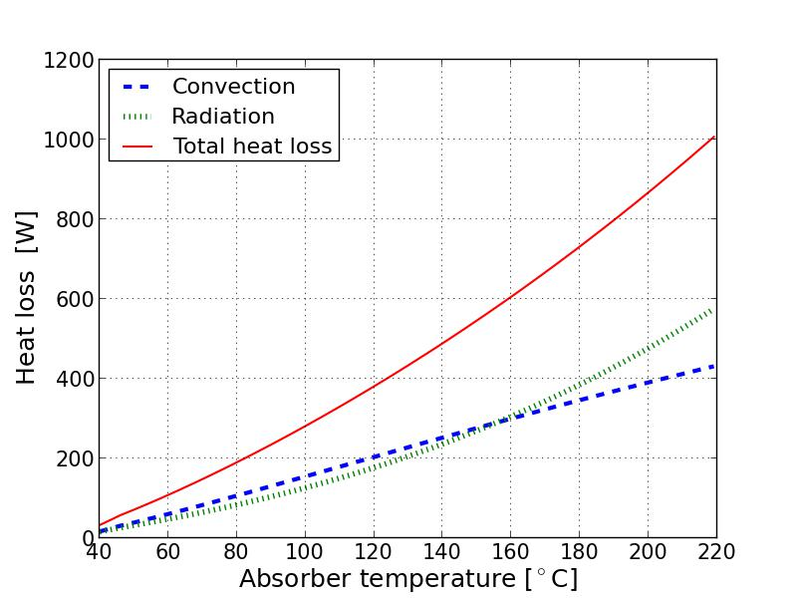(ADD SKETCH THERMAL BALANCE)

Figure 3.7

Even if flat plate collectors reach temperatures above 200 °C, the energy conversion is not highly efficient. Other way for reaching higher temperatures is increasing the energy gain of the absorber. To increase the energy gain, the incident radiation is concentrated on a smaller surface. This can be achieved by placing a reflector between the source of radiation and the absorber. Together with a higher incident flux, the area of the absorber can be decreased, which has a direct effect on the heat loss. Therefore the temperature reached is higher, as can be seen in Figure 3.8

Figure 3.8

This principle is used by line-focusing and point-focusing collectors. The temperature reached by each technology is different, therefore the application fields vary between them. Table 3.3 shows the temperature range of different solar technologies.

Table 3.3

Concentrating collectors are effective only concentrating the direct component of the solar radiation. As explained in section 3.1, the solar position varies along the day and year. Therefore to effectively concentrate the sunlight, a tracking strategy is needed. According to the concentration principle of the sunlight, the technologies are divided in two groups:

- Line-focusing collectors concentrate solar radiation in a line (e.g. a tube). These systems track the sun in one-axis and have a theoretical concentration ratio of 212. Parabolic trough collectors and linear Fresnel collectors are examples of line-focussing technologies. Both technologies can be seen in Figure 3.9

Figure 3.9

- Point-focusing collectors concentrate solar radiation in a point. These systems track the sun in two-axis and have a theoretical concentration ratio of 45000, therefore they are able to reach higher temperatures comparing to line-focussing collectors. Solar tower and parabolic dish concentrators are examples of point-focusing technologies. Point-focussing collectors can be seen in Figure 3.10

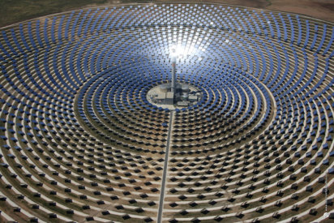
Figure 3.10

Linear Fresnel collector

The linear Fresnel collector is composed of rows of mirrors that reflect the sunlight onto a receiver. The receiver is placed above the primary field and is stationary, therefore the tracking system is acting only on the primary field. A scheme of the collector with its main components is shown in Figure 3.11

Figure 3.11

The main advantages of the linear Fresnel collector are the following
- Primary field located nearly above the level of the ground.
- Primary field with flat or slightly curved reflectors.
- Stationary receiver.
- Possibility of integrating a secondary mirror in the receiver to increase the optical efficiency.

Consequently, the collector design can be achieved with simpler components compare to parabolic trough concentrators, with the potential of cost reduction. Nevertheless the optical efficiency is lower, therefore the cost reduction potential must compensate this.

Main components

Description of the components and definition of the properties that characterize each of them.

Primary field
High optical performance
- Reflectance / transmittance
- Specularity
- Geometrical configuration
Low maintenance (dust free)
Low initial cost
Long life

Primary field: The solar radiation reaches the reflector surface where it is redirected to the receiver.

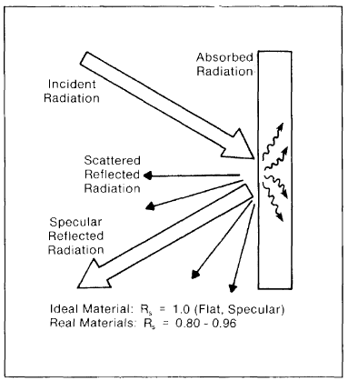
Figure 3.12

High optical performance means solar reflectance Rs or solar transmittance Ts values approaching unity, and a Gaussian beam spread due to nonspecularity and slope errors of less than 2 mrad.
Properties important for consideration
- Mechanical
- Optical
- Chemical

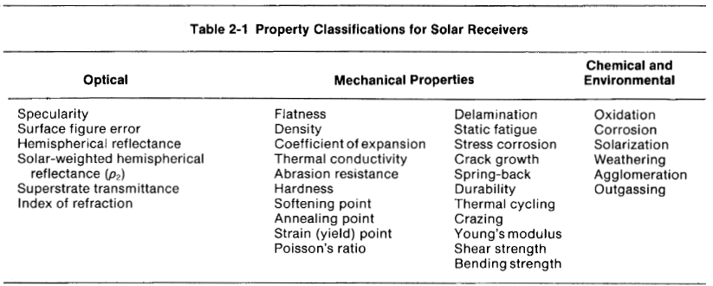

Low coefficient of thermal expansion and high thermal conductivity

Absorber low emittance, high absorptance, coatings stable in medium-temperature range

Figure 3.13

Glass cover (tube envelope or glass plate) high transmittance, low absorptance

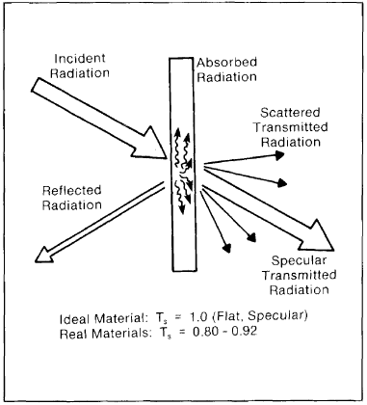

Secondary concentrator high reflectance, low absorptance, coatings stable in medium-temperature range

Structure precision, durability

Tracking system precision

Collector characterization

Description of theory that characterizes the thermal and optical behavior of a LFC

Optical analysis

The primary field is in charge of directing the incident radiation onto the receiver, therefore a tracking strategy must be implemented. In section 3.1 the angles defining the solar position were described. Together with the two angles that determine the sun position, three angles are defined for the collector. The angles stablish the relation between the solar vector and the collector planes. Figure 3.15 shows schematically the relation between the solar angles and the collector angles.

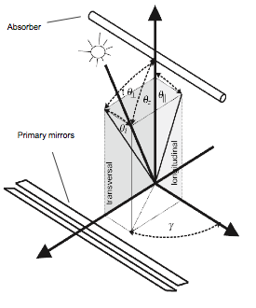
Figure 3.15

Optical efficiency

The optical efficiency of a Linear Fresnel collector determines the fraction of available energy that is absorbed by the absorber. Available energy is defined as the product between DNI (W/$m^{2}$) and the reference area of the collector.

$$η_{opt}= \frac{{\dot{Q}}_{Abs}}{{\dot{Q}}_{Avail}}=\frac{{\dot{Q}}_{Abs}}{{\dot{Q}}_{DNI}∙A_{ref}}$$

The effective area reflecting energy varies with different sun positions.

The optical efficiency $η_{opt}$ depends on the sun position. As a reference value, it is calculated the optical efficiency with the sun located at the zenith ($θ_{z}=0$)

$$η_{opt,0}=\frac{{\dot{Q}}_{Abs}(θ_{z}=0)}{{\dot{Q}}_{DNI}∙A_{ref}}$$

To account the variation of the optical efficiency with varying sun positions, $η_{opt,0}$ is multiplied by a correction factor. The correction factor is called Incidence Angle Modifier (IAM)

$$η_{opt}\left(θ_{z},γ\right)= η_{opt,0 }∙IAM\left(θ_{z},γ\right)$$

The IAM is determined through a factorization considering curves in the longitudinal and transversal plane.

$$IAM\left(θ_{z},γ\right)= IAM_{t}\left(θ_{t}\right) ∙ IAM_{l}\left(θ_{i}\right)$$

Figure 3.16

Source of optical losses

Geometry

- Cosine loss. The area effectively reflecting solar radiation is not equivalent to the total area of the reflector. In order to be able to redirect the solar radiation to the receiver, there must be an angle between the reflector normal and the transversal component of the solar vector.

- Receiver shading. The receiver produces a shadow over the primary field. The effect of the shadow is high with small zenithal angles, and tends to disappear with increasing zenithal angles.

- Structure shading. The structure shadows the primary field. The effect of the shadow is perceived for all sun position and its quantity depends on the specific design of the structure.

- Mirror shading. At low sun positions (e.g. after sunrise and before sunset), the mirrors near the sun block the solar radiation, producing a shadow over the mirrors away from the sun.

- Mirror blocking. At high sun positions (e.g. sun near zenith) the radiation reflected by the mirrors tends to be blocked by the adjacent mirrors.

- End loss. For increasing zenithal angles, the radiation reflected by the primary field has an increasing longitudinal component. The end loss accounts for the reflected radiation that does not hit the absorber tube.

Material losses
The interaction of light with materials has been shown in . These figures show the difference between ideal and real materials.

- Reflection. A perfect mirror reflects the light without loss of intensity and without deviation from the ideal state. However, no mirror is perfect. In all mirrors some quantity of solar radiation is absorbed.

- Transmission. When light interacts with transparent surfaces, most of its intensity is transmmited, but part is reflected and the rest is absorbed. The relation between transmitted and reflected intensity depends strongly on the incident angle. For normal incidence radiation, the reflected fraction is low. Between normal incidence and incidence angles near 60, the fraction is almost constant, and then decreases abruptly to values near 0.

- Absorption. In a similar way as reflection has been explained, there is no perfect absorber. The absoptance of a material reaches its maximum value at normal incidence angles, decreasing as the incidence angle increases.

Optical error

- Surface specularity is generally associated with the fine structure of the reflecting material. It determines the angular spread and intensity of this radiation

- Surface slope error variations typically result from local deviations in the surface normal about the ideal surface shape. It determines the direction of the reflected radiation.

- Tracking.

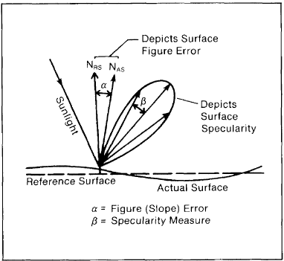

Thermal analysis

As the solar energy is concentrated onto the receiver, its temperature increases and consequently increases the heat loss.
Convection: heat transport by convection takes place between the absorber tube

Description of thermal loss
Radiation exchange
Convection exchange
Equation describing heat loss of linear receivers

Manufacture of components and Chilean local industry

Mirrors

Explanation of materials and manufacturing processes for LFC.
Silver. 97% - 98%
Aluminum 88%-92%

Only silver and aluminum have solar-weighted spectral reflectance values above 90%
Reflectance of aluminum is reduced over the solar region primarily because of an interband absorption centered approximately 800 nm

Primary field

se colocan capas de distintos materiales una encima de la otra. De esta forma, se proteje la superficie reflectante de la degradación que podría producir el ambiente, como indica la

Figure 4.1

Como se observa en la un espejo solar está compuesto por tres capas básicas, donde cada estrato puede subdividirse en distintos materiales para obtener las propiedades requeridas. Las capas básicas son:
- Substrato: la capa mecánica que mantiene la forma del espejo. Suele estar echo de vidrio, pero también es puede ser fabricada a partir de polímeros como PET, metales como el acero o aluminio.
- Lamina reflectante: es la capa diseñada para reflectar tanta energía solar como sea posible. Usualmente se utiliza aluminio o plata como material reflectante.
- Protectores: Otras capas que protegen al reflector, tal como pinturas, respaldos de cobre, barnices. También se consideran capas adicionales, como coberturas para evitar la deposición de polvo o coberturas de interferencia que protegen al reflector de los efectos de ciertas radiaciones como la ultra violeta.
Existen dos familias principales de espejos, a partir de la cual surgen distintas arquitecturas cada una con sus propias variaciones y distintos materiales

Since both silver and aluminum surfaces in solar applications must retain their highest reflectivity for many years, the reflective surfaces are protected with transparent covering materials referred to as superstrates. The mirrors are then called “seconda surface”. Substrates are the base (bottom) materials that protect the back surfaces of the silver or aluminum. A mirror is ‘”first surface” when the reflecting layer preceed the support

- Espejo de primera superficie: La capa metálica es depositada frente al sustrato, evitando la refracción y absorción en el vidrio. Se sugiere utilizar capas protectoras al utilizar esta tecnología.
- Espejo de segunda superficie: La capa metálica es depositada detrás del vidrio, protegiéndolo de la abrasión, oxidación, y otros efectos del clima. Pero esta configuración está sujeta a pérdidas por absorción en el vidrio.
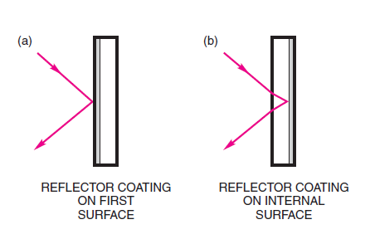
Figure 4.2

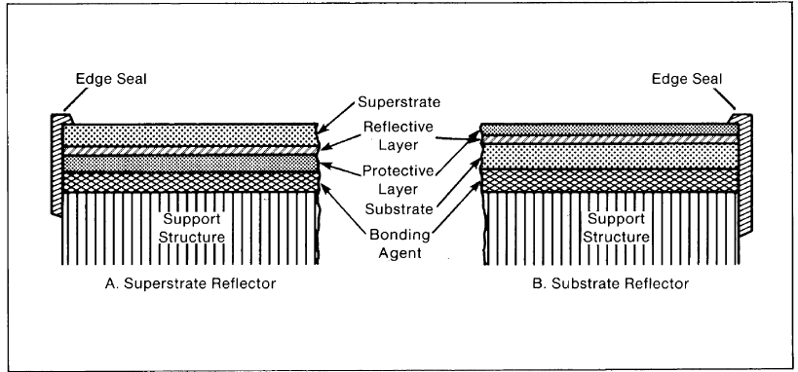

The typical construction of both a front-surface (susbtrate) and second-surface (superstrate) reflector are shown above. In a front-surface mirror, the reflecting layer is applied to the substrate and then overcoated with a protective film. In a second-surface mirror, the reflecting layer is applied to a transparent superstrate (glass or plastic film) which is then bonded to a support structure after applying a protective layer.

Detalles de la forma del reflector

Silvered glass

A thin layer of silver is bounded to glass. Glass acts as a protective barrier, light transmitter and as a structural support. The silver layer is protected with a layer of copper. The layer of copper is protected with layers of paint. Figure 4.3 shows a sketch of a silvered glass arquitecture.

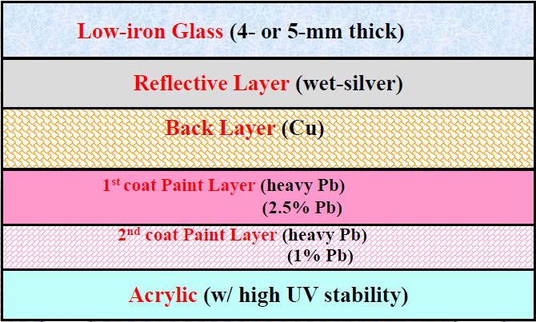
Figure 4.3

Copper and paint layers are needed to protect the silver from chemical and physical deterioration. The advantages of using glass as a superstrate are its clarity (high solar transmittance), low cost, smooth surface, physical strength, abrasion resistance, impermeability, resistance to soiling, ease of cleaning, and inertness. They can be expected to provide high reflectance without unreasonable dispersion, providing the silver remains intact and in contact with the glass.

Materials
Basic ingredient is silica. However, many different glass formulas exist to provide special features as durability, flexibility, and high transmittance, among others.

Vidrio bajo en Hierro
Debido a que el substrato es colocado frente a la superficie reflectante, se requiere de un material que presente alta transmisividad. Dado el requisito de que el material sea permeable, se busca utilizar vidrio con bajo contenido de hierro, debido a que el hierro absorbe gran parte de la radiación infrarroja.
Los fabricantes de vidrio suelen producir vidrio nominalmente estándar, es decir, transparente, gris, bronce y verde. Cada color se logra al incorporar diferentes aditivos al vidrio. El vidrio transparente o estándar no incluye ningún aditivo aparte de la arena utilizada en su fabricación. La Figura. 5.5.1., describe la absorción de cada uno de los vidrios producidos.

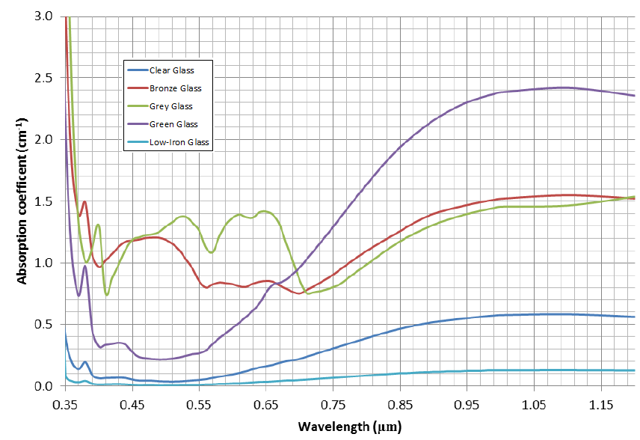
Figure 4.4. Coeficiente de absorción de distintos vidrios comerciales, Grafico de “Optical Modelling for Photovoltaic Panel”, por A. Steen-Nilsen Dynge, Asbion Orheim Stroveland, University of Agder,

Como se observa en el gráfico, el vidrio bajo en Hierro (línea celeste) presenta baja absortancia, permitiendo que gran parte de la energía pase atreves de este material y se refleje en la superficie reflectante. Aún se podría mejorar la absortancia para longitudes de onda de radiación infrarroja (sobre 0.7 μm).
De acuerdo a la unión europea el vidrio bajo en Hierro presenta un contenido en hierro menor a 300PPM, y debe tener una transmisividad de cuanto menos 88%. Entre otras características como resistir cambios bruscos de temperatura Δ150 K, y presentar una resistencia mecánica superior a 90 N/mm²
Los vidrios bajos en hierro, se fabrican a partir de Cal y arena silicatada, virtualmente libre de óxidos de hierro. El resultado es un vidrio transparente, color “blanco agua” con mayor transmisividad que vidrio de cal común. El material bajo en hierro transmite 2-3% más que un vidrio común, ambos con 10 mm de espesor, y llega hasta 8% mayor transmisividad para espesores mayores. Cuando se incorporan cubiertas anti-reflectantes, es posible llegar a un 98-99% de transmisividad.

Manufacturing process

- Vidrio bajo en Hierro: La producción de vidrio con bajo contenido en hierro, requiere de la utilización de arenas con bajo contenido de Hierro, menos de 300 ppm. Este material puede ser obtenido en ciertos yacimientos alrededor del mundo, los principales productores del recurso trabajan el mineral en Inglaterra, Escocia y Canadá.

Es posible trabajar yacimientos con mayores contenidos de hierro, al utilizar herramientas para limpiar el mineral, existen cuanto menos tres métodos para reducir la cantidad de contaminantes como el fierro, Cromita, y otros minerales refractarios. Los principales mecanismos utilizados para remover el hierro son:

- Separación magnética mojada
- Separación seca
- Métodos Químicos

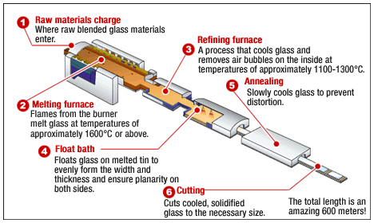
Figure 4.5 Descripción grafica del proceso de producción de vidrio por flotación. EL proceso completo requiere 600 metros de largo.

- Weighing and mixing the proper ratio of raw material ingredient (sand, soda ash, limestone, dolomite, salt cake, crushed coal and rouge)
- Melting the batch raw materials in a high temperature furnace. The furnace actually perform three functions. The initial phase melts the raw materials into a viscous liquid. Then, the melt proceeds through a refining zone allowing gaseous inclusions (bubbles), generated during the melting process, to scape from the molten glass. Finally, the molten glass enters a temperature conditioning zone that stabilizes the glass at a desired viscosity
- Forming the molten glass into a sheet by floating it on molten metal. Glass is formed into a sheet by flowing molten glass onto a bath of molten tin. A density differential between the glass and tin results in the glass “floating” on the tin and forming a continuous ribbon of glass with essentially flat, parallel and fire-polished surfaces. Tha glass ribbon is pulled along the bath of molten tin while simultaneously being cooled to a temperature at which it solidifies. Tin has a lower melting temperature than glass and remains molten throughout the process. It is possible to stretch the glass ribbon during the forming process to achieve the desired thickness before cooling to the point of solidification. The stretching process has been developed to a point that any thickness specification in the range of 1.5 mm to 12 mm can be met routinely.
- Annealing the sheet. The glass then proceeds continuously through the annealing leht that alleviates stresses within the glass ribbon and further cools it to below 150 °C
- Cutting the glass to size. The glass ribbon is moved under a series of cutters that cut it “on-the-fly” to the desired size.
- Packing

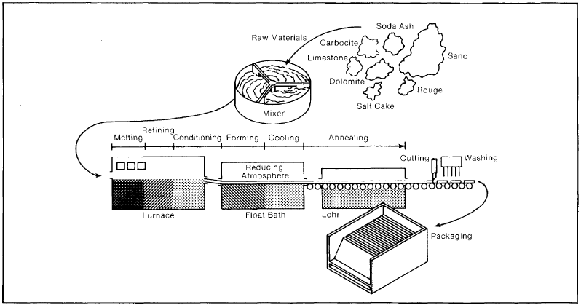

Fundición: Se funde la arena (60%), dolomita y cal (20%), soda y azufre (20%) a 1540°C durante unas 50hrs.
…

El vidrio flotado permite obtener superficie paralelas, con aspereza de entre 0.15μm/20 mm peak-to-peak para substratos de 1.1 mm de espesor, a 0.2μm/20mm peak-to-peak para espesores de 0.7 mm. En caso de pulir el vidrio es posible llegar a calidades superficiales de entre 0.05μm/20 mm peak-to-peak para substratos de 1.1 mm de espesor, a 0.075μm/20mm peak-to-peak para espesores de 0.7 mm.

Respecto a curvar el vidrio existen dos metodologías para realizar el proceso, en caliente y en frio. Para curvar en caliente se sigue el procedimiento:

- Precalentar un molde con la geometría deseada hasta cerca de los 650°C.
- Durante el tiempo que el metal es precalentado, el vidrio es pulido, inspeccionado con radiación ultravioleta para asegurar que no presente pelusas en su superficie.
- Antes de ser colocado sobre el molde el vidrio es cubierto con una mezcla de jabón, greda y carbonato de calcio, evitando la adecion del vidrio al molde.
- El vidrio es colocado sobre el molde y colocado en el horno hasta que por gravedad alcance la geometría del molde. Esto podria tardar varias horas dependiendo de la geometría del vidrio.
- Una vez que el vidrio se ha deformado se deja enfriar lentamente en el horno hasta llegar a temperatura ambiente.

El proceso de doblar el vidrio, se realiza a 650°C, y se logra la geometría objetivo al aprovechar la plasticidad del material, la gravedad y un molde con la geometría objetivo. Una vez lograda la geometría objetivo, se enfría lentamente para no incorporar tensiones adicionales a la estructura.

Para curvar en frio:
-Se utiliza un molde con la concavidad deseada orientada hacia abajo. Se aprovecha el fenómeno de creep al empotrar una sección del cristal al molde y la sección opuesta es cargada bajo el esfuerzo limite, así se deforma lentamente el cristal hasta que alcance la curvatura del molde.
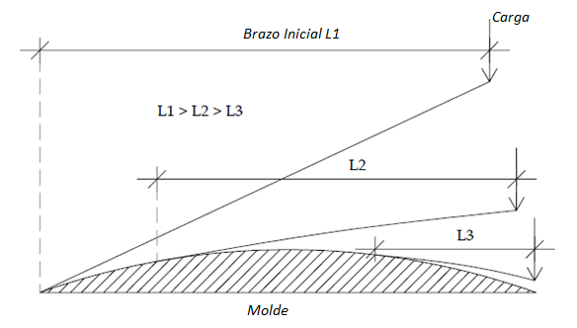
Figure 4.6 Curvado frio de cristales

Dado que el brazo que genera el momento de carga se reduce en la medida que el cristal alcanza el molde, puede ser necesario aumentar gradualmente la carga sobre el cristal.

Reflective and protective layers

Como se describió anteriormente es importante que el reflector presente una superficie de alta reflectancia. Para lograr esto se suele utilizar superficies metálicas, con acabados satinados y cubiertos por materiales que eviten los ataques químicos y mecánicos a la superficie. La Figura 5.5.3. presenta la reflectividad de algunos materiales metálicos, como es el caso de la plata, el aluminio y cobre.

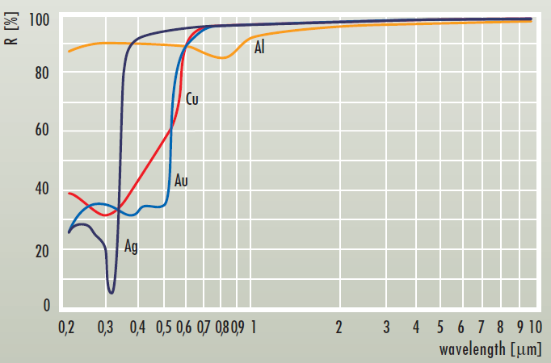
Figure 4.7 Reflectividad de distintos metales para diversas longitudes de onda.

Los materiales más comunes en la manufactura de los reflectores corresponde a la utilización de substratos de vidrio con deposición de plata como material reflectante, alcanzando reflectancias de hasta 93.5%.

Manufacturing process

Glass loading and scrubbing. Process begin with the transfer of individual glass sheets from shipping cases to the conveyor line (untinned surface up to receive the mirror coating). Mirror coating procedure is a wet process from the initial glass cleaning until the deposition of the layers is completed. The top layer is not allowed to dry in order to minimize the detrimental effects that would result from the deposition of solution residues on the surface.
Glass-scrubbing. An abrasive slurry is applied to the glass and wetting agents are added to improve cleaning. Surface abrasion is accomplished by rotating brushes that scrub the surface.
Sensitization and silvering. The glass surface is sprayed with a sensitizing solution that hastens the silver deposition rate and improves the silver/glass adhesion. The silvering chemicals are then sprayed onto the sensitized glass. Commonly used chemical systems consists of three distinct solutions: silver, caustic and reducer.
Copper deposition and drying. It commonly employs an iron filling/water slurry and copper solution.
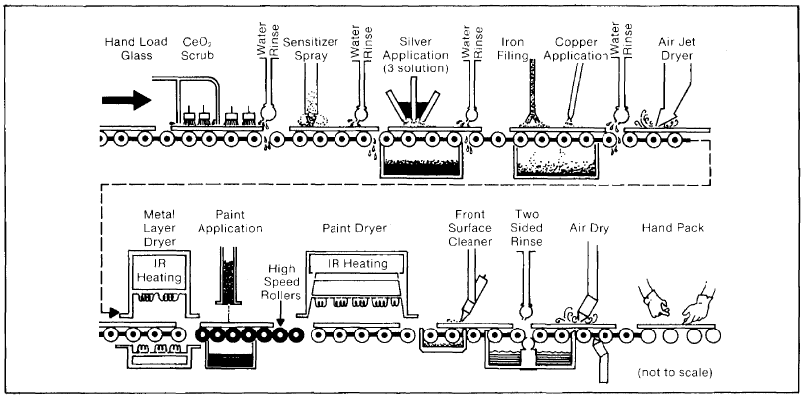

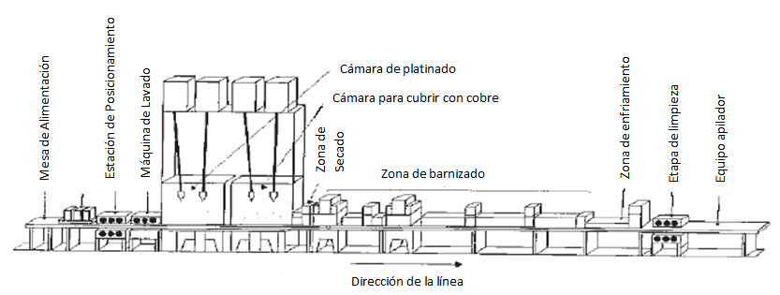
Figure 4.8 Descripción grafica de la línea de platinado.

- Evaporación por filamento de tungsteno
- Cañones de electrones
- Sputtering por Magnetrón
- Deposición de vapor físico asistido por rayo de iones (IBAD

Aluminum

Materials

Para sustratos en reflectores de primera capa se cuenta con un mayor rango de materiales para trabajar, considerando que la transmitancia ya no es relevante para el sustrato. El substrato debe dar resistencia ante la corrosión ambiental, dando garantías de resistencia a más de 10 años, incluso llegando a 20 o 30. La superficie del sustrato debe ser satinada para asegurar elevada especularidad y asegurar el desempeño óptico del reflector. Especialmente, debe contar con una buena adhesión al material reflectante.

- Vidrio:
De la misma forma en que se utiliza para en reflectores de segunda superficie, el vidrio también puede ser utilizado para dar soporte estructural a la superficie reflectante. Sin embargo, se debe cumplir con los otros requisitos de sustrato.

- Metal:
De forma similar a los sustratos de vidrio, el sustrato de metal debe dar la resistencia estructural al reflector. Los reflectores de substrato metálico suelen estar fabricados a partir de aluminio pulido, y no incorporan un material reflectante adicional. EL principal problema de estos reflectores es su rápida degradación óptica en ambientes expuestos al clima. Una de las ventajas de utilizar sustratos de metal, es la capacidad que tiene de integrarse directamente a la estructura del colector, reduciendo costos y tiempos de ensamble. Son reflectores económicos, pero rara vez usados en la industria.

- PET
Una de las formas de reducir los costos en espejos solares es la de metalizar un sustrato económico con buena adhesión al material reflectante, tal es el caso del tereftalato de polietileno (PET por su sigla en inglés). Este sustrato requiere la utilización posterior de una capa protectora durable y resistente a la abrasión.

- Diversos Polímeros:
Los sustratos plásticos suelen ser utilizados en la forma de láminas delgadas, sobre las cuales se deposita el material reflectante. Este diseño suele requerir ser adheridos a otra superficie para mantener su geometría. Estos sistemas no han resultado ser resistentes al clima, y suelen ensuciarse rápidamente debido a la carga eléctrica del plástico, producida por el roce con el viento.

Manufacturing process

Laminación: En caso de fabricar un reflector completamente de aluminio, se necesita una placa de entorno a 4mm de espesor. Por su parte el acero inoxidable no requiere tanto espesor, y el acero austenitico presenta estabilidad a largo plazo, pero una reflectancia solar baja (0.67).
Una técnica que disminuye los costos de fabricación, es la de laminar una película delgada de aluminio sobre un substrato de acero austenitico. Se incorporan adicionalmente lacas, esmaltes y plásticos para proteger la superficie reflectante.
La técnica de laminar materiales distintos, para aprovechar las propiedades de los materiales constituyentes para lograr un producto con propiedades diseñadas a medida para cada aplicación específica. Esta tecnología es aprovechada principalmente para sistemas de empaque, pero también es utilizada en otras industrias. Como ya se mencionó en el capitulo 5.3.1. un reflector solar debe presentar alta reflectancia, bajos costos, larga durabilidad, y resistencia mecánica.
Es posible utilizar planchas de acero con espesores de en torno a 0.5 mm, cubiertas con algún pegamento (entorno a 4μm de adhesivo de poliuretano), luego de lo cual se presiona en caliente o por extrusión con el material reflectante (ya cubierto con la superficie protectora). Por ejemplo, se ha utilizado como material reflectante un conjunto de 25μm de PET, detrás del cual se depositan 20nm de aluminio evaporado, respaldado por una película de 9μm de aluminio laminado en rollos, sobre 20μm de PET. Obteniendo un producto final (llamado laminated Al-on-steel reflector):
- Una capa protectora de 25μm de PET transparente y estable a la radiación UV, con alta transmitancia solar, y con punto de fusión de 255°C.
- Una superficie reflectante de 20nm de aluminio evaporado.
- Un substrato protector de lámina de aluminio (sustituye la reflectancia del aluminio evaporado, en caso de que falle), apoyado en 20μm de PET, todo laminado en caliente a una placa de 0.5 mm de acero austenitico. El acero a utilizar debe mostrar una rigidez adecuada para mantener la geometría del reflector.

Substrate: Aluminum, copper
Reflective layer: Aluminum
Manufacturing process: Physical vapor deposition (PVD)

Empresa | Reflector | Proceso | Comentarios | Industrias relacionadas
Flabeg | Plata de segunda superficie | -Plata, roció húmedo  -Películas base, final y resistente al desierto.  -respaldo de cobre.  Reflectancia: >94% | -Espejo plano, delgado y grueso.  -Parabolico (delgado o grueso a pedido) | -Automotriz  -Vidrio Tecnico.
Rioglass solar | Plata, segunda superficie | -cobertura de plata(rocio húmedo)  -pelicula base, final y protección.  -respaldo de cobre.  Reflectancia: >94% | -Espejos parabolic  -espejos planos a pedido. | Automotriz, arquitectura
AGC Solar | Plata, segunda superficie, con vidrio delgado y recocido. | Estratos: Vidrio-plata-cobre-primera capa-capa final.  Reflectancia: 95.5% | Disco parabólico, y cilindros parabólicos. | Parte del grupo AGC, vidrio(auto y liso), electrónica y energía (semiconductores, componente fotonicos) química.  -AGC Solar produce vidrio para PV y colectores térmicos, coberturas antireflejantes.
AGC Solar | Plata, segunda superficie, con vidrio grueso y recocido. | Estratos: Vidrio – plata - cobre-primera capa -capa intermedia - capa final  Reflectancia: 94% | Torre central y Fresnel
Guardian | Espejos bajos en fierro | Vidrio de 2mm bajo en hierro. Propietarios del sistema. Cobertura protectora.  Reflectancia: >93% (400°C) | Reflector secundario | Vidrio, automotriz, construcción
Guardian | Espejos bajos en fierro de segunda superficie (gruesos), y laminados (delgados). | 1 a 4 mm de vidrio bajo en fierro, platinado, PVB (laminado) – 1.6 a 4mm de vidrio flotado. Reflectancia 93-95% | CSP, disco parabólico, torre y Fresnel | Vidrio Fotovoltaico.
Guardian |  | 1 a 4 mm de vidrio bajo en fierro, platinado, 3 capas de recubrimiento protector.  Reflectancia 93-95% | CSP, disco parabólico, torre y Fresnel | Vidrio Fotovoltaico.
Alanod | Aluminio Anodizado | Nano compuesto – Laminas PVD – película anodizada – tira de aluminio – película anodizada – cobertura epoxica.  Reflectancia: 85-95% | CPC, cilindros parabólicos, heliostatos. | Especialistas en acabado superficial, (luz, tecnología LED y reflectores, automóviles).
Almeco solar | Aluminio | Capa superior resistente al clima – película aumentadora del desempeño óptico de reflectancia – película reflejante de aluminio puro al 99.99% - pegamento – substrato de aluminio anodizado – núcleo plástico – respaldo de aluminio – cubierta protectora  Reflectancia: 90% | Cilindros Parabólicos y Fresnel | Parte del grupo Almeco. Iluminación y decoración.
Constellium | Aluminio | Reflectancia del 80% |  | Iluminación y arquitectura, Aeroespacial, automotriz, empaques, defensa. Socios de OxSiCoat.

Empresa | Reflector | Reflectancia | Durabilidad | Costo
ACA | Protect Al | 0.748 (S 15mrad) | 3% 1000 Horas (roció de solución salina)
ACA | Sola Gold | 0.696 (S 15mrad) | 3% 1000 Horas (rocío de solución salina)
AGC | Solar Mirror Thick | 0.938 (ISO 9050) | Probada en laboratorio
AGC | Solar Mirror Thin | 0.955 (ISO 9050) | Probada en laboratorio
Alanod | Reflective 85 | 0.80 (ISO 7668)
Alanod | MIRO reflective 90 | 0.91 (ISO 7668)
Alanod | MIRO high reflective 95 | 0.93 (ISO 7668)
Alanod | Weatherproof 85 | 0.85 (ISO 7668) | 10 años de garantía
Alanod | MIRO-SUN Weatherproof reflective 90 | 0.87 (ISO 7668) | 10 años de garantía
Alanod | Miro-Sun aluminizado, con protector nanocompuesto | 0.85 (S 25mrad)  0.773 (S 7mrad) |  | 21.5 USD/m²
Almeco | Vegaprime | 0.93 (ISO 7668) | <0.5% pérdida, en 500 h. (ISO 4623)
Almeco | Vega SP195 | >0.89 (ISO7668)
Almeco | Vega SP295 | >0.91 (ISO7668)
Almeco | Vega SP198 | >0.93 (ISO7668)
Almeco | Vega SP298 | >0.94 (ISO7668)
Almeco | Vega WR193 | 0.883 ASTM G173
Almeco | Vega WR293 | >0.88 ASTM G173
Almeco | Specular SWR686 | >0.80 ASTM G173
Flabeg | 4mm vidrio platinado, bajo en hierro | 0.942 (S 7mrad) |  | 43.2-64.8 USD/m²
Naugatuck & Glaverbel | 1mm vidrio platinado. | 0.946 (S 7mrad) |  | 16.1-43 USD/m²
Sky Fuels* | Polímero Platinado | 0.937 (S 25mrad)  0.721 (s 7mrad) |  | 14.0-32.3 USD/m²
3M | ECP-305** | 0.953 (S 25mrad)  0.944 (S 7mrad) | De-laminación (más de 14 años de estudio) | 40.9 USD/m²
3M | SMF1100 | 0.955 (S 25mrad) | 1.5 años operando y sin perdidas | 31.5-49.9 USD/m²

Local industry

Industry associated
Float glass plant

Chile cuenta con una serie de comerciantes y productores de vidrios nacionales. Realizando una búsqueda en la base de datos de la SOFOFA se ha encontrado 65 empresas que trabajan el material. De los cuales tan solo uno produce vidrio a nivel nacional. La tabla 6.2.1, describe las principales características del vidrio producido.

En el país solo se han encontrado empresas que curvan el vidrio en caliente, no se ha encontrado empresa alguna que realice doblado en frio. Destaca la importancia de curvar el vidrio en frio por su facilidad y economía al no requerir elevadas temperaturas. Es importante mencionar que los cristales curvados en caliente a nivel nacional no son capaces de mantener grandes radios de curvatura, pero la curvatura en frio ha sido especialmente diseñada para lograr dichas geometrías.

Los espejos logrados atravez de este proceso de manufactura llegan a reflectancias indicadas en la Figura 6.2.1. y son probados de acuerdo al ensayo CASS para certificar una apropiada manufactura (la resistencia definitiva del espejo depende de que no se dañen los materiales de respaldo duatne el transporte, instalación y operación del espejo). El ensayo CASS consta de tomar la muestra y momentos previos al ensayo cortar el espécimen a un cuadrado 100x100 mm. La muestra es colocada en el lugar de ensayo con sus capas protectoras (pinturas) expuestas hacia arriba. Se procede a realizar el ensayo al rociar una mezcla de:
- 5 partes en peso de sal (NaCl)
- 95 partes en peso de agua
- Los componentes deben asegurar su pureza al presentar una mezcla con pH entre 6 y 7.
- Se agregan 0.25g de CuCl-2H₂O, por cada litro de mezcla.
- Se regula el pH de la mezcla rociada hasta 3.1 a 3.3, agregando ácido acético.
- Se limpia la mezcla para que no muestre sólidos en suspensión.
En el caso de los espejos se mantiene el roció durante 120hrs continuas, una vez cumplido dicho tiempo el espécimen es examinado en luz solar difusa, menor a 600 lux, frente a un fondo oscuro, con una lupa de aumento X7. Para aprobar el ensayo se debe cumplir con:

Parametros de aceptación ensayo CASS
Corrosión en los bordes | Menor o igual 2.5mm
Manchas | 3 con diámetro menor a 0.3mm
Tabla 6.2. 1. Parámetros de aceptación ensayo CASS en espejos

A partir del año 2015, la empresa dejara de lado la deposición de cobre en sus espejos y la reemplazara por deposición de paladio, la principal razón para esto es el impacto ambiental asociado con la deposición del cobre y su asociación con la producción de amoniaco. Por su parte el paladio da la misma adhesión a la pintura y protección ante el oxígeno que el cobre, pero el paladio es resistente a la oxidación brindando aún mayor protección que el cobre. En adición destaca que el paladio no presenta la difusión Ag/Cu asociada con al cobre.
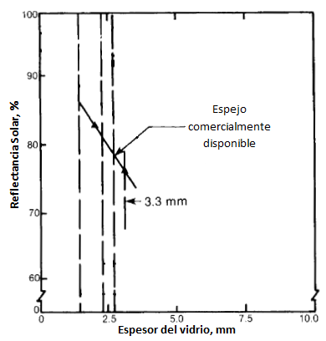
Figura 6.2. 1. Reflectancia de espejos disponibles comercialmente.

Considerando que el vidrio mas delgado que produce la empresa es de 2mm de espesor, se llega a una reflectancia solar máxima de 0.85.

- Aluminum reflector

Receiver

Explanation of different types of receiver. Options of single tube or row of tubes inside a cavity. This work deals only with single tube configurations

Absorber tube

Como es de intuir, el fluido a calentar se desplaza por uno, o múltiples, tubos ubicados en el foco del colector. Los tubos colectores suelen estar fabricados a partir de tubos de acero inoxidable, pero no necesariamente están restringidos a este material. El diámetro de los tubos varía para adecuarse a los requerimientos de presión y caudal de cada proceso.
Al seleccionar el material en sobre el cual se fabricaran los tubos es importante tener en consideración las siguientes pérdidas que se producen en el receptor
- Pérdidas por radiación del absorbedor: es importante seleccionar materiales con baja emisividad o cubrirlos con algún material que le entregue dicha propiedad, a modo de evitar que el tubo receptor pierda energía por el proceso de radiación.
- Pérdidas por convección: Debido a que el tubo receptor presenta una mayor temperatura que su entorno comienza a intercambiar calor con el ambiente.
Para reducir esta pérdida es posible aislar el tubo receptor al encapsularlo en un cilindro de mayor diámetro, y generar un vacío entre los dos cilindros, este método es especialmente utilizado al trabajar con fluidos a alta temperatura.
Otra alternativa para reducir las pérdidas por convección, es la de incorporar una cubierta plástica o de vidrio a la sección inferior del receptor. El objetivo de esta adición es la de reducir el efecto del viento sobre la convección, evitando la convección forzada. Para esta técnica es importante la utilización de materiales con una alta transmitividad, baja reflectividad, y baja absortancia, a modo de maximizar la radiación captada por el receptor.
Luego para optimizar las características del absorbedor se deposita sobre él algún material que aumente las propiedades deseadas. Usualmente se utilizan materiales con buena conducción térmica (como cobre, aluminio o acero) recubiertos por materiales que le den una buena absortancia y baja emisividad al absorbedor. Los recubrimientos se subdividen en seis categorías:
- Intrínsecos: Utiliza materiales que presenten las propiedades deseadas en el rango espectral deseado.
- Tandem semiconductor-metal: Utiliza el ancho de banda semiconductor para absorber radiación de ondas cortas, y el metal para reducir la emitividad térmica.
- Multicapa: utiliza diferentes reflexiones entre capas para absorber la radiación, la combinación de capas se ajusta para optimizar el absorbedor.
- Recubrimiento de compuesto multidielectrico: Utiliza finas partículas de metal en una matriz cerámica.
- Superficie texturada: aprovecha microestructuras dendríticas, porosas o con forma de aguja para reflejar múltiples veces la radiación sobre el cuerpo, aumentando así su absorción.
- Recubrimiento de transmisión solar selectiva sobre absorbedor de cuerpo negro.

Substrates: Tubes of steel or copper
Coatings: name the coating used in medium-temperature range
Manufacturing process: depends on the coatings

- Physical Vapor Deposition
- Dip coating
- Spraying
- Welding (in case there is a coating that could be aaplied in this way)

Secondary concentrator

Aluminum and silvered glass secondary concentrator. Manufacturing process similar to primary field. Details on how final shape is reached

Empresa | Rubro | Producto | Reflectancia | Comentarios
Guardian | Vidrios | Solar Boost-HT | 93%, resiste hasta 400°C, con diferencias de hasta 200°C. | Producen el vidrio, la superficie reflectante y su protección.  Humedad: ISO6270-CH>480 h  Sal: ISO9227>480 h  CASS: >120 h  Ciclos: -40 a 90°C, >10Ciclos.
Almeco | Aluminio | Vega  Specular SWR686 | 80 a 94% | Protegido por película transparente hidrofóbica.  Humedad ISO4623:<0.5%, en 500h  Sal ISO9227: <1% en 3000h  UV ISO 4892: <0.5% en 1000h
Alanod | Luminaria | Miro-sun | 88.4 a 92.8% | Resistente al agua, protegido por nano-compuesto, y respaldado con pintura epoxica.  Ensayo roció de sal acética, DIN50021: >1000h  Ensayo $∆T$ DIN 50928: 672horas  Ensayo UV, ISO4892: 500h

Low-temperature range absorber
- Possibilities of implementing process for medium-temperature range absorbers

La cañería central de un colector puede ser fabricada a partir de una serie de materiales, entre metales y plásticos. A continuación se destacan lo más utilizados
Material | Conductividad térmica [w/mK] | Absortancia solar | Desventajas | Utilización
Acero carbono | 47-54 | 0.85 | Rápida degradación | -----------------
Acero inoxidable | 16-19 | 0.39-0.58 | Baja conductividad | - SEIDO 6-1,  6-2, 6-3  - Schott PTR70
Aluminio | 205-250 | 0.27-0.86 (se utiliza anodizado) | Buen material ampleamente utilizado | - Bay Solar DN701
Oxido de Aluminio | 30 | 0.27-0.86 | Baja conductividad térmica, se utiliza en la cobertura de cañerías de aluminio.
Cobre | 398-401 | 0.3-0.98 | Costos | - Solar skies SS series  - Apricus AP
Tabla 5.5. 2. Materiales utilizadas para confeccionar la cañería del absorbedor
Las cañerías más utilizadas son las de cobre, aluminio y acero. Cada una cuenta con sus propias desventajas, desde los costos, resistencias químico - mecánicas a sus propiedades y limitaciones. En la búsqueda de mejores formas de aprovechar los materiales, los colectores planos se combinan cañerías de cobre a placas de aluminio para aprovechar la absortancia del aluminio y la conductividad del cobre. La misma tecnología desarrollada para colectores planos es aplicable a colectores lineales Fresnel, como indica la Figura 5.5.14.

Dado que los materiales con buena conductividad térmica no presentan la mejor absortancia se utilizan coberturas como pintura negra para aumentar la absortancia del receptor. En la tabla 5.5.16., se describen algunos recubrimientos utilizados en absorbedores.
Material | Substrato | Absortancia | Emisividad | Rango de temperatura [°C] | Deposición
Tinox energy, producido por Almeco | Cobre o Aluminio | 0.95 solar  (a 100 °C) | 0.04  (a 100 °C) | 0 – 195 | Laminas soldadas sobre cobre o aluminio
Tinox nano, producido por Almeco | Cobre o Aluminio | 0.9 solar  (a 100°C) | 0.05  (a 100°C) | 0 – 175 | Laminas soldadas sobre cobre o aluminio
Pintura negra |  | 0.91 a 0.98 | 0.5 a 0.96 | <200
Cu-Co-Mn-Si-O |  | 0.95  (a 100 °C) | 0.12  (a 100°C) | <400 | Sol-gel, cobertura por inmersión.
Al₂O₃:Ni |  | 0.97 | 0.05 |  | Sol Gel por rotación
Titaniuml Anodizado Azul. |  | 0.7 | 0.13 |  | Película soldada
Pelicula de cobre simple |  | 0.32 | 0.02 |  | Película soldada
Pelicula de cobre lijada |  | 0.26 | 0.04 |  | Película soldada
Pelicula de cobre desgastada |  | 0.55 | 0.04 |  | Película soldada
TSSS, fabricado por Solariselect | Aluminio | 0.92 | 0.015  (a 100 °C) | <135 | Pintura
PbS | Aluminio | 0.93-0.99 | 0.21-0.1  (a 100°C) | 200 | Evaporacion térmica
NiCroO_{x} | Acero inoxidable | 0.8 | 0.14 | <200 | Sputering
NiCroO_{x} | Poliamina o cobre | 0.92-0.93 | 0.06 | <200 | Sputering
Acero inoxidable de color. |  | 0.62-0.93 | 0.1 | <200 | Fabricación del substrato
Nickel negro (NiS-ZnS) fabrcado por Maxorb. | Acero inoxdiable o Nickel | 0.88-0.96 | 0.03-0.1 | <200 | Electrodeposicion
Nickel negro, Ni-Sn. Black Crystal. | Cobre | 0.92-0.98 | 0.08-0.25 | 300 | Electrodeposicion o Sol-Gel
Pelicula de grafito. C:H/Cr | Cobre | 0.92 | 0.025 | 250 | Evaporacion física en vacio
Pelicula de grafito: C:H | Aluminio | 0.876 | 0.061 | 250 | Evaporacion física en vacio
Ge en pegamento de Si. | Cobre o acero inox | 0.91 | 0.7 | 300 | Pintura
Si en pegamento de Si. | Cobre o acero inox | 0.83 | 0.7 | 300 | Pintura
PbS en pegamento de Si. | Cobre o acero inox | 0.96 | 0.7 | 300 | Pintura
Ag dieléctrico | Aluminio |  |  | 300 | Sol-gel
Cobre negro, BlCu-Cu₂O:Cu | Cobre | 0.97-0.98 | 0.02 | 250 | Electrodeposicion
Cromo negro Cr-Cr₂O₃. Producido por, MTI, Chromecoat, Energie Solaire | Ni-Cu, cobre, acero | 0.97 | 0.09 | 350 | Electrodeposición
Cromo negro, Mo/Cr₂O₃ | Ni-Cu, cobre, acero | 0.95 | <0.3 | 425 | Electrodeposición
TiN_{x}O_{y} | Cobre | 0.92 | 0.06
CuFeMnO₄/Si | Vidrio, Silicio | 0.6 | 0.29-0.39
Cr,Fe,Mo,Ta,Ti, silicatos de W, y Acero Inox | Cobre | 0.76-0.82 | 0.02 | 250-400 | Sputtering
Cr,Fe,Mo,Ta,Ti, carbonos de W, y Acero Inox | Cobre | 0.76-0.81 | 0.02 | 250-400 | Sputtering
Ni-NiO_{x} Sunstrip | Aluminio | 0.96 | 0.10 | 300 | Sputtering
Ni,Al₂O₃, producido por Tekno Term,  Energi  Showa | Aluminio | 0.85-0.97 | 0.08-0.21 | 300-400 | Anodizado
- Tabla 5.5. 3. Tabla con algunos materiales utilizados para recubrir absorbedores de media y baja temperatura.
Procesos de manufactura
Los procesos de manufactura para los principales materiales absorbedores suelen ser similares a los utilizados para depositar la superficie reflectante de los reflectores, tal como procesos de Evaporación Física en el Vacío, Sputtering, Pinturas, o laminas adheridas. Dos procesos que cobra especial importancia en la manufactura de los absorbedores, son el proceso de deposición por Sol-gel y sputtering.

Sol-gel: El proceso sol-gel es utilizado para depositar material anti-reflectante en torno a al contenedor de vidrio boro-silicatado. La cobertura utilizada consiste en variar la estructura porosa depositada en la superficie del cilindro para generar un grandiente del índice de reflectividad entre la superficie expuesta al aire y la superficie del cilindro de vidrio. Debido a dicha gradiente, la reflectividad puede ser reducida al mínimo teórico. Para realizar el recubrimiento, el cilindro es sumergido en una solución contenedora de dióxido de silicio, acido-modificada, y es recuperado del contenido a una velocidad de 1cm/seg. Se espera que la superficie final cuente con una cobertura de 110nm de espesor. Para obtener la superficie porosa de la película, se incorpora material “porogen” a la solución, material que es removido de la cobertura durante el proceso de tratamiento térmico aplicado al receptor. El procedimiento Sol-gel es ampliamente utilizado para depositar cubiertas anti-reflejantes en vidrio arquitectónicos y receptores.

Sputtering: La superficie selectiva del absorbedor requiere una composición homogénea precisa y un espesor establecido constante, para grandes superficies de material. Dicha spropiedades se logran por medio de la tecnología de sputtering.
El proceso está basado en la descarga auto-sostenida de gases nobles, o plasma, en una cámara de ambiente vacío. Primero el gas es ionizado a baja presión. Luego los iones son acelerados por medio de la aplicación de un campo eléctrico, los iones son forzados a colisionar contra el material que se desea depositar sobre el receptor. Así el material a depositar se desprende de la matriz inicial y se deposita sobre el substrato del receptor. Para dar distintas composiciones a la capa selectiva se cambia el material objetivo, y los aditivos incorporados al gas noble en el ambiente.

En chile se han instalado una serie de empresas que comercializan colectores solares planos fabricados en el extranjero, pero destacan dos instituciones que fabrican sus propios colectores y dan partida para trabajar material de absorción selectiva.
Empresa | Producción | Ubicación | Características
Britec, Codelco | 3,400 m² al año (cobre cubierto en Tinox Cu) | Colina 1, Colina, RM | Absortancia de 0.91 a 0.944, y emitancia acorde a la figura 6.2.2.
THC | 18,000 m² Al año (Polipropileno) | Pudahuel, RM | Utilizado solo para bajas temperaturas
Tabla 6.2. 2. Instaladores de material absorbedor solar en Chile Error! Reference source not found.
Destaca la empresa Britec, capaz con experiencia en la manipulación de tinox. El tinox es un material de alta absortancia, y baja emisividad, capaz de trabajar en un amplio rango de temperatura. La tabla 6.2.7, describe sus principales características, y la Figura 6.2.2, presenta su emisividad en función de la temperatura.

Caracteristica | Medida
Absorción | 95% $±$ 2%
Emisividad (100°C) | 4% $±$ 2%
Razón de absorción Solar | 23.75 (>18, altamente selectivo)
Color | Azul intezo para angulos entre 270° y 300°
Formato entrega | Rollo o Planchas
Substratos | Cobre Cu-DHP, o Cu-OF  Aluminio 99.58% de pureza
Espesor del substrato | 0.12-0.50 +/- 0.02 mm, para Cu  0.3-0.6 +/- 0.02 mm, para Al
Ancho | 1,250 mm
Elongación del substrato | Cu: 8%  Al: 1%
Resistencia a la tracción del substrato | Cu: 240-300 N/mm²  Al: 120-160 N/mm²
0.2% limite elástico del substrato | Cu: 180 N/mm²  Al: 105 N/mm²
Radio de curvatura mínimo | Cu: 5 mm  Al: 10 mm
Calidad superficial, Ra del substrato | Cu: 0.5 μm  Al: 0.5 μm
Densidad del substrato | Cu: 8.92 g/cm³  Al: 2.71 g/cm³
Conductividad térmica del substrato | Cu: >320 W/mK  Al: >230 W/mK
Limpieza | Utilizando un paño suave y alcohol (isopropano)
Tabla 6.2. 3. Propiedades de las películas de absorción selectiva Tinox

Las hojas de Tinox pueden ser utilizadas para envolver al cilindro de cobre, manteniendo radios de curvatura de al menos 5 mm. Para adherir el tinox al cobre se puede utilizar cualquiera de las siguientes técnicas:

- Soldadura Laser
- Soldadura por ultra-sonido
- Soldadura Plasma
- Soldadura Blanda (a la flama)
- Formado
- Pegamento

La empresa Britec, utiliza soldadura por ultra-sonido para unir el cobre a la película de absorción selectiva de Tinox. Se comenta la relación de Almeco como principal proveedor de lámparas Chile, relación que podría llevar a lámparas Chile a expandir su negocio a la incorporación de material absorbedor a cilindros cunductivos para calentar fluidos de trabajo.

Lighting industry
- Aluminum secondary concentrator
- Para la fabricación del reflector secundario en Chile destaca la industria nacional de luminarias. En particular la empresa Lámparas Chile. Dicha institución trabaja el aluminio anodizado provisto por Almeco, las propiedades del metal son descritas en la tabla 6.2.9.

Propiedad | Descripcion | Estándar
Aleación | 1085 – Al 99.85% | EN 573-3
Acabado | Abrillantado y anodizado
Resistencia mínima a la tracción | 125 N/mm² | EN 485-2
0.2% limite elástico | 105 N/mm² | EN 485-2
Elongación mínima al 10% | 2% | EN 485-2
Reflectancia total | 86 | DIN 5036-3
Reflectancia difusa | 15 | DIN 5036-3
Reflectancia especular, a lo largo | 80 (79-81) | ISO 7668
Reflectancia especular, a lo ancho | 78 (77-79) | ISO 7668
Irradiancia | Normal | Interna de Almeco
Precio | 24,000 CLP/Plancha | Planchas de 2,4x1,24 m²
- Figura 6.2. 2. Propiedades del aluminio trabajado en “Lamparas Chile” Error! Reference source not found.
- La empresa declaro trabajar exclusivamente ese material, descartando la posibilidad de utilizar otros aluminios proveidos por Almeco.
- La empresa cuenta con tecnología de punta y experiencia para fabricar la geometría de reflector que resulte conveniente, incluye material reflectante, y la estructura que lo sostiene. Entre la tecnología con la que cuenta destacan:

Equipo | Caracteristicas
Punzadora | Programable, incorpora más de 30 herramientas para realizar cortes solicitados sobre planchas planas.
Plegadora | Programable, pliega el aluminio de acuerdo al programa ingresado por el operador. Puede generar superficies de curvas suaves.
Tratamientos superficiales | Fosfatado
Pintura electrostática | Cuenta con sistema para realizar la deposición electrostática y posterior horneado de la pintura.
- Tabla 6.2. 4. Equipos y Procesos destacados en “Lamparas Chile”.

- La figura 6.2.4. Presenta algunas de las geometrías ya trabajadas por la empresa.
Modelo AEAS | Modelo CTLI | Modelo AET55
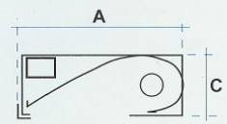 | 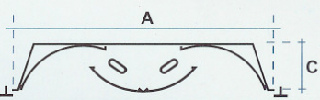 | 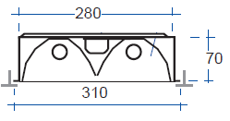
A: 160,220,300 mm  B*: 633,1243 mm  C: 100 mm | A: 600 mm  B*: 600, 1220 mm  C: 125 mm | B*: 1210 mm
Luminaria fluorescente asimétrica, con estructura de acero fosfatado. Reflector de aluminio anodizado | Luminaria fluorescente con tubo traslapado, fabricado en acero termo esmaltado. Reflector de acero blanco, o aluminio especular. | Cuerpo de acero laminado y esmaltado. Difusor aluminio anodizado especular de alta pureza, geometría de parábola completa.
- Tabla 6.2. 5. Algunos productos fabricados por “Lámparas Chile”, B, largo del módulo. Error! Reference source not found.

Structure

Structure

Los procesos de manufactura requeridos para la fabricación e instalación de la estructura no son distintos de los usualmente empleados en maestranzas generales. Destaca:
- Plegado de acero
- Soldadura al arco con varillas, MIG, TIG, Plasma.
- Perforaciones
- Corte por oxicorte o cierra automática
- Esmerilado
Destaca mencionar que en la medida que aumenta la competencia por el mercado, se distinguen las empresas capaces de producir colectores económicos, basado en economías de producción en masa, con diseños de fácil ensamble. El diseño de estas estructuras y procesos de manufactura dan un gran campo para la reducción de precio del sistema completo. Usualmente estas metodologías de trabajo es información sensible para la empresa. Una forma interesante de enfrentar esta situación es la empleada por la empresa Española Sener, utilizando mecanismo de estampado en acero para fabricar los soportes de sus colectores parabólicos.
Para asegurar que el material estructural no se deteriore en el transcurso de su vida útil este debe ser galvanizado. El procedimiento de galvanizado busca depositar material de sacrificio sobre el acero estructural. El material de sacrificio suele ser más económico que el material base utilizado. El zinc ofrece una barrera física, química y eléctrica ante el desgaste de la estructura. Así evita que agentes corrosivos ataquen directamente al acero estructural y en caso de que el agente corrosivo entre en contacto con el acero, el zinc entrega sus electrones al acero evitando la degradación de la estructura. La barrera de zinc tiene la ventaja de autocurarse en caso de rallarse la superficie.
El proceso de galvanizado requiere de las siguientes etapas.

- Desengrase y Decapado: Se remueve la protección grasosa y las impurezas del material base para asegurar la apropiada fijación del zinc a la estructura.
- Enjuague: el material es enjuagado en una piscina de solución alcalina para disolver ácidos de hierros del decapado
- Fundente: Se asegura la limpieza superficial del material al aplicar ácido clorhídrico, cloruro de zinc, y cloruro de amónico.
- Horno de secado: las piezas son secadas a 70°C para reducir la humedad y evitar explosiones de zinc fundido.
- Horno de Galvanizado: La pieza es sumergida en zinc fundido a unos 450°C. el proceso tarda unos 2 a 3 minutos.
- Enfriamiento: con agua, mantiene el brillo del producto.

Materials: galvanized steel
Manufacturing process:
Steel bars Welding, cutting, galvanize

Industry supplying the mining sector
- Experience of building structures in the middle of the dessert
Para asegurar una extensa vida útil de la estructura, esta suele ser galvanizada. En Chile y a nivel mundial se suele utilizar la norma ASTM 123, para asegurar la calidad, durabilidad y requerimientos post tratamiento de los materiales. Para una apropiada galvanización se debe tener presente las siguientes especificaciones. [Especificaciones Técnicas para el Galvanizado por Inmercion en Caliente de Materiales Generales, B. Bosch]
Calidad del acero, el fabricante debe certificar la composición química y resistencia del acero, observando:
- El acero debe contener menos de 0.25% de carbono
- El acero debe contener menos de 0.05% de fósforo
- El acero debe contener menos de 1.35% de magnesio
- El acero debe contener menos de 0.04% de silicio, o entre 0.15% y 0.25%
Antes de ser tratado el acero debe recibir una profunda limpieza superficial, de acuerdo a las normas ASTM A143, A384, A385, tomando especial consideración para limpiar:
- Destajes
- Perforaciones
- Soldaduras

Materiales
Entre las ventajas de los colectores lineales Fresnel destaca su bajo requerimiento de acero pesado, con poco o nada de concreto (facilitando la instalación del equipo).
Los principales materiales requeridos para la fabricación de la estructura son acero y concreto, ambos disponibles a nivel nacional, utilizados principalmente por la industria de la construcción.

Procesos de Manufactura
Los procesos de manufactura requeridos para la fabricación e instalación de la estructura no son distintos de los usualmente empleados en maestranzas generales. Destaca:
- Plegado de acero
- Soldadura al arco con varillas, MIG, TIG, Plasma.
- Perforaciones
- Corte por oxicorte o cierra automática
- Esmerilado
Destaca mencionar que en la medida que aumenta la competencia por el mercado, se distinguen las empresas capaces de producir colectores económicos, basado en economías de producción en masa, con diseños de fácil ensamble. El diseño de estas estructuras y procesos de manufactura dan un gran campo para la reducción de precio del sistema completo. Usualmente estas metodologías de trabajo es información sensible para la empresa. Una forma interesante de enfrentar esta situación es la empleada por la empresa Española Sener, utilizando mecanismo de estampado en acero para fabricar los soportes de sus colectores parabólicos.
Para asegurar que el material estructural no se deteriore en el transcurso de su vida útil este debe ser galvanizado. El procedimiento de galvanizado busca depositar material de sacrificio sobre el acero estructural. El material de sacrificio suele ser más económico que el material base utilizado. El zinc ofrece una barrera física, química y eléctrica ante el desgaste de la estructura. Así evita que agentes corrosivos ataquen directamente al acero estructural y en caso de que el agente corrosivo entre en contacto con el acero, el zinc entrega sus electrones al acero evitando la degradación de la estructura. La barrera de zinc tiene la ventaja de autocurarse en caso de rallarse la superficie.
El proceso de galvanizado requiere de las siguientes etapas.

- Desengrase y Decapado: Se remueve la protección grasosa y las impurezas del material base para asegurar la apropiada fijación del zinc a la estructura.
- Enjuague: el material es enjuagado en una piscina de solución alcalina para disolver ácidos de hierros del decapado
- Fundente: Se asegura la limpieza superficial del material al aplicar ácido clorhídrico, cloruro de zinc, y cloruro de amónico.
- Horno de secado: las piezas son secadas a 70°C para reducir la humedad y evitar explosiones de zinc fundido.
- Horno de Galvanizado: La pieza es sumergida en zinc fundido a unos 450°C. el proceso tarda unos 2 a 3 minutos.
- Enfriamiento: con agua, mantiene el brillo del producto.
La industria metal mecánica se divide en términos generales, en seis subsectores:
- Metálicas básicas
- Productos metálicos
- Maquinaria no eléctrica
- Maquinaria eléctrica
- Material de transporte y carrocería
- Bienes de capital
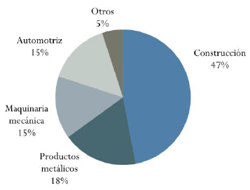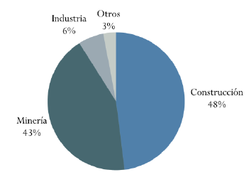
Figura 8.5. 1.Usos del acero en Latinoamerica [izquierda], Usos del acero en Chile [Derecha], Asimet 2014
El desarrollo del sector metal mecánico se ve directamente ligado al comportamiento de los sectores mineros, pesqueros, energéticos, construcción, forestal, y las otras áreas económicas del país. Se debe mencionar que en el país cuenta con una planta siderúrgica integrada (Siderúrgica Huachipato S.A.), instalada a comienzos de la década de 1950 a 14km al noroeste de concepción. Esta planta es capaz de producir acero laminado a partir de minerales de hierro, con una capacidad instalada a 1,450 mil toneladas de acero líquido anual. Y la empresa brasilera instalada en Chile Gerdau AZA, que produce acero laminado a partir de chatarra, con una capacidad instalada de 520,000 Toneladas de acero líquido.

Auxiliary equipment

Auxiliary equipment

Description of the auxiliary equipment needed for implementing solar energy systems for heat process.
- Pumps
- Heat exchangers
- Piping and valves
- Tanks
- Controllers
- …

Brief description of local capacity for manufacturing pumps, heat exchangers, valves, piping, etc

Cost model of collector

System performance evaluation and integration

This chapter is divided in three sections. Section 5.1 characterizes the optical behavior of the collector. First, optical and geometrical characteristics of the components are described. Then, exemplary calculations are presented. The calculations present results for: optical efficiency of the collector, energy gained by the secondary mirror and glass plate, Incidence Angle Modifier (IAM), and for the various mechanisms of optical loss. The energy gained by the secondary mirror and the glass plate are important inputs for the thermal analysis.

Section 5.2 deals with thermal characterization of Linear Fresnel collector receivers. In a beginning, the thermal balance of a receiver is explained. The themal balance presents the various modes of heat transport that take place in the receiver. Following the thermal balance explanation, two techniques to solve it are presented. First technique is Computer Fluid Dynamics (CFD) simulations. CFD simulations solve the equations that describe the dynamics of a fluid in continuous media. Fluid dynamics is represented by a system of partial differential equation, which is simplified by a system of linear equations. The simplification is done by discretizing the problem in time and space. Second technique is a Thermal Resistor Model (TRM). TRM is an own-written code, based on empirical correlations and theoretical relations for the different heat transport modes. For each technique exemplary calculations are presented. Main results of each technique are the heat loss curve and the temperature of the receiver’s components.

Section 5.3 explains the integration of Linear Fresnel collectors to heat processes. The process selected is electro-winning copper recuperation, as it is of relevance for Chile (see section 2.2). First, there is a description of the electro-winning process, identifying the energy demanded and the temperature levels needed to efficiently recover copper. Then, different scenarios regarding temperature and flow rate needed are defined. Finally, it is explained the integration of the solar system to the process, in order to evaluate the performance of the solar system.

Optical characterization

Linear Fresnel collector is an optical device that reflects light onto a receiver. Each component is designed seeking high optical properties (see 3.3.1). In the following section, physical properties of the components of the collector are presented, making a distinction between the components feasible to be manufactured in Chile and the components that need to be imported.

Primary field

Table 5.1 shows the characteristics of reflectors.

Table 5.1 Optical and geometrical properties of mirrors. Column 2 and 3 correspond to mirrors feasible to be manufactured in Chile. Column 4 and 5 corresponds to mirrors available in the international market.
Mirrors primary field
Material | Silvered glass | Anodized aluminum | Silvered glass | Anodized aluminum
Local manufacture | yes | yes | no | No
Specular reflectance (%) | 0.94 | 0.89 | 0.94 | 0.89
Optical error (mrad) | XX | XX | 7
Durability (years) | n.d. | XX | > 20 years
Focal length | XX | Individual
Cost (US$/m²) | XX | 22

Secondary mirror

Secondary mirrors are made either from aluminum or silvered glass. In Chile, the machinery available to bend glass is limited. Therefore the major possibilities for manufacturing secondary receivers are using aluminum. Table 5.2 shows the properties of the secondary mirror feasible to be build in Chile, together with products available in the international market.

Table 5.2 Optical and thermal properties of secondary mirrors feasible to be manufactured in Chile
Secondary mirror
Material | Anodized aluminum | Anodized aluminum | Silvered mirror *
Local manufacture | yes | No | no
Specular reflectance (%) | 0.89 | 0.89 | 0.93
Durability (years) | 5 years | > 15 years
Temperature limit (°C) | 250 | 250 | 400
Cost (US$/m²) | XX
* Data from

Glass cover

The glass cover protects the absorber tube from environmental conditions. High transmittance is required, therefore it is applied anti-reflecting coatings on its front-surface. Table 5.3 shows the properties of the secondary mirrors feasible to be manufactured in Chile, together with the products already available in the international market.

Table 5.3 Optical properties of glass available in Chile
Property | Local manufactured | Imported
Type of glass | Clear glass |  | Clear glass with anti-reflecting coating
Local manufacture | yes |  | no
Nominal transmittance (%) | 0.92 |  | 0.96
Thickness (mm) | 3 |  | 3
Refractive index | 1.52 |  | 1.27 (equivalent)
Extinction coefficient | 4 |  | 4
Cost (US$/m²) | XX |  | XX

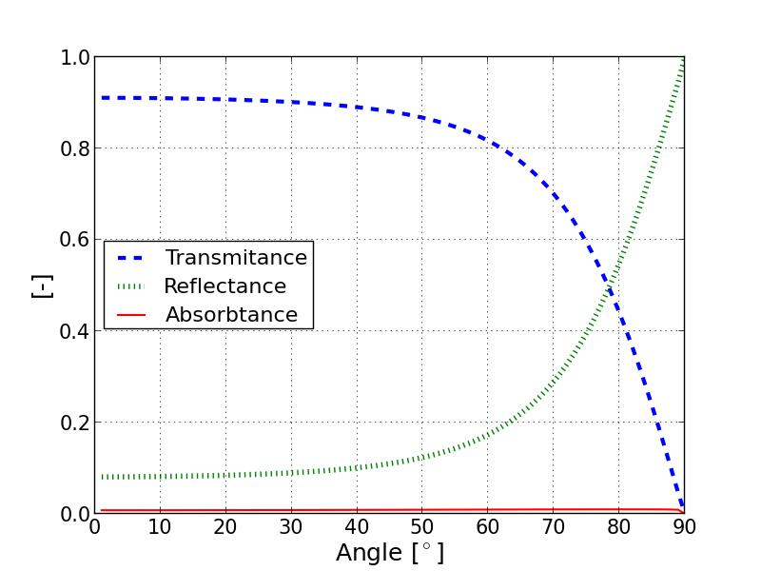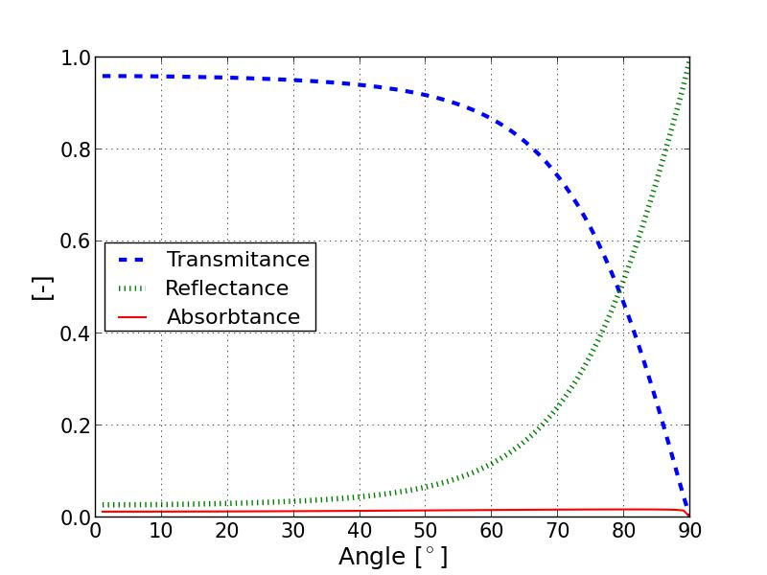
Figure 5.1 Angle-dependent transmittance values of a) clear glass and b) clear glass with anti-reflecting coating

Absorber tube

The properties of the absorber tube with high potential of been manufactured in Chile are shown in Table 5.4.

Table 5.4 Properties of solar selective absorber paint Solkote
Property | Solkote
Absorptance (%) | 0.92
Emittance | 0.14 @ 100 °C
 | 0.29 @ 250 °C
Durability (years) | XX
Temperature limit (°C) | 250
Cost (US$/m²) | XX

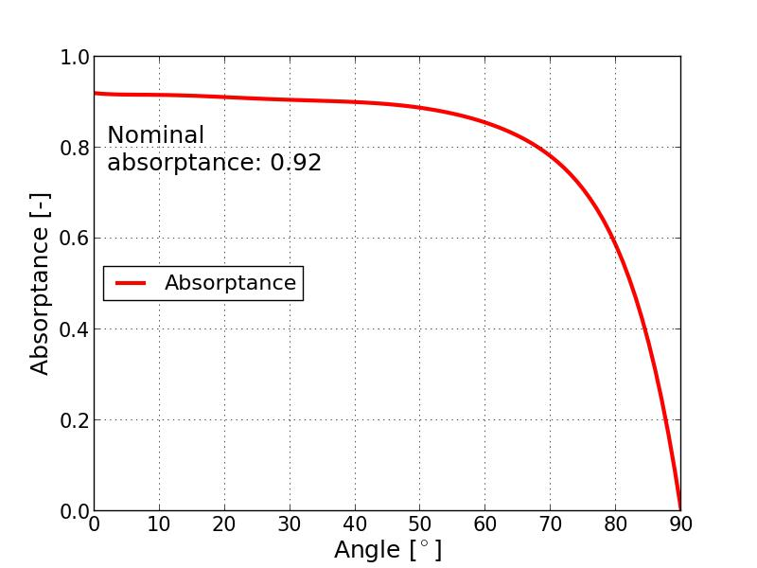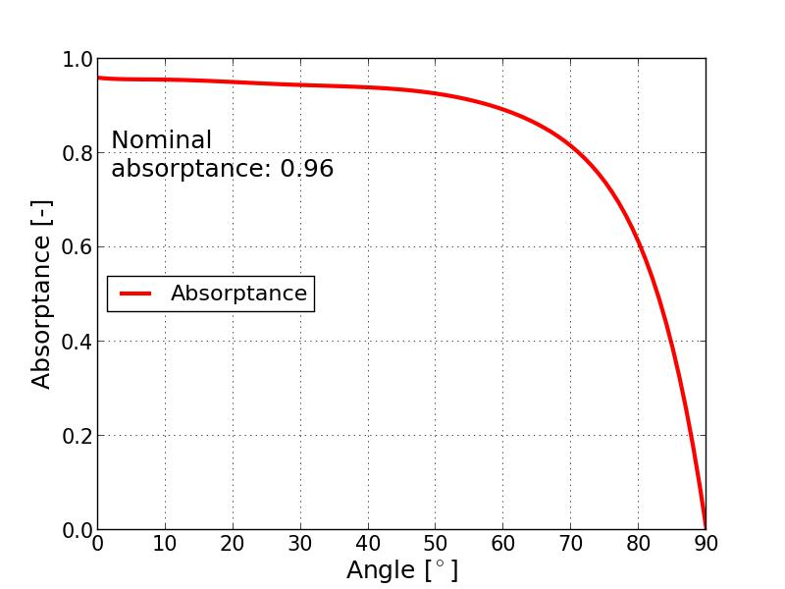
Figure 5.2 Angle-dependent absorptance values of a) Solkote paint and b) electro-deposited black chrome

Exemplary calculations

Table 5.5 Parameters of the system
Parameter
Number of mirrors |  | 10
Width of mirrors (m) |  | 0.6
Distance between mirrors (m) |  | 0.15
Focal length (m) |  | Independant
Receiver height (m) |  | 4.5
Absorber diameter (m) |  | 0.07
Nominal absorptance | 0.92 |  | 0.96
Nominal transmittance glass plate | 0.92 |  | 0.96
Reflectance secondary mirror  Reflectance primary field | 0.89 | 0.94 | 0.93
Optical error primary field (mrad) | 12 |  | 7

Optical efficiency and Incidence Angle Modifier (IAM)

Figure 5.3

Energy gained by the secondary mirror

Part of the energy reflected by the primary field hits the secondary concentrator before reaching the absorber tube. The energy of the light hitting the secondary mirror decreases as an amount is absorbed by it. The radiation absorbed by the secondary mirror increases its temperature. Figure 5.4 shows schematically the interaction of rays within the cavity.

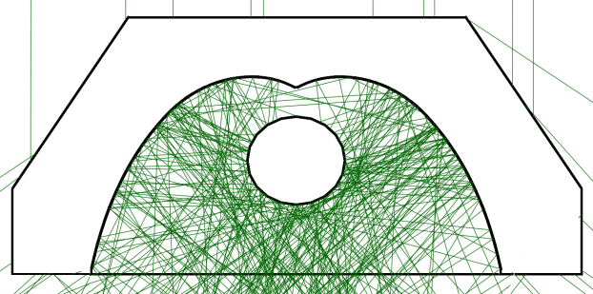
Figure 5.4 Ray tracing model of a LFC receiver (visualisation with reduced number of rays). On the top section of the secondary mirror only a small amount of radiation is incident and thus absorbed by the secondary, this section is mostly blocked by the absorber tube. A larger fraction of the radiation hits the reflector in the middle section, leading to absorption and a rise of temperature.

Associating the absorbed radiation with a Direct Normal Incident (DNI) radiation value and a reflective area of the primary field, the absorbed heat flux by the secondary is determined. Figure 5.5 shows the geometry of a secondary reflector in the first axis and the absorbed heat flux in the second axis. Three main areas are found with regard to the absorbed flux over the secondary mirror. On the top section of the secondary mirror there is a small amount of absorbed radiation, as this section is blocked by the absorbed tube. On the middle section there is a peak of the flux. In the exemplary calculation the peak is about XX $W/m^{2}$. In the lower section the absorbed flux decreases considerably, up to values similar to the ones observed on the top section. Integrating the heat flux over the area of the secondary mirror, the total amount of absorbed radiation is calculated. In the example of Figure 5.5.a), considering a DNI of 1000 $W/m^{2}$ over a primary field area of 6 $m^{2}$, a total amount of XX W is absorbed by the secondary reflector (per meter length of collector). The amount of absorbed radiation is decreasing with the increase of the transversal angle of incidence θ_{t}.
a)
b)
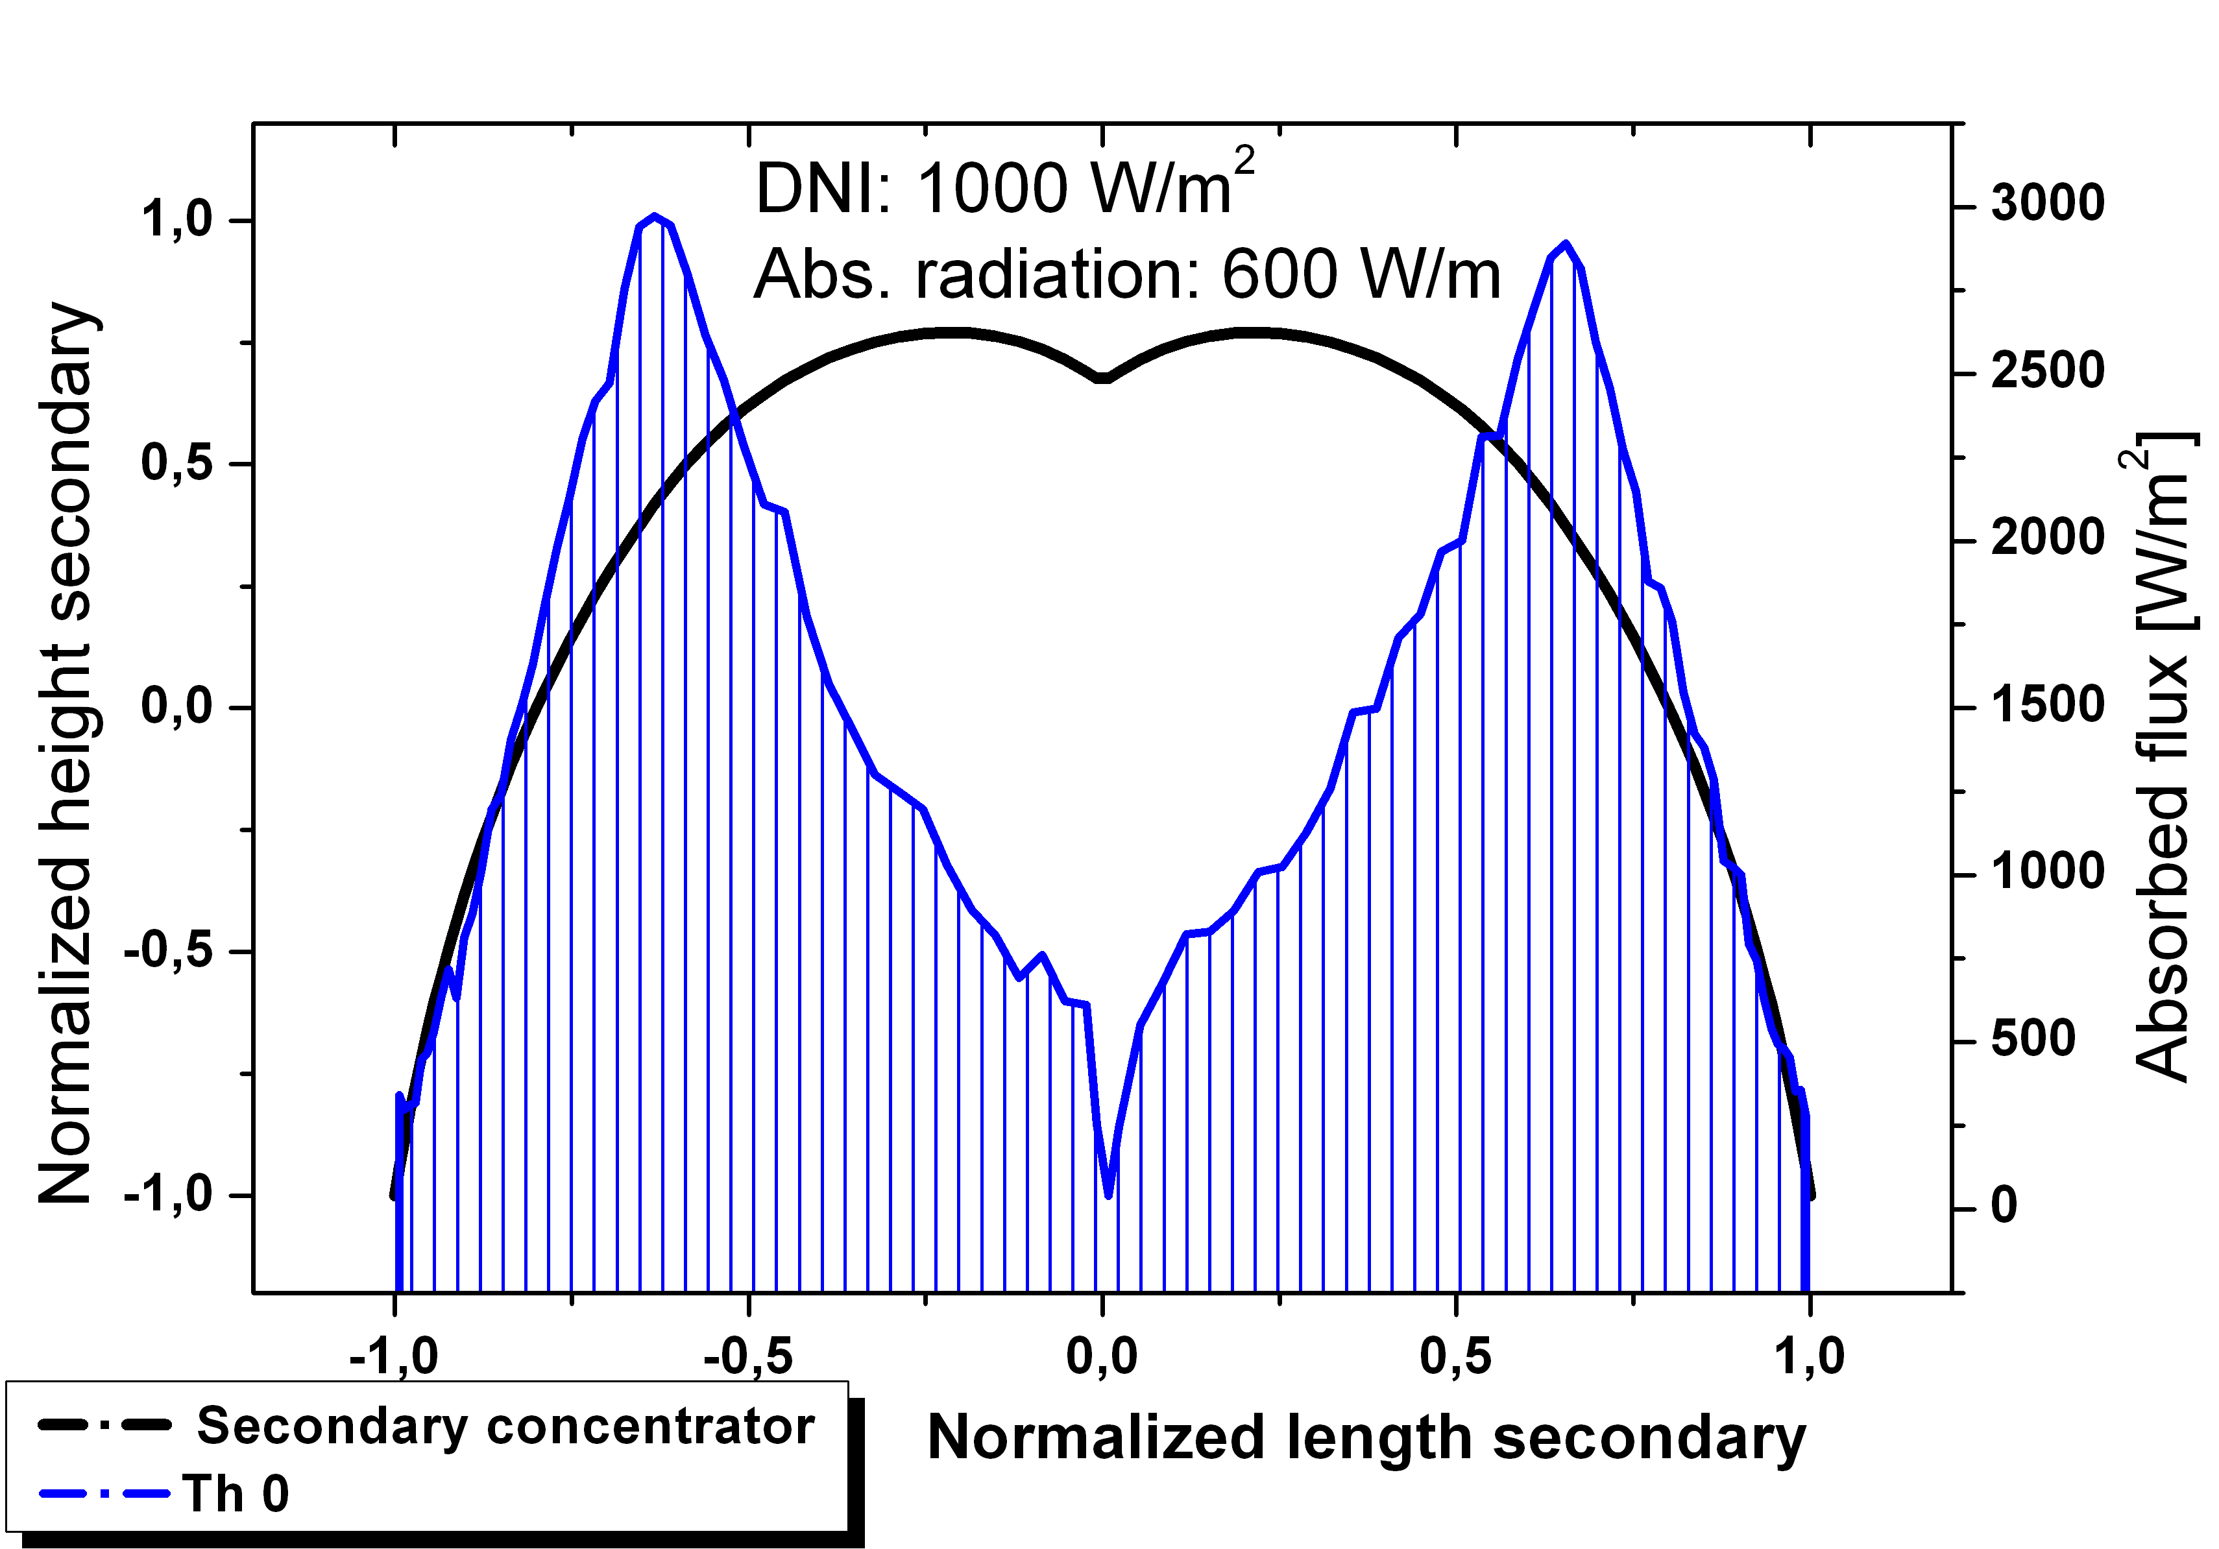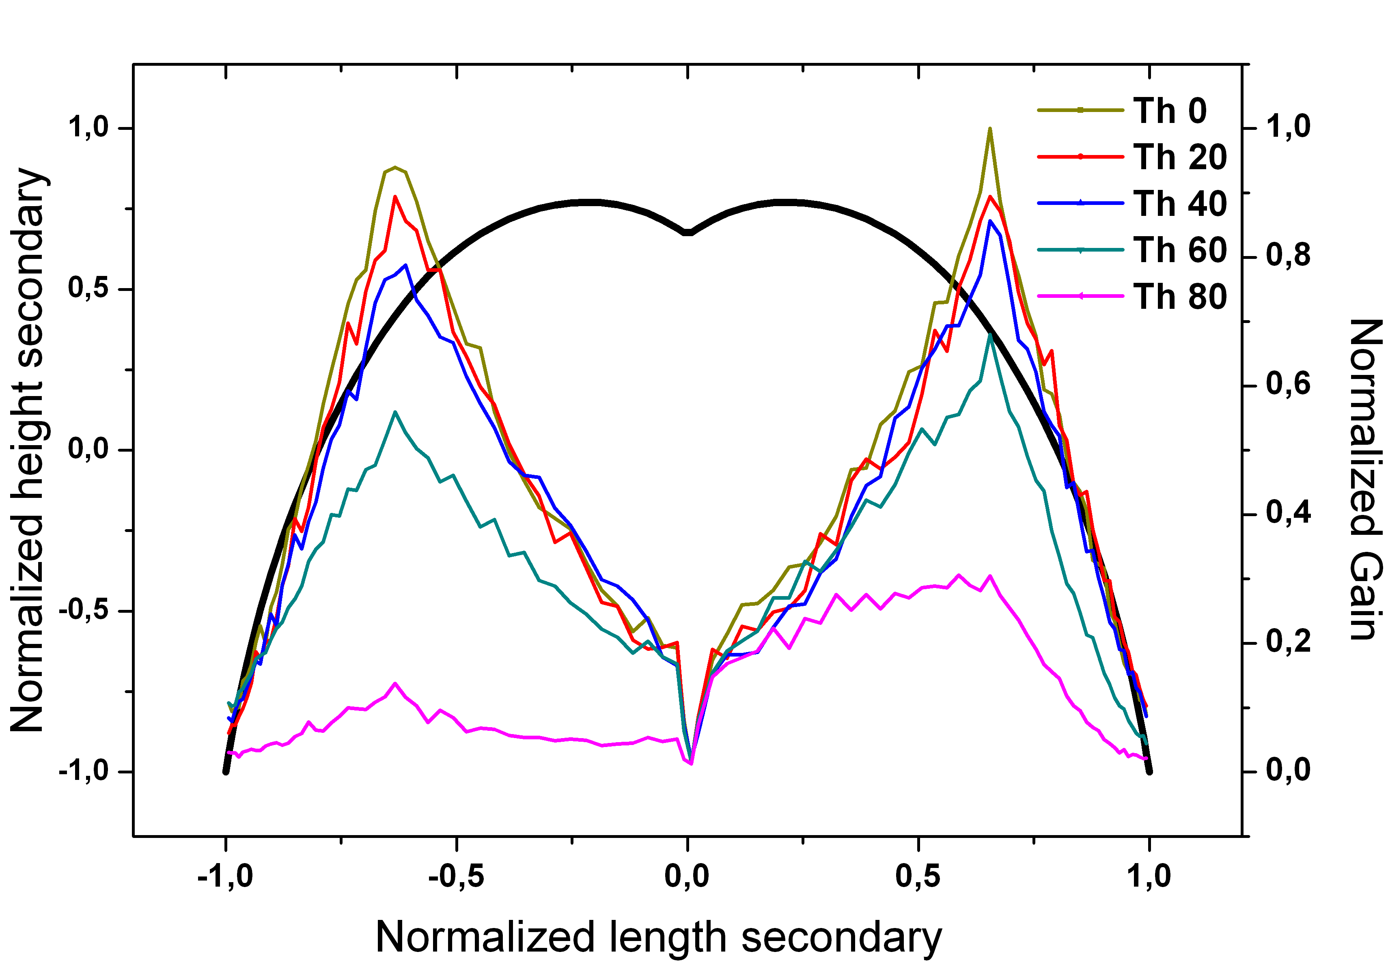
Figure 5.5 Result from ray tracing of the absorbed heat flux (blue) for normal incidence and a DNI of 1000 W/m², the shape of the secondary mirror is indicated by the black line. (b) With an increase of the transversal angle of incidence, the interaction with the secondary mirror decreases. The normal angle of incidence is θ₀.

Energy gain by glass plate

Short wave length radiation is transmited, reflected and absorbed by the glass plate. The energy transmited interacts with the secondary mirror and the absorber tube. The component reflected is an optical loss. The component absorbed is an optical loss as well, but energy is converted in heat. The energy gained by the glass plate increases its temperature. The amount of energy absorbed is calculated considering the reflecting area of the primary field and a DNI value.

Figure 5.6 Energy gain by glass plate

Annual optical yield

Thermal characterization

Thermal balance

The primary mirror field reflects the direct normal radiation into the cavity and due to astigmatism and optical inaccuracies only part of the reflected radiation is hitting the absorber directly. A fraction of the radiation interacts with the secondary reflector and is redirected onto the absorber (see Figure 5.4). Since reflection by the secondary is not loss-less, a component of the short wavelength radiation is absorbed by the secondary reflector, increasing its temperature. While the absorber is being heated, it loses heat by long wavelength radiation and convection to the surroundings. Heat lost from the absorber tube reaches the secondary mirror and the glass plate. Heat is conducted through solid surfaces. The back side of the secondary mirror can be covered with insulation material. Insulation decreases the rate of heat conducted, therefore reducing heat loss. Mineral wools are a common insulating material. The glass plate is not insulated, as it must permit the pass of light through it. Once the heat is conducted and reaches the surfaces in contact with the environment, heat is released by convection and radiation. Figure 5.7 shows schematically the thermal balance of a Linear Fresnel receiver with glass plate on the bottom. The indexes for each transport mode are explained in Table 5.6.

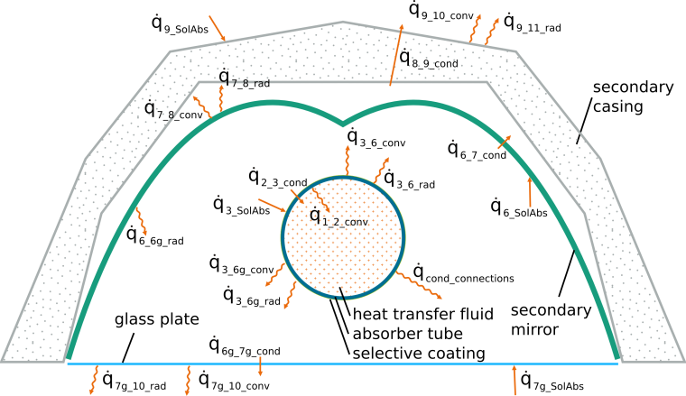
Figure 5.7. Thermal balance of a Linear Fresnel Collector receiver with glass cover. The indices of the heat flows characterize the direction of the heat transport from which surface to which surface with the meanings of the indices according to Table 5.6 (see below).

Table 5.6 Overview of subscripts of individual heat transport effects according to Figure 5.7
Subscript | Surface |  | Subscript | Surface
1 | Heat transfer fluid |  | 7 | Outer secondary mirror surface
2 | Inner absorber surface |  | 7g | Outer glass plate surface
3 | Outer absorber surface |  | 8 | Inner casing surface
6 | Inner secondary mirror surface |  | 9 | Outer casing surface
6g | Inner glass plate surface |  | 10/11 | Ground or air / Sky

In view of the aforementioned heat transfer conditions a fitted system of equations is generated, following the indices of the heat flows according to the explanations in Figure 5.7 and Table 5.6. Radiation terms ${\dot{q}}_{3_rad}$, ${\dot{q}}_{6_rad}$ and ${\dot{q}}_{6g_rad}$ correspond to the sum of all radiation reaching the designated inner surface. The system of equations is as follows:
$${\dot{q}}_{1_2_conv}={\dot{q}}_{2_3_cond}$$
$${\dot{q}}_{2_3_cond}+ {\dot{q}}_{3_6_conv}+{\dot{q}}_{3_6g_conv}={\dot{q}}_{3_SolAbs}+{\dot{q}}_{3_rad}$$
$${\dot{q}}_{3_6g_conv}+ {\dot{q}}_{6g_rad}={\dot{q}}_{6g_7g_cond}$$
$${\dot{q}}_{6g_7g_cond}+{\dot{q}}_{7_SolAbs}= {\dot{q}}_{7g_10_conv}+{\dot{q}}_{7g_10_rad}$$
$${\dot{q}}_{6_SolAbs}+ {\dot{q}}_{3_6_conv}+{\dot{q}}_{6_rad}={\dot{q}}_{6_7_cond}$$
$${\dot{q}}_{6_7_cond}={\dot{q}}_{7_8_conv}+{\dot{q}}_{7_8__rad}$$
$${\dot{q}}_{7_8_conv}+{\dot{q}}_{7_8_rad}={\dot{q}}_{8_9_cond}$$
$${\dot{q}}_{8_9_cond}+{\dot{q}}_{9_SolAbs}={\dot{q}}_{9_10_conv}+{\dot{q}}_{9_11__rad}$$

All the fluxes are represented as positive in the equations, but finally the temperature difference between the surfaces will determine the direction of heat transport.

Computer Fluid Dynamics (CFD) model

Computer Fluid Dynamics (CFD) deals with the analysis of systems involving fluid flow, heat transfer and associated phenomena by means of computer-based simulation. The equations governing the fluid dynamics are derived from the principles of mass, momentum and energy conservation. These principles are represented through a system of partial differential equations.

Problem description and implementation

Considering the thermal balance of a Linear Fresnel collector, the problem to be solved can be described as a temperature source (absorber), placed in a closed cavity (secondary concentrator and glass plate) filled with air. The temperature of the walls’s cavity is influenced by: air inside the cavity, long wavelength radiation from the absorber tube and surrounding walls, short wavelength radiation reflected from the primary field, materials of the walls, and ambient conditions. As there is no standard convection correlation for a tube inside a cavity with a non-uniform wall temperature, CFD simulations are implemented to generate solutions. The scope of the simulation is to describe the fluid dynamics and its interaction with the surrounding walls. The generated results are the temperature of the secondary concentrator and glass plate, together with the heat loss of the absorber tube.

Given the description of the problem, the following conditions are identified

- Buoyancy effects as the main driving force for convection heat transfer inside the cavity.
- Spatially distributed short wavelength radiation absorbed by the secondary mirror and glass plate.
- Exchange of long wavelength radiation between all the surfaces.
Considering the relevant conditions described above, the equations to be solved in steady-state are the following

Mass conservation

$$∇∙\left(ρU\right)=0$$

Momentum

$$∇∙\left(ρU∙U\right)-∇∙\left(μ_{eff}\left(∇U+ ∇U^{T}\right)- \frac{2}{3}μ_{eff}\left(∇∙U\right)I\right)=∇p_{d}- ∇{ρg}_{h}$$

Energy conservation

$$∇∙\left(ρU\right)-∇∙\left(α_{eff}∇h\right)=\frac{∂p}{∂t}- U∙∇p$$

Where
- rho is…

The unknowns of the system of equations are pressure, velocity, stress tensor and temperature. The system of equations is strongly coupled, which makes it extremely difficult to solve analitically. Exact solutions exist for few cases under very controlled conditions. For generating solutions, the problem has to be simplified. The approach of CFD is the approximation of a partial differential system of equations by a linear system of equations. The generation of a linear system of equations is done discretizing the problem in time and space. Time discretization involves the definition of a time step where intermediate results are generated. Space discretization involves the generation of a grid in the domain in order to define where the results are calculated.

The software used is OpenFOAM, which is an opensource code written in C++. Within OpenFOAM a solver called buoyantSimpleFoam is implemented. The solver deals with the system of equations described above, considering the following characteristics

- Compressibility of the fluid to take into account temperature dependence of fluid’s density, which is the driving force for the fluid’s motion inside the cavity.
- RAS model for turbulence.
- View factor model for long wavelength radiation calculation.
The scope of the simulation is to determine the heat loss of the receiver and the temperature distribution over the surrounding surfaces. A simulation is performed for a fixed wall temperature of the absorber tube. The secondary concentrator and the glass plate are defined as walls. Proper boundary conditions of the temperature field are defined to consider material properties and ambient conditions. The radiation transport is solved only between boundary surfaces. For every surface the emissivity is set and, given the temperature values of the thermal balance, radiation exchange is calculated. For convection transport, the thermo-physical properties of air are set. The turbulence is simulated with the Reynolds-averaged stress (RAS) model.

Domain

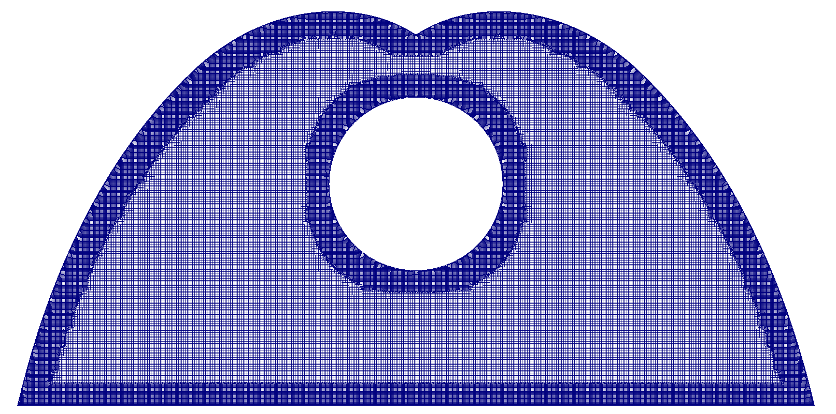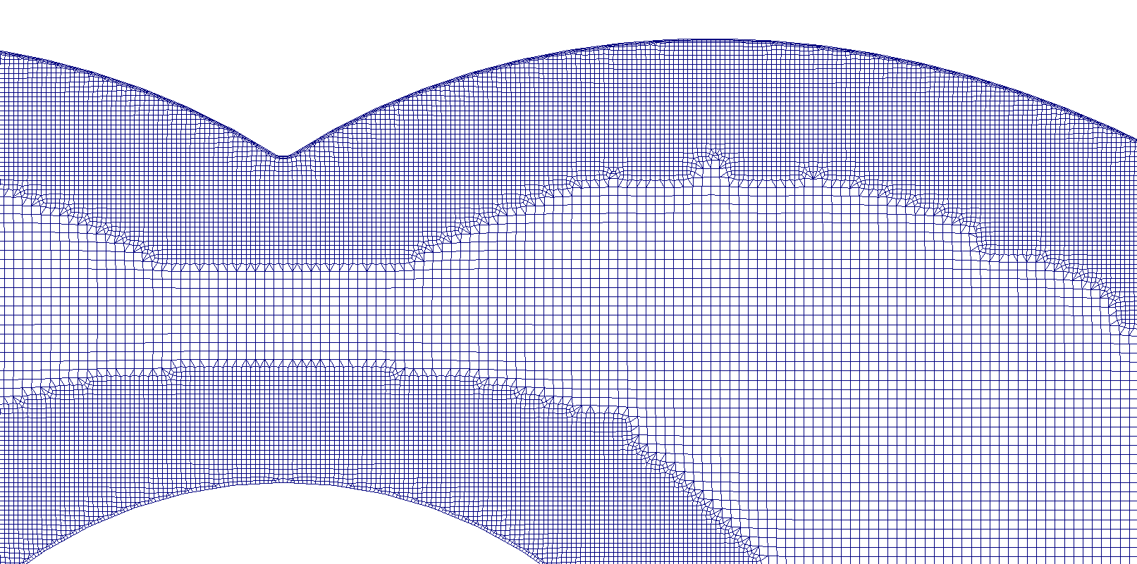

Figure 5.8 Domain discretization. Mesh implemented to spatially solve the discretized set of equations

Boundary conditions

Figure 5.9 Schematic representation of thermal balance in glass plate and secondary mirror/casing

The mathematical formulation of the boundary condition is explained in detail in

Exemplary results

Parameters of the system
Parameter
Absorber temperature (°C) | XX
Absorber emittance (-) | XX
Secondary mirror emittance (-) | XX
Glass plate emittance (-) | XX
Insulation thickness (mm)
Ambient temperature (°C)
Wind velocity (m/s)
Zenithal angle (°)
Azimuthal angle (°)
DNI (W/m²) | XX

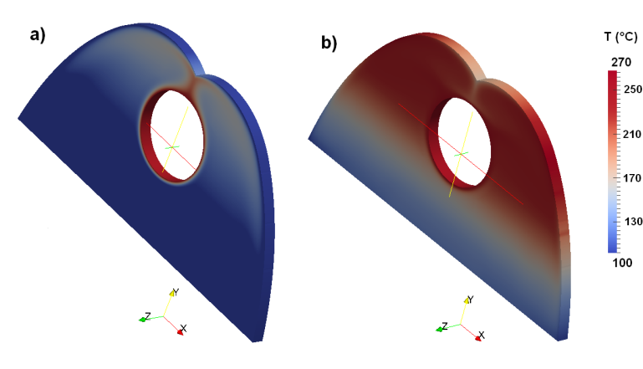(ADD NEW RESULTS!!!)
Figure 5.10 Temperature field

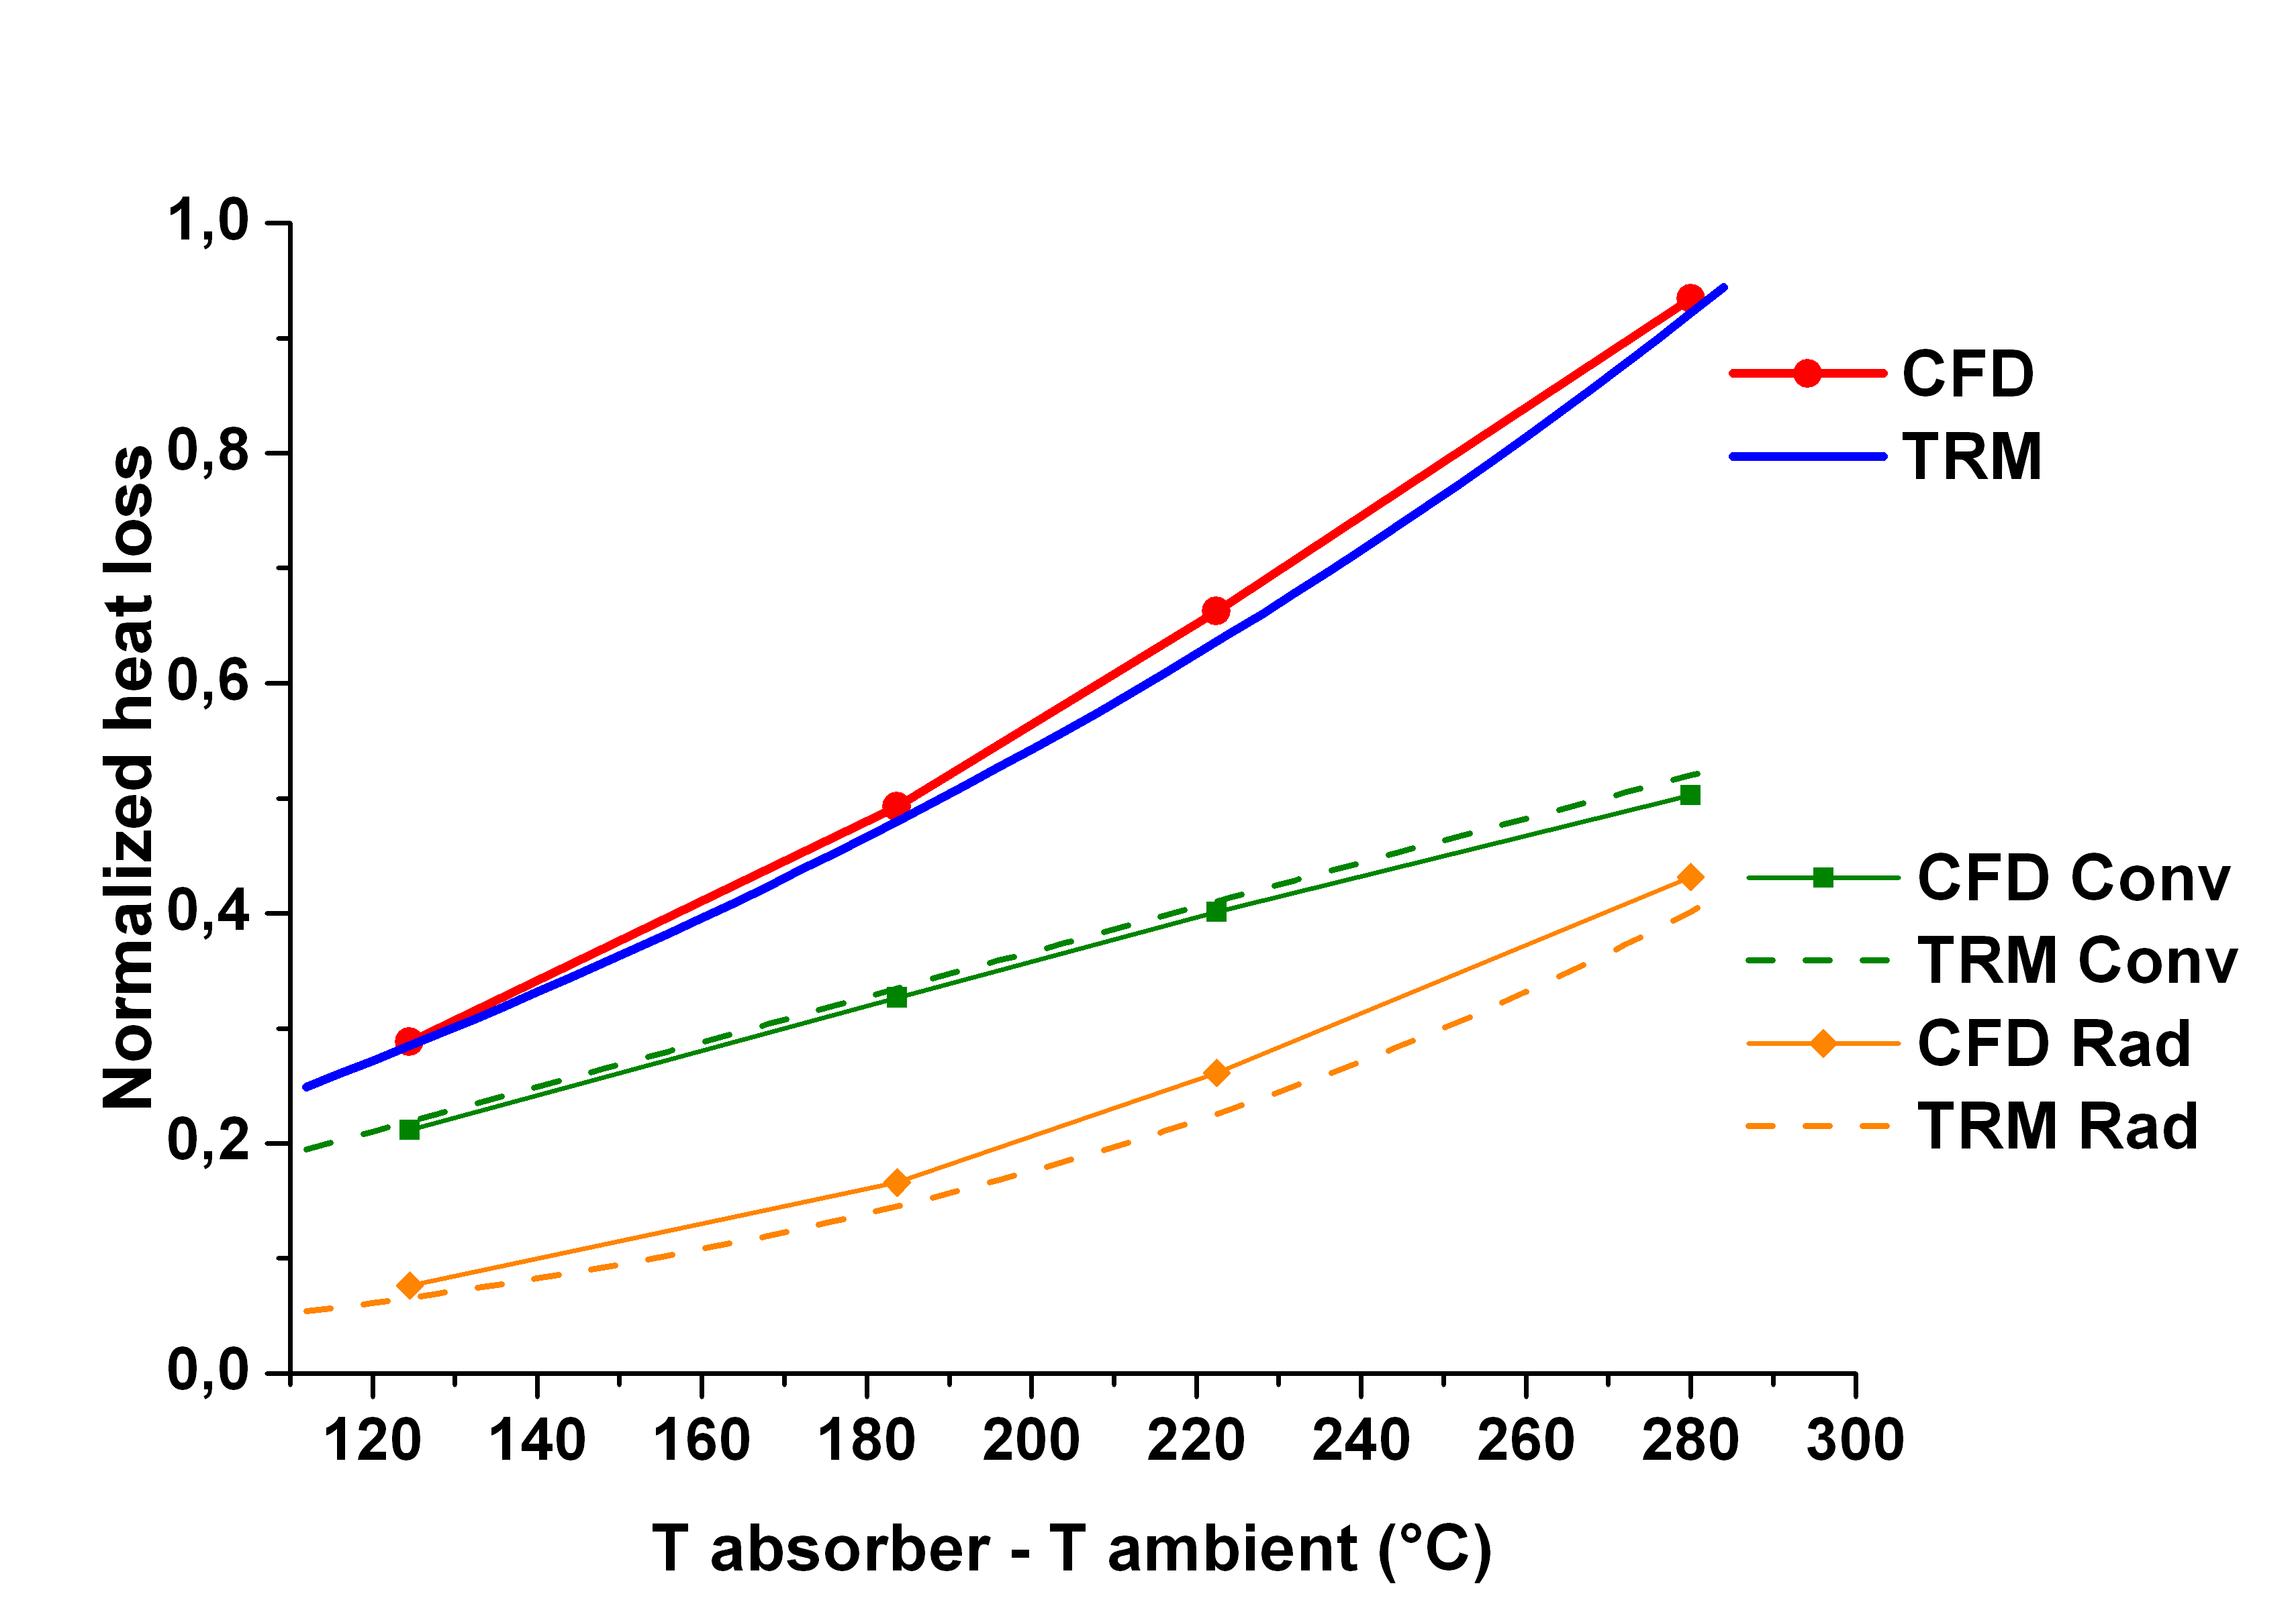( ADD NEW RESULTS!!! PLOT CURVE ONLY FOR CFD RESULTS)
Figure 5.11 Heat loss curve

Thermal Resistance Model (TRM)

Heat transports through conduction, convection and radiation as well as the absorbed solar radiation have been implemented in terms of a thermal resistance model. Figure 5.12 shows the equivalent thermal resistance net.
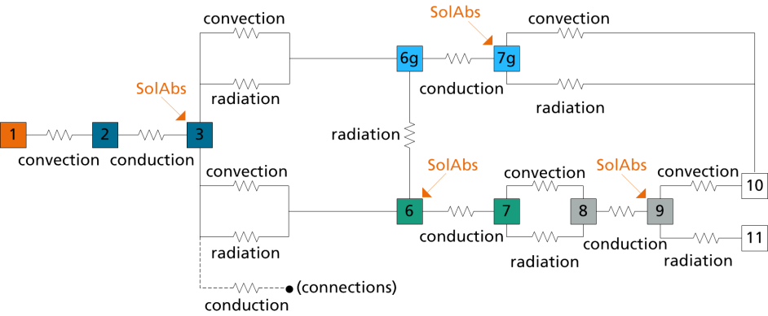
Figure 5.12 Thermal resistance model of a LFC receiver with glass plate (indices according to Table 5.6)

Effects of conduction and convection are calculated by physical equations according to literature [Ref VDI, Cengel]. For the specific geometry of a CPC-like secondary reflector, adapted correlations of similar geometries have been embedded. Radiation within the cavity of the receiver has been implemented via a view factor model. The view factor matrix takes into account the exact geometry and shape of the secondary mirror, glass plate and absorber tube. Apart from radiation, free convection is considered within the cavity of the receiver. Opposed to the detailed CFD model a homogeneous distribution of the solar radiation on the secondary mirror and glass plate is implemented. The value implemented corresponds to the total heat absorbed, calculated by ray tracing simulations, as explained in . The whole thermal balance is considering a single mean temperature value for the secondary mirror and for the glass plate surfaces. Absorption of the non-reflected solar radiation on the secondary mirror is included in the thermal balance in dependence of the aperture area of the collector, the direct normal irradiance and incidence angle of the solar radiation. Heat transfer to the outer surroundings is characterized by incorporating ambient temperature and wind speed.

Exemplary results

Table 5.7

(ADD NEW RESULTS!!! COMPARE TO CFD RESULTS. FIG 5.11)
Figure 5.13

Electro-winning copper recuperation process

Copper recuperation begins with the extraction of the mineral from the pit. After extraction, the rock is crushed or grinded until it is at the optimal size for the hydrometallurgical processing, which entails heap leaching, solvent extraction and electro-winning. The flow diagram of these processes is shown in Figure 5.14 with Cu concentration in every step.

Heap leaching begins with the implementation of a flat-surface heap. The heap is approximately 7 m high and the top area varies between ${10}^{4}$ and ${10}^{6}$m². On the top of the heap a net of pipes and sprinklers is installed. The sprinklers apply drops of $H_{2}{SO}_{4}-H_{2}O$ solution. The solution flows through the heap dissolving copper. The product of heap leaching is a pregnant solution with copper concentration between 1-6 kg Cu/m³. The pregnant solution is directed by gravity to a pond or tank outside the heap and then is sent to solvent extraction.
Figure 5.14 Flow diagram of heap leaching, solvent extraction and electro-winning processes.

The pregnant solution produced by leaching operations is still too dilute in Cu and contains impurities (1-10 kg Fe/m³), therefore it is not optimal for direct electro-deposition. Solvent extraction entails bringing the pregnant solution in contact with a copper liquid organic extractant. The low-Cu solution (raffinate, 0.3 kg Cu/m³) is sent back to leach heap and the Cu-loaded organic (4 kg Cu/m3) is mixed with strong $H_{2}{SO}_{4}$ solution from the electro-winning process, causing Cu to be stripped from the organic into the electrolyte. The stripped organic (1.5 kg Cu/m³) is sent back to contact the pregnant solution and the enriched electrolyte (45 kg Cu/m³) is sent to electro-winning. Solvent extraction process is continuous and takes place in “trains” or circuits of two extraction mixer-settlers for loading and one strip mixer-settler for stripping. Typically there are between one and four trains operating in parallel [3].
The copper concentration of the enriched electrolyte is adequate for electro-deposition. The electrolyte coming from solvent extraction is sent to a storage tank. One half to three quarters of the depleted electrolyte is sent to the electrolyte storage as well. At this point, the electrolyte concentration and PH values are optimum, but it is not warm enough for efficient electro-deposition. Before sending the electrolyte to the electro-winning cells, the electrolyte is circulated through a heat exchanger to increase its temperature from approximately 47 ºC up to 57 ºC. The heated electrolyte is sent to the electro-winning cells, where an electrical potential is applied between anodes and cathodes, plating pure metallic copper from the electrolyte onto the cathodes. The process is continuous and takes place for about one week.

Plant layout and energy demand

The copper concentration during the different stages of the process can be seen in Figure 5.14. To determine the enriched electrolyte flow rate that has to be warmed, we assume a concentration of the pregnant solution of 3.3 kg Cu/m³ and a flow rate of 4000 m³/hr. For the solvent extraction phase, we consider four mixer-settlers “trains” operating in parallel. Cu production rate is defined by the pregnant solution flow rate and the difference of Cu concentration between the pregnant solution and the raffinate.

$Cu_{RATE}=4000{m³}/{hour}*\left(3.3{kg Cu}/{m³}-0.3 {kg Cu}/{m³}\right)=12000 kg Cu/hour$

As there are four mixer-settlers circuits operating in parallel, every circuit works with 1000 m³/hour of pregnant solution and produces 3000 kg Cu/hour. The same Cu production rate must be accomplished in the electro-winning circuit. Considering Cu concentration of 45 kg/m³ for the enriched electrolyte and 35 kg/m³ for the depleted electrolyte, the flow rate is determined by

${\dot{m}}_{ER}=\frac{3000 kg Cu/hour}{\left(45-35\right){kg Cu}/{m³}}=300 m³/hour$

Every train adds 300 m³/hour of enriched electrolyte, resulting in a total flow rate of 1200 m³/hour. Considering these conditions, an annual production of about 100000 tonnes Cu/year is expected. The configuration chosen is a specific case based on [3]. The assumptions for this plant are within the range of mines operating in Chile. Table 5.8 shows operating condition of mines in Chile by 2001 [3] and the parameters defined in our plant.

Table 5.8. Details of Cu mines operating in Chile, 2001 [3]. Right column shows the parameters defined for our simulation.
Mine | Cerro Colorado | El Abra | Zaldivar | ***
Cathode production (tonnes/year) | 130000 | 218000 | 145000 | 100000
Pregnant solution (m³/hour) | 4000 | 5000 - 7500 | 4800 | 4000
Pregnant solution (kg Cu/m³) | 4.8 | 5 – 6 | 3.5 | 3.3
Raffinate (kg Cu/m³) | 0.4 | 0.5 – 1.0 | 0.25 | 0.3
Depleted electrolyte (kg Cu/m³) | 37 | 40 | 42 | 35
Enriched electrolyte (kg Cu/m³) | 52 | 36 | 55 | 45

Optimum temperatures for electro-winning vary between 50 °C and 60 °C. There are several configurations to warm up the electrolyte, which depends on specific aspects of every mine. In our case studied, we consider two configurations. The layout of the configurations can be seen in Figure 5.15

Figure 5.15 Conventional heater configurations. a) Total electrolyte flow rate is warmed. b) Half of electrolyte flow rate is warmed and then mixed.

In configuration a) the electrolyte is heated from 47 ºC to 57 ºC. The electrolyte flow rate is 1200 m³/hr. In configuration b) one half of the electrolyte is heated from 47 ºC to 67 ºC and then is mixed with the other half to reach an equilibrium temperature of 57 ºC.

In Table 5.9 the energy demand and diesel consumption for nominal conditions are shown. Heat loss through piping is neglected, therefore the energy supplied by the conventional heater is the same for both configurations.
Table 5.9 Operation conditions and energy consumption of the conventional heater.
Configuration | a) | b)
Corresponding notation | TProc70 | TProc90
Heater inlet temperature (°C) | 60 | 70
Heater outlet temperature (°C)  Flow rate (m³/hour)  Water specific heat (kJ/kg °C) | 70  1200  4.19 | 90  600
Heater efficiency (%)  Energy supplied (MJ/hour)  Diesel calorific power (MJ/kg)  Diesel consumption (m³/year) | 85  59150  44.8  13900

In principle the copper recuperation process is constant along the day and along the year; however there are situations that affect the availability of raw material and therefore the process continuity. Within the situations we mention equipment maintenance and failures, raw material availability due to the ore nature and time needed to construct and remove the heaps. To consider these situations, we have randomly designed varying conditions for the enriched electrolyte flow rate. As there are four circuits of mixer-settlers operating in parallel, we consider the total flow rate of the enriched electrolyte to be three quarters, one half, or one quarter of the nominal conditions shown in Figure 5.15. This emulates whether three, two or one of the mixer-settlers circuits operating. It is considered as well an extreme case where there are days with no enriched electrolyte to be electrodeposited. Although this case is consider unlikely, it serves to study the response of the solar system under situations with no energy demand. In Figure 5.16 can be seen the three profiles. The profiles are shown for a period of 50 days, but during the simulation they are repeated consistently along the year, meaning that day 51 is the same as day 1 shown in the below.

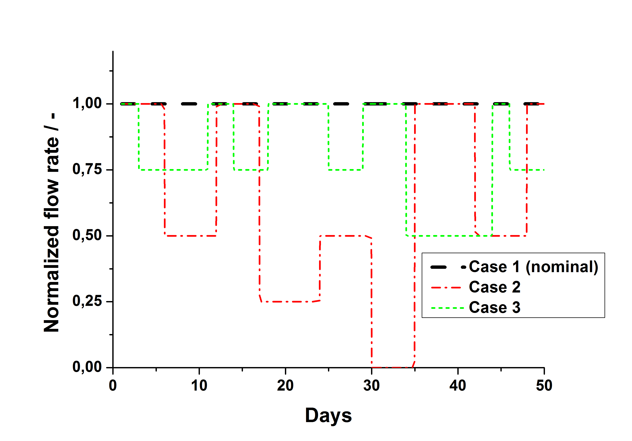
Figure 5.16 Flow rate for three defined cases. The values are shown as a proportion of nominal conditions

The annual values of the energy demand for every profile is shown in Table 5.10

Table 5.10 Energy demand and diesel consumption for the three profiles defined above
Demand profile | Case 1 (nominal) | Case 2 | Case 3
Energy demand (GW/year) | 520000 | 410000 | 290000
Diesel consumption (m³/year) | 13900 | 11070 | 7700

Solar energy integration

The integration of a solar system to the electro-winning circuit has to be done to be minimally invasive. Directly heating the electrolyte in the solar collectors was not considered, as it could affect its composition of the solution due to temperature variations (PH, evaporation of components). Therefore the solar system was integrated into the conventional heater circuit. In case of any problem on the solar field side, the electro-winning circuit can operate independent of the solar system. In Figure 5.17 a nominal layout for the solar system integration is shown.

Figure 5.17 Nominal layout and values of the solar system and electrowinning process. Simulation limits indicated in dashed box.
The solar system operates in series with the conventional heater. The energy gained by the solar system is transferred to the solar storage tank. The water from the top section of the storage is pumped to the process heat exchanger. In case that the temperature of the water is less than the set value of the process, the conventional heater supplies the energy needed to increase the temperature. The water returning from the heat exchanger is returned to the solar storage tank. Both solar plants, concentrating and non-concentrating are integrated in the same way.

Design options

Analysis and optimization

Optical yield

Summary and Outlook

Bibliography

