# 1、搭建环境

## 1、Node环境检查。

使用vue-cli需要Node的基础环境，如果没有则自行安装（傻瓜式安装）

检查Node环境是否正常：npm -v

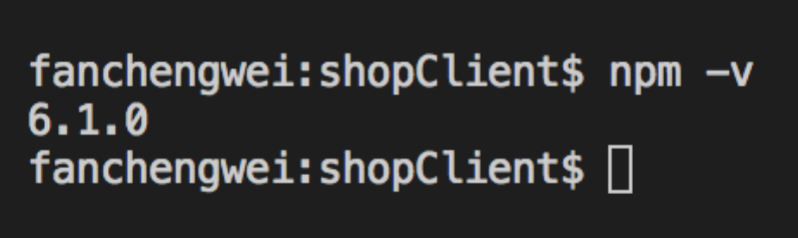

至少5以上的版本

## 2、使用vue-cli生成项目骨架

建议全局安装vue-cli：npm install vue-cli -g

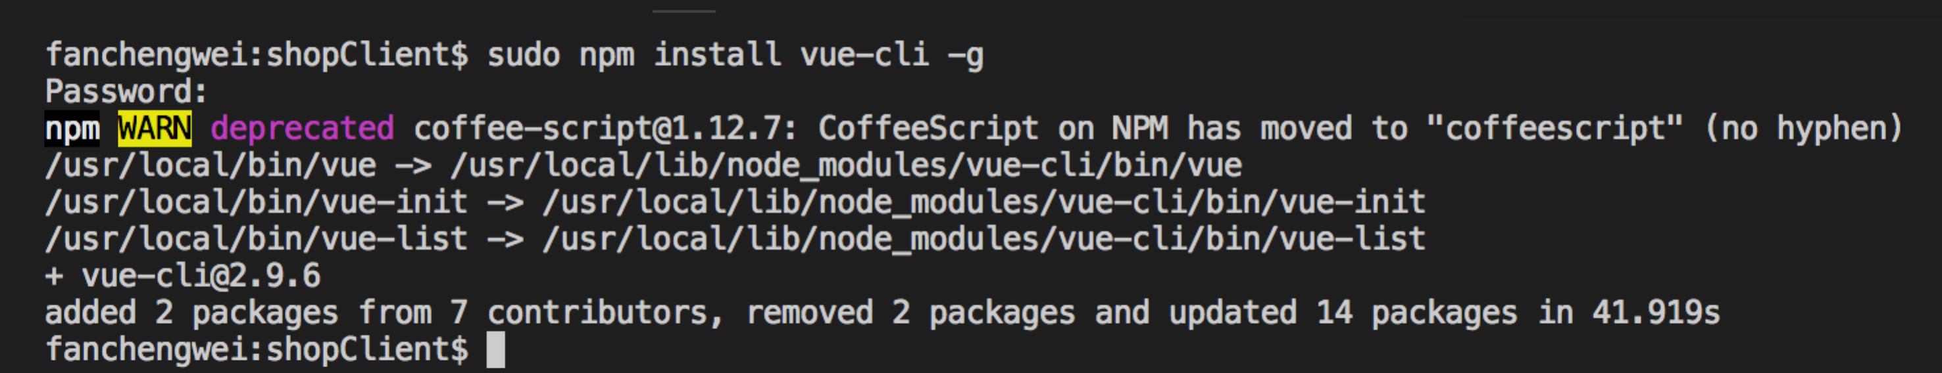

## 3、检查vue版本：vue –V

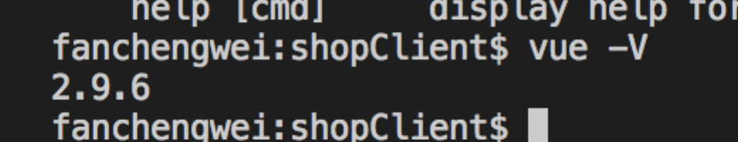

## 4、初始化项目

vue init webpack

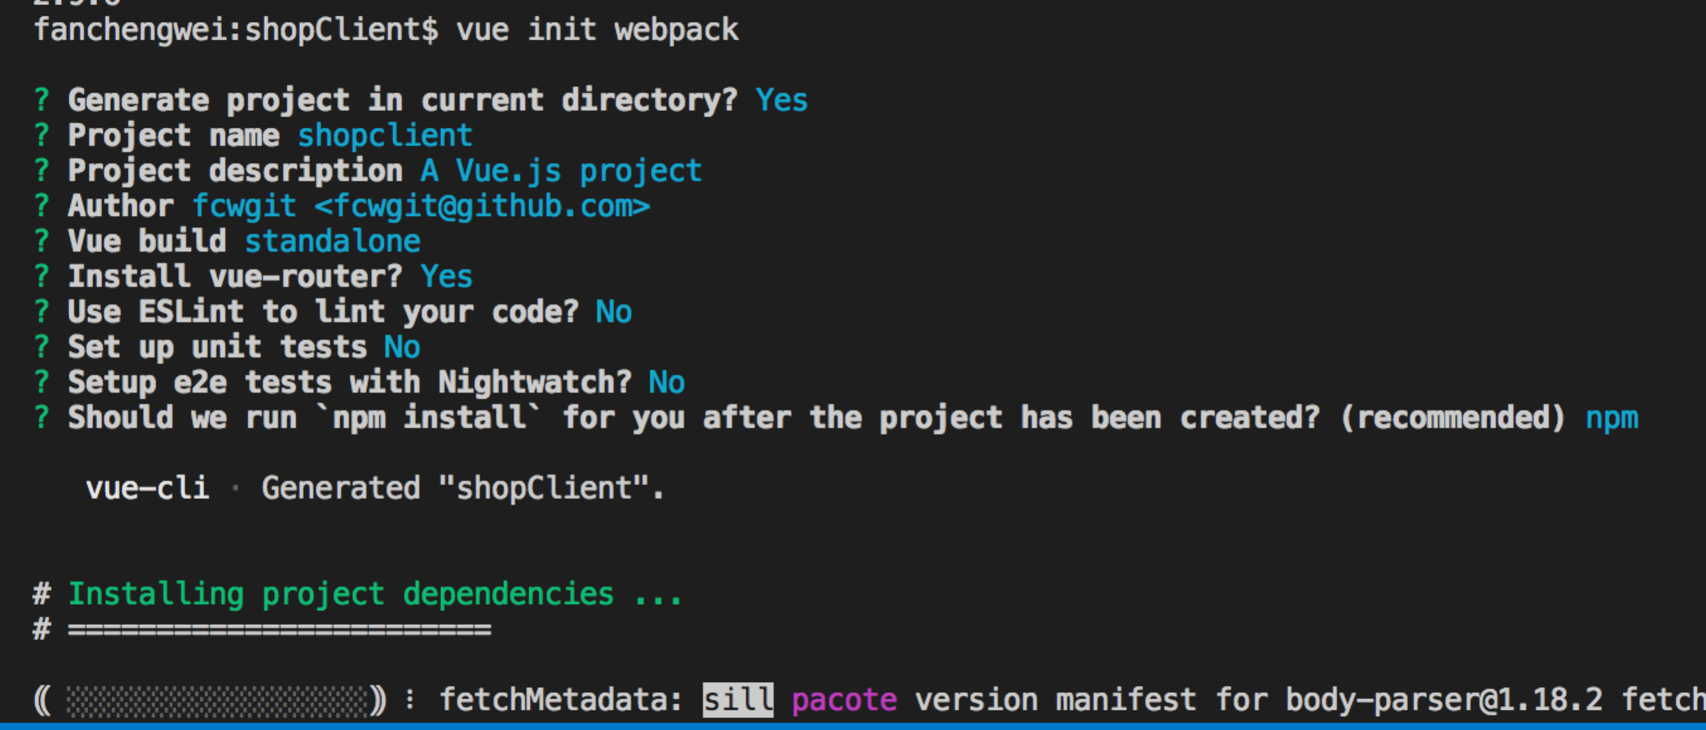

fanchengwei:shopClient$ vue init webpack

? Generate project in current directory? Yes

? Project name shopclient

? Project description A Vue.js project

? Author fcwgit <fcwgit@github.com>

? Vue build standalone

? Install vue-router? Yes

? Use ESLint to lint your code? No

? Set up unit tests No

? Setup e2e tests with Nightwatch? No

? Should we run `npm install` for you after the project has been created? (recommended) npm

vue-cli · Generated "shopClient".

# Installing project dependencies ...

# ========================

> fsevents@1.2.4 install /Users/fanchengwei/Desktop/vueCode/shop/shopClient/node_modules/fsevents

> node install

[fsevents] Success: "/Users/fanchengwei/Desktop/vueCode/shop/shopClient/node_modules/fsevents/lib/binding/Release/node-v57-darwin-x64/fse.node" already installed

Pass --update-binary to reinstall or --build-from-source to recompile

> uglifyjs-webpack-plugin@0.4.6 postinstall /Users/fanchengwei/Desktop/vueCode/shop/shopClient/node_modules/webpack/node_modules/uglifyjs-webpack-plugin

> node lib/post_install.js

npm notice created a lockfile as package-lock.json. You should commit this file.

npm WARN ajv-keywords@3.2.0 requires a peer of ajv@^6.0.0 but none is installed. You must install peer dependencies yourself.

added 1184 packages from 667 contributors in 55.045s

# Project initialization finished!

# ========================

To get started:

npm run dev

Documentation can be found at https://vuejs-templates.github.io/webpack

## 5、测试安装情况

运行：npm run dev

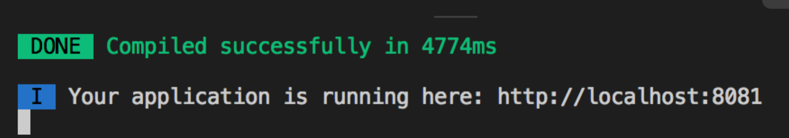

访问：<http://localhost:8081>

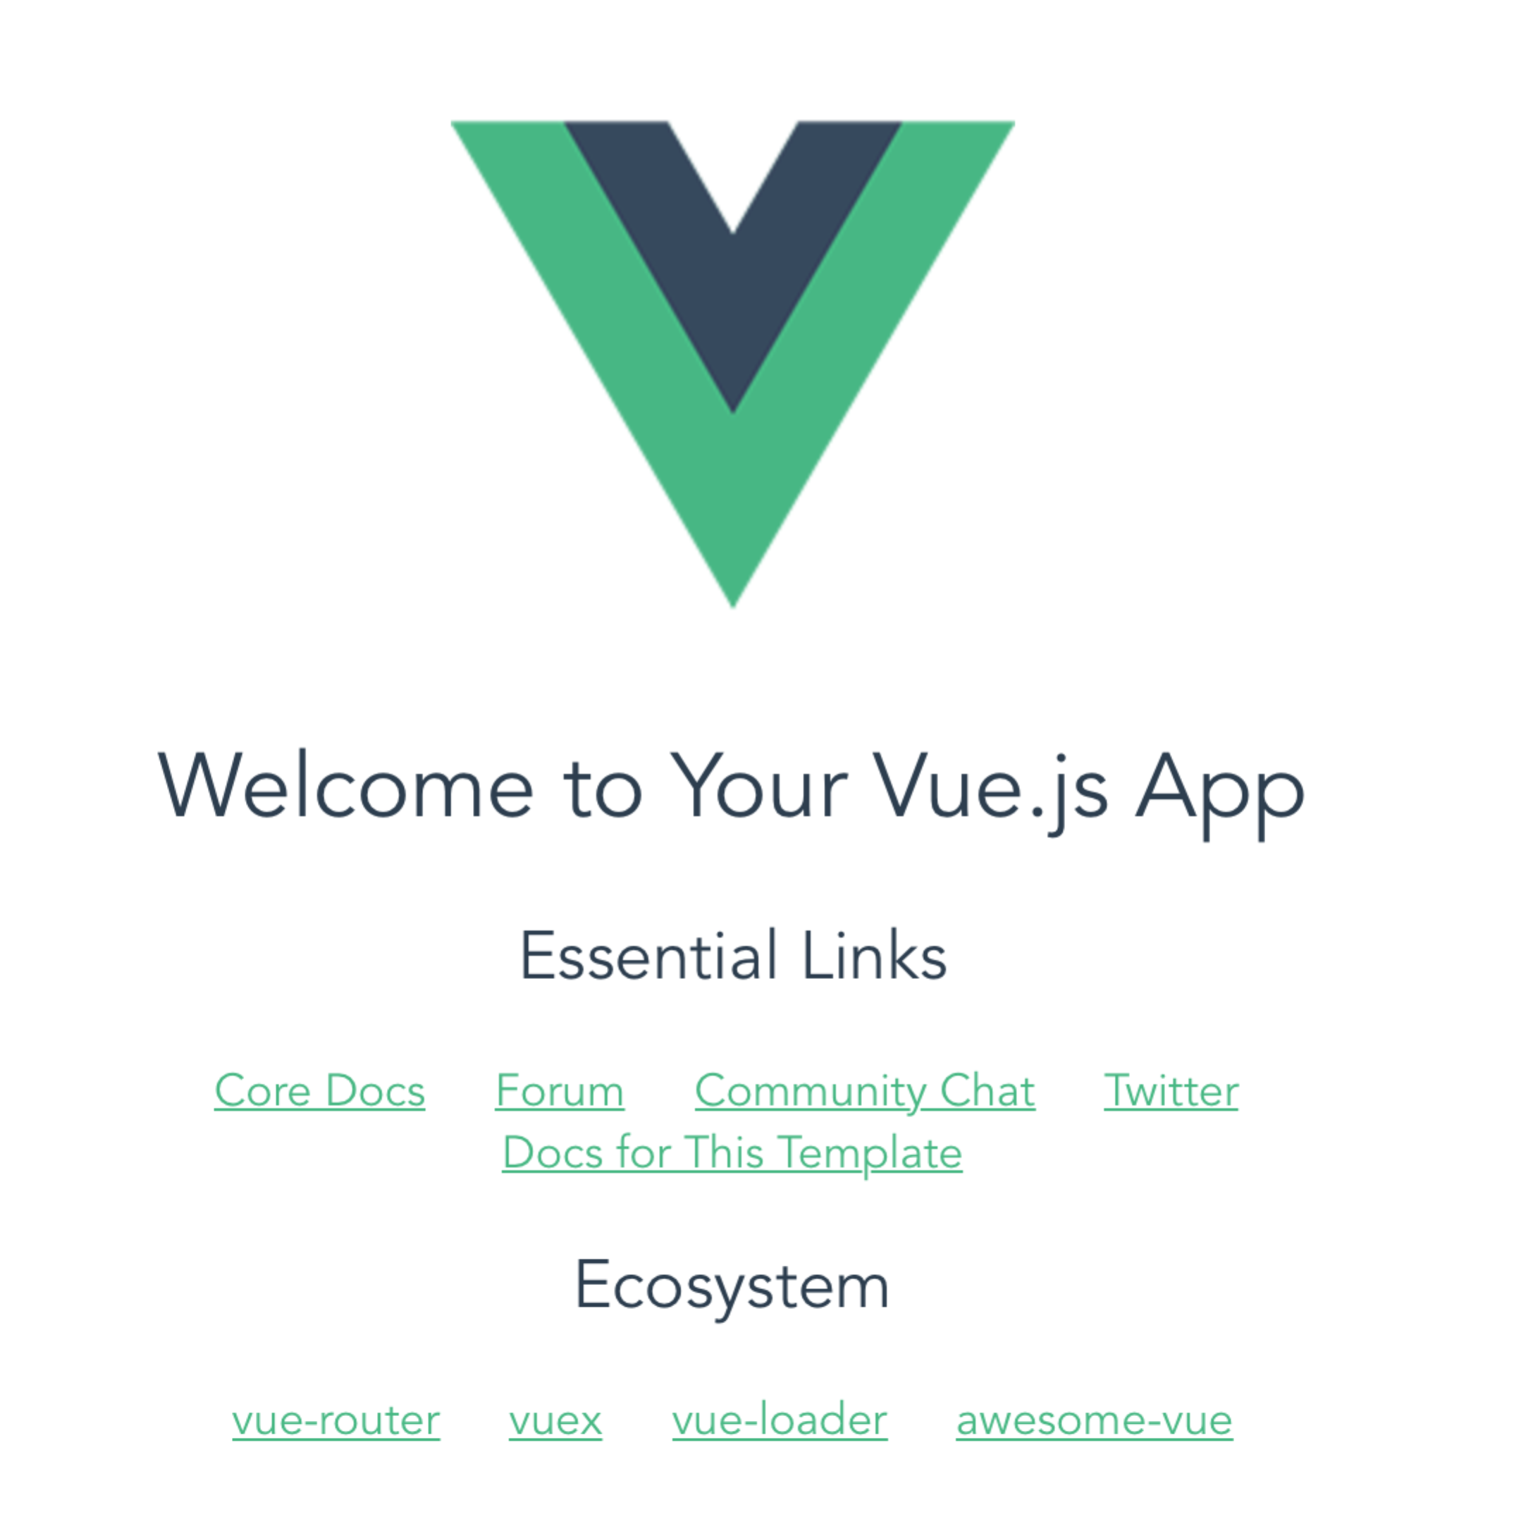

表示初始化成功

基于webpack 3.6 进行打包

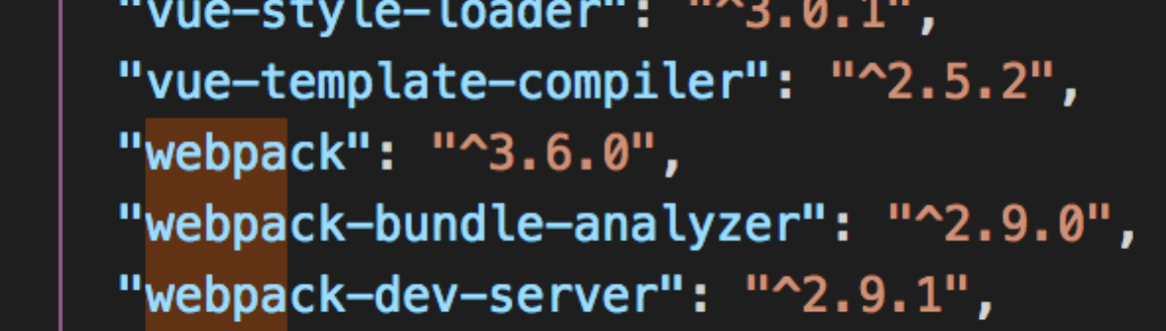

# 2、优雅的引入Vant样式组件库