Eco-Social Policy and Environmental Governance in the Brazilian Amazon
Fernando Cymbaluk
2026-10-18
Table of contents

Front matter

Dedication
To those who inspired me and gave me strength to walk this path.

Acknowledgments
I am deeply grateful to my advisors, colleagues, and family for their unwavering support throughout this journey.

Abstract
[Placeholder. Write from the final state of the four chapters.]

Resumo
[Placeholder. Versão em português do abstract.]

Introduction
Environmental and climate issues are not isolated dimensions of public life. They are tied to economic development and to social well-being. In climate negotiations, countries defend their room for productive growth. In domestic debates over environmental regulation, resistance to conservation measures comes from the groups that bear their costs, and these groups are not always wealthy elites. In the coal regions of Europe and the United States, workers and their unions have defended the mines and plants on which their jobs, pensions and towns depend, and the debate on a just transition exists because that defense carries political weight. In France, the Yellow Vests of 2018 rose against a fuel tax that fell on households that need the car to reach work, a cost on consumption rather than on jobs. The two cases differ in where the cost lands, on production or on consumption. They share the point that matters here: environmental policy imposes costs on people whose well-being is already precarious, and those people resist.
It is clear, then, that environmental and climate issues are multidimensional. How environmental concerns interact with the other priorities of a life, earning an income, security, well-being, is a puzzle far from solved. The explanations on offer are diverse, and they diverge. At one end is the premise that we live a tragedy, in which the pursuit of individual gain on an open-access resource undermines every effort to preserve the commons (Hardin 1968), and its collective-action twin, the free rider who lets others pay for a public good he enjoys (Olson 2003). At the other end is the normative program of a human existence within a safe and just space, above a social foundation that no one falls below and inside planetary boundaries that no one pushes past (Rockström et al. 2009; Raworth 2017). How to counter free riding, or how to bring humanity inside that space, remains an open question.
Twentieth-century research on the environment did not treat it as one problem among many. It concentrated on one other dimension, economic growth, and asked how far conservation could be reconciled with the generation of income by individuals, firms and nations. The answers varied as much as the proposals for reconciling the two. Social well-being was not absent from that research, but it entered in two restricted forms. It entered as a cause of degradation, in the poverty-environment nexus that the Brundtland report made official (WCED 1987). And it entered as a victim of degradation, in the environmental justice literature on who bears the harms, in the inequality-environment nexus (Boyce 1994), and in the environmentalism of the poor (Martinez-Alier 2002). What it did not enter as was a policy domain in its own right, with institutions that protect people from poverty and open opportunities to them, and that might shape whether individuals and groups choose to preserve nature. Well-being is understood here as the satisfaction of human needs, in the sense that needs theory gives the term and that the eco-social literature has adopted (Doyal and Gough 1991; Gough 2017). Social protection is the set of institutions that take that satisfaction out of the market, decommodification in Polanyi’s sense (Polanyi 2025).
Highlighting the dimension of social well-being brings the environmental puzzle we face into sharper focus. The challenge lies in understanding the interplay between environmental interests and social well-being—beyond the mere generation of income. It is easy to envision these two interests aligning positively; consider, for instance, communities that rely on natural resources, for whom preserving nature is synonymous with maintaining a fulfilling life. Conversely, it is less obvious—and perhaps more unsettling—to imagine scenarios where nature conservation and the assurance of human well-being do not go hand in hand. This may be the case for groups whose livelihoods depend on activities that cause environmental degradation, and for whom no easy alternatives exist.
To such wicked problems, we should add a second layer, that is, the institutional one. How do institutions interact with environmental, economic, and social problems?
Argument regarding social institutions: In Europe, social institutions were built in tandem with economic growth—they are, in fact, “growth-dependent” (see literature on “eco-welfare”). Consequently, environmental policies often prove regressive from a social perspective.
In Brazil and Latin America, by contrast, there exists a conservative model of social policy characterized by “regulated citizenship” and an authoritarian legacy, alongside a more recent “inclusion of outsiders.” The Amazon frontier adds a configuration of its own. The state was present there, but for capital. It manufactured land as a source of rent through fiscal incentives, subsidized credit and directed colonization, while frontier labor stayed outside the citizenship regime and outside any social policy. Livelihoods came to depend on activities linked to deforestation. The protective institutions that later reached the frontier, non-contributory and financed by the federal budget, do not rest on those activities. Whether that protection cushions the costs of conservation for the people who bear them, or instead gives local governments a reason not to impose those costs at all, is the question this dissertation asks.
Moving on to the “Amazon puzzle”: how was it possible to reduce deforestation while simultaneously generating economic growth and social inclusion? And why has this trend reversed?
The explanations on offer rest on two sets of causes. The first is market incentives: the commodity prices and the rural credit that make clearing pay, or not. The second is federal command-and-control: the monitoring, fines and embargoes of the environmental agencies, with supply-chain agreements and protected areas as further instruments. Social policy does not appear among the causes studied, and governments below the federal level appear, when they appear at all, as targets of federal pressure. Chapter 3 establishes this characterization through a systematic review and corrects it where the literature proves broader. Is it plausible that the other policies of the period, and the other levels of government, had no part?

1. Literature review placeholder title

2. Historical trajectory placeholder title

3. Systematic review placeholder title

4. Descriptive analysis and causal inference

4.1 Introduction
State efforts to curb Amazon deforestation during the 2000s coincided with two other major developments: the commodity boom and the expansion of social inclusion through cash transfers and sustained increases in the real minimum wage. These three processes were interconnected, but not in the same way.
Economic growth created favorable conditions for social inclusion by supporting labor-market formalization and income gains among lower-income groups, and minimum-wage increases further strengthened earnings at the bottom of the distribution. Economic growth also allowed an increase in social spending, leading to the creation of generous social policies such as cash transfers. Between 2003 and 2013, Brazil’s GDP grew 64%, while minimum wage grew 75%, besides millions of new job opportunities created (Costa 2024; Saboia and Hallak Neto 2018; Souza and Bruce 2022). Growth and inclusion were mutually reinforcing.
Conversely, the relationship between growth and deforestation control was potentially antagonistic. Land conversion for agriculture and cattle ranching has historically generated substantial returns in the Amazon, so rising commodity prices increased the opportunity cost of conservation and strengthened the incentive to clear (Schneider 1995; Mahar 1988; Binswanger 1991). A central task of the literature on Amazon deforestation has therefore been to separate the effects of commodity prices and other market forces from the effects of environmental policy and enforcement. This distinction is necessary to assess how much of the historic decline in deforestation came from public policy rather than from economic conditions.
Econometric studies that estimate the effects of command-and-control conservation policy while accounting for economic drivers, in particular agricultural commodity prices, consistently find that policy contributed substantially to the decline (Assunção, Gandour, and Rocha 2015; Assunção and Rocha 2019; Gandour 2018; Harding, Herzberg, and Kuralbayeva 2021; Hargrave and Kis-Katos 2013; Barber et al. 2014, and Burgess et al. 2012). Assunção, Gandour, and Rocha (2015), for example, estimate that the conservation policies introduced from 2004 onward avoided approximately 73,000 km² of clearing between 2005 and 2009, equivalent to 56% of the deforestation that would have occurred without them.
The principal institutional milestone of this period was the launch, in 2004, of the Action Plan for the Prevention and Control of Deforestation in the Legal Amazon (PPCDAm). The PPCDAm was an interministerial policy framework that combined near-real-time satellite monitoring through the DETER system with coordinated command-and-control operations by federal environmental and law-enforcement agencies. The federal architecture also introduced territorially targeted instruments. Municipalities with critical deforestation levels were designated priority areas for monitoring and enforcement, and access to rural credit was restricted for landholders unable to demonstrate environmental compliance (Assunção, Gandour, and Rocha 2015; Assunção and Rocha 2019).
A substantial strand of this literature uses the municipality-year as its unit of analysis, because the municipal scale captures variation in exposure to both economic pressure and policy pressure. Municipalities differ in the land devoted to agriculture and ranching, in the composition of local production, and in the relative weight of different commodities (Assunção, Gandour, and Rocha 2015; Harding, Herzberg, and Kuralbayeva 2021). These productive structures are shaped by historically determined and potentially endogenous local processes, so studies do not treat them as exogenous. Instead, they interact changes in external commodity prices with predetermined measures of local specialization to build municipality-specific exposure to price shocks (idem).
Exposure to environmental conservation policy also varies across municipalities, but for a different reason. Monitoring, inspections, fines, and embargoes remained largely federal responsibilities. Federal policy was spatially targeted, and this targeting imposed different regulatory pressure in different places. The clearest example is the Priority Municipalities List, which subjected municipalities with critical deforestation dynamics to intensified federal monitoring and enforcement, stricter land-registration requirements, and additional political and economic pressure. Municipal governments could respond by coordinating local agreements, supporting environmental registration, and adopting measures to reduce deforestation, particularly when seeking removal from the list.
Two studies illustrate how this heterogeneity supports identification. Harding, Herzberg, and Kuralbayeva (2021) combine changes in international agricultural prices, differences in municipal productive exposure to those commodities, and variation in coverage by environmental regulation, and ask whether the Priority Municipalities List, the Soy Moratorium, and protected areas altered the sensitivity of deforestation to price pressure. Assunção and Rocha (2019) focus on the Priority Municipalities List itself. They compare changes in deforestation between listed and non-listed municipalities and find that listing reduced deforestation mainly by intensifying law enforcement, rather than through credit restrictions or changes in local production. Other historically important drivers of deforestation, such as transport infrastructure and market access, are stable municipal characteristics and are absorbed by municipality fixed effects models rather than entering as time-varying covariates.
From a broader historical perspective, however, prices and environmental policy were not the only processes intertwined that varied in this period. A third development was the expansion of social inclusion, particularly between the mid-2000s and the mid-2010s. From approximately 2004 to 2014, the growth of income-transfer programs, the rising real minimum wage, employment formalization, and income gains among lower-income groups overlapped substantially with both the commodity boom and the sharp decline in deforestation.
This temporal coincidence raises an empirical and theoretical question. The decline in deforestation occurred during a period of strengthened environmental governance, and at the same time during a broad transformation in the socioeconomic conditions of the Brazilian population. Temporal overlap alone does not show that social policy contributed to environmental conservation. It does suggest that analyses centered exclusively on prices and enforcement may miss a relevant dimension of the institutional and distributive context in which deforestation control took place. Figure 4.1 presents the main policy, economic, social, and environmental milestones of the period of Amazon deforestation decrease.
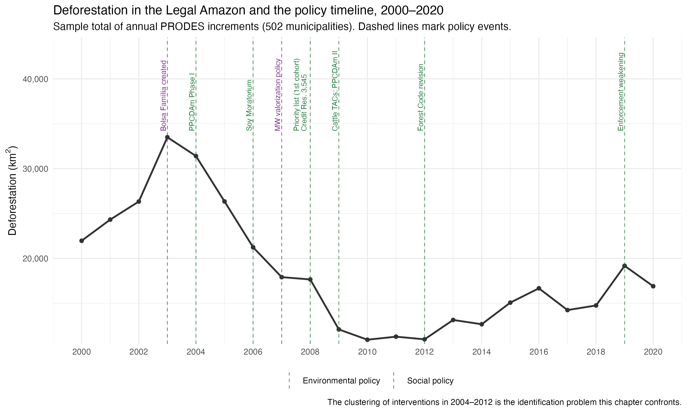
Figure 4.1: Policy, economic, social and environmental milestones of the deforestation decline, 2000-2020
Taking this social dimension seriously is the starting point of the eco-welfare state literature, which argues that environmental governance is embedded in systems of social protection, labor-market regulation, and distributive conflict. From this perspective, the effectiveness and the social consequences of environmental policy may depend on the socioeconomic conditions under which it is implemented. Chapter 1 of this dissertation develops this framework and derives the dimensions along which eco-social interdependence can be observed. Chapter 2 shows historically that Brazil built its social and environmental policy tracks simultaneously but in separate arenas with opposite territorial logics: social policy distributes benefits and reached the Amazon frontier, while environmental enforcement distributes concentrated local costs and never embedded there. Where the two meet, Chapter 2 identifies two mechanisms with opposite signs. Social protection can absorb the local costs enforcement imposes and make it politically sustainable (cushioning as compensation), or social vulnerability can become the justification for local governments not enforcing at all (cushioning as forbearance). This chapter tests empirically what Chapter 2 established historically. Its central hypothesis, that enforcement is more effective where social protection is stronger, is the empirical test of the compensation mechanism.
The chapter examines how social conditions and social policy provision interact with economic incentives and environmental governance in shaping deforestation outcomes in the Brazilian Amazon. It is presented in five stages. First, the theoretical argument, causal mechanisms, and working hypotheses. Second, the data, the panel, and the sample definitions. Third, the exploratory analysis that documents temporal trends and cross-municipal variation in the main environmental, socioeconomic, and policy indicators, and that motivated several design decisions. Fourth, the identification strategy and the reasoning behind it. Fifth, the preliminary results, what they do and do not support, and the problems that remain open.

4.2 Mechanisms and hypotheses
Building on Chapters 1 and 2, this chapter starts from the assumption that environmental enforcement does not operate in a vacuum. Its effectiveness depends on social vulnerability, labor-market conditions, distributive conflict, and uneven state presence across municipalities. Social policies enter this picture through more channels than redistribution alone. By altering the incentives, vulnerabilities, and behavioral constraints of households and local actors, welfare provision may reduce dependence on environmentally harmful livelihoods, lower resistance to regulation, and increase the local feasibility of compliance. The effects of environmental policy are therefore expected to be heterogeneous, conditioned by welfare provision and local social conditions.
Local labor-market conditions matter for the same reason. They shape how much households and communities depend on deforestation-linked livelihoods. Where formal employment is scarce and environmentally harmful activities are central to income generation, enforcement is likely to face stronger resistance. Where more stable and protected income alternatives exist, compliance is easier politically and socially.
The chapter also assumes that this interdependence between social and environmental policy is detectable in data, through variation in policy exposure, local social conditions, and environmental outcomes over time. This assumption justifies the move from a conceptual framework to an identification strategy. The Brazilian Amazon is treated as a critical case for that move because it concentrates the conditions under which the relationship becomes most visible: historically high social vulnerability, persistent inequality, environmental degradation, recent welfare expansion, and uneven enforcement. Brazilian federalism adds the multilevel structure that cross-municipality comparison requires, since policy outcomes are shaped by uneven subnational enforcement and by variation in local institutional environments.
Four causal mechanisms follow from this framework.
Mechanism 1. Social vulnerability conditions the effect of environmental policy. In highly vulnerable territories, environmental restrictions may impose heavy welfare costs even when they are legally justified. This makes environmental policy less effective unless it is accompanied by social protection or alternative livelihoods. The expected implication is that the effect of environmental policy is heterogeneous and weaker in municipalities with higher vulnerability, unless offset by social policy or better labor conditions.
Mechanism 2. Social protection reduces dependence on deforestation-linked livelihoods. Households facing high income insecurity may rely more heavily on environmentally harmful activities, directly or indirectly. Social policy can relax this constraint by providing minimum income security, which reduces the short-term necessity of engaging in or politically supporting deforestation-linked activities. The expected implication is that greater welfare provision should be associated with lower deforestation pressure, especially where environmental restrictions impose short-run costs.
Mechanism 3. Social policy lowers resistance to local environmental enforcement. Environmental regulation generates distributive losses for households, workers, and local economic actors linked to irregular or environmentally harmful activities. Local politicians then face a trade-off between enforcing environmental rules and preserving electoral support, since strict enforcement may trigger local backlash and blame for economic losses. Adapting Milmanda and Garay’s notion of conflict avoidance (Milmanda and Garay 2019, 2020), the mechanism proposed here is that where social protection is weak, politicians have stronger incentives to tolerate noncompliance or selectively relax enforcement. Where social protection cushions the social costs of regulation, local resistance falls and enforcement becomes less politically costly. This is the electoral form of the two mechanisms Chapter 2 identified in the eco-social arena. Weak protection reproduces cushioning as forbearance, strong protection enables cushioning as compensation. The expected implication is that environmental policy should be more effective where social protection is stronger, because welfare provision reduces blame-avoidance incentives and increases the political feasibility of enforcement.
Mechanism 4. Formal labor-market incorporation increases the feasibility of compliance. Where formal employment and stable labor income are more available, local populations depend less on informal or frontier-expanding activities. This reduces the local economic reliance on deforestation and may increase the viability of complying with environmental restrictions. The expected implication is that municipalities with stronger formal labor markets should display lower deforestation, stronger responses to enforcement, or both.
These mechanisms ground four hypotheses.
Hypothesis 1. Vulnerability conditioning. Where social vulnerability is higher, environmental policy is expected to be less effective unless accompanied by compensatory social protection or stronger labor-market alternatives.
Hypothesis 2. Social protection. Municipalities with higher levels of welfare provision are expected to exhibit lower deforestation levels, all else equal, because social protection reduces dependence on environmentally harmful livelihood strategies and increases the political feasibility of enforcement.
Hypothesis 3. Labor incorporation. Municipalities with stronger formal labor-market conditions are expected to exhibit lower deforestation levels, all else equal, because more stable and protected income opportunities reduce reliance on deforestation-linked activities.
Hypothesis 4. Eco-social interdependence. Environmental outcomes in the Brazilian Amazon are shaped by the interaction between environmental policy, social policy, and local socioeconomic structure, and not by environmental regulation alone. Models that incorporate these interdependencies should therefore explain deforestation dynamics better than models that treat the environmental and social domains separately.
The four hypotheses do not make the same kind of claim, and the research design treats them differently. H1 and H4 are conditional claims. They say that the effect of environmental policy depends on social conditions, and Mechanism 3 supplies their political logic. Claims of this form can be tested as moderation, asking if the enforcement effect varies with baseline social protection. H2 and H3 are direct-effect claims. They say that social policy and formal employment reduce deforestation on their own, through Mechanisms 2 and 4. Direct claims are much harder to identify in this period, because cash transfers, wage growth, and formalization expanded at the same time as enforcement, credit restrictions, and the commodity cycle. Section 4.6 explains why this crowding makes the moderation claims the causal spine of the chapter, while the direct-effect claims are documented descriptively. The distinction matters for reading everything that follows. The chapter’s central test is whether enforcement worked better where social protection was stronger, which is H1 and H4 restated, and the empirical counterpart of cushioning as compensation.

4.3 Data, period, and methodological overview

4.3.1 Variables
The empirical basis of the chapter is a balanced municipal panel of 502 municipalities of the Amazon biome observed annually from 2000 to 2020. Each row is a municipality-year. The panel combines administrative and satellite sources that are described in detail in the data documentation, so this section presents only the variables that carry the analysis.
Three variables measure the environmental outcome, all built from MapBiomas satellite data. The first is deforestation_area_km2, the annual deforestation increment in square kilometers, following the PRODES August-to-July measurement year. The second is deforestation_forest_rate, the increment divided by the remaining forest area, which expresses clearing as a proportion of what is left to clear. The third is defor_norm_ref0007, the primary outcome of the causal analysis. It is a within-municipality z-score: each municipality’s annual deforestation is centered and scaled on its own 2000 to 2007 mean and standard deviation. A value of 1 means deforestation one standard deviation above that municipality’s own pre-policy norm. This normalization makes municipalities with very different clearing scales comparable, and Section 4.3.3 explains the sample restriction it requires.
Two variables measure social protection, both from Bolsa Família administrative records. bf_transfers_pc_brl_2024 is the transfer volume per capita, deflated to 2024 prices with the IPCA. bf_families_quota_ratio is the number of families served divided by the municipality’s administrative quota, the federal estimate of eligible families. The two measure different things. Transfer volume tracks how poor a place is. The quota ratio tracks how completely the program reaches its estimated eligible population, which is the construct the theoretical argument means by welfare provision. The quota ratio is the moderator of the causal design, and the reasoning appears in Section 4.3.4.
Three variables measure the formal labor market, built from RAIS employer records normalized by the working-age population (PIA, interpolated from the Census waves). emp_pia_rate_total is formal jobs per working-age adult, the standard employment-to-population ratio. emp_pia_rate_agric is the same ratio for agricultural employment. emp_share_low_workers is the share of formal workers in the lowest of three wage groups, defined by fixed multiples of the 2024 minimum wage (R$1,412) applied to IPCA-deflated wages. Because the thresholds are fixed in real terms, movement across groups reflects changes in the real wage distribution, not reclassification from a moving nominal cutoff. The choice of PIA rather than the labor force as denominator is an identification decision, not a convention, and the data documentation develops it. The labor force responds to the same price variation the analysis studies, while the working-age population is demographic and predetermined.
The remaining variables provide economic and political context. gdp_per_capita_2024 is municipal GDP per capita in 2024 prices, available from 2002. price_index_crop and price_index_cattle are municipality-specific commodity-price indices built with international commodity prices from the World Bank Pink Sheet, weighted by each municipality’s predetermined crop mix and cattle exposure, with weights fixed at the start of the period. All time variation therefore comes from world prices, which no Amazon municipality can influence, filtered through a fixed local production profile. The indices enter regressions with a one-year lag, since deforestation recorded in year t responds to prices observed during the previous season’s land-use decisions. cattle_per_km2 is herd density from the IBGE’s Produção Pecuária Municipal (PPM) survey. elec_enc is the effective number of candidates in mayoral elections, a standard competitiveness measure from Tribunal Superior Eleitoral (TSE) data, assigned to the years each elected government governs.

4.3.2 The analytic period
The panel covers 2000 to 2020, but not every variable spans the full window. Figure 4.2 shows the availability of the main variables by year.
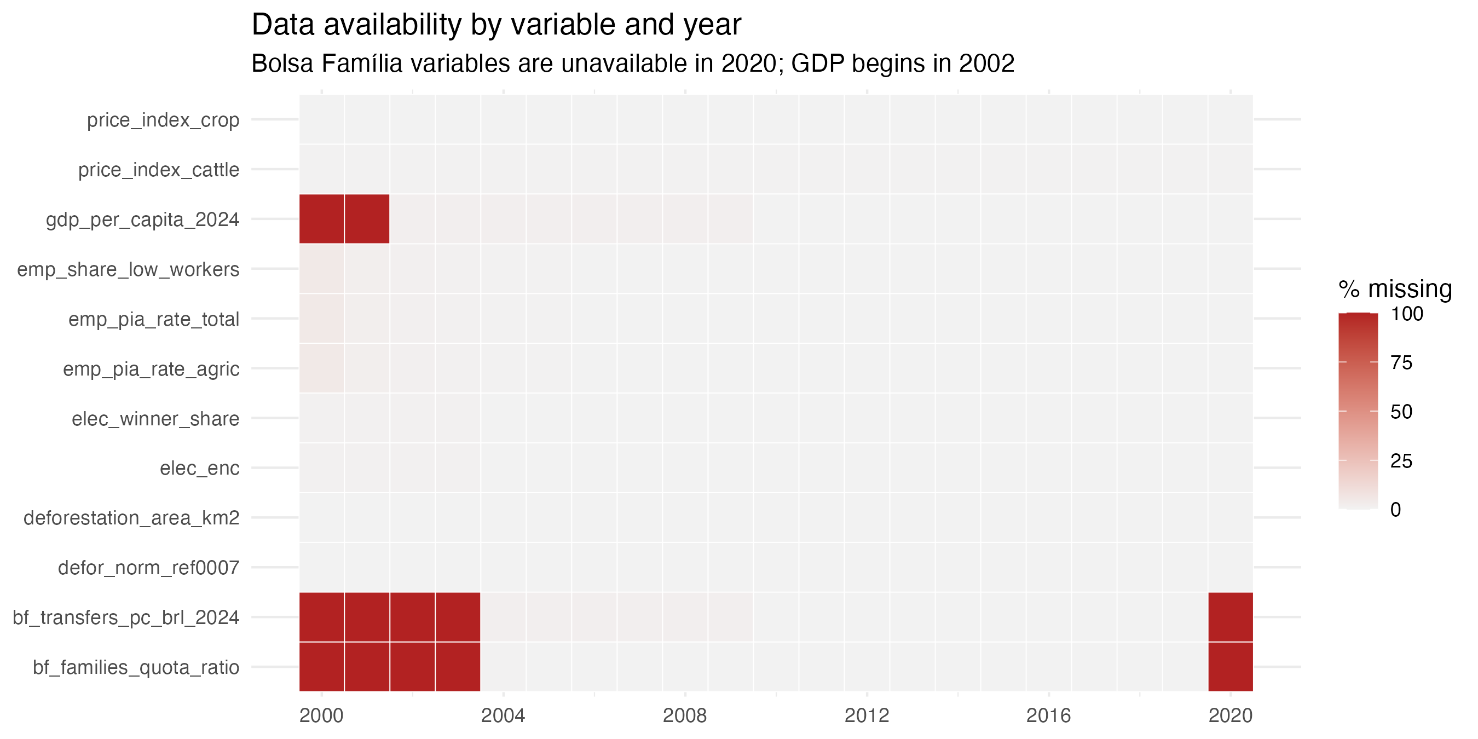
Figure 4.2: Availability of the main variables by year, 2000-2020
Two gaps define the analytic period. GDP per capita begins in 2002, so analyses using it start there. The Bolsa Família variables begin in 2004, when the program consolidated the prior transfer programs, and they are entirely missing in 2020. That is because 2020 Bolsa Família data is problematic due to the change of benefits to the Auxílio Emergencial program. The panel keeps the years 2000 and 2001 even though several variables start later, because the normalized outcome needs the full 2000 to 2007 baseline to be computed.

4.3.3 Samples
Not every municipality can inform the causal question. The normalized outcome divides by each municipality’s own baseline standard deviation, so municipalities that barely deforested in 2000 to 2007 produce explosive z-scores, which lead to the situation in which a trivial clearing episode becomes a huge standardized value. The analysis therefore uses an at-risk sample, municipalities that pass a forest-availability floor and a baseline-deforestation threshold. The narrow version, with 408 municipalities, is the primary sample for anything using defor_norm_ref0007. This is a functional-form necessity, not selection on the outcome, because the restriction is defined on the 2000 to 2007 baseline, before the treatment begins. All 61 municipalities that ever entered the priority list pass it, so no treated unit is lost. A broader forest-floor sample (500 municipalities) is retained for descriptive analyses that use the rate outcome, where the z-score problem does not arise.

4.3.4 Methodological overview
The treatment of the causal design is entry to the Priority Municipalities List. Municipalities entered in waves: 36 in 2008, 7 in 2009, 6 in 2011, 2 in 2012, and a later re-listing round in 2017 and 2018. Treatment timing varies across municipalities, which rules out the simplest designs. A single before-and-after comparison has no untreated benchmark. A two-way fixed effects regression with one treatment dummy seems natural, but with staggered timing and effects that change over time it does something subtle and wrong: it uses already-listed municipalities as controls for later entrants. If the effect of listing grows or fades with time since entry, these comparisons contaminate the estimate. This problem is now well documented in the difference-in-differences literature (Callaway and Sant’Anna 2021; Cunningham 2021).
The estimator of Callaway and Sant’Anna (2021) is built for exactly this structure. It estimates a separate treatment effect for each entry cohort in each year, comparing each cohort only to municipalities not yet listed or never listed. These clean group-time effects are then aggregated into one average treatment effect on the treated (ATT). Nothing already treated ever enters the comparison group.
The identification strategy for the eco-social question rests on the quota ratio of Bolsa Família. The design asks whether the effect of listing differs between municipalities that entered the enforcement period with high Bolsa Família coverage and municipalities that entered with low coverage. This requires the moderator to be a stable municipal characteristic measured before treatment, not a variable that moves with the treatment itself. Section 4.6 develops the identification argument in full.

4.4 Exploratory data analysis
The exploratory analysis starts from the problem Figure 4.1 announced: the deforestation decline sits in the most crowded policy window of the period. This subsection shows the crowding in the data itself, then turns to the social-policy trajectory that motivates the chapter.
Figure 4.3 presents the main series in natural units, as small multiples. Aggregate deforestation across the 502 municipalities peaks near 33,000 km² in 2003 and 2004, falls by roughly two thirds to about 11,000 km² by 2010, stays there through 2012, and partially rebounds afterward. The other panels show what happened around it. Bolsa Família coverage jumps from about a third of the municipal quota in 2004 to above full coverage by 2006 and stays near 1.1 for the rest of the period. Formal employment rises steadily from 5 percent of the working-age population to about 13 percent by 2014. Both price indices climb during the deforestation decline, the crop index sharply from 2007.
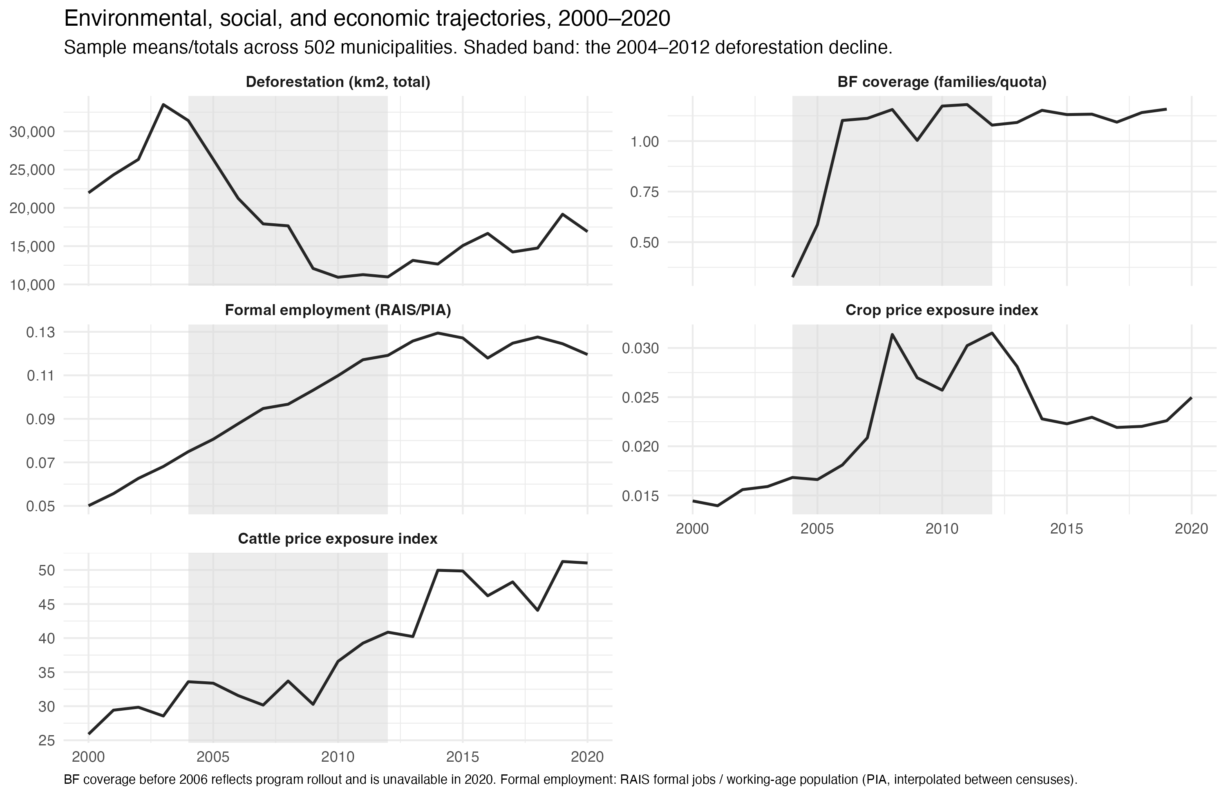
Figure 4.3: Main series in natural units, 502 municipalities, 2000-2020
Figure 4.4 then puts each family of candidate explanations against the deforestation curve directly, with all series indexed and deforestation repeated in every panel as the reference line. Each panel carries a different lesson. Panel A shows economic activity. GDP per capita, crop area, and cattle density all grow through the decline, so production expanded while clearing collapsed. The frontier economy did not shrink its way to lower deforestation. Panel B is the sharpest fact in the figure. Crop prices surged exactly during the years deforestation fell fastest. Clearing declined against price pressure, which is the strongest descriptive argument that policy did real work in this period, and also the reason price exposure must be controlled in any estimate. Panel C shows the formal wage structure. The low-wage employment rate falls closely with deforestation inside the shaded band. Panel D shows Bolsa Família coverage, indexed to 2006. Coverage saturates just before the first priority-list cohort in 2008 and then barely moves. That flatness matters for the design. By the time enforcement arrived, coverage differences across municipalities were a standing characteristic, not a trend, which is why the chapter uses coverage as a cross-sectional moderator rather than a time-varying regressor.
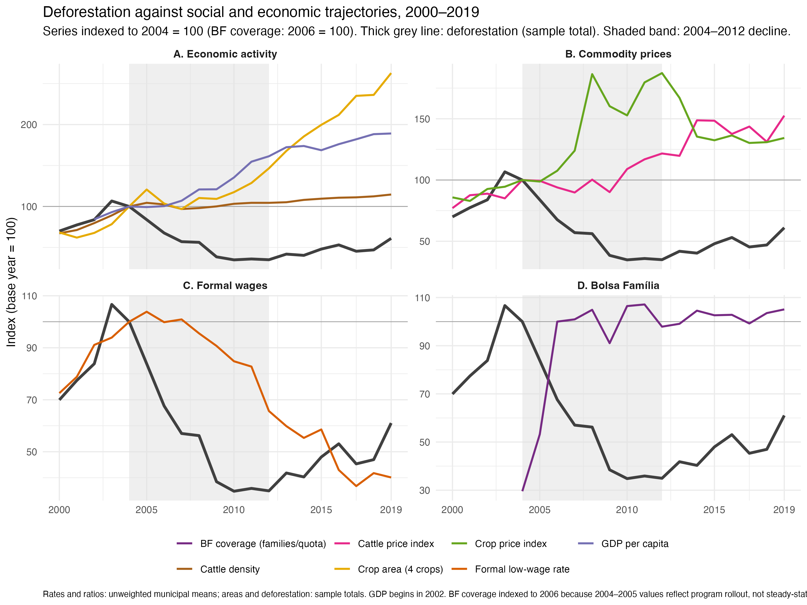
Figure 4.4: Candidate explanations against the deforestation curve, indexed series by group
The joint lesson of the two figures is the one the identification section builds on. Every candidate moved during 2004 to 2012: enforcement, credit policy, supply-chain agreements, prices, transfers, wages, formalization. Aggregate curves cannot separate them. The co-movement motivates the question and rules out answering it at this level, so the analysis moves to municipal variation, where listing arrived in staggered cohorts and coverage differed across places.

4.4.1 The period in numbers
Table 4.1 gives the periodization in municipal averages. The five windows follow the chapter’s reading of the trajectory: the years before the policy turn, the decline, the plateau of the early 2010s, and the two halves of the rise. Deforestation per municipality fell by half between the first and the third window, from about 53 to 25 km² a year, and then climbed back to 32 km² in 2017 to 2020. Measured against the forest that remained, clearing halved as well, from 3.4 percent of the standing forest a year to 1.7 percent, and did not rebound in that metric, because the forest base kept shrinking while the rebound in area was partial.
Table 4.1: Municipal averages by period, 502 municipalities of the Amazon biome (unweighted means of municipality-years, monetary values in R$ of 2024)
variable | 2000-2003 | 2004-2007 | 2008-2012 | 2013-2016 | 2017-2020
Deforestation (km2) | 52.844 | 48.254 | 25.068 | 28.649 | 32.396
Deforestation (share of remaining forest) | 3.392 | 2.633 | 1.785 | 1.781 | 1.714
BF coverage (families / quota) |  | 0.782 | 1.118 | 1.127 | 1.131
BF transfers per capita (R$ 2024) |  | 12.140 | 26.386 | 41.242 | 39.864
Formal employment (jobs / working-age pop.) | 0.059 | 0.085 | 0.109 | 0.125 | 0.124
Share of formal workers at or below 1 MW | 0.673 | 0.598 | 0.407 | 0.234 | 0.165
GDP per capita (R$ 2024) | 12,128 | 13,904 | 18,975 | 23,622 | 26,715
Land-based share of value added | 0.284 | 0.261 | 0.253 | 0.265 | 0.240
Municipal spending per capita, total (R$ 2024) | 1,855 | 2,288 | 3,302 | 3,736 | 4,050
Municipal social spending per capita (R$ 2024) | 993 | 1,287 | 1,946 | 2,356 | 2,549
Health | 336 | 462 | 681 | 795 | 931
Education | 587 | 745 | 1,150 | 1,424 | 1,468
Social assistance | 69 | 80 | 115 | 137 | 150
FPM per capita (R$ 2024) | 653 | 788 | 1,033 | 1,105 | 1,090
SUS transfers per capita (R$ 2024) | 112 | 182 | 285 | 300 | 397
FUNDEB per capita (R$ 2024) | 334 | 452 | 780 | 956 | 1,017
Cattle per km2 | 27.334 | 35.911 | 36.301 | 38.536 | 40.559
Crop price exposure index | 0.015 | 0.018 | 0.029 | 0.024 | 0.023

The social columns move in one direction through the whole period. Bolsa Família coverage goes from 78 percent of the municipal quota in the rollout window to 112 percent in the decline window and stays there. Transfers per capita more than triple between the rollout and the early 2010s and then hold near R$ 40 a month per resident. Formal employment doubles, from 5.9 to 12.4 jobs per hundred working-age adults, and the share of formal workers earning the 2024 minimum wage or less falls from two thirds to one sixth. GDP per capita more than doubles. Municipal social spending per capita, the sum of the health, education and social assistance functions, goes from R$ 993 to R$ 2,549 at 2024 prices, with education the largest function throughout and health the fastest growing after 2016. The transfers that fund this spending grew in step: FPM per capita rose by two thirds, the SUS transfers more than tripled, and FUNDEB tripled. The land-based share of value added, agriculture, livestock, forestry and fishing together, drifted down from 28 to 24 percent.
The last column of the table that matters for the design is not in it but in Table 4.2, which splits the variance of each series into its between-municipality and within-municipality parts. The split says what kind of variation each variable offers an estimator. Deforestation, coverage, formal employment, land-based dependence and cattle density are mostly between-municipality characteristics, with 70 to 96 percent of their variance across places rather than over time. Social spending per capita is the opposite: 60 percent of its variance is within municipalities, because every municipality’s spending grew, and SUS transfers are 80 percent within for the same reason. A fixed-effects regression on spending therefore leans on the common growth path, while one on coverage leans on a cross-sectional difference that barely moves after 2006. This is the empirical reason the correlational exercise of Section 4.5 reports spending and coverage separately and reads both as conditional correlations.
Table 4.2: Between and within shares of the variance of each series, 2002-2020 (percent of the total sum of squares, between on the municipal means around the grand mean, within on the deviations from the own municipal mean)
Variable | Between (%) | Within (%) | Observations | Municipalities
Deforestation (km2) | 70.1 | 29.9 | 9,538 | 502
Deforestation (share of remaining forest) | 62.5 | 37.5 | 9,538 | 502
BF coverage (families / quota) | 71.0 | 29.0 | 8,028 | 502
BF transfers per capita (R$ 2024) | 39.4 | 60.6 | 7,978 | 502
Formal employment (jobs / working-age pop.) | 78.3 | 21.7 | 9,522 | 502
Share of formal workers at or below 1 MW | 22.4 | 77.6 | 9,522 | 502
GDP per capita (R$ 2024) | 65.9 | 34.1 | 9,466 | 502
Land-based share of value added | 82.8 | 17.2 | 9,532 | 502
Municipal spending per capita, total (R$ 2024) | 56.7 | 43.3 | 8,612 | 502
Municipal social spending per capita (R$ 2024) | 40.4 | 59.6 | 8,612 | 502
Health | 48.8 | 51.2 | 8,612 | 502
Education | 39.0 | 61.0 | 8,612 | 502
Social assistance | 56.5 | 43.5 | 8,612 | 502
FPM per capita (R$ 2024) | 81.8 | 18.2 | 8,625 | 502
SUS transfers per capita (R$ 2024) | 19.6 | 80.4 | 8,625 | 502
FUNDEB per capita (R$ 2024) | 40.8 | 59.2 | 8,625 | 502
Cattle per km2 | 96.1 | 3.9 | 9,532 | 502
Crop price exposure index | 95.1 | 4.9 | 9,519 | 501

4.4.2 Social policy, social spending and deforestation, 2004-2020
Figure 4.5 puts the social series the supervisor asked for next to the deforestation curve, year by year, in natural units. The deforestation panel is the one from Figure 4.3, restricted to the Bolsa Família years. Every other panel rises while it falls. Coverage saturates by 2006. Transfers per capita climb without pause from R$ 7 in 2004 to R$ 45 in 2014, then settle near R$ 40. Formal employment rises from 7.5 to 12.9 jobs per hundred working-age adults by 2014 and softens afterward. GDP per capita grows through the whole window. Municipal social spending per capita grows fastest in the decline years, from R$ 1,073 in 2004 to R$ 2,287 in 2012, and then stalls for five years between R$ 2,300 and R$ 2,460 before rising again from 2018. The 2020 jump in health spending is the pandemic year.
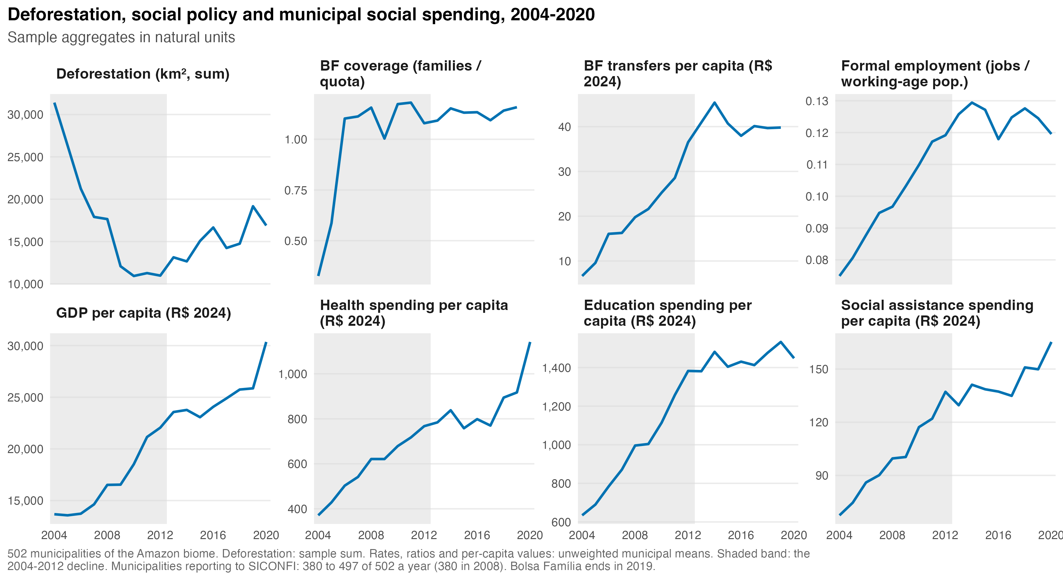
Figure 4.5: Deforestation, social policy and municipal social spending, sample aggregates, 2004-2020
Figure 4.6 overlays each family of series on the deforestation curve with everything indexed to 2004. Two timings stand out. The first is that the decline ends in 2012, the same year municipal social spending stops growing, and the rebound begins in 2013, when transfers per capita and formal employment reach their peaks and start to erode. The second is the asymmetry between the two halves of the window. During the decline, every social series rose steeply. During the rise, the social series were flat or falling, and the only series still climbing is GDP per capita. The decline coincided with social expansion, and the rise coincided with social stagnation. That is the pattern the chapter’s hypothesis predicts, and aggregate curves cannot, on their own, distinguish it from the many other things that changed after 2012.
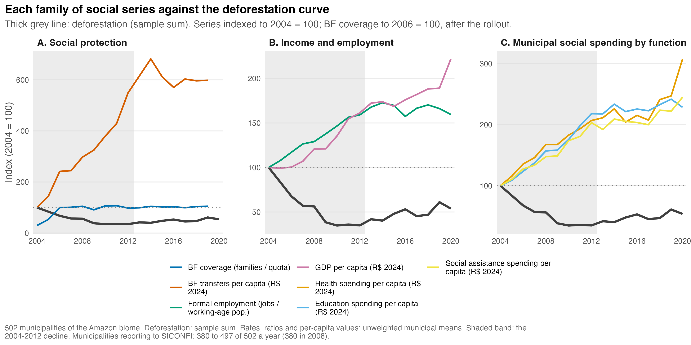
Figure 4.6: Each family of social series against the deforestation curve, indexed to 2004 = 100
Who pays for the municipal spending is the question Figure 4.7 answers. Panel A stacks the revenue sources per capita of the average sample municipality. Own revenue is a thin layer at the bottom, 8 percent of current revenue in 2004 and 9 percent in 2020. The rest is federal money: the unconditioned FPM quota, and the conditioned transfers that follow the social functions, the SUS transfers for health, FUNDEB and the other FNDE lines for education, and FNAS for social assistance, in the classification of Alcaraz (2024) . Panel B puts the conditioned transfers against the social spending they fund. The two lines move together, and the conditioned transfers cover a growing share of social spending, 53 percent in 2004, 59 percent in 2012 and 62 percent in 2020. FPM, by contrast, stops growing in 2011. The social spending that rose during the decline was, to a large extent, federal spending executed by municipalities, and the municipal fiscal base is as dependent on Brasília as the social protection the chapter studies. This matters for the interpretation of any municipal spending variable: it measures how much federal social policy reached a place, through two channels, not how much the place chose to spend.
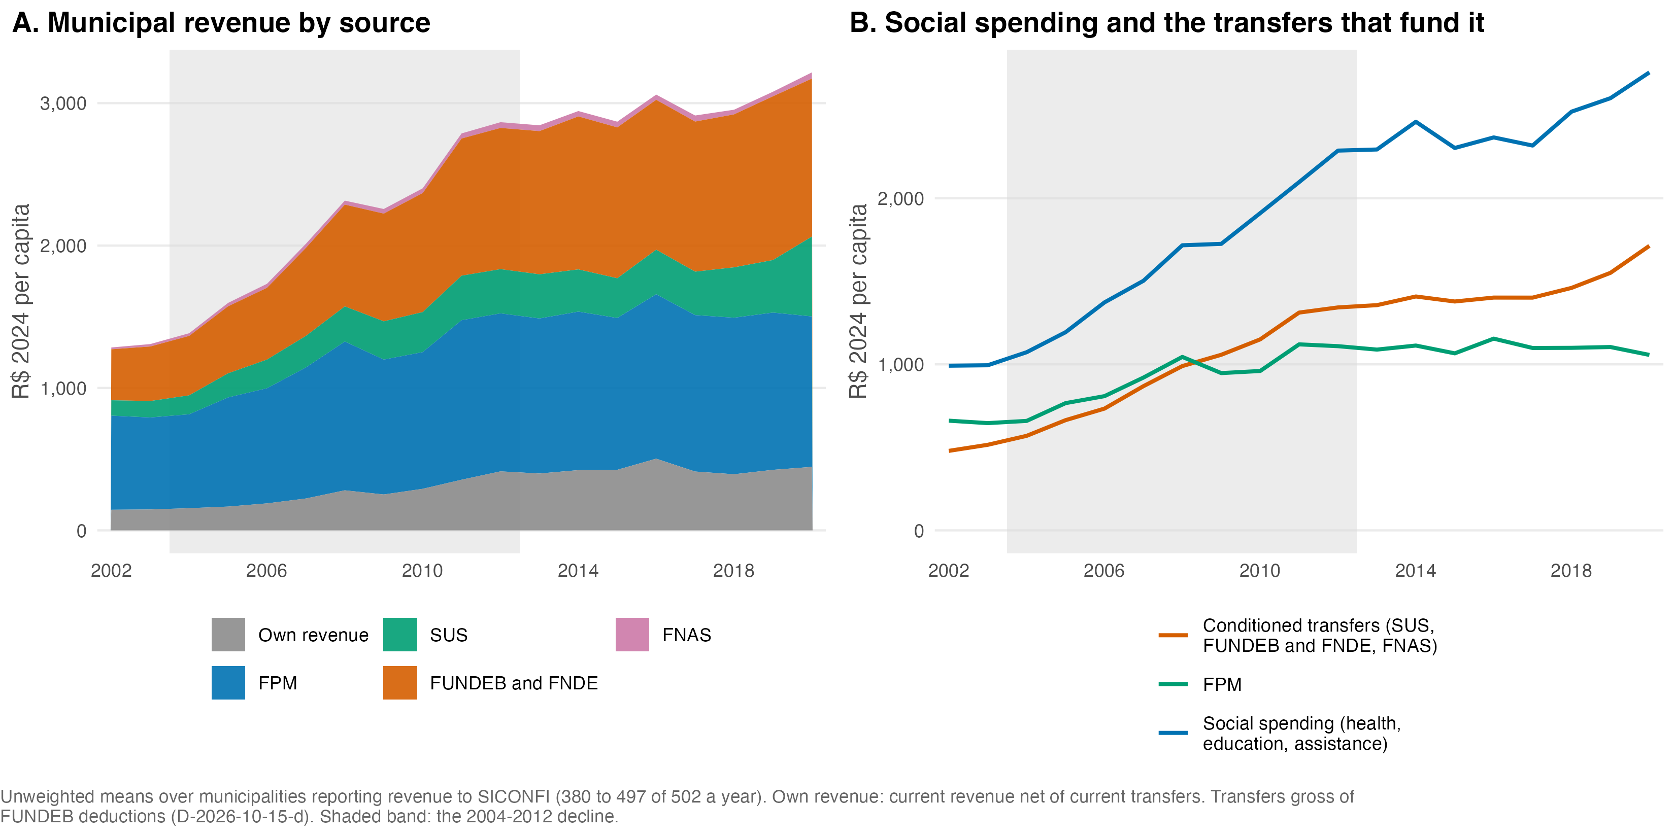
Figure 4.7: Municipal revenue by source and the transfers that fund social spending, sample means, 2002-2020

4.4.3 States and municipalities
The federal structure means social spending reaches the same territory through two subnational governments. Figure 4.8 compares them for the nine states of the Legal Amazon: the state government’s social spending per capita, the aggregate of all its municipalities per capita, and the deforestation of the sample municipalities in the state. The state series starts in 2013 because the consolidated state accounts in Base dos Dados begin there, so the comparison covers the rise, not the decline. Two configurations appear. In the three small states, Acre, Amapá and Roraima, the state government spends two to three times more per resident than the municipalities together, between R$ 3,650 and R$ 3,980 against R$ 1,560 to R$ 2,080, and the municipalities execute about 30 percent of subnational social spending (Table 4.3). In Maranhão, Pará and Mato Grosso, the states that hold most of the sample’s deforestation, the relation is inverted: the municipalities spend more per resident than the state, and carry 58 to 68 percent of subnational social spending. Amazonas, Rondônia and Tocantins sit between. In all nine states the municipal share rose between 2013 and 2024, by five to twelve points, so the trend toward municipal execution continued through the rise in deforestation.
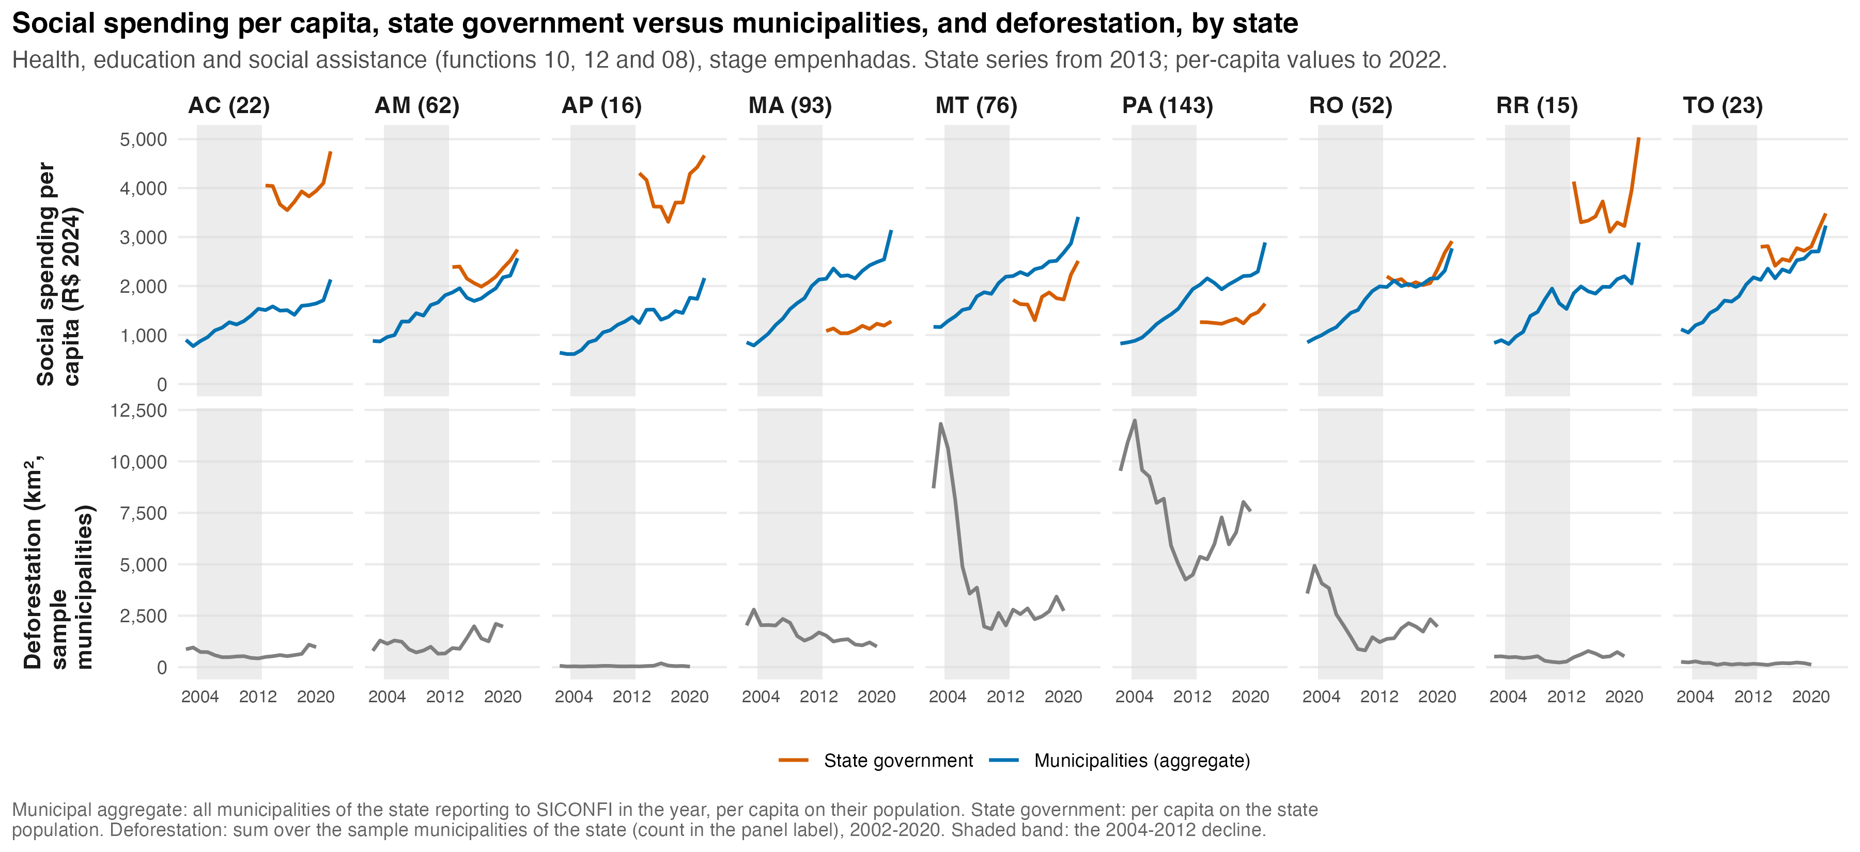
Figure 4.8: Social spending per capita, state government versus municipalities, and deforestation, by state, 2002-2024

Table 4.3: Municipal share of subnational social spending and per-capita levels by state, 2013-2024 (health, education and social assistance, shares on spending in R$ of 2024, per-capita means over 2013-2022)
State | Municipal share 2013 | Municipal share 2024 | Mean share 2013-24 | State gov. per capita | Municipalities per capita
AC | 0.268 | 0.311 | 0.291 | 3,958 | 1,620
AM | 0.434 | 0.523 | 0.468 | 2,288 | 1,980
AP | 0.212 | 0.325 | 0.277 | 3,982 | 1,556
MA | 0.651 | 0.707 | 0.677 | 1,140 | 2,399
MT | 0.556 | 0.588 | 0.582 | 1,814 | 2,541
PA | 0.599 | 0.624 | 0.614 | 1,336 | 2,193
RO | 0.474 | 0.495 | 0.488 | 2,255 | 2,155
RR | 0.294 | 0.388 | 0.360 | 3,654 | 2,083
TO | 0.426 | 0.475 | 0.467 | 2,802 | 2,499

The deforestation row of the figure is a reminder of where the outcome lives. Mato Grosso and Pará each cleared 9,000 to 12,000 km² a year in the sample municipalities in 2004, fell to 2,000 to 4,000 by 2010 to 2012, and Pará climbed back above 7,000 in 2019 to 2020. Rondônia followed the same path at a smaller scale. The other six states contribute little to the area totals, and the biome part of Maranhão and Tocantins is small, which is why the sample counts in the panel labels differ from the states’ municipal counts. The comparison of state and municipal spending is therefore informative about the fiscal structure, but the within-state co-movement of spending and deforestation is visible only in the three frontier states.

4.4.4 The social-policy trajectory in the sample
The two social series deserve a closer look, because their shapes carry design information.
Figure 4.9 breaks Bolsa Família into its components for 2004 to 2019. The coverage panel repeats the rollout-then-saturation shape, showing above full quota coverage by 2006 and stable around 1.1 afterward. The transfer panels show a different rhythm. Total transfers grow through 2014, peak near R$ 700 million a month at 2024 prices (the June disbursement summed over the sample), and then fall back and stabilize. The average transfer per family declines during rollout, when many families entered at the margin of cash transfers (Souza and Bruce 2022), then rises to a peak around R$ 340 in 2014 and erodes after 2016. Per-capita transfers follow the same arc. One fact in this figure does design work. After 2006, the program’s reach relative to need is essentially flat over time, so the variation the chapter can use is the persistent difference between municipalities, which is what the moderator captures at its 2006 to 2007 baseline.
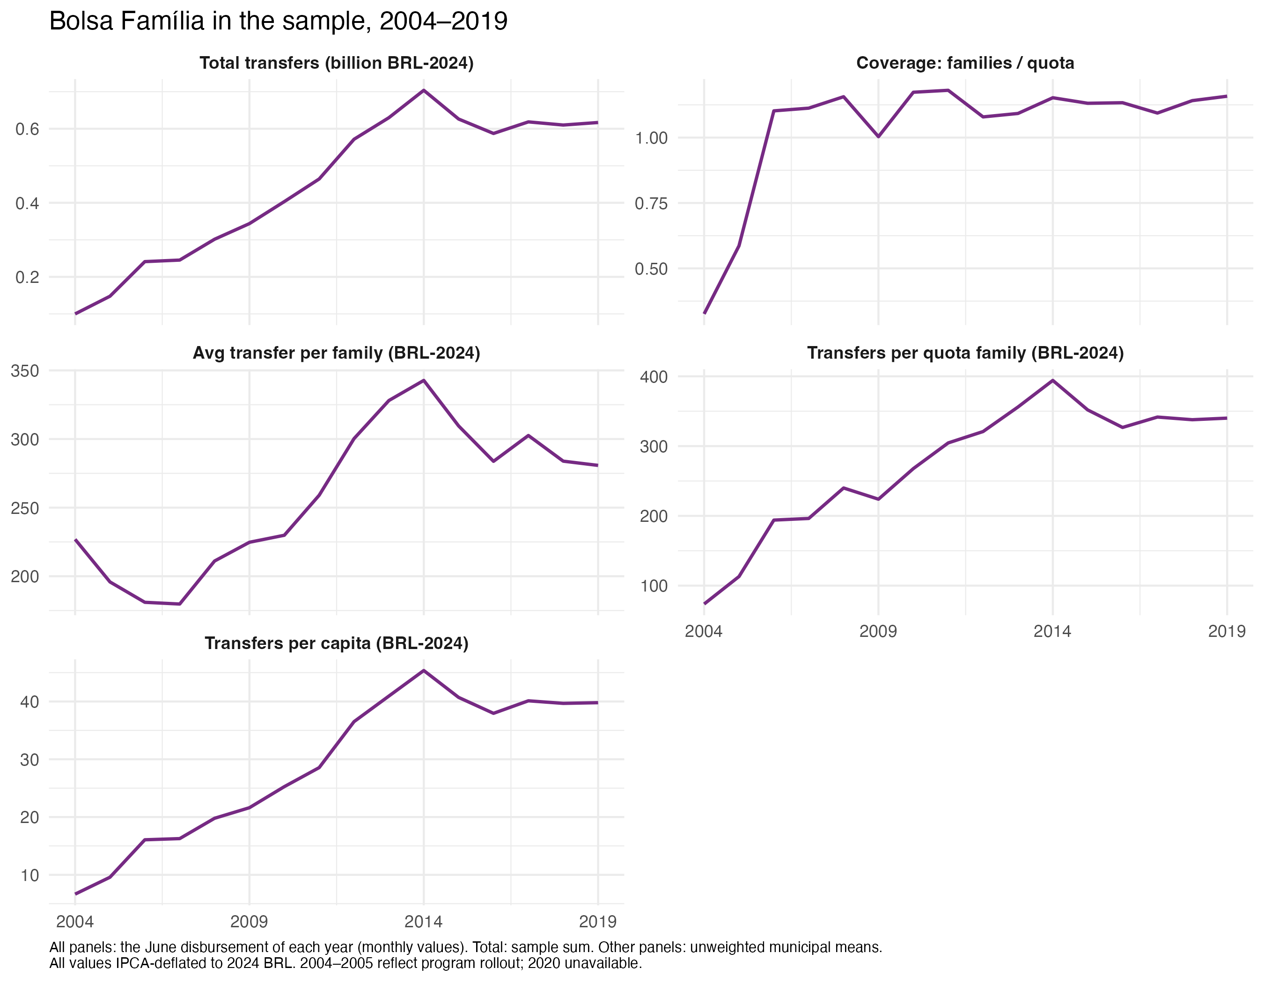
Figure 4.9: Bolsa Família components in the sample, 2004-2019
Figure 4.10 shows the labor-market side, the trajectory behind Mechanism 4 and H3. Panel A plots formal jobs per working-age adult by wage group, with the groups defined by fixed real thresholds. The middle group, between one and four times the 2024 minimum wage, rises from about 1.6 percent of the working-age population to about 10 percent, overtaking the low group around 2006. The low group, at or below one 2024 minimum wage, peaks near 4.5 percent in 2005 and falls to under 2 percent. Panel B shows the consequence for composition. Workers at or below the 2024 minimum fall from about two thirds of formal employment in 2000 to under a fifth by 2017. Because the thresholds are fixed in real terms, this migration across groups measures real wage growth in the formal sector, together with turnover and compositional change. It is the clearest picture in the data of labor-market incorporation reaching the Amazon during the enforcement period.
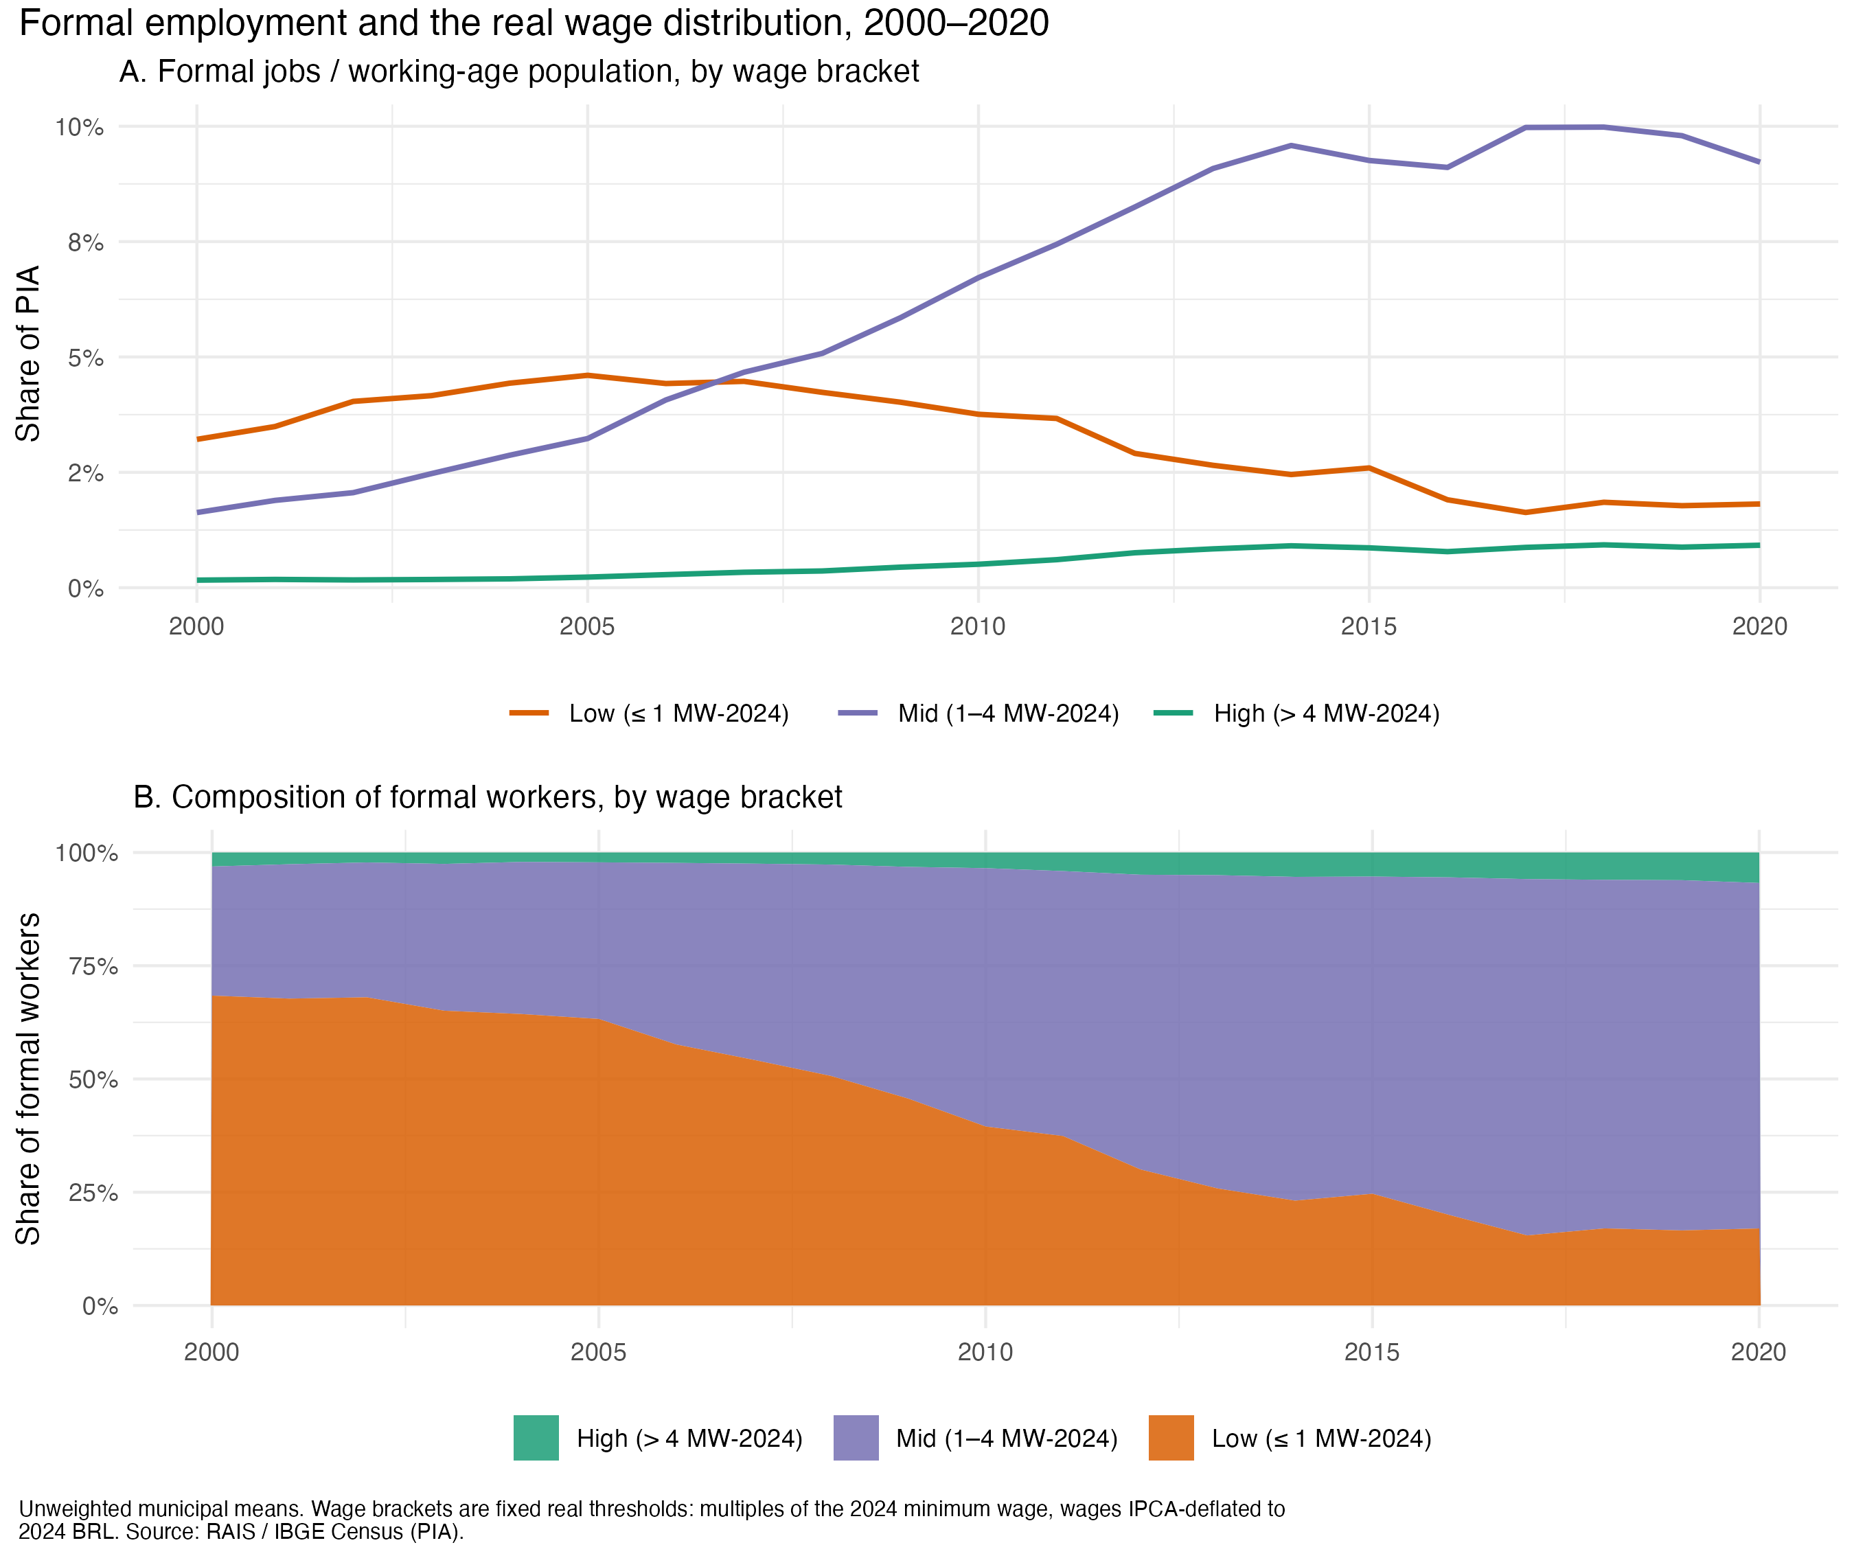
Figure 4.10: Formal employment by real wage group, 2000-2020
Together, the two trajectories are the empirical face of the claim Chapter 2 made historically. Social policy reached the frontier and embedded there. Transfers saturated their quotas within three years, and formal wage growth transformed the composition of employment. Environmental enforcement, arriving in 2008 in selected municipalities, met a frontier where this incorporation was already underway. Whether that mattered for enforcement’s effect is the chapter’s question, and the next subsections turn from trajectories to the treatment itself: which municipalities were listed, how they compare to the rest, and whether the coverage moderator is credible.

4.4.5 Land-based dependence and urbanization
Before comparing listed and unlisted municipalities it helps to know what kinds of places the sample contains. Two structural dimensions matter for the argument: how much of the local economy rests on land, and how urban the population is. Figure 4.11 shows both. Panel A gives the share of agriculture, livestock, forestry and fishing in municipal value added, averaged over 2004 to 2007 and over 2017 to 2020. The median municipality drew 26 percent of its value added from land in the first window and 21 percent in the second, and the whole distribution shifted left, so the frontier became less land-dependent over the period in its own accounts, even where clearing rebounded. Panel B gives the urban population share of the 2000 and 2010 censuses. The median rose from 46 to 53 percent, and the count of municipalities with a rural majority fell from 289 to 215, while those between half and three quarters urban rose from 143 to 208. The census definition of urban is administrative, since municipalities draw their own urban perimeters, so these shares can overstate urbanization and the chapter treats them as a coarse classification. Panel C plots the two dimensions against each other: they are negatively related but far from collinear, and the listed municipalities sit in the middle of the cloud rather than at its land-dependent, rural corner.
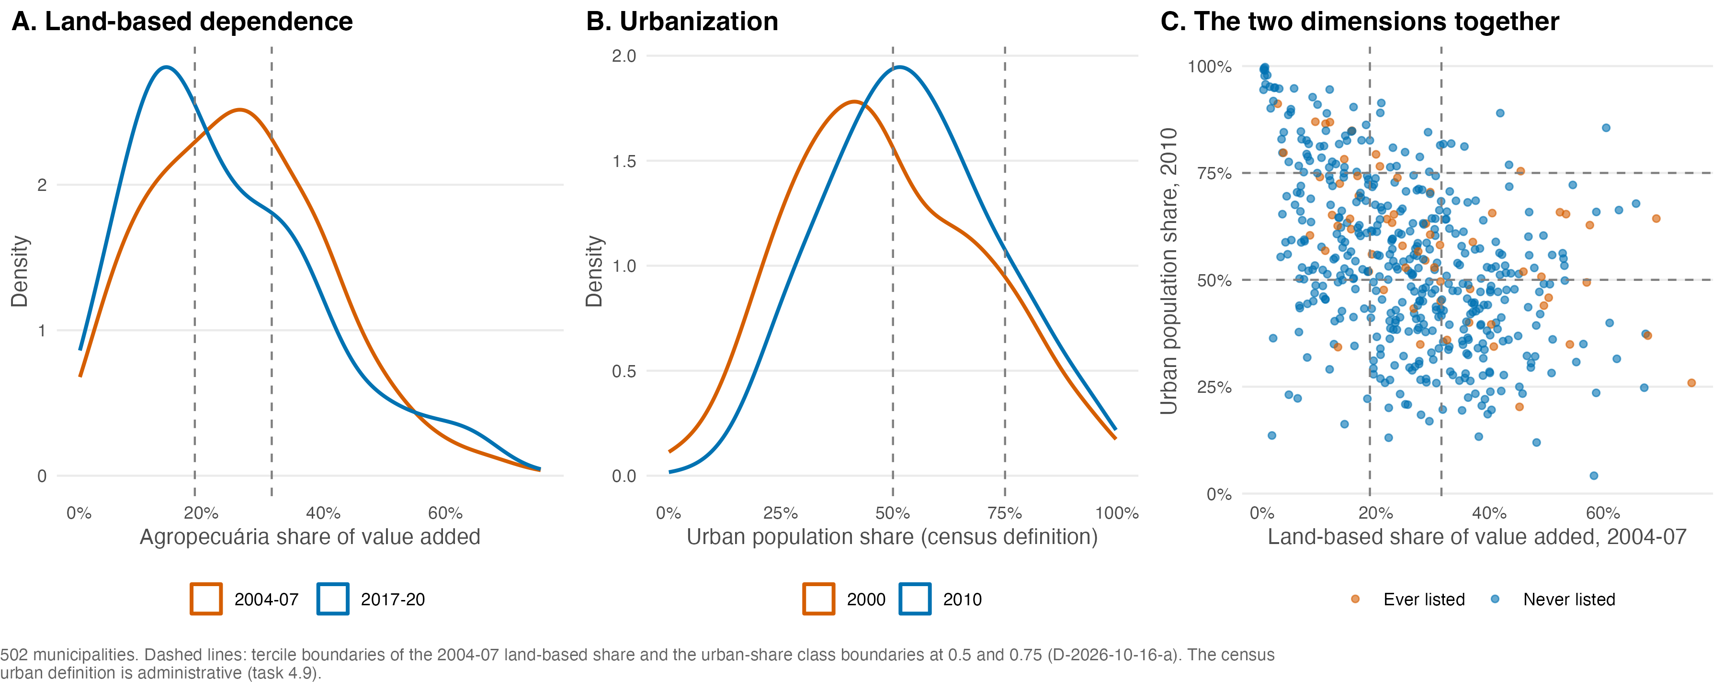
Figure 4.11: Land-based dependence and urbanization in the sample: distributions and their joint position
Figure 4.12 places the two dimensions on the map. Land-based dependence concentrates in the arc of deforestation, from Rondônia through northern Mato Grosso to southern and eastern Pará, and in the Maranhão and Tocantins fringe, while the municipalities of the central and western Amazon, large, forested and sparsely populated, draw little of their value added from land. Urbanization has no such arc: the most urban municipalities are the state capitals and the mid-sized towns of the Belém-Brasília and Cuiabá-Santarém axes, with rural majorities spread across the interior of every state.
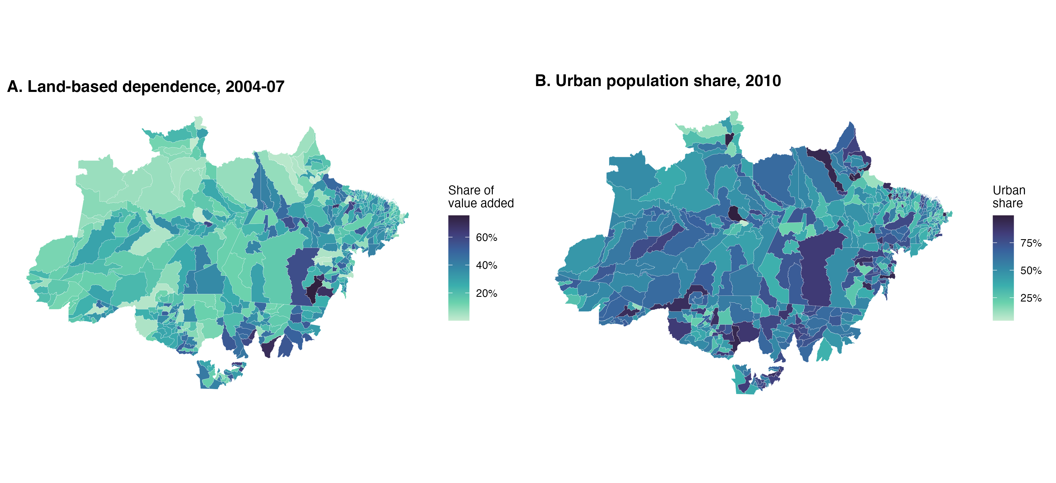
Figure 4.12: Land-based share of value added (2004-07) and urban population share (2010), 502 municipalities
Table 4.4 crosses the two classifications. The largest cell, 108 municipalities, is land-dependent and rural, and the smallest, 7 municipalities, is land-dependent and urban, so the correlation is real. But listing did not pick the land-dependent rural corner: the 61 listed municipalities spread over seven of the nine cells, with the largest counts in the intermediate urban class, 14 in the middle land tercile and 11 in the low tercile. Poverty in 2010 falls monotonically with urbanization within every land tercile, from about half of the population in the rural cells to between 14 and 32 percent in the urban cells, and baseline social spending per capita is highest in the land-dependent cells. The places with the most land in their economy were, at the start of the enforcement period, also the places with the most municipal social spending per resident.
Table 4.4: Municipalities by land-based dependence tercile (2004-07) and urban class (2010 census), with the count ever listed, the 2010 poverty rate and baseline social spending per capita (R$ of 2024)
Land-based tercile | Urban class | Municipalities | Ever listed | Poverty 2010 | Social spending p.c. 2004-07
Low | Rural (urban share below 0.5) | 30 | 1 | 0.530 | 1,242
Low | Intermediate (0.5 to 0.75) | 78 | 11 | 0.386 | 1,237
Low | Urban (0.75 and above) | 60 | 7 | 0.208 | 1,165
Middle | Rural (urban share below 0.5) | 77 | 5 | 0.501 | 1,223
Middle | Intermediate (0.5 to 0.75) | 78 | 14 | 0.377 | 1,252
Middle | Urban (0.75 and above) | 12 | 2 | 0.317 | 1,187
High | Rural (urban share below 0.5) | 108 | 12 | 0.439 | 1,311
High | Intermediate (0.5 to 0.75) | 52 | 8 | 0.288 | 1,568
High | Urban (0.75 and above) | 7 | 1 | 0.144 | 1,597

4.4.6 Trajectories by group
Table 4.5 compares the listed and never-listed municipalities on the baseline window 2004 to 2007, before the first cohort entered the list. The listed municipalities were the frontier: they cleared 208 km² a year on average against 26 for the rest, eight times more, although as a share of their remaining forest they cleared at the same rate, 2.6 percent, because they also had more forest. They were richer and more formalized, with GDP per capita of R$ 20,165 against R$ 13,036 and 13 formal jobs per hundred working-age adults against 8, and their formal wages were higher, with 49 percent of workers at or below the 2024 minimum against 61 percent. Bolsa Família reached them differently: coverage relative to the quota was slightly higher, 0.84 against 0.77, while transfers per capita were lower, R$ 8 against R$ 13, because transfers follow poverty and the listed municipalities were less poor. Municipal social spending per capita was similar, R$ 1,377 against R$ 1,274. Cattle density was lower in the listed group, 24 against 38 head per km², which reflects the size of the listed municipalities rather than the size of their herds.
Table 4.5: Baseline means, 2004-2007, by listing status (ever listed on the priority list versus never listed, monetary values in R$ of 2024)
variable | Ever listed | Never listed | All
Deforestation (km2) | 208 | 26 | 48
Deforestation (share of remaining forest) | 2.591 | 2.638 | 2.633
BF coverage (families / quota) | 0.842 | 0.774 | 0.782
BF transfers per capita (R$ 2024) | 8.019 | 12.711 | 12.140
Formal employment (jobs / working-age pop.) | 0.130 | 0.078 | 0.085
Share of formal workers at or below 1 MW | 0.486 | 0.614 | 0.598
GDP per capita (R$ 2024) | 20,165 | 13,036 | 13,904
Land-based share of value added | 0.298 | 0.256 | 0.261
Municipal spending per capita, total (R$ 2024) | 2,480 | 2,260 | 2,288
Municipal social spending per capita (R$ 2024) | 1,377 | 1,274 | 1,287
Health | 517 | 454 | 462
Education | 782 | 740 | 745
Social assistance | 77.459 | 79.993 | 79.673
FPM per capita (R$ 2024) | 688 | 803 | 788
SUS transfers per capita (R$ 2024) | 179 | 182 | 182
FUNDEB per capita (R$ 2024) | 457 | 451 | 452
Cattle per km2 | 23.746 | 37.596 | 35.911
Crop price exposure index | 0.024 | 0.017 | 0.018

Figure 4.13 follows the two groups from 2004, with each series indexed to its own 2004 value. The listed municipalities cut deforestation faster and further: their index reaches 28 in 2010 while the never-listed group bottoms at 43, and the gap holds through 2014. By 2019 the two groups are back at the same point, around 60 percent of their 2004 clearing, so the rebound erased the listed group’s extra decline. The social series tell a different story. Formal employment grew by 48 percent in the listed group at its 2014 peak and by 79 percent in the rest. Social spending per capita grew less in the listed group, 111 percent by 2019 against 147 percent. Coverage of Bolsa Família in the listed municipalities drifts down from 1.21 in 2010 to 1.00 in 2019, while it holds near 1.18 elsewhere. Transfers per capita, by contrast, grew more in the listed group, as their poorer residents entered the program. The listed municipalities, in short, received the enforcement shock while their social incorporation ran behind the rest of the sample on employment, spending and coverage, and the social series flattened in both groups after 2014, in the years the listed group’s deforestation advantage disappeared.
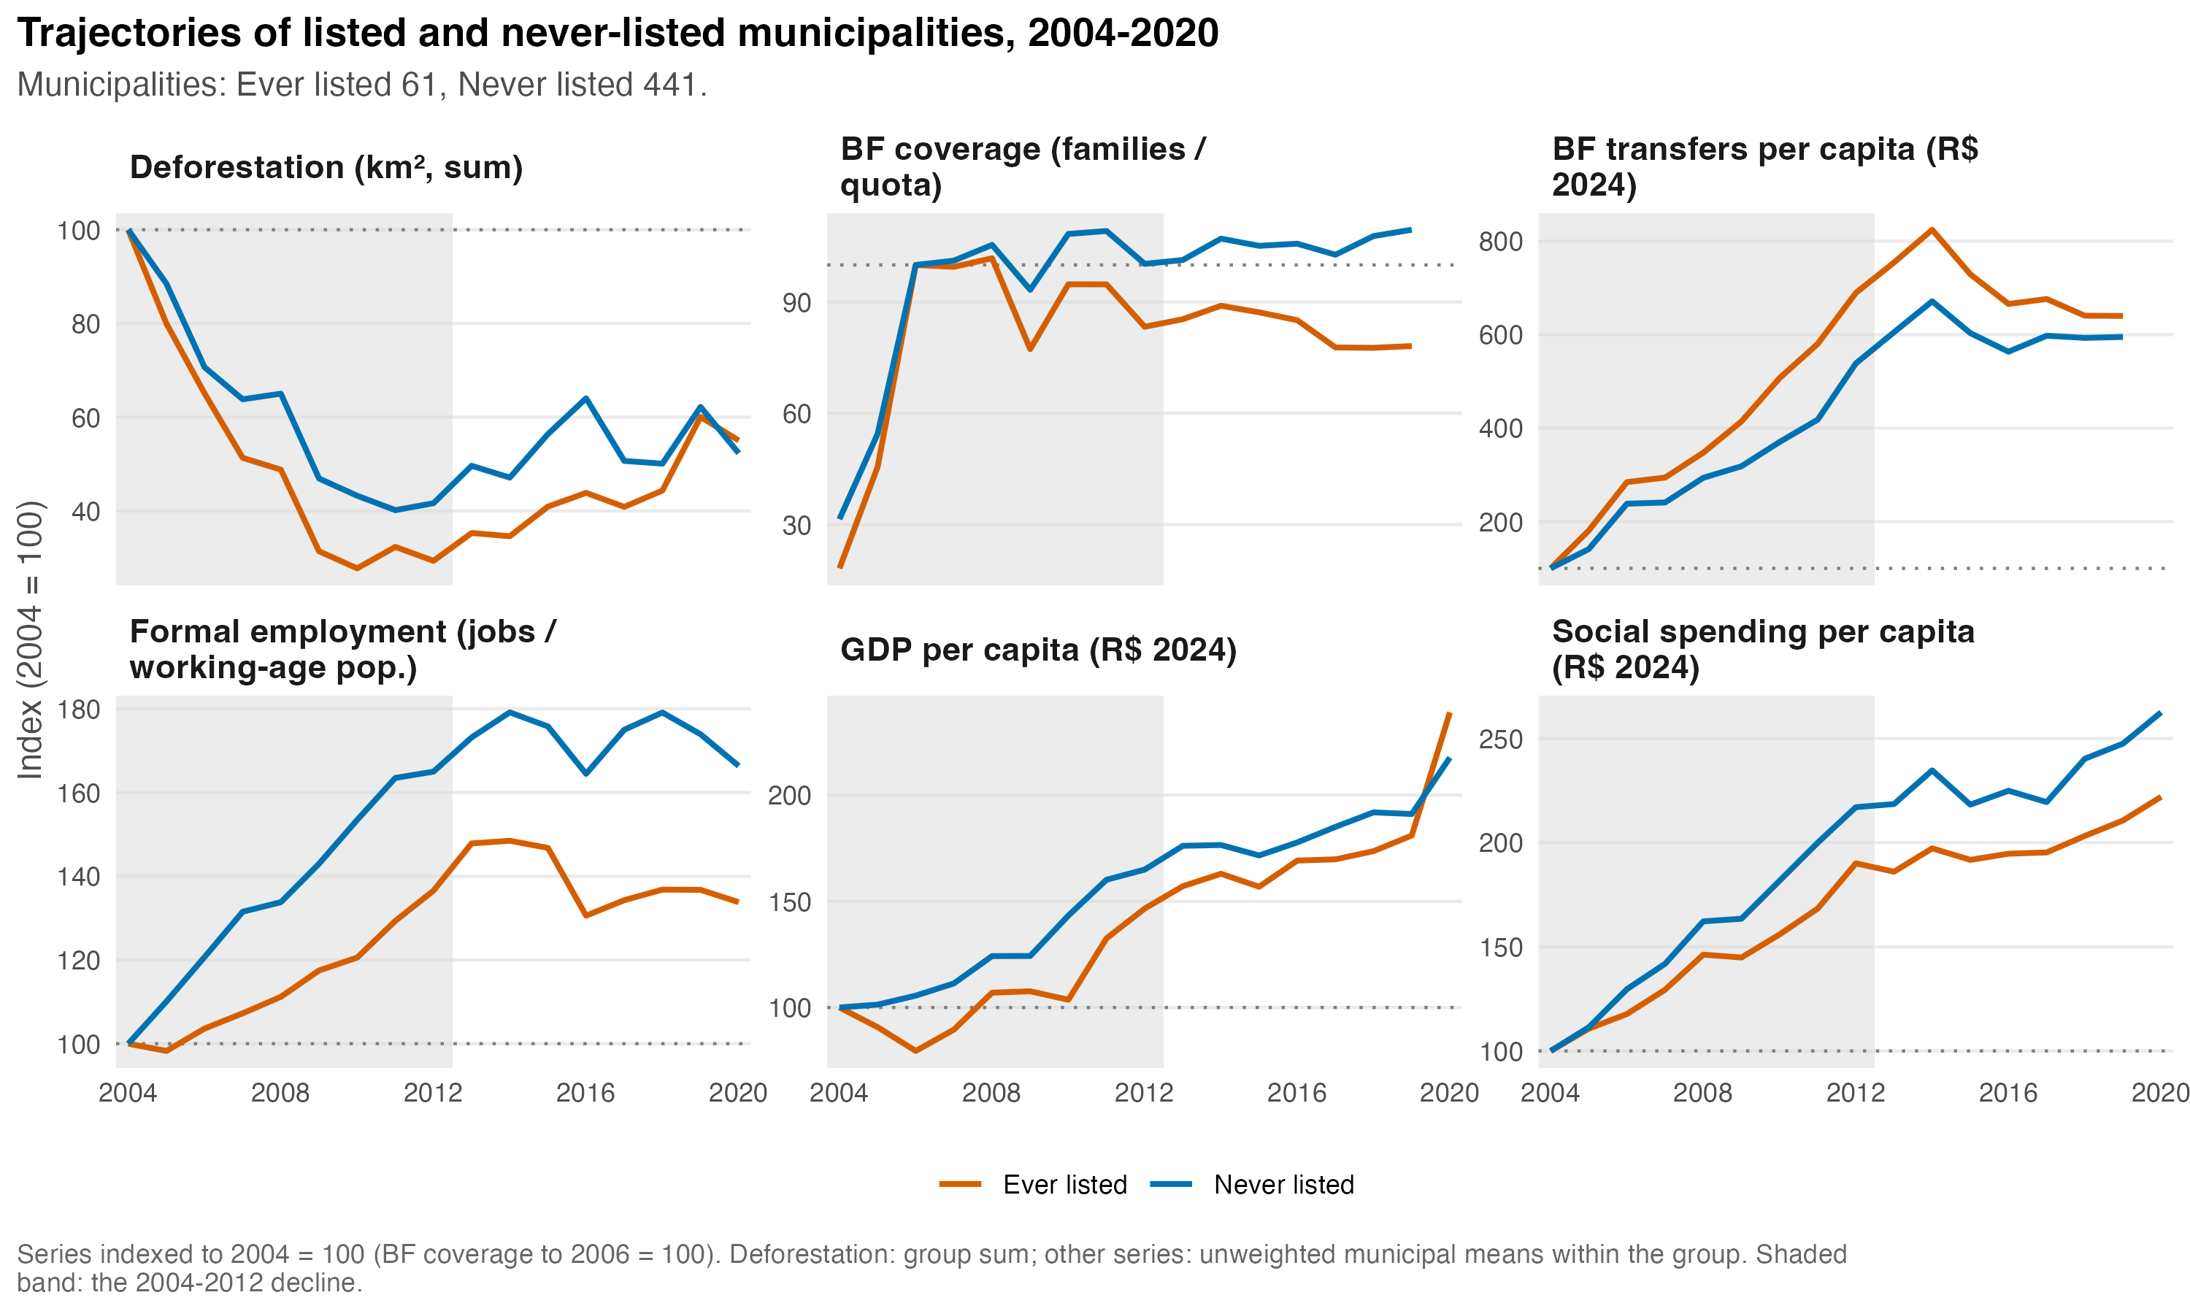
Figure 4.13: Trajectories of listed and never-listed municipalities, indexed to 2004 = 100
Figure 4.14 repeats the exercise for three baseline characteristics, splitting the sample into terciles of social spending per capita in 2004 to 2007, of the 2000 poverty rate, and of land-based dependence in 2004 to 2007. The first column carries the sharpest contrast in the figure. Municipalities in the top spending tercile cut deforestation to a quarter of its 2004 level by 2010 and were still at 35 percent in 2020, while the bottom tercile fell only to 44 percent by 2012 and rebounded to 78 percent by 2019. The spending series itself converged: the low tercile tripled its spending per capita by 2020 while the high tercile roughly doubled, so the places that spent least at the start caught up in spending and rebounded most in clearing. The poverty column shows the mirror image. The poorest tercile barely reduced deforestation at all, hovering between 60 and 100 percent of its 2004 level, but it was also the tercile with the least clearing to begin with, concentrated in Maranhão and the eastern fringe. The least poor tercile, where the frontier municipalities sit, fell to a quarter of its 2004 level and rebounded to 45 percent. Coverage of Bolsa Família falls in the least poor tercile after 2010, as its residents leave the program, and formal employment grew most in the poorest tercile, from a low base. The land-based column shows little difference during the decline and a smaller rebound for the most land-dependent tercile, which ends the period at 45 percent against 68 for the least dependent.
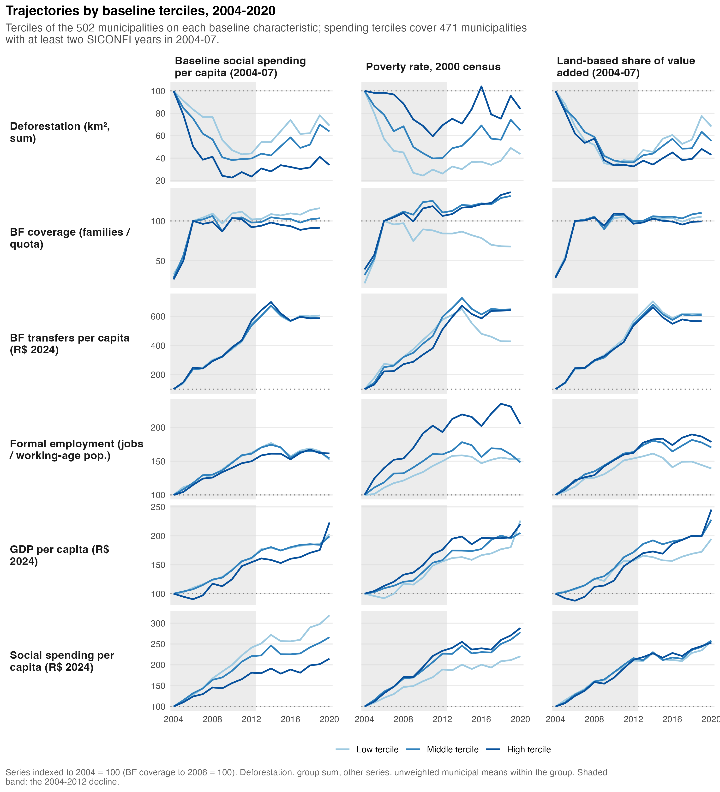
Figure 4.14: Trajectories by baseline terciles of social spending, poverty and land-based dependence, indexed to 2004 = 100
Two readings of the spending column are possible and the descriptive evidence cannot separate them. One is that higher social spending made the enforcement period more effective, which is the chapter’s hypothesis. The other is that the high-spending tercile is where the frontier municipalities with the most clearing to lose were concentrated, so their deeper decline is the enforcement effect itself, and the subsequent catch-up in spending elsewhere is the federal transfer system reaching the poorer interior. The baseline table above shows that the listed municipalities were not, on average, higher spenders, which weakens the second reading but does not dispose of it. Separating the two is the job of the identification section.

4.4.7 Long differences
A last descriptive step collapses the panel into one change per municipality. Figure 4.15 plots, in panel A, the change in municipal social spending per capita between 2004 to 2007 and 2017 to 2020 against the change in the logarithm of annual clearing between the same windows, for the 470 municipalities with at least two reported years in both windows. The relation is negative: municipalities where social spending per capita grew more saw larger declines in clearing, with a slope of −0.17 log points per thousand reais of additional spending per capita (standard error 0.05) and a correlation of −0.14 (Table 4.6). Panel B relates the change in the poverty rate between the 2000 and 2010 censuses to the change in clearing between the windows around them, and finds nothing: the slope is zero to three decimals and the correlation 0.01. Poverty fell everywhere, by 16 points on average, with no relation to how much clearing changed. The two panels make the same point as the group trajectories. The municipalities whose deforestation fell are distinguished by how much social spending reached them, and poverty reduction does not distinguish them. The long difference is a cross-sectional association, and the fixed-effects exercise of Section 4.5 takes it up with controls.
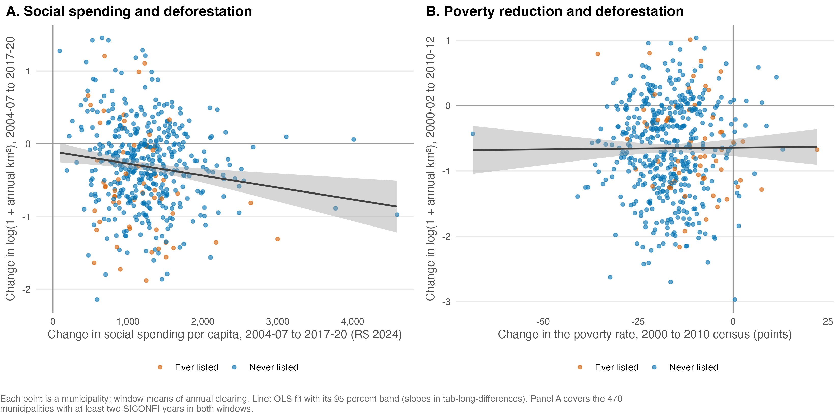
Figure 4.15: Long differences: change in social spending per capita and in the poverty rate against the change in deforestation

Table 4.6: Long-difference regressions, one observation per municipality (OLS slope, standard error and correlation)
Relation | N | Slope | SE | Correlation
Change in log(1 + km2) 2004-07 to 2017-20 on change in social spending per capita (thousand R$ 2024) | 470 | -0.165 | 0.054 | -0.141
Change in log(1 + km2) 2000-02 to 2010-12 on change in poverty rate 2000-2010 (points) | 502 | 0.001 | 0.004 | 0.007

4.5 Correlational exercise
The descriptive sections left two facts side by side: the social series and deforestation mirrored each other in the aggregate, one rising while the other fell, and the municipalities whose clearing fell most were those that received more social spending. This section asks how much of the association survives when each municipality is compared with itself over time and the shocks common to a year are removed. The specification is a two-way fixed-effects regression of the logarithm of one plus annual clearing in square kilometers on the social-policy variables of the previous year, with municipality and year effects and standard errors clustered by municipality, over the outcome years 2004 to 2019, the years with Bolsa Família data. The social regressors are Bolsa Família coverage, transfers per capita, the logarithm of one plus municipal spending per capita on health, on education and on social assistance, and the formal employment rate. The controls are log GDP per capita, the lagged crop and cattle price indices, cattle density and listing status in the outcome year. Each social variable enters first on its own with the controls, then the six together, on one common sample of 6,679 municipality-years and 499 municipalities between 2005 and 2019. The 2004 outcome has no 2003 Bolsa Família value, Santa Cruz do Arari, Ipiranga do Norte and Itanhangá lack the price indices, and SICONFI reporting gaps account for 801 of the remaining 806 missing municipality-years. The estimates are conditional correlations. Nothing in the specification identifies an effect, because none of the regressors was assigned, and Section 4.6 explains why a time-varying coverage variable cannot carry a causal reading in this period.
Table 4.7: Conditional correlations between annual clearing and the social-policy variables lagged one year: two-way fixed-effects regressions of log(1 + cleared km²) with municipality and year effects, standard errors clustered by municipality, one common sample 2005-2019 (controls: log GDP per capita, lagged crop and cattle price indices, cattle density, listing status)
Specification | Regressor, lagged one year | Coefficient | Clustered SE | N | Municipalities | R² within
Separate, with controls | BF coverage (families / quota) | -0.015 | 0.019 | 6679 | 499 | 0.008
Separate, with controls | BF transfers per capita (hundred R$ 2024) | 0.179 | 0.109 | 6679 | 499 | 0.009
Separate, with controls | log(1 + health spending per capita) | -0.008 | 0.013 | 6679 | 499 | 0.008
Separate, with controls | log(1 + education spending per capita) | -0.006 | 0.014 | 6679 | 499 | 0.008
Separate, with controls | log(1 + social assistance spending per capita) | -0.010 | 0.010 | 6679 | 499 | 0.008
Separate, with controls | Formal employment rate (ten points) | -0.025 | 0.023 | 6679 | 499 | 0.008
Separate, with controls | log(1 + social spending per capita) | -0.011 | 0.018 | 6679 | 499 | 0.008
Joint, with controls | BF coverage (families / quota) | -0.026 | 0.020 | 6679 | 499 | 0.010
Joint, with controls | BF transfers per capita (hundred R$ 2024) | 0.199 | 0.115 | 6679 | 499 | 0.010
Joint, with controls | log(1 + health spending per capita) | -0.003 | 0.014 | 6679 | 499 | 0.010
Joint, with controls | log(1 + education spending per capita) | -0.002 | 0.015 | 6679 | 499 | 0.010
Joint, with controls | log(1 + social assistance spending per capita) | -0.008 | 0.011 | 6679 | 499 | 0.010
Joint, with controls | Formal employment rate (ten points) | -0.018 | 0.022 | 6679 | 499 | 0.010

Within municipalities, the social variables carry almost no association with clearing (Table 4.7). The coefficients on coverage, on each spending function and on formal employment are negative, small and at most 1.3 standard errors from zero in every specification. The largest, −0.026 log points per unit of the coverage ratio in the joint specification, has a standard error of 0.020, and the coefficients on the three spending functions are below 0.01 in absolute value, less than one percent of clearing per log point of spending. Transfers per capita are the exception in sign: a hundred reais more per capita in the previous year go with 0.18 to 0.20 log points more clearing, with standard errors of 0.11, and with 0.32 (standard error 0.11) once the controls are removed. Transfers track how poor a place is, and within a municipality they grew where the eligible population grew, so the sign reads as poverty moving with clearing rather than as transfers raising it. The within R² is 0.01 in every column: once the municipal means and the year effects are removed, the social variables and the controls together account for one percent of what is left to explain. Among the controls, the lagged cattle price index (−0.13, standard error 0.06) and listing status (−0.09, standard error 0.05) are the two with the most precise estimates, and the listing sign is the one the enforcement literature reports.
The alternative outcomes do not change this reading (tab-corr-twfe-robustness.csv in the chapter’s output). With clearing measured as a percent of the remaining forest, no coefficient reaches its standard error. With the normalized outcome, the transfers coefficient rises to 1.56 standard deviations per hundred reais (standard error 0.66) and education spending turns to −0.13 (standard error 0.09). That series has a long right tail, with values up to 250 standard deviations above a municipality’s own 2000 to 2007 reference, and the column is read with that in mind. The long-difference cross section (tab-corr-long-difference.csv), one change per municipality between 2004-07 and 2017-20 on the windows of Section 4.4.7, 469 municipalities, adds controls and the Bolsa Família variables to the pattern seen there. Holding constant the changes in log GDP per capita, in the price indices and in cattle density, and ever-listed status, a larger rise in health spending per capita goes with a larger fall in clearing (−0.15 log points per log point, standard error 0.07, in the joint specification), as does social assistance (−0.09, standard error 0.04), and formal employment in the separate specification (−0.12 per ten points, standard error 0.06). Education spending shows no relation (0.05, standard error 0.08). The two Bolsa Família changes are positive: municipalities where coverage and transfers rose more saw smaller declines in clearing (0.13 per unit of the coverage ratio, standard error 0.06, and 0.57 per hundred reais, standard error 0.16). The coverage baseline includes the 2004 and 2005 rollout, so a larger change mostly means a later saturation, and transfers again follow the poor population.
The caveat the exercise needs concerns what the within estimates rest on. Table 4.2 put 71 percent of the variance of Bolsa Família coverage between municipalities and 29 percent within, and a large share of the within part is the rollout of 2004 to 2006, when coverage climbed from a third of the quota to above it and then stayed near 1.1 (Section 4.4). A municipality fixed effect absorbs the between part, so the coverage coefficient is estimated on the small movements of a ratio that barely changed after 2006, which is the empirical reason the chapter treats coverage as a baseline moderator and not as a time-varying regressor. Municipal social spending is the opposite case, with 60 percent of its variance within municipalities, but that within variation is the growth path every municipality shared, and the year effects absorb it in turn. The exercise shows that the association the long differences found is an association between places, and that the year-to-year movements around each municipality’s own path carry no detectable relation to clearing. The identification strategy of the next section is built on the between part.

4.6 Identification strategy
The exploratory analysis showed the problem in the data: enforcement, commodity prices, transfers, and wages all moved inside the same window. The econometric literature attributes most of the 2005 to 2012 decline to enforcement of environmental policies and commodity prices. Cash transfers and the minimum wage are not in that canonical list. A direct-effect claim for social policy therefore fights a strong prior and a set of simultaneous confounders at once, and some of those confounders are not in the panel at all. Credit conditionality is the most dangerous one, because its impact varied across municipalities, so year fixed effects do not absorb it. Because of that limitation, we don’t test H2 and H3, which are related to the direct effect of social policies on deforestation.
H1 and H4, in their turn, do not say that Bolsa Família moved deforestation on its own. They say that the effect of enforcement depends on the social conditions it lands on. That is a heterogeneity question. It asks whether the listing effect was larger where social protection was stronger at baseline. A heterogeneity contrast differences out everything that hit both groups alike, including the confounders the panel does not measure, as long as their incidence does not track the moderator. The route to do that is to estimate the listing effect separately for high-BF-coverage and low-BF-coverage strata with the Callaway and Sant’Anna estimator and test the difference between the two ATTs. That stratified design is the chapter’s center.

4.6.1 Treatment and selection problem
Figure 4.16 shows every listed municipality’s normalized deforestation in event time, by entry cohort and exit status. The figure carries two lessons that discipline the design.
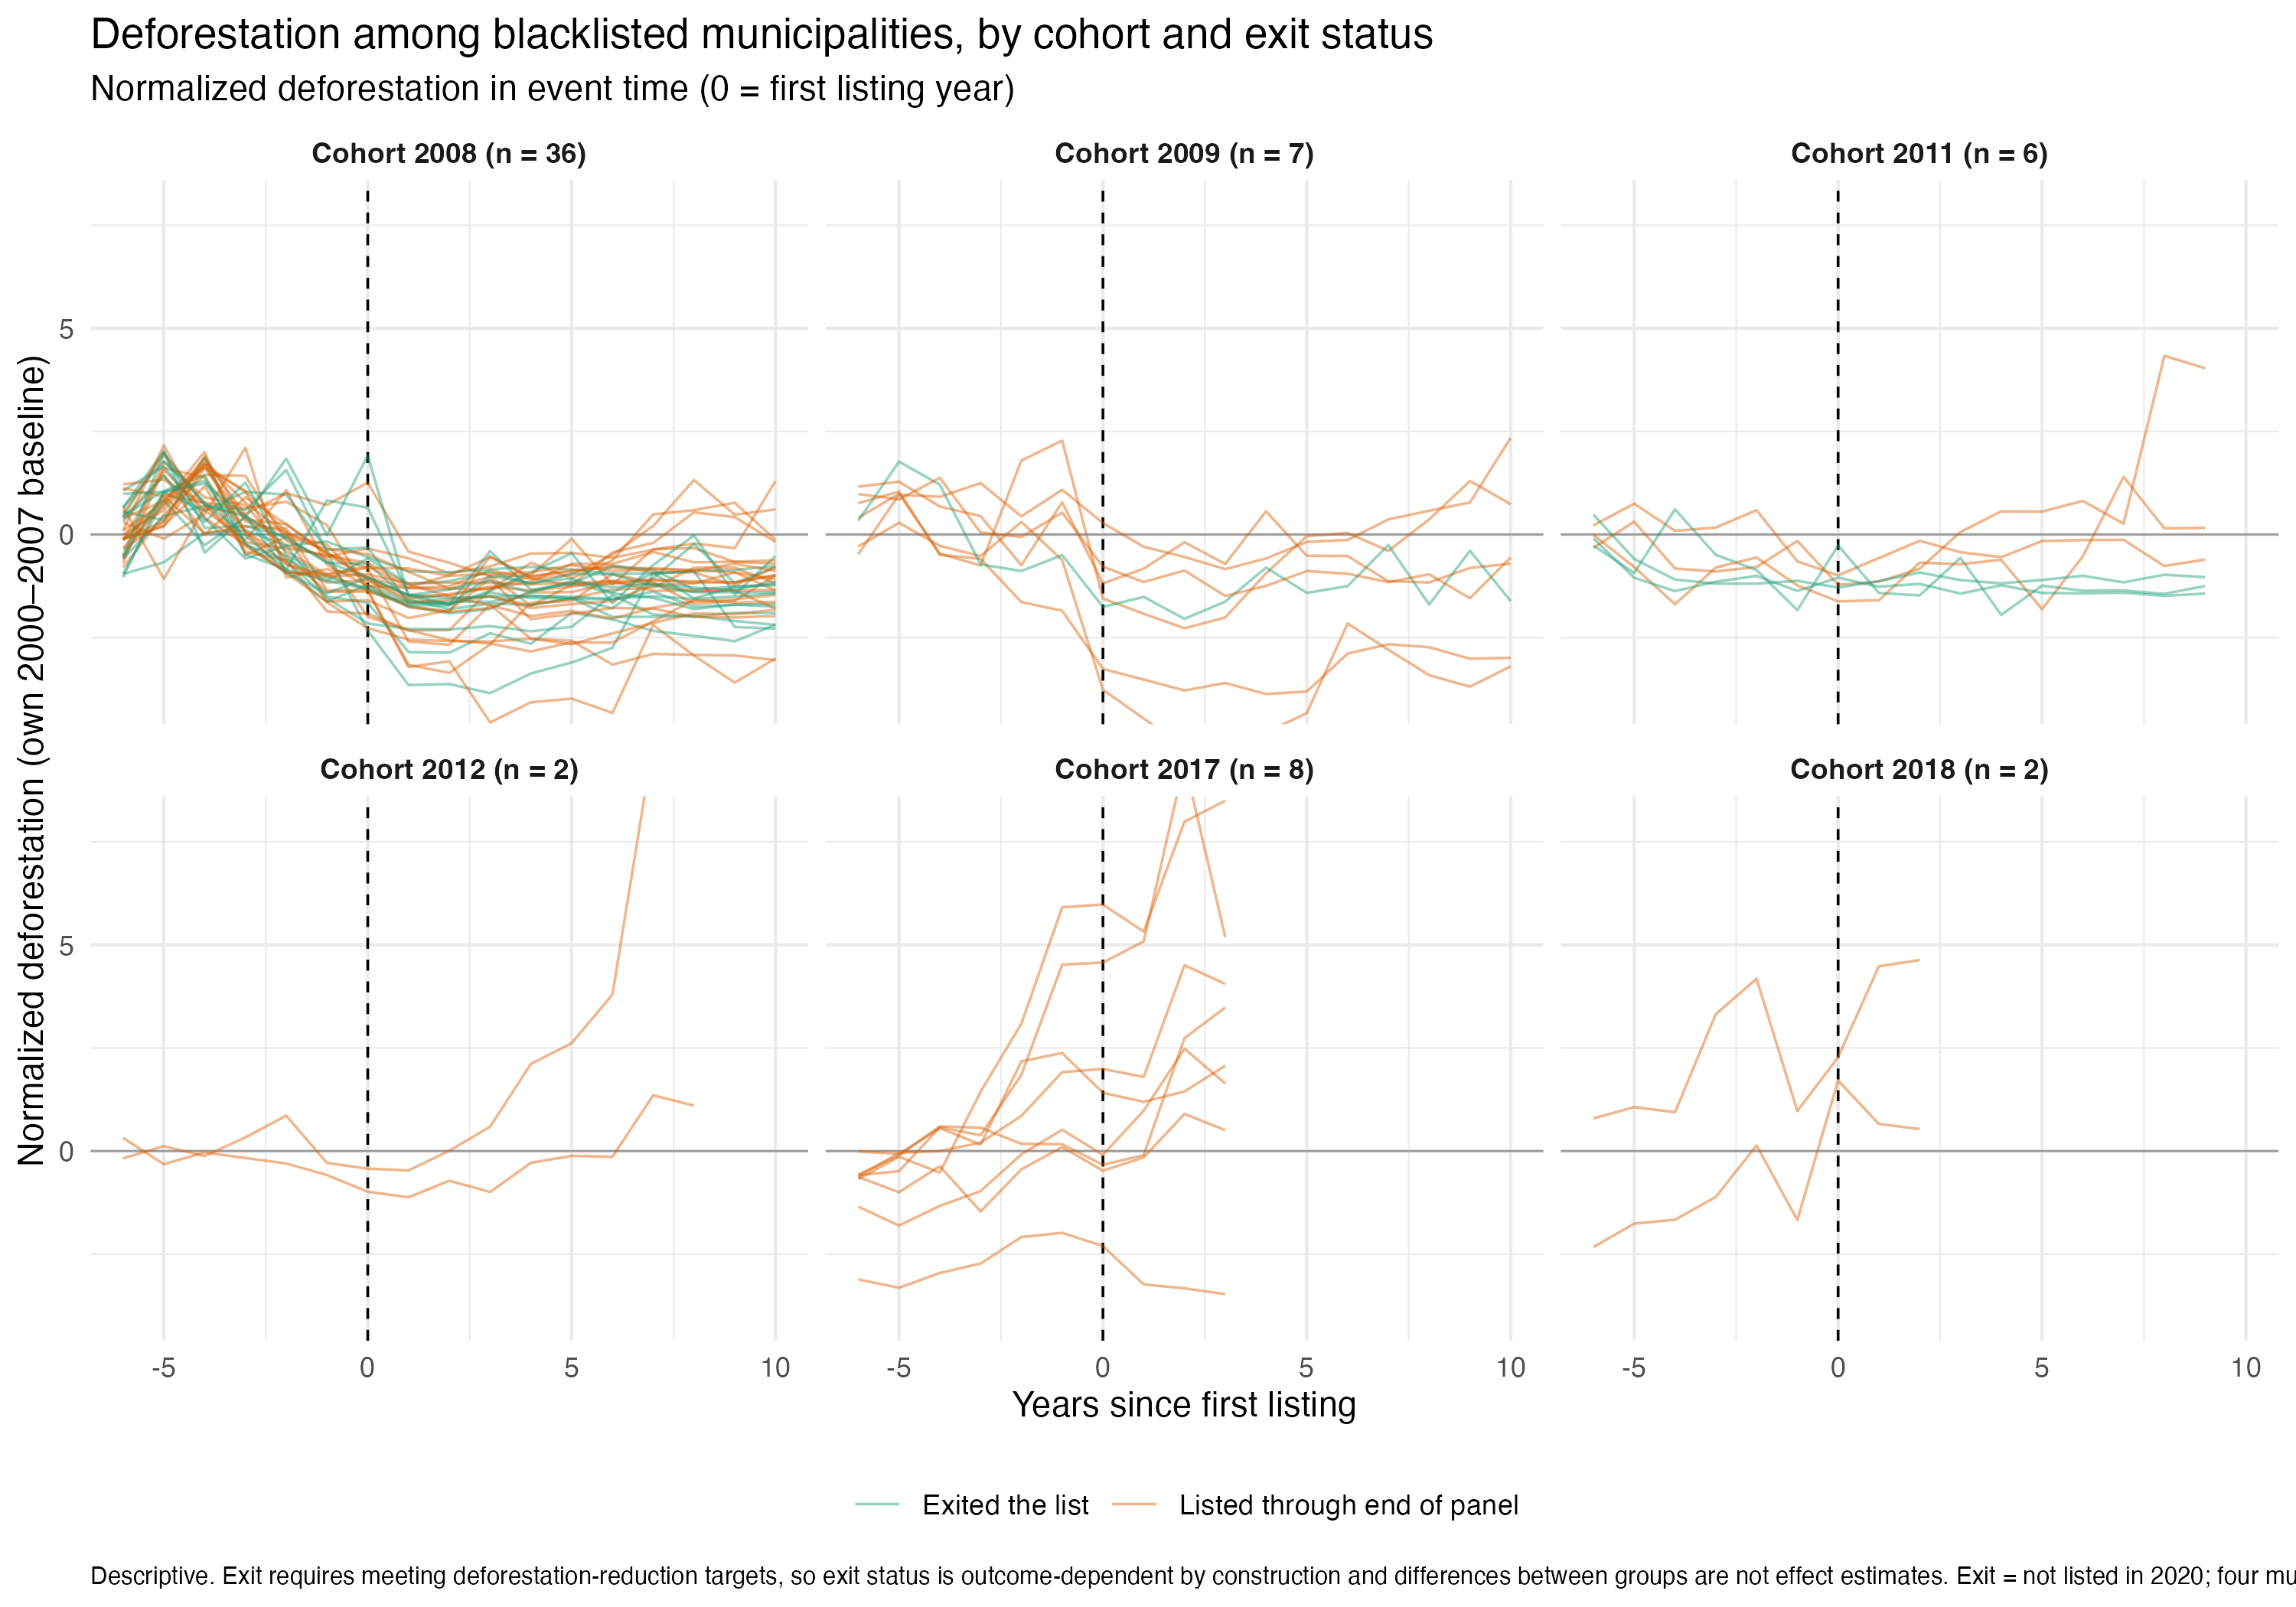
Figure 4.16: Normalized deforestation of listed municipalities in event time, by entry cohort and exit status
The first is who the treated are. Municipalities entered the list because their deforestation was critical, and the 2008 cohort shows it, as the paths rise toward the listing year and fall after it. Treatment was assigned on the outcome’s recent dynamics. This is the central threat to a difference-in-differences reading. The design cannot remove this threat, only confront it, and the pre-trend diagnostics discussed below exist for that reason.
The second is that the cohorts are not one population. The 2008 and 2009 entries, 43 municipalities, entered during the enforcement build-up and form the core treated group. The 2011 and 2012 entries are few, and the 2017 and 2018 re-listings belong to a different regime, they were listed while enforcement was weakening. Pooling them with the core cohorts would average effects from different policy environments, so the stratified analysis runs on the 2008 and 2009 cohorts. Treatment timing always comes from the first year on the annual list.

4.6.2 The moderator
Figure 4.17 maps BF coverage relative to the administrative quota across the sample at its 2006 to 2007 baseline. Coverage varies widely and its geography does not reproduce the deforestation frontier, which is the first hint that it measures something other than structure.
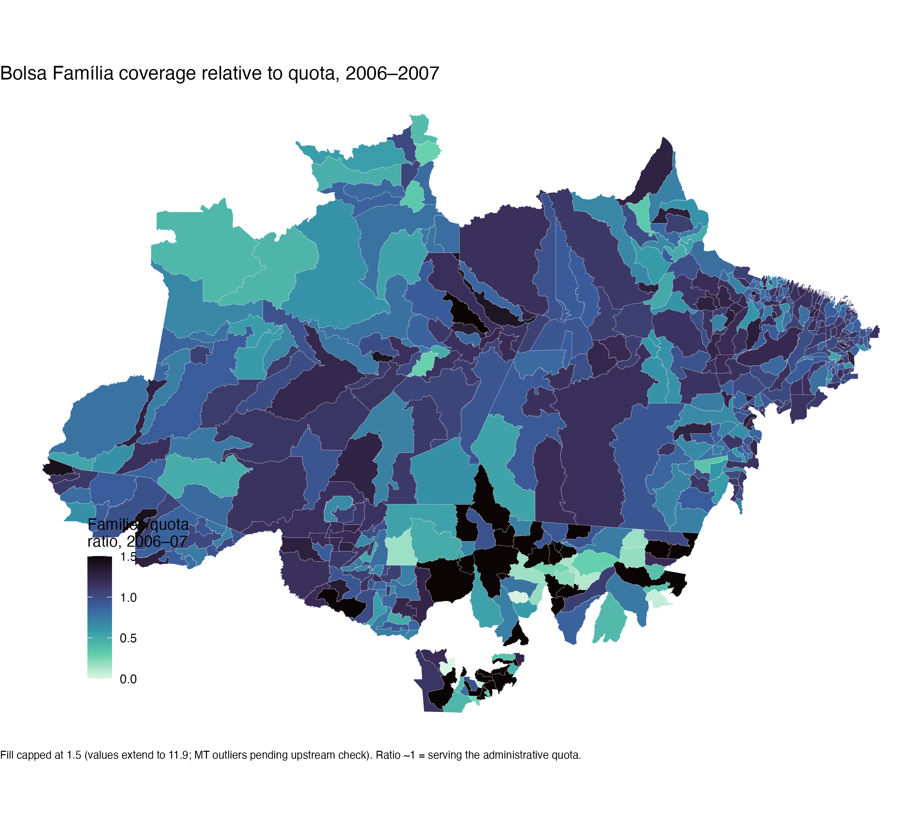
Figure 4.17: Bolsa Família coverage relative to the administrative quota, 2006-2007 baseline
Figure 4.18 shows that, among the candidate moderators, transfers per capita correlate with baseline deforestation at −0.35 in the estimation sample. The families-to-quota ratio correlates at 0.06. Baseline deforestation is the variable that drove selection into treatment, so a moderator correlated with it would bias the strata with treatment assignment itself. The coverage ratio is the candidate that stays out of that trap. It is also the better measure of the theoretical construct. H1, H4, and Mechanism 3 are about provision relative to need, how completely the program reaches its eligible population, not about how much money flows to a poor place. Panel A of Figure 4.18 shows the distribution among the 43 core treated municipalities. The median is 0.96, and the split at the median gives 21 high-coverage and 22 low-coverage treated units, a balanced contrast.
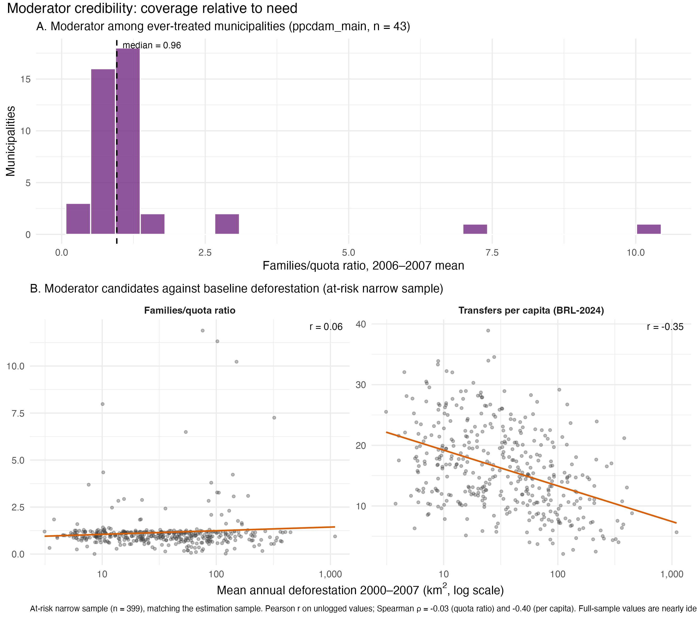
Figure 4.18: Credibility of the candidate moderators: distribution among the core treated and correlation with baseline deforestation

4.6.3 The stratified design
The pieces assemble as follows. Within each coverage stratum, the Callaway and Sant’Anna estimator compares listed municipalities to the never-listed and not-yet-listed at-risk pool in the same stratum, cohort by cohort and year by year, and aggregates to one ATT per stratum. Each stratum contains its own treated and control units, so the comparison is always between similar-coverage places with and without the treatment. The moderation test is the difference between the two stratum ATTs. Estimation runs on the at-risk narrow sample with the normalized outcome, on windows ending in 2010 and 2012, with baseline covariates entering through the estimator’s doubly robust adjustment. Standard errors cluster by municipality.
The design has a genuine alternative on each side, which is what makes it a test. Mechanism A, cushioning as compensation, predicts the listing effect is stronger where coverage was high. Mechanism B, cushioning as forbearance, predicts the opposite, since need would soften enforcement exactly where coverage and poverty run deepest. A clearly reversed difference was a possible outcome, and the direction of the estimate is therefore informative even where its precision is limited.

4.7 Preliminary results
The stratified estimation delivers one clear result, as Table 4.8 shows. Entry to the priority list reduced normalized deforestation in both coverage strata, by similar and substantial amounts. The ATT is −0.662 standard deviations (SE 0.189) in the high-coverage stratum and −0.553 (SE 0.208) in the low-coverage stratum. Both estimates are clearly distinguishable from zero. Read in the outcome’s units, listing moved a municipality’s deforestation roughly 0.6 standard deviations below its own 2000 to 2007 norm, in places that had entered the list precisely because clearing was critical. The magnitude and sign agree with the econometric literature on the priority list, which strengthens confidence that the design recovers the known enforcement effect before asking its conditional question.
Table 4.8: Stratified ATT of priority-list entry on normalized deforestation, by baseline Bolsa Família coverage (Callaway and Sant’Anna, at-risk narrow sample, 2002-2012)
quantity | estimate | se | n_treated | z | p | ci_low | ci_high
ATT, high coverage | -0.662 | 0.189 | 21 | -3.503 | 0.000 | -1.033 | -0.292
ATT, low coverage | -0.553 | 0.208 | 30 | -2.654 | 0.008 | -0.961 | -0.145
Moderation difference (high - low) | -0.109 | 0.281 |  | -0.388 | 0.698 | -0.661 | 0.442

Figure 4.19 shows the effect separately by stratum (high and low BF coverage). The post-entry paths carry the expected shape: the effect appears at entry, deepens over the first two years to around −0.8 to −0.9, and attenuates by the third and fourth year. The two strata track each other closely after entry, which previews the moderation result.
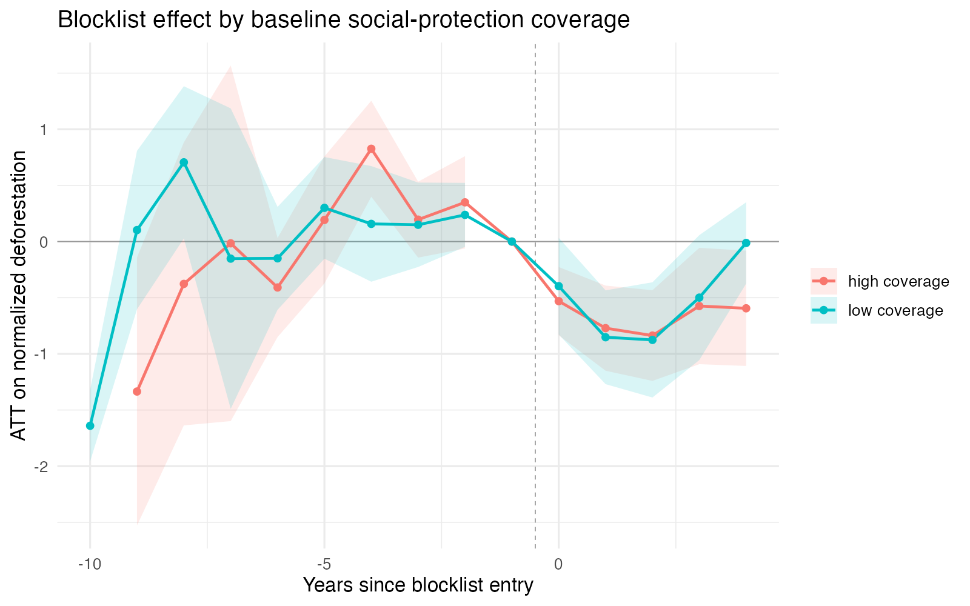
Figure 4.19: Event-study estimates of priority-list entry by coverage stratum

4.7.1 The moderation test
The difference between the two stratum ATTs (high and low BF coverage) is −0.109 (SE 0.281, z = −0.39, p = 0.698). It is not statistically distinguishable from zero. The explanation for this result is mainly that, with 21 and 30 treated units per stratum, the data lack explanatory power.
With that limit stated, two features of the estimate are informative. The first is direction. The high-coverage stratum shows the larger reduction, which is the sign cushioning as compensation predicts. The second is consistency with Chapter 2. The historical account argues that the social and environmental tracks were never integrated, that compensation appeared only in marginal and underfunded forms, and that Bolsa Família was not designed to underwrite enforcement. If that account is right, any moderation in these data comes from incidental cushioning, and incidental effects are small. A large and precisely estimated moderation coefficient would be strange regarding the historical chapter, because it would imply a functioning integration that Chapter 2 says never institutionalized. What the estimate shows, a correctly signed, despite being substantively modest, is what the historical account predicts.
The defensible claim is therefore this: the quantitative evidence does not contradict the historical account, points in the direction compensation predicts, and is too imprecise to confirm it. The imprecision is itself informative. If the compensation channel operated, it did not operate at a scale this design can detect, and that is a substantive finding about the eco-social arena rather than the absence of one.

4.7.2 What the results do not support
Nothing in this design speaks to whether Bolsa Família or wage growth reduced deforestation on their own. H2 and H3 remain descriptive claims in this chapter, for the identification reasons Section 4.6 gave. Also, the estimates describe the effect of listing while enforcement pressure was active. They say nothing about whether social protection sustains compliance after pressure fades, which is a separate exploratory question.

References
Assunção, Juliano, Clarissa Gandour, and Rudi Rocha. 2015. “Deforestation Slowdown in the Brazilian Amazon: Prices or Policies?” Environment and Development Economics 20(6): 697–722. doi:10.1017/S1355770X15000078.
Assunção, Juliano, and Romero Rocha. 2019. “Getting Greener by Going Black: The Effect of Blacklisting Municipalities on Amazon Deforestation.” Environment and Development Economics 24(2): 115–37. doi:10.1017/S1355770X18000499.
Barber, Christopher P., Mark A. Cochrane, Carlos M. Souza, and William F. Laurance. 2014. “Roads, Deforestation, and the Mitigating Effect of Protected Areas in the Amazon.” Biological Conservation 177: 203–9. doi:10.1016/j.biocon.2014.07.004.
Boyce, James K. 1994. “Inequality as a Cause of Environmental Degradation.” Ecological Economics 11: 169–78.
Callaway, Brantly, and Pedro H. C. Sant’Anna. 2021. “Difference-in-Differences with Multiple Time Periods.” Journal of Econometrics 225(2): 200–230. doi:10.1016/j.jeconom.2020.12.001.
Costa, Sérgio. 2024. Desiguais e divididos: Uma interpretação do Brasil polarizado. São Paulo, SP: Todavia.
Cunningham, Scott. 2021. Causal Inference: The Mixtape. New Haven ; London: Yale University Press. doi:10.12987/9780300255881.
Gandour, Clarissa Costalonga e. 2018. “Forest Wars: A Trilogy on Combating Deforestation in the Brazillian Amazon.” Doutor Em {{Economia}}. Pontifícia Universidade Católica do Rio de Janeiro. doi:10.17771/PUCRio.acad.36194.
Hardin, Garrett. 1968. “The Tragedy of the Commons: The Population Problem Has No Technical Solution; It Requires a Fundamental Extension in Morality.” Science 162(3859): 1243–48. doi:10.1126/science.162.3859.1243.
Harding, Torfinn, Julika Herzberg, and Karlygash Kuralbayeva. 2021. “Commodity Prices and Robust Environmental Regulation: Evidence from Deforestation in Brazil.” Journal of Environmental Economics and Management 108: 102452. doi:10.1016/j.jeem.2021.102452.
Hargrave, Jorge, and Krisztina Kis-Katos. 2013. “Economic Causes of Deforestation in the Brazilian Amazon: A Panel Data Analysis for the 2000s.” Environmental and Resource Economics 54(4): 471–94. doi:10.1007/s10640-012-9610-2.
Milmanda, Belén Fernández, and Candelaria Garay. 2019. “Subnational Variation in Forest Protection in the Argentine Chaco.” World Development 118: 79–90. doi:10.1016/j.worlddev.2019.02.002.
Milmanda, Belén Fernández, and Candelaria Garay. 2020. “The Multilevel Politics of Enforcement: Environmental Institutions in Argentina.” Politics & Society 48(1): 3–26. doi:10.1177/0032329219894074.
Olson, Mancur. 2003. The Logic of Collective Action: Public Goods and the Theory of Groups. 21. printing. Cambridge, Mass.: Harvard Univ. Press.
Polanyi, Karl. 2025. The Great Transformation: The Political and Economic Origins of Our Time. Beacon Press Classics edition. Boston, Massachusetts: Beacon Press.
Saboia, João, and João Hallak Neto. 2018. “Salário Mínimo e Distribuição de Renda No Brasil a Partir Dos Anos 2000*.” Economia e Sociedade 27(1): 265–85. doi:10.1590/1982-3533.2017v27n1art9.
Souza, Pedro H. G. Ferreira De, and Raphael Bruce. 2022. “TD 2813 - Uma Avaliação Final Da Focalização e Da Efetividade Contra a Pobreza Do Programa Bolsa Família, Em Perspectiva Comparada.” Texto para Discussão: 1–83. doi:10.38116/td2813.

A normalization inconsistency between the two indices is known and scheduled for correction.
A known indexing correction for the electoral variables is pending.
A classification that does not depend on municipal perimeters, IBGE’s 2017 typology of rural and urban spaces, is scheduled as a robustness check.

