Chapter 3

- Introduction
State efforts to curb Amazon deforestation during the 2000s coincided with two other major developments: the commodity boom and the expansion of social inclusion through cash transfers and sustained increases in the real minimum wage. These three processes were interconnected, but not in the same way.
Economic growth created favorable conditions for social inclusion by supporting labor-market formalization and income gains among lower-income groups, and minimum-wage increases further strengthened earnings at the bottom of the distribution. Economic growth also allowed an increase in social spending, leading to the creation of generous social policies such as cash transfers. Between 2003 and 2013, Brazil’s GDP grew 64%, while minimum wage grew 75%, besides millions of new job opportunities created (Costa 2024; Saboia and Hallak Neto 2018; Souza and Bruce 2022). Growth and inclusion were mutually reinforcing.
Conversely, the relationship between growth and deforestation control was potentially antagonistic. Land conversion for agriculture and cattle ranching has historically generated substantial returns in the Amazon, so rising commodity prices increased the opportunity cost of conservation and strengthened the incentive to clear. (Schneider 1995; Mahar 1988; Binswanger 1991). A central task of the literature on Amazon deforestation has therefore been to separate the effects of commodity prices and other market forces from the effects of environmental policy and enforcement. This distinction is necessary to assess how much of the historic decline in deforestation came from public policy rather than from economic conditions.
Econometric studies that estimate the effects of command-and-control conservation policy while accounting for economic drivers, in particular agricultural commodity prices, consistently find that policy contributed substantially to the decline (Harding et al. 2021; Assunção et al. 2015; Hargrave and Kis-Katos 2013; Gandour 2018b; Assunção and Rocha 2019; Burgess et al. 2012; Barber et al. 2014). Assunção, Gandour, and Rocha (2015), for example, estimate that the conservation policies introduced from 2004 onward avoided approximately 73,000 km² of clearing between 2005 and 2009, equivalent to 56% of the deforestation that would have occurred without them.
The principal institutional milestone of this period was the launch, in 2004, of the Action Plan for the Prevention and Control of Deforestation in the Legal Amazon (PPCDAm). The PPCDAm was an interministerial policy framework that combined near-real-time satellite monitoring through the DETER system with coordinated command-and-control operations by federal environmental and law-enforcement agencies. The federal architecture also introduced territorially targeted instruments. Municipalities with critical deforestation levels were designated priority areas for monitoring and enforcement, and access to rural credit was restricted for landholders unable to demonstrate environmental compliance (Assunção et al. 2015; Assunção and Rocha 2019).
A substantial strand of this literature uses the municipality-year as its unit of analysis, because the municipal scale captures variation in exposure to both economic pressure and policy pressure. Municipalities differ in the land devoted to agriculture and ranching, in the composition of local production, and in the relative weight of different commodities (Harding et al. 2021; Assunção et al. 2015). These productive structures are shaped by historically determined and potentially endogenous local processes, so studies do not treat them as exogenous. Instead, they interact changes in external commodity prices with predetermined measures of local specialization to build municipality-specific exposure to price shocks (idem).
Exposure to environmental conservation policy also varies across municipalities, but for a different reason. Monitoring, inspections, fines, and embargoes remained largely federal responsibilities. Federal policy was spatially targeted, and this targeting imposed different regulatory pressure in different places. The clearest example is the Priority Municipalities List, which subjected municipalities with critical deforestation dynamics to intensified federal monitoring and enforcement, stricter land-registration requirements, and additional political and economic pressure. Municipal governments could respond by coordinating local agreements, supporting environmental registration, and adopting measures to reduce deforestation, particularly when seeking removal from the list.
Two studies illustrate how this heterogeneity supports identification. Harding et al. (2021) combine changes in international agricultural prices, differences in municipal productive exposure to those commodities, and variation in coverage by environmental regulation, and ask whether the Priority Municipalities List, the Soy Moratorium, and protected areas altered the sensitivity of deforestation to price pressure. Assunção and Rocha (2019) focus on the Priority Municipalities List itself. They compare changes in deforestation between listed and non-listed municipalities and find that listing reduced deforestation mainly by intensifying law enforcement, rather than through credit restrictions or changes in local production. Other historically important drivers of deforestation, such as transport infrastructure and market access, are stable municipal characteristics and are absorbed by municipality fixed effects models rather than entering as time-varying covariates.
From a broader historical perspective, however, prices and environmental policy were not the only processes intertwined that varied in this period. A third development was the expansion of social inclusion, particularly between the mid-2000s and the mid-2010s. From approximately 2004 to 2014, the growth of income-transfer programs, the rising real minimum wage, employment formalization, and income gains among lower-income groups overlapped substantially with both the commodity boom and the sharp decline in deforestation.
This temporal coincidence raises an empirical and theoretical question. The decline in deforestation occurred during a period of strengthened environmental governance, and at the same time during a broad transformation in the socioeconomic conditions of the Brazilian population. Temporal overlap alone does not show that social policy contributed to environmental conservation. It does suggest that analyses centered exclusively on prices and enforcement may miss a relevant dimension of the institutional and distributive context in which deforestation control took place. Figure 1 presents the main policy, economic, social, and environmental milestones of the period of Amazon deforestation decrease.

Figure 1
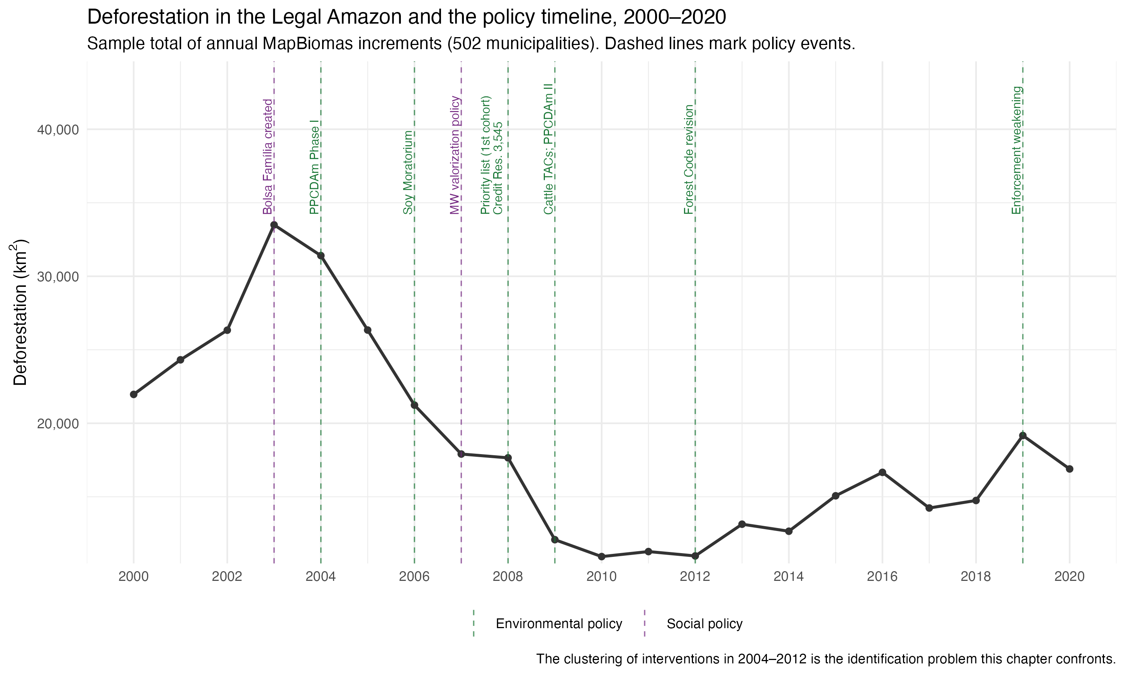

Taking this social dimension seriously is the starting point of the eco-welfare state literature, which argues that environmental governance is embedded in systems of social protection, labor-market regulation, and distributive conflict. From this perspective, the effectiveness and the social consequences of environmental policy may depend on the socioeconomic conditions under which it is implemented. Chapter 1 of this dissertation develops this framework and derives the dimensions along which eco-social interdependence can be observed. Chapter 2 shows historically that Brazil built its social and environmental policy tracks simultaneously but in separate arenas with opposite territorial logics: social policy distributes benefits and reached the Amazon frontier, while environmental enforcement distributes concentrated local costs and never embedded there. Where the two meet, Chapter 2 identifies two mechanisms with opposite signs. Social protection can absorb the local costs enforcement imposes and make it politically sustainable (cushioning as compensation), or social vulnerability can become the justification for local governments not enforcing at all (cushioning as forbearance). Chapter 3 tests empirically what Chapter 2 established historically. Its central hypothesis, that enforcement is more effective where social protection is stronger, is the empirical test of the compensation mechanism.
The chapter examines how social conditions and social policy provision interact with economic incentives and environmental governance in shaping deforestation outcomes in the Brazilian Amazon. It is presented in five stages. First, the theoretical argument, causal mechanisms, and working hypotheses. Second, the data, the panel, and the sample definitions. Third, the exploratory analysis that documents temporal trends and cross-municipal variation in the main environmental, socioeconomic, and policy indicators, and that motivated several design decisions. Fourth, the identification strategy and the reasoning behind it. Fifth, the preliminary results, what they do and do not support, and the problems that remain open.

- Mechanisms and hypothesis

Building on Chapters 1 and 2, this chapter starts from the assumption that environmental enforcement does not operate in a vacuum. Its effectiveness depends on social vulnerability, labor-market conditions, distributive conflict, and uneven state presence across municipalities. Social policies enter this picture through more channels than redistribution alone. By altering the incentives, vulnerabilities, and behavioral constraints of households and local actors, welfare provision may reduce dependence on environmentally harmful livelihoods, lower resistance to regulation, and increase the local feasibility of compliance. The effects of environmental policy are therefore expected to be heterogeneous, conditioned by welfare provision and local social conditions.
Local labor-market conditions matter for the same reason. They shape how much households and communities depend on deforestation-linked livelihoods. Where formal employment is scarce and environmentally harmful activities are central to income generation, enforcement is likely to face stronger resistance. Where more stable and protected income alternatives exist, compliance is easier politically and socially.
The chapter also assumes that this interdependence between social and environmental policy is detectable in data, through variation in policy exposure, local social conditions, and environmental outcomes over time. This assumption justifies the move from a conceptual framework to an identification strategy. The Brazilian Amazon is treated as a critical case for that move because it concentrates the conditions under which the relationship becomes most visible: historically high social vulnerability, persistent inequality, environmental degradation, recent welfare expansion, and uneven enforcement. Brazilian federalism adds the multilevel structure that cross-municipality comparison requires, since policy outcomes are shaped by uneven subnational enforcement and by variation in local institutional environments.
Four causal mechanisms follow from this framework.
Mechanism 1 - Social vulnerability conditions the effect of environmental policy. In highly vulnerable territories, environmental restrictions may impose heavy welfare costs even when they are legally justified. This makes environmental policy less effective unless it is accompanied by social protection or alternative livelihoods. The expected implication is that the effect of environmental policy is heterogeneous and weaker in municipalities with higher vulnerability, unless offset by social policy or better labor conditions.
Mechanism 2 - Social protection reduces dependence on deforestation-linked livelihoods. Households facing high income insecurity may rely more heavily on environmentally harmful activities, directly or indirectly. Social policy can relax this constraint by providing minimum income security, which reduces the short-term necessity of engaging in or politically supporting deforestation-linked activities. The expected implication is that greater welfare provision should be associated with lower deforestation pressure, especially where environmental restrictions impose short-run costs.
Mechanism 3 - Social policy lowers resistance to local environmental enforcement. Environmental regulation generates distributive losses for households, workers, and local economic actors linked to irregular or environmentally harmful activities. Local politicians then face a trade-off between enforcing environmental rules and preserving electoral support, since strict enforcement may trigger local backlash and blame for economic losses. Adapting Milmanda and Garay's notion of conflict avoidance (Milmanda and Garay 2020, 2019), the mechanism proposed here is that where social protection is weak, politicians have stronger incentives to tolerate noncompliance or selectively relax enforcement. Where social protection cushions the social costs of regulation, local resistance falls and enforcement becomes less politically costly. This is the electoral form of the two mechanisms Chapter 2 identified in the eco-social arena. Weak protection reproduces cushioning as forbearance, strong protection enables cushioning as compensation. The expected implication is that environmental policy should be more effective where social protection is stronger, because welfare provision reduces blame-avoidance incentives and increases the political feasibility of enforcement.
Mechanism 4 - Formal labor-market incorporation increases the feasibility of compliance. Where formal employment and stable labor income are more available, local populations depend less on informal or frontier-expanding activities. This reduces the local economic reliance on deforestation and may increase the viability of complying with environmental restrictions. The expected implication is that municipalities with stronger formal labor markets should display lower deforestation, stronger responses to enforcement, or both.
These mechanisms ground four hypotheses.
Hypothesis 1 - Vulnerability conditioning. Where social vulnerability is higher, environmental policy is expected to be less effective unless accompanied by compensatory social protection or stronger labor-market alternatives.
Hypothesis 2 - Social protection. Municipalities with higher levels of welfare provision are expected to exhibit lower deforestation levels, all else equal, because social protection reduces dependence on environmentally harmful livelihood strategies and increases the political feasibility of enforcement.
Hypothesis 3 - Labor incorporation. Municipalities with stronger formal labor-market conditions are expected to exhibit lower deforestation levels, all else equal, because more stable and protected income opportunities reduce reliance on deforestation-linked activities.
Hypothesis 4 - Eco-social interdependence. Environmental outcomes in the Brazilian Amazon are shaped by the interaction between environmental policy, social policy, and local socioeconomic structure, and not by environmental regulation alone. Models that incorporate these interdependencies should therefore explain deforestation dynamics better than models that treat the environmental and social domains separately.
The four hypotheses do not make the same kind of claim, and the research design treats them differently. H1 and H4 are conditional claims. They say that the effect of environmental policy depends on social conditions, and Mechanism 3 supplies their political logic. Claims of this form can be tested as moderation, asking if the enforcement effect varies with baseline social protection. H2 and H3 are direct-effect claims. They say that social policy and formal employment reduce deforestation on their own, through Mechanisms 2 and 4. Direct claims are much harder to identify in this period, because cash transfers, wage growth, and formalization expanded at the same time as enforcement, credit restrictions, and the commodity cycle. Section 5 explains why this crowding makes the moderation claims the causal spine of the chapter, while the direct-effect claims are documented descriptively. The distinction matters for reading everything that follows. The chapter's central test is whether enforcement worked better where social protection was stronger, which is H1 and H4 restated, and the empirical counterpart of cushioning as compensation.

- Data, period, and methodological overview

The empirical basis of the chapter is a balanced municipal panel of 502 municipalities of the Amazon biome observed annually from 2000 to 2020. Each row is a municipality-year. The panel combines administrative and satellite sources that are described in detail in the data documentation, so this section presents only the variables that carry the analysis.
Three variables measure the environmental outcome, all built from MapBiomas satellite data. The first is deforestation_area_km2, the annual deforestation increment in square kilometers, following the PRODES August-to-July measurement year. The second is deforestation_forest_rate, the increment divided by the remaining forest area, which expresses clearing as a proportion of what is left to clear. The third is defor_norm_ref0007, the primary outcome of the causal analysis. It is a within-municipality z-score: each municipality's annual deforestation is centered and scaled on its own 2000 to 2007 mean and standard deviation. A value of 1 means deforestation one standard deviation above that municipality's own pre-policy norm. This normalization makes municipalities with very different clearing scales comparable, and Section 3.3 explains the sample restriction it requires.
Two variables measure social protection, both from Bolsa Família administrative records. bf_transfers_pc_brl_2024 is the transfer volume per capita, deflated to 2024 prices with the IPCA. bf_families_quota_ratio is the number of families served divided by the municipality's administrative quota, the federal estimate of eligible families. The two measure different things. Transfer volume tracks how poor a place is. The quota ratio tracks how completely the program reaches its estimated eligible population, which is the construct the theoretical argument means by welfare provision. The quota ratio is the moderator of the causal design, and the reasoning appears in Section 3.4.
Three variables measure the formal labor market, built from RAIS employer records normalized by the working-age population (PIA, interpolated from the Census waves). emp_pia_rate_total is formal jobs per working-age adult, the standard employment-to-population ratio. emp_pia_rate_agric is the same ratio for agricultural employment. emp_share_low_workers is the share of formal workers in the lowest of three wage groups, defined by fixed multiples of the 2024 minimum wage (R$1,412) applied to IPCA-deflated wages. Because the thresholds are fixed in real terms, movement across groups reflects changes in the real wage distribution, not reclassification from a moving nominal cutoff. The choice of PIA rather than the labor force as denominator is an identification decision, not a convention, and the data documentation develops it. The labor force responds to the same price variation the analysis studies, while the working-age population is demographic and predetermined.
The remaining variables provide economic and political context: gdp_per_capita_2024 is municipal GDP per capita in 2024 prices, available from 2002. price_index_crop and price_index_cattle are municipality-specific commodity-price indices built with international commodity prices from the World Bank Pink Sheet, weighted by each municipality's predetermined crop mix and cattle exposure, with weights fixed at the start of the period. All time variation therefore comes from world prices, which no Amazon municipality can influence, filtered through a fixed local production profile. The indices enter regressions with a one-year lag, since deforestation recorded in year t responds to prices observed during the previous season's land-use decisions. cattle_per_km2 is herd density from the IBGE’s Produção Pecuária Municipal (PPM) survey. elec_enc is the effective number of candidates in mayoral elections, a standard competitiveness measure from Tribunal Superior Eleitoral (TSE) data, assigned to the years each elected government governs.

  - The analytic period
The panel covers 2000 to 2020, but not every variable spans the full window. Figure 2 shows the availability of the main variables by year.

Figure 2
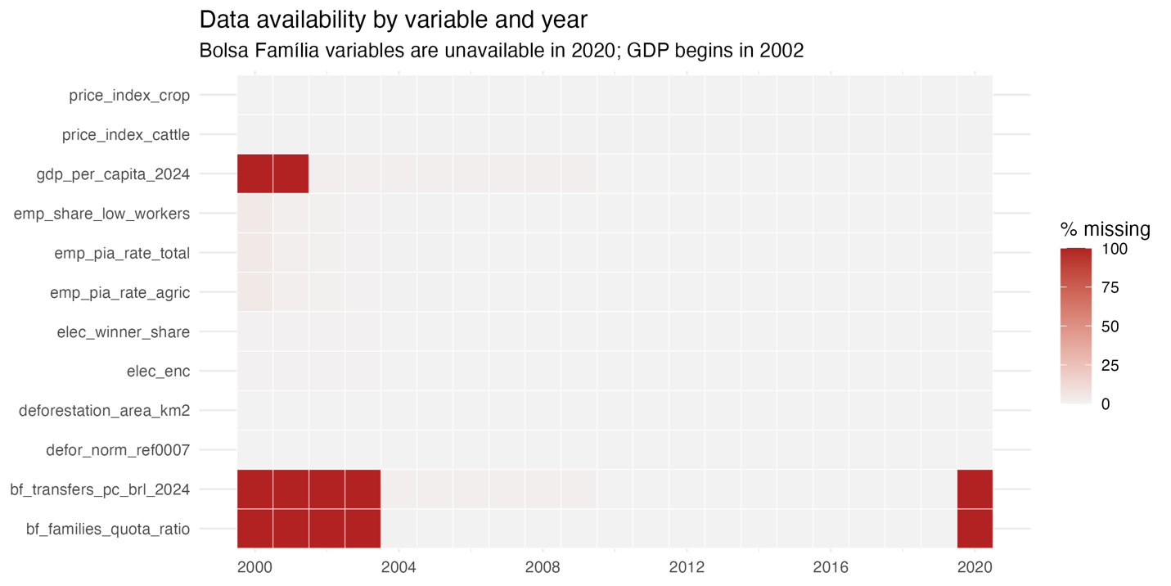

Two gaps define the analytic period. GDP per capita begins in 2002, so analyses using it start there. The Bolsa Família variables begin in 2004, when the program consolidated the prior transfer programs, and they are entirely missing in 2020. That is because 2020 Bolsa Família data is problematic due to the change of benefits to the Auxílio Emergencial program. The panel keeps the years 2000 and 2001 even though several variables start later, because the normalized outcome needs the full 2000 to 2007 baseline to be computed.

  - Samples
Not every municipality can inform the causal question. The normalized outcome divides by each municipality's own baseline standard deviation, so municipalities that barely deforested in 2000 to 2007 produce explosive z-scores, which lead to the situation in which a trivial clearing episode becomes a huge standardized value. The analysis therefore uses an at-risk sample, municipalities that pass a forest-availability floor and a baseline-deforestation threshold. The narrow version, with 408 municipalities, is the primary sample for anything using defor_norm_ref0007. This is a functional-form necessity, not selection on the outcome, because the restriction is defined on the 2000 to 2007 baseline, before the treatment begins. All 61 municipalities that ever entered the priority list pass it, so no treated unit is lost. A broader forest-floor sample (499 municipalities) is retained for descriptive analyses that use the rate outcome, where the z-score problem does not arise.

  - Methodological overview
The treatment of the causal design is entry to the Priority Municipalities List. Municipalities entered in waves: 36 in 2008, 7 in 2009, 6 in 2011, 2 in 2012, and a later re-listing round in 2017 and 2018. Treatment timing varies across municipalities, which rules out the simplest designs. A single before-and-after comparison has no untreated benchmark. A two-way fixed effects regression with one treatment dummy seems natural, but with staggered timing and effects that change over time it does something subtle and wrong: it uses already-listed municipalities as controls for later entrants. If the effect of listing grows or fades with time since entry, these comparisons contaminate the estimate. This problem is now well documented in the difference-in-differences literature (Callaway and Sant’Anna 2021; Cunningham 2021).
The estimator of Callaway and Sant'Anna (2021) is built for exactly this structure. It estimates a separate treatment effect for each entry cohort in each year, comparing each cohort only to municipalities not yet listed or never listed. These clean group-time effects are then aggregated into one average treatment effect on the treated (ATT). Nothing already treated ever enters the comparison group.
The identification strategy for the eco-social question rests on the quota ratio of Bolsa Família. The design asks whether the effect of listing differs between municipalities that entered the enforcement period with high Bolsa Família coverage and municipalities that entered with low coverage. This requires the moderator to be a stable municipal characteristic measured before treatment, not a variable that moves with the treatment itself. Section 5 develops the identification argument in full.

- Exploratory Data Analysis

The exploratory analysis starts from the problem Figure 1 announced, the deforestation decline sits in the most crowded policy window of the period. This subsection shows the crowding in the data itself, then turns to the social-policy trajectory that motivates the chapter.
Figure 3 presents the main series in natural units, as small multiples. Aggregate deforestation across the 502 municipalities peaks near 33,000 km² in 2003 and 2004, falls by roughly two thirds to about 11,000 km² by 2010, stays there through 2012, and partially rebounds afterward. The other panels show what happened around it. Bolsa Família coverage jumps from about a third of the municipal quota in 2004 to above full coverage by 2006 and stays near 1.1 for the rest of the period. Formal employment rises steadily from 5 percent of the working-age population to about 13 percent by 2014. Both price indices climb during the deforestation decline, the crop index sharply from 2007.

Figure 3
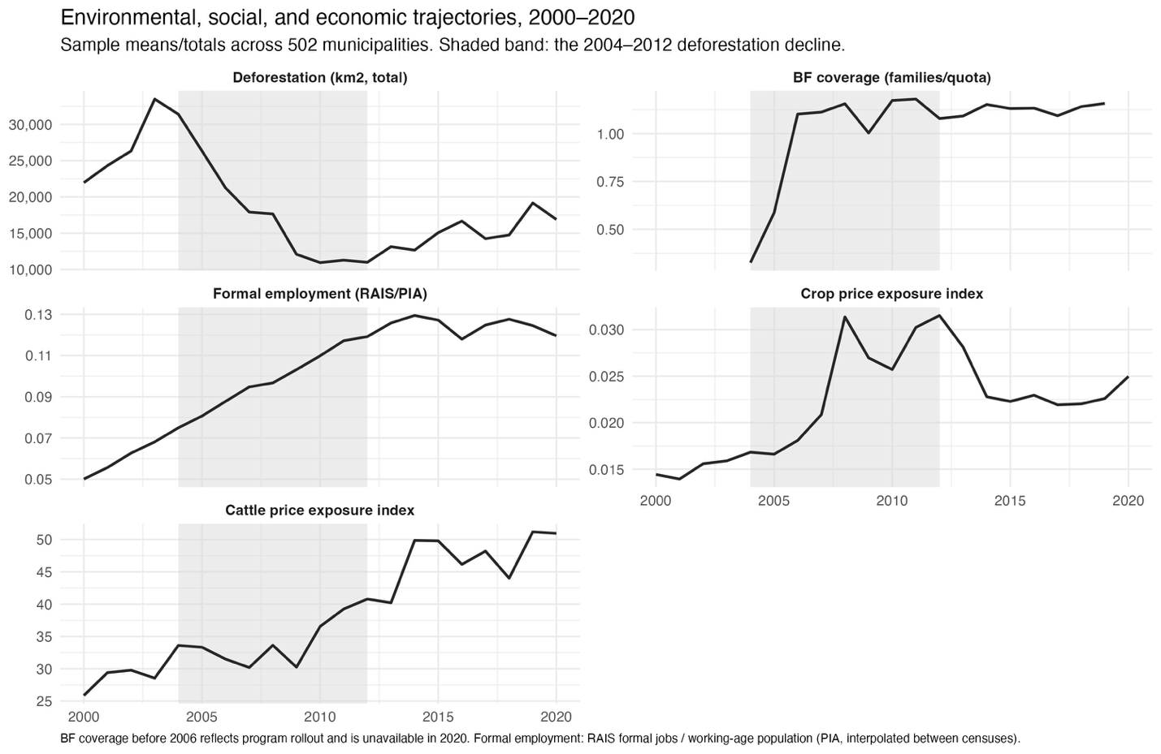

Figure 4 then puts each family of candidate explanations against the deforestation curve directly, with all series indexed and deforestation repeated in every panel as the reference line. Each panel carries a different lesson. Panel A shows economic activity. GDP per capita, crop area, and cattle density all grow through the decline, so production expanded while clearing collapsed. The frontier economy did not shrink its way to lower deforestation. Panel B is the sharpest fact in the figure. Crop prices surged exactly during the years deforestation fell fastest. Clearing declined against price pressure, which is the strongest descriptive argument that policy did real work in this period, and also the reason price exposure must be controlled in any estimate. Panel C shows the formal wage structure. The low-wage employment rate falls closely with deforestation inside the shaded band. Panel D shows Bolsa Família coverage, indexed to 2006. Coverage saturates just before the first priority-list cohort in 2008 and then barely moves. That flatness matters for the design. By the time enforcement arrived, coverage differences across municipalities were a standing characteristic, not a trend, which is why the chapter uses coverage as a cross-sectional moderator rather than a time-varying regressor.

Figure 4
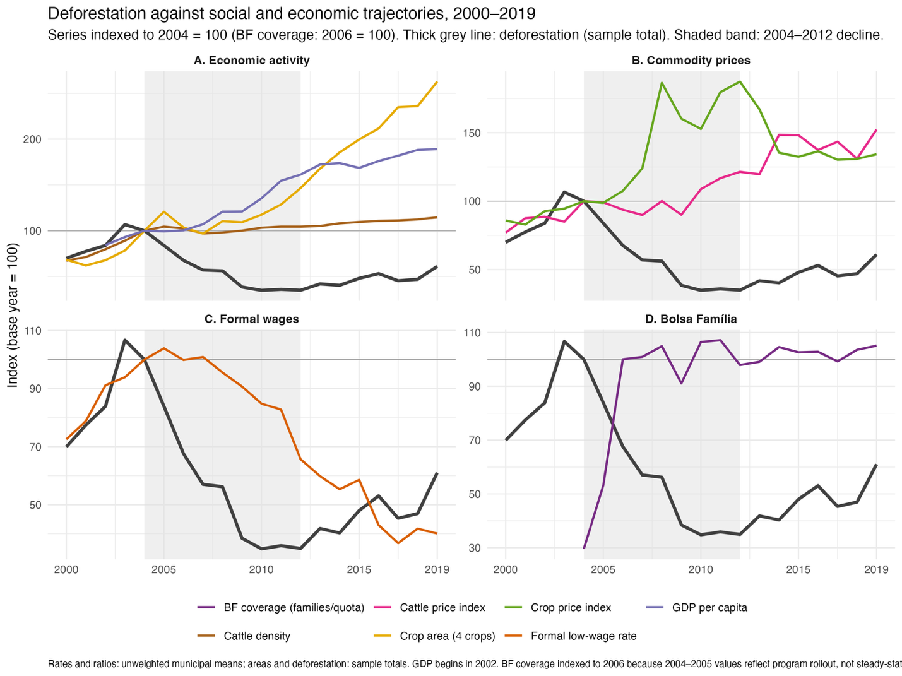

The joint lesson of the two figures is the one the identification section builds on. Every candidate moved during 2004 to 2012: enforcement, credit policy, supply-chain agreements, prices, transfers, wages, formalization. Aggregate curves cannot separate them. The co-movement motivates the question and rules out answering it at this level, so the analysis moves to municipal variation, where listing arrived in staggered cohorts and coverage differed across places.

  - The social-policy trajectory in the sample

The two social series deserve a closer look, because their shapes carry design information.
Figure 5 breaks Bolsa Família into its components for 2004 to 2019. The coverage panel repeats the rollout-then-saturation shape, showing above full quota coverage by 2006 and stable around 1.1 afterward. The transfer panels show a different rhythm. Total transfers grow through 2014, peak near R$ 65 million at 2024 prices, and then fall back and stabilize. The average transfer per family declines during rollout, when many families entered at the margin of cash transfers (Souza and Bruce 2022), then rises to a peak around R$ 340 in 2014 and erodes after 2016. Per-capita transfers follow the same arc. One fact in this figure does design work. After 2006, the program's reach relative to need is essentially flat over time, so the variation the chapter can use is the persistent difference between municipalities, which is what the moderator captures at its 2006 to 2007 baseline.

Figure 5
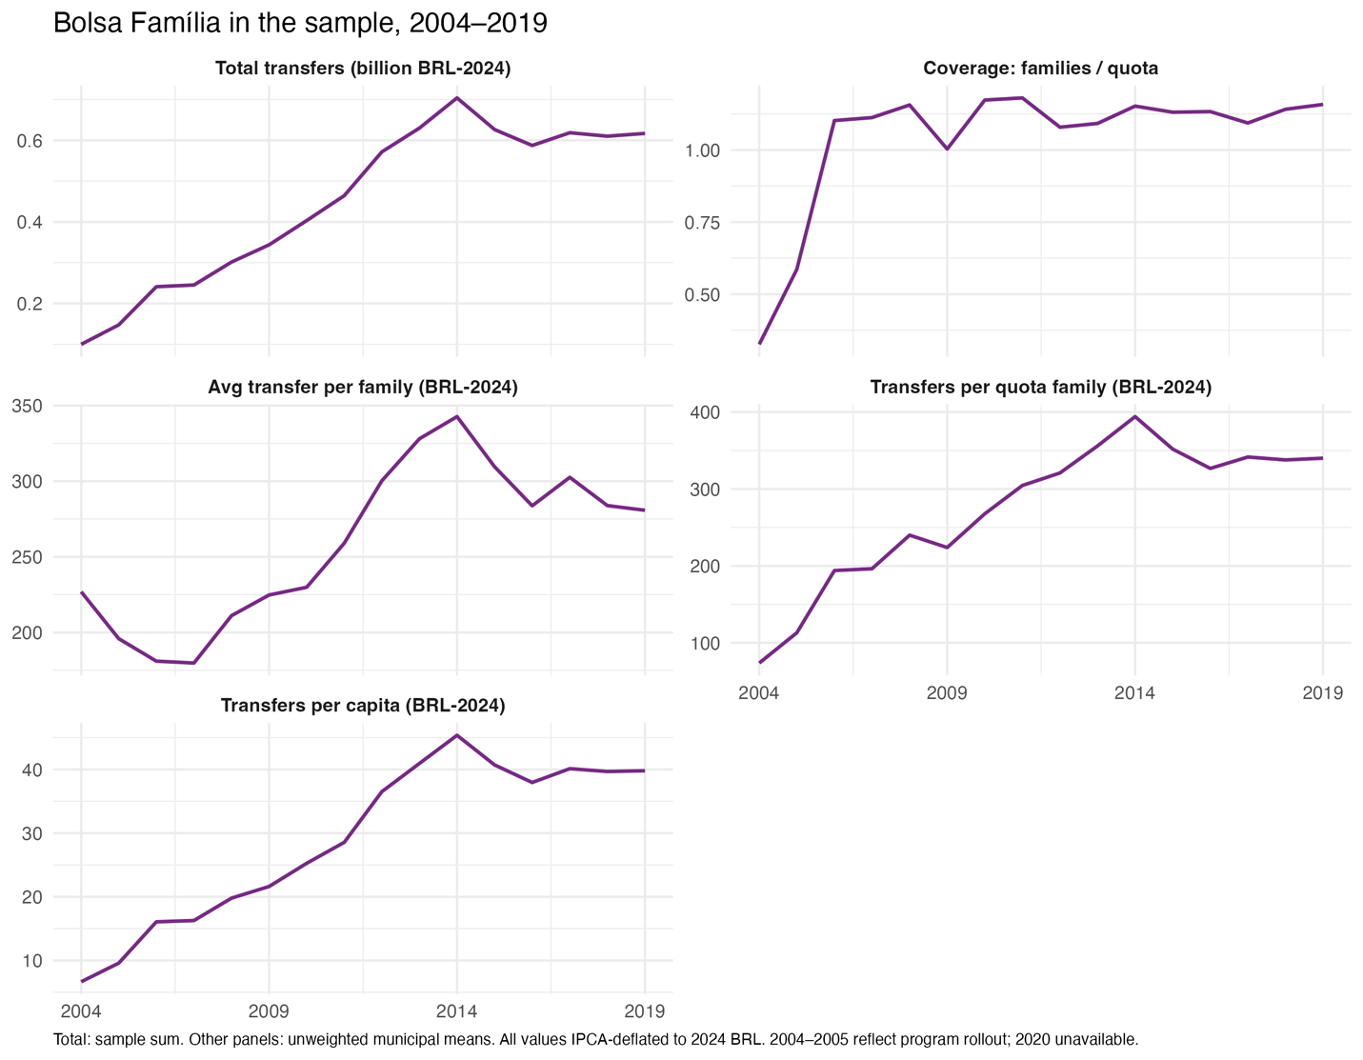

Figure 6 shows the labor-market side, the trajectory behind Mechanism 4 and H3. Panel A plots formal jobs per working-age adult by wage group, with the groups defined by fixed real thresholds. The middle group, between one and four times the 2024 minimum wage, rises from about 1.3 percent of the working-age population to about 10 percent, overtaking the low group around 2006. The low group, at or below one 2024 minimum wage, peaks near 4.5 percent in 2005 and falls to under 2 percent. Panel B shows the consequence for composition. Workers at or below the 2024 minimum fall from about two thirds of formal employment in 2000 to under a fifth by 2017. Because the thresholds are fixed in real terms, this migration across groups measures real wage growth in the formal sector, together with turnover and compositional change. It is the clearest picture in the data of labor-market incorporation reaching the Amazon during the enforcement period.

Figure 6
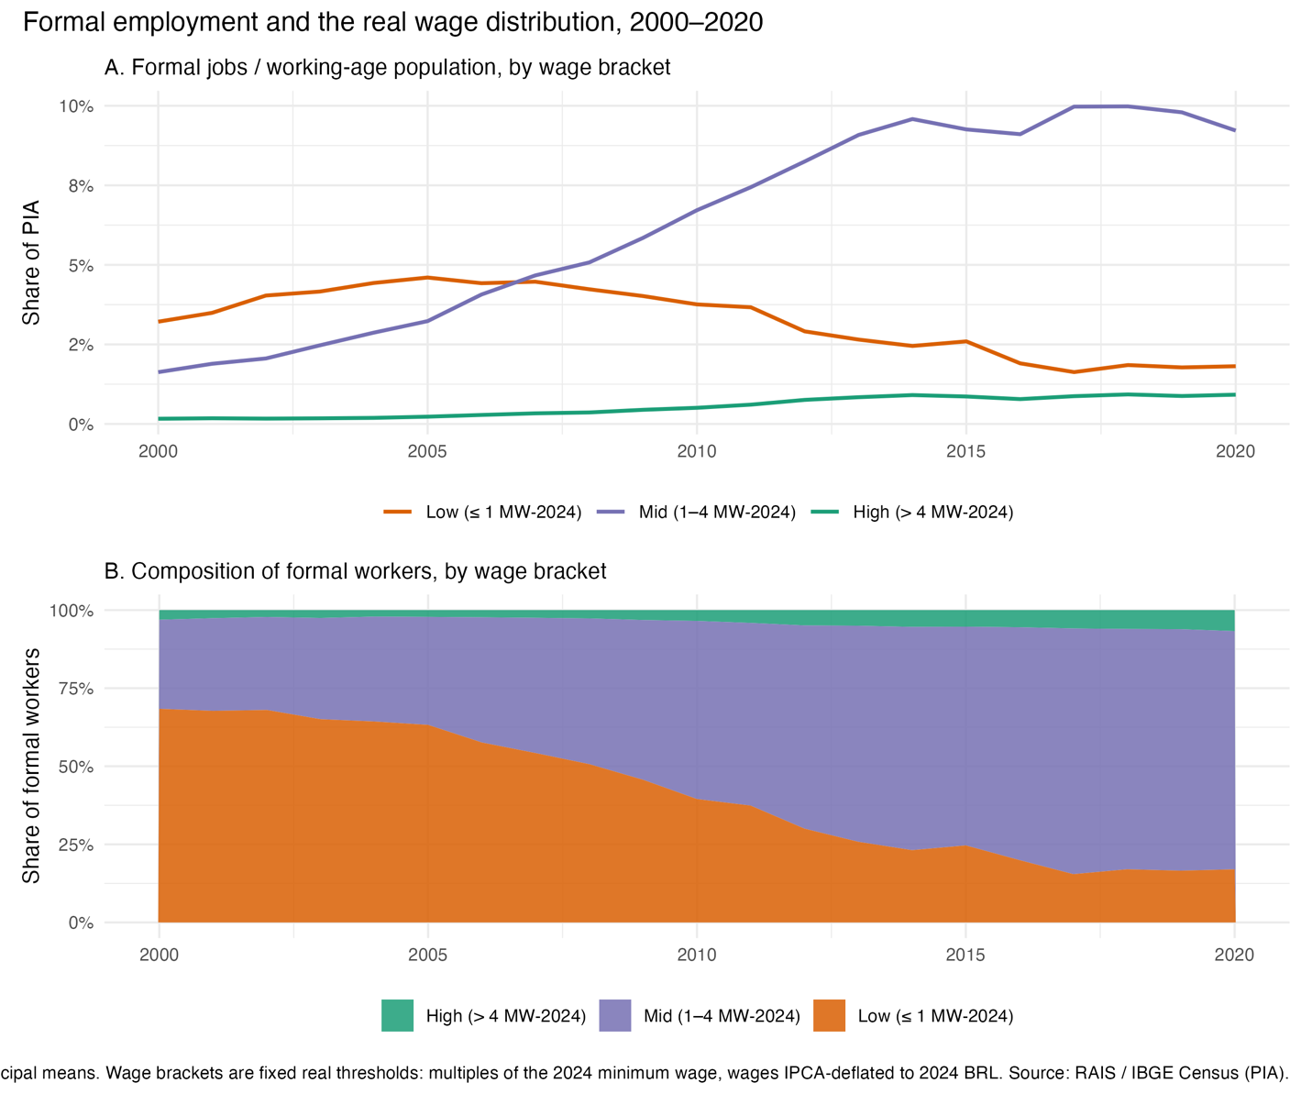

Together, the two trajectories are the empirical face of the claim Chapter 2 made historically. Social policy reached the frontier and embedded there. Transfers saturated their quotas within three years, and formal wage growth transformed the composition of employment. Environmental enforcement, arriving in 2008 in selected municipalities, met a frontier where this incorporation was already underway. Whether that mattered for enforcement's effect is the chapter's question, and the next subsections turn from trajectories to the treatment itself: which municipalities were listed, how they compare to the rest, and whether the coverage moderator is credible.

- Identification strategy

The exploratory analysis showed the problem in the data: enforcement, commodity prices, transfers, and wages all moved inside the same window. The econometric literature attributes most of the 2005 to 2012 decline to enforcement of environmental policies and commodity prices. Cash transfers and the minimum wage are not in that canonical list. A direct-effect claim for social policy therefore fights a strong prior and a set of simultaneous confounders at once, and some of those confounders are not in the panel at all. Credit conditionality is the most dangerous one, because its impact varied across municipalities, so year fixed effects do not absorb it. Because of that limitation, we don’t test H2 and H3, which are related to the direct effect of social policies on deforestation.
H1 and H4, in their turn, do not say that Bolsa Família moved deforestation on its own. They say that the effect of enforcement depends on the social conditions it lands on. That is a heterogeneity question. It asks whether the listing effect was larger where social protection was stronger at baseline. A heterogeneity contrast differences out everything that hit both groups alike, including the confounders the panel does not measure, as long as their incidence does not track the moderator. The route to do that is to estimate the listing effect separately for high-BF-coverage and low-BF-coverage strata with the Callaway and Sant'Anna estimator and test the difference between the two ATTs. That stratified design is the chapter's center.

  - Treatment and selection problem
Figure 7 shows every listed municipality's normalized deforestationn in event time, by entry cohort and exit status. The figure carries two lessons that discipline the design.

Figure 7
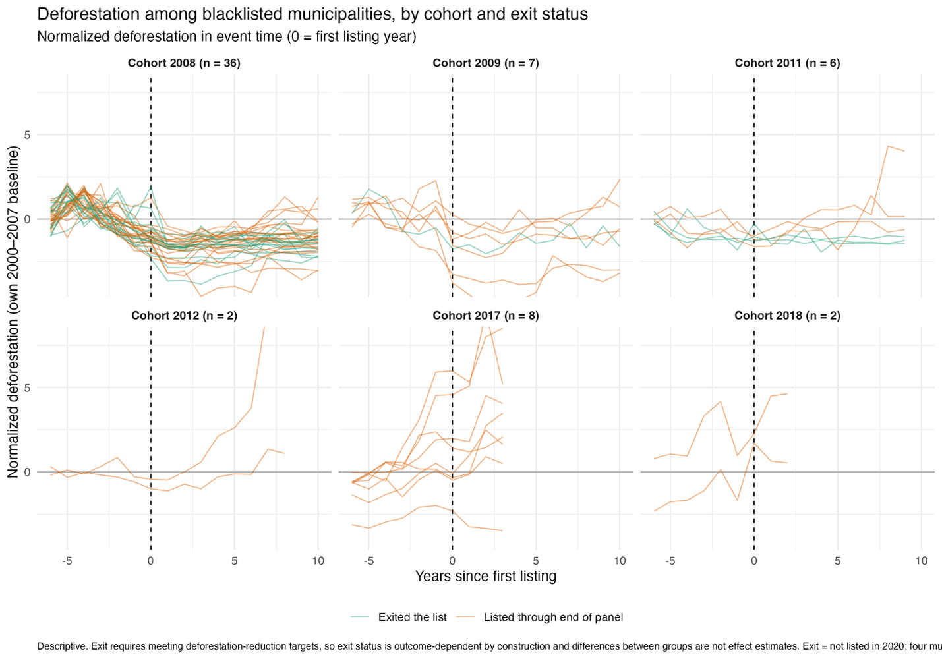

The first is who the treated are. Municipalities entered the list because their deforestation was critical, and the 2008 cohort shows it, as the paths rise toward the listing year and fall after it. Treatment was assigned on the outcome's recent dynamics. This is the central threat to a difference-in-differences reading. The design cannot remove this threat, only confront it, and the pre-trend diagnostics discussed below exist for that reason.
The second is that the cohorts are not one population. The 2008 and 2009 entries, 43 municipalities, entered during the enforcement build-up and form the core treated group. The 2011 and 2012 entries are few, and the 2017 and 2018 re-listings belong to a different regime, they were listed while enforcement was weakening. Pooling them with the core cohorts would average effects from different policy environments, so the stratified analysis runs on the 2008 and 2009 cohorts. Treatment timing always comes from the first year on the annual list.

  - The moderator
Figure 9 maps BF coverage relative to the administrative quota across the sample at its 2006 to 2007 baseline. Coverage varies widely and its geography does not reproduce the deforestation frontier, which is the first hint that it measures something other than structure.

Figure 9
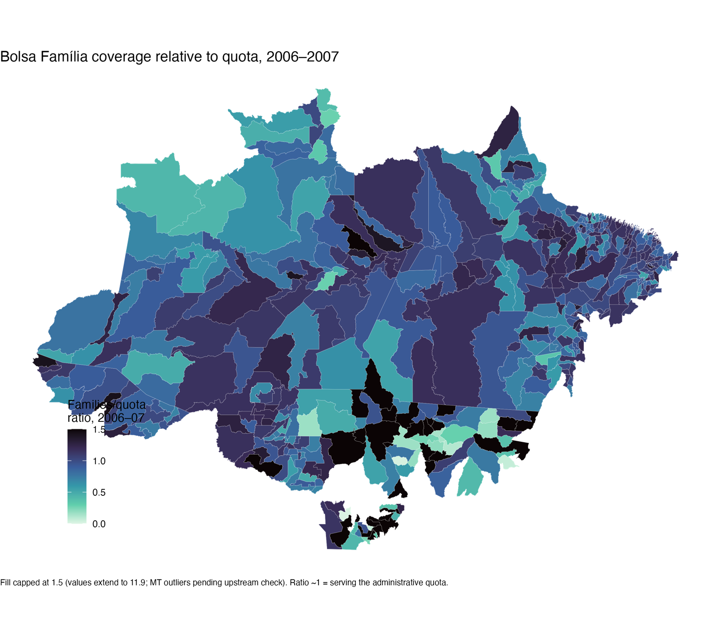
Figure 10 shows that, among the candidate moderators, transfers per capita correlate with baseline deforestation at −0.35 in the estimation sample. The families-to-quota ratio correlates at 0.06. Baseline deforestation is the variable that drove selection into treatment, so a moderator correlated with it would bias the strata with treatment assignment itself. The coverage ratio is the candidate that stays out of that trap. It is also the better measure of the theoretical construct. H1, H4, and Mechanism 3 are about provision relative to need, how completely the program reaches its eligible population, not about how much money flows to a poor place. Panel A of Figure 10 shows the distribution among the 43 core treated municipalities. The median is 0.96, and the split at the median gives 21 high-coverage and 22 low-coverage treated units, a balanced contrast.

Figure 11
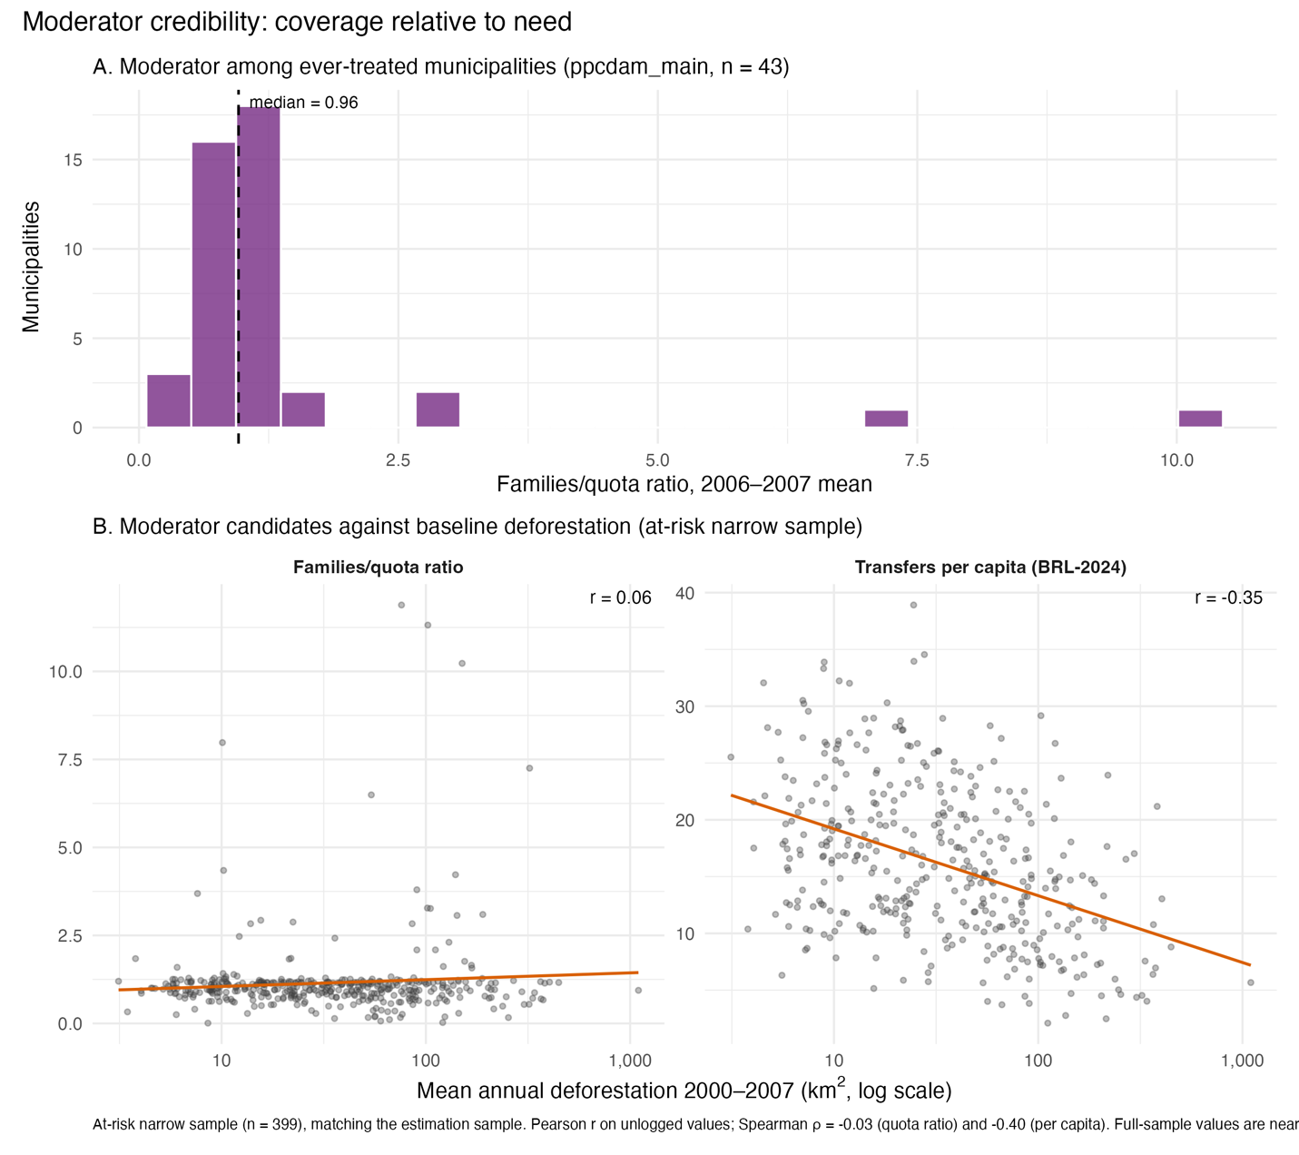

  - The stratified design
The pieces assemble as follows. Within each coverage stratum, the Callaway and Sant'Anna estimator compares listed municipalities to the never-listed and not-yet-listed at-risk pool in the same stratum, cohort by cohort and year by year, and aggregates to one ATT per stratum. Each stratum contains its own treated and control units, so the comparison is always between similar-coverage places with and without the treatment. The moderation test is the difference between the two stratum ATTs. Estimation runs on the at-risk narrow sample with the normalized outcome, on windows ending in 2010 and 2012, with baseline covariates entering through the estimator's doubly robust adjustment. Standard errors cluster by municipality.
The design has a genuine alternative on each side, which is what makes it a test. Mechanism A, cushioning as compensation, predicts the listing effect is stronger where coverage was high. Mechanism B, cushioning as forbearance, predicts the opposite, since need would soften enforcement exactly where coverage and poverty run deepest. A clearly reversed difference was a possible outcome, and the direction of the estimate is therefore informative even where its precision is limited.

- Preliminary results

The stratified estimation delivers one clear result, as the table 2 shows. Entry to the priority list reduced normalized deforestation in both coverage strata, by similar and substantial amounts. The ATT is −0.662 standard deviations (SE 0.194) in the high-coverage stratum and −0.553 (SE 0.213) in the low-coverage stratum. Both estimates are clearly distinguishable from zero. Read in the outcome's units, listing moved a municipality's deforestation roughly 0.6 standard deviations below its own 2000 to 2007 norm, in places that had entered the list precisely because clearing was critical. The magnitude and sign agree with the econometric literature on the priority list, which strengthens confidence that the design recovers the known enforcement effect before asking its conditional question.

Table 2
quantity | estimate | se | n_treated | z | p | ci_low | ci_high
ATT, high coverage | -662 | 194 | 21 | -3.412 | 1 | -1.043 | -282
ATT, low coverage | -553 | 213 | 22 | -2.594 | 9 | -971 | -135
Moderation difference (high - low) | -109 | 288 | NA | -379 | 705 | -674 | 456

Figure 11 shows the effect separately by stratum (high and low BF coverage). The post-entry paths carry the expected shape: the effect appears at entry, deepens over the first two years to around −0.8 to −0.9, and attenuates by the third and fourth year. The two strata track each other closely after entry, which previews the moderation result.

Figure 11
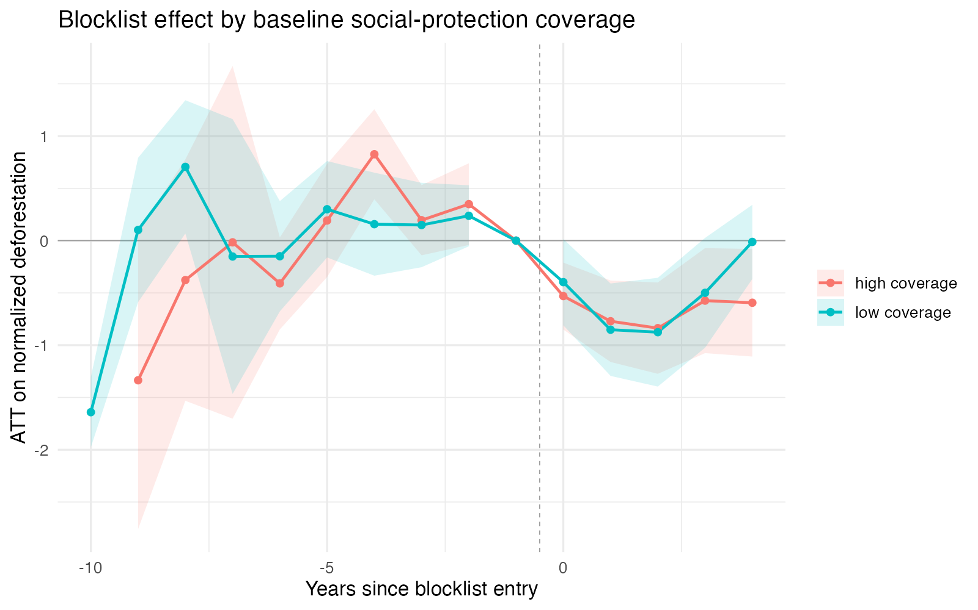

  - The moderation test
The difference between the two stratum ATTs (high and low BF coverage) is −0.109 (SE 0.288, z = −0.38, p = 0.705). It is not statistically distinguishable from zero. The explanation for this result is mainly that, with 21 and 22 treated units per stratum, the data lack explanatory power.
With that limit stated, two features of the estimate are informative. The first is direction. The high-coverage stratum shows the larger reduction, which is the sign cushioning as compensation predicts. The second is consistency with Chapter 2. The historical account argues that the social and environmental tracks were never integrated, that compensation appeared only in marginal and underfunded forms, and that Bolsa Família was not designed to underwrite enforcement. If that account is right, any moderation in these data comes from incidental cushioning, and incidental effects are small. A large and precisely estimated moderation coefficient would be strange regarding the historical chapter, because it would imply a functioning integration that Chapter 2 says never institutionalized. What the estimate shows, a correctly signed, despite being substantively modest, is what the historical account predicts.
The defensible claim is therefore this: the quantitative evidence does not contradict the historical account, points in the direction compensation predicts, and is too imprecise to confirm it. The imprecision is itself informative. If the compensation channel operated, it did not operate at a scale this design can detect, and that is a substantive finding about the eco-social arena rather than the absence of one.

  - What the results do not support
Nothing in this design speaks to whether Bolsa Família or wage growth reduced deforestation on their own. H2 and H3 remain descriptive claims in this chapter, for the identification reasons section 5 gave. Also, the estimates describe the effect of listing while enforcement pressure was active. They say nothing about whether social protection sustains compliance after pressure fades, which is a separate exploratory question.

- Bibliography

Assunção, Juliano, Clarissa Gandour, and Rudi Rocha. 2015. “Deforestation Slowdown in the Brazilian Amazon: Prices or Policies?” Environment and Development Economics 20 (6): 697–722. https://doi.org/10.1017/S1355770X15000078.
Assunção, Juliano, and Romero Rocha. 2019. “Getting Greener by Going Black: The Effect of Blacklisting Municipalities on Amazon Deforestation.” Environment and Development Economics 24 (2): 115–37. https://doi.org/10.1017/S1355770X18000499.
Barber, Christopher P., Mark A. Cochrane, Carlos M. Souza, and William F. Laurance. 2014. “Roads, Deforestation, and the Mitigating Effect of Protected Areas in the Amazon.” Biological Conservation 177 (September): 203–9. https://doi.org/10.1016/j.biocon.2014.07.004.
Binswanger, Hans P. 1991. “Brazilian Policies That Encourage Deforestation in the Amazon.” World Development 19 (7): 821–29.
Burgess, Robin, Matthew Hansen, Benjamin A. Olken, Peter Potapov, and Stefanie Sieber. 2012. “The Political Economy of Deforestation in the Tropics*.” The Quarterly Journal of Economics 127 (4): 1707–54. https://doi.org/10.1093/qje/qjs034.
Callaway, Brantly, and Pedro H. C. Sant’Anna. 2021. “Difference-in-Differences with Multiple Time Periods.” Journal of Econometrics 225 (2): 200–230. https://doi.org/10.1016/j.jeconom.2020.12.001.
Carneiro, Francimary Da Silva, Klewton Adriano Oliveira Pinheiro, Mateus Trindade Barbosa, et al. 2022. “Dinâmica do desmatamento ilegal ocorrido em onze anos no estado do Pará-Brasil.” Research, Society and Development 11 (7): e21311728308. https://doi.org/10.33448/rsd-v11i7.28308.
Carneiro, Marcelo, and William Assis. 2015. “O Controle Do Desmatamento Na Amazônia Como Um Processo de Modernização Ecológica: A Experiência Do Projeto Município Verde.” Revista Pós Ciências Sociais 12 (24): 53. https://doi.org/10.18764/2236-9473.v12n24p53-76.
Costa, Sérgio. 2024. Desiguais e divididos: Uma interpretação do Brasil polarizado. Todavia.
Cunningham, Scott. 2021. Causal Inference: The Mixtape. Yale University Press. https://doi.org/10.12987/9780300255881.
Gandour, Clarissa Costalonga e. 2018a. “Forest Wars: A Trilogy on Combating Deforestation in the Brazilian Amazon.” Doutor em Economia, Pontifícia Universidade Católica do Rio de Janeiro. https://doi.org/10.17771/PUCRio.acad.36194.
Gandour, Clarissa Costalonga e. 2018b. “Forest Wars: A Trilogy on Combating Deforestation in the Brazillian Amazon.” Doutor em Economia, Pontifícia Universidade Católica do Rio de Janeiro. https://doi.org/10.17771/PUCRio.acad.36194.
Harding, Torfinn, Julika Herzberg, and Karlygash Kuralbayeva. 2021. “Commodity Prices and Robust Environmental Regulation: Evidence from Deforestation in Brazil.” Journal of Environmental Economics and Management 108 (July): 102452. https://doi.org/10.1016/j.jeem.2021.102452.
Hargrave, Jorge, and Krisztina Kis-Katos. 2013. “Economic Causes of Deforestation in the Brazilian Amazon: A Panel Data Analysis for the 2000s.” Environmental and Resource Economics 54 (4): 471–94. https://doi.org/10.1007/s10640-012-9610-2.
Mahar, Dennis. 1988. Government Policies and Deforestation in Brazil’s Amazon Region. Environment Department Working Paper No. 7. The World Bank. https://documents1.worldbank.org/curated/en/865991493311211082/pdf/Government-policies-and-deforestation-in-Brazils-Amazon-region.pdf.
Milmanda, Belén Fernández, and Candelaria Garay. 2019. “Subnational Variation in Forest Protection in the Argentine Chaco.” World Development 118 (June): 79–90. https://doi.org/10.1016/j.worlddev.2019.02.002.
Milmanda, Belén Fernández, and Candelaria Garay. 2020. “The Multilevel Politics of Enforcement: Environmental Institutions in Argentina.” Politics & Society 48 (1): 3–26. https://doi.org/10.1177/0032329219894074.
Pará, Governo do (Secretaria de Meio Ambiente e Sustentabilidade). 2023. “Programa Municípios Verdes.” https://www.municipiosverdes.pa.gov.br/.
Saboia, João, and João Hallak Neto. 2018. “Salário Mínimo e Distribuição de Renda No Brasil a Partir Dos Anos 2000*.” Economia e Sociedade 27 (1): 265–85. https://doi.org/10.1590/1982-3533.2017v27n1art9.
Schneider, Robert R. 1995. Government and the Economy on the Amazon Frontier. The World Bank. https://doi.org/10.1596/0-8213-3353-4.
Sills, Erin O., Diego Herrera, A. Justin Kirkpatrick, et al. 2015. “Estimating the Impacts of Local Policy Innovation: The Synthetic Control Method Applied to Tropical Deforestation.” PLOS ONE 10 (7): e0132590. https://doi.org/10.1371/journal.pone.0132590.
Souza, Pedro H. G. Ferreira De, and Raphael Bruce. 2022. “TD 2813 - Uma Avaliação Final Da Focalização e Da Efetividade Contra a Pobreza Do Programa Bolsa Família, Em Perspectiva Comparada.” Texto Para Discussão, November 18, 1–83. https://doi.org/10.38116/td2813.

A normalization inconsistency between the two indices is known and scheduled for correction.
A known indexing correction for the electoral variables is pending.

