


CERTIFICATE

[[COMPANY]]

[[ADDRESS]]

IFC Global Certification confirms that the above-named organization's management system has been assessed and complies with the requirements of the following standard.
Standard:

[[STANDARD]]
Scope:
[[SCOPE]]
[[CATEGORY]]

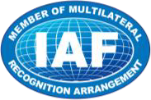
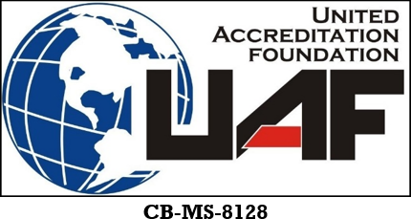
Initial Date | [[INITIAL_DATE]]
Issue Date | [[ISSUE_DATE]]
Revision No | [[REVISION]]
Date of Validity | [[VALIDITY_DATE]]
Expiry Date | [[EXPIRY_DATE]]
Certificate No | [[CERTIFICATE_NO]]

Approval

