



CERTIFICATE

[[COMPANY]]

[[ADDRESS]]

IFC Global Certification confirms that the above-named organization's management system has been assessed and complies with the requirements of the following standard.
Standard:

[[STANDARD]]
Scope:

[[SCOPE]]

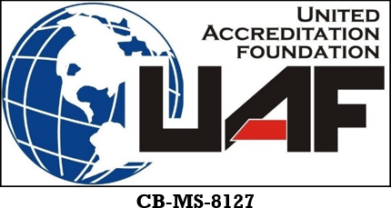
[[INITIAL_DATE]]
Initial Date
Issue Date
Revision Date
Date of Validity
Expiry Date
Certificate No

[[ISSUE_DATE]]
[[REVISION]]
[[VALIDITY_DATE]]
[[EXPIRY_DATE]]
[[CERTIFICATE_NO]]

Approval

