**SAT 5424 – POPULATION HEALTH INFORMATICS ASSINGNMENT**

Architecture Development Part 3: Generation Of Synthea Patient And Syndromic Surveillance Data For Hospital EHRs To Simulate Disease Outbreak

Name: Frederick Damptey

1. Synthea Covid-19 syndromic surveillance disease outbreak HL7 FHIR .json files screenshots

**Aspirus Hospital**

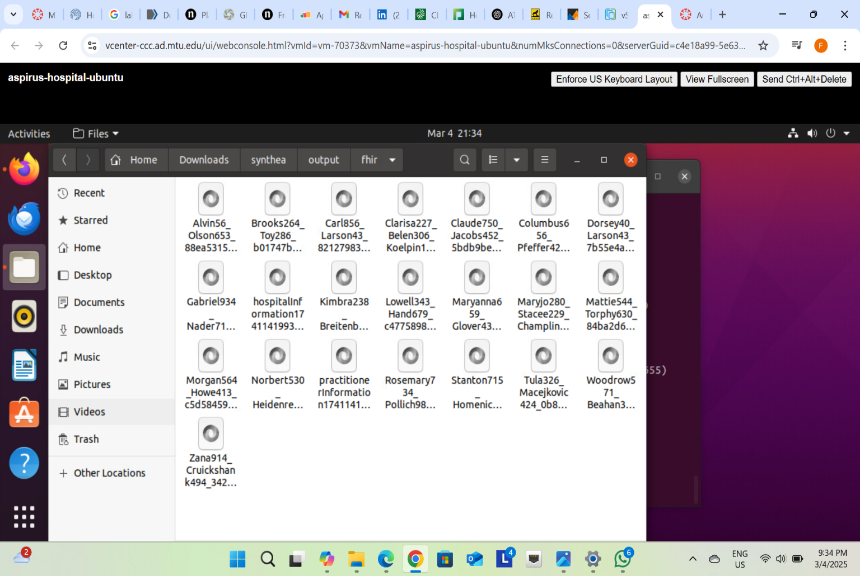

**Portage Health Hospital**

**

**MGH Hospital**

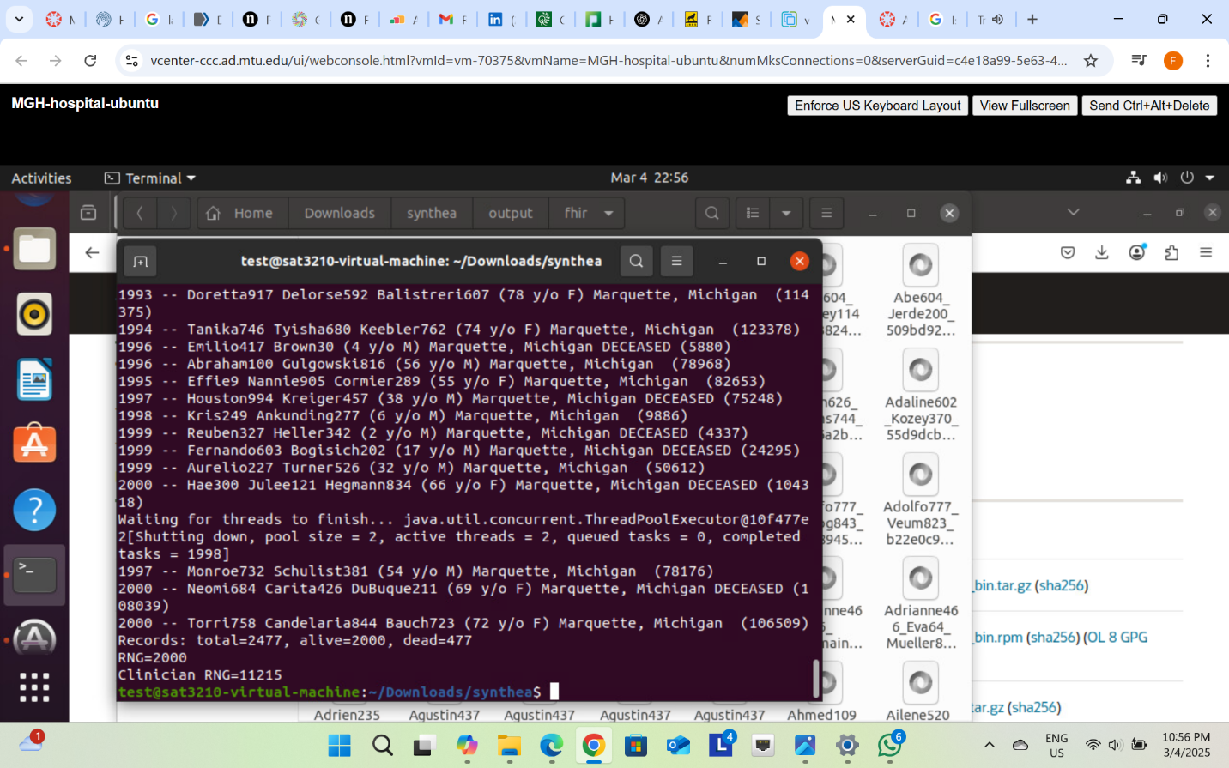

1. **Completed Table**

|  |  |  |
| --- | --- | --- |
| Hospital | % Used of Total Served  Hospital Population | Amount of COVID Patients Created |
| Aspirus | 0.4 | 20 |
| Portage Health | 0.5 | 45 |
| BCMH | 2 | 140 |
| MGH | 10 | 2000 |

1. This project was not very challenging. However, I was uncertain about which java development kit (kit) to download because a number of downloadable files were available on the website.