**SAT 5424 – HAPI FHIR ASSIGNMENT**

**Name: Frederick Damptey**

1. Screenshots of default web UI of Hapi FHIR

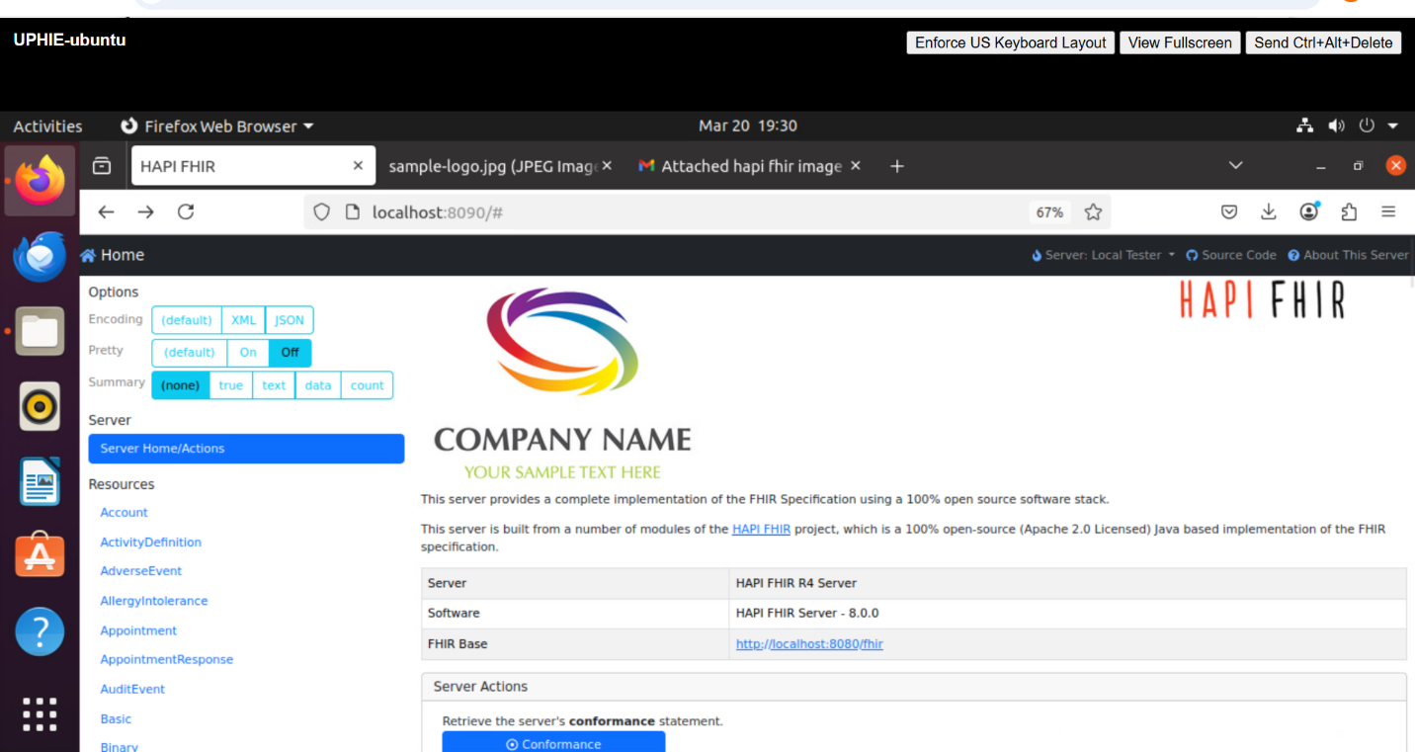

1. Command for checking the total, used, and free memory in system if you thought the HAPI-FHIR server was not running properly due to lack of memory.

**Command: free -h**

1. Command for checking if port 8090 is opened and active

**Command 2: sudo nc -zp “VM IP address” 8090 – This displays specifics.**

Or

**Command1: sudo ufw status – This displays active port.**

1. If the HAPI-FHIR server fails to start and you want to ensure that there are no other processes occupying the default port 8090. What command should you use to check if the port 8080 is currently in use?

Answer

**Command: sudo netstat tuln | grep 8090**

**Screenshot**

