# Initial wildfire suppression efforts select for more extreme fuel and climate burning conditions in a seasonally dry forest

Michael J. Koontz1,2,*, Zachary L. Steel3, Andrew M. Latimer1,2, Malcolm P. North1,2,4

1Graduate Group in Ecology, University of Californa, Davis, CA, USA  
2Department of Plant Sciences, University of California, Davis, CA, USA  
3Department of Environmental Science and Policy, University of California, Berkeley, CA, USA  
4USDA Forest Service, Pacific Southwest Research Station, Mammoth Lakes, CA, USA

*Correspondence: michael.koontz@colorado.edu

Date report generated: April 21, 2019

## Abstract

Typical fire effects in Sierra yellow pine/mixed-conifer forests are dominated by large fires, and potential fire effects of rapidly suppressed fires are never realized. Milder fuel and weather conditions facilitate suppression, and thus typical fire effects materialize during more extreme conditions on average. This amounts to a selection pressure on burning conditions that may lead to a selection bias in average fire effects. We formalize this selection framework and measure its influence on correlated, multivariate burning conditions of fuel and climate using the evolutionary ecology concept of phenotypic selection. Using fire “survivorship” to initial attack suppression efforts as a fitness metric, we find that initial containment efforts select for fires burning in more homogeneous fuel conditions and during hotter/drier conditions. Fire effects arise from a complex social-ecological system, with management decision-making having a strong ability to influence outcomes. We show a strong selection pressure on burning conditions imposed by management, and encourage further dismantling of barriers to applying this selection for resource benefit, such as by expanding implementation of wildfire use fires where natural ignitions are allowed to burn under moderate conditions.

## Introduction

A legacy of fire suppression is an oft-cited root cause underpinning the increasing size and severity of wildfires in the yellow pine/mixed-conifer forests of California’s Sierra Nevada mountain range (Miller and Thode 2007; Calkin *et al.* 2015; Safford and Stevens 2017). While most of this ecosystem would experience frequent, low- to moderate-severity wildfire every 8 to 15 years in the several centuries prior to Euroamerican settlement, suppression management has largely eliminated fire effects from much of western dry forested land in the past 100 years (Steel *et al.* 2015; Safford and Stevens 2017; Miller and Safford 2017). A lack of frequent fire has led to densification of Sierra yellow pine/mixed-conifer, which increases fuel loading and homogenizes forest structure (Collins *et al.* 2016; Stephens *et al.* 2018). Synergistic alignment of these extreme fuel conditions with earlier snow melt, longer fire seasons, and hotter droughts (aka “climate change droughts”) (Westerling 2006, 2016; Abatzoglou and Kolden 2013; Abatzoglou and Williams 2016) increases the probability that fires will generate self-propagating behavior (Coen *et al.* 2018) and kill all (or nearly all) overstory vegetation (Koontz *et al.* 2019b) in large, contiguous patches of mortality (Stevens *et al.* 2017). The Sierra yellow pine/mixed-conifer community is ill-adapted to regenerate in the centers of these large patches, which are far from seed sources (Welch *et al.* 2016). Thus the modern trend of atypically large, contiguously stand-replacing fires in this system compromises forest resilience and increases the potential for long-term shifts in vegetation type to shrub- or grasslands (North *et al.* 2009; Millar and Stephenson 2015; Stevens *et al.* 2017).

Ongoing fire suppression also strongly influences fire effects. Fire suppression generally is very effective at its immediate goal of extinguishing fires; between 1970 and 2002, 97 to 99% of fires burning on U.S. Forest Service land were contained before they reached 120 hectares in size (Calkin *et al.* 2005, 2015). The “10 a.m. policy”, which dictated that fires should be put out before 10 a.m. on the day following their discovery, has been modified since its establishment as firefighting policy in the 1930’s but its aggressive spirit persists in today’s modern firefighting apparatus (Dale 2006; Johnson *et al.* 2009). Mild weather and fuel conditions facilitate early suppression efforts (Calkin *et al.* 2015; Abatzoglou *et al.* 2018), and the fires that escape initial attack and grow large are often assumed to have grown to these sizes because they were burning under more extreme conditions (Calkin *et al.* 2014).

While the vast majority of fires are managed for suppression in the western U.S., including the Sierra yellow pine/mixed-conifer system (Calkin *et al.* 2015), a small number of natural ignitions are allowed to burn under moderate conditions as “wildland fire use” (WFU) fires in recognition of the benefit that fire has to forest resources (Davis 1979). WFU fire effects tend to fall within the natural range of variation for the Sierra Nevada yellow pine/mixed-conifer system (Meyer 2015). Though many studies recommend WFU fires as a means to restore forest resilience (Mallek *et al.* 2013; Meyer 2015; North *et al.* 2015; Collins *et al.* 2017; Stevens *et al.* 2017), barriers remain to their more widespread adoption (Doane *et al.* 2006).

The same mild fuel and weather conditions that contribute to beneficial outcomes of WFU fires contribute to early success of suppression efforts. Fire effects that may have arisen from fires that succumb to early suppression efforts never materialize. Instead, fire effects from suppression fires in this ecosystem are dominated by large fires, which account for approximately 97.5% of total burned area, exhibit fire effects that increase the likelihood of state change, and likely burn under the more extreme fuel and weather conditions that hindered early suppression efforts (Calkin *et al.* 2005). Thus, the general short-term success of fire suppression policy paired with its long-term cumulative effect has led to a management paradox with respect to forest management aiming to restore resilience: *we shouldn’t put out the fires that we can, and we can’t put out the fires that we should*.

Wildfire suppression management has shifted the distribution of fire behavior, and therefore the distribution of fire effects, to be more extreme (Calkin *et al.* 2015). Here, we introduce the evolutionary ecology concept of “phenotypic selection” as a formal framework for measuring the magnitude of this distributional shift– the selection by suppression. We use a new dataset of fire severity (Koontz *et al.* 2019a) to quantify the strength of “selection” on wildfire burning conditions (regional climate, wind speed, vegetation density, vegetation continuity) imposed by initial attack suppression efforts, and discuss its implications for fire effects.

## Methods

### Study system

The Sierra Nevada yellow pine/mixed-conifer (hereafter Sierra YPMC) is a disturbance-prone forest system in the Sierra Nevada mountain range of California, U.S.A. It spans the full 628 kilometer latitudinal length of the Sierra Nevada, and 2,500 meters of elevation (300 meters to 2800 meters), primarily on the western slope of the mountain range (Safford and Stevens 2017). The forest is dominated by ponderosa pine (*Pinus ponderosa*), sugar pine (*Pinus lambertiana*), white fir (*Abies concolor*), and incense cedar (*Calocedrus decurrens*) in varying mixes. Prior to Euroamerican settlement, the ecosystem experienced frequent, low- to moderate-severity wildfire every 8 to 15 years on average (Steel *et al.* 2015; Safford and Stevens 2017), which consumed surface fuels but generally had minimal effects on large, established trees. This fire regime generated heterogeneous horizontal forest structure, with groups of relatively even-aged trees having interlocking crowns, individual trees with distinct crowns, and variably-sized gaps between these tree clump and individual tree structural features (Lydersen *et al.* 2013). A century of fire suppression has led to infill of these gaps, homogenizing the horizontal forest structure and compromising forest resilience in an era of climate change-induced hotter droughts (North *et al.* 2009; Millar and Stephenson 2015; Collins *et al.* 2016).

For our study, we compiled the Sierra YPMC type using the U.S. Forest Service Fire Return Interval Departure (FRID) dataset and included “dry mixed-conifer”, “moist mixed-conifer”, and “yellow pine” vegetation types following Steel *et al.* (2018) and Koontz *et al.* (2019b). These classifications represent “potential vegetation” given the climate of the area, such that there is no influence of recent disturbance events (Harvey *et al.* 2016; Steel *et al.* 2018; Koontz *et al.* 2019b).

### Context of Sierra YPMC wildfire

To describe the modern context of wildfire activity in the Sierra Nevada yellow pine/mixed-conifer system, we used geospatial records contained in Short (2017) (U.S. Forest Service Fire Program Analysis Fire Occurrence Database; FPAFOD), the most comprehensive database of wildfire occurrence for the United States representing 1.88 million wildfire records from 1992 to 2015.

The FPAFOD contains point locations for the centroids of each fire’s footprint, rather than the perimeter of each fire as in some other databases (Eidenshink *et al.* 2007). We spatially subsetted the FOD data to fire events whose centroids occurred within the Sierra Nevada mountain range, as defined by the Jepson geographic subdivisions (north, central, and south Sierra Nevada Foothills and High Sierra Nevada, as well as the Tehachapi Mountain Area) (JepsonFloraProject 2016). For each fire record, we approximated its footprint by creating a circular buffer around the centroid with an area equivalent to the reported area of the fire. Using this footprint approximation, we calculated the proportion of area that intersected with our compilation of Sierra YPMC from the FRID dataset. We retained all fires with greater than zero area of the approximate footprint covering the Sierra YPMC extent. We calculated burn duration as the number of days between the containment date and the alarm date, and retained all fires with a burn duration of greater than 0 and less than 364 days to eliminate likely errors in reporting of alarm and containment dates (e.g., switched alarm date and containment date creating negative burn duration, typo in containment year creates a 5+ year burn duration).

### Measuring wildfire severity

The CalFire Fire Resource and Protection Program (FRAP; <http://frap.fire.ca.gov/>) maintains the most comprehensive Dataset of wildfire perimeters in the state of California, including attribute data for each fire such as its discovery date, its containment date, and the management objective. The management objective represents the approach taken by the management unit overseeing the wildfire– either “suppression”, with a goal of extinguishing the fire, or “wildland fire use”, with a goal of allowing the fire to burn to benefit forest resources so long as it didn’t threaten lives or property (Meyer 2015). This dichotomy is somewhat simplistic, as each wildfire can be managed for multiple objectives, but it is a generally useful framework for understanding the primary management goal (Meyer 2015). This dataset contains all fires >4 hectares (and a non-comprehensive set of fires <4 hectares), and thus has greater representation of fire events compared to other wildfire events datasets, though it lacks severity information. For instance, the Monitoring Trends in Burn Severity (MTBS) database only contains wildfires in the western U.S. that are larger than 400 hectares (Eidenshink *et al.* 2007) and the U.S. Forest Service Region 5 geospatial database contains wildfires in the Sierra Nevada that are larger than 80 hectares (Steel *et al.* 2018), though both of these datasets contain information on wildfire severity.

Koontz *et al.* (2019a) used the expanded FRAP dataset of over 1,000 wildfire perimeters to calculate wildfire severity and calibrate satellite-derived measures using ground-based overstory composite burn index (CBI) (Koontz *et al.* 2019b), which is an integrated measure of the effect of a wildfire on the forest overstory one year after the burn (Key and Benson 2006). CBI correlates well with direct measures of fire impact to vegetation in Sierra YPMC, such as percent of overstory mortality (Miller and Thode 2007). Thresholds of wildfire severity (unchanged, low, moderate, and high) calibrated to the full dataset (Koontz *et al.* 2019b) were imposed on each fire and then contiguous pixels of each category were vectorized into polygons to form patches of each severity category. We subsetted this FRAP-derived dataset of fire severity to 622 that burned in majority yellow pine/mixed-conifer forest (547 suppression fires; 75 WFU fires).

### Burning conditions per fire event

In addition to mapping wildfire severity across each fire in the FRAP perimeter database, Koontz *et al.* (2019b) also calculated fuel and regional climate variables within the burn perimeter. The prefire Normalized Difference Vegetation Index (NDVI; Rouse *et al.* (1973)]) was found to correlate strongly with local wildfire severity, as was the standard deviation of NDVI within the 90m x 90m window surrounding each pixel, which represents a measure of horizontal forest structure and fuel continuity (Koontz *et al.* 2019b). The gridMET product (Abatzoglou 2013) was used to calculate the energy release component, a modeled estimate of expected fire behavior in conifer forest, for the 3 days prior to each fire’s discovery date as well as the wind speed for the first three days of the fire. The gridMET product has a daily temporal resolution and a 4 kilometer spatial resolution, so our climate variables capture regional conditions over time periods of several days, but not very local weather events that might occur over the span of hours. Each of these variables has a strong impact on wildfire behavior at macroscales (Abatzoglou and Kolden 2013).

For this study, we assigned prefire burning conditions for each fire as the mean fuel (prefire NDVI, prefire standard deviation of NDVI within 90m x 90m moving windows) and regional climate (energy release component for 3 days prior to the fire, wind speed for first 3 days of the fire) values within each fire perimeter.

For each fire, we calculated the total number of fires burning on that fire’s alarm date, the proportion of area represented by each severity category, as well as the maximum patch size of each severity category. Finally, we calculated the stand replacing decay coefficient (SDC) (Collins *et al.* 2017; Stevens *et al.* 2017), a single metric that integrates high severity patch size and shape such that a lower SDC corresponds to a larger, more circular high severity patches with effectively more area within those patches far from the patch edges.

### Designating “survivorship” of suppression fires

For each wildfire in the Koontz *et al.* (2019b) dataset with a suppression management objective, we determined whether it “survived” initial attack by whether its burn duration (discovery date subtracted from the containment date) was greater than 1 day. Following Abatzoglou *et al.* (2018), we assumed that fires under a suppression management objective that burned for more than one day would require different firefighting tactics than direct attack and thus represented a reconfiguration of firefighting personnel and resource allocation.

### Quantifying the selection effect of fire suppression

We treated the prefire fuel (prefire NDVI, heterogeneity of NDVI) and climate conditions (prefire energy release component, early fire wind speed) as wildfire “phenotypes” having some distribution, and used logistic regression to measure the extent to which wildfire suppression “selected” for particular burning condition phenotypes using the survivorship of each fire to initial attack as a binary response fitness metric in an evolutionary ecology framework (Lande and Arnold 1983; Janzen and Stern 1998).

### Implications of selection by suppression

We graphically compare fire effects (event size, stand replacing decay coefficient, proportion high severity) of suppression fires to those of wildfire use (WFU) fires to draw inferences about how the “lost contribution” of fires that succumbed to early containment may have influenced fire effects.

### Software and data availability

Our selection model was fit using the brms (Bürkner 2017) package in R (R Core Team 2018). Our workflow greatly benefited from the tidyverse group of packages (Wickham 2017), and we manipulated spatial data using the following R packages: sf (Pebesma 2018), raster (Hijmans *et al.* 2019), velox (Hunziker 2017), stars (Pebesma 2019a), lwgeom (Pebesma 2019b), fasterize (Ross 2018), and APfun (Plowright 2018).

The original severity dataset created by (Koontz *et al.* 2019a) can be found on the Open Science Framework (<https://osf.io/ke4qj/>). The data and code for this study can also be found on the Open Science Framework.

## Results

### Fire event size and burn duration context of Sierra YPMC wildfire

We found that 16219 fire events burned at least partially in Sierra Nevada yellow pine/mixed-conifer between 1992 and 2015 covering 2.19 million total hectares and 1.18 million hectares of this forest type. A total of 14873 fires burned in greater than 50% Sierra yellow pine/mixed-conifer in the same period. The vast majority of these fire events were very small. Comparing the distribution of fire sizes in this system between 1992 and 2015 to relevant reference sizes:

* 61.46% of fires were smaller than 0.09 hectares– the size of a single pixel from Landsat which is a USGS satellite product often used to measure fire effects by comparing imagery just before the fire to imagery one year after the fire (Miller and Thode 2007).
* 98.87% of fires were smaller than 400 hectares– the minimum fire size for inclusion in the MTBS dataset for the western U.S. (Eidenshink *et al.* 2007), meaning that MTBS would include approximately 1.13% of fires in this system.
* 97.93% of fires were smaller than 80 hectares– the minimum fire size for inclusion in the USFS Region 5 geospatial dataset (Steel *et al.* 2018), meaning that the USFS Region 5 data accounts for approximately 2.07% of fires in this system.
* 94.88% of fires were smaller than 4 hectares– the minimum fire size for inclusion in the CalFire FRAP fire perimeter dataset which was used to derive the Koontz *et al.* (2019a) severity dataset. Thus, the Koontz *et al.* (2019a) dataset includes approximately 5.12% of fires in this system during its time span of 1984 to 2017.

### Context of suppression fires compared to wildfire use (WFU) fires

There is a clear multimodality in the distribution of suppression fire event size while wildfire use fire event sizes are lognormally distributed (Figure 1). Under a suppression management objective, most fires are successfully contained at relatively small sizes while WFU fires are larger on average. This effect is obscured when comparing median fire sizes between management objectives using just larger fires (Table 1).

Table 1: Comparison of fire event sizes by management objective for fires burning in majority yellow pine/mixed-conifer in the Sierra Nevada between 1984 and 2017. Median fire size of all suppression fires is much lower than the median fire size of WFU fires, owing to the highly successful early suppression efforts. This size difference becomes less apparent as the minimum fire size in the dataset is increased, as is the case for fire effects datasets that focus on tracking larger fire events (e.g., U.S. Forest Service Region 5 GIS dataset with a minimum fire size of 80 ha or MTBS with a minimum fire size of 400 ha in the western U.S. The size difference is likely to be even more dramatic than what can be seen in the FRAP-derived Koontz *et al.* (2019b) dataset with its comprehansive coverage of fire greater than 4 ha (and some additional fires smaller than this threshold), as nearly 95% of wildfires in the Sierra yellow pine/mixed-conifer region remain even smaller than 4 ha.

|  |  |  |  |  |
| --- | --- | --- | --- | --- |
| Management objective | Median fire size (ha) All FRAP fires | Median fire size (ha) Fires > 4ha | Median fire size (ha) Fires > 80ha | Median fire size (ha) Fires > 400ha |
| suppression | 16.77 | 29.13 | 582 | 1459 |
| wfu | 193.1 | 205.4 | 506.7 | 866.5 |

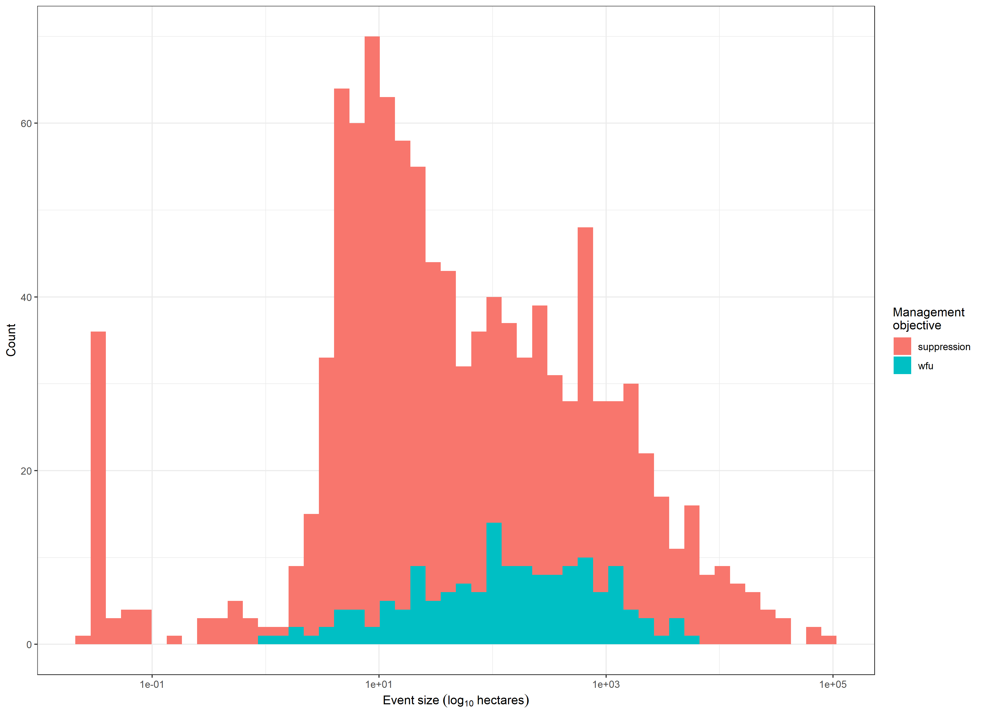

Figure 2: Distribution of log fire event size by management objective. While wildfire use fires exhibit a lognormal distribution in size, suppression fires exhibit clear multimodality with many fires extinguished when they are very small.

### Selection by suppression

We found a sizable effect of phenotypic selection of initial attack suppression on the heterogeneity of NDVI and prefire energy release component. Wildfires that survived initial attack were more likely to be burning in more extreme, homogeneous fuels (lower heterogeneity of NDVI) and in more extreme, hotter/drier climate conditions (higher energy release component) compared to wildfires that succumbed to the initial attack. We detected no selection pressure on prefire vegetation density as measured by NDVI or wind speed during the first three days of the fire (Figure 3; Figure 4).

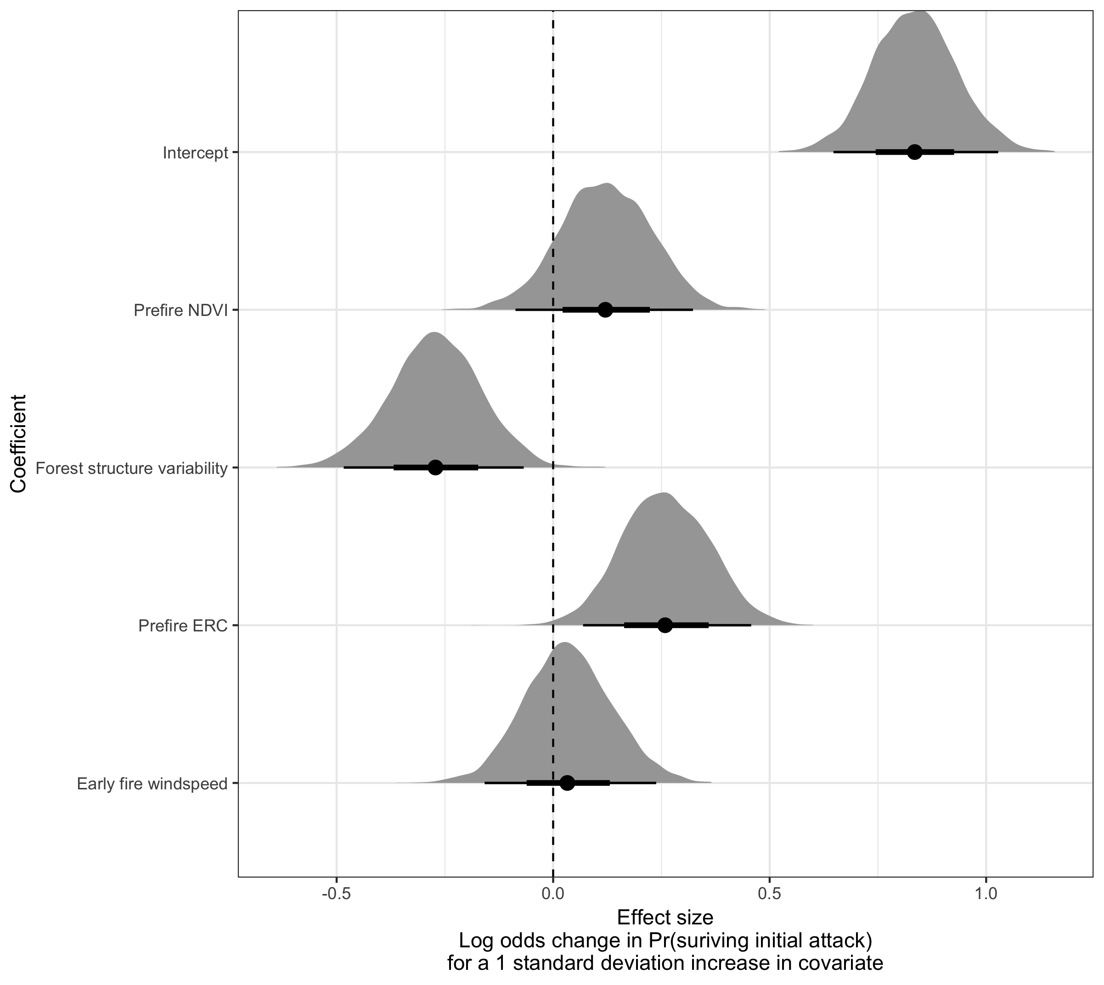

Figure 3: Halfeye plot showing posterior distributions of coefficient estimates for model predicting the probability of wildfire survivorship in the first 48 hours of initial attack. The effect sizes are proportional to the ‘strength of selection’ of initial attack on the burning conditions of wildfire. Credible intervals are shown below each probability density function with the point representing the mean, the dark line representing the 66% credible interval, and the light line representing the 95% credible interval. The dotted line shows an effect size of zero.

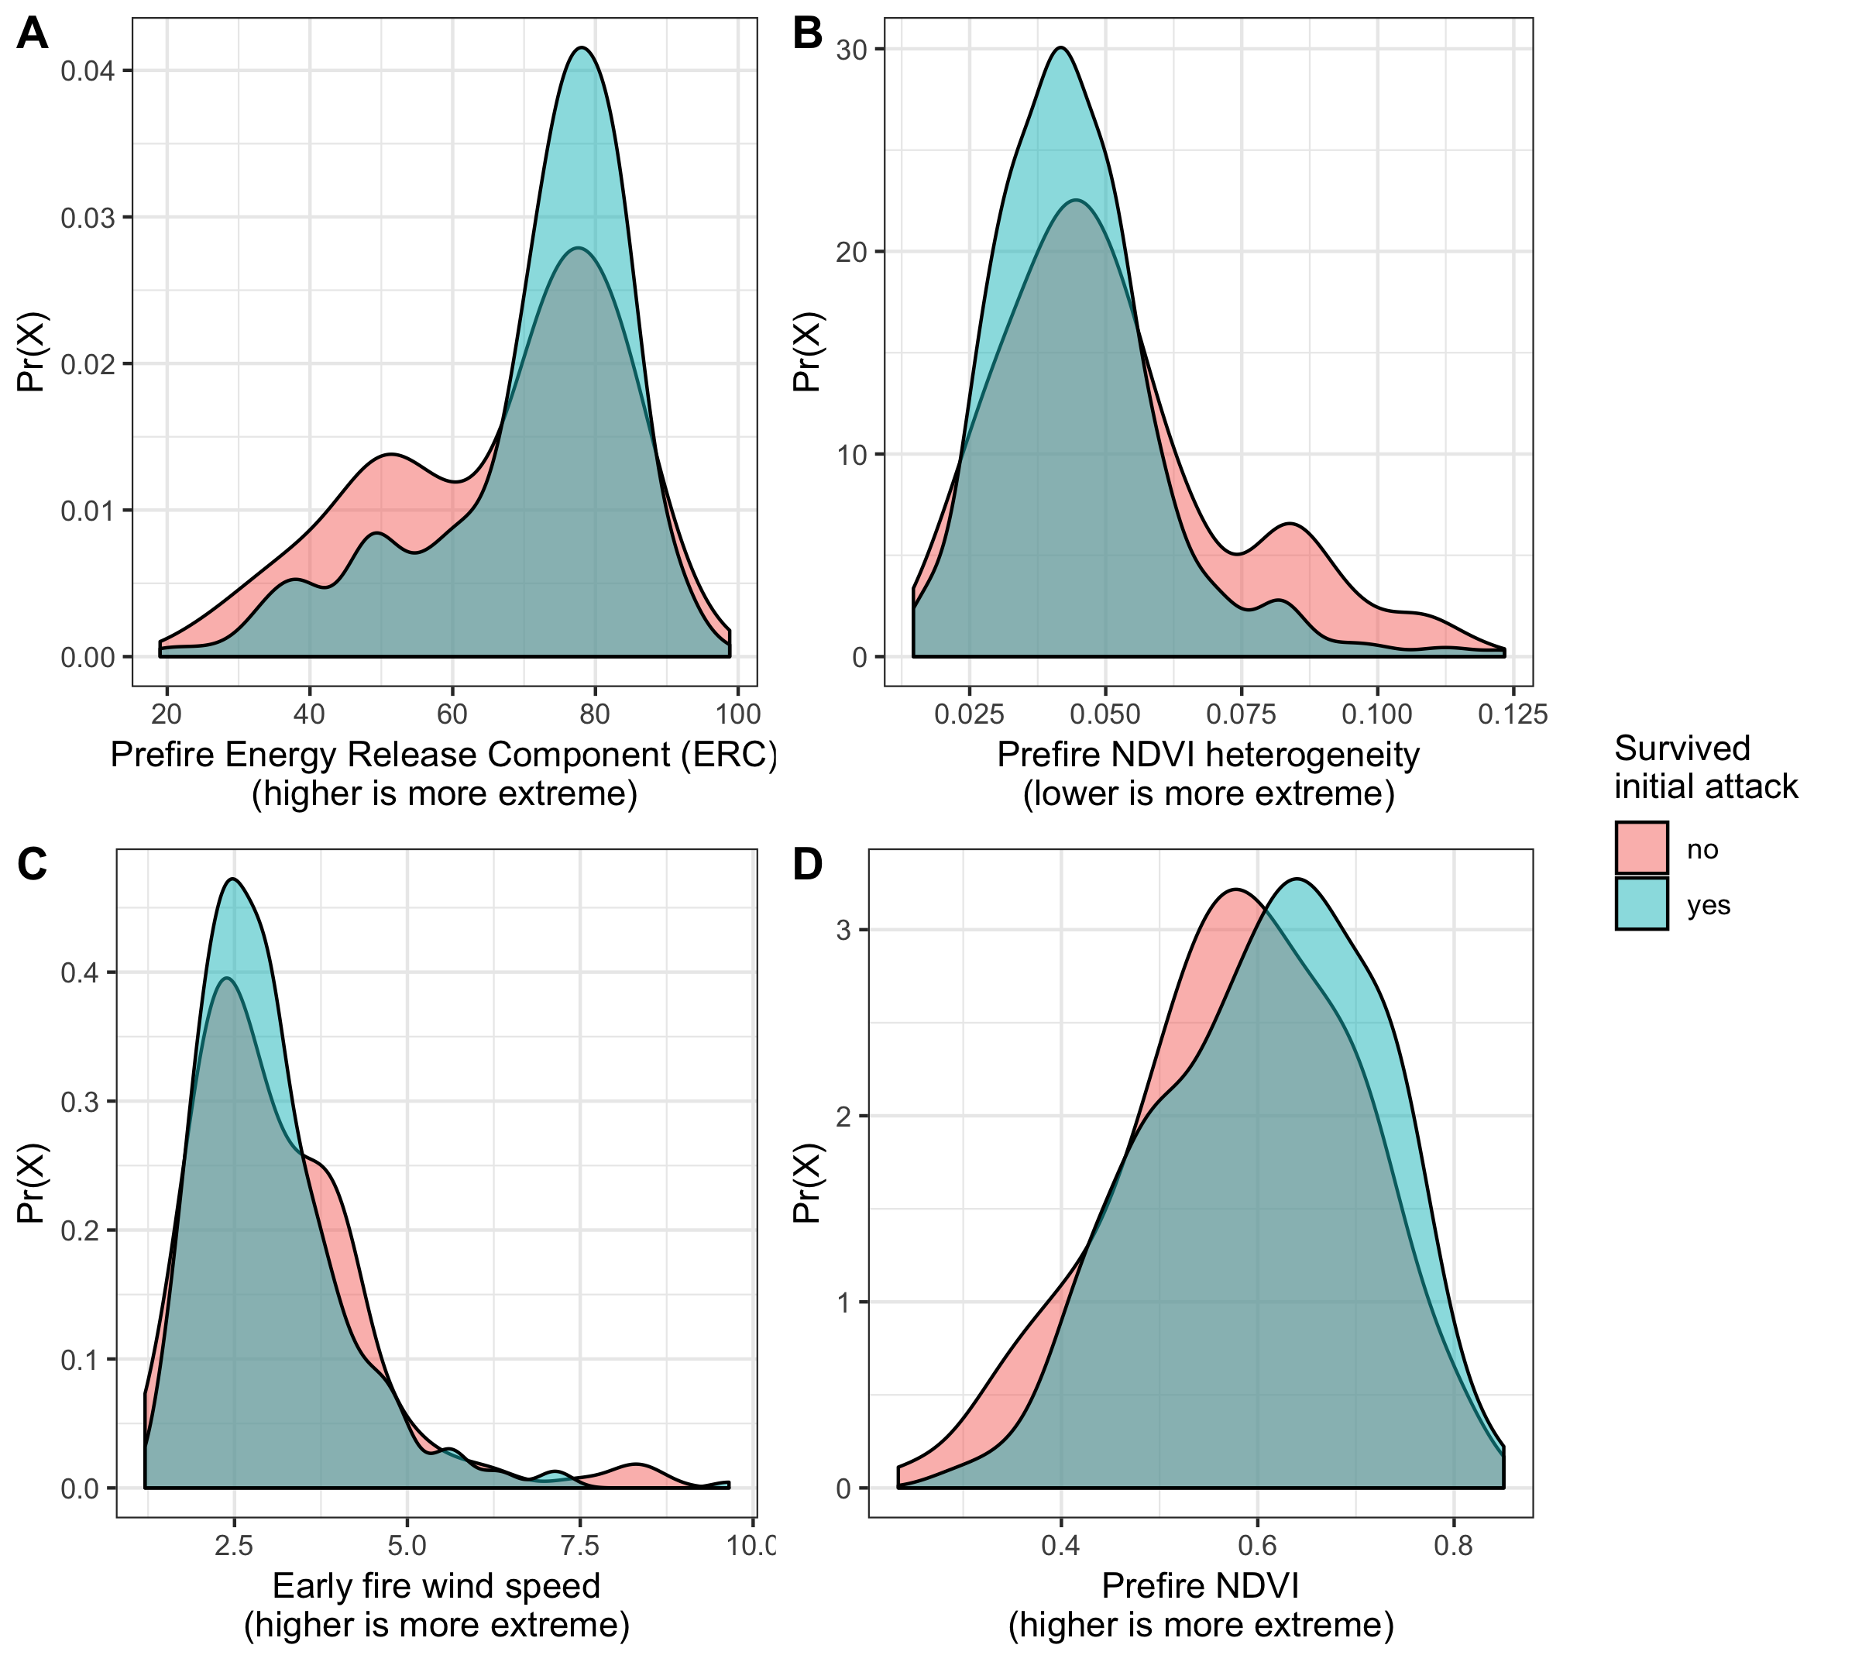

Figure 4: The selection effect on the vegetation and climate burning conditions of suppressed wildfires. A) Early suppression efforts selected for greater energy release components, an estimate of fireline intensity correlated to hot, dry conditions. B) Fires surviving initial suppression efforts burn in more homogenous fuels, as measured by the standard deviation of NDVI in a 90m x 90m window. C) We detected no selection pressure on windspeed for the first 3 days of the fire. D) We detected no selection pressure on prefire NDVI, which is correlated with overstory canopy density and surface fuel loads.

### Implications of selection by suppression for fire effects

We also found that fire effects of event size, proportion of high severity, and stand replacing decay coefficient showed a similar trend (i.e., slope) in suppression versus WFU fires as a function of burn duration, except for those suppression fires with short burn durations. However, the average fire effects (i.e., intercept) of suppression fires tended to depart from effects of WFU fires and resulted in greater proportion of high severity and a lower stand replacing decay coefficient. The notable exception to these trends are suppression fires with short burn durations, which experienced a strong selection pressure on their burning conditions and whose fire effects were dramatically different from fire effects of suppression fires that burned for longer. Suppression fires that succumbed early to containment were much smaller, had lower proportions of high severity, and had much higher stand replacing decay coefficients than suppression fires that escaped initial attack Figure 5). The fire effects of suppression fires that were successfully contained were within the range of variation of WFU fires for similar burn durations.

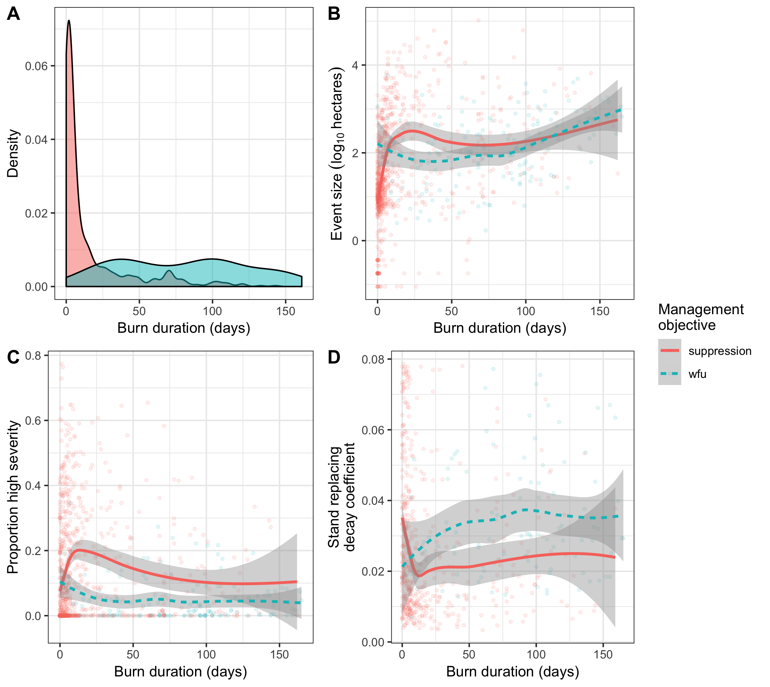

Figure 5: A) Distribution of burn duration by management objective. Most suppression fires are quickly extinguished. B) Effect of burn duration on fire event size shows that there’s a similar trajectory between suppressed and wildfire use fires except early in the burning period when suppression fires remain small. C) The high severity portion of the fire tends to increase with shorter-duration suppression fires, but is relatively constant across burn durations for wildfire use fires. D) For fires with a high severity component, the stand replacing decay coefficient sharply declines for short-lived fires indicating that the high severity patches are larger and simpler which may reduce tree propagule pressure in the center of these patches and compromise dry forest regeneration. The SDC tends to increase with the burn duration for wildfire use fires.

## Discussion

Wildfire effects to forest vegetation are outcomes of a complex social-ecological system dynamic (Calkin *et al.* 2015). Direct causes of fire effects to vegetation arise from fire behavior and intensity (Keeley 2009), which are coupled to fuel, weather, and topography (McKenzie and Hessl 2008; Cansler and McKenzie 2014; Harvey *et al.* 2016). Wildfire effects are indirectly related to firefighting resource availability, legacies of management policy that change fuel distributions, and incentive structures that often prioritize mitigating short term loss of resources over long-term benefits of wildfire (Houtman *et al.* 2013; Calkin *et al.* 2014, 2015). Fire suppression allows some fires to “survive” initial containment efforts and contribute to fire effects on the landscape, while other fires are “killed” by initial containment and their potential fire effects are never realized. Because milder fuel and climate conditions facilitate fire containment efforts, initial attack suppression imposes selection for fires that burn under more extreme conditions and shifts the concomitant distribution of fire effects to also be more extreme. We measured this selection pressure and found a sizable influence of initial suppression efforts that decreased average fuel heterogeneity and increased average energy release component for fires that contribute to fire effects on the landscape (i.e., those that survive initial containment). Two primary implications follow from our findings:

1. There is a lost contribution to overall fire effects in Sierra Nevada yellow pine/mixed-conifer forests associated with fires that are extinguished before they have a chance to burn under the milder conditions that facilitated their early containment (Figure 5).
2. The fire effects that are measured only on large fires reflect a selection bias imposed by suppression efforts (Figure 6).

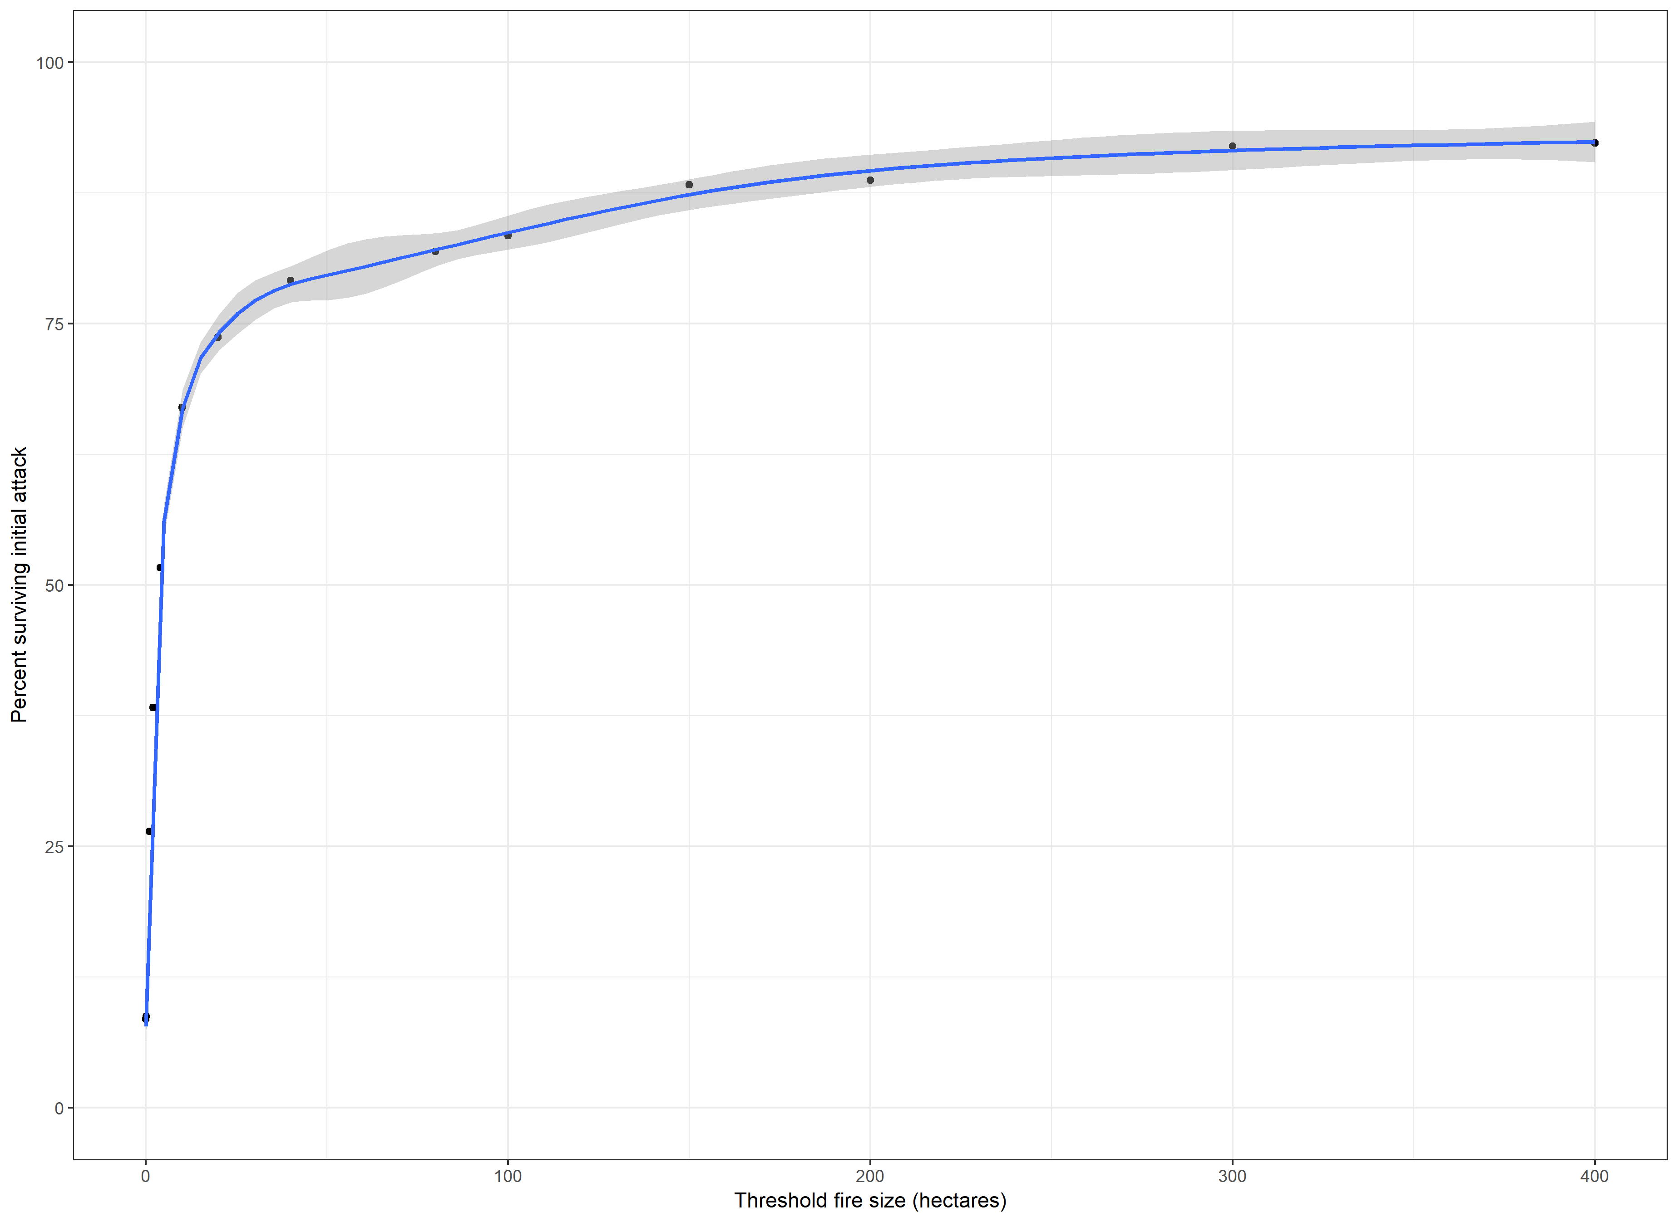

Figure 6: As the minimum fire event size of a dataset increases, a greater proportion of those fire events survived initial attack suppression efforts and burned on average under more extreme conditions. Thus databases with larger minimum fire sizes exhibit a stronger bias towards fires that burned in extreme conditions as a result of selection by suppression.

### Context of suppression management on fire effects

We compared fires managed for suppression to those managed for wildfire use/resource benefit to assess how the selection pressure on burning conditions may ultimately influence fire effects. We demonstrated a clear multi-modality in the fire event size distribution of wildfires managed with a suppression objective (Figure 1). The median fire size of all fires in the dataset was much larger for WFU fires than for suppression fires, but the median fire size of *large* fires (e.g., fires greater than 80 or 400 hectares) was much larger for suppression fires (Table 1). Miller and Safford (2017) found a similar pattern in comparing the average size of modern fires, most of which are managed with a suppression objective, to pre-Euroamerican settlement fires– modern, suppression fires are smaller on average compared to the natural range of variation, but modern large fires are much larger compared to the natural range of variation (Safford and Stevens 2017; Miller and Safford 2017).

Fire effects of escaped suppression fires were more departed from effects of WFU fires for the same burn duration (Figure 5). However, fire effects of suppression fires that succumbed to early suppression efforts were generally beneficial when considering WFU fires as a reference for beneficial effects. We cannot use our data to make a rigorous counterfactual prediction of how suppression fires that didn’t survive initial attack may have ultimately influenced the overall distribution of fire effects if they had been allowed to burn. However, the detected selection by suppression effect for extreme burning conditions suggests that, had these fires burned for longer, they may have contributed to shifting the average fire effects of all suppression fires closer to the observed fire effects for WFU fires (Figure 5).

### No detected effect of windspeed

Surprisingly, we found no selection pressure on wind speed by early suppression efforts (Figure 3). Abatzoglou *et al.* (2018) found across the U.S. that greater wind speeds during the first two days after human-caused ignitions increased the likelihood that fires would grow large. Wind speed may not reflect a limiting factor in early suppression efforts in this region compared to fuel continuity and fuel moisture as measured by energy release component. Alternatively, the gridMET-derived wind speed in our study may be less representative of how wind affects fire behavior in this particular system. That is, wind may play a strong role, but the mountainous terrain may create more local wind conditions than can be captured by the gridMET product, despite its high spatial and temporal resolution (Abatzoglou 2013).

### Selection beyond initial attack

We demonstrated a strong directional effect of selection imposed by initial suppression efforts on the initial burning conditions of wildfires in the Sierra yellow pine/mixed-conifer system. Fire effects arise from the confluence of fuel, weather, and topographical conditions in space and time, and thus our event-level (i.e., per fire) measurements of burning conditions may mask some of this selection effect. We suspect this effect may be even stronger if weather conditions were known at finer temporal scales and fuel conditions were known at finer spatial scales. While we have shown a selection effect of suppression during an initial attack response, the effect may not be limited to soon after ignition (i.e., the scope of our investigation). Whether a similar selection by suppression effect would materialize beyond initial attack and *throughout* the course of a fire’s burn duration depends on the extent to which success in suppression is contingent upon fuel and weather conditions cooperating with firefighting efforts. That is, preventing additional fire effects to the landscape by extinguishing fires as soon as the weather or fuel conditions become more conducive to suppression amounts to imposing a similar selection effect that we detected during initial attack suppression. Finer spatial and temporal resolution of burning conditions (e.g., daily climate variables paired with daily fire spread/severity maps) throughout the course of wildfires may help tune our understanding of how management efforts can select for burning conditions. For example, aggressive suppression management may impose the strongest selection pressure on fuel and climate conditions from the day of or the day prior to the fire. Alternatively, WFU management may impose the strongest selection pressure on *future* fuel and climate conditions, which would reflect managers’ efforts to guide the spread of fire into forecasted spatiotemporally favorable intersections of fuel and climate.

### Positive feedbacks

Selection for more extreme burning conditions favors future extreme burning conditions in positive feedbacks of fuel and climate. Homogeneous local forest structure makes this system more likely to burn at high severity, with complete or nearly-complete mortality of overstory vegetation (Koontz *et al.* 2019b). While some high severity fire is expected (Safford and Stevens 2017), elevated average levels and increased continuity of high-severity fire and make it more likely that regenerating vegetation and future fuel structure will also be homogeneous (North *et al.* 2009; Coppoletta *et al.* 2016; Miller and Safford 2017; Stevens *et al.* 2017). On longer time scales, the selection by suppression for hotter/drier average burning conditions may favor high-severity fire in the short run (Fried *et al.* 2004; Koontz *et al.* 2019b), and may compromise forest recovery (Young *et al.* 2019), carbon stock stability (Earles *et al.* 2014), and carbon sequestration (Millar and Stephenson 2015) in the long run. A reduction in carbon sequestration capacity contributes to climate forcing, which is likely to perpetuate hot, dry conditions in California (Diffenbaugh *et al.* 2015; Mann and Gleick 2015). Ongoing selection for extreme burning conditions by fire suppression therefore creates positive feedbacks of burning conditions that are unfavorable to yellow pine/mixed-conifer forest persistence.

### A selection effect on WFU fires, too

A conceptually similar, but directionally opposite selection pressure may bias the distribution of fire effects that arise from wildfire use fires. The decision to let a candidate WFU ignition continue to burn as a WFU fire when conditions are more mild selects for a distribution of fire effects that arises from these more mild burning conditions. As with the selection by suppression, the distribution of fire effects of WFU fires will be dictated by the fires whose fire effects were allowed to materialize (i.e., by deciding to let them burn in the WFU case versus being unable to stop them from burning in the case of suppression fires that escape initial attack). The fire effects from WFU fires are largely seen as beneficial, but their average effect should be considered as a better-than-average scenario for reintroducing fire to previously fire-suppressed forests compared to the expectations of fire effects if all candidate WFU ignitions were allowed to burn. Similarly, the fire effects of suppression fires that escape initial attack are largely seen as negative, but their average effect should be treated as a worse-than-average scenario for reintroducing fire to the landscape compared to fire effects that would arise from letting all ignitions run their course.

The selection bias in both cases (suppression and WFU fires) reflects the social element in the coupled social-ecological system of wildfire and wildfire management. Management decisions, even as a fire burns, can hold great sway over ultimate fire effects to the forest system in their capacity to impose selection on the distribution of burning conditions. This strong influence of on-the-ground management decision-making points to the immense value of reducing barriers to implementing more wildfire use fires through increased training and reorganized incentive structures (Doane *et al.* 2006).

## References

Abatzoglou JT. 2013. Development of gridded surface meteorological data for ecological applications and modelling. *International Journal of Climatology* **33**: 121–31.

Abatzoglou JT and Kolden CA. 2013. Relationships between climate and macroscale area burned in the western United States. *International Journal of Wildland Fire* **22**: 1003.

Abatzoglou JT and Williams AP. 2016. Impact of anthropogenic climate change on wildfire across western US forests. *Proceedings of the National Academy of Sciences* **113**: 11770–5.

Abatzoglou JT, Balch JK, Bradley BA, and Kolden CA. 2018. Human-related ignitions concurrent with high winds promote large wildfires across the USA. *Int J Wildland Fire* **27**: 377–86.

Bürkner P-C. 2017. **Brms** : An *R* Package for Bayesian Multilevel Models Using *Stan*. *Journal of Statistical Software* **80**.

Calkin DE, Cohen JD, Finney MA, and Thompson MP. 2014. How risk management can prevent future wildfire disasters in the wildland-urban interface. *PNAS* **111**: 746–51.

Calkin DE, Gebert KM, Jones JG, and Neilson RP. 2005. Forest Service Large Fire Area Burned and Suppression Expenditure Trends, 19702002. *j for* **103**: 179–83.

Calkin DE, Thompson MP, and Finney MA. 2015. Negative consequences of positive feedbacks in US wildfire management. *Forest Ecosystems 2:9 doi: 101186/s40663-015-0033-8* **2**.

Cansler CA and McKenzie D. 2014. Climate, fire size, and biophysical setting control fire severity and spatial pattern in the northern Cascade Range, USA. *Ecological Applications* **24**: 1037–56.

Coen JL, Stavros EN, and Fites-Kaufman JA. 2018. Deconstructing the King megafire. *Ecological Applications* **28**: 1565–80.

Collins BM, Lydersen JM, and Fry DL *et al.* 2016. Variability in vegetation and surface fuels across mixed-conifer-dominated landscapes with over 40 years of natural fire. *Forest Ecology and Management* **381**: 74–83.

Collins BM, Stevens JT, and Miller JD *et al.* 2017. Alternative characterization of forest fire regimes: Incorporating spatial patterns. *Landscape Ecology* **32**: 1543–52.

Coppoletta M, Merriam KE, and Collins BM. 2016. Post-fire vegetation and fuel development influences fire severity patterns in reburns. *Ecological Applications* **26**: 686–99.

Dale L. 2006. Wildfire Policy and Fire Use on Public Lands in the United States. *Society & Natural Resources* **19**: 275–84.

Davis JB. 1979. A new fire management policy on Forest Service lands. *Fire Technol* **15**: 43–50.

Diffenbaugh NS, Swain DL, and Touma D. 2015. Anthropogenic warming has increased drought risk in California. *PNAS* **112**: 3931–6.

Doane D, O’Laughlin J, Morgan P, and Miller C. 2006. Barriers to wildland fire use. **12**: 3.

Earles JM, North MP, and Hurteau MD. 2014. Wildfire and drought dynamics destabilize carbon stores of fire-suppressed forests. *Ecological Applications 24(4): 732-740* **24**: 732–40.

Eidenshink J, Schwind B, and Brewer K *et al.* 2007. A Project for Monitoring Trends in Burn Severity. *Fire Ecology* **3**: 3–21.

Fried JS, Torn MS, and Mills E. 2004. The Impact of Climate Change on Wildfire Severity: A Regional Forecast for Northern California. *Climatic Change* **64**: 169–91.

Harvey BJ, Donato DC, and Turner MG. 2016. Drivers and trends in landscape patterns of stand-replacing fire in forests of the US Northern Rocky Mountains (1984-2010). *Landscape Ecology* **31**: 2367–83.

Hijmans RJ, Etten J van, and Sumner M *et al.* 2019. Raster: Geographic Data Analysis and Modeling.

Houtman RM, Montgomery CA, and Gagnon AR *et al.* 2013. Allowing a wildfire to burn: Estimating the effect on future fire suppression costs. *Int J Wildland Fire* **22**: 871–82.

Hunziker P. 2017. Velox: Fast Raster Manipulation and Extraction.

Janzen FJ and Stern HS. 1998. Logistic Regression for Empirical Studies of Multivariate Selection. *Evolution* **52**: 1564–71.

JepsonFloraProject (Ed). 2016. Jepson eFlora.

Johnson JF, Bengston DN, and Fan DP. 2009. US Policy Response to the Wildfire Fuels Management Problem: An Analysis of the News Media Debate about the Healthy Forests Initiative and the Healthy Forests Restoration Act. *Journal of Environmental Policy & Planning* **11**: 129–42.

Keeley JE. 2009. Fire intensity, fire severity and burn severity: A brief review and suggested usage. *International Journal of Wildland Fire* **18**: 116.

Key CH and Benson NC. 2006. Landscape Assessment (LA).: 55.

Koontz MJ, Fick SE, and Werner CM *et al.* 2019a. Wildfire severity, vegetation characteristics, and regional climate for fires covering more than 4 hectares burning in yellow pine/mixed-conifer forests of the Sierra Nevada, California, USA from 1984 to 2017. *Open Science Framework*.

Koontz MJ, North MP, and Werner CM *et al.* 2019b. Local variability of vegetation structure increases forest resilience to wildfire. *EcoEvoRxiv*.

Lande R and Arnold SJ. 1983. THE MEASUREMENT OF SELECTION ON CORRELATED CHARACTERS. *Evolution* **37**: 1210–26.

Lydersen JM, North MP, Knapp EE, and Collins BM. 2013. Quantifying spatial patterns of tree groups and gaps in mixed-conifer forests: Reference conditions and long-term changes following fire suppression and logging. *Forest Ecology and Management* **304**: 370–82.

Mallek C, Safford H, Viers J, and Miller J. 2013. Modern departures in fire severity and area vary by forest type, Sierra Nevada and southern Cascades, California, USA. *Ecosphere* **4**: art153.

Mann ME and Gleick PH. 2015. Climate change and California drought in the 21st century. *PNAS* **112**: 3858–9.

McKenzie D and Hessl AE. 2008. A neutral model of low-severity fire regimes. *In: Narog, Marcia G, tech coord 2008 Proceedings of the 2002 Fire Conference: Managing fire and fuels in the remaining wildlands and open spaces of the Southwestern United States Gen Tech Rep PSW-GTR-189 Albany, CA: US Department of Agriculture, Forest Service, Pacific Southwest Research Station p 139-150* **189**: 139–50.

Meyer MD. 2015. Forest Fire Severity Patterns of Resource Objective Wildfires in the Southern Sierra Nevada. *Journal of Forestry* **113**: 49–56.

Millar CI and Stephenson NL. 2015. Temperate forest health in an era of emerging megadisturbance. *Science* **349**: 823–6.

Miller JD and Safford HD. 2017. Corroborating Evidence of a Pre-Euro-American Low- to Moderate-Severity Fire Regime in Yellow PineMixed Conifer Forests of the Sierra Nevada, California, USA. *Fire Ecology* **13**: 58–90.

Miller JD and Thode AE. 2007. Quantifying burn severity in a heterogeneous landscape with a relative version of the delta Normalized Burn Ratio (dNBR). *Remote Sensing of Environment* **109**: 66–80.

North MP, Stephens SL, and Collins BM *et al.* 2015. Reform forest fire management. *Science* **349**: 1280–1.

North M, Stine P, and O’Hara K *et al.* 2009. An ecosystem management strategy for Sierran mixed-conifer forests. Albany, CA: U.S. Department of Agriculture, Forest Service, Pacific Southwest Research Station.

Pebesma E. 2018. Simple Features for R: Standardized Support for Spatial Vector Data. *The R Journal*.

Pebesma E. 2019a. Stars: Spatiotemporal Arrays, Raster and Vector Data Cubes.

Pebesma E. 2019b. Lwgeom: Bindings to Selected ’liblwgeom’ Functions for Simple Features.

Plowright A. 2018. APfun: Geo-Processing Helper Functions.

R Core Team. 2018. R: A Language and Environment for Statistical Computing. Vienna, Austria: R Foundation for Statistical Computing.

Ross N. 2018. Fasterize: Fast Polygon to Raster Conversion.

Rouse W, Haas RH, Deering W, and Schell JA. 1973. MONITORING THE VERNAL ADVANCEMENT AND RETROGRADATION (GREEN WAVE EFFECT) OF NATURAL VEGETATION. Greenbelt, MD, USA: Goddard Space Flight Center.

Safford HD and Stevens JT. 2017. Natural Range of Variation for Yellow Pine and Mixed-Conifer Forests in the Sierra Nevada, Southern Cascades, and Modoc and Inyo National Forests, California, USA.

Short KC. 2017. Spatial wildfire occurrence data for the United States, 1992-2015 [FPA_FOD_20170508] (4th Edition).

Steel ZL, Koontz MJ, and Safford HD. 2018. The changing landscape of wildfire: Burn pattern trends and implications for California’s yellow pine and mixed conifer forests. *Landscape Ecology* **33**: 1159–76.

Steel ZL, Safford HD, and Viers JH. 2015. The fire frequency-severity relationship and the legacy of fire suppression in California forests. *Ecosphere* **6**: art8.

Stephens SL, Collins BM, and Fettig CJ *et al.* 2018. Drought, Tree Mortality, and Wildfire in Forests Adapted to Frequent Fire. *BioScience* **68**: 77–88.

Stevens JT, Collins BM, and Miller JD *et al.* 2017. Changing spatial patterns of stand-replacing fire in California conifer forests. *Forest Ecology and Management* **406**: 28–36.

Welch KR, Safford HD, and Young TP. 2016. Predicting conifer establishment post wildfire in mixed conifer forests of the North American Mediterranean-climate zone. *Ecosphere* **7**: e01609.

Westerling AL. 2006. Warming and Earlier Spring Increase Western U.S. Forest Wildfire Activity. *Science* **313**: 940–3.

Westerling AL. 2016. Increasing western US forest wildfire activity: Sensitivity to changes in the timing of spring. *Philosophical Transactions of the Royal Society B: Biological Sciences* **371**: 20150178.

Wickham H. 2017. Tidyverse: Easily Install and Load the ’Tidyverse’.

Young DJN, Werner CM, and Welch KR *et al.* 2019. Post-fire forest regeneration shows limited climate tracking and potential for drought-induced type conversion. *Ecology* **100**: e02571.