Federico Cámara Halac

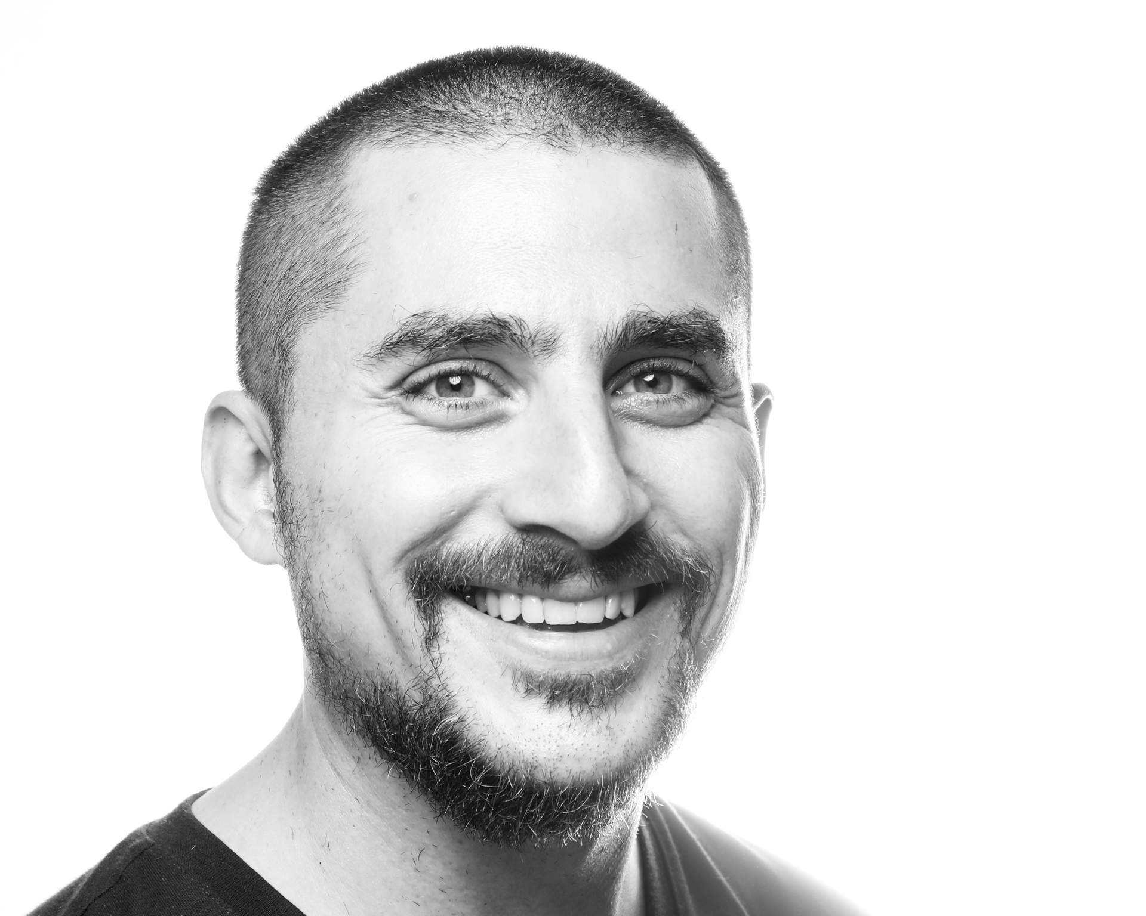

# Federico Nicolás Cámara Halac

* + 1 (614) 440-7529
* <camarahalac.1@osu.edu>
* <https://fdch.github.io>
* 349C Sullivant Hall,  
  1813 North High Street,  
  Columbus, OH 43210
* 8th May 1988, Córdoba, Argentina

# Education

## PhD

* **Music Composition and Theory, New York University.** Graduate School of Arts and Sciences. Dissertation title: “Database Music: A History, Technology, and Aesthetics of the Database in Music Composition”. Advisor: Jaime Oliver La Rosa (NYU GSAS). Readers: Elizabeth Hoffman (NYU GSAS), Martin Daughtry (NYU GSAS), William Brent (American University), and Robert Rowe (NYU Steinhardt). New York, NY (USA). Sep 2013 - Jun 2019.

## Licenciate

* **Music Composition, Universidad Nacional de Córdoba.** Facultad de Artes. Thesis Title: “A Form of Pleasure: Music as an Experience of Pleasure”. Advisor: José Halac. Readers: Eleazar Garzón, Sergio Poblete, Claudio Bazán, and Pablo de Giusto (Bachelor and Masters equivalence). Córdoba (Argentina). Mar 2006 - Jul 2012.

# Professional Appointments

## Postdoctorate

* **Postdoctoral Scholar in Immersive Audio, The Ohio State University.** Global Arts and Humanities Discovery Theme, School of Music, Advanced Computing Center for the Arts and Design. Columbus, OH (USA). 2019-2021.

# Research Interests

Computer Music. Spatial Audio. Immersive Sound. Machine Learning. Digital Signal Processing. Algorithmic Composition. Computer Vision. Networked Music Performance. Sonification. Database Music.

# Publications

## Conference Proceedings

* **Visual Cues as an Aid in the Auditory Stream Segregation of Music.** International Conference on Music Perception and Cognition - European Society for the Cognitive Sciences of Music. Samantha Burgess, Federico Camara Halac, and Daniel Shanahan. 28 September 2021.
* **‘The Woods:’ A Mixed Reality Two-Player Cooperative Game.** SIGGRAPH. Scott Swearingen, Kyoung Swearingen, Federico Camara Halac, Sruthi Ammannagari, and Matt Hall. 09 August 2021.
* **DreamSound: Deep Activation Layer Sonification.** International Community for Auditory Displays. Federico Camara Halac and Matias Delgadino. 25 July 2021.
* **Comparing Musical Performances of the ‘Goldberg Variations’ Using Supervised Machine Learning Techniques.** Future Directions of Music Cognition (Accepted but not presented). Arturo Barrios, Leo A. Glowacki, Lindsay Warrenburg, and Federico Camara Halac. 12 February 2021.
* **A Spectral Experience: Self Convolution and Face Tracking.** International Computer Music Conference (Accepted but not presented). 11 October 2017.

## Conference Poster

* **PathoSonic: Performing Sound In Virtual Reality Feature Space.** New Interfaces for Musical Expression. Federico Camara Halac and Shadrick Addy. 24 January 2020.

## Conference Panel

* **[clone fd_dacout]: real-time massively multichannel spatialization in Pure Data.** Jornadas de Informática y Electrónica Musical - Espacios Sonoros. 05 March 2020.

## PhD Dissertation Defense

* **Database Music: A History, Technology, and Aesthetics of the Database in Music Composition.** New York University. 06 May 2019.

## Guest Speaker

* **A History of the Database in Computer Music.** Festival Atemporáneas. 13 September 2021.
* **Composing Database: Opening A Space For The Concept Of An Anarchic Unwork Of Art..** Delian Academy for New Music. 11 June 2018.
* **Inopera: A Multimedia Work for Loadbang and Pure Data.** Universidad Nacional de Córdoba. 15 June 2016.

## Other Publications

* **‘For Young Years:’ A Response To Elsa Justel’s Marelle.** Open Space Magazine - Issue 21 . 10 August 2017.

# Awards and Honors

## Fellowships

* **Dean’s Dissertation.** Graduate School of Arts and Sciences (New York University). Berlin (Germany).
* **Graduate Research Initiative.** Provost (New York University). Florence (Italy).
* **Graduate Research Initiative.** Provost (New York University). Paris (France).
* **The Henry M. MacCracken Program.** Graduate School of Arts and Sciences (New York University). New York City (USA).

## Prizes

* **"Ciudad Invertida" (Selected Works).** Elsa Justel (Fundación Destellos). Mar del Plata (Argentina).
* **"Venas" (Selected Works) .** Elsa Justel (Fundación Destellos). Mar del Plata (Argentina).
* **"Lagos" (Orchestral Premiere).** Orquesta Sinfónica de la UNC - Músicas en Dirigible (Universidad Nacional de Córdoba). Córdoba (Argentina).

## Conference Funds

* **Student Senators Council.** Graduate School of Arts and Sciences (New York University). Shanghai (China).

## Exchange Program

* **Programa Cuarto Centenario.** Prosecretaría de Relaciones Internacionales (Universidad Nacional de Córdoba and Université de Montréal). Montréal (Canada).

# Performances

## Solo

* **Concierto de arte sonoro en Espacio B.** Ricardo Barney & Pedro Fraguela. Laptop. Espacio B - Madrid (Spain). 04 March 2020.
* **Lorenz Variations.** Cube Fest at Virginia Tech - Blacksburg, VA (USA). 03 August 2017.
* **Opening Portals.** Jessica Rosen. Bookentiometers. ShapeShifter Lab in Brooklyn - New York City, NY (USA). 11 October 2016.

## The Sonic Arts Ensemble at OSU

* **8th Music and/as Process Conference: Networked Collaborative Processes 2021.** Thornblower. Netty McNetface - Columbus, OH (USA). 26 June 2021.
* **SEAMUS (TWELVE).** Thornblower. CCRMA - Stanford, CA (USA). 23 April 2021.
* **Earth Day Art Model 2021.** Thornblower. EDAM Festival - Indianapolis, IA (USA). 22 April 2021.
* **Sonic Arts Ensemble Live-Stream Performance.** Thornblower. Netty McNetface - Columbus, OH (USA). 06 April 2021.
* **Into The Multiverse.** Thornblower. The Wexner Center for the Arts - Columbus, OH (USA). 20 October 2020.
* **Sonic Arts Ensemble and Atelier Avant Austria present “Virtuoso Chances”.** Andreas Weixler, Se-Lien Chuang, Marc Ainger, Ann Stimmson, and the Sonic Arts Ensemble. Pure Data, joyosc, and a PS4 Controller. ACCAD Motion Lab - Columbus, OH (USA). 23 September 2019.

## Hijos de Distinta Madre

* **Thanks to Federico Ragessi and Franco Pellini (Hijos de Distinta Madre), Marmotas Dreams (Berenice Llorens and Constanza Pellicci) , and Jorge Castro (fisterni @ La Cúpula) for an amazing performance and night..** Pure Data, joyosc, and a PS4 Controller. La Cúpula Galería de Arte - Córdoba (Argentina). 09 May 2020.
* **HDDM + ffddcchh + Marmotas Dreams & friends.** Pure Data, joyosc, and a PS4 Controller. La Cúpula Galería de Arte - Córdoba (Argentina). 21 December 2019.
* **HDDM + ffddcchh.** Pure Data, joyosc, and a PS4 Controller. Casa Mandarina - Córdoba (Argentina). 19 December 2019.
* **Mermetom + Fede Camara Halac.** Mermetom (Gustavo Alcaraz & Vero Guevara) and . Pure Data, joyosc, and a PS4 Controller. La Cúpula Galería de Arte - Córdoba (Argentina). 08 December 2019.

## Live Video and Electronics

* **Electroacoustic Improvisations.** Joan Bages i Rubi, Bernardo Barros, Kyle Motl, and Joan Marti Frasquier,. Midi controller and Laptop. NYU Waverly Labs r.220 - New York City, NY (USA). 19 June 2017.
* **a.le.a.** Talea Ensemble. Midi controller and networked Laptops. The Dimenna Center for Classical Music - New York City, NY (USA). 07 April 2017.
* **Ciudad Invertida.** RAGE THORMBONES. Laptop. ShapeShifter Lab - New York City, NY (USA). 22 November 2016.
* **sk.** TAK Ensemble. Laptop. Waverly Labs, r.220 - New York City, NY (USA). 29 September 2016.
* **INOPERA.** Loadbang Ensemble. Midi controller and Laptop. The Dimenna Center for Classical Music - New York City, NY (USA). 20 April 2016.
* **Ciudad Invertida.** Rocío Elizalde y Manuel Pastrana. Laptop. Bienal 3 en Composición e Investigación Musical - Córdoba (Argentina). 20 August 2015.
* **Mise-En at German House.** Samuel Marques. Pure Data live processing. German Consulate - New York City, NY (USA). 06 February 2015.
* **Momenta Quartet Plays NYU Composers.** Momenta Quartet. Laptop. NYU Silver Center r.220 - New York City, NY (USA). 21 April 2014.

## LEIM Ensemble

* **Ciclo Experimentalia.** Piano, Analog Synthesizer. Centro Cultural España Córdoba - Córdoba (Argentina). 10 August 2012.
* **Summer Concert.** Piano, Analog Synthesizer. Auditorio CePIA - Córdoba (Argentina). 10 November 2011.
* **Teatro Acústico.** Piano, Analog Synthesizer. Facultad de Artes, UNC - Córdoba (Argentina). 02 October 2011.
* **Ciclo Contengo-Arte.** Piano, Analog Synthesizer. Instituto Italiano de Cultura - Córdoba (Argentina). 14 September 2011.
* **Micro-Simposio de Análisis Musical.** Piano, Analog Synthesizer. Facultad de Artes, UNC - Córdoba (Argentina). 12 September 2011.
* **Winter Concert.** Piano, Analog Synthesizer. Auditorio CePIA - Córdoba (Argentina). 23 August 2011.
* **Ciclo Experimentalia.** Piano, Analog Synthesizer. Centro Cultural España Córdoba - Córdoba (Argentina). 20 June 2011.
* **TSONAMI.** Piano, Analog Synthesizer. Centro Cultural Recoleta - Buenos Aires (Argentina). 10 May 2011.
* **Nosocomio.** Piano, Analog Synthesizer. Centro Cultural España Córdoba - Córdoba (Argentina). 12 December 2010.
* **Summer Concert.** Piano, Analog Synthesizer. Auditorio CePIA - Córdoba (Argentina). 14 November 2010.
* **1st International Biennial of Music Composition and Education.** Piano, Analog Synthesizer. Auditorio CePIA - Córdoba (Argentina). 14 September 2010.
* **Performances and Workshops.** Piano, Analog Synthesizer. LEIM Facultad de Artes - Córdoba (Argentina). 01 January 2009.

## Proyecto [Red] Ensemble

* **Canon.** Midi controller and Laptop. Centro Cultural Graciela Carena - New York City, NY (USA). 06 August 2016.
* **Concert.** Piano. Auditorio CePIA - Córdoba (Argentina). 12 November 2012.
* **Aniversario de la Facultad de Artes.** Piano, Trumpet, Midi Controller. Auditorio CePIA - Córdoba (Argentina). 01 November 2012.
* **John Cage Festival.** Piano. Auditorio CePIA - Córdoba (Argentina). 05 September 2012.
* **Concert at B2CIM.** Piano, Trumpet, Midi Controller. Auditorio CePIA - Córdoba (Argentina). 23 August 2012.
* **Concierto de Alquimistas.** Piano. Aula Magna FCEFyN - Córdoba (Argentina). 29 June 2012.
* **Concierto Final de Tesis.** Piano. Auditorio CePIA - Córdoba (Argentina). 12 June 2012.
* **Congreso de Ciencias Humana.** Electric Guitar. Escuela Monserrat - Córdoba (Argentina). 20 October 2011.
* **Micro-Simposio de Análisis Musical.** Piano. Aula Magna de la Facultad de Artes - Córdoba (Argentina). 10 September 2011.
* **Arte Forum 2: Homage to Oscar Bazán.** Piano. Auditorio CePIA - Córdoba (Argentina). 18 August 2011.
* **Winter Concert.** Electric Guitar, Piano. Auditorio CePIA - Córdoba (Argentina). 10 July 2011.
* **Summer Concert.** Conductor. Auditorio CePIA - Córdoba (Argentina). 20 November 2010.
* **Ciclo La Máquina de Tiempo.** Trumpet. Centro Cultural España Córdoba - Córdoba (Argentina). 02 July 2010.

## Other Roles

* **CLIMATE GATHERING.** Norah Zuniga Shaw. Max/MSP and Ipad. Movement Lab at Barnard College - New York City, NY (USA). 15 January 2020.
* **Guest Pianist.** LAMOI. Piano. Paseo del Buen Pastor - Córdoba (Argentina). 10 March 2012.
* **Inserto Beat.** Luisina Couto, Pablo Behm. Guitar. Cineclub Municipal Hugo del Carril - Córdoba (Argentina). 18 September 2010.
* **Guest Pianist.** Orquesta Sinfónica de Río Ceballos. Piano. Teatro Municipal - Río Ceballos, CBA (Argentina). 12 March 2010.

# Teaching

## Professor

* **Computational Musicology 8824.** The Ohio State University. School of Music. Columbus, OH (USA). Spring 2021.
* **Sonic Arts Ensemble.** The Ohio State University. Advanced Computing Center for the Arts and Design. Columbus, OH (USA). Fall 2021.
* **Sonic Arts Ensemble.** The Ohio State University. Advanced Computing Center for the Arts and Design. Columbus, OH (USA). Spring 2020.
* **Sonic Arts Ensemble.** The Ohio State University. Advanced Computing Center for the Arts and Design. Columbus, OH (USA). Fall 2019.
* **Harmony and Counterpoint I.** New York University. Faculty of Arts and Science. New York, NY (USA). Fall 2015.

## Course Assistant

* **Computer Music Theory and Techniques.** New York University. Faculty of Arts and Science. New York, NY (USA). Fall 2016.

## Teaching Assistant

* **Harmony and Counterpoint II.** New York University. Faculty of Arts and Science. New York, NY (USA). Spring 2015.
* **Harmony and Counterpoint I.** New York University. Faculty of Arts and Science. New York, NY (USA). Fall 2014.
* **Composición Musical I.** Universidad Nacional de Córdoba. Facultad de Artes. Córdoba, CBA (ARG).
* **Composición Musical I.** Universidad Nacional de Córdoba. Facultad de Artes. Córdoba, CBA (ARG).
* **Audioperceptiva I.** Universidad Nacional de Córdoba. Escuela de Artes - FFyH. Córdoba, CBA (ARG).
* **Audioperceptiva I.** Universidad Nacional de Córdoba. Escuela de Artes - FFyH. Córdoba, CBA (ARG).

# Artistic Collaborations

## Networked Music Performance

* **1002: A Networked Music Performance with CollidePd** (ongoing). International Computer Music Conference. Federico Ragessi. Córdoba (Argentina).
* **The Sonic Arts Ensemble at OSU** (ongoing). Advanced Computing Center for the Arts and Design. Marc Ainger and Ann Stimson. Columbus, OH (USA).

## Installations

* **The Woods** (ongoing). Advanced Computing Center for the Arts and Design. Kyoung Swearingen, Scott Swearingen, Marc Ainger, Sruthi Ammanngari, and Matt Hall. Columbus, OH (USA).
* **Hearing the Self: A Spectral Experience.** Xuhui Art Museum. Matias Delgadino and Lucia Simonelli. Shanghai (China).

## Theatre

* **Poroto.** Pabellón Azul - UNC . Celeste Lozada and Valentina Echeverría. Córdoba (Argentina).
* **Itinerante: un Viaje a Través de Los Sentidos.** Sindicato de Vendedores de Diarios y Revistas. Agustina Muñoz. Córdoba (Argentina).
* **Tesis de Licenciatura de Teatro.** Plazoleta del Fundador. Luisina Couto. Córdoba (Argentina).
* **Inserto Beat.** Cineclub Municipal Hugo del Carril. Luisina Couto. Córdoba (Argentina).

## Other Collaborations

* **Los Chicos de Abril (Opera).** Teatro Municipal de Río Cuarto. Luis Perez, Pablo Behm, and Franco Pellini. Río Cuarto , CBA (Argentina).
* **Al Cielo o al Infierno (Film).** Cines Gran Rex. Lauro Racosky. Córdoba (Argentina).
* **Alicia en el País de las Maravillas (Dance).** Teatro del Libertador San Martín. José Halac. Córdoba (Argentina).

# Service

## Disciplinary Service

* **New Interfaces for Musical Expression** (ongoing). Reviewer. Paper and Installation submissions. New York City (USA).
* **Festival Atemporáneas.** Reviewer. Installation, Audiovisual, and Sound Art submissions. Buenos Aires (Argentina). 2019-2020.
* **New York City Electroacoustic Music Festival** (ongoing). Reviewer. Music submissions. New York City (USA).
* **International Computer Music Conference** (ongoing). Reviewer. Installations and Music Submissions. New York City (USA).
* **PdCon16~.** Organizer. Website and Conference Program. New York City (USA).
* **Bienal Composición Córdoba.** Organizer. Website and Conference Program. Córdoba (Argentina). 2010-2015.

## University Service

* **Waverly Project.** Founding Member. Website and Program. New York City (USA). 2013-2017.
* **Proyecto [Red] Ensamble.** Founding Member. Website and Program. Córdoba (Argentina). 2010-2015.

# Other Skills

* **Spanish** (Native) **English** (Advanced) **French** (Intermediate) **German** ( Beginner, A2 Level. Currently Studying.)
* **Pure Data** (Expert) **Python** (Advanced: Numpy, Scipy, tensorflow, librosa) **JavaScript** (Advanced: Web Audio API, Node.js) **C** (Pure Data Externals) **C++** (GEM and Max MSP Externals) **Bash** (Server-side scripting) **HTML** (Web Publishing with CSS) **Latex** (Text Publishing) **Git** (Version management, software release)
* **Max/MSP.** **Csound.** **Jacktrip.** **Audacity.** **REAPER.** **Ableton Live.** **Adobe Creative Suite.**