CTFname:
Cyber Spike CTF
Challenge name: Joker [BETA]
Challenge description
There are some applications that are usually used for specific purposes but also give the user the ability to run external commands (often known as a shell escape). Complete this challenge by gaining by gaining root privileges on the target server.
Challenge category: Sudo, sudoers, shell privilege escalation
Challenge points – unknown
Estimated time is 45 minutes – 4 hours maximum duration
Year and date: - march 6^{h} 2020

TL;DR:
This challenge can be quite when one is familiar with vim. If not: bash commands can be executed by vim (privilege escalation) as root. Use :! as a prefix and cat the flag.txt file.

The first step of the challenge is to ssh to the corresponding server:
ssh student@192.168.6.2
username: student
password: student

service –status-all is used to get an overview of the available services.
whoami and id point out that our user (student) is a sudoer but the amount of available commands are limited – so the sudo command works. Commands like sudo or whoami cannot be executed because ‘student’ is not allowed to do this on the server. There is no access to root folder in any way, meaning that commands like ls, cat, etc.. return no valid information.

The system has 3 users: student, rfadmin and root.
student@server:~$ id rfadmin uid=1000(rfadmin) gid=1000(rfadmin) groups=1000(rfadmin),27(sudo) student@server:~$ id uid=1001(student) gid=1001(student) groups=1001(student),27(sudo)

compgen -c can be used to show what commands can be used. However, sudo -l is more suitable as this shows what can be used as root.

Some tested options
- chmod (777)to change permissions
- add new user
- Putting a script in the ~/.bashrc file to run.
- chroot (change root point)
..are no success

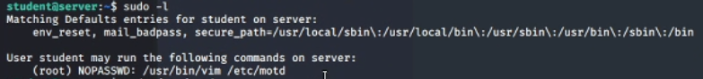
Meanwhile, vim is in the output of sudo -l along with the command /usr/bin/vim/etc/motd

when navigating folders note that vi is vim

Explored possibilities related to vim and/or motd:

- CVE-2018-6557 is a particular option that is considered – no result.
- Another explored possibility is to link another file to vim to be executed in order to gain root access.
- privilege escalation if kernel symlink disabled
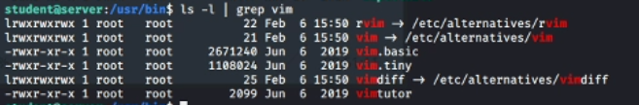
- Adjusting the vim sourcecode

Worth mentioning: sudo_as_admin_successfull is a file encountered. Attempting to run commands or a script from this file does not make any progress. It’s a dead end.
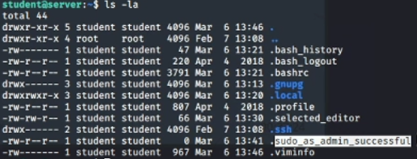
The options are far fetched. So vim itself is used to execute commands in the linux terminal. Various commands can be executed but again there is not much progress.

Finally its figured out that bash commands can be ran from vim using the :! prefix
After that the solution is simple. :! cat root/flag.txt

