Week 4 Recap Paper
Cohort 2 | Week 4 | Saturday 31 October 2026 | 120 minutes | 39 items in 6 parts | ungraded

What this paper is for
This week you took five tickets at companies the room uses: Uber's peak-hour guarantee in Hyderabad, twice; Swiggy Instamart's bought-together strip in Pune; Zomato Gold's members in Chennai; and Flipkart's festive packer plan in Lucknow. Each day the same method ran again on Kalpa Retail in the lab. This paper puts the week's calls back to you: which number a scheme should pay for, what goes on one slide and how a number sized from nothing is checked, which pairs beat chance, where a membership loses people, which forecast goes to the plan, and what changes when the method moves to another company. The room's score in each part, set beside the rating you give that part in step one, tells Monday's session where to start.
Rules
Rule | Detail
Time | 120 minutes in one sitting for 39 items, which the blueprint paces at 119 minutes. Each part gives its minutes as a guide; move on when an item is eating your time, and come back to it at the end.
Tools | Pen and this paper only: no laptop, no phone, no notes and no assistant. Rough working goes in the margins and in the working boxes.
Answers | Every answer goes on the answer sheet at the back, which is the page that is marked: one box for a lettered item, every correct box for a starred one, the letter for a word-bank or match item, and the number or the letters in order in the space. A wrong answer costs nothing, so answer every item.
Levels | Every item shows its level beside its number, easy, medium or hard. A hard item is several steps on an exhibit, never an obscure fact.
Exhibits | An exhibit is printed once, labelled by its part as Exhibit 2A, 2B, and every item that reads it follows it.
Company | Parts 1 to 5 open on the week's cases at Uber, Swiggy Instamart, Zomato Gold and Flipkart, and each is an illustrative case: the company is real, the situation and the data are synthetic, built for this class. The Kalpa items continue the labs at Kalpa Retail, where Meera Raghavan is the CEO and Anand Iyer the finance controller; the head of Retail-Plus, the merchandising team and the app team are named by role. Part 6 moves to Kalpa's other units: Rohan Desai, head of risk at Kalpa Financial Services; Dr Priya Menon, COO of Kalpa Health; Ananya Bose, COO of Kalpa Connect; and the head of operations at Kalpa Logistics, named by role. Items that use a public case (Wells Fargo, Delhi Metro, Flipkart, NPCI's UPI count, DMart, Amazon, Swiggy and the M5 competition) give the source beside the fact, and every number an item needs is on the page.
Afterwards | Papers are swapped and marked against the key, then the discussion takes the items the room missed most. The paper is ungraded and ranks nobody; the room's rates by part and by tag set Monday's revision.
Step one, before Part 1
On the answer sheet, rate yourself from 1 to 4 on each part before you read any item. Rate yourself as you are today: the comparison between your rating and your score in each part is the most useful thing this paper produces for Monday.
1  I have not used this | 2  I can follow it when someone shows me | 3  I can do it alone on a small problem | 4  I can find and fix mistakes in someone else's version
One rating for each of the 6 parts in the table below, in the boxes on the answer sheet.
The paper at a glance
Part | Title | Items | What it shows | Minutes | Easy | Medium | Hard
1 | Which number should the plan chase, and which should a scheme pay for? | Q1 to Q7 (7) | whether you can choose the number a plan chases and a scheme pays for, and read what happened where one was gamed | 19 | 3 | 2 | 2
2 | Can the number survive the room, and can you size a city from nothing? | Q8 to Q14 (7) | whether you can put one claim on one slide, answer an objection to it, and size a number from nothing and check it | 24.5 | 1 | 2 | 4
3 | Which pairs beat chance, and what is a slot worth? | Q15 to Q21 (7) | whether you can choose the pairs a strip should show and put a rupee value on a slot | 21.5 | 0 | 4 | 3
4 | Where is the tier losing people? | Q22 to Q28 (7) | whether you can tell where a membership loses people and decide what to fix first | 23 | 0 | 5 | 2
5 | Which forecast earns the plan's trust? | Q29 to Q33 (5) | whether you can choose the forecast that goes to the plan and say how wrong it could be | 19 | 1 | 2 | 2
6 | What changes when the method moves company? | Q34 to Q39 (6) | whether you can carry the week's methods to another company and say what changes there | 12 | 4 | 2 | 0
 | Total | 39 |  | 119 | 9 | 17 | 13
Pacing
Each band is as wide as its part's minutes; the timed items fill 119 of the 120 minutes, and the minute each part starts is under it.
Part 1  19 min | Part 2  24.5 min | Part 3  21.5 min | Part 4  23 min | Part 5  19 min | Part 6  12 min
0 | 19 | 43.5 | 65 | 88 | 107
Part 1. Which number should the plan chase, and which should a scheme pay for?
7 items, Q1 to Q7, about 19 minutes. What it shows: whether you can choose the number a plan chases and a scheme pays for, and read what happened where one was gamed.
On Monday 31 August 2026 Uber's Hyderabad city team launched a peak-hour earnings guarantee for enrolled drivers: a floor of Rs 300 per peak online hour, with Uber paying the gap between a driver's trip earnings in the peak window and the floor as a top-up. The launch note's goal was more drivers on the road at peak, so riders are picked up faster. Exhibit 1A sets the six weeks after the launch against the six weeks before. The city head must decide whether to extend the scheme to two more cities. Illustrative case: the company is real, the situation and the data are synthetic, built for this class. In the lab the same method ran on Kalpa Retail, where the head of Retail-Plus had proposed reorders per member as the growth plan's number.
Exhibit 1A How the guarantee pays, and Uber Hyderabad's peak numbers, the six weeks beginning 20 July 2026 against the six beginning 31 August 2026, the launch day.
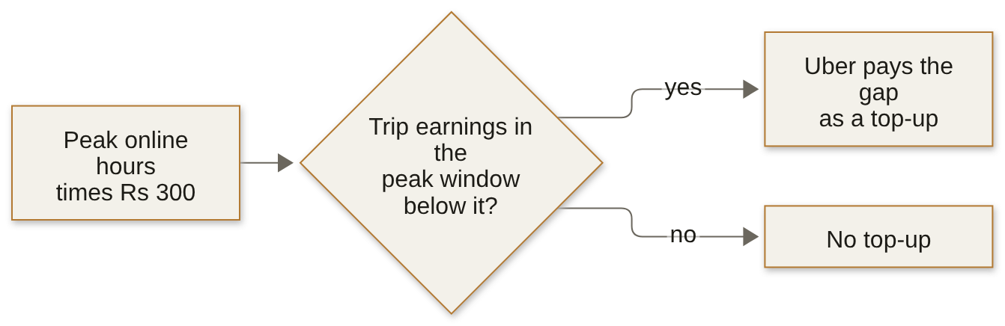
Measure | Six weeks before | Six weeks after
Peak online hours, all enrolled drivers | 118,000 | 146,300
Completed peak trips | 224,200 | 230,900
Trips per peak online hour | 1.90 | 1.58
Rider requests at peak | 251,910 | 256,556
Rider requests per peak online hour | 2.13 | 1.75
Offers accepted over offers shown | 0.86 | 0.73
Median rider wait at peak, minutes | 4.8 | 4.6
Top-up paid | Rs 0 | Rs 1.9 crore

Word bank 1 Write the letter of the word or phrase that completes each statement. Each is used once at most, and some are not used.
A proxies | B window | C leading inputs
D baseline | E guardrails | F target

Q1 Easy · Complete the north-star line · a letter from Word bank 1
The metric a plan exists to move is the north-star, and the metrics that catch harmful ways of hitting it are called ____.

Q2 Medium · Complete the definition · a letter from Word bank 1
A complete metric definition names its numerator, its denominator, its ____ and its exclusions.

Q3 Easy · Judge the statement · one letter
The city team's dashboard puts rider requests per peak online hour, zone by zone, beside its north star, completed peak trips per enrolled driver online at peak each week. Statement: a leading indicator moves after the north-star metric has already moved. True or false, and why?
A. True: requests per online hour fell from 2.13 to 1.75 over the six weeks after the north star had moved, which is how it confirms the north star.
B. True: a leading indicator is read once the quarter's result is in, which is why the dashboard keeps it on the page beside the north star it explains.
C. False: it moves first, while the team can act; requests per online hour by zone say where to send drivers before the week's trips are in.
D. False: a leading indicator moves in the same week as the north star, since both are counted from that week's completed peak trips in every zone.

Exhibit 1B Six drivers, one week from the six before the launch, the week beginning 10 August 2026, and one week from the six after it, the week beginning 21 September 2026. Shamshabad and Rajendranagar are two of the city's three outer zones.
Driver | Zone | Week | Peak online hours | Offers shown | Offers accepted | Completed trips
A | Jubilee Hills | before | 10 | 24 | 21 | 21
A | Jubilee Hills | after | 11 | 25 | 22 | 22
B | Banjara Hills | before | 9 | 20 | 17 | 17
B | Banjara Hills | after | 10 | 21 | 18 | 18
C | Gachibowli | before | 11 | 25 | 22 | 22
C | Gachibowli | after | 12 | 26 | 23 | 23
D | Madhapur | before | 10 | 22 | 19 | 19
D | Madhapur | after | 11 | 23 | 20 | 20
E | Shamshabad | before | 10 | 21 | 18 | 18
E | Shamshabad | after | 16 | 14 | 4 | 3
F | Rajendranagar | before | 10 | 20 | 17 | 17
F | Rajendranagar | after | 14 | 12 | 3 | 2

Q4 Hard · Read six drivers · one letter
The city team's note to the city head reads: "Peak online hours up 24 percent: supply target met. We recommend extending the guarantee to two more cities." What do the six drivers in Exhibit 1B show, and which number answers the note?
A. Averaged driver by driver, the six fell only to 1.31, less than the totals say, so the reply tells the city head the guarantee cut trips per hour 31 percent across the city.
B. Summed, the six fell from 1.90 to 1.19 trips an hour, further than the city's 1.58 on Exhibit 1A, so the reply quotes 1.58 and shows E and F as where hours went.
C. Summed, the six fell from 1.90 to 1.19 trips an hour, so the reply tells the city head the guarantee cut trips per hour 37 percent across the city.
D. Averaged driver by driver, the six fell only to 1.31, less than the totals say though further than the city's 1.58, so the reply quotes 1.58 and shows E and F as where hours went.

Exhibit 1C Wells Fargo's cross-sell metric, as the SEC's order of February 2020 (Release 34-88257) describes it, checked 13 October 2026.
Line | What the order found
What it counted | Accounts and products per retail bank household
Use | No usage condition: an unused debit card, the largest product category, could stay in the count for up to four years
How staff were judged | Against sales goals, with the number of products sold a significant criterion in their evaluations
What staff did | Opened accounts customers had not asked for; moved customers' money into new accounts so they counted as funded; changed contact details so satisfaction surveys would not reach customers
The 2013 change | Remittance accounts already open were added to the count without investors being told, giving 0.04 of that year's 0.11 rise in the ratio; the rest of the rise came from more accounts and products inactive for at least 365 days

Q5 Easy · Judge the statement on a case · one letter
Statement: any target changes the behaviour of the people who are paid to hit it. Judge it on Exhibit 1C. True or false, and why?
A. False: a target changes behaviour only where its rules leave a gap, and the order describes rules that some staff broke, never the target itself.
B. False: staff were paid on sales, so the cross-sell count moved only when the bank itself changed the definition, as it did in 2013.
C. True: the count rose because customers bought more products, and staff behaviour followed the customers' new demand for accounts.
D. True: staff judged on products sold opened accounts nobody asked for, staged funding and dodged the surveys, each to move their count.

Q6 Medium · Choose two additions · one letter
Exhibit 1C's last row is the 2013 change. Which two additions to the ratio's written definition would have shown investors the 0.04, and kept the rest of that year's rise out of the ratio?
A. A guardrail on revenue per household, read beside the ratio every quarter on the same households; and an exclusion that drops any product unused for a year
B. A guardrail on revenue per household, read beside the ratio every quarter on the same households; and an exclusion that drops the remittance accounts added to the count that year
C. A dated log of every change to what is counted, with that year's ratio also on the old definition; and an exclusion that drops any product unused for a year
D. A dated log of every change to what is counted, with that year's ratio also on the old definition; and an exclusion that drops the remittance accounts added to the count that year

Exhibit 1D Kalpa Retail's Retail-Plus tier, 120 members, as Monday's lab found it: 10 to 30 September 2026 against 20 August to 9 September 2026.
Measure | Window over comparison
Reorders placed per member | 1.22 times
Booked value of those placements per member | 0.96 times
Placements in the window that became a separate delivered order | None: every one was an auto-reorder the app placed, then cancelled, merged into a later order or left pending

Q7 Hard · Mark the definition sheet · every correct letter
Meera Raghavan, Kalpa Retail's CEO, wants one number for the growth plan and the numbers that stop it being gamed. The head of Retail-Plus proposed reorders per member, and the lab found Exhibit 1D. Which lines of the plan's definition sheet are right? Mark every correct option.
A. North star: reorders placed per Retail-Plus member per month, which the window shows rising 1.22 times
B. Leading input: last quarter's audited revenue, broken down by store and by member tier
C. Exclusions: placements cancelled, merged into a later order or still pending, so a reorder nobody received never counts
D. Guardrail: revenue per active customer, read each month beside the north star on the same members
E. Leading input: add-to-cart events per active app member, counted each week from the app's event log
Part 2. Can the number survive the room, and can you size a city from nothing?
7 items, Q8 to Q14, about 24.5 minutes. What it shows: whether you can put one claim on one slide, answer an objection to it, and size a number from nothing and check it.
On Tuesday the city head asked for Monday's answer on one slide at Thursday's city review: five minutes, with the driver-operations lead, the marketing lead and the finance partner in the room, each of whom loses something under Monday's redesign of the pay. The number the slide must explain is in Exhibit 2A. In the afternoon the city head asked a second question with no dataset: roughly how many drivers must be online at the weekday evening peak to keep the median rider wait under five minutes. Illustrative case: the company is real, the situation and the data are synthetic, built for this class. In the lab each learner presented Kalpa's north star on one slide to a Kalpa head, then sized Anand's new-store question against DMart.
Exhibit 2A Who sits in Thursday's review, and the same peak bookings read three ways, Uber Hyderabad, the six weeks before the launch and the six weeks after.
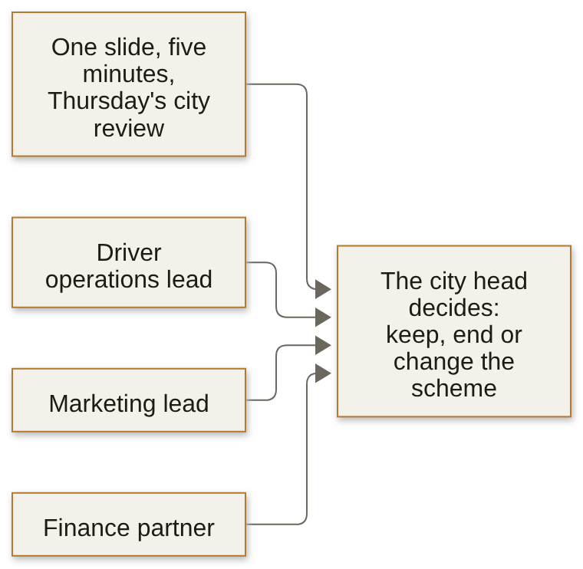
Read | Six weeks before | Six weeks after
Bookings per peak online hour | Rs 314 | Rs 260
Bookings per active driver-week | Rs 5,817 | Rs 5,861
Bookings per completed trip | Rs 165 | Rs 165

Q8 Hard · Build the slide · letters in order
The one-slide answer runs, from the top: the claim, written as the title; the evidence; the caveat; and the action. Four of these seven lines fill the four slots on Exhibit 2A's numbers, and three would spoil the slide. Leave those three out and write the other four in slot order, from the top.
A. Move every driver in every zone to the redesigned pay from Monday; the city head signs
B. Bookings per peak online hour fell 17 percent, from Rs 314 to Rs 260, at the same Rs 165 a trip
C. Bookings per active driver-week rose 0.8 percent, so the scheme is paying its way
D. The monsoon ended inside the six weeks after the launch, and no weeks from last year are in the data
E. The guarantee is paying for peak online hours in which drivers complete no trips
F. Test the redesigned pay on half the drivers, picked at random, for six weeks; the city head signs
G. Bookings per peak online hour fell 21 percent, from Rs 314 to Rs 260, at the same Rs 165 a trip
Write the letters in order on the answer sheet.

Q9 Hard · Keep two elements · every correct letter
A second draft argues that riders got little for the Rs 1.9 crore of top-up. Which two elements carry that claim? Mark both; every other element moves to an appendix page headed by the question a named role will ask.
A. Median rider wait at peak, 4.8 to 4.6 minutes
B. Rider requests at peak, 251,910 to 256,556
C. Top-up for each extra trip: Rs 2,836, for a trip worth Rs 165
D. Top-up for each completed trip: Rs 82, for a trip worth Rs 165
E. The top-up split: 61 percent to driver-weeks under half acceptance

Exhibit 2B Uber Hyderabad's peak weeks, the six before the launch on 31 August 2026 and the six after it: rider requests at peak and trips per peak online hour, week by week.
Week beginning | Window | Rider requests at peak | Trips per peak online hour
20 July | before | 41,155 | 1.88
27 July | before | 41,608 | 1.91
3 August | before | 41,896 | 1.89
10 August | before | 42,101 | 1.92
17 August | before | 42,431 | 1.93
24 August | before | 42,719 | 1.88
31 August | after | 43,589 | 1.64
7 September | after | 43,878 | 1.59
14 September | after | 43,507 | 1.57
21 September | after | 42,602 | 1.55
28 September | after | 41,819 | 1.56
5 October | after | 41,161 | 1.56

Q10 Hard · Judge the defence · one letter
At the review the finance partner says: "The monsoon ended inside your six weeks, so what your slide shows is the season, not your scheme." Statement: the strongest reply concedes nothing, since any concession hands the objector the meeting. Judge it on Exhibit 2B. True or false, and why?
A. True: concede nothing, and show that peak requests rose 1.8 percent over the six weeks after the launch, from 251,910 to 256,556, while trips per peak online hour fell from 1.90 to 1.58.
B. True: concede nothing, and show that in the last three weeks peak requests sat back inside their range before the launch while trips per peak online hour held near 1.56.
C. False: grant that the rains ended inside the window, then show that in the last three weeks peak requests sat back inside their range before the launch while trips per peak online hour held near 1.56.
D. False: grant that the rains ended inside the window, then show that peak requests rose 1.8 percent over the six weeks after the launch, from 251,910 to 256,556, while trips per peak online hour fell from 1.90 to 1.58.

Q11 Easy · Judge the memo · one letter
A colleague cites Amazon's 2017 letter to shareholders, which says Amazon's meetings start with a six-page memo read in silence, use no slides, and that a great memo probably takes a week or more to write. Statement: the city head's Thursday review should get a memo in place of the one slide. True or false, and why?
A. True: a memo forces full sentences where bullets hide the reasoning, so it beats a slide in any meeting, whatever the slot it is given.
B. True: a memo can carry all three appendix pages in its body, so no role's question is left without its answer in the room.
C. False: the letter says Amazon reads its memos after the meeting has ended, so a memo would leave the room no time to argue at the review.
D. False: the ask is one slide in five minutes, and the letter itself says a great memo probably takes a week or more to write.

Q12 Medium · Order the estimate · letters in order
The city head's afternoon ask is roughly how many drivers must be online at the weekday evening peak to keep the median rider wait under five minutes. The guesstimate runs clarify, map, calculate, validate: four of these six steps make it, and two would spoil it. Leave those two out and write the other four in the order they run.
A. Re-run the chain at Exhibit 1A's 1.90 trips per peak online hour before the launch, which gives about 5,000 drivers
B. Ask whether it is drivers online at one moment or across the window, which window, which product, and the city's median or every zone's
C. Re-run the chain at Exhibit 1A's 2.13 rider requests per peak online hour before the launch, which gives about 4,500 drivers
D. Write the formula: drivers online equal trips to serve in an hour, over trips one online driver completes in an hour, times a buffer for the busiest half hour
E. Work it aloud: about 8,330 evening trips an hour over 1.68 trips per online driver-hour is about 4,960, and 15 percent more for the busiest half hour is about 5,700
F. Re-run the chain at Exhibit 1A's 1.58 trips per peak online hour after the launch, the latest weeks, which gives about 6,100 drivers
Write the letters in order on the answer sheet.

Q13 Medium · Check four sources · every correct letter
Before the review, a colleague lines up five checks on four numbers. Three come from published sources: NPCI counted 24.07 billion UPI transactions in September 2026, "averaging 802 million daily transactions" (Outlook Money, 2 October 2026); "Flipkart recorded 6.3 million concurrent users in a minute" (Flipkart Stories, 9 October 2026); and DMart's FY26 total revenue was Rs 66,968 crore, with 85 stores added to reach 500 (Avenue Supermarts, 2 May 2026). The fourth is a city invented for a drill. Which checks are sound? Mark every correct option.
A. UPI, September 2026: 24.07 billion transactions over the month's 30 days, 802 million a day, set against an estimate of payments a day
B. Flipkart, 9 October 2026: 63 million concurrent users in a minute as the festive season opened, set against an estimate of users online at peak
C. DMart, FY26: Rs 66,968 crore over the year's average of 415 and 500 stores, about Rs 146 crore a store, set against an estimate of revenue a store
D. A city of two million people, invented for a drill: 5 lakh households at four people to a household, set against an estimate of the city's UPI users
E. UPI, September 2026: the same 802 million a day, set against an estimate of the payments made on Diwali day itself

Exhibit 2C Delhi Metro's published counts and how DMRC counts a journey, each in the words its source uses, checked 13 October 2026.
Count | Value | When | Source
Average daily passenger journeys | 64.06 lakh | the current average, August 2026 | The Tribune, 9 August 2026, citing DMRC
Passenger boardings | 82,44,903 | 17 September 2026, DMRC's highest-ever day, during a bus strike | Republic World, 18 September 2026, quoting DMRC
How a journey is counted | One for each line, or corridor, a passenger uses to reach the destination | PTI's report of DMRC's method, 30 August 2023 | Deccan Herald, reporting PTI
Line uses and riders when the line count began | 45,35,932 line uses on 29 May; nearly 27 lakh commuters a day on the network in February | 2018, PTI's report of 30 May 2018 | LatestLY, reporting PTI

Q14 Hard · Read the metro counts · one letter
A pair's chain puts Delhi Metro at about 60 lakh rider trips on a weekday, each trip counted once from the gate where the rider enters to the gate where they leave (invented). They set it against Exhibit 2C, call their estimate 6 to 27 percent low, and raise it. Which reading of the check holds?
A. Converted at 2018's mix of line uses to riders, the record day's 82,44,903 passenger boardings are about 49 lakh trips, so the chain runs about 22 percent high and is checked down.
B. Converted at 2018's mix of line uses to riders, the average day's 64.06 lakh journeys are about 38 lakh trips, so the chain runs about 57 percent high and is checked down.
C. Set against the average day alone, since 17 September was a record during a strike, 64.06 lakh puts the chain 6 percent low, so it is raised to about 64 lakh.
D. Set against the record day, the busiest day the network has carried, 82,44,903 puts the chain 27 percent low, so it is raised toward 82 lakh.
Part 3. Which pairs beat chance, and what is a slot worth?
7 items, Q15 to Q21, about 21.5 minutes. What it shows: whether you can choose the pairs a strip should show and put a rupee value on a slot.
Swiggy Instamart's cart page in Pune shows a strip of three suggested items under the cart. Until 6 September 2026 the strip was a curated list by category; from Monday 7 September it ranked items by how often they sit in the same cart as the items already in it, counted over the previous four weeks. The strip's click-through, clicks over impressions, fell from 6.1 percent in the three weeks before the switch to 3.8 percent in the three weeks after. The category manager and the growth lead want the pairs the strip should show and a rupee value on a slot. Illustrative case: the company is real, the situation and the data are synthetic, built for this class. In the lab Kalpa Retail's merchandising team wanted every product paired with the Rs 199 phone charger, "because it is in 80 percent of baskets".
Exhibit 3A Swiggy Instamart, Pune: the strip before and after the switch, and the ticket's headline numbers.
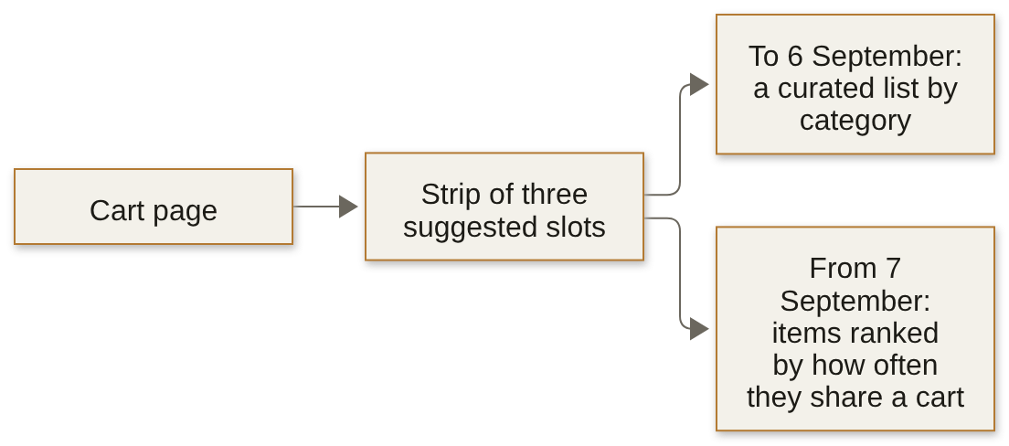
Measure | Value
Carts in the September sample | 40,000 carts from 12,000 customers in eight zones
Carts holding toned milk | 71 percent
Strip click-through, 17 August to 6 September | 6.1 percent
Strip click-through, 7 to 27 September | 3.8 percent

Exhibit 3B Click-through by slot on the strip, the three weeks before the switch on 7 September 2026 and the three weeks after. Before the switch, milk was suggested only in slot 3, on 2 percent of the strip's impressions.
Slot | Milk's share of the slot's impressions, after | Click-through on milk, after | Click-through on other items, before | Click-through on other items, after
Slot 1 | 70 percent | 1.4 percent | 7.5 percent | 8.2 percent
Slot 2 | 50 percent | 1.1 percent | 6.1 percent | 6.8 percent
Slot 3 | 30 percent | 0.9 percent | 4.9 percent | 5.4 percent
The strip | 50 percent, from 2 before | 1.2 percent, 1.2 before | 6.2 percent | 6.4 percent

Q15 Hard · Read the strip by slot · one letter
The growth lead's draft for the category manager reads: "Shoppers clicked the strip less after the monsoon, so the strip needs a redesign." Using Exhibit 3B, which reading holds, and which slot is fixed first?
A. Shoppers clicked less after the monsoon, and slot 1 fell furthest, from 7.5 percent, so slot 1's suggestions are redesigned first.
B. Neither milk nor other items click less; milk went from 2 to 50 percent of impressions, so slot 1, at 70 percent milk, is re-ranked first.
C. Neither milk nor other items click less; milk went from 2 to 50 percent of impressions, so slot 3, where milk clicks least, at 0.9 percent, is re-ranked first.
D. Shoppers clicked less after the monsoon, and slot 3's milk clicks least, at 0.9 percent, so slot 3's suggestions are redesigned first.

Exhibit 3C Two pairs in September 2026's 40,000 Pune carts from 12,000 customers. The top tenth of customers, 1,200 of them, place 38 percent of all carts and 73 percent of the carts that hold chips and cold drink together.
Pair | Carts with the first item | Carts with the second item | Carts with both | Lift with chance counted within each cart's size | The same, with each customer also counted once
Chips and cold drink | 4,800 | 4,920 | 2,000 | 2.48 | 1.95
Onions and tomatoes | 8,800 | 8,000 | 3,000 | 1.38 | 1.38

Q16 Medium · Award the strip's slots · one letter
The strip gives a slot only to a pair with a lift of at least 1.5. Exhibit 3C holds two pairs' counts and their lifts recomputed for cart size and for heavy buyers. Which pairs keep a slot?
A. Both: per cart they read 3.39 and 1.70, both above 1.5, and the recomputed lifts only restate the same carts.
B. Neither: 73 percent of the chips-and-cold-drink carts come from a tenth of the customers, so its lift belongs to a few heavy buyers.
C. Chips and cold drink only: it holds 1.95 after both corrections, while onions and tomatoes falls from 1.70 to 1.38.
D. Onions and tomatoes only: at 1.70 per cart it clears 1.5 on the most carts, 3,000, while chips and cold drink rests on a tenth of the customers.

Set 1. The case
A round sample of 1,000 Kalpa consumer baskets, with Business orders left out (illustrative counts): the phone charger is in 850 of them, a phone case is in 200, and both are in 165.
Exhibit 3D Set 1's round counts, as the situation gives them.
Baskets | Count
All consumer baskets in the sample | 1,000
With the phone charger | 850
With a phone case | 200
With both | 165

Q17 Medium · Compute the confidence · a word or number
The confidence of 'case, then charger' is ____ (three decimals).

Q18 Medium · Compute the lift · a word or number
The lift of the pair is ____ (two decimals).

Q19 Medium · Make the call to merchandising · one letter
What do you tell merchandising about bundling the case with the charger?
A. Promote it, since more than 80 percent of the case buyers also put a charger into the same basket as the case.
B. Collect another quarter of baskets first, since 1,000 baskets cannot support any lift at all.
C. Drop it: the lift is below 1, so case buyers take a charger slightly less often than shoppers in general.
D. Promote it at a deeper discount, since the pairing is already the strongest one in the data.

Exhibit 3E Two pairs with a high lift. Ice cream is in 4 percent of Pune carts.
Pair | Where | Holding both | Out of | Lift
Car phone mount and car charger | Kalpa Retail, the lab's consumer baskets | 2 baskets | 812 | 4.0
Ice cream and chocolate sauce | Swiggy Instamart, Pune, September | 100 carts | 40,000 | 4.6

Q20 Hard · Judge two high-lift pairs · one letter
Statement: a pair with a lift of about 4 and a support of about 0.25 percent belongs on a watch list, to be counted again or tested, before it belongs in a campaign. Judge it on both pairs in Exhibit 3E. True or false, and why?
A. True: Kalpa's lift rests on 2 baskets, so one basket moves it by half; Instamart's 100 carts beat chance, yet no test shows the suggestion sells more.
B. True: both pairs sit at the same support of 0.25 percent, and ice cream is in only 4 percent of carts, so both wait a quarter of carts before any test.
C. False: a lift of 4 is four times what chance gives, and a lift that far above 1 earns a campaign slot whatever the pair's support turns out to be.
D. False: Instamart's 100 carts are over four times the 22 chance gives, so its pair earns a campaign beside the 4 percent of carts holding ice cream now.

Q21 Hard · Price the bundle slot · one letter
Swiggy's shareholder letter for April to June 2025 describes Maxxsaver, a discount unlocked once a cart passes a set size, as handing part of the larger basket's margin back to the user. A growth lead proposes a bundle slot on the same logic, with these invented numbers: 30,000 cart-page views a day; 5 percent of views click the slot; half the clicks add the item; the item sells for Rs 30 and earns Rs 10 of margin before a Rs 3 bundle discount; and half of the adds would have happened anyway, through search or habit. What is the slot worth a day?
A. Rs 22,500: the 750 adds a day at the item's Rs 30 price, the sales the slot rings up at the till
B. Rs 5,250: the 750 adds a day at the Rs 7 left after the discount, every add counted as new
C. Rs 1,500: the 375 new adds' Rs 10 of margin, less the Rs 3 discount paid on all 750 adds
D. Rs 2,625: the 375 new adds at the Rs 7 left after the discount, paid on those adds alone
Part 4. Where is the tier losing people?
7 items, Q22 to Q28, about 23 minutes. What it shows: whether you can tell where a membership loses people and decide what to fix first.
Zomato Gold's membership dashboard for Chennai reports month-two retention flat at 38 percent in June, July, August and September 2026: of the members two or more months past their signup month, the share who ordered in the month. Exhibit 4A gives each signup month's own month-one rate. The August cohort was grown by a sale week on a discounted first month. On Monday 14 September 2026 a new checkout flow shipped on Android. The membership lead asks whether it is a cohort problem or an everyone problem, which step of the order flow owns the loss, and what should be fixed first. Illustrative case: the company is real, the situation and the data are synthetic, built for this class. In the lab the head of Retail-Plus put the same questions about Kalpa Retail's tier.
Exhibit 4A Zomato Gold, Chennai: the order flow a member walks through, and members by signup month in 2026 with the share who ordered in month one, the calendar month after signup. September's 5,089 members, too new for a month-one rate, bring January to September to 53,089.
Signup month | Members | Ordered in month one
January | 4,854 | 58 percent
February | 5,055 | 56 percent
March | 5,449 | 55 percent
April | 4,859 | 53 percent
May | 4,905 | 52 percent
June | 4,821 | 50 percent
July | 5,057 | 49 percent
August | 13,000 | 31 percent

Set 2. The case
In May, cohort A has 1,000 members at 50 percent retention and cohort B has 3,000 at 38 percent. In June, A retains 46 percent and B retains 35 percent, and a new cohort C of 2,000 members retains 47.5 percent.
Exhibit 4B Set 2's three cohorts, as the situation gives them.
Cohort | Members | Retention in May | Retention in June
A | 1,000 | 50 percent | 46 percent
B | 3,000 | 38 percent | 35 percent
C | 2,000 | not yet joined | 47.5 percent

Q22 Medium · Compute May's blend · a word or number
Blended retention in May is ____ percent.

Q23 Medium · Compute June's blend · a word or number
Blended retention in June is ____ percent.

Q24 Medium · Choose the honest headline · one letter
What is the honest headline for June, and what would June's blend read without cohort C?
A. Both existing cohorts fell and a large new cohort in its first month hid it; without C, June's blend reads about 37.8 percent.
B. Both existing cohorts fell and a large new cohort in its first month hid it; without C, June's blend reads about 40.5 percent.
C. The new members are the weaker ones, since C retains less than A did in May; without C, June's blend reads about 37.8 percent.
D. The new members are the weaker ones, since C retains less than A did in May; without C, June's blend reads about 40.5 percent.

Exhibit 4C Zomato Gold members in Chennai, September 2026: the order flow counted in sessions and in members.
Step | Sessions that reached it | Members who reached it
Open | 194,211 | 49,822
Search | 131,974 | 45,865
Menu view | 155,729 | 46,477
Add to cart | 52,948 | 28,351
Checkout start | 42,358 | 25,740
Order placed | 27,212 | 21,574

Q25 Hard · Read the flow two ways · one letter
The membership lead's chart for September reads "search to menu view: 118 percent" and "menu view to add-to-cart: 34 percent, the biggest loss". Exhibit 4C counts the same flow two ways, for September alone. Which reading holds?
A. Menu view to add-to-cart is the loss: at 34 percent it is the lowest step of the flow, so the menu pages are the first thing to fix.
B. Every step should be divided by the 194,211 sessions that opened the app, which puts search at 68, menu view at 80 and add-to-cart at 27 percent.
C. A step above 100 percent means the event log counts menu views twice, so every count after search is suspect until the log is rebuilt.
D. Search is a step members can skip, going from Open straight to a menu, so that step tops 100 percent; per member, menu to cart is 61 percent.

Exhibit 4D Add-to-cart to order, per session, 1 August to 13 September 2026 against 14 to 30 September. Starting checkout held at 80 percent of carts on every platform; completing a started checkout went from 72.5 to 55 percent for Android members, 71 to 70 for iOS members and 65 to 64 for non-members on Android. Every Android session moved to the new checkout on 14 September.
Who | Platform | Before 14 September | From 14 September
Members | Android | 58 percent | 44 percent
Members | iOS | 57 percent | 56 percent
Members | Web | 55 percent | 55 percent
Non-members | Android | 52 percent | 51 percent

Q26 Hard · Find the fix and its cost · one letter
The app team says the new Android checkout cannot be at fault, since non-members use the same checkout and held at 51 percent. Android members reached add-to-cart in 22,841 sessions from 14 to 30 September, 17 days. What is fixed first, and what does the loss cost a week, at Rs 300 to Rs 500 of order value an order?
A. The member path of the new Android checkout, from 14 September: about 3,198 orders a week lost against the old rate, about Rs 9.6 to 16.0 lakh of order value.
B. The member path of the new Android checkout, from 14 September: about 1,317 orders a week lost against the old rate, about Rs 4.0 to 6.6 lakh of order value.
C. The August sale cohort, with its 31 percent month one: about 1,317 orders a week lost against the old rate, about Rs 4.0 to 6.6 lakh of order value.
D. The August sale cohort, with its 31 percent month one: about 3,198 orders a week lost against the old rate, about Rs 9.6 to 16.0 lakh of order value.

Exhibit 4E An invented cohort of ten users: how many were active in each quarter after joining, before and after its five weakest users were weaned away.
Quarter after joining | 1 | 2 | 3 | 4
All ten users, active | 7 | 5 | 4 | 3
The five kept after the weakest five are weaned away, active | 5 | 5 | 4 | 3

Q27 Medium · Read the weaned cohort · one letter
Swiggy's shareholder letter for July to September 2025 says it "weaned away certain users from the platform with low potential Lifetime values", and it prints a table of Instamart cohort spend indexed to one cohort's first quarter. Exhibit 4E is invented. A deck shows this cohort's third quarter after the weakest five are weaned away and calls it strong retention. What does the third quarter read for the ten who joined and for the five kept, and what do you ask before trusting a published cohort chart?
A. 40 percent of the users who joined and 80 percent of those kept; ask what each cell divides by, users who joined or kept, and whether it counts users, orders or spend.
B. 40 percent of the users who joined and 80 percent of those kept; ask whether the cohort was acquired in a sale quarter, which would explain a strong cohort.
C. 40 percent of the users who joined and 60 percent of those kept; ask what each cell divides by, users who joined or kept, and whether it counts users, orders or spend.
D. 40 percent of the users who joined and 60 percent of those kept; ask whether the cohort was acquired in a sale quarter, which would explain a strong cohort.

Exhibit 4F Kalpa Retail's Retail-Plus tier in the app, as Thursday's lab found it. Blended retention, the members who joined before the month and opened the app in it, held at the same rate in July, August and September 2026.
Stretch of 2026 | Carts | Checkouts | Add-to-cart to checkout
Before 20 August | 34 | 28 | 82 percent
20 August to 9 September | 12 | 10 | 83 percent
10 to 30 September, the auto-reorder window | 11 | 7 | 64 percent

Q28 Medium · Answer the app team · one letter
The app team says the auto-reorder feature has been fixed and asks the head of Retail-Plus to close the ticket, since blended retention has not moved. Which reply holds on Exhibit 4F?
A. Close it: 7 checkouts from 11 carts is only 3 fewer than the 10 from 12 before, within the noise three weeks of carts can carry, so the step can be left alone.
B. Keep it open: checkouts fell from 10 to 7 against the three weeks before, 30 percent fewer, so the feature is probably still breaking the checkout step.
C. Rebuild checkout now: 7 of 11 against 10 of 12 is a 19-point fall, the largest move in the tier's funnel, and a full three-week window is enough to act on.
D. Keep it open: 7 of 11 carts checked out against 10 of 12 before, about 2 checkouts short at the old rate; flag the step, then read the next three weeks.
Part 5. Which forecast earns the plan's trust?
5 items, Q29 to Q33, about 19 minutes. What it shows: whether you can choose the forecast that goes to the plan and say how wrong it could be.
Flipkart's Lucknow fulfilment centre has 104 weeks of outbound shipments, the weeks beginning 30 September 2024 to 21 September 2026. The planner must book packer shifts for the eight festive weeks beginning 12 October to 30 November 2026, and a packer packs about 120 shipments a shift. Finance's rule is the same weeks last year plus 4 percent; a vendor's curve promises 22 percent more. Diwali's dates are in Exhibit 5A. Illustrative case: the company is real, the situation and the data are synthetic, built for this class. In the lab Anand Iyer, Kalpa Retail's finance controller, had the same choice for the board: two forecasts eighteen points apart.
Exhibit 5A Diwali in the Government of India's holiday lists for 2024, 2025 and 2026 (DoPT, as reproduced by staffnews.in, checked 13 October 2026).
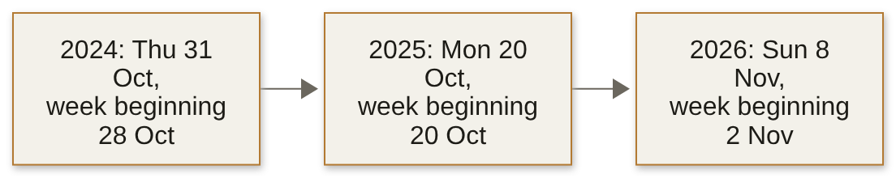
Year | Diwali | The week it falls in
2024 | Thursday 31 October 2024 | the week beginning 28 October 2024
2025 | Monday 20 October 2025 | the week beginning 20 October 2025
2026 | Sunday 8 November 2026 | the week beginning 2 November 2026

Q29 Easy · Give two baselines · show the working
Diwali fell in October in both 2024 and 2025. A retailer booked Rs 3.2 crore in October 2024, its Diwali month, and Rs 2.1 crore in September 2025 (illustrative numbers). At the end of September 2025, give the naive forecast and the seasonal naive forecast for October 2025.

Working. The final answer goes on the answer sheet.

Exhibit 5B Kalpa Retail's revenue in October and November, Rs lakh, from Friday's lab.
Month | 2024 | 2025
October | 415.1 | 427.6
November | 286.8 | 297.0

Q30 Hard · Set October and November · show the working
Anand's board line needs October and November 2026. Using Exhibits 5A and 5B, give the seasonal naive for both months, then a seasonal baseline with Friday's 4 percent growth that puts the festival in its own month, and say which month should carry the festival's spike.

Working. The final answer goes on the answer sheet.

Exhibit 5C The M5 forecasting competition, 2020: Walmart's daily unit sales of 3,049 products, every entry scored on 28 days it never saw. From the official scores workbook and the accuracy paper, checked 13 October 2026.
Entry | Average error, lower is better
The winning team | 0.520
Seasonal naive, the same day of the week before | 0.847
Multilayer perceptron, a machine-learning benchmark | 0.977
Random forest, a machine-learning benchmark | 1.010
Naive, the last day seen | 1.752

Q31 Medium · Answer the sponsor · one letter
The vendor's sponsor says: "Our curve fits two years of Lucknow's weeks within 2 percent, and machine learning won M5, so the curve should go to the plan." Using Exhibit 5C, which test must the curve pass before it goes to the plan?
A. Hold back the latest thirteen weeks, and send the curve to the plan only if it beats the seasonal naive on those weeks.
B. Hold back thirteen weeks drawn at random from the two years, and send the curve to the plan only if it beats the seasonal naive on those weeks.
C. Hold back the latest thirteen weeks, and send the curve to the plan only if it beats the naive on those weeks.
D. Hold back thirteen weeks drawn at random from the two years, and send the curve to the plan only if it beats the naive on those weeks.

Exhibit 5D Lucknow's thirteen hidden weeks. A packer-shift is booked for 120 shipments and costs Rs 650 if it sits idle, and a late shipment costs Rs 25; both are assumptions.
Forecast | Shipments forecast too high, summed | Shipments forecast too low, summed | Weeks too high, of 13
Festival-aligned, last year's weeks matched by Diwali plus 4 percent | 40,748 | 45,248 | 6
Same week last year | 7,300 | 120,500 | 2
The vendor's curve | 211,300 | 1,900 | 12

Q32 Hard · Price the misses · one letter
What is each forecast's mean absolute error a week, which costs least on these weeks with its misses priced, and what follows for the plan?
A. 6,615, 9,831 and 16,400 a week; festival-aligned, with the smallest error, also costs least once its misses are priced, so the plan books its numbers exactly as they stand.
B. About 346, 8,708 and 16,108 a week; the vendor costs least, about Rs 11.9 lakh, only because it errs high, the cheap side, so each is first set at the plan share its two costs give.
C. About 346, 8,708 and 16,108 a week; festival-aligned, with the smallest error, also costs least once its misses are priced, so the plan books its numbers exactly as they stand.
D. 6,615, 9,831 and 16,400 a week; the vendor costs least, about Rs 11.9 lakh, only because it errs high, the cheap side, so each is first set at the plan share its two costs give.

Exhibit 5E Kalpa Retail's forecasts for October 2026 to March 2027, as Friday's lab found them. Each forecast's average miss is on April to September 2026, six months it never saw. October 2025 to March 2026, a year before the forecast months, booked Rs 18.93 crore.
Forecast | Six months, Rs crore | Against a year earlier | Average miss a month, Rs lakh
The same month last year | 18.93 | level | 11.7
Finance's rule, the same month last year plus 4 percent | 19.69 | 4 percent above | 3.5
Festival-aligned, matched by Diwali, plus 4 percent | 19.69 | 4 percent above | 3.5
The vendor's curve | 23.09 | 22 percent above | 38.8

Q33 Medium · Answer Anand's three questions · one letter
The plan line for the same six months is Rs 21.77 crore, the months a year earlier plus 15 percent. Anand asks which number goes in front of the board for October 2026 to March 2027, how wrong it could be, and whether the plan line can stand as the board's forecast. Using Exhibits 5A and 5E, which answer holds?
A. Rs 19.69 crore, festival-aligned, off by about Rs 3.5 lakh a month on six unseen months, none with a Diwali; the plan line stands as the board's forecast, since it sits inside the forecasts' range, Rs 18.93 to 23.09 crore.
B. Rs 19.69 crore, festival-aligned, off by about Rs 3.5 lakh a month on six unseen months, none with a Diwali, about Rs 21 lakh if all six miss one way; the plan sits Rs 2.08 crore above, a target the forecast does not reach.
C. Rs 21.39 crore, midway between finance's rule and the vendor's curve, off by about Rs 3.5 lakh a month on six unseen months, none with a Diwali, about Rs 21 lakh if all six miss one way; the plan sits Rs 38 lakh above, within two such errors.
D. Rs 21.39 crore, midway between finance's rule and the vendor's curve, off by about Rs 3.5 lakh a month on six unseen months, none with a Diwali; the plan line stands as the board's forecast, since it sits inside the forecasts' range, Rs 18.93 to 23.09 crore.
Part 6. What changes when the method moves company?
6 items, Q34 to Q39, about 12 minutes. What it shows: whether you can carry the week's methods to another company and say what changes there.
This afternoon's spoken drill hands each pair of groups a one-paragraph brief, at another company the room uses or at one of Kalpa's other units, and each answer says what carries over from the week and what does not. This part puts the same move to you on paper. Kalpa Financial Services is Rohan Desai's payments and lending business; Kalpa Logistics moves parcels, and its head of operations is named by role; Kalpa Health, whose COO is Dr Priya Menon, runs laboratories and patient service centres that test US patients and bill US payers in dollars; and Kalpa Connect, whose COO is Ananya Bose, runs telecom and subscriptions. The briefs are illustrative.
Exhibit 6A The week's five tickets, each found at one company, and the Kalpa units this part carries them to.
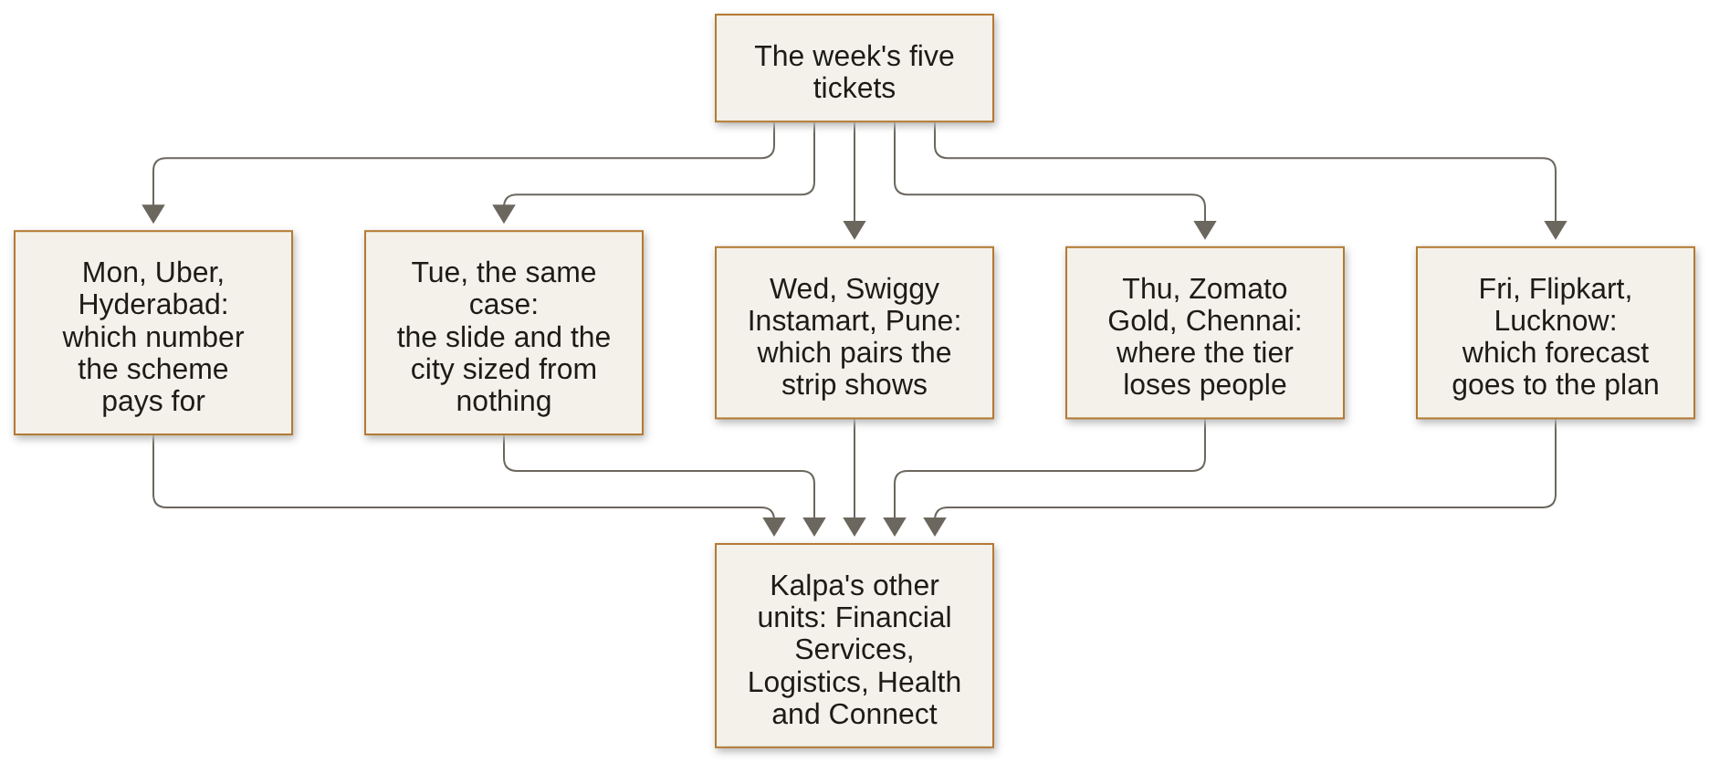

Q34 Medium · Say what stays · every correct letter
Rohan Desai, head of risk at Kalpa Financial Services, asks which customers to nudge first toward a second product, where a wrong nudge in lending costs twenty times a wrongful rejection. What stays the same from the retail method? Mark every correct option.
A. writing the metric's definition down before reading any number
B. attaching a guardrail the measured team cannot move
C. the rupee amount each kind of wrong nudge costs
D. testing against a baseline before trusting a lift

Match table 1 Each numbered row opens a Kalpa brief. Write the letter of the method that answers it. Each letter is used once at most, and two are not used.
Item |  | Match
Q35  Easy | Kalpa Logistics' head of operations: the on-time delivery rate has risen since dispatchers were allowed to move a parcel's promised date once a delay was known. |  | A | the second product most customers already hold
Q36  Easy | Dr Priya Menon: which step between a test booked and a visit completed loses the most dollars, metro area by metro area? |  | B | cohorts by start month, each read at the same age
Q37  Easy | Ananya Bose: blended monthly churn has held steady for four months while subscribers who joined since the spring seem to cancel sooner. |  | C | the average of each row's own rate across the table
Q38  Easy | Rohan Desai: which second product should a customer be offered first, beyond what any customer takes up anyway? |  | D | a definition the people measured cannot change after the fact
 |  |  | E | each funnel step over the step before, in one unit
 |  |  | F | lift above a support floor, on enough customers to trust it
Write each letter on the answer sheet.

Q39 Medium · Set the plan share · one letter
Amazon India, a fulfilment centre's festive packer plan (illustrative case: the company is real, and every number below except Amazon's own figure is hypothetical). Amazon says its Great Indian Festival 2025 drew over 276 crore customer visits, 70 percent of them from tier 2 and 3 cities. Suppose its centre in a tier 2 city pays Rs 650 for an idle packer-shift of 120 shipments, as Lucknow does, while a late shipment costs it Rs 10, against Lucknow's Rs 25. What share of weeks should its plan cover, and what carries over from Lucknow unchanged?
A. About 0.35; the festival-aligned copy, held-back weeks and a price on each way of missing carry over.
B. About 0.35; the copy of last year's calendar weeks carries over, the plainest baseline any plan has.
C. About 0.65; the copy of last year's calendar weeks carries over, the plainest baseline any plan has.
D. About 0.65; the festival-aligned copy, held-back weeks and a price on each way of missing carry over.
Stretch: untimed, and not marked
For anyone who finishes early. Nothing here is counted. Stretch 1 to 4 are the kind an interviewer asks after your first answer, so write the answer you would say. Stretch 5 is a quick check on the week's material, answered on the line.
Stretch 1 Written · the answer you would say aloud
In Hyderabad the 180 drivers in the idle tail completed 33,440 peak trips in the six weeks after the launch, about 31 trips and 39 peak online hours a driver a week. If the redesign drives all of them off the app, who carries those trips, how many more peak online hours does that take, and what do you watch in the first month?
Your answer

Stretch 2 Written · the answer you would say aloud
A growth lead wants to test one suggestion: half the shoppers in two zones, picked at random, see a second item beside the first. With invented numbers, today 5 percent of carts holding the first item also hold the second, and a rise to 8 percent would pay for the slot. How many carts holding the first item does each half need, at 5 percent significance and 80 percent power, and what happens to that count if only half of the rise is new buying?
Your answer

Stretch 3 Written · the answer you would say aloud
An AI writing assistant launched two months ago, and its weekly active users hit a record in launch week and are still near it. Is the product sticking?
Your answer

Stretch 4 Written · the answer you would say aloud
A planner reads where the plan should sit, against the chosen forecast, from the same thirteen weeks that chose the forecast. Is that circular, and what would you do instead?
Your answer

Stretch 5 Recall · one line
True or false: MAPE divides each miss by that month's actual value, so a Rs 10 lakh miss counts for more in a Rs 90 lakh month than in a Rs 120 lakh month.
Answer: ________________________________________
Answer sheet
Week 4 Recap Paper | Cohort 2 | Week 4. Fill in pen. Mark one box per row, or every correct box for a starred item; if you change your mind, cross the old box fully and mark the new one. Write words and numbers clearly, one per space.

Name | Seat | Marked by | Items right
 |  |  | ____ of 39
Step one: rate each part before you read any item
Part | 1 | 2 | 3 | 4 | Items right (marker)
Part 1. Which number should the plan chase, and which should a scheme pay for? |  |  |  |  | ____ of 7
Part 2. Can the number survive the room, and can you size a city from nothing? |  |  |  |  | ____ of 7
Part 3. Which pairs beat chance, and what is a slot worth? |  |  |  |  | ____ of 7
Part 4. Where is the tier losing people? |  |  |  |  | ____ of 7
Part 5. Which forecast earns the plan's trust? |  |  |  |  | ____ of 5
Part 6. What changes when the method moves company? |  |  |  |  | ____ of 6
1 = I have not used this; 2 = I can follow it when someone shows me; 3 = I can do it alone on a small problem; 4 = I can find and fix mistakes in someone else's version
Lettered items: one box, or every correct box for a starred item. True or false: one box
   | A | B | C | D | E
  Q3
  Q4
  Q5
  Q6
  Q7*
  Q9*
  Q10
  Q11
  Q13*
   | A | B | C | D | E
  Q14
  Q15
  Q16
  Q19
  Q20
  Q21
  Q24
  Q25
  Q26
   | A | B | C | D | E
  Q27
  Q28
  Q31
  Q32
  Q33
  Q34*
  Q39
* Mark every correct box. A shaded box is a letter the item does not offer.
Letters, words, numbers and orders: one answer per space
   | Answer | Write it here
  Q1 | Letter
  Q2 | Letter
  Q8 | Letters in order
    1 | 2 | 3 | 4
  Q12 | Letters in order
    1 | 2 | 3 | 4
  Q17 | Word or number
  Q18 | Word or number
  Q22 | Word or number
   | Answer | Write it here
  Q23 | Word or number
  Q29 | Final answer
  Q30 | Final answer
  Q35 | Letter
  Q36 | Letter
  Q37 | Letter
  Q38 | Letter

