Week 5 Recap Paper
Cohort 2 | Week 5 | Saturday 7 November 2026 | 60 minutes | 22 items in 5 parts | ungraded

What this paper is for
This week one real file carried every decision: 41,188 calls a Portuguese bank made to sell a term deposit, scored by the pipeline the room ran from Monday to Friday. The same questions ran on Kalpa in the lab, priced in Kalpa's rupees. This paper puts the week's calls back to you: whether a question needs a model and how the rows are split, which number tells the truth on a lopsided outcome and where the threshold goes, which columns the model was allowed to know, whether a model is learning or memorising, and what the committee needs before it signs and what moves to lending. Most items join two of the week's ideas on one exhibit, the way an interviewer pushes past the first answer. The room's score in each part, set beside the rating you give that part in step one, tells the next session where to start.
Rules
Rule | Detail
Time | 60 minutes in one sitting for 22 items, which the blueprint paces at 58.5 minutes. Each part gives its minutes as a guide; move on when an item is eating your time, and come back to it at the end.
Tools | Pen and this paper only: no laptop, no phone, no notes and no assistant. Rough working goes in the margins and in the working boxes.
Answers | Every answer goes on the answer sheet at the back, which is the page that is marked: one box for a lettered item, every correct box for a starred one, and the number or the letters in order in the space. A wrong answer costs nothing, so answer every item.
Levels | Every item shows its level beside its number, easy, medium or hard. A hard item is several steps on an exhibit, never an obscure fact.
Exhibits | An exhibit is printed once, labelled by its part as Exhibit 2A, 2B, and every item that reads it follows it.
Company | Every part opens on the UCI Bank Marketing dataset (Moro, Rita and Cortez, CC BY 4.0), a real bank's real calls, and on the numbers the week's pipeline printed on it; the rupee costs are Kalpa's, from the labs. Kalpa Retail's people are Meera Raghavan, the CEO, and Anand Iyer, the finance controller, with the marketing lead named by role; Kalpa Financial Services is Rohan Desai's payments and lending business, where he is head of risk. Items that use a public case (Zech and others on pneumonia X-rays, Instacart, Booking.com, Stripe and Flipkart) give the source beside the fact, and every number an item needs is on the page.
Afterwards | Papers are swapped and marked against the key, then the discussion takes the items the room missed most. The paper is ungraded and ranks nobody; the room's rates by part and by tag set Monday's revision.
Step one, before Part 1
On the answer sheet, rate yourself from 1 to 4 on each part before you read any item. Rate yourself as you are today: the comparison between your rating and your score in each part is the most useful thing this paper produces for Monday.
1  I have not used this | 2  I can follow it when someone shows me | 3  I can do it alone on a small problem | 4  I can find and fix mistakes in someone else's version
One rating for each of the 5 parts in the table below, in the boxes on the answer sheet.
The paper at a glance
Part | Title | Items | What it shows | Minutes | Easy | Medium | Hard
1 | Should the bank build a model, and what must it beat? | Q1 to Q4 (4) | whether you can frame a prediction problem, split the rows honestly and read what a model's score says | 10 | 0 | 1 | 3
2 | Which number tells the truth, and where does the line go? | Q5 to Q9 (5) | whether you can read a confusion matrix, price each error and set the line the business can afford | 15.5 | 0 | 3 | 2
3 | What was the model allowed to know? | Q10 to Q13 (4) | whether you can test each column against the moment of prediction and say what a coefficient does and does not prove | 10.5 | 0 | 1 | 3
4 | Is the model learning, or memorising? | Q14 to Q17 (4) | whether you can read training against validation, choose complexity by cross-validation and say when the simpler model ships | 10 | 0 | 2 | 2
5 | Would the committee sign, and what moves to lending? | Q18 to Q22 (5) | whether you can say what a memo must prove, how a model is caught going stale and why the same model draws an opposite line in lending | 12.5 | 0 | 1 | 4
 | Total | 22 |  | 58.5 | 0 | 8 | 14
Pacing
Each band is as wide as its part's minutes; the timed items fill 58.5 of the 60 minutes, and the minute each part starts is under it.
Part 1  10 min | Part 2  15.5 min | Part 3  10.5 min | Part 4  10 min | Part 5  12.5 min
0 | 10 | 25.5 | 36 | 46
Part 1. Should the bank build a model, and what must it beat?
4 items, Q1 to Q4, about 10 minutes. What it shows: whether you can frame a prediction problem, split the rows honestly and read what a model's score says.
From May 2008 to November 2010 a Portuguese retail bank phoned its clients to sell a term deposit. The UCI Machine Learning Repository publishes the 41,188 calls, in date order, as the Bank Marketing dataset (bank-additional-full.csv, CC BY 4.0), and 4,640 of them, 11.27 percent, ended in a yes. This week the room ran one pipeline on that file: on Monday 20 percent of the rows were sealed as the test slice, to be opened once on Friday, and the rest split three to one into training and validation. Exhibit 1A shows the week's picture, the slices and the first two scores on the 8,238 validation clients. The bank's marketing head asks whom to call in the next campaign. In the lab the same question ran at Kalpa Retail, where the marketing lead asked which members to nudge and Anand Iyer priced a wasted nudge at Rs 40 and a missed repeat buyer at about Rs 1,200.
Exhibit 1A The week's picture and the week's split: UCI Bank Marketing, bank-additional-full.csv, as the week's pipeline split and scored it (random seed 42, the outcome kept at the same share in every slice).
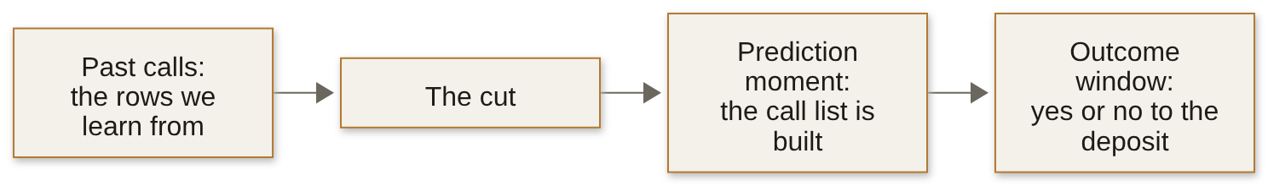
Line | On the week's run
Training slice | 24,712 clients, 11.27 percent yes
Validation slice | 8,238 clients, 928 of them yes (11.26 percent)
Test slice, sealed on Monday | 8,238 clients, opened once on Friday
Call nobody, on validation | accuracy 0.887; finds 0 of the 928 buyers
Logistic regression on the customer table, threshold 0.5 | accuracy 0.897; AUC 0.761; finds 174 of the 928

Q1 Medium · Sort the asks · every correct letter
The bank's marketing head brings four asks. Which need a model that predicts? Circle every correct letter.
A. the clients to call first next month, ranked by their chance of saying yes
B. the count of yes answers in each month of 2009, for the annual report
C. the clients whose previous campaign ended in success, listed by branch
D. each new client's own chance of a yes on a first call, before anyone calls

Q2 Hard · Read one score · one letter
The logistic model on the customer table gives one client a score of 0.71, and its validation AUC is 0.761 (Exhibit 1A). What does the 0.71 say, and what would let the memo read it that way?
A. A 71 percent chance of a yes, and the AUC of 0.761 already shows the scores can be read as chances.
B. The model is right on about 71 percent of the clients it scores, which the validation slice confirms.
C. The client will say yes, since a score above 0.5 is a yes once the model beats calling nobody.
D. About 71 in 100 such clients say yes, if about 71 in 100 validation clients scored near 0.71 did.

Q3 Hard · Predict the fresh score · one letter
On Monday a junior tried 60 versions of the model, each on a different list of columns, scored all 60 on the same 2,000 held-out clients and kept the best: accuracy 0.9055 there, where calling nobody scores 0.8875. On 6,238 fresh clients, where calling nobody scores 0.8873, what does the chosen version score, and what have the 2,000 clients become?
A. About 0.906 again, since the version never trained on the 2,000; they remain a fair test of it.
B. About 0.887, since the loop found only luck and its edge vanishes; the 2,000 have become training.
C. About 0.897: part of the 1.8-point edge was luck the loop picked; the 2,000 are now validation.
D. About 0.80, since 60 versions overfit the 2,000 and fall below calling nobody; they are now spent.

Q4 Hard · Judge the split · one letter
The calls run in date order. On the week's run the earliest 70 percent of rows say yes 5.6 percent of the time and the latest 30 percent say yes 24.6 percent of the time. Statement: for the question "whom do we call in the next campaign", a split by date estimates the model's score more honestly than a random split of all the rows. True or false, and why?
A. True: a random split trains on later months than it validates on; train early and score late, like the ask.
B. True: a split by date keeps more yes rows in validation, so its score is less noisy than a random split's.
C. False: a stratified random split keeps 11.27 percent yes in every slice, so each is a fair sample of clients.
D. False: the model never reads a date column, so the order in which the calls were made cannot move its score.
Part 2. Which number tells the truth, and where does the line go?
5 items, Q5 to Q9, about 15.5 minutes. What it shows: whether you can read a confusion matrix, price each error and set the line the business can afford.
On Tuesday the room scored the customer-table model the way the business will judge it. Exhibit 2A gives two matrices on the same 8,238 validation clients: calling nobody, and the model at the default threshold of 0.5. Each outcome is priced at Kalpa's costs, as Tuesday priced them: a call to a client who says no wastes Rs 40, and a buyer the list leaves out loses about Rs 1,200 of margin. The marketing head's question is the bank's version of the marketing lead's at Kalpa: whom to call, and how many.
Exhibit 2A Two confusion matrices on the 8,238 validation clients, and what each box costs at Kalpa's prices.
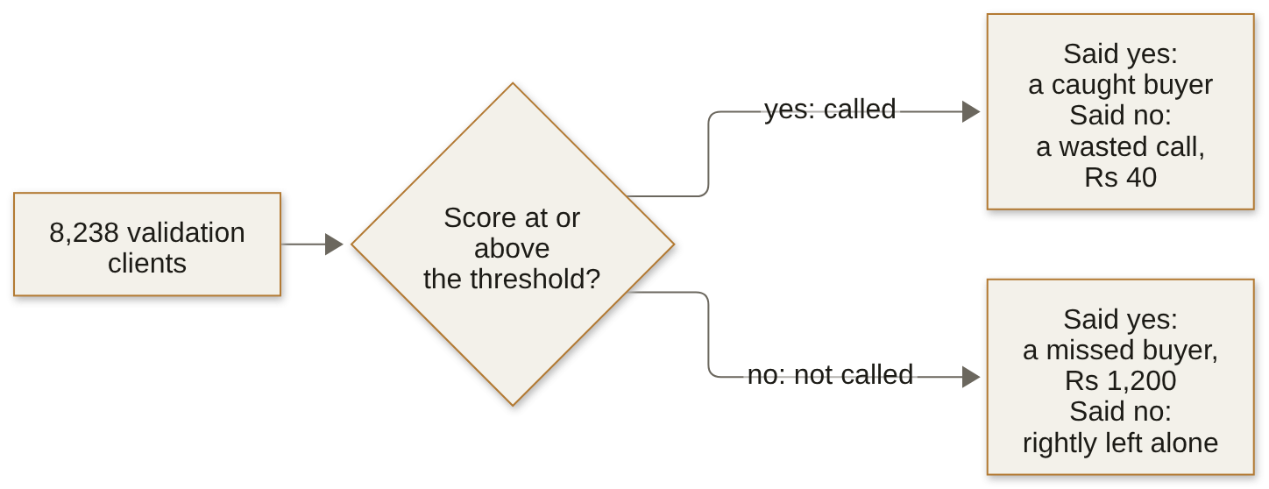
Matrix | Called, said yes | Called, said no | Not called, said yes | Not called, said no
Call nobody | 0 | 0 | 928 | 7,310
Model at 0.5 | 174 | 94 | 754 | 7,216

Q5 Medium · Judge the accuracy claim · one letter
Statement: an accuracy of 0.897 against 0.887 for calling nobody shows that the model at 0.5 is good enough to run the campaign. True or false, and why?
A. True: it beats its baseline on the same 8,238 clients, and a model that beats its baseline is ready to run.
B. True: it gets 848 clients wrong against the baseline's 928, so it makes 80 fewer mistakes in the campaign.
C. False: accuracy is fair only on the sealed test slice, so 0.897 means nothing until Friday's envelope is opened.
D. False: calling nobody already scores 0.887, so accuracy says little; at 0.5 the model finds 174 of 928 buyers.

Q6 Medium · Work the matrix · show the working
From the model's row of Exhibit 2A, compute its precision, recall and F1 at the threshold of 0.5, each to two decimal places. Show the working.

Working. The final answer goes on the answer sheet.

Q7 Medium · Draw the line · show the working
A call to a client who says no wastes Rs 40, and a buyer left off the list loses about Rs 1,200. Above what chance of a yes is a call worth making, and which way does that move the threshold from 0.5? Show the working.

Working. The final answer goes on the answer sheet.

Exhibit 2B The customer-table model at four thresholds on the 8,238 validation clients.
Threshold or cut | Called | Caught buyers | Wasted calls | Missed buyers
0.5 | 268 | 174 | 94 | 754
0.20 | 864 | 376 | 488 | 552
0.10 | 2,754 | 616 | 2,138 | 312
The cost line | 7,438 | 913 | 6,525 | 15

Q8 Hard · Choose by F1 or by the bill · show the working
Two teammates choose between the thresholds of 0.20 and 0.10 in Exhibit 2B: one by F1, the other by the error bill at Rs 40 a wasted call and Rs 1,200 a missed buyer. Which threshold does each choose, with the figures that decide it, and why do the two choices differ? Show the working.

Working. The final answer goes on the answer sheet.

Q9 Hard · Spend 1,000 calls · one letter
The call centre can make 1,000 calls in the next campaign, and the cost line would call 7,438 of these 8,238 clients (Exhibit 2B). Which plan goes to the marketing head?
A. Call the 864 clients above 0.20, at a precision of 0.435, and hold the other 136 calls in reserve.
B. Call the 268 clients above 0.5, where precision is at its highest, and save the rest of the budget.
C. Rank every client by score and call the top 1,000, wherever that cut happens to fall on the scores.
D. Draw 1,000 clients at random from the 7,438 above the cost line, since every one of them clears it.
Part 3. What was the model allowed to know?
4 items, Q10 to Q13, about 10.5 minutes. What it shows: whether you can test each column against the moment of prediction and say what a coefficient does and does not prove.
On Wednesday two more feeds were joined to the customer table: five economic indicators, each published for its month or quarter, and this campaign's call log. Exhibit 3A gives the validation scores as each feed joins. A junior analyst wants to ship the last line tonight, and the marketing head asks which line to trust for next month's call list.
Exhibit 3A The three feeds joined on Wednesday, and the logistic model's validation scores as each feed joins, threshold 0.5, the 928 validation buyers.
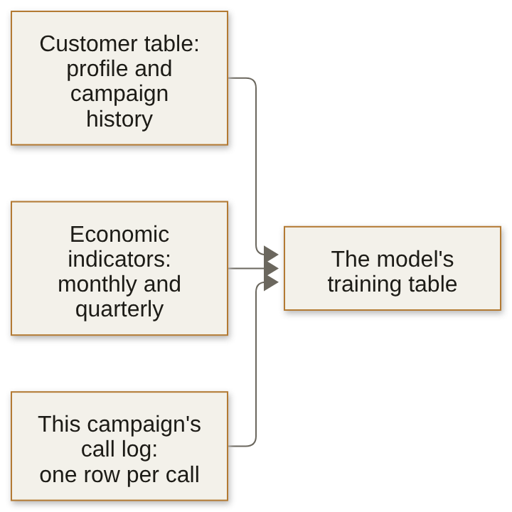
Columns in the model | Validation AUC | Accuracy at 0.5 | Buyers found at 0.5
The customer table: profile and campaign history | 0.761 | 0.897 | 174
The customer table and the five economic indicators | 0.795 | 0.899 | 211
All of those and duration, the call's length in seconds | 0.932 | 0.907 | 390

Q10 Medium · Answer the junior · one letter
The junior's message reads: "Adding duration lifts AUC from 0.795 to 0.932. Shipping tonight." What is the reply?
A. Ship it: the dataset's authors put duration in the file, so it is a fair column for the model.
B. Hold it: accuracy only rose from 0.899 to 0.907, so the AUC jump must be noise in validation.
C. Drop it: a call's length exists only once the call ends, so no list can use it; report 0.795.
D. Keep it but scale it first, since a column measured in raw seconds is what inflates the AUC.

Q11 Hard · Test each column · every correct letter
The list for next month's campaign is built on the morning before the first call. Which columns pass the prediction-time question? Circle every correct letter.
A. duration, the length in seconds of this campaign's last call to the client
B. poutcome, the last campaign's result; 65 percent of its successes say yes
C. age, job and housing, as they stand in the customer table that morning
D. nr.employed for the current quarter, filled in once that quarter closes

Exhibit 3B A pneumonia model trained on chest X-rays from two hospital systems, as Zech and others report it (PLOS Medicine, 2018).
What the paper reports | Value
The model's AUC on held-out X-rays from its own two hospital systems | 0.931
The same model's AUC at a third hospital system | 0.815
AUC from sorting X-rays from the two training systems by hospital alone | 0.861
Pneumonia rate in the two training systems | 34.2 percent and 1.2 percent
X-rays from one system whose hospital a network identified | 22,050 of 22,062

Q12 Hard · Diagnose the drop · one letter
Exhibit 3B reports a pneumonia model that scored well on held-out X-rays and worse at a new hospital. Which reading holds, and which check would have caught it before launch?
A. It learned which hospital took each X-ray, a shortcut its held-out set shared; test it on a new site.
B. It memorised its training X-rays, so a stronger penalty or a smaller network would have closed the gap.
C. The new hospital's X-rays were poorer, so the drop says nothing about the model and needs no check.
D. 0.815 is still a strong AUC, so the model carries over, and the drop is the noise of one test set.

Exhibit 3C Two readings of Wednesday's models on the week's run: the importance chart of the model with every column, and the logistic model's weight on euribor3m, the three-month interest rate, on the standardised scale.
What the week's run shows | Value
duration's place on the importance chart of the model with every column | first
Mean call length: clients who said yes; clients who said no | 553 seconds; 221 seconds
euribor3m's weight with no other column in the model | -0.92
euribor3m's weight beside the customer table and the other four indicators | +0.39

Q13 Hard · Check two conclusions · one letter
The marketing head reads Exhibit 3C and draws two conclusions. One: longer calls make deposits, so agents should be coached to keep clients on the line. Two: higher rates bring deposits, since euribor3m's weight is +0.39 once the other columns are held fixed. Which reply holds?
A. Both hold: the chart and the weight come from models that scored well on the validation slice.
B. One fails, since a yes makes the call long; two holds, since the full model holds the other columns fixed.
C. One holds, since 332 seconds is far beyond chance; two fails, since the weight flips as columns join.
D. Both fail: a yes lengthens the call, and the rate moves with the other indicators; neither is an effect.
Part 4. Is the model learning, or memorising?
4 items, Q14 to Q17, about 10 minutes. What it shows: whether you can read training against validation, choose complexity by cross-validation and say when the simpler model ships.
On Thursday the room grew a decision tree on the honest columns, the customer table and the economic indicators, first with no limit on its depth and then reined in. Exhibit 4A gives the tree's training and validation scores by depth; calling nobody scores 0.887 accuracy on the same validation clients. The committee's question for Friday is which model goes into the memo, and why that one.
Exhibit 4A A decision tree on the honest columns: accuracy on training and on validation by maximum depth, with validation AUC, the week's split.
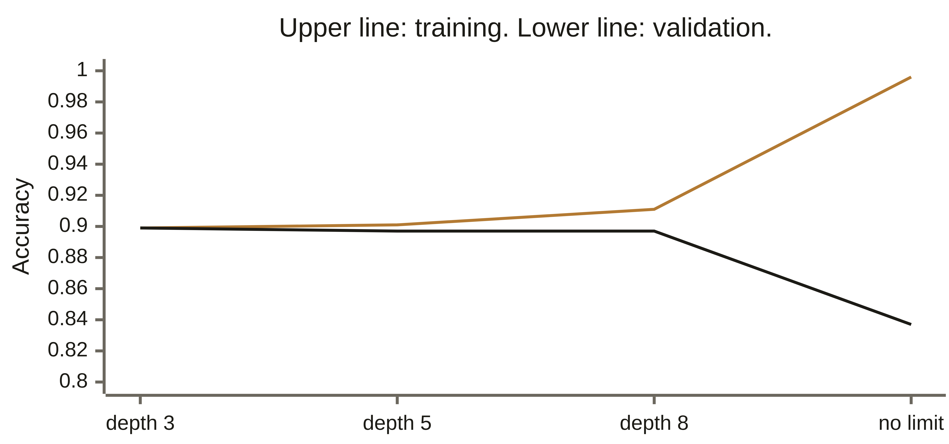
Maximum depth | Training accuracy | Validation accuracy | Validation AUC
3 | 0.899 | 0.899 | 0.751
5 | 0.901 | 0.897 | 0.783
8 | 0.911 | 0.897 | 0.777
No limit | 0.996 | 0.837 | 0.619

Q14 Medium · Read the depth curve · one letter
The unlimited tree scores 0.996 on training and 0.837 on validation, below calling nobody. Which reading and which next step are right?
A. It memorised the training clients; cap the depth near the validation peak, confirmed by CV.
B. It needs more columns to learn from; join the call log so validation catches up with training.
C. It has not trained long enough; grow it further until validation rises to meet training.
D. Validation has drifted from training; refit the unlimited tree on validation and report it.

Q15 Medium · Pick the brakes · every correct letter
Which of these put a brake on overfitting? Circle every correct letter.
A. capping the tree's depth, or asking for more clients in every leaf
B. a stronger penalty on the logistic weights, a smaller C in scikit-learn
C. refitting until the training rows score 1.0 at every new setting
D. a simpler depth or penalty, chosen by five-fold cross-validation

Exhibit 4B Five-fold cross-validation of the logistic model on the 24,712 training clients, honest columns, and three model families scored on the 8,238 validation clients.
Run | AUC
Logistic, fold 1 | 0.771
Logistic, fold 2 | 0.769
Logistic, fold 3 | 0.797
Logistic, fold 4 | 0.796
Logistic, fold 5 | 0.798
Logistic, mean of the five folds | 0.786
Logistic regression, on validation | 0.795
Random forest, on validation | 0.799
Gradient boosting, on validation | 0.806

Q16 Hard · Count the folds · one letter
Five-fold cross-validation of the logistic model gave the five fold scores in Exhibit 4B. How many models were fitted, on about how many clients each, and what does the spread tell the committee?
A. One model, scored five times on 4,942 clients each; the spread is that one model's error.
B. Five models on about 19,770 clients each; one split could have read 0.77 or 0.80.
C. Five models on about 4,942 clients each; the spread says the model needs more rows.
D. Five models on all 24,712 clients each; the spread is noise and says nothing of a split.

Q17 Hard · Judge the winner · one letter
Statement: the logistic model should go into the memo, although gradient boosting scores the highest validation AUC of the three families in Exhibit 4B. True or false, and why?
A. True: a logistic model cannot overfit its rows, so its validation score is the safer one to quote.
B. True: a gap of 0.011 can flip on another split, as the folds' spread shows; the plainer model ships.
C. False: 0.806 is above 0.799 and 0.795 on the same validation rows, and the memo reports the best found.
D. False: AUC cannot compare models of different families, so the committee needs each accuracy at 0.5.
Part 5. Would the committee sign, and what moves to lending?
5 items, Q18 to Q22, about 12.5 minutes. What it shows: whether you can say what a memo must prove, how a model is caught going stale and why the same model draws an opposite line in lending.
On Friday the room wrote the memo for Meera Raghavan's committee: Anand Iyer, the marketing lead and Rohan Desai of Kalpa Financial Services, who is watching for his own business. The bank's file showed what time does to a model. Trained on the earliest 70 percent of the calls and scored on the latest 30 percent, the logistic model on the honest columns met a world where far more clients said yes than it had learned (Exhibit 5A). Exhibit 5B, with the first item, sets two public cases beside it.
Exhibit 5A The four lines of the committee memo, and the bank's file split by date instead of at random: the logistic model on the honest columns.
Line | On the week's run
Earliest 70 percent of calls, 28,831 clients | 5.6 percent said yes
Latest 30 percent of calls, 12,357 clients | 24.6 percent said yes
Mean predicted chance of a yes on the latest 30 percent | 0.152

Exhibit 5B Two public cases. Instacart: Fortune, 9 June 2020, and Instacart's engineering blog, 10 July 2023. Booking.com: Bernardi, Mavridis and Estevez, KDD 2019, section 3.
Case | What the source reports
Instacart's item-availability model, March 2020 | A metric used to evaluate the model that predicts whether an item is in stock fell from 93 percent to 61 percent, which told the engineers to retrain; by June it read about 85 percent
Instacart, looking back | Models respond slowly to a shock because they need enough new observations; thresholds on top of the model were changed without training new models
Booking.com, 23 comparisons of a new model against a proven one | Offline gain (ROC AUC or mean reciprocal rank) against the gain in a business metric when the two models were compared live: Pearson correlation -0.1, 90 percent interval -0.45 to 0.27

Q18 Hard · Set the alarm · one letter
On the latest 30 percent of calls the model's mean score was 0.152 while 24.6 percent said yes (Exhibit 5A). Which monitoring rule catches this first, and what happens to the cut on these scores that the cost line sets?
A. Set each month's called yes rate against the mean score, with a stated gap; the cut moves down, as scores run low.
B. Set each month's called yes rate against the mean score, with a stated gap; the cut moves up, as more clients now say yes.
C. Retrain every night on the newest calls; the scores then stay current, so the cut on them needs no second look.
D. Compare training accuracy month by month; a fall there flags the drift, and the cut stays where Tuesday drew it.

Q19 Medium · Fill the caveat · every correct letter
Which lines belong in the memo's caveat? Circle every correct letter.
A. the validation AUC of 0.795, against 0.761 for the customer table alone
B. the segment where the model performs worst, with how many clients it holds
C. the gap between predicted and actual yes rates that would trigger a retrain
D. the number of calls the campaign budget pays for in the next month

Q20 Hard · Choose the evidence · one letter
Anand Iyer asks what evidence would make him sign. Across 23 comparisons, Booking.com found offline gains and business gains almost uncorrelated (Exhibit 5B). Which test does the memo propose for next month?
A. Call every client by the list next month, then compare its deposits per call with this month's, before the switch.
B. Score the list once on the sealed test slice, and sign if its AUC holds near the 0.795 it scored on validation.
C. Run the list beside today's rule for a month, each on the branches it suits best, and compare deposits sold.
D. Assign next month's clients at random, half to the list and half to today's rule; compare deposits per call.

Q21 Hard · Move the line to lending · one letter
Rohan Desai's lending book: approving a borrower who defaults costs Rs 60,000, and rejecting a good borrower costs Rs 3,000 of lost interest. His model, calibrated on recent loans, gives applicant P a 4 percent chance of default and applicant Q an 8 percent chance. Whom does Rohan approve?
A. Both: each is far below a 50 percent chance of default, the neutral line for a yes or no decision.
B. P only: the line sits near a 5 percent chance of default, so Q at 8 percent costs more than it pays.
C. Both: an 8 percent chance of default means 92 in 100 such borrowers repay, a strong book for any lender.
D. Neither: a default costs twenty times a rejection, so any chance above 1 in 20 must mean a rejection.

Exhibit 5C Two public fraud cases. Stripe: its primer on machine learning for fraud protection. Flipkart with Carnegie Mellon: Hooi and others, BIRDNEST, arXiv 1511.06030.
Case | What the source reports
Stripe's worked example | A sale earns a profit of 2.08 dollars and a fraudulent sale loses 38.92 dollars, so one fraud costs the profit of 18.71 good sales and the break-even precision of a block is 5.07 percent
Stripe, on false declines | In a survey Stripe cites, 33 percent of consumers said they would not shop again at a business after a false decline
Flipkart's ratings-fraud model | The trust team investigated the 250 accounts the model ranked most suspicious, and 211 of them were involved in fraud

Q22 Hard · Answer Rohan's question · one letter
Rohan Desai asks one question about a fraud model for Kalpa Financial Services' payments app: "Do we tune it for precision or for recall?" Exhibit 5C sets two public cases beside his question. What is the best first reply?
A. Recall: Stripe's arithmetic blocks above a 5 percent break-even, so a missed fraud is the cost; catch all of it.
B. Precision: a third of customers leave after a false decline, so flag only the payments the model is sure of.
C. Ask first: does a flag block the payment or send it to a reviewer, and how many can the team review a day?
D. F1: fraud is rare, so F1 weighs both errors at once, and the threshold goes where F1 peaks on validation.
Stretch: untimed, and not marked
For anyone who finishes early. Nothing here is counted; each item is the kind an interviewer asks after your first answer, so write the answer you would say.
Stretch 1 Written · the answer you would say aloud
German Credit, the take-home's dataset (OpenML credit-g), documents its own cost matrix: classing a bad borrower as good costs 5, and classing a good borrower as bad costs 1. Above what chance of repaying should that lender approve, and how does it sit beside Rohan Desai's line?
Your answer

Stretch 2 Written · the answer you would say aloud
Two models score within a hair of each other on validation, and one is far harder to explain. Name the evidence that would make you ship the harder one, and say how you would size the gap in rupees at the budget of 1,000 calls.
Your answer

Stretch 3 Written · the answer you would say aloud
An interviewer asks: "Walk me through a model you built." Write the 30-second version with three numbers from this week's run and one choice you would make differently.
Your answer

Answer sheet
Week 5 Recap Paper | Cohort 2 | Week 5. Fill in pen. Mark one box per row, or every correct box for a starred item; if you change your mind, cross the old box fully and mark the new one. Write words and numbers clearly, one per space.

Name | Seat | Marked by | Items right
 |  |  | ____ of 22
Step one: rate each part before you read any item
Part | 1 | 2 | 3 | 4 | Items right (marker)
Part 1. Should the bank build a model, and what must it beat? |  |  |  |  | ____ of 4
Part 2. Which number tells the truth, and where does the line go? |  |  |  |  | ____ of 5
Part 3. What was the model allowed to know? |  |  |  |  | ____ of 4
Part 4. Is the model learning, or memorising? |  |  |  |  | ____ of 4
Part 5. Would the committee sign, and what moves to lending? |  |  |  |  | ____ of 5
1 = I have not used this; 2 = I can follow it when someone shows me; 3 = I can do it alone on a small problem; 4 = I can find and fix mistakes in someone else's version
Lettered items: one box, or every correct box for a starred item. True or false: one box
   | A | B | C | D
  Q1*
  Q2
  Q3
  Q4
  Q5
  Q9
  Q10
   | A | B | C | D
  Q11*
  Q12
  Q13
  Q14
  Q15*
  Q16
  Q17
   | A | B | C | D
  Q18
  Q19*
  Q20
  Q21
  Q22
* Mark every correct box. A shaded box is a letter the item does not offer.
Letters, words, numbers and orders: one answer per space
   | Answer | Write it here
  Q6 | Final answer
  Q7 | Final answer
   | Answer | Write it here
  Q8 | Final answer

