Week 2 Recap Paper
Cohort 2 | Week 2 | Saturday 17 October 2026 | 120 minutes | 33 items in 6 parts | ungraded

What this paper is for
This week you computed Anand's Monday numbers in the warehouse, set booked revenue against the cash actually collected, drew up Marketing's protect list, built the customer table in pandas and carried it to the leadership deck in Excel. This paper finds which of those decisions you can make cold, with no notes and no assistant, on the week's own tables, on public cases from well-known organisations and on the tables an AI team keeps. The room's scores by part, set beside the ratings you give in step one, tell Monday's session where to start.
Rules
Rule | Detail
Time | 120 minutes in one sitting for 33 items, which the blueprint paces at 113 minutes. Each part gives its minutes as a guide; move on when an item is eating your time, and come back to it at the end.
Tools | Pen and this paper only: no laptop, no phone, no notes and no assistant. Rough working goes in the margins and in the working boxes.
Answers | Every answer goes on the answer sheet at the back, which is the page that is marked: one box for a lettered item, every correct box for a starred one, the letter for a word-bank or match item, and the number or the letters in order in the space. A wrong answer costs nothing, so answer every item.
Levels | Every item shows its level beside its number, easy, medium or hard. A hard item is several steps on an exhibit, never an obscure fact.
Exhibits | An exhibit is printed once, labelled by its part as Exhibit 2A, 2B, and every item that reads it follows it. Read code and queries as written: Python 3 and PostgreSQL unless the item says otherwise.
Company | Parts 1 to 4 and the workbook in Part 5 are set inside Kalpa Retail, the fictional company of Weeks 1 and 2: Anand Iyer is its finance controller, Kavya Nair its senior analyst and Meera Raghavan its CEO, and the head of Retail-Plus, the data platform lead and Meera's chief of staff are named by role. Six items draw on public cases at Facebook, Public Health England, genomics journals, an economics paper, JPMorgan and Uber, each with its source beside it. Part 6 imagines the AI team of a food-delivery company, and its tables and numbers are illustrative. Every number an item needs is on the page.
Afterwards | Papers are swapped and marked against the key, then the discussion takes the items the room missed most. The paper is ungraded and ranks nobody; the room's rates by part and by tag set Monday's revision.
Step one, before Part 1
On the answer sheet, rate yourself from 1 to 4 on each part before you read any item. Rate yourself as you are today: the comparison between your rating and your score in each part is the most useful thing this paper produces for Monday.
1  I have not used this | 2  I can follow it when someone shows me | 3  I can do it alone on a small problem | 4  I can find and fix mistakes in someone else's version
One rating for each of the 6 parts in the table below, in the boxes on the answer sheet.
The paper at a glance
Part | Title | Items | What it shows | Minutes | Easy | Medium | Hard
1 | Anand's Monday numbers | Q1 to Q6 (6) | how you work with the numbers Anand's Monday sheet reports | 16 | 2 | 2 | 2
2 | Booked against collected | Q7 to Q11 (5) | how you set the cash collected against the revenue booked | 19.5 | 0 | 1 | 4
3 | The protect list and the plan line | Q12 to Q16 (5) | how you build Marketing's protect list and read the quarter against its plan | 17 | 0 | 2 | 3
4 | One row per customer | Q17 to Q20 (4) | how you build Marketing's customer table in pandas | 16 | 0 | 0 | 4
5 | The last mile, and spreadsheets in public | Q21 to Q27 (7) | how you build the workbook for Monday's review, and read spreadsheets from public cases | 22 | 0 | 4 | 3
6 | Read the code, read the data: an AI team's tables | Q28 to Q33 (6) | how you read the tables an AI team keeps, and the numbers it acts on | 22.5 | 0 | 1 | 5
 | Total | 33 |  | 113 | 2 | 10 | 21
Pacing
Each band is as wide as its part's minutes; the timed items fill 113 of the 120 minutes, and the minute each part starts is under it.
Part 1  16 min | Part 2  19.5 min | Part 3  17 min | Part 4  16 min | Part 5  22 min | Part 6  22.5 min
0 | 16 | 35.5 | 52.5 | 68.5 | 90.5
Part 1. Anand's Monday numbers
6 items, Q1 to Q6, about 16 minutes. What it shows: how you work with the numbers Anand's Monday sheet reports.
Anand Iyer, Kalpa Retail's finance controller, keeps the books every revenue figure has to match. Every Monday he wants revenue, orders and customers for each segment, the groups Kalpa sells to (Business, Retail-Core, Retail-Plus, which is the paid-membership tier, and Student), and for each channel (app, web and store). His words: "Compute them from the warehouse itself. No notebooks, no exports, nothing a person can mistype." The warehouse is the company's central Postgres database, and his analyst audits every query line by line. It stores Kalpa's first quarter, April to June, as quarter 'Q1' and its second, July to September, as 'Q2'.
Exhibit 1A The Retail-Plus branch of Anand's revenue tree, as the warehouse holds it: revenue is members who ordered, times orders per member, times revenue per order.
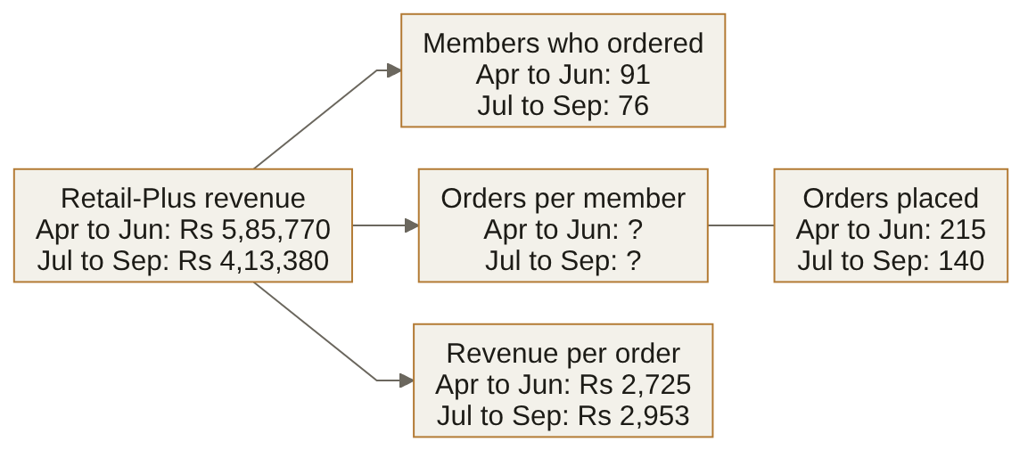

Q1 Hard · Predict and read the leaf · show the working
Anand's analyst fills the missing leaf with SELECT quarter, count(*) / count(DISTINCT customer_id) FROM rp_orders GROUP BY quarter, where rp_orders holds the Retail-Plus orders above, and drafts a note to the head of Retail-Plus from what it returns. What does the query print for each quarter, and what should the note say orders per member did from the first quarter to the second? Show the working.

Working. The final answer goes on the answer sheet.

Word bank 1 Write the letter of the word or phrase that completes each statement. Each is used once at most, and some are not used.
A sort | B CTE | C view
D guarantee | E subquery

Q2 Easy · Complete the LIMIT rule · a letter from Word bank 1
Without ORDER BY, the database makes no ____ about which five rows LIMIT 5 returns.

Q3 Easy · Complete the WITH rule · a letter from Word bank 1
A named query step introduced by the keyword WITH is called a ____.

Exhibit 1B The analyst's query for the head of Retail-Plus.
WITH member_step AS (
SELECT c.customer_id, sum(o.amount) AS spend
FROM customers c
LEFT JOIN orders o
ON o.customer_id = c.customer_id AND o.quarter = 'Q2'
WHERE c.segment = 'Retail-Plus'
GROUP BY c.customer_id)
SELECT round(avg(spend)) AS avg_spend
FROM member_step;

Q4 Medium · Predict the average · one letter
Retail-Plus has 120 members on its books, and from July to September 76 of them ordered, spending Rs 4,13,380 between them. The head of Retail-Plus asks for the average spend per member on the books, and the analyst runs the query above. What does it print?
A. An error, since avg cannot read a spend that is NULL
B. 3445, the average over all 120 members on the books
C. 5439, the average over the 76 members who ordered
D. NULL, since one missing spend leaves the whole average empty

Q5 Medium · Choose where it runs · one letter
On Monday afternoon the head of Retail-Plus asks the analyst for a chart of orders per member, week by week across both quarters, to see how the figure moved before anyone decides what to report. With Anand's rule in mind, where should that work happen?
A. In a notebook that reads the warehouse, since this chart is none of the Monday figures the rule governs
B. In the Monday suite as a saved query, since Anand's rule covers every number that anyone at Kalpa looks at
C. In a workbook built from Monday's export, since a weekly chart is what Excel does best for a tier's head
D. Nowhere yet, since a chart of a figure Finance has not defined will mislead whoever reads it

Exhibit 1C Five illustrative people who played a video and the seconds each watched, with the average Facebook defined and the one it calculated (TechCrunch, 2016).
WITH viewers (viewer_id, seconds) AS (VALUES
(1, 2.0), (2, 14.0), (3, 1.0), (4, 9.0), (5, 4.0))
SELECT round(sum(seconds) / count(CASE WHEN seconds >= 3 THEN 1 END), 1) AS calculated,
round(sum(seconds) / count(*), 1) AS defined
FROM viewers;

Q6 Hard · Size the overstatement · one letter
In 2016 Facebook told advertisers that it had defined the average duration of video viewed as the total time spent watching a video divided by the number of people who played it, and had calculated it by dividing by only the people who watched for three seconds or more (TechCrunch, 2016). The query above rebuilds both on five illustrative viewers. By how much does the calculated average overstate the defined one?
A. About 40 percent
B. 50 percent
C. Not at all; the two agree
D. About 67 percent
Part 2. Booked against collected
5 items, Q7 to Q11, about 19.5 minutes. What it shows: how you set the cash collected against the revenue booked.
Booked revenue is the value of the orders customers placed; collected revenue is the cash that actually arrived for them. Anand asks: "Show me, order by order, what we actually collected against what we booked from July to September. If there is a gap, I want to know which orders and which channel." A reconciliation is the written account of every rupee between the two figures.
Set 1. The case
The quarter from July to September, stored as quarter 'Q2', holds 462 orders booked at Rs 9,84,00,000. In the payments feed, 216 of them have one payment row; 188 have two rows, instalments 1 and 2 of one invoice; 28 have two identical rows, because the gateway posted instalment 1 twice; and 30 delivered orders have no payment row at all. Eight further payment rows carry an order_id that no order has.
Exhibit 2A The quarter's orders by their payment rows, as the situation describes them.
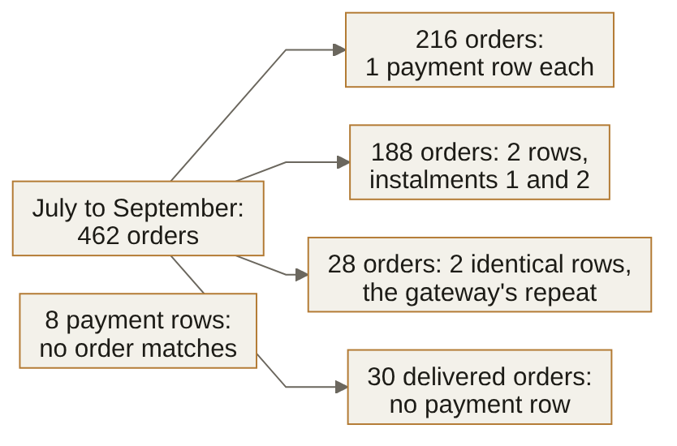

Exhibit 2B The first query in Anand's report, run before any rupee is summed.
SELECT count(*) AS rows_out,
count(p.payment_id) AS payment_rows
FROM orders o
LEFT JOIN payments p ON p.order_id = o.order_id
WHERE o.quarter = 'Q2';

Q7 Hard · Size the join first · one letter
Before the report goes to Anand, the analyst sizes the join by hand. What will the query above return?
A. 678 and 648
B. 462 and 432
C. 650 and 620
D. 686 and 656

Q8 Hard · Order the report's steps · letters in order
Five of these six steps make Anand's collected-revenue report, and one would spoil it. Leave that step out, and write the other five in the order they must run.
A. Send booked, collected and the gap to Anand, channel by channel
B. LEFT JOIN the quarter's 462 orders to each order's collected figure
C. Check that the result has one row for each of the 462 orders, and that each channel's gap equals its unpaid orders' booked value
D. Drop every order that has two payment rows, since those are the gateway's double posts
E. Keep one payment row for each order and instalment number
F. Sum the payment rows to one collected figure for each order
Write the letters in order on the answer sheet.

Exhibit 2C The analyst's query, with three of the quarter's orders and their payment rows written into it.
WITH orders (order_id, amount) AS (VALUES
('O-1', 1200), ('O-2', 800), ('O-3', 500)),
payments (order_id, paid_date, paid) AS (VALUES
('O-1', DATE '2026-07-04', 600), ('O-1', DATE '2026-08-04', 600),
('O-2', DATE '2026-10-01', 800))
SELECT count(*) AS rows_out, sum(o.amount) AS booked
FROM orders o
LEFT JOIN payments p ON p.order_id = o.order_id
WHERE p.paid_date BETWEEN DATE '2026-07-01' AND DATE '2026-09-30';

Q9 Hard · Run the query by hand · one letter
Anand wants every order of the quarter beside what was collected on it within the quarter, so the analyst adds a date filter on the payments. Before the report goes to him, the analyst runs the query above to count its rows and their booked value. What does it return?
A. 1 row, booked Rs 1,200
B. 2 rows, booked Rs 2,400
C. 3 rows, booked Rs 2,900
D. 4 rows, booked Rs 3,700

Exhibit 2D Suppose these are the report's figures by channel at the end of a later reporting day; the figures are illustrative. The report's row count and its booked total both match their sources.
Channel | Booked, Rs | Collected, Rs | Unpaid orders' booked value, Rs
App | 4,25,90,270 | 4,25,82,150 | 8,120
Store | 3,21,48,730 | 3,11,90,920 | 9,57,810
Web | 2,36,61,000 | 2,28,50,250 | 7,89,000

Q10 Medium · Decide what leaves tonight · one letter
It is the end of the reporting day, and Anand expects the report tonight. His rule for a late failure is to send what reconciles and hold what does not, and in each channel the gap, booked less collected, should equal the unpaid orders' booked value. What do you send?
A. Booked and collected for every channel, with any unexplained gap added to that channel's unpaid list
B. Booked for every channel, collected for app and web, and store's collected held back
C. Booked for every channel, collected for app and store, and web's collected held back
D. Booked for every channel, with all collected held back until every bridge closes

Exhibit 2E Suppose one day's files from three labs looked like this; the counts are illustrative. An .xls sheet holds 65,536 rows, one of them the header.
Lab file | Records in the lab's CSV | Data rows in the .xls sheet | Rows loaded | Rows loaded the day before
Lab A | 41,200 | 41,200 | 41,200 | 39,850
Lab B | 70,900 | 65,535 | 65,535 | 61,020
Lab C | 12,480 | 12,480 | 12,480 | 13,110

Q11 Hard · Choose the checks · every correct letter
In October 2020 Public Health England found that 15,841 positive COVID-19 cases from 25 September to 2 October had been left out of the daily figures, because some files had exceeded the maximum size the load could take (GOV.UK, 2020). The labs' CSV files had been converted to the older .xls format, and records past its limit were "simply left off and not counted when imported" (The Register, 2020). Which of these checks, run on every file, would have stopped Lab B's file on the day in the table? Mark every correct option.
A. Compare rows loaded with data rows in the .xls sheet, and stop the file when they differ
B. Remove duplicate rows from each file before it is loaded, so that no case counts twice
C. Compare rows loaded with records in the lab's CSV, and stop the file when they differ
D. Stop any file whose rows loaded fall below that lab's rows loaded the day before
E. Stop any file whose sheet holds exactly 65,535 data rows, the most the format allows
Part 3. The protect list and the plan line
5 items, Q12 to Q16, about 17 minutes. What it shows: how you build Marketing's protect list and read the quarter against its plan.
Retail-Plus is Kalpa's paid-membership tier, and Marketing will offer a retention benefit to the members it most wants to keep: "Give us the top fifty customers in each segment by revenue for July to September, and flag anyone whose monthly spend has fallen for two months running." That list is the protect list. Meera also wants to see the quarter's revenue build up week by week against the plan line, the revenue the growth plan expects by the end of each week.
Exhibit 3A Retail-Plus members in rows 46 to 53 when sorted by the quarter's revenue, highest first, with tied members in order of their ids.
Row, highest revenue first | Member | Revenue, July to September, Rs
46 | C-0162 | 3,600
47 | C-0264 | 3,540
48 | C-0189 | 3,480
49 | C-0206 | 3,480
50 | C-0185 | 3,350
51 | C-0242 | 3,350
52 | C-0259 | 3,200
53 | C-0252 | 3,150

Q12 Hard · Apply the head's rule · one letter
Retail-Plus had 76 members who ordered from July to September. Sorted by their revenue for the quarter, highest first, the top 45 each spent a different amount, all above Rs 3,600, and rows 46 to 53 are in the table. The head of Retail-Plus sets the rule for the protect list: "If two members spent the same, rank them the same. Keep every member who spent at least as much as the fiftieth, and nobody who spent less." Which ranking gives that list, and how many members does it keep?
A. DENSE_RANK, keeping every member ranked 50 or better: 52 members
B. ROW_NUMBER with member id as tiebreaker, keeping rows 1 to 50: 50 members
C. Whole ties only, cutting before any tie that crosses the fiftieth place: 49 members
D. RANK, keeping every member ranked 50 or better: 51 members

Q13 Medium · Choose the approach · one letter
Marketing's first protect list sorted every customer by revenue for July to September and kept the top fifty: all 35 Business customers who ordered, because the smallest of their spends is ten times the largest retail spend, then 11 Retail-Plus members and 4 Retail-Core customers, and no Student. For a pilot, Marketing now wants the top three customers in each segment. Which approach answers it?
A. GROUP BY segment with LIMIT 3, which applies the limit to each group in turn
B. A rank within PARTITION BY segment, which an outer query keeps at 3 or better
C. ORDER BY revenue DESC with LIMIT 3, which returns the top rows of each segment
D. HAVING count(*) <= 3, which keeps the three largest rows inside each group

Q14 Medium · Choose the share query · one letter
Marketing wants each Retail-Plus member's spend beside the member's share of the tier's spend for July to September. The table member_step holds one row per member who ordered, with the columns customer_id and spend. Which query gives each member's share?
A. SELECT customer_id, spend, spend / sum(spend) OVER () FROM member_step
B. SELECT customer_id, spend, spend / sum(spend) FROM member_step GROUP BY customer_id, spend
C. SELECT customer_id, spend, spend / sum(spend) OVER (ORDER BY spend DESC) FROM member_step
D. SELECT customer_id, spend, spend / sum(spend) OVER (PARTITION BY customer_id) FROM member_step

Exhibit 3B Four Retail-Plus members' monthly spend in rupees, from the warehouse's orders.
Member | Apr | May | Jun | Jul | Aug | Sep
C-0161 | 3,520 |  |  | 4,200 | 3,100 | 1,900
C-0171 |  | 2,210 | 4,130 | 3,800 | 2,600 | 1,400
C-0185 | 3,880 | 6,990 | 2,690 | 1,900 |  | 1,450
C-0216 |  | 6,440 |  | 4,300 |  | 2,540

Q15 Hard · Run the falling flag · one letter
The falling flag reads member_month, which sums each member's orders by calendar month. It takes prev1 = LAG(spend, 1) and prev2 = LAG(spend, 2), each partitioned by member and ordered by month, and flags a member whose September spend is below prev1 while prev1 is below prev2. Marketing will call every member the flag names and say that their spend fell in both August and September. How many calls does Marketing make, and how many of them say something untrue?
A. 2 calls, none of them untrue
B. 4 calls, two of them untrue
C. 3 calls, one of them untrue
D. 1 call, and it is true

Exhibit 3C Revenue booked so far in the quarter against the plan so far, at the end of every other week and at the close: the bars are booked, the line is plan, and the table gives both.
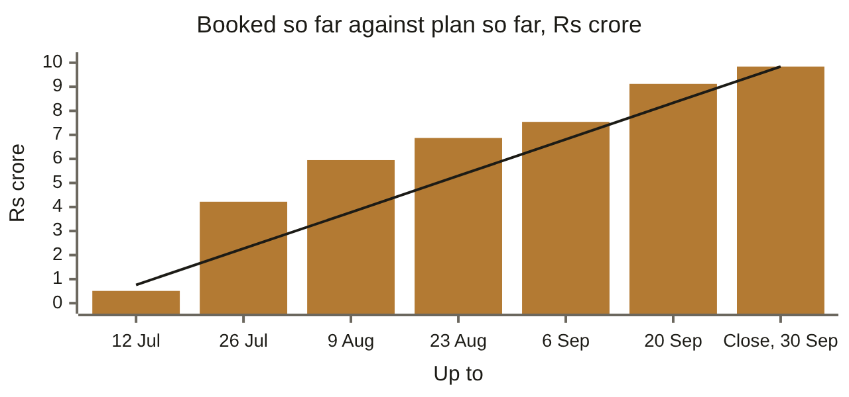
Up to | 12 Jul | 26 Jul | 9 Aug | 23 Aug | 6 Sep | 20 Sep | Close, 30 Sep
Booked so far | 0.51 | 4.22 | 5.95 | 6.87 | 7.54 | 9.12 | 9.84
Plan so far | 0.76 | 2.27 | 3.78 | 5.30 | 6.81 | 8.33 | 9.84

Q16 Hard · Read the plan line · one letter
The quarter closed at Rs 9,84,00,000 against a plan of Rs 9,83,99,990. Meera's chief of staff wants one line for Monday's front page on how it got there, and the figures above are all there is. Which line do they support?
A. Furthest ahead by 26 July, by about Rs 2.0 crore, and back to level with the plan by 6 September
B. Behind the plan from mid-August until the last fortnight, after two strong fortnights in July
C. Furthest ahead by 9 August, by about Rs 2.2 crore, and about Rs 0.8 crore ahead on 20 September
D. Further ahead at every point until 20 September, and level with plan only at the close
Part 4. One row per customer
4 items, Q17 to Q20, about 16 minutes. What it shows: how you build Marketing's customer table in pandas.
Marketing chooses who gets which offer from one table with one row per customer: recency (days since the last order), frequency (orders placed) and monetary value (rupees spent), with the customer's segment and whether the monsoon sale reached them. The data platform lead: "The warehouse queries are fine for Finance, but Marketing's analysts live in Python. Build them the table in pandas, from the warehouse, and make it refreshable in one run." It is rebuilt every Monday, and Kavya Nair, the senior analyst, reviews it before it leaves the team.
Set 2. The case
The customer table has 340 rows, one per customer, and its spend column adds up to the book's Rs 19,84,00,000 for both quarters. The monsoon sale's exposure feed, which lists the customers the sale reached, holds 136 rows for 130 customers. The analyst merges the feed onto the table with how='left' and sends the result to Excel, where a pivot sums spend.
Exhibit 4A Monday's refresh, as the situation describes it.
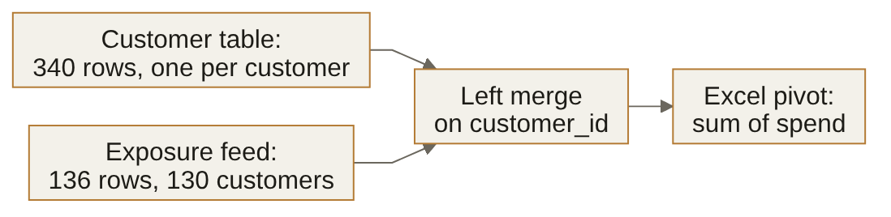

Q17 Hard · Size the merge · one letter
How many rows does the merged table hold, and what should Monday's refresh carry before the pivot is built?
A. 346 rows, and validate='one_to_one' on the merge, which raises a MergeError
B. 340 rows, and nothing more, since a left merge keeps the customer table's rows
C. 352 rows, and drop_duplicates() on the merged table to take out the extra rows
D. 136 rows, and indicator=True on the merge to flag the rows before the pivot

Exhibit 4B Next Monday's feed from the campaign tool, its rows for three customers in the order it sends them, and the step the refresh now runs on the feed before the merge.
customer_id | campaign_id | exposed_date
C-0001 | CMP-MONSOON-26 | 2026-08-11
C-0002 | CMP-MONSOON-26 | 2026-08-11
C-0001 | CMP-MONSOON-26 | 2026-08-03
C-0002 | CMP-MONSOON-26 | 2026-08-03
C-0012 | CMP-MONSOON-26 | 2026-08-03
first = feed.drop_duplicates(subset="customer_id")

Q18 Hard · Trace the first exposure · one letter
Marketing's rule is one exposure per customer, the first by date, and the sale's report credits the sale with every order a customer places from that exposure on. Which exposure does the step above keep for C-0001, and what does the report make of C-0001's orders?
A. The 3 August send, so each order C-0001 placed from then on is credited to the sale
B. Both sends, since they differ in exposed_date, so C-0001's orders after its second send count twice
C. Neither send, since the step drops every customer the feed repeats, so none of C-0001's orders count
D. The 11 August send, so the orders C-0001 placed in the eight days before it go uncredited

Exhibit 4C The analyst's months view for the head of Retail-Plus, on five illustrative orders.
import pandas as pd
plus = pd.DataFrame({
"member": ["M1", "M1", "M1", "M2", "M2"],
"month": ["Jun", "Jun", "Jul", "Jun", "Jun"],
"amount": [3000, 1000, 2400, 1800, 600]})
wide = plus.pivot_table(index="member", columns="month", values="amount")
long = wide.reset_index().melt(id_vars="member", value_name="amount")
print(wide.loc["M1", "Jun"], len(long), long["amount"].sum())

Q19 Hard · Predict the months view · one letter
The head of Retail-Plus wants one row per member and one column per month, to read who is drifting, and a long copy of the same view for a trend chart. What does the code above print?
A. 4000.0 5 8800.0
B. 2000.0 4 5600.0
C. 3000.0 3 7200.0
D. 4000.0 3 8800.0

Exhibit 4D A lab's gene list after a trip through Excel, and the lab's reference table of gene panels; the values are illustrative (Genome Biology, 2016).
import pandas as pd
lab = pd.DataFrame({"symbol": ["TP53", "2-Sep", "BRCA1", "1-Mar"],
"fold_change": [2.1, 0.4, 1.8, 3.2]})
ref = pd.DataFrame({"symbol": ["TP53", "TP53", "SEPT2", "BRCA1", "MARCH1"],
"panel": ["A", "D", "B", "A", "C"]})
m = lab.merge(ref, on="symbol", how="left")
print(len(m), m["panel"].notna().sum())

Q20 Hard · Predict the merge · one letter
Gene symbols are the short names genes go by in papers and databases. Ziemann and colleagues found that Excel's default settings turn some symbols into dates, and that about a fifth of genomics papers with Excel gene lists carried such errors (Genome Biology, 2016). The code above merges a lab's list, after a trip through Excel, onto the lab's reference table of panels. What does it print?
A. 4 4
B. 5 3
C. 7 5
D. 4 2
Part 5. The last mile, and spreadsheets in public
7 items, Q21 to Q27, about 22 minutes. What it shows: how you build the workbook for Monday's review, and read spreadsheets from public cases.
Meera's chief of staff builds the deck for Monday's growth review and works only in Excel: "The revenue tree by segment for both quarters, the top-fifty protect list with a lookup so I can find any member by member code, and one number on the front page with its trend. If a director changes an assumption in the room, the sheet must recalculate in front of them." Excel is where the week's analysis meets its audience.
Exhibit 5A The chief of staff's workbook for Monday's review, and two rows of Friday's export: one row per payment, with the order's booked amount, order_amount, repeated on each.
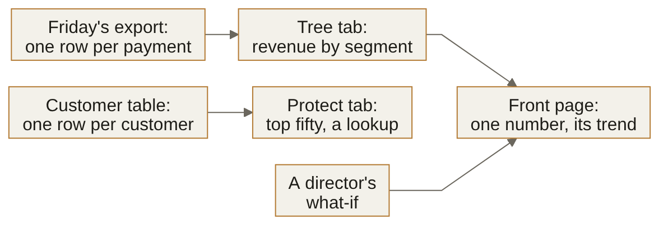
order_id | segment | order_amount | paid_amount
KR-00028 | Business | 6,35,000 | 3,81,000
KR-00028 | Business | 6,35,000 | 2,54,000

Match table 1 Each numbered row is a job the chief of staff's workbook must do. Write the letter of the technique that does it. Each letter is used once at most, and two are not used.
Item |  | Match
Q21  Medium | Find any member by member code, and print a plain message for an unknown code |  | A | SUBTOTAL with function number 109
Q22  Medium | A figure under the protect list that adds only the members a filter to Mumbai leaves on screen |  | B | VLOOKUP with its fourth argument left out
Q23  Medium | Booked revenue by segment from Friday's export, in which an invoice paid in two instalments appears twice |  | C | a labelled input cell feeding a scenario line
Q24  Medium | Let a director try Rs 5,00,000 for Retail-Plus in July to September, with the warehouse's figures untouched |  | D | XLOOKUP with its if_not_found argument set
 |  |  | E | Remove Duplicates across every column
 |  |  | F | a first-row flag per order, then SUMIFS
Write each letter on the answer sheet.

Exhibit 5B An illustrative sheet that sets growth in high-debt years against growth in other years for six countries, in percent.
Row | A: Country | B: High-debt years | C: Other years
2 | Country 1 | -1.0 | 2.0
3 | Country 2 | 1.0 | 1.0
4 | Country 3 | -3.0 | 2.0
5 | Country 4 | 1.0 | 1.0
6 | Country 5 | 6.0 | 2.0
7 | Country 6 | 5.0 | 1.0
8 | Average | =AVERAGE(B2:B5) | =AVERAGE(C2:C7)

Q25 Hard · Reproduce the comparison · show the working
In 2013 Herndon, Ash and Pollin rebuilt an influential 2010 paper by Reinhart and Rogoff from the authors' own working spreadsheet, and found that the paper's average growth for countries with public debt over 90 percent of GDP, published as -0.1 percent, was 2.2 percent when properly calculated (PERI working paper 322, 2013). The illustrative sheet above goes to a review today. What does it report for the two columns, what do the six countries' figures give, and does its comparison hold? Show the working.

Working. The final answer goes on the answer sheet.

Exhibit 5C Illustrative rates and the sheet's formula for a day's change (JPMorgan Chase, 2013).
Row | Old rate, column B | New rate, column C | The sheet's change, column D
2 | 2.00 | 2.60 | =(C2-B2)/(B2+C2)
3 | 3.00 | 2.40 | =(C3-B3)/(B3+C3)
4 | 1.50 | 1.80 | =(C4-B4)/(B4+C4)

Q26 Hard · Work the risk figure · show the working
JPMorgan's task force on the 2012 losses in its Chief Investment Office reported on a value-at-risk model, an estimate of how much a trading book can lose on a bad day, that ran through Excel spreadsheets filled by copying and pasting (JPMorgan Chase, 2013). Suppose the model's documentation defines a day's change as the difference between the new and old rates divided by their average, and that its value at risk moves in step with the size of those changes. The sheet above reports a value at risk of 70 million dollars against the desk's limit of 120 million dollars; both figures are illustrative. What value at risk should the sheet have reported, and is the desk inside its limit? Show the working.

Working. The final answer goes on the answer sheet.

Exhibit 5D Three illustrative trips and the commission charged on each.
Trip | Gross fare, dollars | Taxes and fees, dollars | Commission charged, dollars
1 | 30.00 | 2.40 | 7.50
2 | 20.00 | 1.60 | 5.00
3 | 44.00 | 4.00 | 11.00

Q27 Hard · Size the commission · show the working
In 2017 Uber told New York City drivers that it had been taking too much commission from them, and that each affected driver would get a refund of about 900 dollars, interest included (CBS News, 2017). Suppose the drivers' terms set the commission at 25 percent of the fare after taxes and fees. How much commission did the three trips above overcharge the driver, and what share of the commission charged is that? Show the working.

Working. The final answer goes on the answer sheet.

Part 6. Read the code, read the data: an AI team's tables
6 items, Q28 to Q33, about 22.5 minutes. What it shows: how you read the tables an AI team keeps, and the numbers it acts on.
Suppose a food-delivery company runs a support assistant, a chatbot that answers customers and hands hard cases to a person. Its AI team scores each model version on a fixed set of test tickets, which is an evaluation run; it collects customers' ratings of the replies; and it logs every conversation, every handoff to a person, every call to the model and every visit. The tables and every number below are illustrative.
Exhibit 6A The assistant team's tables, as this part imagines them.
Table | One row per | Columns
predictions | test ticket | ticket, pred
labels | label from the annotation vendor | ticket, label
eval_runs | evaluation run | model, run_id, finished_on, accuracy
replies | reply to a customer | reply_id, model, rating
conversations | conversation | conversation_id
handoffs | handoff to a person | conversation_id
calls | call to the model | call_id, day, tokens
visits | a user's use of the assistant on a day | day, user_id

Exhibit 6B The team's scoring code, on five illustrative test tickets.
import pandas as pd
preds = pd.DataFrame({"ticket": ["T1", "T2", "T3", "T4", "T5"],
"pred": ["refund", "late", "refund", "late", "other"]})
labels = pd.DataFrame({"ticket": ["T1", "T2", "T3", "T4", "T5", "T3", "T5"],
"label": ["refund", "late", "late", "late", "refund",
"late", "refund"]})
m = preds.merge(labels, on="ticket")
print(round((m["pred"] == m["label"]).mean(), 2))

Q28 Hard · Predict the accuracy · one letter
The team scores a model that sorts support tickets into refund, late and other against labels from an annotation vendor, and ships a model only if it scores 0.5 or better. What does the code above print, and what happens to the model?
A. 0.6, so the model clears the 0.5 bar and ships this week
B. 0.71, so the model clears the bar with room to spare and ships
C. 0.43, so the model falls short of the bar and is held back
D. A MergeError, since two tickets repeat in the labels, so the model waits

Exhibit 6C The table eval_runs: the team's evaluation runs, illustrative.
model | run_id | finished_on | accuracy
bot-a | 7 | 1 September | 0.81
bot-b | 8 | 2 September | 0.84
bot-a | 9 | 8 September | 0.78
bot-b | 10 | 9 September | 0.86
bot-b | 11 | 9 September | 0.74

Q29 Hard · Choose the query · one letter
The team promotes bot-b over bot-a if bot-b's latest run scores higher than bot-a's latest. Runs are numbered in the order they start, and of two runs that finish on the same day, the one that started later counts as the latest. Which query gives the team the right call, and what is the call?
A. ROW_NUMBER partitioned by model, by finished_on descending, then run_id descending, keeping row 1: bot-b's latest scores 0.74, so bot-a stays
B. ROW_NUMBER partitioned by model, by finished_on descending, then run_id ascending, keeping row 1: bot-b's latest scores 0.86, so bot-b is promoted
C. GROUP BY model with max(finished_on) and max(accuracy): bot-b's latest reads 0.86, so bot-b is promoted
D. RANK partitioned by model, by finished_on descending, keeping rank 1: bot-b's latest scores 0.86, so bot-b is promoted

Exhibit 6D Nine replies, the ratings customers gave them and the analyst's query, illustrative.
WITH replies (reply_id, model, rating) AS (VALUES
(1, 'bot-a', 1), (2, 'bot-a', 4), (3, 'bot-a', 2), (4, 'bot-a', 2),
(5, 'bot-b', 2), (6, 'bot-b', 5), (7, 'bot-b', 4),
(8, 'bot-c', 5), (9, 'bot-c', 1))
SELECT model, count(*) AS low_rated
FROM replies
WHERE rating <= 2
GROUP BY model
HAVING count(*) >= 3;

Q30 Hard · Predict the rows · one letter
Customers rate each reply from 1 to 5. The team lead asks for every model with at least three replies this week, beside how many of its replies were rated 2 or below, and will retrain every model on the list. What does the query above return, and which models are retrained?
A. bot-a and bot-b, each beside its count of low ratings, so the lead retrains both
B. bot-a and bot-b, each beside its count of all its replies, so the lead retrains both
C. bot-a, bot-b and bot-c, each beside its low ratings, so the lead retrains all three
D. bot-a alone, beside its 3 low ratings, so the lead retrains bot-a

Exhibit 6E Four conversations and the handoff log, illustrative.
WITH conversations (conversation_id) AS (VALUES ('c1'), ('c2'), ('c3'), ('c4')),
handoffs (conversation_id) AS (VALUES ('c2'), ('c4'), (NULL))
SELECT count(*) AS resolved_by_bot
FROM conversations
WHERE conversation_id NOT IN (SELECT conversation_id FROM handoffs);

Q31 Hard · Predict the count · one letter
The weekly review reads how many of the four conversations the assistant resolved without a person, and the product lead cuts the assistant's budget if that is under 40 percent. What does the query above return, and what happens to the budget?
A. 2, half the conversations, so the budget stays
B. 0, none of the conversations, so the budget is cut
C. 3, three of the four, so the budget stays
D. An error, so no figure reaches the review and the budget waits

Exhibit 6F Four model calls and the tokens each used, illustrative.
WITH calls (call_id, day, tokens) AS (VALUES
(1, DATE '2026-09-21', 400), (2, DATE '2026-09-22', 300),
(3, DATE '2026-09-22', 500), (4, DATE '2026-09-23', 200))
SELECT call_id, sum(tokens) OVER (ORDER BY day) AS tokens_so_far
FROM calls
ORDER BY call_id;

Q32 Hard · Find the first routed call · one letter
The model's bill is charged per token, so the finance partner routes every call to a cheaper model once tokens_so_far, read from the query above, passes 1,000. Which call is the first one routed to the cheaper model?
A. Call 2
B. Call 3
C. Call 4
D. None of them

Exhibit 6G One week of the visits log, illustrative: the users who opened the assistant on each day.
Day | Mon | Tue | Wed | Thu | Fri | Sat | Sun
Users | U1, U2, U3 | U1, U4 | U2, U3, U5 | U1, U2 | U3, U4, U6 | U1 | U2, U6

Q33 Medium · Count the week's users · one letter
The product manager wants the week's active users for the deck. Which number goes on the slide?
A. 16
B. 2.3
C. 3
D. 6
Stretch: untimed, and not marked
For anyone who finishes early. Nothing here is counted; each item is the kind an interviewer asks after your first answer, so write the answer you would say.
Stretch 1 Written · the answer you would say aloud
Anand now wants collected revenue week by week instead of for the whole quarter. Which date decides the week a rupee is collected in, and what happens to an order paid in two instalments?
Your answer

Stretch 2 Written · the answer you would say aloud
The head of Retail-Plus asks whether members who ordered in both quarters spent more in the second. How would you build that comparison, and what would you say about members who ordered in only one quarter?
Your answer

Stretch 3 Written · the answer you would say aloud
In 2020 the body that names human genes renamed every gene whose symbol Excel turned into a date. Explain to a product manager in two sentences why the fix went into the gene names, and what you would still check in every file you receive.
Your answer

Stretch 4 Written · the answer you would say aloud
A director says the front page should read Rs 19.84 crore because "that is the real number". Answer in two sentences.
Your answer

Answer sheet
Week 2 Recap Paper | Cohort 2 | Week 2. Fill in pen. Mark one box per row, or every correct box for a starred item; if you change your mind, cross the old box fully and mark the new one. Write words and numbers clearly, one per space.

Name | Seat | Marked by | Items right
 |  |  | ____ of 33
Step one: rate each part before you read any item
Part | 1 | 2 | 3 | 4 | Items right (marker)
Part 1. Anand's Monday numbers |  |  |  |  | ____ of 6
Part 2. Booked against collected |  |  |  |  | ____ of 5
Part 3. The protect list and the plan line |  |  |  |  | ____ of 5
Part 4. One row per customer |  |  |  |  | ____ of 4
Part 5. The last mile, and spreadsheets in public |  |  |  |  | ____ of 7
Part 6. Read the code, read the data: an AI team's tables |  |  |  |  | ____ of 6
1 = I have not used this; 2 = I can follow it when someone shows me; 3 = I can do it alone on a small problem; 4 = I can find and fix mistakes in someone else's version
Lettered items: one box, or every correct box for a starred item. True or false: one box
   | A | B | C | D | E
  Q4
  Q5
  Q6
  Q7
  Q9
  Q10
  Q11*
  Q12
   | A | B | C | D | E
  Q13
  Q14
  Q15
  Q16
  Q17
  Q18
  Q19
  Q20
   | A | B | C | D | E
  Q28
  Q29
  Q30
  Q31
  Q32
  Q33
* Mark every correct box. A shaded box is a letter the item does not offer.
Letters, words, numbers and orders: one answer per space
   | Answer | Write it here
  Q1 | Final answer
  Q2 | Letter
  Q3 | Letter
  Q8 | Letters in order
    1 | 2 | 3 | 4 | 5 | 6
  Q21 | Letter
  Q22 | Letter
   | Answer | Write it here
  Q23 | Letter
  Q24 | Letter
  Q25 | Final answer
  Q26 | Final answer
  Q27 | Final answer

