**Exercise 1: Determine a is odd or even**

**Flow chart:** 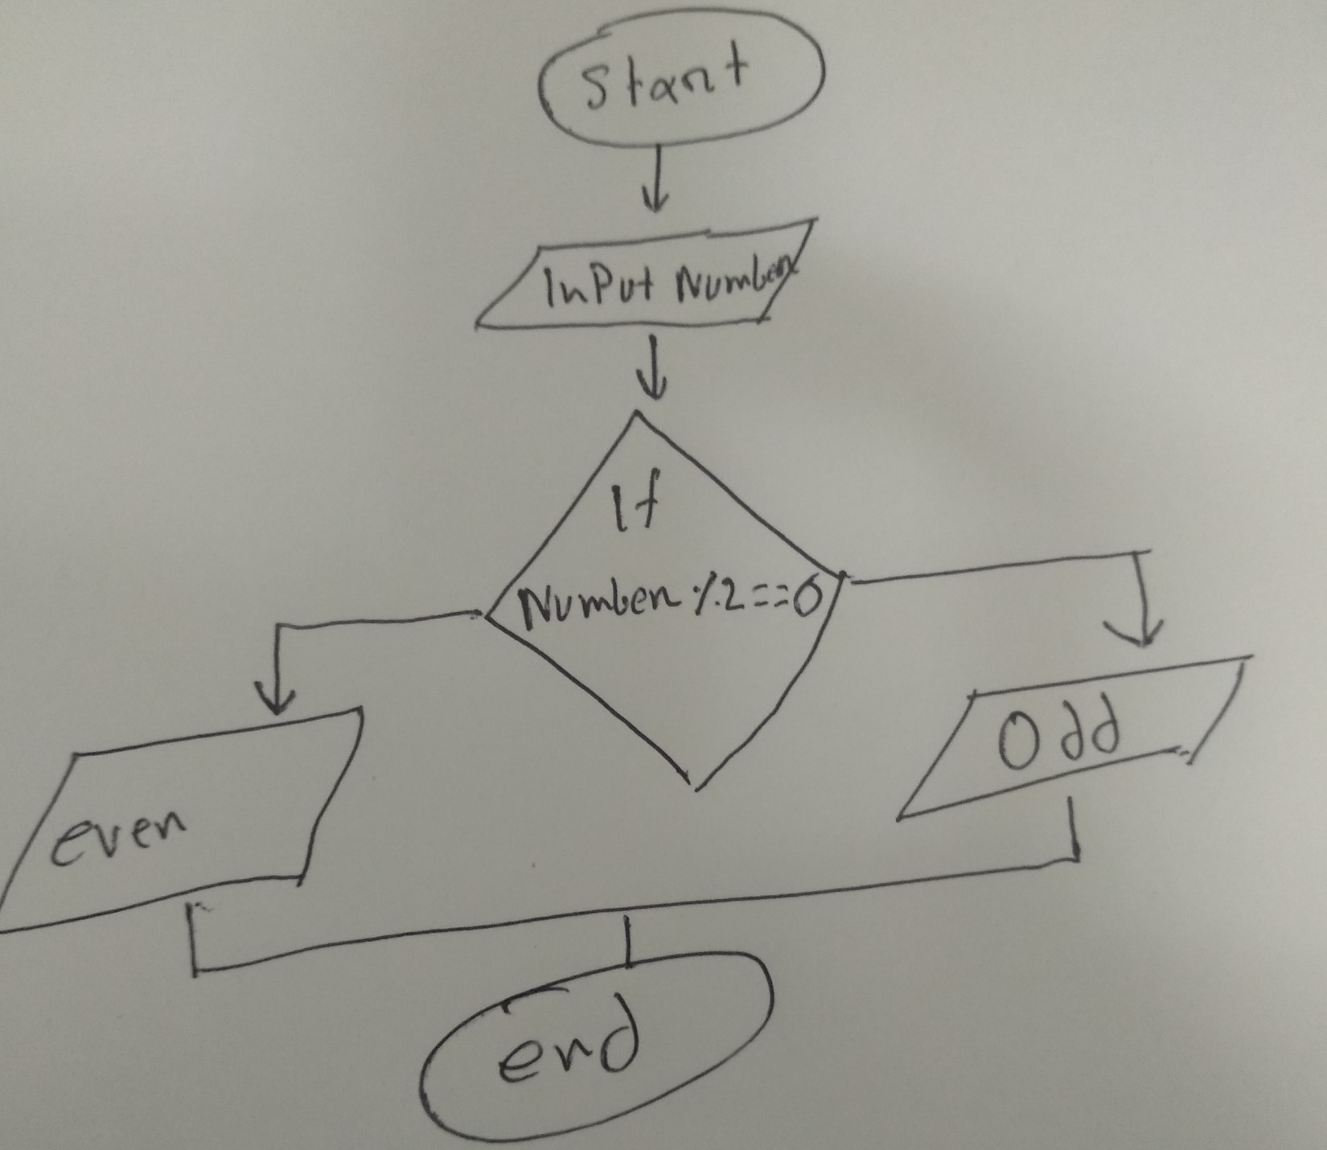

**Python coding:**

n=int(input(**'please enter your number : '**));  
**if** (n%2==0):  
 print(**'This number is Even'**)  
**else**:  
 print(**'This number is Odd'**)

**Exercise 2:Find Leap Year**

**Flow Chart:**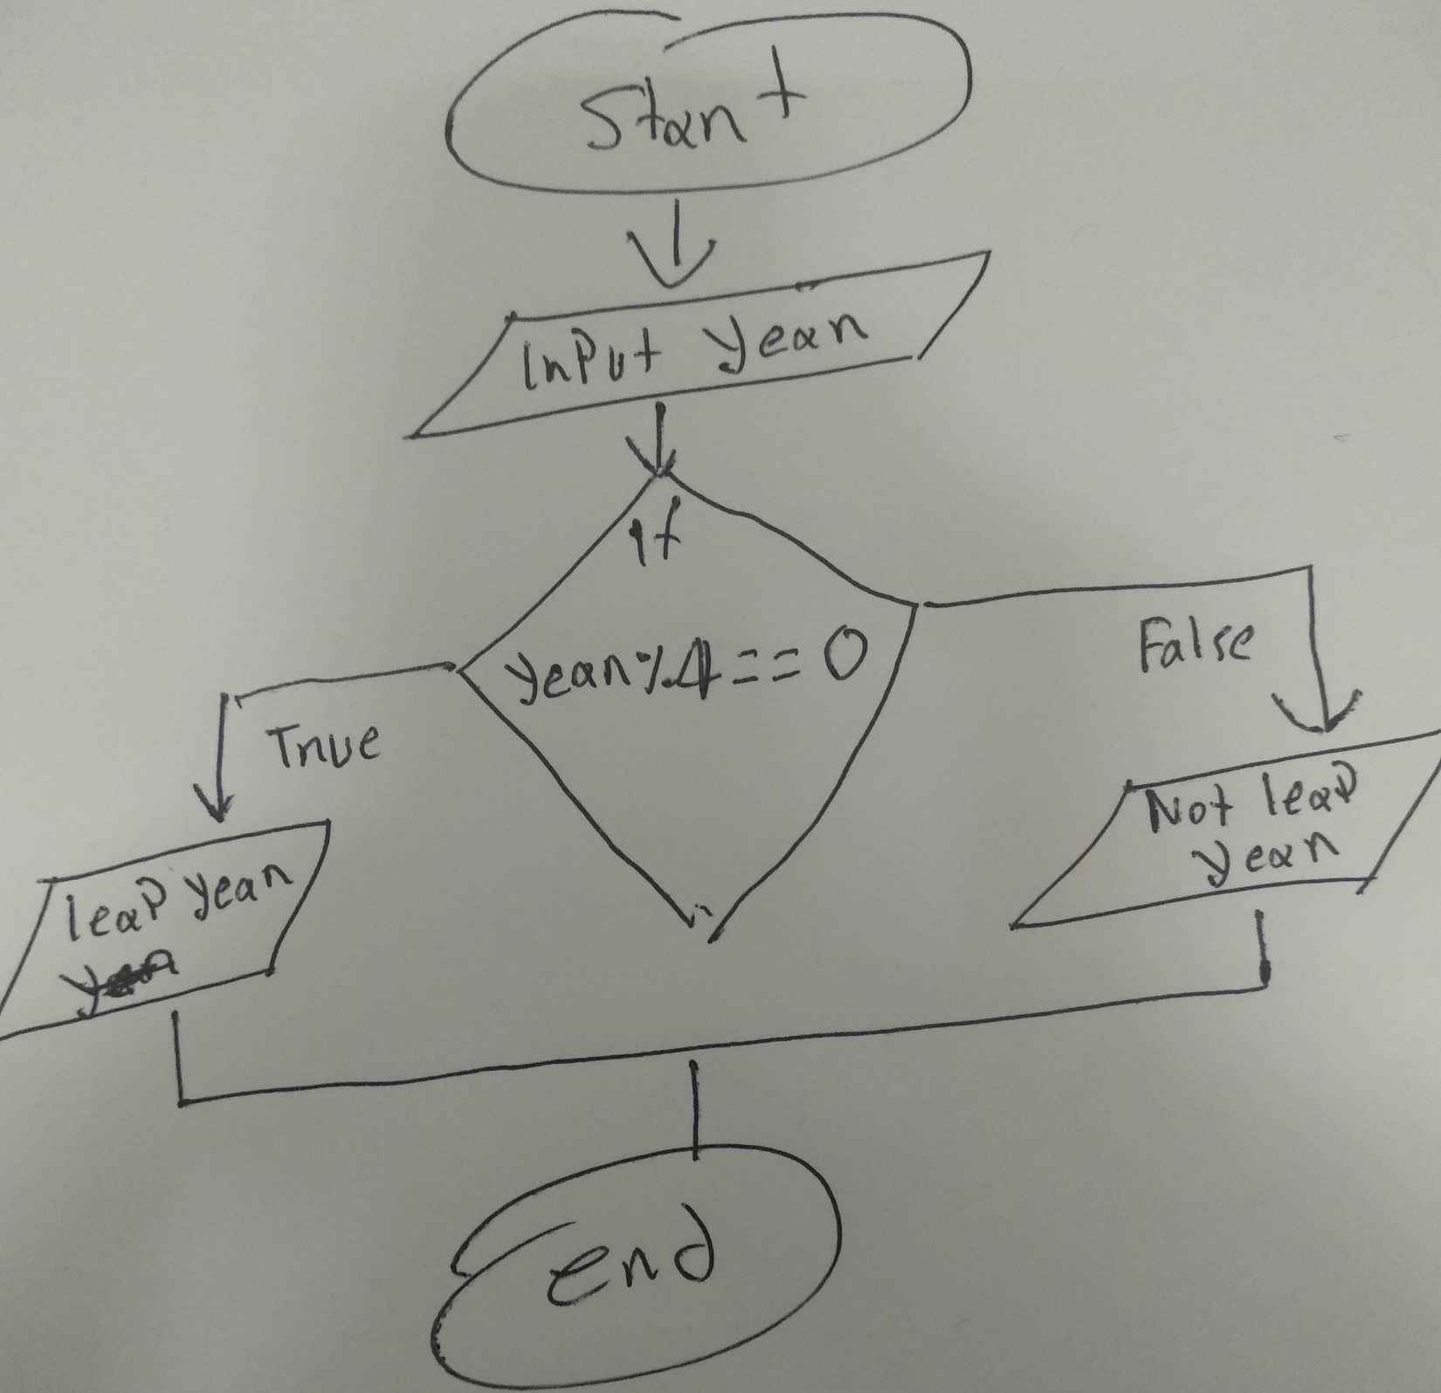

**Python coding:**

year=int(input(**'Enter a year : '**))  
**if** year%4==0:  
 print (year, **'is a Leap year'**)  
**else**:  
 print (year, **'is not a Leap year'**)

**Exercise 4:Check Positive or negetive**

**Flow chart:**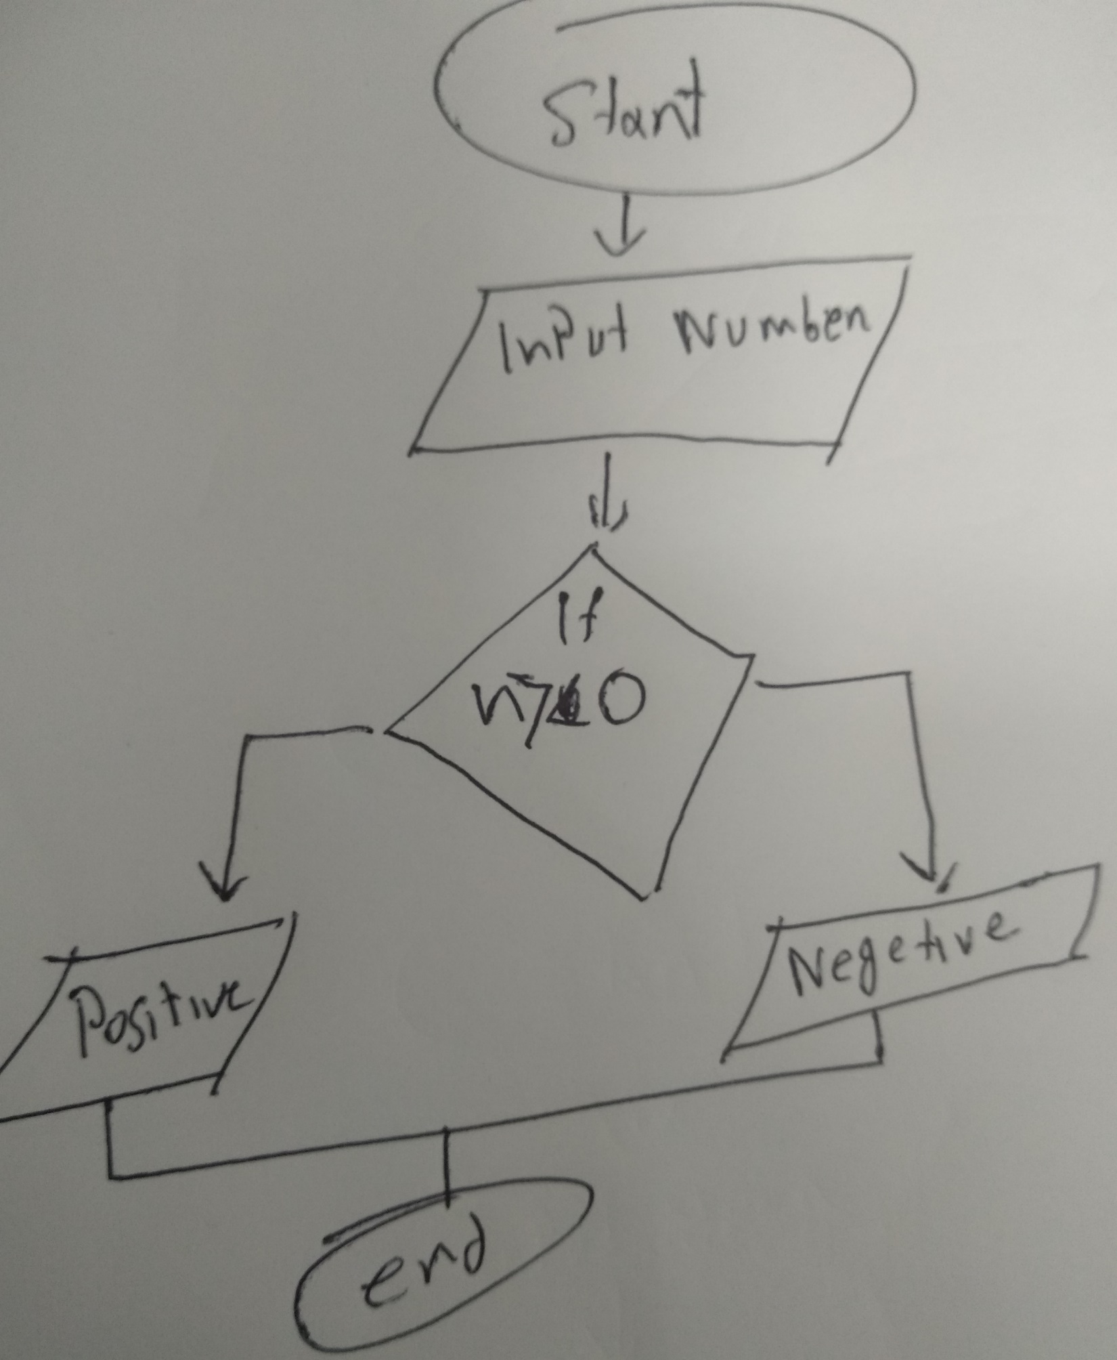

**Python coding:**

n=int(input())  
**if** n>0:  
 print (**'Positive'**)  
**else**:  
 print (**'Negative'**)

**Exercise 5:Print absolute value of number**

**Flow chart:**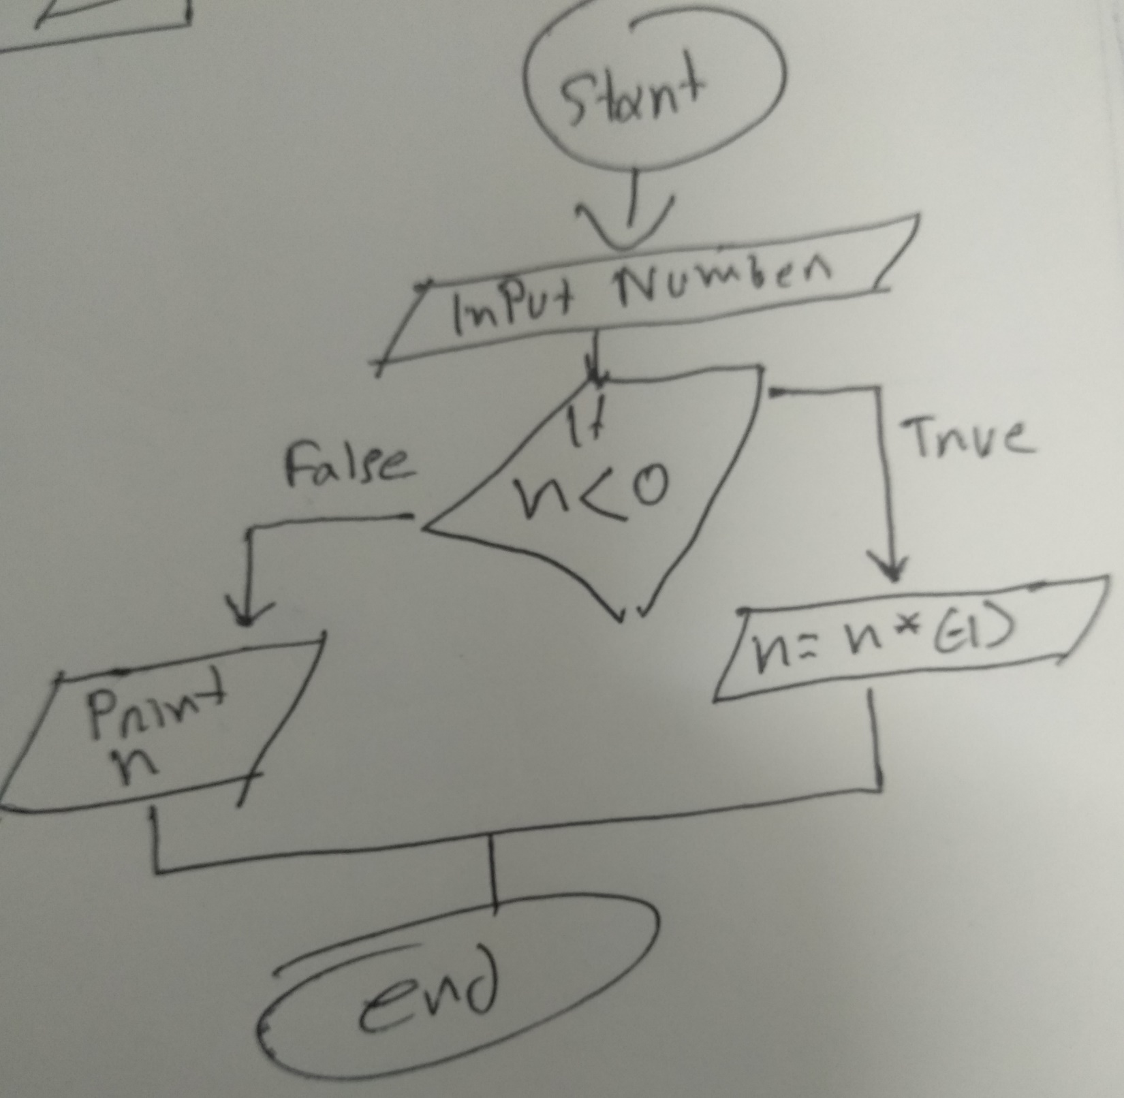

**Python coding:**

n=int(input())  
**if** n<0:  
 print (n*(-1))  
**else**:  
 print (n)

**Exercise 6: which one is greater between two numbers**

**Python coding:**

n1=int(input(**'input your first number : '**))  
n2=int(input(**'input your second number : '**))  
**if** (n1>=n2):  
 print(**'Largest number is'**, n1)  
**else**:  
 print(**'Largest number is'**, n2)

**Exercise 7: which one is less between two numbers**

**Python coding:**

n1=int(input(**'input your first number : '**))  
n2=int(input(**'input your second number : '**))  
**if** (n1<=n2):  
 print(**'Less number is'**, n1)  
**else**:  
 print(**'Less number is'**, n2)

**Exercise 8: which one is greater between three numbers**

**Python coding:**

n1=int(input(**'input your first number : '**))  
n2=int(input(**'input your second number : '**))  
n3=int(input(**'input your third number : '**))  
**if** (n1>=n2)**and**(n1>=n3):  
 print(**'Largest number is'**, n1)  
**elif** (n2>=n1)**and**(n2>=n3):  
 print(**'Largest number is'**, n2)  
**else**:  
 print(**'Largest number is'**, n3)

**Exercise 9: which one is less between three numbers**

**Python coding:**

n1=int(input(**'input your first number : '**))  
n2=int(input(**'input your second number : '**))  
n3=int(input(**'input your third number : '**))  
**if** (n1<=n2)**and**(n1<=n3):  
 print(**'less number is'**, n1)  
**elif** (n2<=n1)**and**(n2<=n3):  
 print(**'less number is'**, n2)  
**else**:  
 print(**'less number is'**, n3)

**Exercise 10: determine vowel or not**

**Python coding:**

l = input(**"Input a letter of the alphabet: "**)  
  
**if** l **in** (**'a'**, **'e'**, **'i'**, **'o'**, **'u'**):  
 print(**"%s is a vowel."** % l)  
**else**:  
 print(**"%s is a consonant."** % l)