Museum of Archaeology and Anthropology

Fire extinguisher testing. (4 pages)
To be completed: Monthly
Test procedure:
- Ensure that the fire extinguishers are in the correct position and are not obstructed in any way;
- Check the extinguisher for exterior defects such as rust, damage, or signs of tampering;
- Inspect the locking pin to ensure that it is intact and working;
- Check that the seal is unbroken and has not been tampered with;
- Check the pressure gauge, if the extinguisher has one, to ensure that the correct pressure is being displayed;

Address issue as identified and if necessary open a ticket in INVIDA

Date | Location |  | Result | Initials
 | H₂O: Ground Floor by Door to West Building | 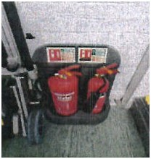 |  | F.G.
 | CO₂: Ground Floor by Door to West Building | 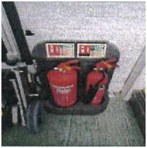 |  | F.G.
 | H₂O: Ground Floor by Lift | 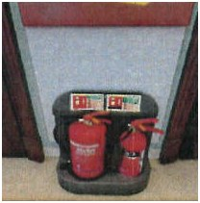 |  | F.G.

Date | Location |  | Result | Initials
 | CO₂: Ground Floor by Lift | 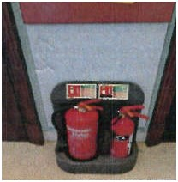 |  | F.G.
 | H₂O: Ground Floor Next to Double Doors to Keyser Corridor | 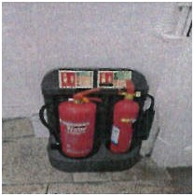 |  | F.G.
 | CO₂: Ground Floor Next to Double Doors to Keyser Corridor | 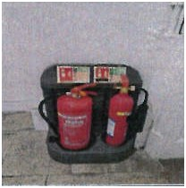 |  | F.G.
 | CO₂: Keyser Store | 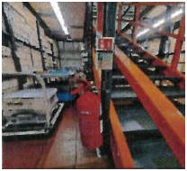 |  | F.G.
 | CO₂: 1st Floor Gallery by Lift | 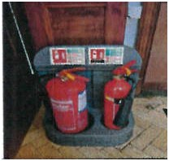 |  | F.G.
 | H₂O: 1st Floor Gallery by Lift | 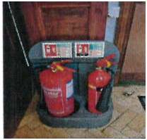 |  | F.G.
 | H₂O: 1st Floor Gallery by Spiral Staircase | 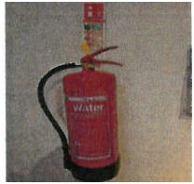 |  | F.G.
 | CO₂: 1st Floor Babington Corridor After Double Doors | 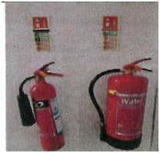 |  | F.G.
Date | Location |  | Result | Initials
 | H₂O: 1st Floor Babington Corridor After Double Doors | 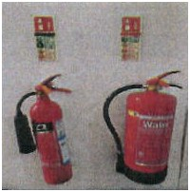 |  | F.G.
 | CO₂: Babington Store (Entrance) | 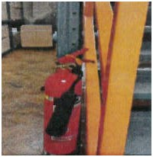 |  | F.G.
 | CO₂: Babington Store (Mezzanine Next to Door to Archive 2) | 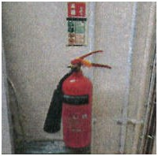 |  | F.G.
 | CO₂: 2nd Floor Gallery by Lift | 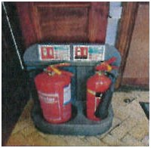 |  | F.G.
 | H₂O: 2nd Floor Gallery by Lift | 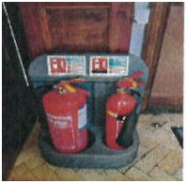 |  | F.G.
 | CO₂: 2nd Floor Gallery by Entrance to the Bevan | 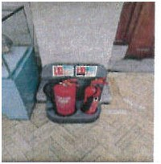 |  | F.G.
 | H₂O: 2nd Floor Gallery by Entrance to the Bevan | 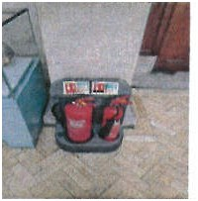 |  | F.G.
 | CO₂: Bevan Workroom (Next to Entrance Doors) | 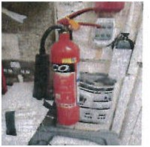 |  | F.G.
Date | Location |  | Result | Initials
 | H₂O: Bevan Store (Next to Entrance) | 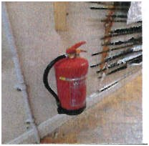 |  | F.G.
 | H₂O: Bevan Store (Top of Mezzanine Stairs) | 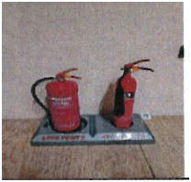 |  | F.G.
 | CO₂: Bevan Store (Top of Mezzanine Stairs) | 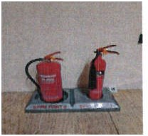 |  | F.G.
 | H₂O: 3rd Floor Outside Conservation Lab | 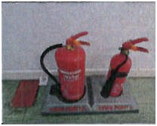 |  | F.G.
 | CO₂: 3rd Floor Outside Conservation Lab | 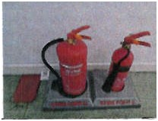 |  | F.G.
 | H₂O: 4th Floor Photo Store | 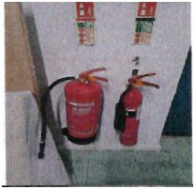 |  | F.G.
 | CO₂: 4th Floor Photo Store | 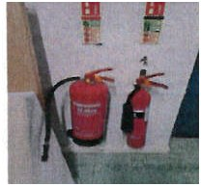 |  | F.G.
 | CO₂: 4th Floor Corridor | 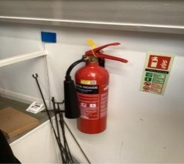 |  | F.G.

