MSCS634 - Data Analysis and Data Preparation Techniques

Farheen Dhanani
University of Cumberlands
MSCS-634-M20: Advanced Big Data and Data Mininges
Dr. Satish Penmatsa
01/16/2026

Data Analysis and Data Preparation Techniques

1. Descriptive Statistics and Data Distribution Analysis
Given Dataset
The ages of participants in a community program are:
$$12,14,14,17,18,19,20,21,21,23,24,24,26,28,30,32,33,34,36,38,40,42,44,45,50,55,60$$

(a) Mean and Median
Mean Calculation:
The mean is calculated by dividing the sum of all values by the total number of values.
- Sum of values = 810
- Number of values = 27
$$\text{Mean}=\frac{810}{27}=30$$
Median Calculation:
Since there are 27 values (an odd number), the median is the middle (14th) value when the data is ordered.
- Median = 28

Explanation
The mean age of 30 indicates the average participant age. The median of 28 represents the central value of the dataset. Since the mean is slightly higher than the median, the data is mildly right-skewed, influenced by higher age values such as 50, 55, and 60.

(b) Mode and Modality
The mode is the value(s) that occur most frequently in the dataset.
- Modes: 14, 21, 24

Explanation
Because more than one value occurs with the highest frequency, the dataset is multimodal. This suggests that there are multiple common age groups within the community program.

(c) Midrange
The midrange is calculated using the minimum and maximum values.
- Minimum = 12
- Maximum = 60
$$\text{Midrange}=\frac{12+60}{2}=36$$

Explanation
The midrange represents the midpoint between the youngest and oldest participants. While simple to calculate, it is sensitive to extreme values.

(d) First Quartile (Q1) and Third Quartile (Q3)
- First Quartile (Q1) = 21
- Third Quartile (Q3) = 40

Explanation
Q1 represents the value below which 25% of the data falls, while Q3 represents the value below which 75% of the data falls. These quartiles help describe the spread of the data.

(e) Five-Number Summary
Statistic | Value
Minimum | 12
Q1 | 21
Median | 28
Q3 | 40
Maximum | 60

Explanation
The five-number summary provides a concise description of the dataset’s distribution, central tendency, and spread.
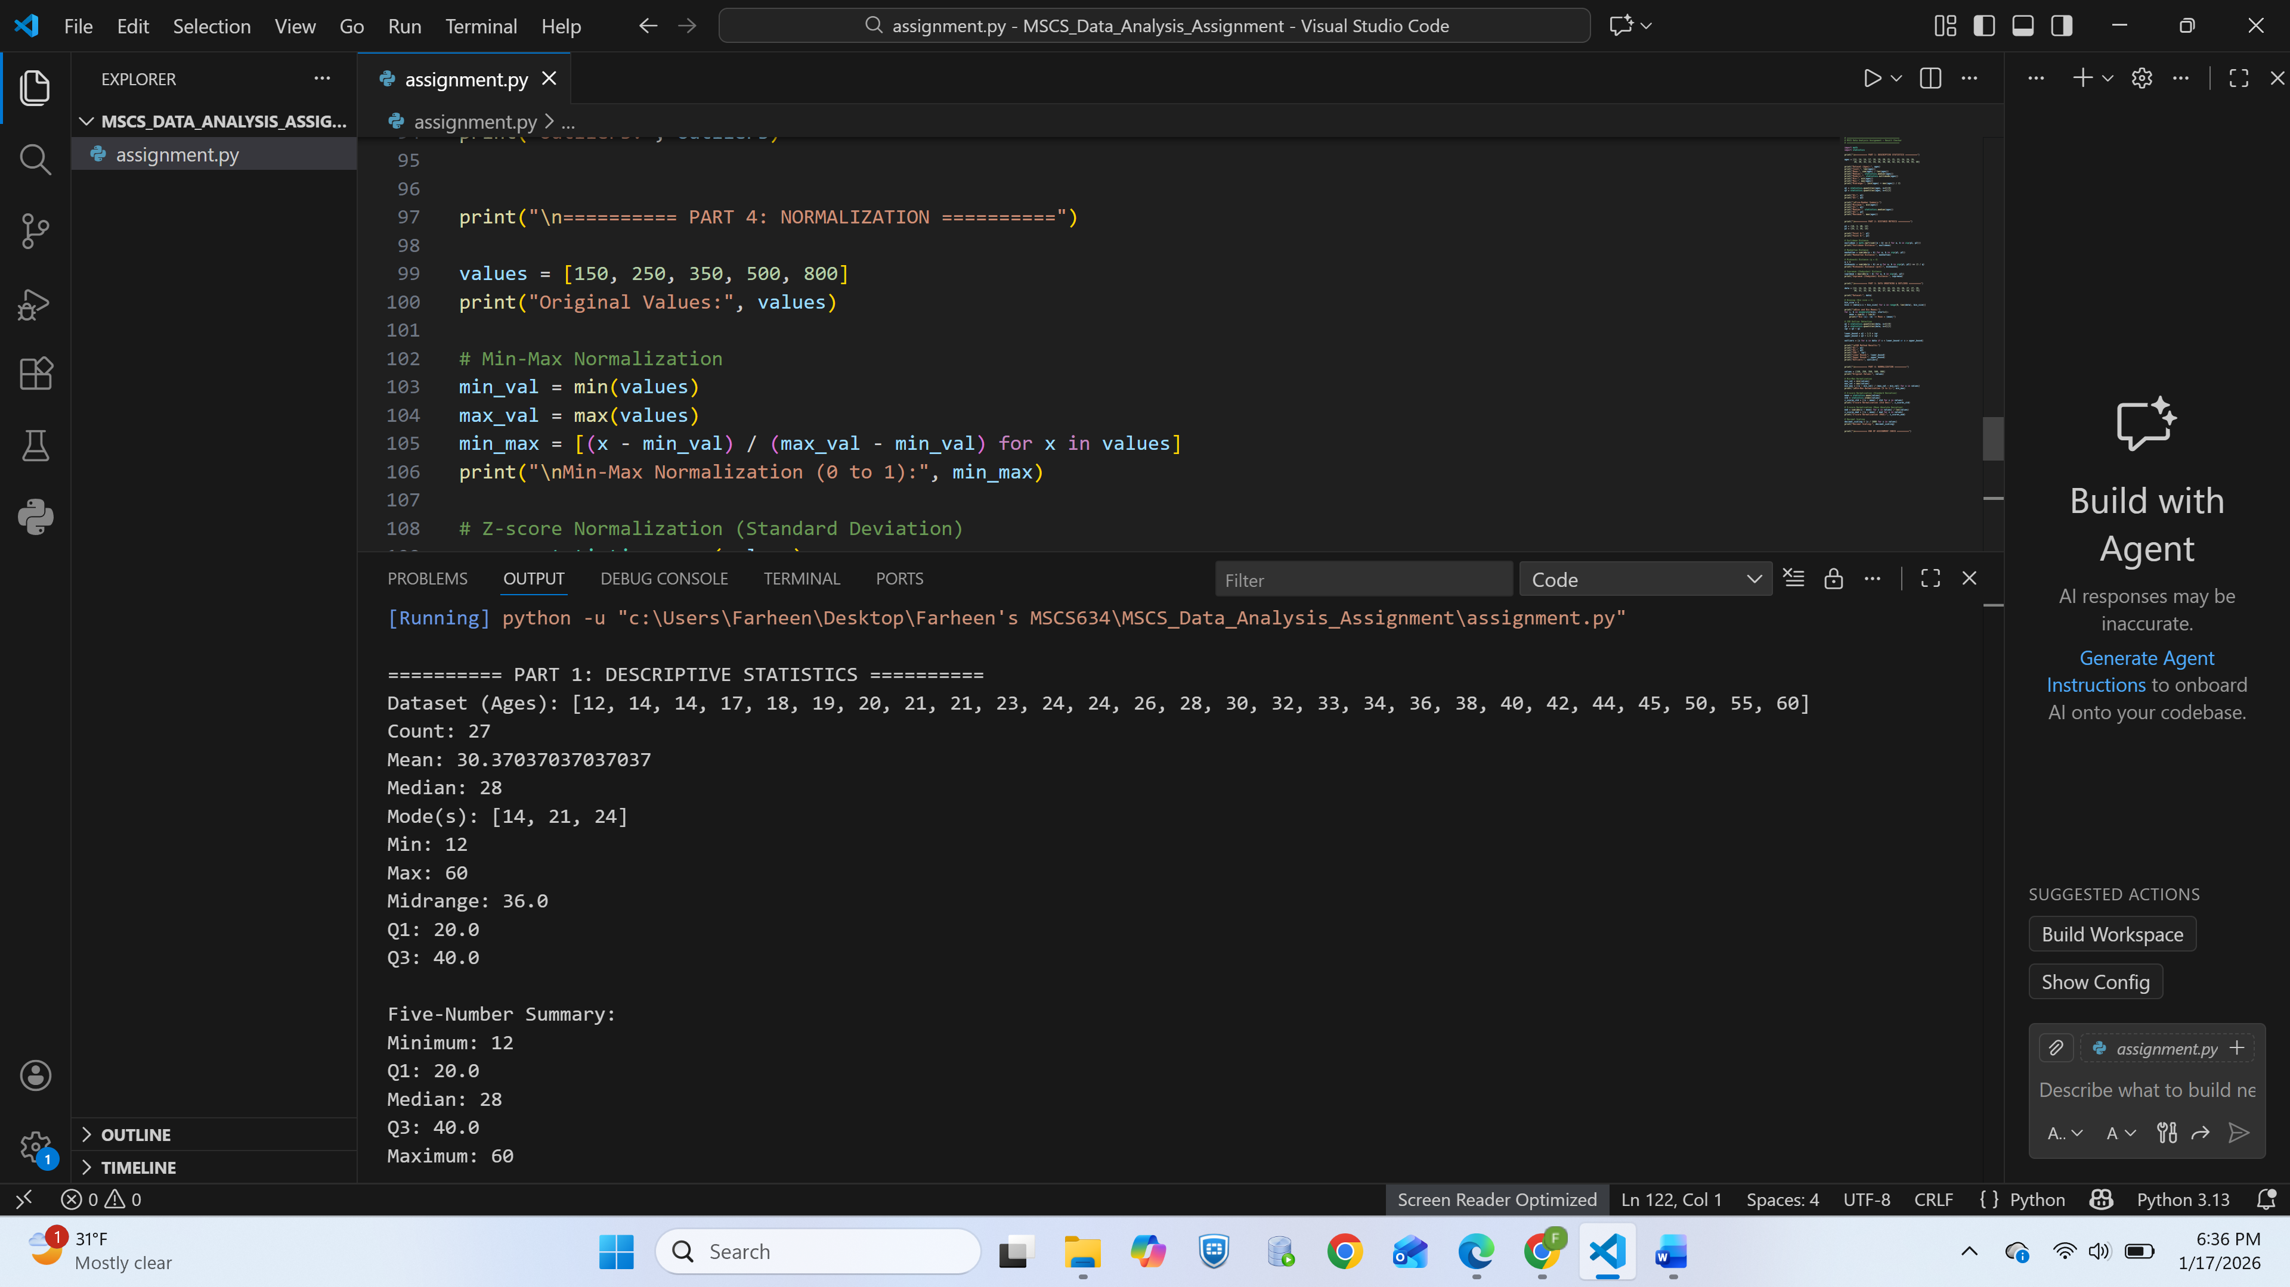
Screenshot showing the results for Part 1

2. Distance Metric Calculations
Given Objects
- Object A: (18, 3, 40, 12)
- Object B: (25, 2, 38, 15)

(a) Euclidean Distance

$$\sqrt{\left(18-25)^{2}+(3-2)^{2}+(40-38)^{2}+(12-15)^{2}\right.} \\ =\sqrt{49+1+4+9}=\sqrt{63}≈7.94$$Explanation
Euclidean distance measures the straight-line distance between two points and is commonly used for continuous numerical data.

(b) Manhattan Distance
$$∣18-25∣+∣3-2∣+∣40-38∣+∣12-15∣ \\ =7+1+2+3=13$$

Explanation
Manhattan distance measures distance along grid-like paths. Unlike Euclidean distance, it does not use diagonal shortcuts.

(c) Minkowski Distance (q = 4)

$${\left(∣18-25∣^{4}+∣3-2∣^{4}+∣40-38∣^{4}+∣12-15∣^{4}\right)}^{1/4} \\ =(2401+1+16+81)^{1/4}≈7.08$$Explanation
Changing the value of $q$alters the sensitivity to large differences. Higher values of $q$place greater emphasis on larger coordinate differences.

(d) Supremum (Chebyshev) Distance

$$max⁡(∣18-25∣,∣3-2∣,∣40-38∣,∣12-15∣) \\ =max⁡(7,1,2,3)=7$$Explanation
Chebyshev distance measures the maximum difference across any dimension and is useful in applications such as chessboard movement or quality control.
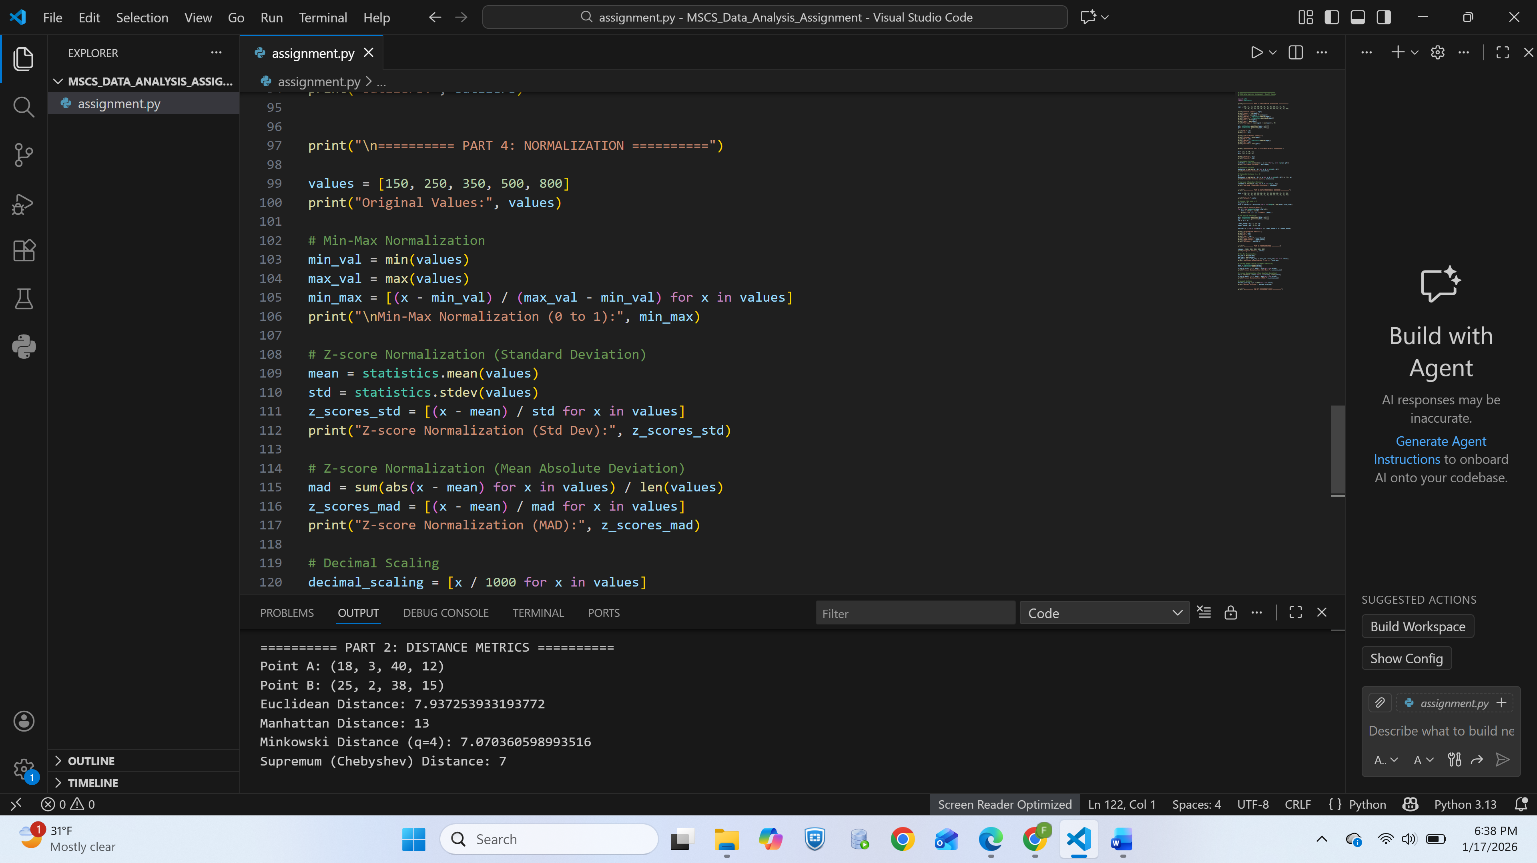
Screenshots of testing results for part II

3. Data Smoothing and Outlier Detection
Given Dataset
$$12,14,15,18,19,20,22,22,23,24,26,27,27,28,30,31,33,35,36,36,37,38,40,42,44,50,53,75$$

(a) Smoothing by Bin Means (Bin Size = 4)
Bin | Values | Mean
1 | 12, 14, 15, 18 | 14.75
2 | 19, 20, 22, 22 | 20.75
3 | 23, 24, 26, 27 | 25
4 | 27, 28, 30, 31 | 29
5 | 33, 35, 36, 36 | 35
6 | 37, 38, 40, 42 | 39.25
7 | 44, 50, 53, 75 | 55.5

Explanation
Smoothing by bin means reduces noise by replacing values with local averages. This highlights overall trends while minimizing small fluctuations.

(b) Outlier Detection Using IQR
- Q1 = 22
- Q3 = 40
- IQR = 18
Lower Bound:
$$22-1.5(18)=-5$$
Upper Bound:
$$40+1.5(18)=67$$
Outlier Identified: 75

Explanation
The value 75 lies above the upper bound and is considered an outlier, indicating an unusually high observation compared to the rest of the dataset.

(c) Alternative Smoothing Techniques
- Moving Average Smoothing
Averages values over a sliding window and is commonly used in time-series data to reduce short-term fluctuations.
- Regression Smoothing
Fits a regression line to the data to model overall trends, useful when the relationship between variables is important.
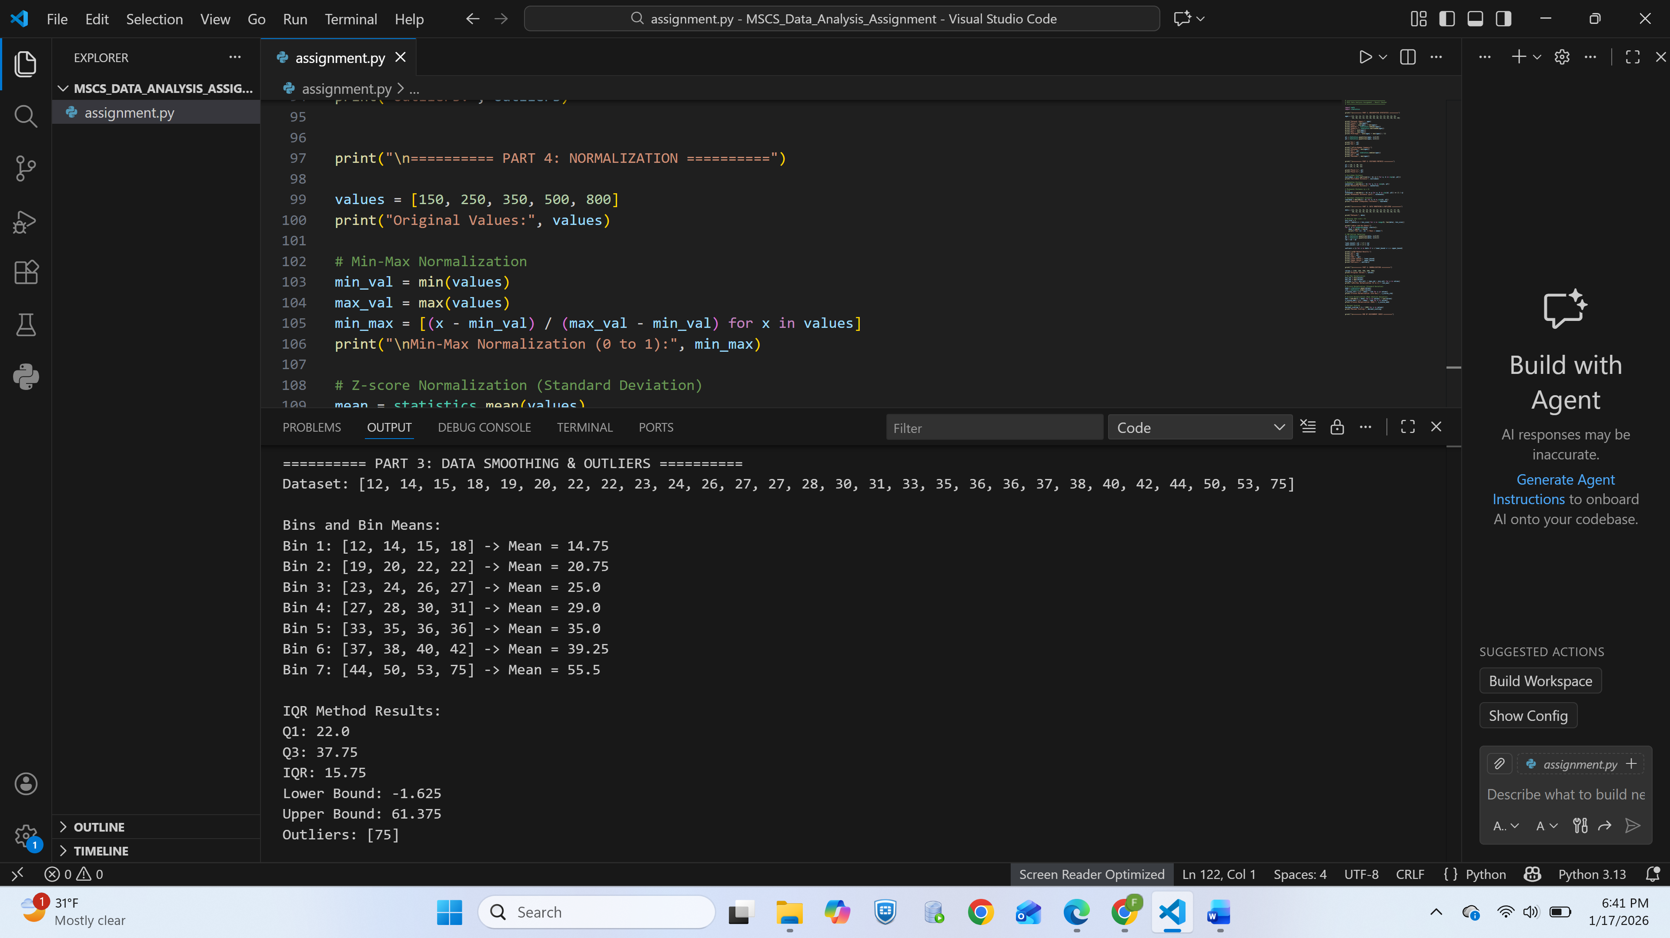
Screenshot of testing results for part III

4. Data Normalization Techniques
Given Dataset
$$150,250,350,500,800$$

(a) Min-Max Normalization
$$\frac{x-150}{800-150}$$
Normalized Values:
$$0.00, 0.15, 0.31, 0.54, 1.00$$

Explanation
Min-max normalization scales values between 0 and 1, preserving relative distances.

(b) Z-Score Normalization (Standard Deviation)
$$z=\frac{x-μ}{σ}$$

Explanation
This method centers data around zero and measures values in terms of standard deviations from the mean.

(c) Z-Score Normalization (Mean Absolute Deviation)
$$z=\frac{x-μ}{\text{MAD}}$$

Explanation
Using MAD instead of standard deviation reduces sensitivity to extreme values.

(d) Decimal Scaling Normalization
$$x^{'}=\frac{x}{1000}$$
Normalized Values:
$$0.15, 0.25, 0.35, 0.50, 0.80$$

Explanation
Decimal scaling moves the decimal point to normalize values into a manageable range.
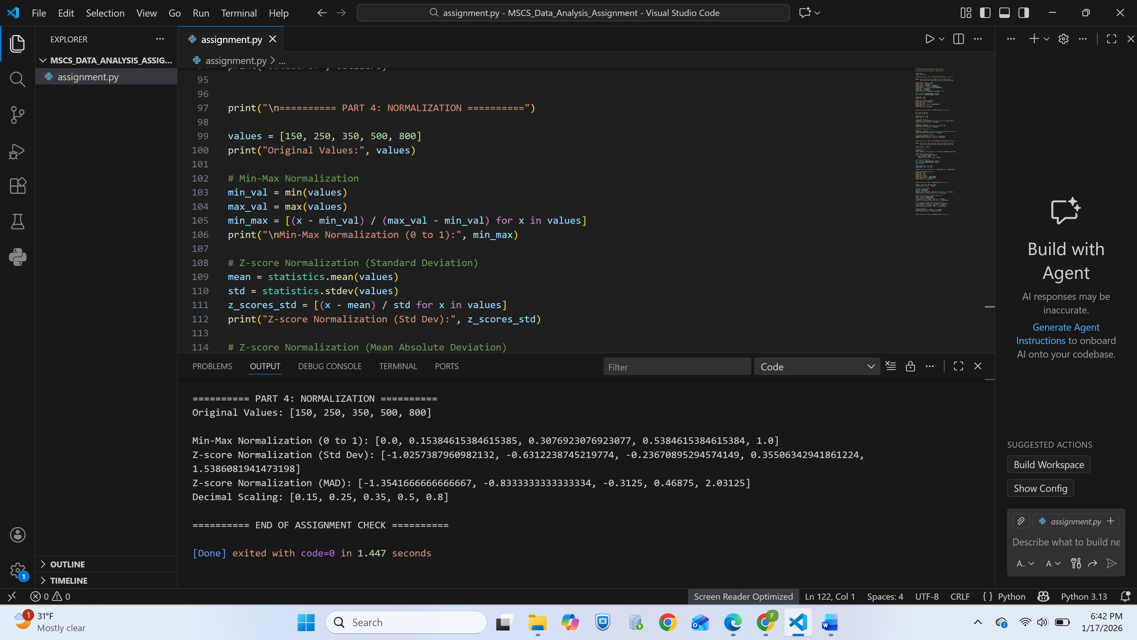
Screenshot of part 4 showing the results

Conclusion
This assignment demonstrated essential data preparation techniques including descriptive statistics, distance metrics, data smoothing, outlier detection, and normalization. These methods are fundamental for understanding data behavior and preparing datasets for effective analysis.

References
Han, J., Kamber, M., & Pei, J. (2012). Data mining: Concepts and techniques (3rd ed.). Morgan Kaufmann.

Jain, A. K., Murty, M. N., & Flynn, P. J. (1999). Data clustering: A review. ACM Computing Surveys, 31(3), 264–323. https://doi.org/10.1145/331499.331504

Tan, P.-N., Steinbach, M., Karpatne, A., & Kumar, V. (2019). Introduction to data mining (2nd ed.). Pearson.

Zaki, M. J., & Meira, W. (2014). Data mining and analysis: Fundamental concepts and algorithms. Cambridge University Press. https://doi.org/10.1017/CBO9780511810114

Montgomery, D. C., & Runger, G. C. (2018). Applied statistics and probability for engineers (7th ed.). Wiley.

