Free Financial Data Management (FFDM)

The Logo is a real Computer I own and the photo for the icon and the icon design I did myself: https://en.wikipedia.org/wiki/Atari_Portfolio.

Watchlist
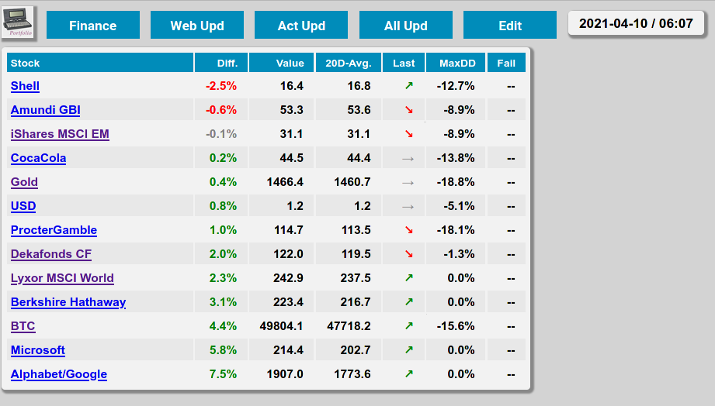
The date indicates the day and time of last data update

The Finance Button switches between Finance and Watchlist view

WebUpd does a manual update of stock data

ActUpd does a manual update of account data (CSV in certain directories) – this usually runs every 5 minutes anyway

Edit is work in progress to edit the Watchlist

All stock data is in Euros!

Finance view on Desktop
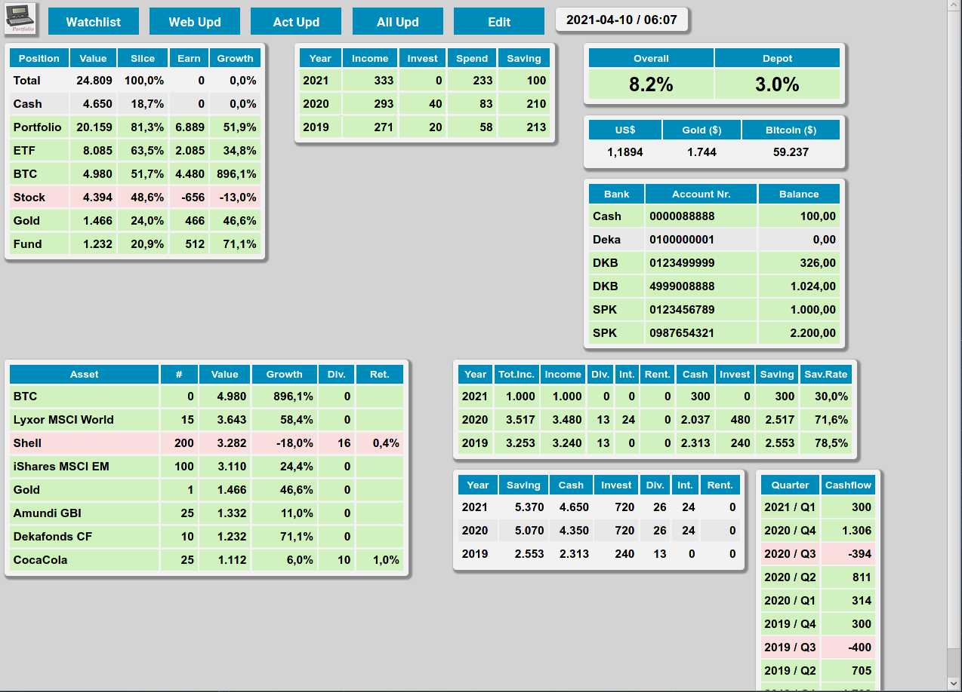

Top left: total overview
Top middle: monthly averages per year
Top right:
1 Performance (overall includes BTC and Gold, depot is only stock and funds/ETF)
2 Accounts (easy to compare and check if all data is correctly in the DB)

Lower left: detailed depot view with one line per investment item
Lower right:
Yearly analysis (only per year!)
below: Yearly analysis (compounded!)

Lower right right:
Cashflow per Quarter

Mobile View (looks better on tablet or phone)
