

CS 4732

MACHINE VISION

PROJECT 4

deep learning for classification

INSTRUCTOR
Dr. Mahmut KARAKAYA

Franck DIPANDA
001049149

1. ABSTRACT

This project aimed to develop and evaluate a convolutional neural network (CNN) to classify German traffic signs into three simplified categories: circles, triangles, and blue signs. Using the GTSRB dataset, images were preprocessed and grouped based on label mappings provided in the assignment. I used a pretrained model, AlexNet, and fine-tuned it by transfer learning on the new three-class training set.

Image resizing and data augmentation were applied to handle input constraints and increase model robustness. The training process was completed over 5 epochs using a mini-batch size of 64 and a learning rate of 0.0001. Evaluation was performed using a separate test set, resulting in a test accuracy of 99.82%, with only a few misclassifications observed.

This work demonstrates how transfer learning can be effectively applied to adapt existing deep learning architectures for new classification with high accuracy.

2. Test RESULTS

2.1 Table of Key Parameters

Learning Rate | Epochs | Batch Size | Accuracy
0.0001 | 5 | 64 | 99.82%

Figure 1: Table of Key Parameters + Accuracy

2.2 Training Progress + Confusion Matrix Result

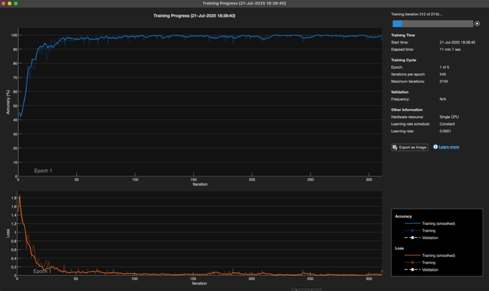  (a) | 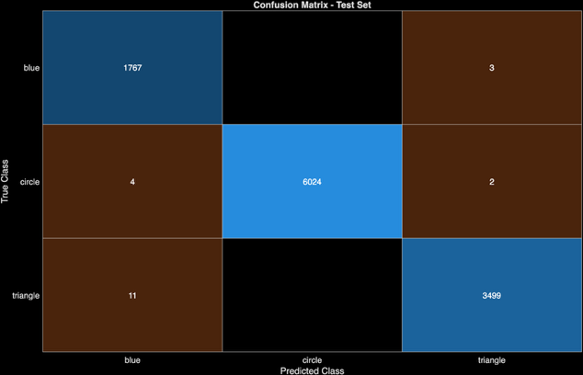  (b)
Figure 2: (a) Training Progress, (b) Confusion Matrix

2.3 Result Summary

The final model achieved a test accuracy of 99.82%, correctly classifying nearly all test images into their respective shape categories. The confusion matrix shows very few misclassifications, indicating strong generalization. The model was trained using a fine-tuned AlexNet architecture, with minimal overfitting observed due to the careful use of hyperparameters and preprocessing.

3. CODES

3.1 Code to Organize Test Images

% Franck Dipanda
% ID#: 001049149
% Project 3

testTable = readtable('Test.csv', 'VariableNamingRule', 'preserve');

circleLabels = [0:5, 7:10, 15:17];
triangleLabels = [11, 13, 18:31];
blueLabels = 33:40;
ignoreLabels = [6, 12, 14, 32, 41, 42];

dstFolder = 'Grouped_Test';

% Create folders if they don't exist
shapes = {'circle', 'triangle', 'blue'};
for s = 1:length(shapes)
shapePath = fullfile(dstFolder, shapes{s});
if ~exist(shapePath, 'dir')
mkdir(shapePath);
end
end

for i = 1:height(testTable)
label = testTable.ClassId(i);
filename = testTable.Path{i};

% Skip ignored labels
if ismember(label, ignoreLabels)
continue;
end

% Determine destination folder
if ismember(label, circleLabels)
shapeFolder = 'circle';
elseif ismember(label, triangleLabels)
shapeFolder = 'triangle';
elseif ismember(label, blueLabels)
shapeFolder = 'blue';
else
continue;
end

src = filename;
[~, name, ext] = fileparts(filename);
dst = fullfile(dstFolder, shapeFolder, [name ext]);

% Copy image
if isfile(src)
copyfile(src, dst);
else
warning('File not found: %s', src);
end
end

3.2 Code to Organize Training Images

trainTable = readtable('Train.csv', 'VariableNamingRule', 'preserve');

circleLabels = [0:5, 7:10, 15:17];
triangleLabels = [11, 13, 18:31];
blueLabels = 33:40;
ignoreLabels = [6, 12, 14, 32, 41, 42];

srcFolder = 'Train'; % Root folder
dstFolder = 'Grouped_Train';

mkdir(fullfile(dstFolder, 'circle'));
mkdir(fullfile(dstFolder, 'triangle'));
mkdir(fullfile(dstFolder, 'blue'));

for i = 1:height(trainTable)
label = trainTable.ClassId(i);
filename = trainTable.Path{i};

% Skip ignored labels
if ismember(label, ignoreLabels)
continue;
end

% Determine destination folder
if ismember(label, circleLabels)
shapeFolder = 'circle';
elseif ismember(label, triangleLabels)
shapeFolder = 'triangle';
elseif ismember(label, blueLabels)
shapeFolder = 'blue';
else
continue;
end

% Source and destination file paths
src = filename;
[~, name, ext] = fileparts(filename);
dst = fullfile(dstFolder, shapeFolder, [name ext]);

% Copy the image
if isfile(src)
copyfile(src, dst);
else
warning('File not found: %s', src);
end
end

3.3 Code to Train Model

% Load training data
imdsTrain = imageDatastore('Grouped_Train', ...
'IncludeSubfolders', true, ...
'LabelSource', 'foldernames');

% Load test data
imdsTest = imageDatastore('Grouped_Test', ...
'IncludeSubfolders', true, ...
'LabelSource', 'foldernames');

% Resize images
inputSize = [227 227];
augTrain = augmentedImageDatastore(inputSize, imdsTrain);
augTest = augmentedImageDatastore(inputSize, imdsTest);

% Modify final layers for 3-class output
layers = net.Layers;
layers(end-2) = fullyConnectedLayer(3);
layers(end) = classificationLayer;

% Set training options
options = trainingOptions('sgdm', ...
'InitialLearnRate', 1e-4, ...
'MaxEpochs', 5, ...
'MiniBatchSize', 64, ...
'Shuffle', 'every-epoch', ...
'Verbose', false, ...
'Plots', 'training-progress');

% Train the model
trainedNet = trainNetwork(augTrain, layers, options);

3.4 Code to Evaluate Model

% Predict Test Labels
[predictedLabels, scores] = classify(trainedNet, augTest);

% Actual Labels
actualLabels = imdsTest.Labels;

% Accuracy
testAccuracy = mean(predictedLabels == actualLabels);
fprintf('Test Accuracy: %.2f%%\n', testAccuracy * 100);

% Confusion Matrix
figure;
confusionchart(actualLabels, predictedLabels);
title('Confusion Matrix - Test Set');

4. DISCUSSION

This project reinforced the value of transfer learning in image classification tasks, especially when working with complex datasets like GTSRB. Using a pretrained CNN significantly reduced training time while achieving excellent accuracy.

A key takeaway was the importance of correctly organizing datasets and applying appropriate preprocessing steps, such as resizing and augmentation, to meet model input requirements.

If more time were available, I would explore training with additional augmentations (e.g., rotation, scaling) and experiment with other networks like ResNet50 or VGG to compare performance and speed.

